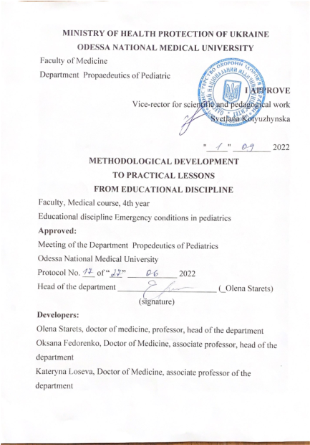

Developers:
Olena Starets, doctor of medicine, professor, head of the department
Oksana Fedorenko, Doctor of Medicine, associate professor, vice-head of the department
Kateryna Loseva, Doctor of Medicine, associate professor of the department

PRACTICAL TRAINING
Practical lesson No. 1
Topic: Initial and resuscitation care for newborns
Goal:
Know:
• Changes that occur in the body of a newborn during the transition from the intrauterine to the extrauterine state in normal conditions and during asphyxia
• Algorithm of initial and resuscitation care for newborns in the first minutes of life
Be able:
• Identify indications and provide initial and resuscitation care to newborns according to the algorithm
Basic concepts: asphyxia, the algorithm for providing emergency care to a newborn , tactile stimulation of breathing, chest compressions, lung ventilation
Equipment: Manikin-simulator of a newborn baby, suction equipment:
1. Rubber pear (only disposable, sterile)
2. Gastric probe 8F and 20-ml syringe
Equipment for lung ventilation and oxygen therapy:
1. A sterile bag for resuscitation of newborns with a pressure limiting valve or a manometer (the bag should provide 90-100% oxygen supply)
2. Sterile face masks with soft edges
3. A set of oxygen tubes
Other:
1. Disposable gloves (at least 5 pairs) and personal protective equipment
2. Warm diapers, clothes (cap, socks)
3. Diaper - a roller under the shoulders
4. Neonatal stethoscope
5. Scissors, clamps, etc. to cut the umbilical cord
Plan:
1. Organizational measures (greetings, verification of those present, announcement of the topic, purpose of the lesson, motivation of higher education seekers to study the topic).
2. Control of the reference level of knowledge (written work, written test, frontal survey, etc.) (if necessary):
⎯ requirements for students' theoretical readiness to perform practical classes (knowledge requirements, list of didactic units);
⎯ questions (test tasks, problems, clinical situations) to check basic knowledge on the subject of the lesson.
3. Formation of professional abilities and skills (mastery of skills, conducting curation, determining the treatment scheme, conducting laboratory research, etc.):
⎯ content of tasks (tasks, clinical situations, etc.);
recommendations (instructions) for performing tasks (professional algorithms, orientation maps for the formation of practical skills and abilities, etc.);
requirements for work results, including registration;
⎯ control materials for the final stage of the lesson: problems, assignments, tests, etc. (if necessary).
4. Summary:
Assessment of practical skills, knowledge of the algorithm of emergency care for a newborn child
Answers to the final test tasks
5. List of recommended literature (main, additional, electronic information resources):
Main:
Initial, resuscitation and post-resuscitation care for newborns in Ukraine". Unified clinical protocol and adapted evidence-based clinical guidelines approved by order of the Ministry of Health of Ukraine No. 225 of March 28, 2014
Additional:
Neonatal resuscitation. Textbook of the American Association of Pediatricians.
An overview of the updated recommendations of the American Heart Association for CPR and emergency care in cardiovascular diseases from 2015

