ODESSA NATIONAL MEDICAL UNIVERSITY
Department of General, Military and Pediatric Surgery with the course of Urology and Ophtalmology

METHODOLOGICAL DEVELOPMENT
practical lesson for students

Lesson topic: Topic 10. Surgical treatment of male sexual disorders.

Course 5, Faculty of Medicine
Level higher education: second ( master's )
Branch of knowledge: 22 “Healthcare”
Specialty: 222 "Medicine"
Educational and professional program: Medicine

Approved
on methodical at the meeting department
28. 08. 2024.
Protocol No. 1

Head of the department, professor Kashtalyan M.A. _______________

Odesa 2024
- Relevance of the topic: The relevance of studying this section of andrology by students is determined by the prevalence, social significance of the problem, the level of its influence on social and sexual adaptation, self-esteem and quality of life of the men. Disorders of the external genitalia are especially troubling for patients because of the potential emotional significance of these reproductive structures and, probably, the possible impact of the anomalies on the person and on future generations.
Given that congenital anomalies of male reproductive system also determine libido and sexual capabilities as well as fertility and constitution, the actuality of surgical treatment of this pathologies is beyond doubt.

2. Class duration: ___2__ (hours)

3. Learning goal (specific goals):
The student should know:
- Penile agenesis – definition, basis of diagnostic and surgical treatment
- Penile duplication– definition, basis of diagnostic and surgical treatment
- Microphallus– definition, basis of diagnostic and surgical treatment
- Penile torsion– definition, basis of diagnostic and surgical treatment
- Lateral penile curvature – definition, basis of diagnostic and surgical treatment
- Penoscrotal transposition– definition, basis of diagnostic and surgical treatment
- Webbed and buried penis– definition, basis of diagnostic and surgical treatment
- Megaprepuce– definition, basis of diagnostic and surgical treatment
- Scrotal agenesis– definition, basis of diagnostic and surgical treatment
- Ectopic and accessory scrotum– definition, basis of diagnostic and surgical treatment
- Splenogonadal fusion– definition, basis of diagnostic and surgical treatment
- Cryptorchidism
  - Definition and classification
  - Physical examination
  - Treatment
    - General approaches to the treatment
    - Medication treatment of cryptorchidism
    - Surgical treatment
- Hypospadias
  - Definition and classification
  - Assessment and diagnostic
  - Treatment options
  - Follow-up and prognosis
- Epispadias
  - Definition and classification
  - Assessment and treatment options
- Hydrocele– definition, basis of diagnostic and surgical treatment
- Varicocele – options of surgical treatment

The student should be able to:
a) to obtain comprehensive information about the disease from the patient or his close relatives or based on the analysis of the medical documentation available;
b) palpate the organs of the genitourinary system in full;
c) evaluate the data of objective and various laboratory research methods;
d) correctly appoint, evaluate data of various laboratory, instrumental, functional methods and tests;
e) establish a preliminary diagnosis of the main disease and complications.
e) to determine the indications for the surgery
g) to choose the type of surgical intervention.

The student must acquire practical skills:
- determine the need and sequence of special research methods /laboratory, instrumental, radiological, functional, etc./, perform them and give their correct assessment;
- evaluate the results of biochemical blood tests, functional hormonal tests;
- carry out differential diagnosis of the main andrological diseases in different age groups, justify the clinical diagnosis;
- justify the scheme, plan and tactics of patient management, indications and contraindications for surgery.

- Basic knowledge, skills, and abilities necessary for studying the topic (interdisciplinary integration)
Names of previous disciplines | Acquired skills
1. Human anatomy.  2. Histology.  3. Physiology.  4. Pathological anatomy.  5. Pathological physiology.  6. Radiation diagnostics.  7. General surgery  8. Topographic anatomy and operation surgery  9. Urology  10. Patient care. | Know the structure and functions of the organs of the male reproductive system, the pathological anatomy and physiology of the male reproductive system, the rules of care for patients with diseases of the urinary and reproductive system, the basic rules of medical ethics and deontology. Assess changes in the functioning of the organs of the reproductive system that indicate a violation of the patient's condition, conduct an objective examination of the patient to identify symptoms and syndromes that indicate damage to the organs of the reproductive system and the patient's serious condition. To prepare patients for instrumental, functional and laboratory methods of researching the organs of the male reproductive system. To be able to interpret the results of additional radiological methods of diagnosis of organs of the male reproductive system, to care for patients with diseases of the urinary system.

- Advice to the student.

  - Topic content:

Anomalies in Males

Penile agenesis
Congenital absence of the penis (aphallia), is an extremely rare anomaly caused by developmental failure of the genital tubercle. Its approximate incidence is 1 case per 30 million population. The phallus is completely absent, including the corpora cavernosa and corpus spongiosum; however, some children reportedly have small portions of corpora cavernosa. ^{[4]} Usually, the scrotum is normal and the testes are maldescended. The urethra opens at any point of the perineal midline from over the pubis to, most frequently, the anus or the anterior wall of the rectum.
More than 50% of patients with penile agenesis have associated genitourinary anomalies, the most common of which is cryptorchidism; renal agenesis and dysplasia also occur. Gastrointestinal (GI) defects, such as caudal axis anomalies, have also been described. Reports indicate that aphallia may be associated with pregnancy complicated by poorly controlled maternal diabetes.
Historically, these infants have undergone gender reassignment surgery, including bilateral orchiectomy with preservation of scrotal skin for later vaginal reconstruction, labial construction, and urethral transposition. However, questions remain regarding in-utero gender imprinting and long-term psychological effects of gender conversion; the timing, role, and necessity of gender reassignment are controversial. The long-accepted notion regarding the presence of a phallus or phenotypic phallic growth potential should not be the major criterion in recommending gender reassignment.
Because some studies have emphasized that most of these patients have a male sex identity despite reconstruction as female, male sex assignment has been recommended as a prudent decision. Accordingly, patients with aphallia should be raised as male, though experience with phalloplasty in pediatric-age patients is limited.
The most commonly performed phalloplasty procedure in postpubertal patients is the microvascular transfer radial forearm flap. For congenital aphallia, a technique by De Castro has been described that is based on a suprapubic skin flap as initially described by Bettocchi et al. An alternative surgical technique, especially for the presence of midline suprapubic abdominal scars, is a vascularized groin flap fashioned as reported by Perovic. A modified scrotal flap technique involving the addition of an acellular dermal matrix patch has been described as well.

Penile duplication
Duplication of the penis (diphallia) is another extremely rare anomaly resulting from incomplete fusion of the genital tubercle. Two distinct forms of penile duplication are recognized, as follows:
- The most common form is associated with bladder-exstrophy complex; the patient exhibits a bifid penis, which consists of two separated corpora cavernosa that are associated with two independent hemiglands
- The second form (true diphallia) is an extremely rare congenital condition that presents in many ways, ranging from duplication of the glans alone to duplication of the entire lower genitourinary tract; the urethral opening can be in normal position or in a hypospadiac or epispadiac position
Associated anomalies of the GI, genitourinary, and musculoskeletal systems are expected. Because these anomalies are the principal causes of mortality, examining and treating patients for these conditions as soon as possible is important.

Microphallus
The term microphallus, or micropenis, is applicable only to a normally formed yet abnormally short penis. Specifically, the term applies to a penis with a stretched length that is more than 2.5 standard deviations (SD) below the mean for age.
This condition may be considered a minor form of ambiguous genitalia with correlated medical and psychological problems similar to those of the major form seen in a disorder (difference) of sex development (DSD). The scrotum is usually normal, but testes may be small and undescended. In a few cases, the corpora cavernosa are severely hypoplastic. Measurement (ie, stretched penile length) is very important in differenting the various types of pseudomicropenis, particularly the buried penis in the obese infant and the penis concealed by an abnormal skin attachment.
Micropenis results from a multiplicity of endocrine and nonendocrine conditions. The most common etiologies are as follows:
- Hypogonadotropic hypogonadism - In this condition, secretion of gonadotropin-releasing hormone (GnRH) by the hypothalamus is impaired, which leads to decreased pituitary secretion of luteinizing hormone (LH) and follicle-stimulating hormone (FSH), depriving the testis of its stimulus to secrete testosterone; this pathogenesis is recognized in some hypothalamic dysfunctions, such as Kallmann syndrome or Prader-Willi syndrome
- Hypergonadotropic hypogonadism - Micropenis secondary to this condition is associated with conditions in which the testes are functionally impaired and unable to respond to hypothalamic-pituitary stimulation (eg, gonadal dysgenesis)
- Idiopathic micropenis - In this condition, endocrine analysis demonstrates a normal hypothalamic-pituitary-testicular axis
Because micropenis is the result of numerous pathologic conditions, assignment of sex of rearing has generally been deferred until a physician determines a potential cause and whether the penis can grow in response to testosterone administration. In individuals with microphallus who are insensitive to the androgen, castration and gender conversion might be an option. However, in most patients with micropenis, male gender assessment can be maintained with androgen stimulation.
Clinical management of micropenis has been contentious, with disagreement regarding the capacity of testosterone treatment to induce a functionally adequate adult penis; moreover, there is no general consensus regarding dosage, method of administration, timing, and duration of androgen treatment. The most common therapeutic regimen includes testosterone enanthate, 25-50 mg intramuscularly (IM) once a month for 3 months. Some physicians also use testosterone cream, but its absorption varies and is not easily controllable.
Debate also surrounds the timing of androgen stimulation. Research indicates that testosterone therapy in infancy and childhood augments penile size into the normal range for age in boys with micropenis secondary to fetal testosterone deficiency. Replacement therapy at the age of puberty is indicated for gonadal deficiency. Final adult penis size is usually below the mean but within 2.5 SD.
In a small (N = 6) single-center study aimed at assessing the effects of continuous subcutaneous infusion of recombinant human gonadotropins on stretched penile length and hormone levels in infants with congenital micropenis, Stoupa et al found that this approach safely corrected micropenis in five of the six patients, including the one infant with partial androgen insensitivity syndrome. Long-term follow-up data will be necessary to determine whether this treatment has any impact on future fertility and reproduction.

Penile torsion
Verneuil first described penile torsion in 1857. In the past, physicians did not recommend operative correction, because they believed that attempts to move the skin would not correct spiral alignment of the corpora cavernosa.
The embryologic abnormality is often an isolated skin and dartos defect that can be remedied simply by freeing the penile shaft of its investing tissue. The rotation is usually to the left in a counterclockwise fashion. The urethral meatus is placed in an oblique position, and the median raphe makes a spiral curve from the base of the penis to the meatus. However, in some cases, penile torsion is associated with mild forms of hypospadias or hooded prepuce.
Frequently, torsion is corrected by reflection of the skin and dartos tunic only. In some cases, resection of the Buck fascia provides correction. Careful alignment of the skin during closure gives an excellent cosmetic result, even when the torsion is not corrected by reflection of the penile investments. A newer technique has been described that is based on a dorsal dartos flap rotated around the right side of the penile shaft and attached to the ventral aspect. The relative ease of achieving a normal appearance seems to justify surgical correction.

Lateral penile curvature
Congenital penile curvature secondary to asymmetry of corpora cavernosa length is an uncommon penile deformity. Hemihypertrophy of a corpus cavernosum and thickening of its accompanying tunica albuginea, with or without contralateral concomitant hypoplasia (rudimentary corpus), are responsible for the lateral deviation in congenital curvature of the penis. Rarely, penile deviation is accompanied by penile torsion. The anomaly can be associated with trauma, but often the patient does not have a history of corporal injury.
Although the deformity generally is not severe enough to preclude sexual intercourse, it can be a source of great concern to the patient and may cause him to avoid sexual contact. The Nesbit procedure is a simple effective surgical technique to correct lateral or ventral curvature. Good results have been reported for both the modified Nesbit corporoplasty and the Lue 16-dot plication technique ; the reported success rates of corporal plication were similar in prepubertal and postpubertal boys.

Penoscrotal transposition
Complete penoscrotal transposition is an uncommon condition in which the scrotum is located in a cephalad position with respect to the penis. A less severe form is a bifid scrotum, in which the two halves of the scrotum meet above the penis. It is a heterogeneous anomaly, and detection warrants careful clinical evaluation to rule out other major and life-threatening anomalies, especially of the urinary system, GI tract, upper limbs, craniofacial region, and central nervous system (CNS).
Major renal anomalies include complete agenesis of the urinary system, unilateral or bilateral renal agenesis, polycystic or dysplastic kidneys, horseshoe kidney, ectopic pelvic kidney, and obstructive uropathy. Genital abnormalities include a disproportionately long flaccid penis, complete urethral atresia, and hypospadias.
Although most reported cases are sporadic, some suggest a genetic basis for a normal penoscrotal relation. The embryologic sequence responsible for this defect remains unclear. Abnormal positioning of the genital tubercle in relation to the scrotal swellings during the critical period at 4-5 weeks' gestation may affect the inferomedial migration and fusion of the scrotal swellings.
If the phallic tubercle is also intrinsically abnormal, development of the corporal bodies and the urethral groove and folds may be affected; this explains the frequent occurrence of the other genital abnormalities. Accurate antenatal diagnosis of this malformation by means of ultrasonography (US) has been demonstrated.
Surgical correction is recommended for physiologic and psychological reasons. When associated with severe hypospadias, penoscrotal transposition may involve a staged surgical repair. Scrotoplasty is completed with an inverted omega skin incision that is made around the scrotal skin and the base of the penis, bringing the scrotal flaps beneath the penis.

Webbed and buried penis
Webbed penis (see the image below) is a common congenital abnormality in which a web or fold of scrotal skin obscures the penoscrotal angle. If the physician performing circumcision does not recognize the condition, the penis may become buried in a tentlike fold of skin. Recircumcision to remove the excess skin makes the situation worse by drawing hair-bearing scrotal skin onto the penis.
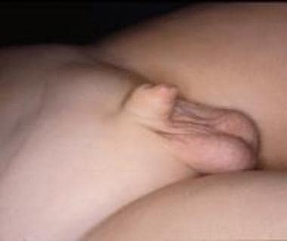Webbed penis.
In hidden penis, the penile shaft is buried below the surface of the prepubic skin. This happens in children with obesity because the prepubic fat is very abundant and hides the penis. The condition may also derive from poor anchorage of penile skin to deep fascia or may be acquired when the shaft of the penis is entrapped in scarred prepubic skin after an extreme circumcision or other trauma.
The literature describes numerous techniques for correction. Usually, treatment is based on resection of adherent bands and deep anchorage of the shaft at the basis of the penis. Some also advocate excision of redundant skin, multiple Z-plasties, liposuction, or preputial island pedicle flap. Others advocate watchful waiting, with emphasis on weight loss and yearly follow-up. Ruling out micropenis in this situation is essential.

Megaprepuce
Congenital megaprepuce is a rare malformation of unknown etiology that is characterized by extensive redundancy of the inner preputial skin, which causes the penis to be buried within the prepuce. This condition may be associated with an abnormal distal preputial opening that prevents normal flow of urine from under the foreskin. An enormous preputial cavity surrounds the entire shaft before micturition. In one of the first reported patients affected by congenital megaprepuce, micturating cystography was performed; the preputial volume was so huge that it was defined as a “preputial bladder.”
The aspect of congenital megaprepuce is typical: the penis is totally buried, and before micturition there is an enormous preputial cavity surrounding the entire shaft; after urination, dribbling may be noted. Numerous surgical techniques have been described to correct this anomaly. The cosmetic arrangement of the shaft skin with excision of the redundant inner preputial skin, especially in the ventral part, is the more difficult step of reconstructive surgery.
Unfortunately, congenital megaprepuce is one such congenital deformity that at birth often goes unrecognized. Circumcision with congenital megaprepuce may yield catastrophic complications, such as scarred buried penis with possible flow obstruction.

Scrotal agenesis
Aside from penoscrotal transposition, the scrotum is generally resistant to embryologic abnormalities; therefore, congenital malformations are unusual. Congenital absence of the scrotum is an extremely rare anomaly; according to a report by Corona-Rivera et al, only nine cases (seven bilateral and two unilateral) had been described in the literature as of January 2014.
Reports indicated that upon examination, the scrotum was not present, the skin between the base of penis and the anus was completely flat without rugosa, and both testes were retained in the tubercle area lateral to the base of the penis. Only minor associated abnormalities, including slight bilateral clinodactyly in both fourth toes and bilateral nystagmus, were noted. Chromosomal and hormonal anomalies were not reported.
The idea of constructing the scrotum with a pedicle flap from the perineal skin was discarded. In view of the subsequent development of the neoscrotum, the preputial skin was used because it is richer than other tissues in androgen receptors. The procedures were uneventful, and the results were functionally and cosmetically satisfactory. (See the images below.)
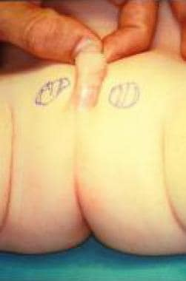Agenesis of scrotum in 6-month-old child.
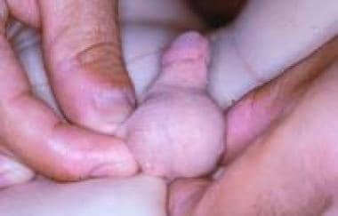Agenesis of scrotum after scrotal reconstruction with preputial skin. Appearance of external genitalia is normal.

Ectopic and accessory scrotum
Ectopic scrotum is a rare anomaly that includes an anomalously positioned hemiscrotum. Usually, the ectopic scrotum is found near the external inguinal ring, but it may assume several forms. Accessory scrotum is a small empty pouch of scrotal tissue attached to the scrotum or the perineum. One review identified 16 reported cases of a suprainguinal ectopic scrotum, four cases of a femoral ectopic scrotum, and 19 cases of accessory perineal scrotum. ^{[27]}
The testis generally accompanies the hemiscrotum to its abnormal position and may be normal or dysplastic. These congenital lesions of the scrotum can occur as an isolated anomaly but are often accompanied by abnormalities of the upper urinary tract.
Accessory perineal scrotum has also been observed in association with anorectal malformation. The gubernaculum is a prerequisite for the ultimate location of both the testis and scrotum, and its role is complicated by subsequent differential growth of the labioscrotal folds in which the gubernaculum is stabilized. If this interaction is disturbed, the result may be suprainguinal ectopia, penoscrotal transposition, or perineal scrotum.
Although the etiology of these malformations is probably multifactorial, the existence of an inbred strain of rats that are characterized by a high incidence of ectopic scrotum suggests a genetic component to this anomaly.
Treatment should attempt to bring down the scrotum and the testis. If the gonad is dysplastic and the ectopic scrotum is rudimentary, removal of one or both structures should be considered.

Splenogonadal fusion
Splenogonadal fusion is a congenital anomaly that affects both sexes, with a male-to-female ratio of 16:1. In males, the left testicle or other derivatives of the mesonephros connect to splenic tissue, usually an accessory spleen. In the female, a similar fusion occurs between the left ovary and splenic tissue. The connection may be either continuous (56%) or discontinuous (44%). In the continuous type, the spleen is connected to the gonad by a strand of tissue.
Patients often exhibit limb defects, micrognathia, or other congenital malformations, such as anal atresia, microgastria, spina bifida, craniosynostosis, thoracopagus, diaphragmatic hernia, hypoplastic lung, and abnormal lung fissures. The discontinuous type is not usually associated with congenital defects, and the fused gonad has no connection with the native spleen.
Reports total approximately 140 cases, mostly in the urology and pathology literature.This is because diagnosis typically occurs during orchiopexy or herniorrhaphy, or on autopsy.
In many cases, the accessory spleen that is attached to the testicle may be misinterpreted as a primary malignant testicular tumor or an adenomatoid tumor. Knowledge of this distinction is important if the testis is to be preserved at surgery, though a rare case of simultaneous splenogonadal fusion and mixed malignant tumor of the testis has been reported.
If splenogonadal fusion is suspected preoperatively, technetium-99m radiocolloid spleen scintigraphy can establish the correct diagnosis and permit testicular salvage. Simple excision of the splenic nodule is sufficient in all cases of discontinuous fusion. In continuous splenogonadal fusion, exploratory laparotomy is usually required to clarify the anatomy.

Cryptorchidism
In cryptorchidism (from Greek kryptos ["hidden"] and orchis ["testis"]), the testis is not located in the scrotum; it can be ectopic, incompletely descended, retractile, and absent or atrophic. Cryptorchidism is the most common abnormality of male sexual development.
Sir John Hunter, the British anatomist, reported this condition in 1786. In 1877, Annandale performed the first successful orchidopexy. In 1899, Bevan published the principles of testicular mobilization, separation of the processus vaginalis, and repositioning of the testis into the scrotum. Since then, testicular maldescent has been the subject of many clinical studies, but its embryology, effects on fertility, and ultimate clinical impact still remain topics of discussion and research.
Physical examination is the most important tool in the diagnostic evaluation of cryptorchidism. Closely observing the scrotum before manipulation is important. The frog-leg or catcher position may be used to facilitate palpation of the testis. Determining if the testis is palpable is essential. If the testis is palpable, ascertain whether it can be retracted. The retractile testis should stay in the dependent portion of the scrotum after manipulation.
Diagnostic laparoscopy is the most reliable technique for localizing the nonpalpable testis.
The main goals of treatment, whether hormonal or surgical, are (1) to allow the testicle to occupy a normal anatomic position, (2) to preserve fertility and hormonal production, and (3) to diagnose potential testicular malignancies. Other putative benefits include correction of associated hernias and prevention of testicular torsion.

Engle proposed hormonal manipulation as a treatment for cryptorchidism in the 1930s. Whether treatment is hormonal or surgical, the main goals are as follows:
- To allow the testicle to occupy a normal anatomic position
- To preserve fertility and hormonal production
- To diagnose potential testicular malignancies
Other putative benefits include correction of associated hernias and prevention of testicular torsion.
The risk of trauma and possible psychological effects of having a missing testis must be taken into account. Orchiopexy should be considered after 4 months of life; the rate of descent diminishes considerably after this point.
For postpubertal adolescents and men younger than 32 years who underwent unilateral orchiopexy, orchiectomy should be considered. For postpubertal men older than 32 years, close observation and routine physical examination should be considered. Any man with bilateral undescended testes should undergo bilateral testicular biopsy and orchiopexy.
Guidelines for management of pediatric cryptorchidism have been developed by the American Urological Association (AUA) and the Canadian Urological Association (CUA)–Pediatric Urologists of Canada (PUC) (see Guidelines).
Several surgical approaches to the undescended testis have been described. The approach chosen is determined by the position of the testis and the surgeon's expertise.
The palpable testis can be approached via a scrotal, subinguinal, inguinal, or suprainguinal approach. The nonpalpable testis can be approached via an inguinal, suprainguinal, or laparoscopic approach.
During the period between January 2002 and July 2009, one study showed a shift in surgical approach toward more scrotal-approach procedures for palpable testes and fewer transinguinal abdominal orchidopexies for nonpalpable testes.
In a prospective study of 200 patients with palpable undescended testis who underwent orchidopexy via either a two-incision inguinal approach or a single-incision scrotal approach between January 2011 and December 2013, Ben Dhaou et al found the latter approach to be safe and effective for undescended testicles palpable in the inguinal canal or in a high scrotal position.
In a randomized study by Nazem et al, single-incision transscrotal orchiopexy (group I) was compared with traditional two-incision inguinal-scrotal orchiopexy (group II) in 100 children who required surgical treatment for undescended testis. Success rates were 98% in group I and 94% in group II, and the two groups did not differ significantly with respect to wound infection, testicular atrophy, testicular hypotrophy, and relapse. However, the single-incision transscrotal approach was judged more successful in terms of cosmetic results, patient satisfaction, and duration of hospitalization.
Several authors have reported successful treatment of cryptorchidism with laparoscopic techniques. A systematic review and meta-analysis of five studies (N = 705) by Anand et al concluded that laparoscopic orchiopexy was safe and effective in children with palpable cryptorchidism and was comparable to conventional open orchiopexy with respect to the rates of redo orchiopexy, early complications, and testicular atrophy.
Routine testicular biopsy during orchiopexy is not recommended and should be considered only in cases involving prune belly syndrome, ambiguous genitalia, abnormal karyotypes, or postpubertal adolescents or men. Some authors have recommended that if the biopsy reveals carcinoma in situ, repeat exploration and unilateral orchiectomy should be performed. In bilateral cases, radiation therapy may be useful.
Palpable testis
Look for the testis after incising the Scarpa fascia to avoid injuring a testis and its cord found outside of the external inguinal ring (ectopic testis in the superficial inguinal pouch).
Divide all attachments, including the gubernaculum, the cremasteric fibers, and the lateral spermatic fascia.
Identify the patent processus vaginalis in the anteromedial surface of the cord, separate it from the cord structures, and perform a high ligation; be careful not to trap the vas or vessels.
Place the testis in a subdartos pouch.
Nonpalpable testis
Diagnostic laparoscopy should be preferred to inguinal exploration.
Blind-ending vas and vessels confirm the diagnosis of a vanishing testis and do not warrant further therapy. Consideration should be given to exploring the contralateral scrotum and placing some anchoring stitches to prevent possible testis torsion on the other side.
Vessels entering the internal inguinal ring require further inguinal or scrotal exploration to identify the undescended testis or testicular nubbin.
In patients with findings of a vanishing testis or a testicular nubbin, fixation of the contralateral testis should be considered but is controversial.
A small intra-abdominal testis or an abnormal testis requires orchiectomy.
Length-increasing maneuvers
The Prentiss maneuver involves rerouting the cord under the epigastric vessels or the division of epigastric vessels.
The internal inguinal ring can be opened to perform more complete retroperitoneal mobilization.
The Fowler-Stephens principle involves dividing the testicular vessels to allow the blood supply to the vas deferens to keep the undescended testis viable. The testicular vessels should be divided away from the testis.
Testicular autotransplantation can be performed by transecting the testicular vessels and by performing a microvascular anastomosis to the inferior epigastric vessels.
The surgical procedure is done on an outpatient basis. Pain control medications should be prescribed as needed; minimal pain medication is required in the first 24-48 hours. The surgical incision site should be kept dry for 48 hours. If surgical buttons were used, consider removing them 7-10 days after the operation.
Children should avoid playing on straddle toys and participating in physical education for 1-2 weeks after surgery.
Complications related to the surgical correction of the maldescended testis include the following:
- Testicular atrophy (5%)
- Injury to vas deferens (1-2%)
- Reascent of the testicle or abnormal anatomic position (< 10%)
- Epididymo-orchitis
- Hydrocele

Penile hypospadias

Congenital malformations of male genitalia include a wide range of clinical situations such as hypospadias, epispadias (in the bifid clitoris) with bladder exstrophy, and hidden penis. This article addresses the surgical treatment of penile hypospadias.
History of the Procedure
The earliest report concerning urethral hypoplasia and its treatment dates back to Celsius (25 AD) and Galen (second century AD), with the description of hypospadias malformation.
Duplay began the modern era in this field in 1874 by publishing a detailed procedure for urethra reconstruction. Currently, more than 200 techniques have been described. Most of the procedures are multistage reconstruction; all consist of a first emergency stage that addresses correction of the stenotic meatus, if required, and a second stage that eliminates the chordee and the recurvatum.
Techniques differ regarding the third stage, the urethroplasty (creation of a neo-urethra and its coverage).
Numerous problems are associated with the multistaged techniques: they required multiple operations, the meatus often did not reach the tip of the glans or retract with time because of multiple tissue manipulations and repeated scarring, urethral stricture and/or fistula formation were frequent, and the final aesthetic result was poor.
To overcome the high frequency of complications, Hinderer introduced one-stage hypospadias repair in 1960.
Numerous modifications and innovative techniques were promulgated by other surgeons in the subsequent decade, all affirming the advantage of using unscarred tissue to reconstruct the urethra while minimizing the number of operations.
One-stage hypospadias repair claims ideal anatomic and functional urethral reconstruction, with good aesthetic restoration of external genitalia, a low complication rate, minor psychological involvement, and reduced social costs.
Multistaged repairs
- The first stage addresses correction of the stenotic meatus if required.
- The second stage eliminates the chordee and the recurvatum.
- The third stage reconstructs a neo-urethra to the tip of the glans.
Milestones in urethroplasty
- 1874: Duplay performed tubulization around a catheter of the ventral skin of the penis.
- 1897: Novè Josserand performed urethroplasty with a skin graft tubed around a catheter and anastomosed to the urethral meatus.
- 1899: Rochet performed tubulization of a meatus-based flap from the scrotum.
- 1917: Beck raised and tubed two paramedian ventral skin flaps.
- 1911: Ombredanne created a turnover flap harvested proximally to the meatus and sutured to two paramedian incisions performed distally to the meatus on the ventral penile skin.
- 1946: Denis Browne performed the buried skin stripe technique showing a spontaneous re-epithelialization of a neo-urethra around a catheter.
One-stage repairs
- This involved correction of the recurvatum and reconstruction of the urethra in the same sitting.
- 1917: Beck performed a one-stage procedure for distal hypospadias with skeletonization and an advancement of the urethra to reach the tip of the glans.
- 1961: Horton and Devine performed a one-stage procedure, modified in 1967, which uses two flaps, one harvested from the glans and the other from the ventral penile skin, to reconstruct the urethra in distal hypospadias while a skin graft was suggested in the more proximal malformations.
- Hinderer in 1968, Hodgson and Toksu in 1970, Standoli in 1979, Duckett in 1980, Scuderi in 1981, and Koyanagi in 1993 performed a one-stage procedure based on using a preputial flap for urethroplasty.
Hypospadias consists of external urethral meatus dystopia, which may sort on the ventral surface of the penile shaft at any distance between the tip of the glans and the perineum, ventral absence of the preputium, and wide dorsal apron.
Curvature of the penile shaft and stenosis of the external meatus are often associated.
This malformation is seldom linked with genitourinary anomalies (eg, cryptorchidism, varicocele, hydrocele, ureteral duplication) and, rarely, with cardiovascular and craniofacial malformations.
Epidemiology
Frequency
Hypospadias presents in 1 in 350 live male births in the United States and is the most frequent malformation of the genitourinary tract.
Etiology
The enlargement of the genital tubercle and subsequent development of the phallus and urethra depend on the level of testosterone during embryogenesis.
If the testes fail to produce adequate amounts of testosterone or if the cells of the genital structures lack adequate androgen receptors or the androgen-converting enzyme 5 alpha-reductase, virilization is not complete and hypospadias results.
Genetic and nongenetic factors are involved in the etiology of hypospadias. A familial occurrence of hypospadias is found in approximately 28% of patients.
The exact genetic mechanism may be complicated and variable. The possibility of an autosomal dominance inheritance with low penetrance has been discussed. Another hypothesis is an autosomal recessive inheritance with incomplete manifestation.
Chromosomal aberration is found sporadically in patients with hypospadias.
Hypospadias is associated with several uncommon syndromes.
The main nongenetic factor associated with hypospadias is the administration of sex hormones; an increased incidence of hypospadias was found among infants born to women exposed to estrogen therapy during pregnancy.
Prematurity is associated more often in patients with hypospadias than in the general population.
Pathophysiology
The penis begins to form at approximately the fifth fetal week under the influence of testosterone. The urethral folds start to fuse over the urethral groove, and by the 14th week the process is complete (see image below). A short ingrowth from the tip of the glans progresses inward to meet the urethral tube at the fossa navicularis. The prepuce is then formed at the end of the development process.
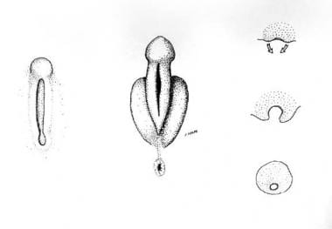Left: External genitalia during the undifferentiated stage. Middle: Male external genitalia at ninth week of intrauterine life. Right, from above to below: Transverse section of male genital area during the development of the urethral channel.
Hypospadias occurs when the fusion of the urethral folds stops proximal to the tip of the glans penis and can occur anywhere along the urethral groove.
Severe forms of hypospadias are accompanied by shortening of the urethral groove, which causes ventral tethering of the penis, a condition termed "chordee."
Presentation
This deformity presents with different severity according to the time of pathogen noxa during embryologic development. The meatus can sort in a glanular (60%), penile (35%), or scrotoperineal position (5%) and is clinically inadequate in 75% of patients and is often stenotic (see images below).
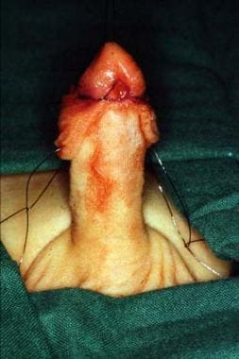Distal hypospadias: spatulated glans, ventrally cleft preputium.
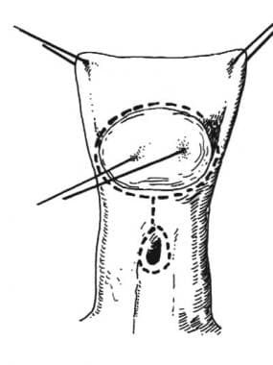Distal hypospadias. A traction suture is placed through the glans. Incision lines according to Scuderi repair: a coronal incision extended up to and around the meatus.
The glans is often spatulated and the prepuce is cleft ventrally with a dorsally hooded foreskin (see images above). Penile curvature of different degrees is observed in many patients (45%).
Several urogenital defects are associated with hypospadias.
- Cryptorchidism (9%)
- Inguinal hernia (9%)
- Megalourethra, urethral fistulae, and hypoplastic testicles (reported less often)
- Upper urinary tract defects (observed in association with proximally located hypospadias)
Indications
- Meatotomy is indicated at any age when the meatus caliber is reduced, causing dysuria.
- Correction of glanular hypospadias with distal urethra repositioning, creation of a symmetric glans (glanuloplasty), and preputium plasty is indicated in childhood or adolescence at the patient's request for cosmetic or psychological reasons.
- Correction of penile and penoscrotal hypospadias is indicated in childhood in patients younger than school age for the following reasons:
  - To permit normalization of voiding
  - To allow normal erection and intercourse
  - To avoid urinary tract infections
  - To correct impotentia generandi and coeundi
  - To achieve cosmetic sexual identity
- Hypospadias is corrected by penile "chordee" resection and by creation of a urethra of adequate caliber and length (urethroplasty).
Relevant Anatomy
The two corpora cavernosa and the corpus spongiosum of the urethra with the glans form the penis.
These structures are made from erectile tissue surrounded by the tunica albuginea (Buck fascia) and by the dartos fascia more superficially, which contains terminal branches of external pudendal arteries and veins, pudendal nerves, and the superficial lymphatics (see images below).
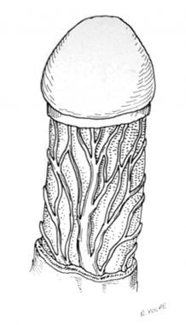The dartos fascia is outlined with the terminal branches of the external pudendal arteries and veins.
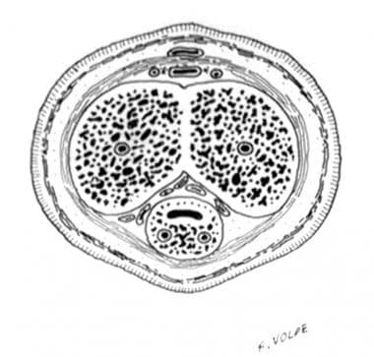Transverse section of the penis at midshaft level. From outside, the dartos fascia is visible with the blood vessels, the tunica albuginea surrounding the corpora cavernosa, and, in a ventral position, the urethra surrounded by its erectile tissue.
The normal male urethra runs from the bladder through the penile shaft, ventrally to the corpora cavernosa, and sorts with the external urethral meatus at the tip of the glans.
Contraindications
Reconstruction of the urethra and restoration of the normal appearance of the genitalia is contraindicated in infancy because of the difficulty related to the small dimension of the structures.
Surgical Therapy
The aims of the surgical procedures are as follows:
- Widening of the meatus
- Correction of the curvature
- Reconstruction of the missing portion of the urethra
- Restoration of the normal aspect of the external genitalia
Surgery differs according to the severity of the malformation.
A meatotomy is required if the size of the external urethral meatus is inferior to that considered normal according to the age of the patient.
The distal urethra missing in glanular hypospadias, usually without recurvatum, is well reconstructed with local flaps based on the meatus (eg, Santanelli procedure, Flip Flap, MAGPI [meatal advancement and glanuloplasty]), including preputium plasty at the same sitting (see images below).
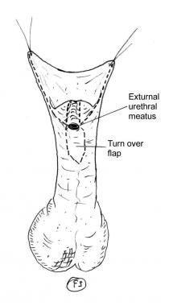Distal hypospadias. Incision lines are shown.
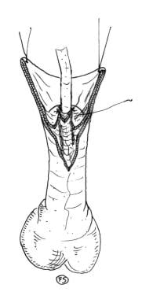The spatulated flap is turned over and sutured to the glans.
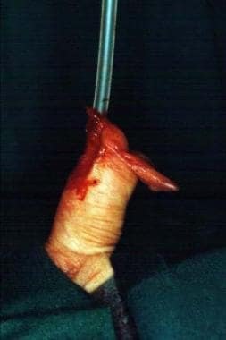The urethra is reconstructed and sutured between the glanular flaps.
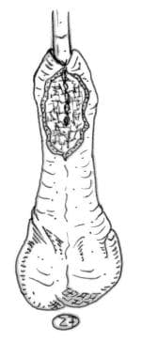Preputium plasty. Reconstruction of the inner layer.
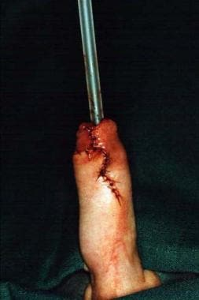Preputium plasty. Reconstruction of the outer surface.
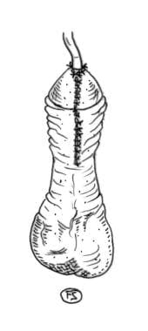Normal mobility of the preputium after its reconstruction.
In penile and penoscrotal types of malformation, resection of the chordee and reconstruction of the missing part of the urethra are performed with a single-stage procedure (eg, Duckett, Standoli, Scuderi, modified Koyanagi).
In some clinical situations (eg, perineal hypospadias, genital ambiguity, significant hypospadias with previous circumcision), more extensive operations are necessary, and the former multistage operations may be of occasional use.
A study by Arnaud et al indicated that in proximal penile hypospadias repair, the presence of a bifid scrotum predicts the need to transect the urethral plate. Of 18 children with a bifid scrotum, plate transection was considered necessary in 15, compared with two out of 11 children without a bifid scrotum.
Single-stage procedure
See the list below:
- Place a traction suture through the glans and extend a coronal incision around the meatus (see images below).
Distal hypospadias: spatulated glans, ventrally cleft preputium.
Distal hypospadias. A traction suture is placed through the glans. Incision lines according to Scuderi repair: a coronal incision extended up to and around the meatus.
Lift the penile skin, including the prepuce, and raise it in the plane between the Buck and dartos fascia.
- Deglove the meatus and penile urethra and separate them from the corpora cavernosa to the point that normal spongy tissue is detected. Excise the hypoplastic stenotic portion of the urethra.
- Perform an artificial erection with intracavernous injection of saline solution to assess the presence and degree of curvature (see images below). Perform chordectomy and straightening of the penile shaft when needed.
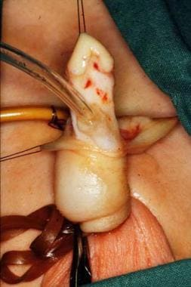Artificial erection. An intracavernous injection of saline is performed while controlling the back flow at the basis of the penis with an elastic band.
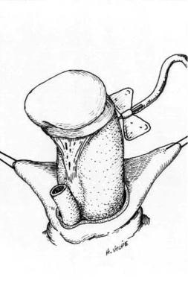Artificial erection achieved with normal saline injected in the corpora cavernosa while controlling the backward flow.
At this point, evaluate the actual urethral defect and begin the reconstruction. Harvest a peno-preputial skin flap, which may include both sides of the apron to increase its length, longitudinally along the penile vascular axis according to Scuderi and Koyanagi (Scuderi technique, see images below). The preputial flap can also be raised transversally from the ventral surface (according to Duckett) or from the dorsal aspect of the apron (according to Standoli).
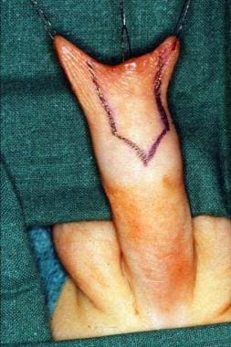Two 5/0 traction sutures are placed on either side of the preputial apron. Outlining of the vertical preputial flap after resection of the chordee and evaluation of the urethral defect.
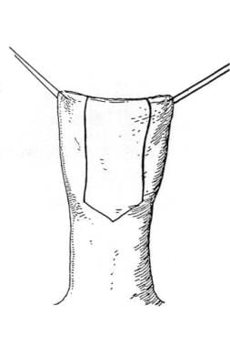Vertical preputium flap after Scuderi repair. Note the "V" shape pattern on the inferior part of the cutaneous flap.
Mobilize the flap with a large subcutaneous pedicle from the dartos fascia to ensure an appropriate vascularization (see images below).
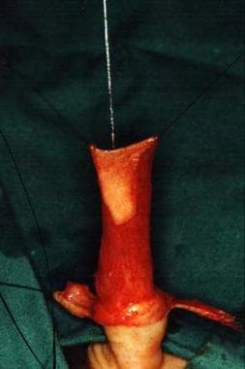The vertical preputial flap is elevated on the dorsal cutaneous side of the penis, vertically disposed along the vascular axis (Scuderi technique), to comply with the defect to be reconstructed. The flap is mobilized with a large subcutaneous pedicle.
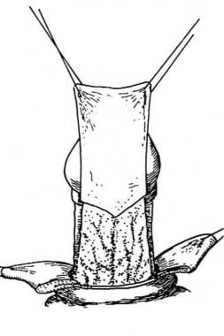Elevation of the vertical preputial flap with its subcutaneous pedicle.
- In the Scuderi procedure, a buttonhole incision is performed bluntly into the pedicle (see first 2 images below), and the flap is transposed ventrally by passing the penile body through the pedicle (see second 2 images below).
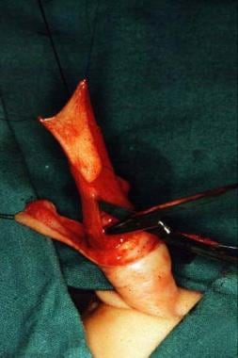Buttonhole incision along the midline of the subcutaneous pedicle of the vertical preputial flap, along the axis of the blood vessel, taking care not to jeopardize the vascularization.
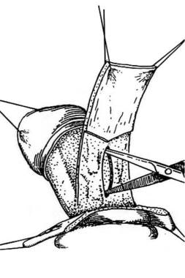Buttonhole incision along the median line of the pedicle.
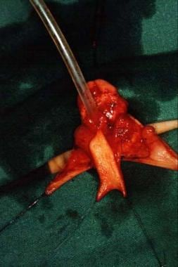The flap is transposed ventrally through the buttonhole incision without tractioning or twisting the pedicle, which may impair the blood supply. Key suture between the flap and the urethra.
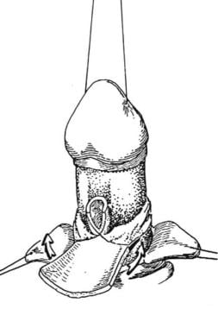Key suture between the flap and the urethra.
- If raised according to Koyanagi, the skin flap is divided into two portions at the 12 o'clock position to form a Y-shape, whereas in the modified Koyanagi repair, a button-hole is made trough the pedicle.
- If raised according to Duckett or Standoli, ventrally transpose the flap by its rotation around the corpora cavernosa.To reduce the incidence of stenosis of the proximal urethral anastomosis, the preputial flap must be V-shaped proximally and joined to a distal incision of 5 mm performed on the ventral wall of the urethra along its medial line.
- Continue suturing between the proximal side of the flap and the urethra (see first 2 images below) and extend it by rolling the flap into a tube around a 12F or 14F silicone catheter (see third image below).
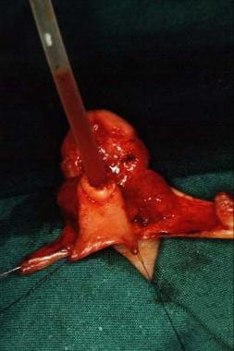The lower edge of the flap is sewn all around the urethral orifice.
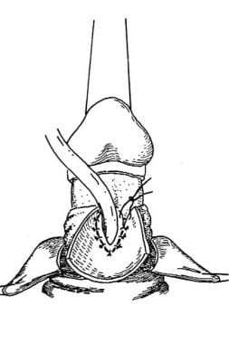The flap is transferred ventrally, and the lower edge of the flap is sewn all around the urethral orifice.
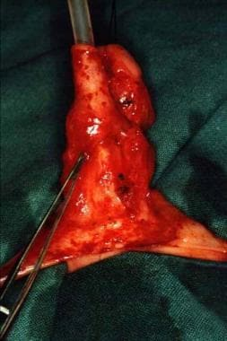The flap is tubed around a urinary catheter. In this manner, the anastomosis is covered by the pedicle and the longitudinal suture lies deep between the corporeal bodies, reducing the possibility of fistula occurrence.
Remove a vertical strip of tissue from the ventral surface of the glans (see first 2 images below) and raise two triangular flaps to cover the terminal part of the neo-urethra (see third image below).
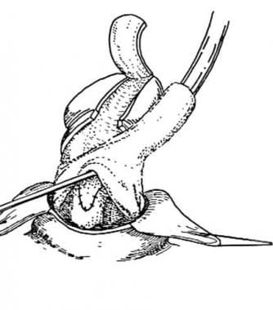The flap is rolled into a tube.
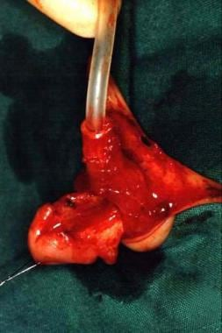The glans is split to permit the placement of the exit of the neo-meatus at the tip of the glans. A vertical strip of tissue from the ventral surface of glans is removed, and two thick triangular flaps are raised to cover the distal part of the neo-urethra. A well-closed urethra during intercourse is achieved.
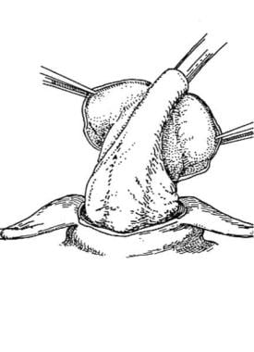Splitting of the glans.
Carry out the distal anastomosis. At the end of the procedure, discharge redundant poorly vascularized foreskin (see first 2 images below) and pull up the penile skin and suture it to the corona, creating an appearance similar to a circumcised penis (see second 2 images below).
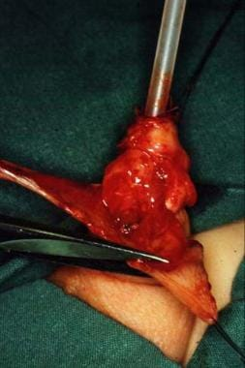Trimming of the preputium in excess.
The excess preputium is removed to provide the penis a circumcised appearance.
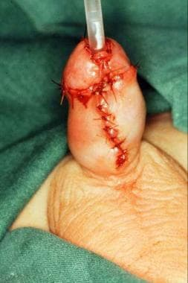Final appearance at the end of the operation.
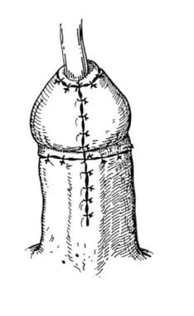Final appearance.
Stent the urethra and apply a mild compressive dressing.
Intraoperative considerations include the following:
- After penile degloving, an artificial erection with intracavernous injection of saline solution is performed to assess the presence and degree of curvature.
- The external urethral meatus is then resected together with the most distal hypoplastic portion of the urethra.
- Cordectomy and straightening of the penile shaft is performed if required.
- At this stage, the actual urethral defect shows and the urethral reconstruction is planned.
- A penile-preputial flap is harvested according to the preferred technique, taking into consideration the age-related urethral size. The flap is inset to the proximal urethral stump and tubed around a silicone catheter.
- The glans is split and two flaps that reach the tip of the glans are elevated to cover the distal part of the neo-urethra.
- The redundant foreskin is discharged and the penile skin is pulled up and sutured to the corona to achieve a final aspect similar to a circumcised penis.

Postoperative considerations include the following:
- Restraints for arm and legs may be necessary.
- Remove the urethral stent after 48 hours.
- The dressings remain in place for 4 days if no problems occur.
- Remove the diverting urinary catheter after 8-10 days.
- Discharge the patient after removal of the urinary diversion and when spontaneous voiding occurs without difficulties.
A randomized pilot study by Canon et al suggested that postoperative prophylactic oral antibiotic use in patients who have undergone distal hypospadias surgery with urethral stent drainage does not lower the risk of symptomatic urinary tract infection.
However, a prospective, randomized trial by Roth et al involving patients who underwent mid-to-distal hypospadias surgery reported that, while again, prophylactic antibiotic use did not appear to affect the incidence of postoperative symptomatic urinary tract infection, it did seem to discourage the development of bacteriuria and pyuria. At stent removal, the incidence of bacteriuria and pyuria in patients who received antibiotic prophylaxis was 11% and 18%, respectively, compared with 63% and 55%, respectively, in patients who received no antibiotics.
Follow-up
- Patients are observed with fluximetry tests including registration of the micturition volume, maximum flow, medium flow, and micturition time.
- A pressure-flow study with urethrogram and endoscopy (see image below) before removal of the urinary diversion may be indicated to evaluate the detrusorial pressure and the morphologic and urodynamic aspects of the newly reconstructed urethra.
Normal flow rate (down) 1 year after dilatation Perform a flow rate study at 3 weeks postoperatively. Examine patients showing a normal flow rate again at 3 and 12 months postoperatively. In patients exhibiting mild stenosis, urethra dilatation is indicated; repeat the flow rate study after 3 weeks.
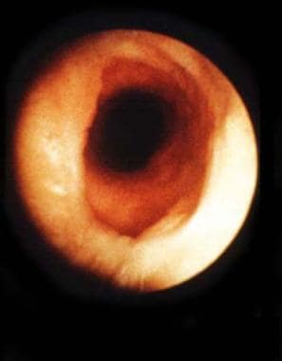Endoscopic view of the anastomosis.
At the 3-month follow-up visit, question patients about the persistence of the curvature or other problems.
- It is reported that the majority (range, 50-81%) of hypospadias repair complications (fistula, glans dehiscence, meatal stenosis, urethral stricture, and diverticulum) are diagnosed by the first year after surgery. Nevertheless, late complications are detected in patients with symptoms.
- Long-term follow-up care is necessary at least through puberty to exclude late failure caused by hypertrophic urethral scarring or undetected chronic inflammation.

Complications
Early complications include bleeding, infection, wound separation, flap necrosis, and edema. Temporary stenosis from edema or hypertrophic scarring at the anastomotic site may occur in 7% of repairs. Normalization is achieved after dilatation with urethral probes of progressive caliber and stabilization of the healing process.
Early urinary leakage from delayed healing of the urethral suture has been reported with an incidence of 3-9%. Spontaneous resolution occurs by keeping the suprapubic diversion for a longer time.
Urethrocutaneous fistulas with urinary leakage from the new urethra range from 0.6-23% in the one-stage operation and from 2-37.3% in the two-stage operation.
In a study of children aged 1-3 years who underwent repair for distal to mid-shaft hypospadias (via tubularized incised plate urethroplasty), Roshandel et al found that a neourethrocutaneous fistula can develop subsequent to postoperative infection at the repaired site. The investigators reported that out of eight patients with acute surgical site infection, four (50%) experienced fistula development, compared with two out of 93 patients (2.2%) without acute infection.
Urethral stricture complicates approximately 8.5% of hypospadias repairs. Persistent chordee caused by incomplete excision requires secondary surgical excision of all fibrous tissue.

Outcome and Prognosis
Functional results obtained with one-stage correction of hypospadias in terms of overall success rate, incidence of fistulas or stenosis, and mean hospitalization time have proved to be superior than those obtained with multistage procedures, and the prognosis is good.
The use of a well-nourished and innervated flap with a long and pliable pedicle is the reason for the high success rate reported in the literature when using one-stage reconstruction.
Glanuloplasty and residual preputial trimming are always associated with urethral repair and allow the reconstruction of a cosmetically acceptable glans with a neomeatus at the tip, closed during intercourse, and with a final appearance close to a normal circumcised penis.
The different techniques of preputial flap (Duckett, Standoli, Scuderi, Koyanagi) allow good functional results in primary hypospadias or in physically disabled patients where prepuce is no longer available and the flap can be harvested from the dorsal preputial skin.
The aforementioned study by Roshandel et al indicated that in children aged 1-3 years who undergo repair for distal to mid-shaft hypospadias (via tubularized incised plate urethroplasty), the preoperative distance of the meatus from the coronal margin positively correlates with the incidence of major complications.

Epispadias
Epispadias is an uncommon congenital malformation of the penis and is often part of the condition termed epispadias-exstrophy of the bladder.
Epispadias is a rare congenital malformation of the male or female urogenital apparatus that consists of a defect of the dorsal wall of the urethra. The extent of the defect can vary from a mild glandular defect (see first image below) to complete defects as are observed in bladder exstrophy, diastasis of the pubic bones, or both (see second image below). Simple epispadias occurs less commonly than the more severe form associated with exstrophy of the bladder.
Normally, the male urethra runs through the penile shaft, ventrally to the corpora cavernosa, and meets with the meatus at the tip of the glans.
The penis is formed by the corpus spongiosum surrounding the urethra and by 2 corpora cavernosa; these structures are composed of erectile tissue surrounded by the tunica albuginea (Buck fascia) and the dartos fascia more superficially, which contains terminal branches of external pudendal arteries and veins and the superficial lymphatics.
The vascular axial pattern of the skin-dartos complex originating from the external pudendal vessels is present, but it is dislocated on the ventral aspect of the penile shaft. Additional vascular supply to the prepuce comes from collateral vessels of the terminal glanular branches of the dorsal penile artery. The Buck fascia surrounds the corpora cavernosa and splits to encircle the neurovascular bundle.
Surgical Therapy
Most of the repair techniques are based on multistaged reconstruction procedures used in hypospadias correction.
The first stage addresses correction of the eventually stenotic meatus, the second stage addresses elimination of the dorsal chordee and penile straightening, and the third stage addresses the urethroplasty.
Together with the progress in surgical treatment of hypospadias, one-stage procedures have also been used to correct epispadias.
The goals of surgical procedures are (1) correction of the curvature, (2) reconstruction of the missing portion of urethra, (3) restoration of the normal aspect of the external genitalia, and (4) reconstruction of the anterior wall of the bladder when necessary. Surgery differs according to the complexity of the malformation.
Epispadias is treated with the same technique as hypospadias located in the same anatomic position, with the exception that the repair is reversed and the epispadias reconstruction is on the dorsal surface.
Continence is a difficult goal in exstrophy-epispadias complex repair. Presumably, all anatomic components involved in the exstrophy-epispadias abnormality are present but are displaced laterally and anteriorly. A staged approach has often been used for the management of the exstrophy-epispadias complex. The Cantwell-Ransley repair and the Young procedure have also been used. Partial penile disassembly of the corporal bodies, leaving the urethral plate attached to preserve the blood supply, with their attachments extended down to the horizontal branches of the pubic bones, has been successfully used for primary or secondary repairs.
Single-stage procedure
In glandular epispadias with a straight penis, local flaps based from the glans are often used to reconstruct the missing distal urethra (see following image). In penile malformation, accomplish a suprapubic urinary diversion before degloving the penile skin at the level of the Buck fascia.
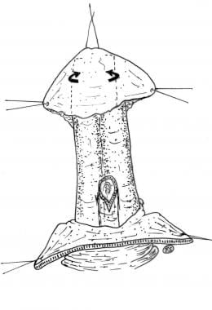Reconstruction of distal penile urethra using local flaps (arrows).
Isolate the external urethral meatus, and resect it together with the most distal hypoplastic portion of the urethra. Induce an artificial erection with an intracavernous injection of saline solution to assess for the presence and the degree of curvature. Perform an extensive dorsal chordectomy and straightening of the penile shaft when needed.
According to the urethral defect and age-related urethral size, tailor a penile-preputial flap that was harvested longitudinally from the ventral penile and preputial skin (see following image). Stent the neourethra with a 12- or 14-Ch (Charrière) silicone catheter for 48 hours.
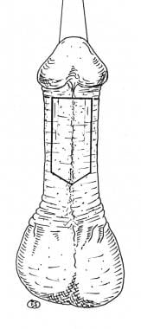Vertical island flap drawn on the ventral aspect of the penis.
Apply a mild compressive bandage. When possible, the glandular urethra can be reconstructed using local flaps from the glans. At the end of the procedure, the penis has a circumcised appearance.
Intraoperative Details
After penile degloving, induce an artificial erection with an intracavernous injection of saline solution to assess for the presence and the degree of curvature. Perform cordectomy and straightening of the penile shaft if required. At this stage, the actual urethral defect shows, and the urethral reconstruction is planned.
Harvest a penile-preputial flap with the preferred technique, taking into consideration the age-related urethral size. Inset the flap to the proximal urethral stump, and tube it around a silicone catheter (see following images).
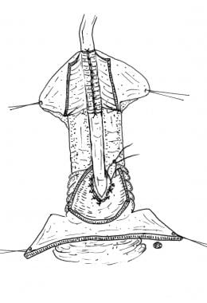Island flap transferred dorsally and anastomosed to the urethra.
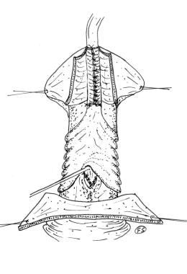Island flap sutured into a tube to reconstruct the missing portion of the urethra.
Split the glans and elevate local flaps to cover the distal part of the neourethra that reaches the tip of the glans (see following image).
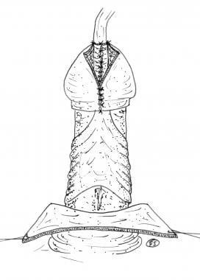Urethral reconstruction is completed.
Remove the redundant foreskin. Pull up the penile skin and suture it to the corona to achieve a final appearance similar to that of a circumcised penis (see following images).
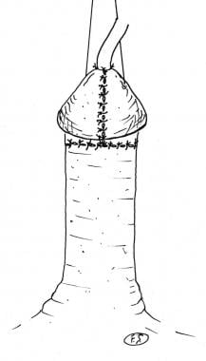Drawing of the final appearance at the end of the operation.
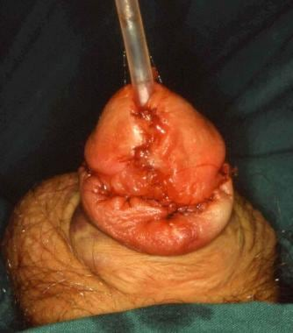Photograph of the final appearance at the end of the operation.
Arm and leg restraints may be necessary. The dressings remain in place for 4 days if no problems occur. Remove the diverting urinary catheter after 8-10 days. Discharge the patient after removal of the urinary diversion and when spontaneous voiding occurs without difficulty.
Follow-up
Monitor patients with a flow rate study at 3 weeks and at 3 and 12 months postoperatively. If a mild urethral stenosis is noticed, dilate the urethra with probes of increasing sizes and repeat the flow rate study after 3 weeks. Question patients about persistence of the curvature 3 weeks postoperatively.
Long-term follow-up care is necessary at least through puberty to exclude late failure due to hypertrophic urethral scarring or undetected chronic inflammation.
Complications
Early complications include bleeding, infection, wound separation, flap necrosis, and edema. Urethrocutaneous fistula with urinary leakage from the new urethra and urethral stricture occur in approximately 10-19% of all epispadias repairs.
Outcome and Prognosis
In terms of overall success rates, the incidence of fistulas or stenosis, and the mean hospitalization time, functional results obtained with one-stage epispadias correction have proved to be superior to those obtained with multistage procedures; the prognosis is good.
For one-stage reconstruction, the use of a well-nourished and innervated flap with a long and pliable pedicle is necessary to achieve the high success rate reported in the literature.
Surgical repair generally results in both continence (ability to control the flow of urine) and a good cosmetic outcome. Successful reconstruction of epispadias improves the body image and enables the patient to perform sexually.
A study by Kertai et al indicated that in patients with bony pelvic abnormalities associated with exstrophy-epispadias complex, those who as newborns undergo symphyseal approximation without osteotomy do not suffer impairment of long-term hip function. The study included 17 postpubescent patients (14 male; 3 female) who had undergone the procedure in early childhood. The great majority of patients demonstrated no dysplastic or degenerative hip disease on follow-up.
In a study of male patients who underwent reconstruction for epispadias, Reddy et al reported that these individuals were able to engage in postoperative intercourse and impregnate a sexual partner. Twelve of the study’s 15 patients stated that the quality of sexual intercourse was satisfactory overall, although 11 patients experienced at least one problem with sexual function, such as abnormal ejaculation, reduced sensation, or difficulty maintaining an erection. Five patients reported that they had impregnated a partner.

Hydrocele

In pediatric patients, communicating hydroceles are surgically managed if they persist beyond the first year or two of life. Additionally, large noncommunicating hydroceles may also warrant surgical management.
Abdominoscrotal hydroceles (and canal of Nuck hydroceles) require an inguinal approach so that the abdominal extent can be managed. Surgical excision has been considered appropriate for these entities, although excision of the intra-abdominal component can be quite challenging. A combined laparoscopic-inguinal approach may allow more complete determination of resection. ^{[24]}
Asymptomatic adults with isolated noncommunicating hydroceles can be observed indefinitely or until they become symptomatic, as complications such as infection or testicular compromise are exceedingly rare. However, if the diagnosis is in question or underlying pathology cannot be excluded, operative exploration is warranted.
Surgical Therapy
Surgical therapy can be divided into three approaches: inguinal, scrotal, and sclerotherapy.
Inguinal
The inguinal approach, with ligation of the processus vaginalis high within the internal inguinal ring, is the procedure of choice for pediatric hydroceles (typically, communicating). If a testicular tumor is identified on testicular ultrasonography, an inguinal approach with high control/ligation of the cord structures is mandated.
In a study by Saka et al, 69 patients with hydrocele underwent either laparoscopic percutaneous extraperitoneal closure (40 patients) or open repair (29 patients), and the safety and efficacy of the two approaches were compared. There were no significant differences in length of operation, anesthesia, or complications for the two procedures; and no recurrences were observed for either procedure.
In addition, the authors reported on the features of the internal inguinal ring (IIR) found in cases of hydrocele and in cases of inguinal hernia treated during the study period. In the cases of hydrocele, 59.1% of the IIRs were narrow patent processus vaginalis (PPV) with a peritoneal veil; for patients with inguinal hernia, 92% of the IIRs were widely opened PPV.
Peng et al reported the successful use of minilaparoscopic procedures in 125 boys (age range, 12-68 months) with multiple peritoneal folds in the hydrocele sac orifice. Modified single-port, double-needle, minilaparoscopic surgery in which an Endo Close needle was used to spread the peritoneal folds and facilitate circular extraperitoneal suturing produced outcomes comparable to those with a two-port laparoscopic procedure, during which a 3-mm grasping forceps was used to grasp the folds around the internal inguinal ring. The authors suggest that the modified single-port technique is safe, effective, and more cosmetically appealing for the management of complicated pediatric hydroceles.
Wang et al reported success with single-site laparoscopic percutaneous extraperitoneal closure of the internal ring in 483 children with hydrocele. Their technique, which uses an epidural and spinal needle, required a median operation time of 18 minutes (range, 10-30 min) and no patient developed intraoperative or postoperative complications.
Scrotal
The scrotal approach, with excision or eversion and suturing of the tunica vaginalis, is recommended for chronic noncommunicating hydroceles. This approach should be avoided if there is any suspicion for underlying malignancy.
In contrast, Alp et al report that the scrotal approach is an effective alternative for the treatment of communicating hydrocele in pediatric patients. In their study of 43 boys (46 testicular units) treated with the classic inguinal approach and 27 boys (30 testicular units) treated with a scrotal approach, operative time was significantly lower in the scrotal group (P < 0.0001), the early minor complication rate did not differ between the two groups, no major complications noted, and none of the patients had hydrocele recurrence after a mean follow-up of 6 months.
Sclerotherapy
An additional adjunctive, if not definitive, procedure, is scrotal aspiration and sclerotherapy of the hemiscrotum using tetracycline or doxycycline solutions. Recurrence after sclerotherapy is common, as is significant pain and epididymal obstruction, making this treatment a last resort in poor surgical candidates with symptomatic hydroceles and in men in whom fertility is no longer an issue.
A review by Taylor et al of aspiration and sclerotherapy treatment for hydroceles in aging men concluded that sodium tetradecyl sulphate (STDS) is the sclerosing agent with the best cure rate after a single injection and rates of adverse effects. Cure rates with STDS were 76% after a single aspiration and injection and 94% after multiple treatments. Patient satisfaction rates at a mean of 40 months were 95%. Complication rates were generally low and much lower than those seen with surgical repair.
Lund et al, in a study of 76 patients with hydrocele testis, found that aspiration and sclerotherapy with polidocanol is an effective treatment with a low recurrence rate. In this prospective, double-blind, randomized study, 36 patients given polidocanol (group 1) were compared with 41 patients given placebo (group 2). Recurrence after the first treatment was seen in 16 (44%) of the polidocanol patients and in 32 (78%) of the placebo patients. Recurrence after re-treatment with polidocanol in both groups was seen in four patients (25%) in group 1 and in 14 patients (44%) in the former placebo group. The overall success rate of treatment in group 1 was 89%.
Jahnson et al reported that in patients undergoing sclerotherapy, adjuvant treatment with an antibiotic and a nonsteroidal anti-inflammatory drug resulted in an increased cure rate and a lower incidence of subclinical epididymitis/swelling (SES). In their prospective observational study of 191 men who underwent polidocanol sclerotherapy for hydrocoele/spermatocoele, the patients who received anti‐inflammatory medication after the procedure had a decreased rate of SES (5% vs 26%) and an increased cure rate (96% vs 88%), compared with those who did not receive anti-inflammatory medication. The usual regimen in the treatment group was trimethoprim 160 mg (occasionally ciprofloxacin 500 mg) twice daily and diclofenac 50 mg three times daily for 10 days.
Preoperative Details
Preoperative considerations are minimal because outpatient treatment is the routine. Nothing by mouth (NPO) provisions are age- and institution-dependent. Proper provisions for postoperative transportation and observation are arranged prior to surgery.
Intraoperative Details
Intraoperative considerations during inguinal repair include meticulous attention to spermatic cord structures. A "no-touch" approach to the reactive testicular vessels and delicate vasa helps minimize complications. Excessive dissection around the testicular vessels may result in thrombophlebitis of the pampiniform plexus. The distal processus is spatulated widely to provide free drainage of scrotal fluid. The proximal processus is ligated above (deep to) the internal inguinal ring. Failure to identify a patent processus during inguinal exploration should prompt (1) a thorough reexamination of the cord structures and (2) partial or complete excision of the hydrocele or needle aspiration of only the hydrocele prior to closing.
During scrotal approaches, excision of redundant tunica vaginalis (with or without eversion) and suturing of the reflected tunica behind the epididymis results in a postoperative testis that is more easily and more reliably examined. Care must be taken to not injure the vas or epididymis during this procedure. A running hemostatic suture around the line of excision is helpful for assuring hemostasis. Plication of the sac (Lord procedure) is another technique useful for management of large hydroceles. Electrocautery fulguration of the edge of the excised tunica vaginalis promotes scarring and decreases recurrence while decreasing operative time.
Unexpected findings may be dealt with, as appropriate, either for the scrotal approach or by converting to an inguinal approach (eg, testicular tumors). If a testicular tumor is encountered, biopsy with frozen section and orchiectomy with resection of the spermatic cord up to the internal ring is warranted if tumor is confirmed. Placing a drain in the dependent portion of the scrotum is prudent for large hydroceles. A nonsuction drain such as a Penrose can be removed within the first 24-48 hours after surgery. If a drain is not used, expect a large hematoma and significant edema. Often, this enlargement is worse than the original problem, although it is almost always transient.
Postoperative Details
Children undergoing inguinal herniorrhaphies for repair of communicating hydroceles generally recuperate with minimal discomfort and exceedingly few restrictions. Tub baths are to be avoided for 5-7 days. The wounds of diaper-aged children are sealed with tissue adhesive or occlusive dressing. No activity restrictions are required, and nonnarcotic analgesics are used minimally.
Patients undergoing scrotal approaches benefit from supportive dressings in a scrotal support or athletic supporter. Rest and avoidance of vigorous activity help minimize discomfort. Showers may be resumed within 24-48 hours. Occasional doses of synthetic or semisynthetic narcotics may help relieve postoperative discomfort. Adult patients should be counseled that the hydrocele may transiently reaccumulate for a month or so postoperatively owing to edema.
Follow-up
At least one postoperative follow-up visit is recommended. For small infants, patients with chronic recurring hydroceles, or patients with unsuspected intraoperative findings, more protracted follow-up evaluations may be warranted biweekly, monthly, or every 2-3 months to ensure complete recovery and normal testicular size and architecture.
Complications
Complications are largely avoided with meticulous dissection and gentle tissue handling. In addition, extensive dissection should be avoided, as it increases the risk for nerve damage, vascular damage leading to testicular atrophy, and postoperative hematomas.
Injury to spermatic cord structures can occur. The vas or testicular vessels may be injured in 1-3% of inguinal approaches. Some testicular shrinkage has been described in nearly 10% of children undergoing inguinal hernia repair.
Recurrence of the hydrocele after inguinal approaches is most often reactive in nature and usually resolves within several months. Rarely, aspiration or scrotal surgery is warranted.
Either poor intraoperative hemostasis or excessive cord dissection (with inguinal approaches) may result in postoperative bleeding. Hematomas typically resolve over time. If the patient has evidence of ongoing bleeding or is extremely symptomatic, exploration and hematoma evacuation is warranted.
The Ilioinguinal/genitofemoral nerves may be entrapped or divided during inguinal approaches. The injury may be temporary or permanent.
Postoperative wound infections are quite uncommon, particularly in children. Wound infections should be managed with antibiotics and, if necessary, opening the wound.
Outcome and Prognosis
Inguinal repairs of communicating hydroceles are exceedingly successful, with a less than 1% recurrence rate. If a unilateral approach is completed, the small but recognized risk for a metachronous hydrocele or inguinal hernia developing remains, but the rate is likely less than 10%. Likewise, recurrence after tunica excision is also uncommon.
Future and Controversies
Many surgeons have begun to advocate routine diagnostic laparoscopy of the contralateral groin in patients (particularly children) with unilateral hernias. The premise is that this will permit identification and repair of unsuspected contralateral hernias prior to clinical recognition. However, many more patent processus are being ligated than true hernias are being repaired. Whether an increased use of this technique will reduce the incidence of hydroceles in older children or adults remains to be seen. Furthermore, whether utilization of this intraoperative modality is of any utility in inguinal hydrocele repairs is open for debate.
Medical management, or, more importantly, prevention of patent processus vaginalis, has been theorized as possible after full elucidation of the intricate molecular processes that control fetal cell migration, proliferation, and adherence. Although the idea of preventing hydroceles or indirect hernias is interesting, it is far from being applicable in clinical medicine.
Prevention
In 2000, the World Health Organization (WHO) launched the Global Program to Eliminate Lymphatic Filariasis (GPELF), with a goal of eliminating lymphatic filariasis by 2030. In 2018, three of nine countries participating in the program in Southeast Asia had eliminated LF and Bangladesh was in reach of its elimination goal. In 2020, the program had thus far prevented or cured 74.9 million infections, resulting in a 84.2% reduction of lymphodema and hydrocele.

Varicocele

References to dilated and tortuous veins of the spermatic cord, now referred to as a varicocele, occurred as early as 1885. Even at that time, varicoceles were known to be associated with ipsilateral testicular atrophy, which appeared to be reversible after ligation. Four years later Bennett commented on his observation of a change in the character of seminal fluid after ligation of a varicocele.
Since these reports, considerable debate regarding the etiology and effects of varicoceles has appeared in the literature. The direct relation between varicoceles and testicular atrophy, changes in Leydig and Sertoli cell function, abnormal seminal parameters, and endocrine abnormalities has been studied. Over the past few decades, the advent of interventional radiology and minimally invasive surgical techniques has affected the way in which physicians approach adolescent varicocele.
Varicoceles usually become evident around adolescence and are rarely reported to arise in older men. Patients are commonly referred to the urologist either after detection of a scrotal mass, classically described as a "bag of worms," or after detection of a difference in testicle size during a well-child visit or sports physical. Most varicoceles are asymptomatic; however, testicular pain or a mass may be a presenting symptom.
Moderate evidence supports the view that varicocele treatment results in improvement of testicular volume and sperm concentration. To date, the physical findings or diagnostic criteria that dictate surgical intervention in adolescents have not been strictly defined. Controversies and opinions regarding when to operate and on whom to operate abound. Each case is handled individually, with a discussion among the patient, parents, and physician regarding the risks of intervention and potential impact on future fertility.
Ipsilateral testicular growth retardation is the most frequent relative indication for varicocele repair in adolescents; the concern is that patients with varicocele and ipsilateral testicular growth retardation at that age may manifest impaired fertility in adulthood.
Although controversial, general guidelines used by the pediatric urologist to determine if surgery is indicated typically include the presence of one or more of the following:
- Varicocele associated with decreased ipsilateral testicular size - A generally accepted indication for correction is an orchidometer or ultrasonography (US) measurement revealing a 20% volume deficit in the involved testis
- Bilateral varicoceles
- Symptomatic painful varicocele
- Abnormal findings on semen analysis
Other disconcerting factors include grade 2 or 3 varicocele or significant difference in testicular consistency, with a softer ipsilateral testis.
The European Association of Urology (EAU) has published recommendations for management of varicocele in children and adolescents (see Guidelines).
A 2019 review of childhood and adolescent varicocele from an endocrinologic perspective suggested the following:
- In patients with peak retrograde flow (PRF) less than 30 cm/s, testicular asymmetry less than 10%, and no evidence of sperm and hormonal abnormalities, conservative management may be considered
- In patients with 10-20% testicular volume asymmetry or PRF greater than 30 cm/s but less than or equal to 38 cm/s or sperm abnormalities, careful follow-up may ensue
- In the case of absent catchup growth or sperm recovery, varicocele repair should be proposed
- In patients with painful varicocele, testicular volume asymmetry 20% or greater, PRF greater than 38 cm/s, infertility, and failure of testicular development, treatment can be proposed at the initial consultation
If the decision is made to defer surgery, the patient should be monitored every 6-12 months so that any deleterious effects can be detected as early as possible. The question of surgical intervention is readdressed at that time.
Varicocele ligation in a healthy patient has no specific contraindications, but various surgical approaches offer different advantages, and certain procedures should be avoided in specific settings. For example, a history of previous surgery may influence venous disruption within the site. With previous abdominal or retroperitoneal surgery, laparoscopic surgery is less desirable.
A history of inguinal surgery makes a second inguinal approach more difficult and potentially hazardous to the spermatic cord structures. Previous inguinal surgery may have also compromised the arterial supply of the testis.
For this reason, when an adolescent who has previously undergone inguinal hernia surgery develops a varicocele, the best technique involves an inguinal approach with microscopic magnification to optimally identify and preserve the testicular artery. A retroperitoneal approach with testicular artery ligation is contraindicated because the initial hernia surgery could have inadvertently injured the vasal artery, and high ligation of the internal spermatic artery may cause testis atrophy due to arterial insufficiency.
Further research may provide a method of adequately determining which adolescents with varicoceles are at significant risk for infertility and, thus, when intervention is warranted. This would resolve present controversies as to relative versus absolute indications for surgery. Modifications and improvements in surgical techniques are ongoing, and lower recurrence and complication rates are likely to result. Finally, better understanding of the impact of a varicocele on the germinal epithelium of the testis may provide alternative management options.
Medical Therapy
No known medical therapy is available for varicocele. Watchful management may be an option with yearly checkups and reevaluation of testis size.
Surgical Therapy
Surgical ligation of the spermatic veins is the procedure used. Several methods are used, differing primarily in the level at which the vessels are approached. These include abdominal retroperitoneal (Palomo), inguinal (Ivanissevitch), and subinguinal approaches. Microsurgical techniques and laparoscopic-assisted transperitoneal or retroperitoneal approaches are also employed.
In a comparison of subinguinal and high inguinal microsurgical techniques, Shiraishi et al found that the two approaches appear to have similar success rates with regard to testicular growth.​ However, the high inguinal approach, which involves fewer divisions of veins and is associated with a larger diameter of the spermatic artery, is easier to perform.
Interventional venography has also been used for transcatheter occlusion of the spermatic veins. This is accomplished by percutaneous embolization of the testicular veins, identified by means of transfemoral venography. Embolization materials include balloons, coils, and dextrose.
A systematic review and meta-analysis by Fabiani et al compared surgical ligation with sclero-embolization for treatment of varicocele in children, adolescents and adults. There were no significant differences in in overall complications, wound infection, testis pain, surgical-site hematoma, total sperm count, sperm motility, pregnancy, or recurrence rate.
Operative details
The aim of varicocele surgery is to identify and ligate the ascending venous network that drains the testis, epididymis, and vas deferens. A thorough history and a careful physical examination, with particualr attention to past surgical procedures, are necessary to choose the best approach for ligation.
The testicular artery is generally spared with the use of a microscope in the inguinal approach. The artery and any branches are identified with direct visualization with administration of papaverine or lidocaine directly onto the vessels or with a Doppler probe. Placing the operating table in a slight reverse Trendelenburg position may help dilate the internal spermatic veins, facilitating their identification during surgery.
With the transperitoneal or retroperitoneal method, the internal spermatic artery is also usually divided in addition to the veins. Ligation of the internal spermatic artery in the retroperitoneum does not usually cause testicular atrophy because of the generous collateral circulation to the testicle.
Subinguinal approach
The incision is made over the external ring. Dilated cremasteric veins are ligated, and the spermatic cord is opened. The spermatic veins in the pampiniform plexus are separated and ligated, as are any dilated veins that accompany the vas deferens.
Microscopic subinguinal approach
The incision is made over the external ring, and the spermatic cord is dissected into the operative field. The operating microscope is used to identify and ligate the internal spermatic veins. Care is taken to identify and preserve the testicular artery by using Doppler US or by visually identifying a pulsatile artery in the spermatic cord. Lymphatic vessels are also preserved when possible to prevent future hydrocele formation.
If the procedure is performed with local anesthesia and light sedation, the patient can perform a Valsalva maneuver to fill any remaining veins. Some authors advocate the additional step of delivering the testicle into the wound and performing ligation of the external spermatic and gubernacular veins. Division of the veins after ligation is optional.
Inguinal approach
The incision is made over the course of the inguinal canal, and the external inguinal ring is incised toward the internal inguinal ring. Care is taken to preserve the ilioinguinal nerve coursing under the external oblique aponeurosis. After the spermatic cord is delivered, the internal spermatid fascia is incised, and the branches of the internal spermatic vein are identified and separated from the gonadal artery with the help of Doppler US. The branches of the internal spermatic vein are ligated.
A microscope may be used with this approach as well. Again, division of the veins after ligation is optional.
Retroperitoneal approach
This approach consists of high ligation of the entire spermatic pedicle, approached via a low abdominal incision above the internal inguinal ring. A laparoscopic-assisted approach is recommended in obese patients because of the limited exposure obtained with an open approach. Care is taken to sweep the peritoneum from the spermatic vessels and to stay extraperitoneal. This operation may also be performed as a testicular artery–sparing procedure by opening the spermatic fascia to identify and preserve the artery.
Laparoscopic-assisted retroperitoneal approach
A camera port is placed along the lower portion of the umbilicus, along with a single 3- to 5-mm instrument port placed just laterally. The internal inguinal ring, where the vas deferens joins the spermatic cord, is identified. The scrotum is compressed to dilate the spermatic veins.
An incision is made in the peritoneum over the gonadal vessels approximately 4-5 cm proximal to the internal ring, and dissection is used to mobilize the cord vessels. (See the video below.) Lymphatic vessels are dissected off the spermatic cord, and the remaining artery and veins are clipped, tied, or cauterized and may be divided. The artery may be spared, with division of the spermatic veins, but this lengthens the procedure, increases the risk of varicocele recurrence, and has not been shown to impact catchup growth.
Laparoscopic varicocelectomy.
Postoperative Care
Varicocele ligation is an outpatient procedure. The patient is advised to expect postoperative wound and scrotal discomfort and possibly edema and ecchymosis. Proper wound care instructions are provided and oral analgesics prescribed. Icing and elevation of the scrotum may help reduce painful swelling. The patient may return to school or work in 2-3 days.
Complications
Varicocelectomy, regardless of the technique employed, carries a risk of complications. The complication rate varies with the surgical method used (see Table below). The microscopic-assisted procedures carry the lowest complication rates (< 1%). Inguinal, retroperitoneal, and laparoscopic ligations carry a postoperative hydrocele risk of less than 10%; embolization is very infrequently associated with hydrocele formation.
Table. Postoperative Complication Rates
Technique | Hydrocele | Recurrence or Failure
Open inguinal/sublingual | 3-9% | 15% average
Microscopic inguinal/sublingual | < 1% | 1-3%
Retroperitoneal mass ligation | 7.2% | 2%
Retroperitoneal artery sparing | < 7.2% | 11%
Laparoscopic | Similar to open | Similar to open
Embolization | None | 10-25%
Hydrocele formation is the most common complication of varicocelectomy and most likely results from lymphatic obstruction. An effort to spare lymphatics intraoperatively with the laparoscopic approach has been shown to result in lower hydrocele rates.
Less common complications include testicular atrophy, hematoma, injury to the vas deferens, chronic testicular pain, and recurrence or persistence of the varicocele. Postoperative pain may be reducible with intraoperative administration of local anesthetics.
Percutaneous embolization carries the unique, yet infrequent, risks of contrast reactions, puncture of the femoral artery, hemorrhage, extravasation, and migration of embolization balloons.
In a large multicenter analysis of complications and recurrence after treatment of varicocele in young (< 19 y) men, Lurvey et al found that the retreatment rate was significantly higher with percutaneous embolization than with either open or laparoscopic varicocelectomy and that open and laparoscopic varicocelectomy did not differ significantly from each other with regard to retreatment rate and hydrocele formation.
Long-Term Monitoring
Routine postoperative visits for wound and testicular assessment are standard. In the first year, testicular volume and scrotal texture are periodically assessed to ensure that testicular atrophy, recurrence of the varicocele, or hydrocele formation has not occurred.

5.2. Theoretical questions for the lesson:
- Penile agenesis – definition, basis of diagnostic and surgical treatment
- Penile duplication– definition, basis of diagnostic and surgical treatment
- Microphallus– definition, basis of diagnostic and surgical treatment
- Penile torsion– definition, basis of diagnostic and surgical treatment
- Lateral penile curvature – definition, basis of diagnostic and surgical treatment
- Penoscrotal transposition– definition, basis of diagnostic and surgical treatment
- Webbed and buried penis– definition, basis of diagnostic and surgical treatment
- Megaprepuce– definition, basis of diagnostic and surgical treatment
- Scrotal agenesis– definition, basis of diagnostic and surgical treatment
- Ectopic and accessory scrotum– definition, basis of diagnostic and surgical treatment
- Splenogonadal fusion– definition, basis of diagnostic and surgical treatment
- Cryptorchidism
  - Definition and classification
  - Physical examination
  - Treatment
    - General approaches to the treatment
    - Medication treatment of cryptorchidism
    - Surgical treatment
- Hypospadias
  - Definition and classification
  - Assessment and diagnostic
  - Treatment options
  - Follow-up and prognosis
- Epispadias
  - Definition and classification
  - Assessment and treatment options
- Hydrocele– definition, basis of diagnostic and surgical treatment
- Varicocele – options of surgical treatment

  - Practical works (tasks) performed in class:

5.3. Practical works (tasks) performed in class:
Work 1. Formulate a clinical diagnosis and prescribe a surgical treatment of patient with hypospadias.
The student collects complaints, anamnesis of the disease and life history of the patient. Conducts an objective examination, identifies the main clinical signs of hypospadias, draws up a diagnostic program, prescribe a surgical treatment.
Questions to be answered by the student:
1. What is the classification of hypospadia?
2. What are the main appearance and symptoms of hypospadia?
3. What methods of treatment of hypospadia do you know?
4. What are the main complications and overall prognosis of hypospadia?
Work 2. Carrying out a differential diagnosis of cryptorchidism and provide a treatment tactic.
On the basis of complaints, anamnesis of the disease and life, objective examination data, laboratory and instrumental studies, the student conducts a differential diagnosis of a patient with cryptorchidism and provide a tactic of management.
Questions to be answered by the student:
What methods allow differential diagnosis of cryptorchidism?
2. What are the indications for the surgery in cryptorchidism?
3. What treatment choice is based on?
Work 3. Prescribe a treatment for the patient with varicocele.
The student collects complaints, anamnesis of the disease and the life of the patient, conducts an objective examination, assess the instrumental data and compiles the treatment program of varicocele.
Questions to be answered by the student:
1. What are the indications for the surgery in patient with varicocele?
2. What types of surgery are performed because of varicocele?
2. What diagnostic criteria determine the need for the surgery in adolescent and adult patients?

5.4. Materials for self-control:
A. Questions for self-control:
      - What is the surgical treatment for Penile agenesis?
      - Microphallus– give the definition and provide the treatment options.
      - How to diagnose and to treat the Penile torsion?
      - What are the treatment options for Penoscrotal transposition?
      - Give the definition and provide the treatment modalities for webbed and buried penis.
- What is a treatment for Megaprepuce?
- What is the basis of diagnostic and surgical treatment for Splenogonadal fusion?
- What is a definition and classification of Cryptorchidism?
- What are the general approaches to the treatment of cryptorchidism?
- When and how the medication treatment of cryptorchidism is being provided?
- What is the surgical treatment of cryptorchidism?
- What is a definition and classification of hypospadias?
- What are the treatment options for hypospadia?
- What is the definition and classification of edispadias?
- What are the treatment options for epispadias?
- What is a surgical treatment of epispadias?
- What are the options of surgical treatment of varicocele?

B. Tasks for self-control
1. After delivery, a male neonate is evaluated by the inpatient pediatrician for circumcision. He is diagnosed with hypospadias and severe chordee.
Which of the following is the next step?
A. Delay circumcision and urology evaluation
B. Perform scrotal US
C. Proceed with circumcision
D. Perform renal US

Answer. A. Delay circumcision and urology evaluation. Hypospadias is associated with a classic clinical triad consisting of proximal displacement of the urethral opening, penile curvature, and a
ventrally deficient hooded foreskin, it is the second most common congenital anomaly in males, occurring in approximately 1 in 300 male births; recurrence rates are as high as 13% in first-degree relatives. Nearly 90% of hypospadias cases are isolated penile defects, but if concomitant cryptorchidism is also identified, further evaluation differences (disorders) of sex development (DSDs) is warranted. Hypospadias is described as perineal, penoscrotal, penile, coronal, glandular, with approximately 70% of cases occurring distally. The type and location of the hypospadias and the nature and severity of the associated findings will determine the surgical intervention ultimately required (generally after the age of 6 months). The goals of therapy are
(1 to optimize function and (2) to provide an improved cosmetic appearance.

- A male infant is referred to the urology clinic when his pediatrician is unable to palpate his right testicle. Which of the following should not be performed?
A Scrotal US
B. Physical examination under anesthesia prior to orchiopexy
C Annual physical examination in the case of a retractile testis
D. Orchiopexy within the first 18 months of life

Answer: A. Scrotal US.
Cryptorchidism is one of the most common GU problems encountered in pediatric urology. The exact etiology is unknown but is likely to be multifactorial, involving hormones and gubernaculum development. Commonly, patients are referred to a specialist when the primary care provider cannot palpate a testicle within the scrotum. Approximately 70% of undescended testicles can be palpated, with diagnostic laparoscopy required for the remaining 30%. Imaging is not recommended for undescended testicles. Patients who present with bilateral nonpalpable
testicles should be further evaluated for DSDs and referred to pediatric endocrinology and urology; such patients may be genetically female with congenital adrenal hyperplasia (CAH). Cryptorchidism is treated by means of orchiopexy if the testicles remain undescended by 6 months of age. Orchiopexy in the first 18 months of life is recommended to preserve available fertility potential. The risk of testicular malignancy is increased in patients with cryptorchidism, with some studies quoting a two- to fivefold increase; patients should be counseled accordingly.
Potential impairment of fertility is a concern. Although children with one undescended testis have near-normal fertility, nearly two thirds of those with bilateral cryptorchidism are infertile.

- A 25-year-old man has no right testicle in the scrotum. According to ultrasound and MRI, it is small and located in the proximal moiety of the inguinal channel. Left testis is normal in size and location. What treatment option is optimal for this patient?
  - Orchipexy
  - Hormonal treatment with hCG
  - Orchiectomy
  - Testicular autotransplantation
Answer: C. Orchiectomy. In adult patient, an abnormal testicle revealed outside the scrotum, due to the high potential of malignancy, is a direct indication for the surgical removal.

- In the patient Yu., 16 years old, with no clinical signs, a left-sided varicocele was revealed. A net of slightly enlarged veins is palpated on a level of upper testicular pole. Peak retrograde flow is 5cm/s. The spermogram results and serum testosterone, LH and FSH are normal, left testis is normal in size and density. No testicular volume asymmetry is present. What is the treatment tactic for the patient?
- Inguinal surgical repair of varicocele
- MRI of the testicles
- Watchful waiting, reassess ultrasound and spermogram in 1-2 years
- Laparoscopic varicocelectomy
Answer: C. Watchful waiting. With early-stage varicocele without both clinical symptoms and laboratory manifestations, low testicular asymmetry and peak retrograde flow, there is no indications for the surgery. Concerning to the age of the patient, reassessment in 1-2 years is essential.

Developers :
Head of department of urology and nephrology, professor F.I. Kostyev
Professor of the department of urology and nephrology Yu.M. Dekhtyar
Professor of the department of urology and nephrology M.I. Ukhal
Associate professor of the department of urology and nephrology I.V. Rachok
Associate professor of the department of Urology and Nephrology L.I. Krasylyuk
Associate professor of the department of urology and nephrology M.V. Shostak
Associate professor of the department of urology and nephrology R.V. Savchuk
Associate professor of the department of urology and nephrology O.M. Kvasha
Assistant professor of the department of urology and nephrology S.V. Bogatskiy

Recommended literature.
Main:
- S.P. Pasechnikov ; Urology : textbook / Ed. S. P. Pasyechnikova, S. A. Vozianov, V. N. Lesovy [and others]. - Kind. 3rd – Vinnytsia: New Book, 2019.
- Pasechnikov S.P. Modern problems of urology : [ guide ]: reference book doctor / S.P. Pasechnikov, V.I. Zaitsev. - Kyiv : B-ka Health of Ukraine ; 2017.
- Andrology for urologists / Clinical recommendations // Ed. Shchepleva P.A. - Medical Congress. -2019. - 424 p.
- Bylych G.L. Handbook of andrology and sexology / G.L. Bylych, E.Yu. Zygalova. — 4th ed., revised. — M.: Practical medicine, 2018. — 384 p. - illustrations. — (Library of a practicing doctor).
- Vozianov O.F., Lyulko O.V. Atlas - guide to urology : In 3 volumes - 2nd ed., revised. and additional - Dnipropetrovsk : RVA " Dnipro - VAL", 2001. - Volume 1.
- Dedov I.I. Age-related androgen deficiency in men / Dedov I.I., Kalinchenko S.Yu. Moscow: Practical Medicine, 2006. - 240 p.
- Acting protocols granting medical assistance / Scientific and methodical edition // edited by Doctor of Medicine, Professor S.P. Pasechnikova. - K.: "Doctor- media " LLC, 2011. - 626 p.
- Kalynychenko S.Yu. Practical andrology. Practical manual / Kalynychenko S.Yu., Tyuzykov I.A. Moscow: Practical Medicine, 2009. — 399 p.
- Educational a guide for doctors interns of the 2nd year of studies in the specialty " Urology " / H. V. Bachurin. – Zaporizhzhia : ZDMU, 2015. – 135 p.
- Sexology and andrology / Authors: N.Y. Boyko, Yu.A. Borysenko, A.A. Bystrov and others; under the editorship Vozianova A.F., Gorpinchenko I.I. - Kyiv: Abrys, 1997.
- Stus V.P., Pasechnikov S.P. Urology ( practical skills for intern doctors ) / Educational method manual.- Dnipropetrovsk : Akcent PP LLC, 2015. - 282 p.
- Modern problems of urology : [ guide ] : guide doctor / S. P. Pasechnikov, V. I. Zaitsev. – Kyiv : Bka " Health ". of Ukraine ", 2017. - 218 p.
- 11. Urology : National at hand for students higher _ honey. shut up app. IV level accreditation / edited by S.P. Pasechnikova. – 3rd ed., ed. and added _ – Vinnytsia : Nova kn., 2019. – 423 p
- Stus V.P. Urology (practical skills for intern doctors) / V.P. Stus, S.P. Pasechnikov. Educational and methodological manual. - Dnipropetrovsk: LLC "Akcent PP", 2016.
- O.V., Lyulko, O.F. Vozianov Textbook " Urology " 3rd edition. Thresholds Dnipropetrovsk. - 2012 p.
- " Urology ( Methodical developments of practical classes for students )" edited by Professor V.P. Stusya, second edition, supplemented. / A.P. Stus. Moieinko M.M., Fridberg A.M., Pollion M.Yu., Barannik K.S., Suvaryan A.L., Krasnov V.M., Kryzhanivskyi O.Yu. - Dnipro: TOV "Accent ". - 2018. - 336c.
- Urology: textbook for students. higher med. academic _ established: translation from Ukrainian publications / S.P. Pasechnikov, S.A. Vozianov, V.N. Lesovoy, F.I. Kostev, V.P. Stus, etc./ Ed. S.P. Pasechnikov - Edition 2. - Vinnytsia: Novaya Knyga, 2015. - 456 p.: illus.
- Uro1 ogy: textbook for students of higher medical education institutions / SP Pasechnikov, S. Oh _ Vozianov, VM Lesovoy (et at.); ed. by Pasechnikov. / Ѕ. R. _ Pasechnikov, S. _ Oh _ Vozianov, VM Lesovoy (et at.) - Vinnytsia : Nova Knyha, 2016. - 400
- EAU Guidelines, edition presented at the 28th EAU Annual Congress, Milan 2021. ISBN 978-90-79754-7 1 - 7. EAU Guidelines Office, Arnhem, The Netherlands.

Additional:

- Boyko M.I., Pasechnikov S.P., Stus V.P. and others _ Clinical andrology // Directory doctor "Androlog ". - K.: LLC " Library " Health of Ukraine ", 2013. - 222 p.
- Sarychev L. P. Clinical anatomy and physiology of organs of the urinary and male reproductive system: method. river _ for teachers / comp. L. P. Sarychev, S. A. Sukhomlyn, S. M. Suprunenko. – Poltava, 2019. – 11 p.
- Sarychev L.P. Symptoms of urological diseases: method. river _ for teachers / L. P. Sarychev, S. M. Suprunenko, S. A. Sukhomlyn, Ya. V. Sarychev. – Poltava, 2019. – 14 p.
- Atlas-guide to urology. Ed. A.F. Vozianova, A.V. Lulko _ Dnipropetrovsk, 2002.-T. 1,2,3.
- Medical student's library. Urology. Edited by F.I. Kosteva. - Odesa, 2004. - 296c.
- Urology / Ed. Prof. O.S. Fedoruka - Chernivtsi : Bukovynskyi state medical University, 2011. – 344 p.

13. Information resources

University website https://onmedu.edu.ua
Library library.odmu.edu.ua
1. https://uroweb.org/
2. https://www.nccn.org/
3. https://www.auanet.org
4. https://www.inurol.kiev.ua/
5. https://www.sooo.org.ua/

