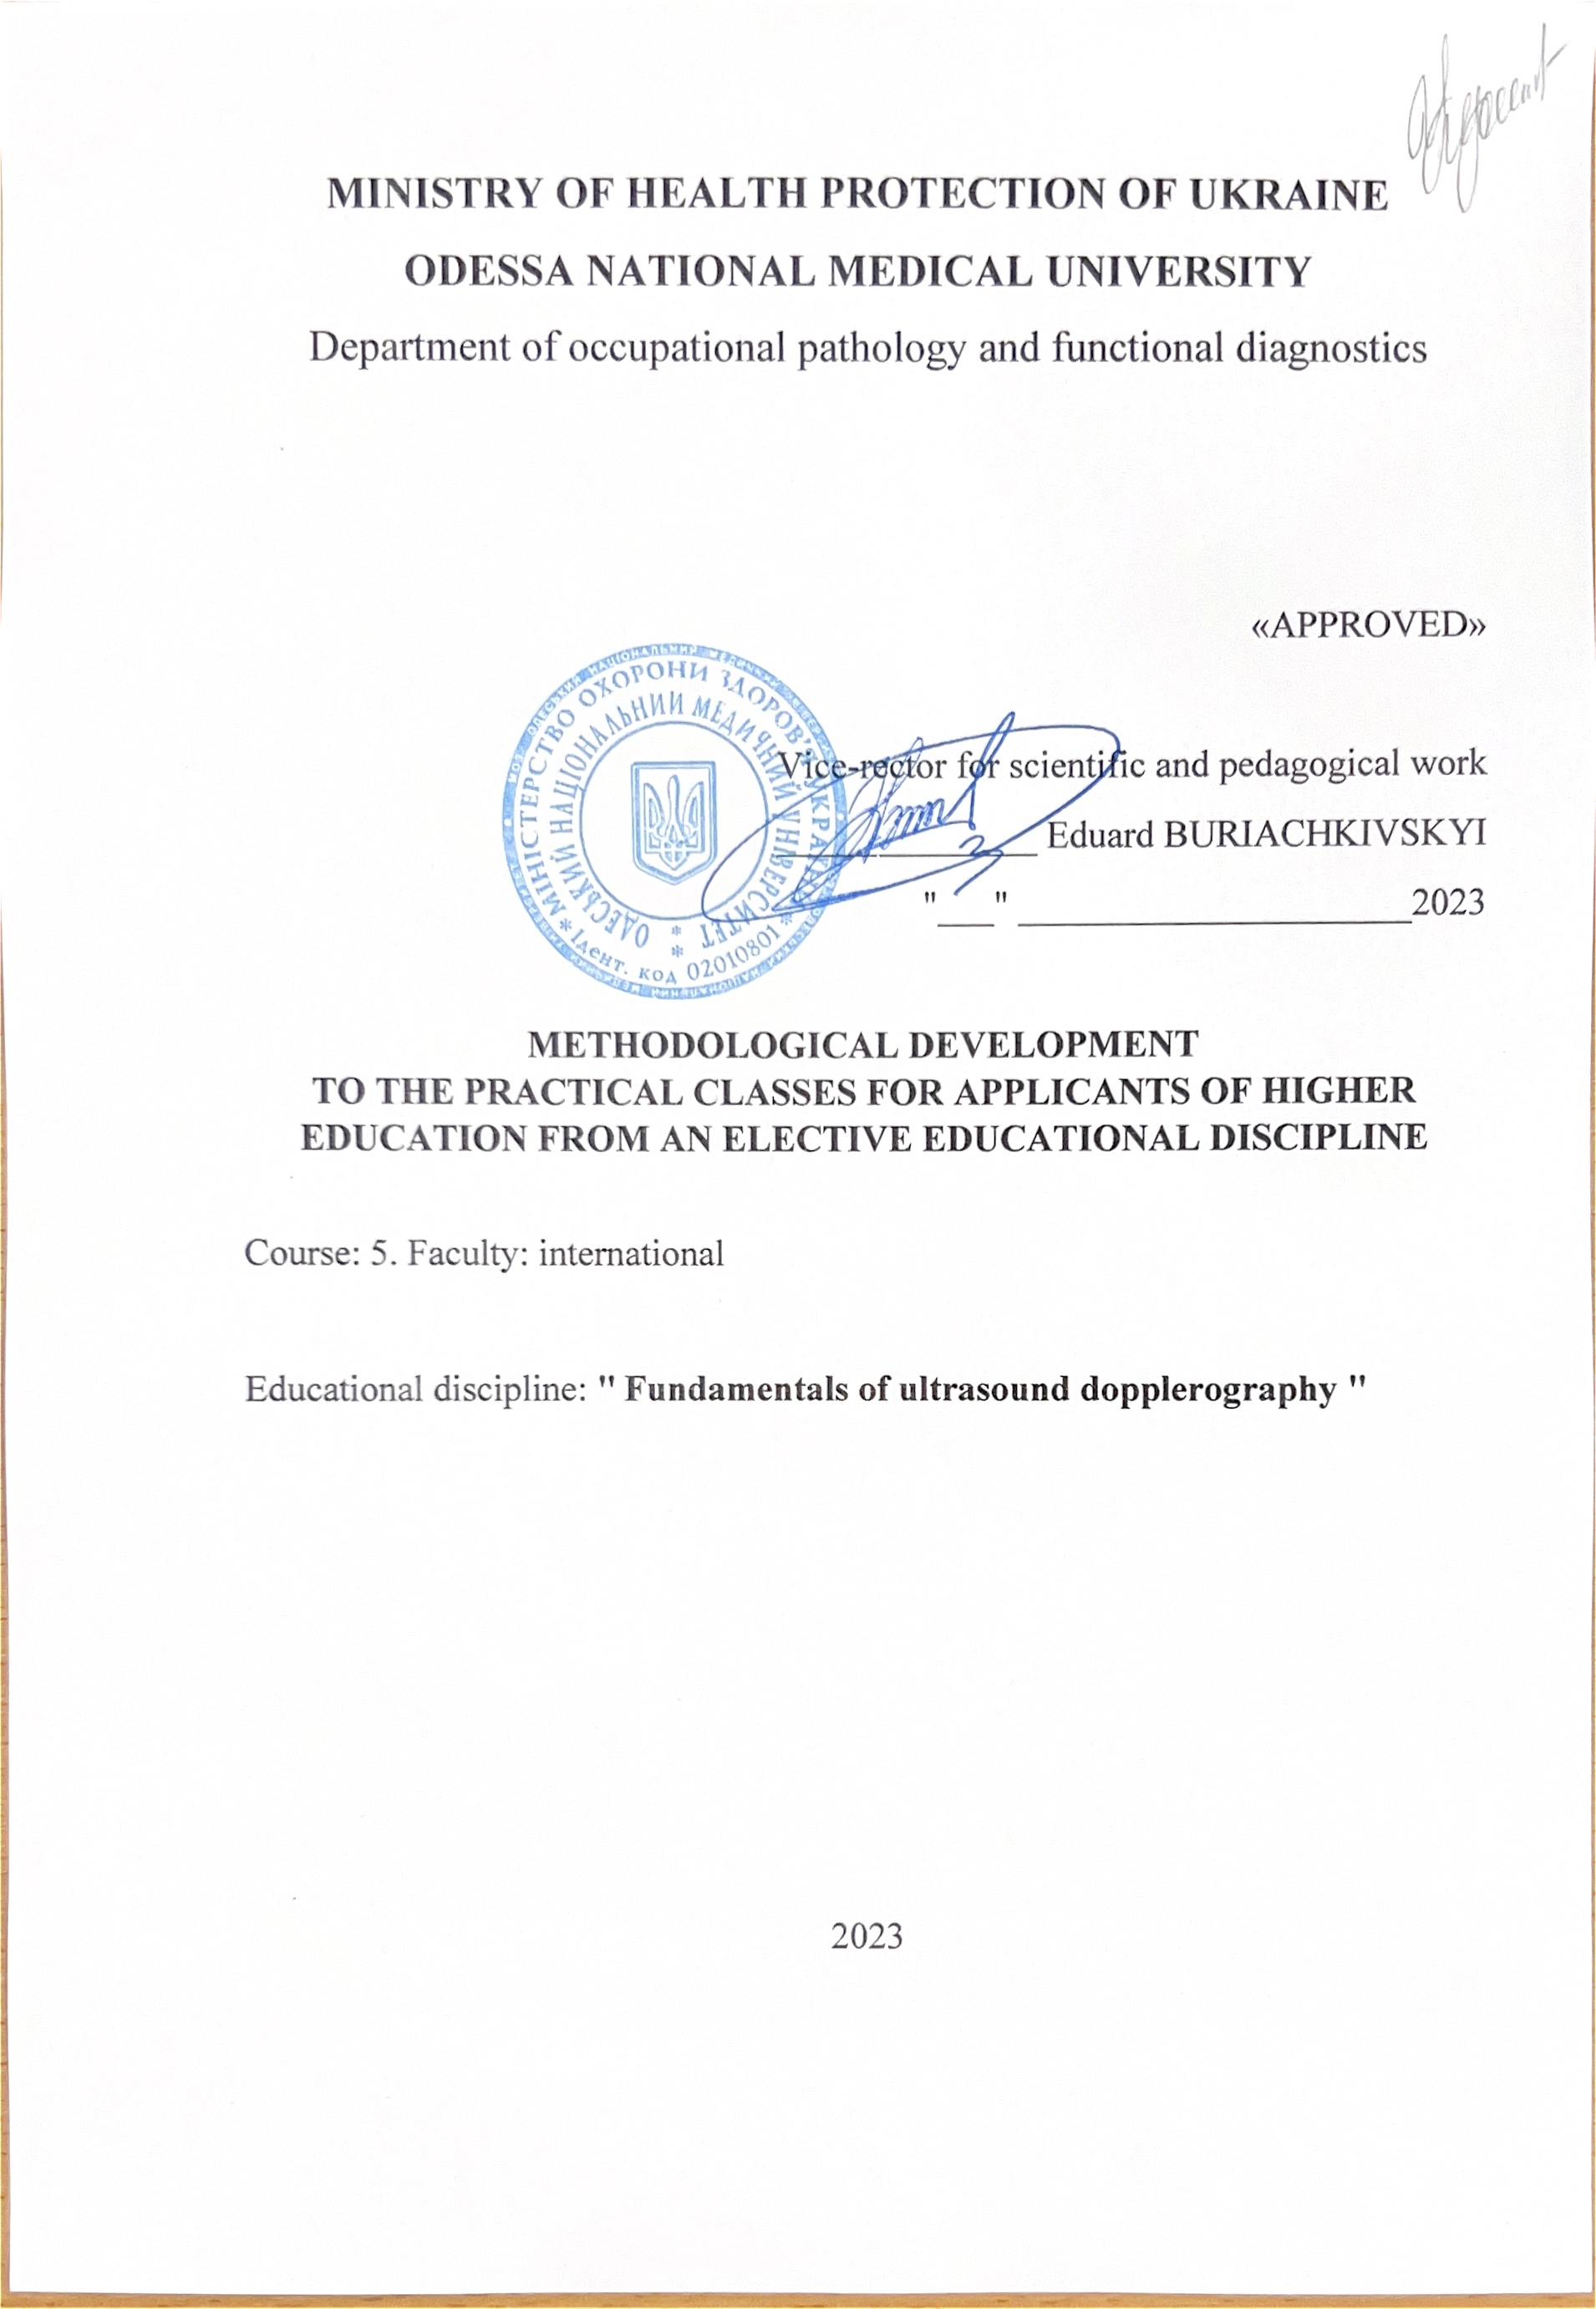

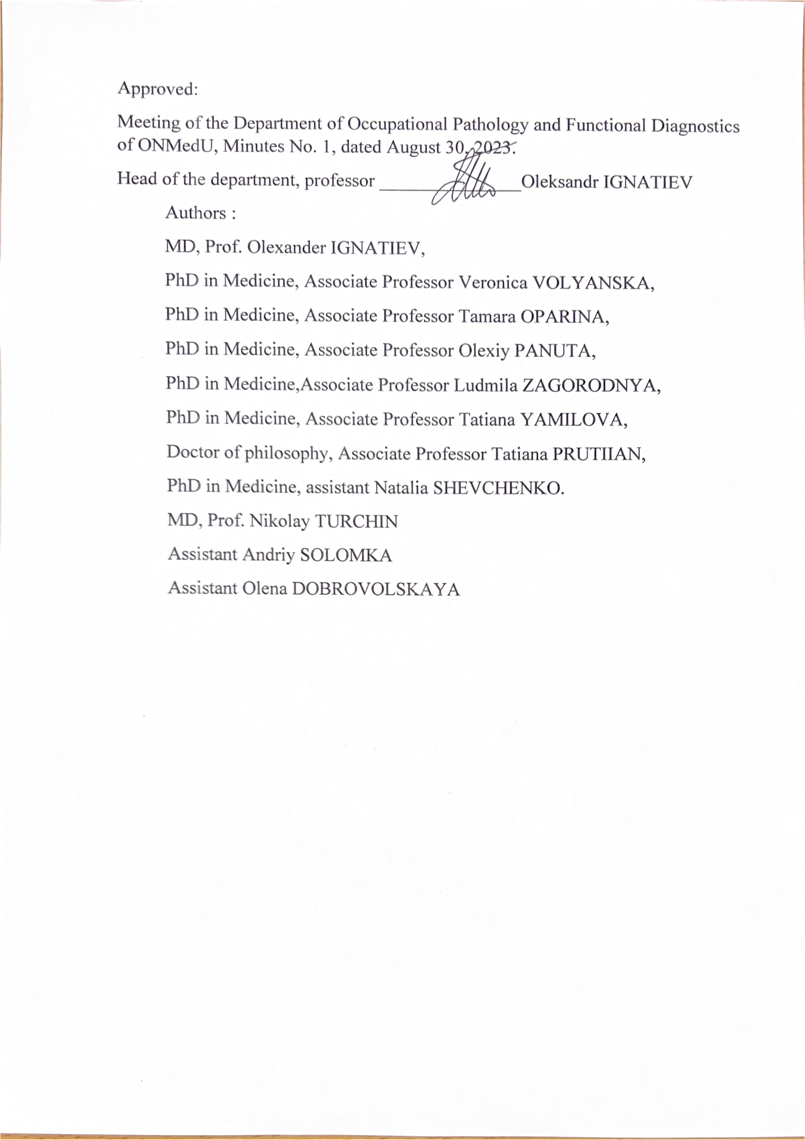

Practical lesson № 1

Topic: 1. Physical foundations of dopplerography. General issues of dopplerography

Purpose: definition of the concept of ultrasound, history of ultrasound diagnostics,
types of ultrasound sensors, to explain the physics of ultrasound and possible modes of ultrasound scanning, to determine the main ultrasound artifacts, the formation of a basic worldview in ultrasound diagnostics of the vascular system.

Basic concepts: ultrasound, ultrasound diagnostics, ultrasound
sensors, modes of ultrasound scanning, basic characteristics of the Doppler spectrum, ultrasound artifacts.

Equipment: laptop with presentation, multimedia projector
Plan:
- Organizational measures (greetings, verification of those present, notification of the topic, the purpose of the lesson, the motivation of students of higher education regarding the study of the topic).
- Control of the reference level of knowledge (written work, written test,
frontal survey on basic terminology, etc.) (if necessary).
- Questions (test tasks) to check basic knowledge on the subject of the practical lesson:
1. The process on which the application of the ultrasonic research method is based is:
A. Visualization of organs and tissues on the device screen.
B. Interaction of ultrasound with tissues of the human body.
С. Reception of reflected signals. +
D. Propagation of ultrasonic waves. +
Е. Grayscale representation of the image on the device screen.
2. Ultrasound is a sound whose frequency is not lower than:
A. 15 kHz.
B. 20000 Hz. +
С. 1 MHz.
D. 30 Hz.
E. 20 Hz.
3. Dopplerography using a continuous wave includes:
A. Pulse duration. +
B. Pulse repetition rate.
C. Frequency.
D. Wave length.
E. Frequency and wavelength.+
4. The Doppler mode is based on:
a) analysis of the difference in frequencies of emitted and incoming ultrasound echoes +
b) analysis of amplitudes and intensity of echo signals.
5. Doppler frequency shift (DF) is determined according to the Doppler equation:
a) DF ​​= 2Fo x V x cosθ / С, where: Fo is the frequency of ultrasound sent by the source, C is the speed of propagation of ultrasound in the medium, V is the speed of movement of the object (erythrocytes) reflecting the ultrasound, θ is the angle between blood flow and direction of propagation of ultrasonic waves. +
b) DF = 2V cosθ / Fo C

Situational problem № 1
Describe the main characteristics of a Doppler wave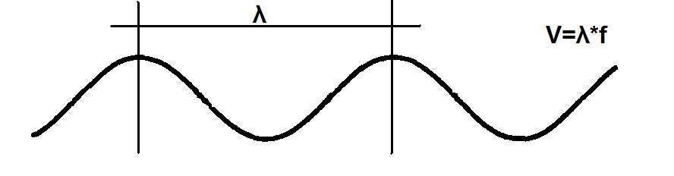

Situational problem № 2
Propagation of a sound wave (which wave graph, indicated by speed, corresponds to a certain environment)

Environment?
4080м/с
Environment? 1540 м/с
Environment?
330 м/с
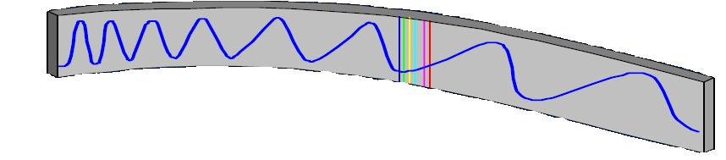
Situational problem № 3
Determine which position of the sensor is shown in the figure
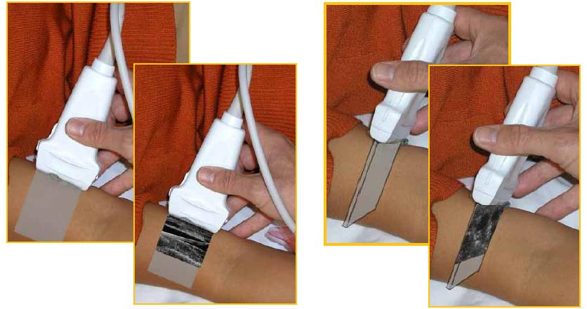

4. Discussion of theoretical issues:
1. How are ultrasonic devices fundamentally divided;
2. What are the devices that combine ultrasound-Doppler examination and two-dimensional scanning mode called;
3. What is the Doppler effect;
4. What are Doppler modes based on;
5. What is a generator of ultrasonic vibrations;
6. How the radiation of the ultrasonic scanner is carried out;
7. Why is the ultrasound reflection coefficient directly proportional.
8. What two basic options does the Doppler mode have?
9. Traditionally, ultrasonic sensors are subdivided.
Note. The discussion of theoretical issues can take place in the form of answers to the questions, debates, discussions, performances with reports, abstracts, discussion of reports and abstracts, review of answers students of higher education, etc.
5. Thematic reports/abstracts:
- Physical foundations of ultrasound
- The history of the development of ultrasound Doppler diagnostics in medicine
- Concept of types of ultrasonic sensors and devices. Modes
ultrasound scanning
- Echo signal visualization modes
Note. When preparing a report, essay, analytical review, etc., students of higher education can, along with this, prepare didactic visual materials in the form of tables, code diagrams, slides, drawings, drug schemes, etc.
6. Summary
7. List of recommended literature (main, additional, electronic information resources):
Main:
- Clark's Essential Guideto Clinical Ultrasound: Jan Dodgeon, Gill Harrison: CRC Press. – 2023. 392 р.
- Diagnostic Ultrasound, Third Edition Peter R Hoskins, Kevin Martin, Abigail Thrush CRC Press. -2019. 400 p
- Vascular ULTRASOUND HOW, WHY AND WHEN Abigail Thrush Timothy Hartshorne Colin Deane Elsevier; 4th edition. – 2022. 350 p.
- Vascular Ultrasound. B-Mode, Color Dopplerand Duplex Ultrasound, Contrast-Enhanced Ultrasound Kubale, R. — Stiegler, H. — Weskott, H. Editorial Thieme LIBRO IMPRESO. 1ª Edición Julio– 2023. 574 p.
- Naritaka H., Ishikawa M., Terao S., Kojima A., Kagami H., Inaba M., Kato S. Ultrasonographic Superb Microvascular Imaging for Emergency Surgery of Intracerebral Hemorrhage. J. Clin. Neurosci. 2020; 75:206–209. doi: 10.1016/j.jocn.2020.03.002.
- Ультразвукова детекція церебральної мікроемболії прикаротидних стенозах: досягнення та перспективи (огляд літератури) М.В. Глоба Ендоваскулярна нейрорентгенохірургія – 2020. -№ 1(31). -С. 56-67 https://doi.org/10.26683/2304-9359-2020-1(31)-56-67.
- Pellerito J., Polak J.F. Introduction to Vascular Ultrasonography, 7th Ed. Elsevier,2020, 882 p.
- Питання стандартизації протоколу ультразвукового дослідження судин шиї: огляд сучасних рекомендацій Н.М. Носенко, Д.В. Щеглов, Г.В. Друк Ендоваскулярна Нейрорентгенохірургія. – 2019. No 2(28) С.73-85.
- Sharma P, Hegde R, Kulkarni A, Sharma S, Soin P, Kochar PS, et al. Traumatic vertebral artery injury: a review of the screening criteria, imaging spectrum, mimics, and pitfalls. Pol J Radiol. - 2019;84:e307–18.https://doi.org/10.5114/pjr.2019.88023.

Additional:
- Essentials of Abdomino-Pelvic Sonography: A Handbook for Practitioners Goyal Routledge: 2018: 296 p
- Yum S.K., Im S.A., Seo Y.M., Sung I.K. Enlarged subarachnoid space on cranial ultrasound in preterm infants: Neurodevelopmental implication. Sci Rep. 2019; 9(1): 19072.
- Xiaohong Chen, JialiangXu, Yumeng Zhang, Muhui Lin, Hao Wang, Ying Song, Evaluation of hemodynamic characteristics in posterior circulation infarction patients with vertebral artery dominance by color doppler flow imaging and transcranial dopplersonography, International Journal of Neuroscience, 10.1080/00207454.2020.1773820, 131, 11, (1078-1086). 2020.
- Доплерографія магістральних судин шиї / Р. Я. Абдуллаев, В. Й. Калашников. В. Г. Марченко та iн. — Навч. nociб. — X.: Нове слово. 2008. — 48с.
- Caterina Kulyk, Chiara Voltan, Marialaura Simonetto, Anna Palmieri, Filippo Farina, Francesca Vodret, Federica Viaro, Claudio Baracchini, Vertebral artery hypoplasia: an innocent lamb or a disguise?, Journal of Neurology, 10.1007/s00415-018-9004-7, 265, 10, (2346-2352). 2018.
- Nasra K, Osher M. Sonography Vascular Peripheral Arterial Assessment, Protocols, And Interpretation. [Updated 2022 Apr 30]. In: StatPearls [Internet]. Treasure Island (FL): StatPearls Publishing; 2022 Jan-. Available from: https://www.ncbi.nlm.nih.gov/books/NBK570577/
- Оцінка мозкового кровопливу в пацієнтів з вертебробазилярною недостатністю відповідно до наявності структурних змін в системі задньої циркуляції / М. В. Глоба, Л. М. Сулій, В. В. Ващенко, Т. Г. Новікова // Зб. наук. пр. Співробітників НМАПО ім. П. Л. Шупика. - 2018. - Вип. 30. - С. 557-566.
Information resources:
Information and educational environment info.onmedu https://info.odmu.edu.ua/chair/occupational diseases and functional diagnostics /files
• ultrasound.net.ua - Ukrainian portal of ultrasound diagnostics
• http://moz.gov.ua – Ministry of Health of Ukraine
• www.ama-assn.org - American Medical Association / AmericanMedicalAssociation
• www.who.int - World Health Organization
• www.dec.gov.ua/mtd/home/ - State Expert Center of the Ministry of Health of Ukraine
• http://bma.org.uk - British Medical Association
• www.gmc-uk.org - General Medical Council (GMC)
• www.bundesaerztekammer.de – German Medical Association

Practical lesson №2

Topic: 2. Basic laws of hemodynamics.

Purpose: to study the classification of blood vessels, the structure of the vascular wall. To know the basic patterns of blood movement in vessels. Know how blood pressure affects the hemodynamics of the blood vessels of the head and neck. Know what venous hemodynamics is.
Basic concepts: Resistance of the circulatory system. The driving force of blood flow. Volume of regional blood flow in different organs. Functional classification of vessels. Cross-section of blood vessels and linear velocity of blood flow.
Equipment: laptop with presentation, multimedia projector
Plan:
1. Organizational activities (greetings, verification of those present, announcement of the topic, purpose of the lesson, motivation of higher education seekers to study the topic).
2. Control of the reference level of knowledge (written work, written test, frontal survey on basic terminology, etc.) (if necessary).
3. Questions (test tasks) to check basic knowledge on the topic of the practical session:
1. The greatest linear flow velocity at the moment of its maximum acceleration in systole is:
a) peak systolic speed; +
b) end diastolic velocity;
c) time-averaged maximum velocity of blood flow.
2. The blood flow rate does not depend on:
a) the angle between the direction of blood flow and the axis of the ultrasound beam;
b) position of the patient; +
c) frequency shift values.
3. Normally, during the flow, the following is recorded in the vessel during Doppler imaging:
a) laminar +
b) turbulent
4. At the ultrasonic location of the laminar flow, the spectrum of the Doppler frequency shift is characterized by:
a) with a small width, which corresponds to a small spread of velocities in the surveyed volume. +
b) a large width, which corresponds to a large spread of velocities in the surveyed volume.
5. Turbulent blood flow is characterized by the presence of:
a) a large number of eddies of different sizes with a chaotic change in speed. +
b) parallel moving liquid layers that do not mix with each other.
6. Resistance vessels:
a) affect the total peripheral resistance +
b) do not affect the total peripheral resistance

Situational problem № 1
Sensor frequency and resolution. Describe which sensors should be used for which research area:
Low-frequency sensors (3-5 MHz) - scan ……….. ?
High frequency sensors (10-15 MHz) allow you to scan…..?
Medium-frequency sensors (4-7 MHz) - scan ....?

Situational problem №2
What types of sensors are shown in the picture
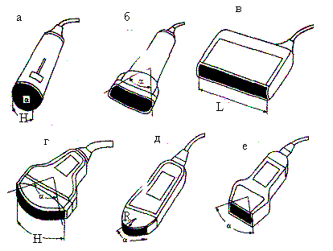

Situational task No. 3
Define this research method, which regimes take place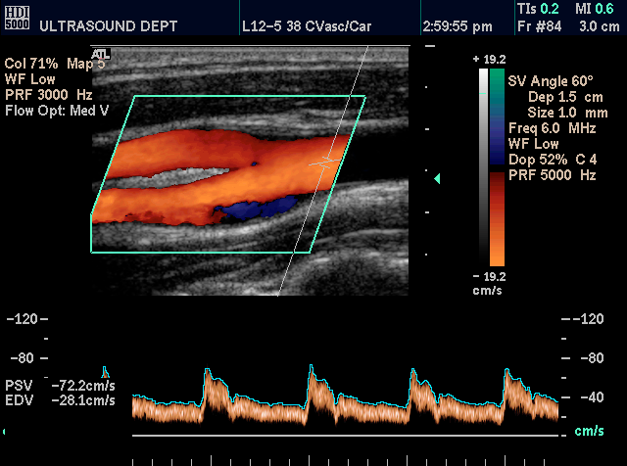
4. Discussion of theoretical issues:
1. What is spectral-wave doppler, its characteristics.
2. How are arteries and veins classified according to the classification of muscular vessels;
3. Which vessels belong to the "boiler" vessels, which components make up the vessel wall;
4. By which law is the movement of blood through vessels described in general terms;
5. The main differences between laminar and turbulent blood flow;
6. What components determine the BP value;
7. What two types of vascular tone do you know;
8. What are the elastic properties of blood vessels.
5. Topics of reports/abstracts:
- Doppler mode
- Blood flow characteristics
- Duplex, Triplex scanning, advantages, which is better to choose
- Vascular tone, how to define it, its components.
Note. When preparing a report, essay, analytical review, etc., students of higher education can, along with this, prepare didactic visual materials in the form of tables, cadograms, slides, drawings, drug schemes, etc.
6. Summary
7. List of recommended literature (main, additional, electronic information resources):
Main:
      - Clark's Essential Guideto Clinical Ultrasound: Jan Dodgeon, Gill Harrison: CRC Press. – 2023. 392 р.
      - Diagnostic Ultrasound, Third Edition Peter R Hoskins, Kevin Martin, Abigail Thrush CRC Press. -2019. 400 p
      - Vascular ULTRASOUND HOW, WHY AND WHEN Abigail Thrush Timothy Hartshorne Colin Deane Elsevier; 4th edition. – 2022. 350 p.
      - Vascular Ultrasound. B-Mode, Color Dopplerand Duplex Ultrasound, Contrast-Enhanced Ultrasound Kubale, R. — Stiegler, H. — Weskott, H. Editorial Thieme LIBRO IMPRESO. 1ª Edición Julio– 2023. 574 p.
      - Naritaka H., Ishikawa M., Terao S., Kojima A., Kagami H., Inaba M., Kato S. Ultrasonographic Superb Microvascular Imaging for Emergency Surgery of Intracerebral Hemorrhage. J. Clin. Neurosci. 2020; 75:206–209. doi: 10.1016/j.jocn.2020.03.002.
      - Ультразвукова детекція церебральної мікроемболії прикаротидних стенозах: досягнення та перспективи (огляд літератури) М.В. Глоба Ендоваскулярна нейрорентгенохірургія – 2020. -№ 1(31). -С. 56-67 https://doi.org/10.26683/2304-9359-2020-1(31)-56-67.
      - Pellerito J., Polak J.F. Introduction to Vascular Ultrasonography, 7th Ed. Elsevier,2020, 882 p.
      - Питання стандартизації протоколу ультразвукового дослідження судин шиї: огляд сучасних рекомендацій Н.М. Носенко, Д.В. Щеглов, Г.В. Друк Ендоваскулярна Нейрорентгенохірургія. – 2019. No 2(28) С.73-85.
      - Sharma P, Hegde R, Kulkarni A, Sharma S, Soin P, Kochar PS, et al. Traumatic vertebral artery injury: a review of the screening criteria, imaging spectrum, mimics, and pitfalls. Pol J Radiol. - 2019;84:e307–18.https://doi.org/10.5114/pjr.2019.88023.
Additional:
- Essentials of Abdomino-Pelvic Sonography: A Handbook for Practitioners Goyal Routledge: 2018: 296 p
- Yum S.K., Im S.A., Seo Y.M., Sung I.K. Enlarged subarachnoid space on cranial ultrasound in preterm infants: Neurodevelopmental implication. Sci Rep. 2019; 9(1): 19072.
- Xiaohong Chen, JialiangXu, Yumeng Zhang, Muhui Lin, Hao Wang, Ying Song, Evaluation of hemodynamic characteristics in posterior circulation infarction patients with vertebral artery dominance by color doppler flow imaging and transcranial dopplersonography, International Journal of Neuroscience, 10.1080/00207454.2020.1773820, 131, 11, (1078-1086). 2020.
- Доплерографія магістральних судин шиї / Р. Я. Абдуллаев, В. Й. Калашников. В. Г. Марченко та iн. — Навч. nociб. — X.: Нове слово. 2008. — 48с.
- Caterina Kulyk, Chiara Voltan, Marialaura Simonetto, Anna Palmieri, Filippo Farina, Francesca Vodret, Federica Viaro, Claudio Baracchini, Vertebral artery hypoplasia: an innocent lamb or a disguise?, Journal of Neurology, 10.1007/s00415-018-9004-7, 265, 10, (2346-2352). 2018.
- Nasra K, Osher M. Sonography Vascular Peripheral Arterial Assessment, Protocols, And Interpretation. [Updated 2022 Apr 30]. In: StatPearls [Internet]. Treasure Island (FL): StatPearls Publishing; 2022 Jan-. Available from: https://www.ncbi.nlm.nih.gov/books/NBK570577/
- Оцінка мозкового кровопливу в пацієнтів з вертебробазилярною недостатністю відповідно до наявності структурних змін в системі задньої циркуляції / М. В. Глоба, Л. М. Сулій, В. В. Ващенко, Т. Г. Новікова // Зб. наук. пр. Співробітників НМАПО ім. П. Л. Шупика. - 2018. - Вип. 30. - С. 557-566.
Information resources:
Information and educational environment info.onmedu https://info.odmu.edu.ua/chair/occupational diseases and functional diagnostics /files
• ultrasound.net.ua - Ukrainian portal of ultrasound diagnostics
• http://moz.gov.ua – Ministry of Health of Ukraine
• www.ama-assn.org - American Medical Association / AmericanMedicalAssociation
• www.who.int - World Health Organization
• www.dec.gov.ua/mtd/home/ - State Expert Center of the Ministry of Health of Ukraine
• http://bma.org.uk - British Medical Association
• www.gmc-uk.org - General Medical Council (GMC)
• www.bundesaerztekammer.de – German Medical Association

Practical lesson № 3

Topic 3. Factors affecting speed indicators and the shape of the spectrum. Resistance to blood flow. Degree of resistance. Resistance indices. Turbulent and laminar blood flow. Formation of turbulent flow.

Purpose: to learn what vascular resistance is, the degree of resistance, resistance indices. Be able to distinguish turbulent blood flow from laminar. To know the basic principles of the formation of turbulent blood flow and under what conditions it can appear.
Basic concepts: Blood flow resistance. Degree of resistance. Resistance indices. Turbulent and laminar blood flow. Formation of turbulent flow.
Equipment: laptop with presentation, multimedia projector
Plan:
1. Organizational activities (greetings, verification of those present, announcement of the topic, purpose of the lesson, motivation of higher education seekers to study the topic).
2. Control of the reference level of knowledge (written work, written test, frontal survey on basic terminology, etc.) (if necessary).
3. Questions (test tasks) to check basic knowledge on the topic of the practical session:
1. Shunt vessels - arteriolo-venular anastamoses ensure the discharge of blood from the artery to the veins:
a) bypassing capillaries +
b) through capillaries
2. Exchange vessels are:
a) capillaries +
b) veins c) arteries
3. Capacitive vessels are:
a) trunk arteries
b) veins +
c) resistance vessels
4.Increased peripheral resistance in the circulatory system:
a) Reduces the volumetric velocity of blood flow +
b) Increases the volumetric velocity of blood flow
c) the speed of blood flow does not affect the size of the volume
5. Volumetric velocity of blood flow is:
a) the amount of blood flowing through the cross-section of a vessel per unit of time in l/min or ml/sec. +
b) speed of movement of specific blood particles and substances carrying it.
6. The linear speed of blood flow is:
a) movement of stream particles per unit of time in m/sec, measured at a specific point +
b) blood mass in kg/min or g/sec.

Situational problem № 1
What type of blood flow is shown on the dopplerogram (prove your opinion)?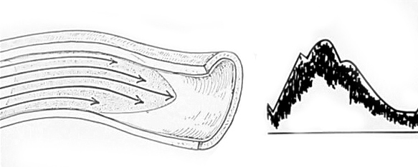
Situational task № 2
What type of blood flow is shown on the dopplerogram (justify your opinion)?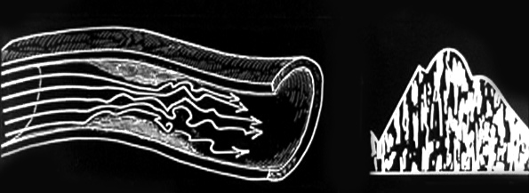

Situational task № 3
What streams of blood flow are shown in the picture? Determine how the blood flow streams that will go to the applicator and those that will go from the sensor will be mapped. 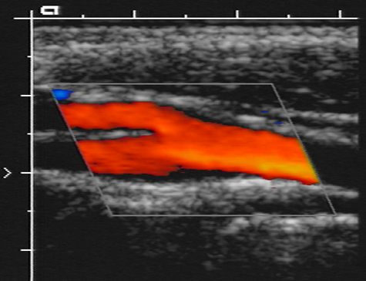
4. Discussion of theoretical issues:
1. Physiological aspects of hemodynamics (classification of vessels, peculiarities of the structure of the vascular wall of arteries and veins, vascular tone - its regulation));
2. Resistance indices, what do they depend on, what do they reflect.
3. Vascular tone, elastic properties of blood vessels.
4. The main regularities of the movement of blood through vessels.
5. The most important quantitative characteristics of the Doppler spectrum.
6. Hemodynamic manifestations of changes in vascular resistance.
7. Endothelial regulation of vascular tone
8. Venous hemodynamics
5. Topics of reports/abstracts:
- Classification of blood vessels
- Vascular wall
- Basic patterns of blood movement in vessels
- Blood pressure, types of pressure, its influence on dopplerography indicators.
- Elastic properties of arteries
- Qualitative assessment of the Doppler spectrum
Note. When preparing a report, essay, analytical review, etc., students of higher education can, along with this, prepare didactic visual materials in the form of tables, cadograms, slides, drawings, drug schemes, etc.
6. Summary
7. List of recommended literature (main, additional, electronic information resources):
Main:
- Diagnostic Ultrasound, Third Edition Peter R Hoskins, Kevin Martin, Abigail Thrush CRC Press. -2019. 400 p
- Vascular ULTRASOUND HOW, WHY AND WHEN Abigail Thrush Timothy Hartshorne Colin Deane Elsevier; 4th edition. – 2022. 350 p.
- Vascular Ultrasound. B-Mode, Color Dopplerand Duplex Ultrasound, Contrast-Enhanced Ultrasound Kubale, R. — Stiegler, H. — Weskott, H. Editorial Thieme LIBRO IMPRESO. 1ª Edición Julio– 2023. 574 p.
- Naritaka H., Ishikawa M., Terao S., Kojima A., Kagami H., Inaba M., Kato S. Ultrasonographic Superb Microvascular Imaging for Emergency Surgery of Intracerebral Hemorrhage. J. Clin. Neurosci. 2020; 75:206–209. doi: 10.1016/j.jocn.2020.03.002.
- Ультразвукова детекція церебральної мікроемболії прикаротидних стенозах: досягнення та перспективи (огляд літератури) М.В. Глоба Ендоваскулярна нейрорентгенохірургія – 2020. -№ 1(31). -С. 56-67 https://doi.org/10.26683/2304-9359-2020-1(31)-56-67.
- Pellerito J., Polak J.F. Introduction to Vascular Ultrasonography, 7th Ed. Elsevier,2020, 882 p.
- Питання стандартизації протоколу ультразвукового дослідження судин шиї: огляд сучасних рекомендацій Н.М. Носенко, Д.В. Щеглов, Г.В. Друк Ендоваскулярна Нейрорентгенохірургія. – 2019. No 2(28) С.73-85.
- Sharma P, Hegde R, Kulkarni A, Sharma S, Soin P, Kochar PS, et al. Traumatic vertebral artery injury: a review of the screening criteria, imaging spectrum, mimics, and pitfalls. Pol J Radiol. - 2019;84:e307–18.https://doi.org/10.5114/pjr.2019.88023.
- Clark's Essential Guideto Clinical Ultrasound: Jan Dodgeon, Gill Harrison: CRC Press. – 2023. 392 р.

Аdditional:
- Essentials of Abdomino-Pelvic Sonography: A Handbook for Practitioners Goyal Routledge: 2018: 296 p
- Yum S.K., Im S.A., Seo Y.M., Sung I.K. Enlarged subarachnoid space on cranial ultrasound in preterm infants: Neurodevelopmental implication. Sci Rep. 2019; 9(1): 19072.
- Xiaohong Chen, JialiangXu, Yumeng Zhang, Muhui Lin, Hao Wang, Ying Song, Evaluation of hemodynamic characteristics in posterior circulation infarction patients with vertebral artery dominance by color doppler flow imaging and transcranial dopplersonography, International Journal of Neuroscience, 10.1080/00207454.2020.1773820, 131, 11, (1078-1086). 2020.
- Доплерографія магістральних судин шиї / Р. Я. Абдуллаев, В. Й. Калашников. В. Г. Марченко та iн. — Навч. nociб. — X.: Нове слово. 2008. — 48с.
- Caterina Kulyk, Chiara Voltan, Marialaura Simonetto, Anna Palmieri, Filippo Farina, Francesca Vodret, Federica Viaro, Claudio Baracchini, Vertebral artery hypoplasia: an innocent lamb or a disguise?, Journal of Neurology, 10.1007/s00415-018-9004-7, 265, 10, (2346-2352). 2018.
- Nasra K, Osher M. Sonography Vascular Peripheral Arterial Assessment, Protocols, And Interpretation. [Updated 2022 Apr 30]. In: StatPearls [Internet]. Treasure Island (FL): StatPearls Publishing; 2022 Jan-. Available from: https://www.ncbi.nlm.nih.gov/books/NBK570577/
- Оцінка мозкового кровопливу в пацієнтів з вертебробазилярною недостатністю відповідно до наявності структурних змін в системі задньої циркуляції / М. В. Глоба, Л. М. Сулій, В. В. Ващенко, Т. Г. Новікова // Зб. наук. пр. Співробітників НМАПО ім. П. Л. Шупика. - 2018. - Вип. 30. - С. 557-566.
Information resources:
Information and educational environment info.onmedu https://info.odmu.edu.ua/chair/occupational diseases and functional diagnostics /files
• ultrasound.net.ua - Ukrainian portal of ultrasound diagnostics
• http://moz.gov.ua – Ministry of Health of Ukraine
• www.ama-assn.org - American Medical Association / AmericanMedicalAssociation
• www.who.int - World Health Organization
• www.dec.gov.ua/mtd/home/ - State Expert Center of the Ministry of Health of Ukraine
• http://bma.org.uk - British Medical Association
• www.gmc-uk.org - General Medical Council (GMC)
• www.bundesaerztekammer.de – German Medical Association

Practical lesson № 4

Topic 4. Principles of distinguishing modes in ultrasound dopplerography.

Purpose: to learn what ultrasound dopplerography is. Be able to distinguish duplex scanning from triplex scanning. Know the advantages of duplex and triplex scanning. Learn how to properly adjust the image in duplex and triplex scanning mode.
Basic concepts: Ultrasound dopplerography (UZDG). The concept of duplex scanning. The concept of triplex scanning. Advantages of duplex (triplex) scanning versus ultrasound
Equipment: laptop with presentation, multimedia projector
Plan:
1. Organizational activities (greetings, verification of those present, announcement of the topic, purpose of the lesson, motivation of higher education seekers to study the topic).
2. Control of the reference level of knowledge (written work, written test, frontal survey on basic terminology, etc.) (if necessary).
3. Questions (test tasks) to check basic knowledge on the topic of the practical session:
1. The amount of hydrodynamic resistance of the circulatory system depends on:
a) blood viscosity; +
b) friction forces;
c) vessel diameter;
d) vessel length;
e) a, c and d are true.
2. The quantitative measure of flow turbulence is:
a) Reynolds number; +
b) blood density;
c) Purcell index.
3. The hemodynamic significance of artery stenosis is determined by:
a) value of distal perfusion pressure; +
b) degree of collateral development;
c) degree of stenosis;
d) the amount of cardiac output.
4. With angiodysplasia (macrofistular form), the value of diastolic blood flow velocity
a) remains within the norm;
b) increases; +
c) decreases.

Situational task No. 1
Define what kind of study this is and show the main components of this scan mode.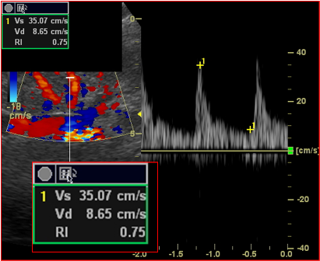

Situational task No. 2
Which sensor was used to diagnose this study and which mode is indicated in this figure.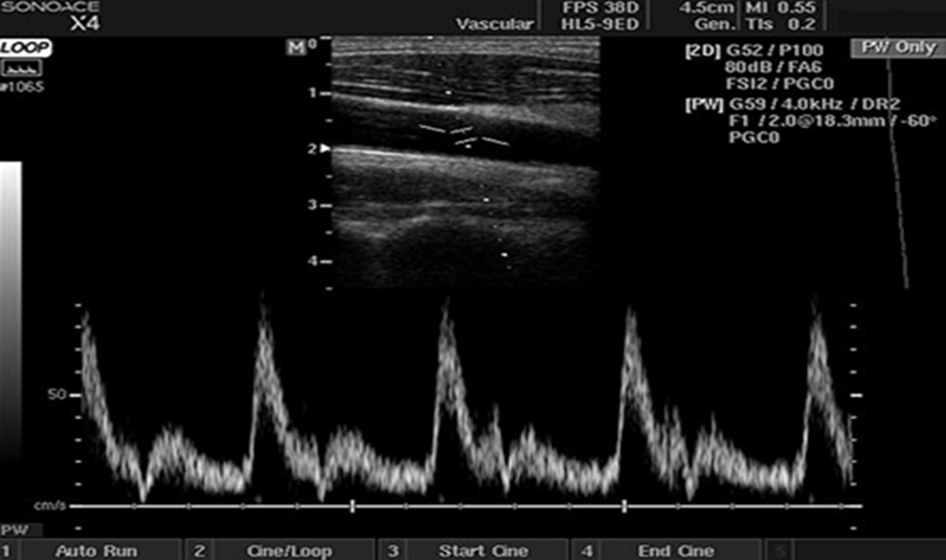

Situational task No. 3
What type of scan is shown in this picture, prove your statement.
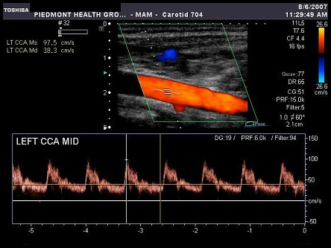

Situational task No. 4
What scanning mode is shown in the picture, what are its advantages and area of ​​application.
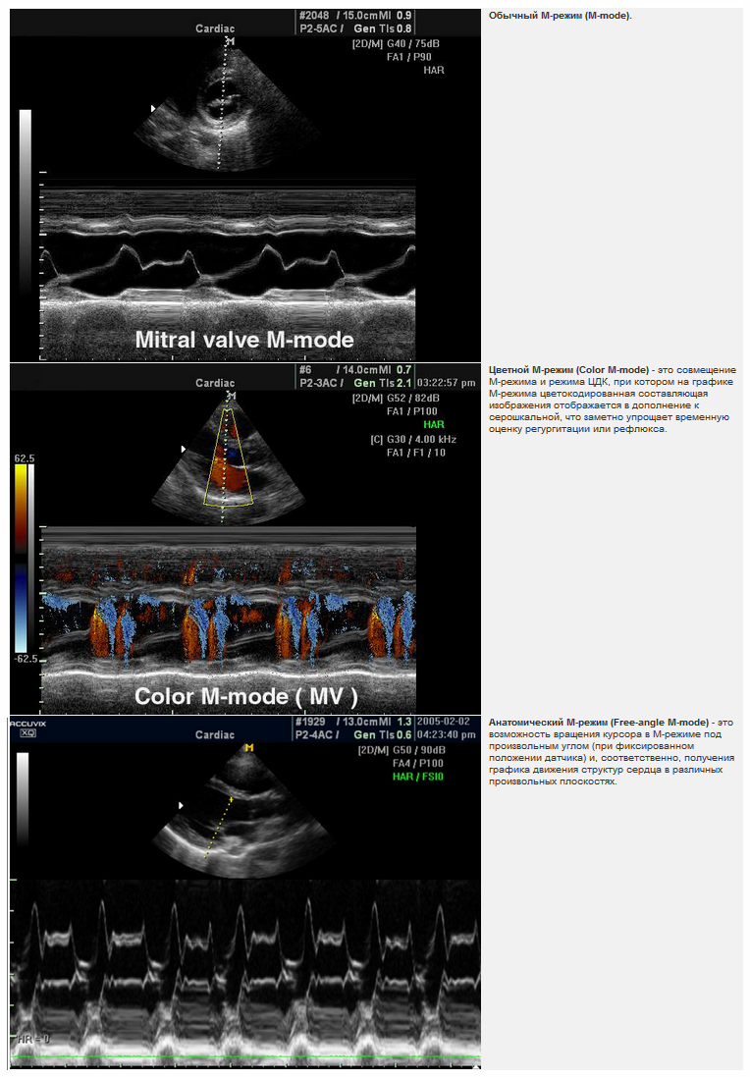
4. Discussion of theoretical issues:
1. Doppler modes.
2. Duplex scanning, its component
3. Triplex scanning, its component
4. "Blind" Doppler, what are the pluses and minuses of this technique
5. The main settings of the modes in the Doppler are investigated.
6. How to correctly adjust the Doppler angle and what it depends on.
7. What is the aliasing effect and how to get rid of it.
8. What are the possible artifacts during duplex and triplex scanning.
5. Topics of reports/abstracts:
- The main indications for performing a duplex ultrasound examination (US) of the carotid arteries in accordance with the recommendations of the ESC and the Working Group on Aorta and Peripheral Vascular Diseases
- Doppler modes.
- Setting the Doppler mode
- Preparing the patient for the study, what are the indications and contraindications for dopplerography.
- Image optimization methods for Doppler imaging.
- B-Flow Color and eTracking.
Note. When preparing a report, essay, analytical review, etc., students of higher education can, along with this, prepare didactic visual materials in the form of tables, cadograms, slides, drawings, drug schemes, etc.
6. Summary
7. List of recommended literature (main, additional, electronic information resources):
Main:
- Clark's Essential Guideto Clinical Ultrasound: Jan Dodgeon, Gill Harrison: CRC Press. – 2023. 392 р.
- Diagnostic Ultrasound, Third Edition Peter R Hoskins, Kevin Martin, Abigail Thrush CRC Press. -2019. 400 p
- Vascular ULTRASOUND HOW, WHY AND WHEN Abigail Thrush Timothy Hartshorne Colin Deane Elsevier; 4th edition. – 2022. 350 p.
- Vascular Ultrasound. B-Mode, Color Dopplerand Duplex Ultrasound, Contrast-Enhanced Ultrasound Kubale, R. — Stiegler, H. — Weskott, H. Editorial Thieme LIBRO IMPRESO. 1ª Edición Julio– 2023. 574 p.
- Naritaka H., Ishikawa M., Terao S., Kojima A., Kagami H., Inaba M., Kato S. Ultrasonographic Superb Microvascular Imaging for Emergency Surgery of Intracerebral Hemorrhage. J. Clin. Neurosci. 2020; 75:206–209. doi: 10.1016/j.jocn.2020.03.002.
- Ультразвукова детекція церебральної мікроемболії прикаротидних стенозах: досягнення та перспективи (огляд літератури) М.В. Глоба Ендоваскулярна нейрорентгенохірургія – 2020. -№ 1(31). -С. 56-67 https://doi.org/10.26683/2304-9359-2020-1(31)-56-67.
- Pellerito J., Polak J.F. Introduction to Vascular Ultrasonography, 7th Ed. Elsevier,2020, 882 p.
- Питання стандартизації протоколу ультразвукового дослідження судин шиї: огляд сучасних рекомендацій Н.М. Носенко, Д.В. Щеглов, Г.В. Друк Ендоваскулярна Нейрорентгенохірургія. – 2019. No 2(28) С.73-85.
- Sharma P, Hegde R, Kulkarni A, Sharma S, Soin P, Kochar PS, et al. Traumatic vertebral artery injury: a review of the screening criteria, imaging spectrum, mimics, and pitfalls. Pol J Radiol. - 2019;84:e307–18.https://doi.org/10.5114/pjr.2019.88023.

Аdditional:
- Essentials of Abdomino-Pelvic Sonography: A Handbook for Practitioners Goyal Routledge: 2018: 296 p
- Yum S.K., Im S.A., Seo Y.M., Sung I.K. Enlarged subarachnoid space on cranial ultrasound in preterm infants: Neurodevelopmental implication. Sci Rep. 2019; 9(1): 19072.
- Xiaohong Chen, JialiangXu, Yumeng Zhang, Muhui Lin, Hao Wang, Ying Song, Evaluation of hemodynamic characteristics in posterior circulation infarction patients with vertebral artery dominance by color doppler flow imaging and transcranial dopplersonography, International Journal of Neuroscience, 10.1080/00207454.2020.1773820, 131, 11, (1078-1086). 2020.
- Доплерографія магістральних судин шиї / Р. Я. Абдуллаев., В. Й. Калашников. В. Г. Марченко та iн. — Навч. nociб. — X.: Нове слово. 2008. — 48с.
- CaterinaKulyk, Chiara Voltan, MarialauraSimonetto, Anna Palmieri, Filippo Farina, Francesca Vodret, Federica Viaro, Claudio Baracchini, Vertebral artery hypoplasia: an innocent lamb or a disguise?, Journal of Neurology, 10.1007/s00415-018-9004-7, 265, 10, (2346-2352). 2018.
- Nasra K, Osher M. Sonography Vascular Peripheral Arterial Assessment, Protocols, And Interpretation. [Updated 2022 Apr 30]. In: StatPearls [Internet]. Treasure Island (FL): StatPearls Publishing; 2022 Jan-. Available from: https://www.ncbi.nlm.nih.gov/books/NBK570577/
- Оцінка мозкового кровопливу в пацієнтів з вертебробазилярною недостатністю відповідно до наявності структурних змін в системі задньої циркуляції / М. В. Глоба, Л. М. Сулій, В. В. Ващенко, Т. Г. Новікова // Зб. наук. пр. Співробітників НМАПО ім. П. Л. Шупика. - 2018. - Вип. 30. - С. 557-566.
Information resources:
Information and educational environment info.onmedu https://info.odmu.edu.ua/chair/occupational diseases and functional diagnostics /files
• ultrasound.net.ua - Ukrainian portal of ultrasound diagnostics
• http://moz.gov.ua – Ministry of Health of Ukraine
• www.ama-assn.org - American Medical Association / AmericanMedicalAssociation
• www.who.int - World Health Organization
• www.dec.gov.ua/mtd/home/ - State Expert Center of the Ministry of Health of Ukraine
• http://bma.org.uk - British Medical Association
• www.gmc-uk.org - General Medical Council (GMC)
• www.bundesaerztekammer.de – German Medical Association

Practical lesson No. 5
Topic 5. Peculiarities of dopplerography of vessels with high and low peripheral resistance. Vascular resistance indices. Vessels with high and low resistance, their speed characteristics.
Purpose: to study and know what vessels are, related to vessels with low peripheral resistance, vessels with high peripheral resistance. Know the indices of total peripheral resistance, resistance index, pulsation index. To be able to identify dopplerographic data of vessels with low and high peripheral resistance.
Basic concepts: vessels with low and high peripheral resistance, RI and PI indices, Doppler data of blood flow spectrum of vessels with low and high resistance.
Equipment: laptop with presentation, multimedia projector
Plan:
1. Organizational activities (greetings, verification of those present, announcement of the topic, purpose of the lesson, motivation of higher education seekers to study the topic).
2. Control of the reference level of knowledge (written work, written test, frontal survey on basic terminology, etc.) (if necessary).
3. Questions (test tasks) to check basic knowledge on the topic of the practical session:
1. The main type of blood flow is characterized by:
a) a sharp peak in systole, reverse blood flow during early diastole and blood flow during late diastole; +
b) decrease and rounding of the systolic peak, slow rise and fall of the blood flow velocity curve.
2.The collateral type of blood flow is characterized by:
a) expansion, splitting of the peak in systole, absence of reverse blood flow in diastole;
b) decrease and rounding of the systolic peak, slow rise and fall of the blood flow velocity curve. +
3. What indicator reflects the degree of flow turbulence:
a) peripheral resistance index; +
b) spectral expansion index;
c) systole-diastolic ratio.
4. Referential, in relation to ultrasound methods of research of the vascular system, are:
a) computer tomography; +
b) magnetic resonance imaging;
c) angiography;
d) radiography.
5. Increase in peripheral resistance in the circulatory system:
a) Reduces the volumetric velocity of blood flow +
b) Increases the volumetric velocity of blood flow
c) the speed of blood flow does not affect the size of the volume
6. The speed of ultrasound propagation increases if:
a) the density of the environment increases;
b) the density of the medium decreases;
c) elasticity increases;
d) density, elasticity increases;
e) density decreases, elasticity increases.
7. The speed of ultrasound propagation is determined by:
a) frequency;
b) amplitude;
c) wavelength;
d) period;
e) the environment.
8. In the formula describing the parameters of the wave, there is no:
a) frequency;
b) period;
c) amplitude;
d) wavelength;
e) propagation speed.
9.Normally, the blood flow in the arteries of the lower extremities has:
a) high peripheral resistance
b) low peripheral resistance
c) has no peripheral resistance
d) insignificant peripheral resistance
e) unknown peripheral resistance

Situational task No. 1. Determine where the pulse wave occurs in arteries with high and low peripheral resistance.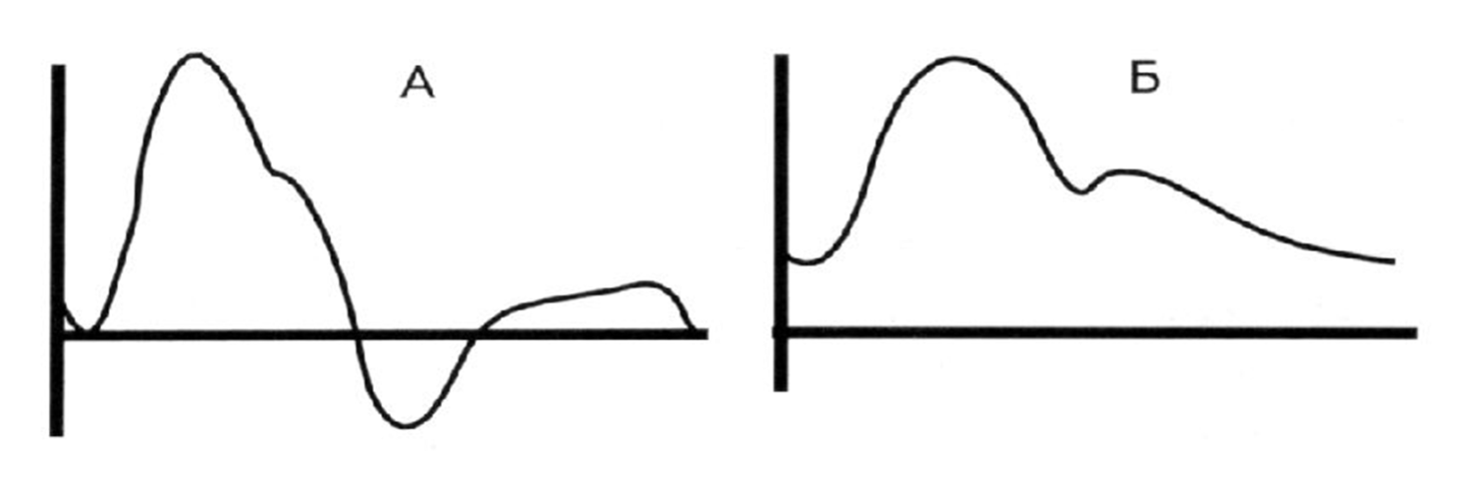

Situational task No. 2
List the components of the Doppler curve and to which resistance this spectrum of blood flow belongs.
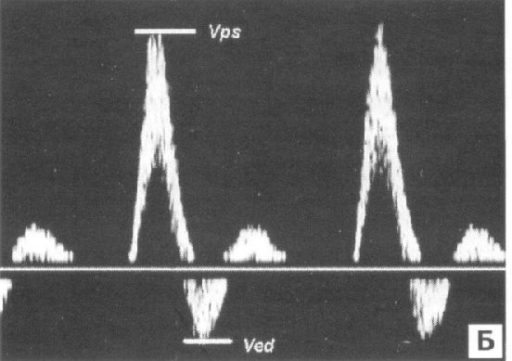

Situational task No. 3
Justify your answer: why this spectrum of blood flow belongs to vessels with low peripheral resistance. What is the name of this scanning mode?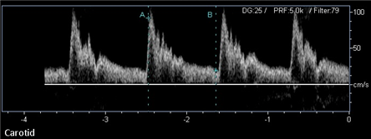

4. Discussion of theoretical issues:
1. Spectral Doppler study of the blood flow of the main arteries and veins of the head and neck.
2. Adjusting the ultrasound device according to the research tasks;
3. Setting the parameters of the Doppler spectrum;
4. Determination of vascular reactivity;
5. Angle correction during spectral examination of a vessel;
6. Classification of blood vessels depending on resistance.
7. Components of the blood flow spectrum that are present in arteries with high resistance and arteries with low resistance.
5. Topics of reports/abstracts:
- Doppler characteristics of the blood flow spectrum in the carotid basin
-Dopplerographic characteristics of the spectrum of blood flow in the vertebro-basilar basin and the subclavian artery.
-Optimization of the image in the mode of color Doppler mapping. blood flow
- Safety principles of conducting a dopplerographic study.
- Classification of arteries and their Doppler component
Note. When preparing a report, essay, analytical review, etc., students of higher education can, along with this, prepare didactic visual materials in the form of tables, cadograms, slides, drawings, drug schemes, etc.
6. Summary
7. List of recommended literature (main, additional, electronic information resources):
Main:
- Clark's Essential Guideto Clinical Ultrasound: Jan Dodgeon, Gill Harrison: CRC Press. – 2023. 392 р.
- Diagnostic Ultrasound, Third Edition Peter R Hoskins, Kevin Martin, Abigail Thrush CRC Press. -2019. 400 p
- Vascular ULTRASOUND HOW, WHY AND WHEN Abigail Thrush Timothy Hartshorne Colin Deane Elsevier; 4th edition. – 2022. 350 p.
- Vascular Ultrasound. B-Mode, Color Dopplerand Duplex Ultrasound, Contrast-Enhanced Ultrasound Kubale, R. — Stiegler, H. — Weskott, H. Editorial Thieme LIBRO IMPRESO. 1ª Edición Julio– 2023. 574 p.
- Naritaka H., Ishikawa M., Terao S., Kojima A., Kagami H., Inaba M., Kato S. Ultrasonographic Superb Microvascular Imaging for Emergency Surgery of Intracerebral Hemorrhage. J. Clin. Neurosci. 2020; 75:206–209. doi: 10.1016/j.jocn.2020.03.002.
- Ультразвукова детекція церебральної мікроемболії прикаротидних стенозах: досягнення та перспективи (огляд літератури) М.В. Глоба Ендоваскулярна нейрорентгенохірургія – 2020. -№ 1(31). -С. 56-67 https://doi.org/10.26683/2304-9359-2020-1(31)-56-67.
- Pellerito J., Polak J.F. Introduction to Vascular Ultrasonography, 7th Ed. Elsevier,2020, 882 p.
- Питання стандартизації протоколу ультразвукового дослідження судин шиї: огляд сучасних рекомендацій Н.М. Носенко, Д.В. Щеглов, Г.В. Друк Ендоваскулярна Нейрорентгенохірургія. – 2019. No 2(28) С.73-85.
- Sharma P, Hegde R, Kulkarni A, Sharma S, Soin P, Kochar PS, et al. Traumatic vertebral artery injury: a review of the screening criteria, imaging spectrum, mimics, and pitfalls. Pol J Radiol. - 2019;84:e307–18.https://doi.org/10.5114/pjr.2019.88023.
Аdditional:
- Essentials of Abdomino-Pelvic Sonography: A Handbook for Practitioners Goyal Routledge: 2018: 296 p
- Yum S.K., Im S.A., Seo Y.M., Sung I.K. Enlarged subarachnoid space on cranial ultrasound in preterm infants: Neurodevelopmental implication. Sci Rep. 2019; 9(1): 19072.
- Xiaohong Chen, JialiangXu, Yumeng Zhang, Muhui Lin, Hao Wang, Ying Song, Evaluation of hemodynamic characteristics in posterior circulation infarction patients with vertebral artery dominance by color doppler flow imaging and transcranial dopplersonography, International Journal of Neuroscience, 10.1080/00207454.2020.1773820, 131, 11, (1078-1086). 2020.
- Доплерографія магістральних судин шиї / Р. Я. Абдуллаев, В. Й. Калашников. В. Г. Марченко та iн. — Навч. nociб. — X.: Нове слово. 2008. — 48с.
- Caterina Kulyk, Chiara Voltan, Marialaura Simonetto, Anna Palmieri, Filippo Farina, Francesca Vodret, Federica Viaro, Claudio Baracchini, Vertebral artery hypoplasia: an innocent lamb or a disguise?, Journal of Neurology, 10.1007/s00415-018-9004-7, 265, 10, (2346-2352). 2018.
- Nasra K, Osher M. Sonography Vascular Peripheral Arterial Assessment, Protocols, And Interpretation. [Updated 2022 Apr 30]. In: Stat Pearls [Internet]. Treasure Island (FL): StatPearls Publishing; 2022 Jan-. Available from: https://www.ncbi.nlm.nih.gov/books/NBK570577/
- Оцінка мозкового кровопливу в пацієнтів з вертебробазилярною недостатністю відповідно до наявності структурних змін в системі задньої циркуляції / М. В. Глоба, Л. М. Сулій, В. В. Ващенко, Т. Г. Новікова // Зб. наук. пр. Співробітників НМАПО ім. П. Л. Шупика. - 2018. - Вип. 30. - С. 557-566.
Information resources:
Information and educational environment info.onmedu https://info.odmu.edu.ua/chair/occupational diseases and functional diagnostics /files
• ultrasound.net.ua - Ukrainian portal of ultrasound diagnostics
• http://moz.gov.ua – Ministry of Health of Ukraine
• www.ama-assn.org - American Medical Association / AmericanMedicalAssociation
• www.who.int - World Health Organization
• www.dec.gov.ua/mtd/home/ - State Expert Center of the Ministry of Health of Ukraine
• http://bma.org.uk - British Medical Association
• www.gmc-uk.org - General Medical Council (GMC)
• www.bundesaerztekammer.de – German Medical Association

Practical lesson No. 6

Topic 6. Ultrasound anatomy of vessels of the head and neck.

Purpose: to study and know the anatomy and ultrasound anatomy of the main arteries and veins of the head and neck. Know the indications for conducting an ultrasound examination of the vessels of the neck and head, the location of extracranial and intracranial vessels. Know the main approaches to ultrasound examination of extracranial vessels of the neck.
Basic concepts: anatomy and ultrasound anatomy of the main vessels of the neck and head, temporal windows for scanning brain vessels, occipital ultrasound window, for scanning the arteries of the vertebrobasilar basin.
Equipment: laptop with presentation, multimedia projector
Plan:
1. Organizational activities (greetings, verification of those present, announcement of the topic, purpose of the lesson, motivation of higher education seekers to study the topic).
2. Control of the reference level of knowledge (written work, written test, frontal survey on basic terminology, etc.) (if necessary).
3. Questions (test tasks) to check basic knowledge on the topic of the practical session:
1. The right and left vertebral arteries are normal:
a) merge into the main artery
b) merge into the posterior cerebral arteries
c) merge into the upper cerebellar artery
d) do not merge
e) true b) and c)
2. The vertebral artery departs from;
and. lower semicircle of the subclavian artery
b. upper semicircle of the subclavian artery +
in. brachiocephalic trunk
d. there is no correct answer
3.Hypoplasia of the vertebral artery is characterized by:
a) decrease in the diameter of the vertebral artery to 3 mm or less
b) decrease in the diameter of the vertebral artery to 2 mm or less +
c) decrease in the diameter of the vertebral artery to 2.5 mm or less
4. Transcranial dopplerography of the arteries of the circle of Willis is performed using a sensor:
a) 8 MHz
b) 4 MHz
c) 2 MHz +
5. The ophthalmic artery is a continuation of the branch:
a) external carotid artery;
b) middle cerebral artery;
c) internal carotid artery; +
d) superficial.
6. The right and left vertebral arteries merge into:
a) posterior cerebral arteries
b) main artery +
c) in the superior cerebellar artery
7. The vertebral artery departs from:
a) subclavian artery
b) humeral shaft
c) aortic arch
d) thoracic aorta
e) abdominal part of the aorta
8. Normally, the internal carotid artery takes part in blood supply:
a) brain
b) face and neck skin
c) chest organs
d) organs of the abdominal cavity
e) true in) and d)

Situational problem №1
Name the vessels by their serial numbers
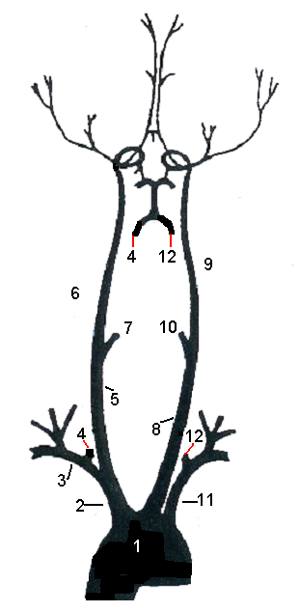
Situational task № 2
Give the characteristics of Doppler, determine which vessel this spectrum of blood flow corresponds to.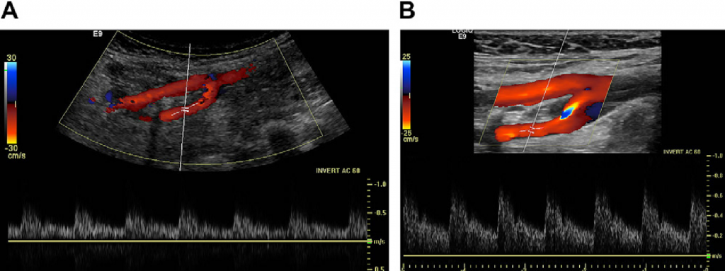
Situational task No. 3
Define spectral blood flow, which vessel it belongs to. What kind of sensor was used to visualize carotene?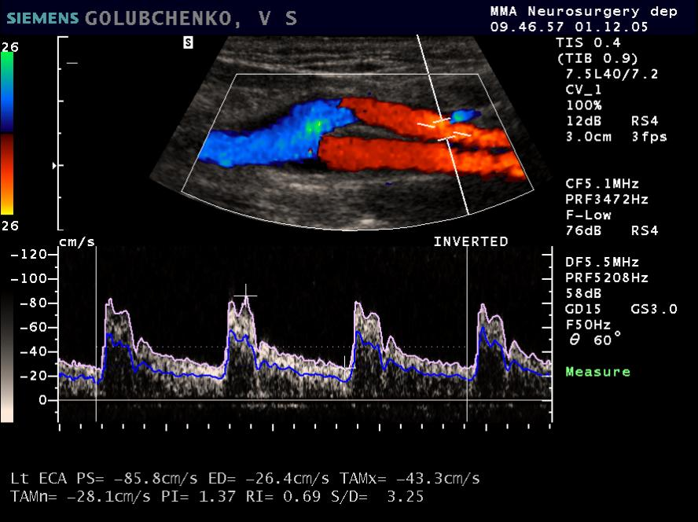

4. Discussion of theoretical issues:
1. From which anatomical structure does the common carotid artery begin on the right;
2. Which vessels first depart from the aortic arch;
3. In which anatomical zone does the common carotid artery divide into terminal branches: external and internal carotid artery;
4. Normally, at what level of the transverse processes does the vertebral artery enter the channel;
5. What are the available indications for conducting transcranial ultrasound dopplerography;
6. What is the vertebral venous system;
7. What are the differential signs for ultrasonic identification of the internal and external carotid artery;
8. Vilizievo circle, its ultrasound anatomy

5. Topics of reports/abstracts:
- The structure of the carotid basin: the main anatomical components of the carotid basin (brachiocephalic trunk; aortic arch). Internal jugular vein, spinal veins.
- Visualization of carotid arteries and brachiocephalic veins: lumen of brachiofacial arteries, spectrum of blood flow, physiological turbulence. Differentiation of internal and external carotid artery. Measurement of the diameter of the vertebral artery. Character of blood flow for subclavian arteries. Lumen of brachiocephalic veins.
- Anatomy of intracranial vessels: anterior, posterior arterial circulation. Anomalies of the structure of the circle of Willis. Collateral blood circulation of the circle of Willis. Deep veins of the brain.
Note. When preparing a report, essay, analytical review, etc., students of higher education can, along with this, prepare didactic visual materials in the form of tables, cadograms, slides, drawings, drug schemes, etc.
6. Summary
7. List of recommended literature (main, additional, electronic information resources):
Main:
- Clark's Essential Guideto Clinical Ultrasound: Jan Dodgeon, Gill Harrison: CRC Press. – 2023. 392 р.
- Diagnostic Ultrasound, Third Edition Peter R Hoskins, Kevin Martin, Abigail Thrush CRC Press. -2019. 400 p
- Vascular ULTRASOUND HOW, WHY AND WHEN Abigail Thrush Timothy Hartshorne Colin Deane Elsevier; 4th edition. – 2022. 350 p.
- Vascular Ultrasound. B-Mode, Color Dopplerand Duplex Ultrasound, Contrast-Enhanced Ultrasound Kubale, R. — Stiegler, H. — Weskott, H. Editorial Thieme LIBRO IMPRESO. 1ª Edición Julio– 2023. 574 p.
- Naritaka H., Ishikawa M., Terao S., Kojima A., Kagami H., Inaba M., Kato S. Ultrasonographic Superb Microvascular Imaging for Emergency Surgery of Intracerebral Hemorrhage. J. Clin. Neurosci. 2020; 75:206–209. doi: 10.1016/j.jocn.2020.03.002.
- Ультразвукова детекція церебральної мікроемболії прикаротидних стенозах: досягнення та перспективи (огляд літератури) М.В. Глоба Ендоваскулярна нейрорентгенохірургія – 2020. -№ 1(31). -С. 56-67 https://doi.org/10.26683/2304-9359-2020-1(31)-56-67.
- Pellerito J., Polak J.F. Introduction to Vascular Ultrasonography, 7th Ed. Elsevier,2020, 882 p.
- Питання стандартизації протоколу ультразвукового дослідження судин шиї: огляд сучасних рекомендацій Н.М. Носенко, Д.В. Щеглов, Г.В. Друк Ендоваскулярна Нейрорентгенохірургія. – 2019. No 2(28) С.73-85.
- Sharma P, Hegde R, Kulkarni A, Sharma S, Soin P, Kochar PS, et al. Traumatic vertebral artery injury: a review of the screening criteria, imaging spectrum, mimics, and pitfalls. Pol J Radiol. - 2019;84:e307–18.https://doi.org/10.5114/pjr.2019.88023.

Аdditional:
- Essentials of Abdomino-Pelvic Sonography: A Handbook for Practitioners Goyal Routledge: 2018: 296 p
- Yum S.K., Im S.A., Seo Y.M., Sung I.K. Enlarged subarachnoid space on cranial ultrasound in preterm infants: Neurodevelopmental implication. Sci Rep. 2019; 9(1): 19072.
- Xiaohong Chen, JialiangXu, Yumeng Zhang, Muhui Lin, Hao Wang, Ying Song, Evaluation of hemodynamic characteristics in posterior circulation infarction patients with vertebral artery dominance by color doppler flow imaging and transcranial dopplersonography, International Journal of Neuroscience, 10.1080/00207454.2020.1773820, 131, 11, (1078-1086). 2020.
- Доплерографія магістральних судин шиї / Р. Я. Абдуллаев, В. Й. Калашников. В. Г. Марченко та iн. — Навч. nociб. — X.: Нове слово. 2008. — 48с.
- Caterina Kulyk, Chiara Voltan, Marialaura Simonetto, Anna Palmieri, Filippo Farina, Francesca Vodret, Federica Viaro, Claudio Baracchini, Vertebral artery hypoplasia: an innocent lamb or a disguise?, Journal of Neurology, 10.1007/s00415-018-9004-7, 265, 10, (2346-2352). 2018.
- Nasra K, Osher M. Sonography Vascular Peripheral Arterial Assessment, Protocols, And Interpretation. [Updated 2022 Apr 30]. In: StatPearls [Internet]. Treasure Island (FL): StatPearls Publishing; 2022 Jan-. Available from: https://www.ncbi.nlm.nih.gov/books/NBK570577/
- Оцінка мозкового кровопливу в пацієнтів з вертебробазилярною недостатністю відповідно до наявності структурних змін в системі задньої циркуляції / М. В. Глоба, Л. М. Сулій, В. В. Ващенко, Т. Г. Новікова // Зб. наук. пр. Співробітників НМАПО ім. П. Л. Шупика. - 2018. - Вип. 30. - С. 557-566.
Information resources:
Information and educational environment info.onmedu https://info.odmu.edu.ua/chair/occupational diseases and functional diagnostics /files
• ultrasound.net.ua - Ukrainian portal of ultrasound diagnostics
• http://moz.gov.ua – Ministry of Health of Ukraine
• www.ama-assn.org - American Medical Association / AmericanMedicalAssociation
• www.who.int - World Health Organization
• www.dec.gov.ua/mtd/home/ - State Expert Center of the Ministry of Health of Ukraine
• http://bma.org.uk - British Medical Association
• www.gmc-uk.org - General Medical Council (GMC)
• www.bundesaerztekammer.de – German Medical Association

Practical lesson No. 7
Topic 7. Ultrasound anatomy and diagnosis of arteries of the base of the brain. Methods of research of vessels of the neck. Ultrasound diagnostics of the main arteries of the brain.
Purpose: to study and know the ultrasound anatomy of the relationship between the arteries of the base of the brain and the adjacent structures. Know the technology of ultrasound examination of vessels of the neck and brain. Scanning planes during ultrasound examination. Know the identification of the intracranial part of the internal carotid artery; anterior, middle and posterior cerebral arteries, basilar arteries, extra and intracranial segments of vertebral arteries.
Basic concepts: extracranial and intracranial section of the vertebral artery (anatomy and ultrasound picture). The spectrum of blood flow in the vertebral artery in the extracranial and intracranial sections. Doppler imaging of the anterior, middle and posterior cerebral arteries. Difficulty scanning.
Equipment: laptop with presentation, multimedia projector
Plan:
1. Organizational activities (greetings, verification of those present, announcement of the topic, purpose of the lesson, motivation of higher education seekers to study the topic).
2. Control of the reference level of knowledge (written work, written test, frontal survey on basic terminology, etc.) (if necessary).
3. Questions (test tasks) to check basic knowledge on the topic of the practical session:
1. The right and left vertebral arteries are normal:
a) merge into the main artery
b) merge into the posterior cerebral arteries
c) merge into the upper cerebellar artery
d) do not merge
e) true b) and c)
2.The vertebral artery departs from:
a) subclavian artery
b) humeral shaft
c) aortic arch
d) thoracic aorta
e) abdominal part of the aorta
3. Classic structure of the arteries of the circle of Willis:
a) 2 anterior cerebral arteries, 2 middle cerebral arteries, 2 posterior cerebral arteries, 1 anterior connecting artery, 2 posterior connecting arteries
b) 2 anterior cerebral arteries, 2 middle cerebral arteries, 2 posterior cerebral arteries, 2 anterior connecting arteries, 1 posterior connecting artery
c) 2 anterior cerebral arteries, 2 middle cerebral arteries
d) 2 middle cerebral arteries, 2 posterior cerebral arteries
e) 1 anterior connecting artery, 2 posterior connecting arteries
4. Normally, the internal carotid artery takes part in blood supply:
a) brain
b) face and neck skin
c) chest organs
d) organs of the abdominal cavity
e) true in) and d)
5. With atherosclerosis, the following are more often affected:
a) external carotid artery
b) common carotid artery
c) internal carotid artery
d) true a) and b)
e) everything is wrong
6. The type of blood flow through the subclavian artery is normal:
a) trunk
b) main-changed
c) collateral
d) collaterally changed
e) mixed
7. The size of the intima-media layer of the arterial wall in the common carotid artery is normally:
a) up to 1.0 mm
b) up to 1.5 mm
c) up to 2.0 mm
d) up to 2.5 mm
e) up to 3.0 mm
8. Hypoplasia of the vertebral artery is characterized by a decrease in the diameter of the vertebral artery to:
a) 5.0 mm
b) 4.0 mm
c) 3.0 mm
d) 2.5 mm

Situational task No. 1 Describe the sonogram, describe the blood flow.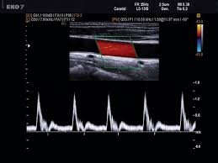

Situational task No. 2
What sensor was used to perform the study, describe and give the characteristics of the speed indicators of dopplerography.
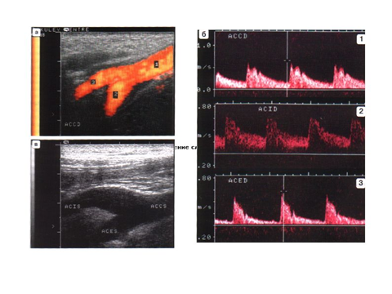

Situational task No. 3
Define what kind of vessel it is and its Doppler characteristics
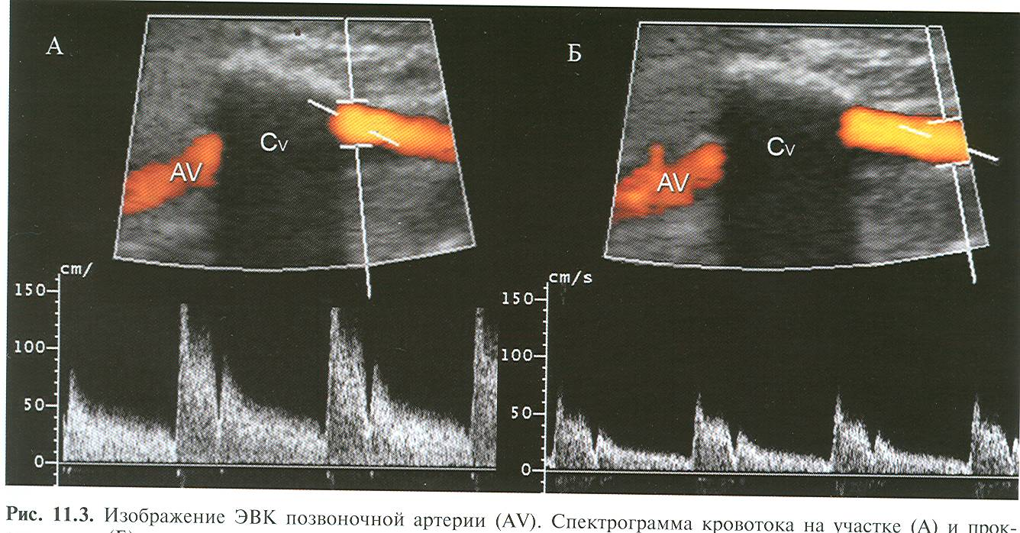

Situational task No. 4
Determine the options for the structure of the Vilysius circle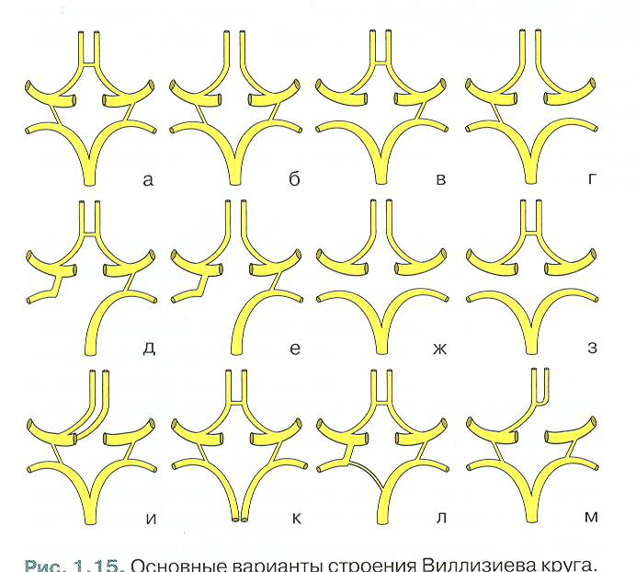

Situational problem No. 5
Determine: what is this research method, what vessels are represented on sonograms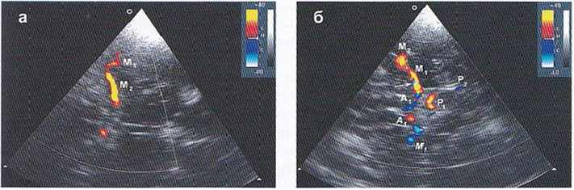

Situational task No. 6
Describe the triplex not scanning (what is the study area indicated by the arrows)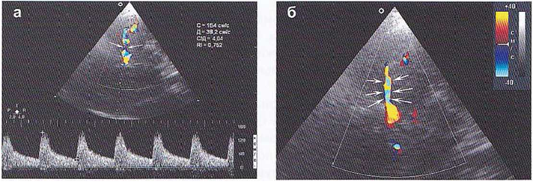

4. Discussion of theoretical issues:
- ultrasound anatomy of the main arteries of the head and neck and with adjacent organs. Description of the ultrasound picture;
- visualization of the main arteries of the head and neck in the B-mode. Description of the ultrasound picture;
- color Doppler study of the blood flow of the main arteries of the neck;
- spectral Doppler study of the blood flow of the main arteries of the neck and head;
- ultrasound diagnosis of main arteries of the head and neck in B-mode, PWD-mode, CD-mode;
5. Topics of reports/abstracts:
- Spectral Doppler study of blood flow in neck arteries
- Spectral Doppler study of blood flow in the arteries of the circle of Willis.
- Identification of the intracranial part of the internal carotid artery; anterior, middle and posterior cerebral arteries, basilar arteries, intracranial segment of vertebral arteries.
- Parameters of unchanged blood flow in the arteries of the brain during color Doppler examination.
Note. When preparing a report, essay, analytical review, etc., students of higher education can, along with this, prepare didactic visual materials in the form of tables, cadograms, slides, drawings, drug schemes, etc.
6. Summary
7. List of recommended literature (main, additional, electronic information resources):
Main:

- Clark's Essential Guideto Clinical Ultrasound: Jan Dodgeon, Gill Harrison: CRC Press. – 2023. 392 р.
- Diagnostic Ultrasound, Third Edition Peter R Hoskins, Kevin Martin, Abigail Thrush CRC Press. -2019. 400 p
- Vascular ULTRASOUND HOW, WHY AND WHEN Abigail Thrush Timothy Hartshorne Colin Deane Elsevier; 4th edition. – 2022. 350 p.
- Vascular Ultrasound. B-Mode, Color Dopplerand Duplex Ultrasound, Contrast-Enhanced Ultrasound Kubale, R. — Stiegler, H. — Weskott, H. Editorial Thieme LIBRO IMPRESO. 1ª Edición Julio– 2023. 574 p.
- Naritaka H., Ishikawa M., Terao S., Kojima A., Kagami H., Inaba M., Kato S. Ultrasonographic Superb Microvascular Imaging for Emergency Surgery of Intracerebral Hemorrhage. J. Clin. Neurosci. 2020; 75:206–209. doi: 10.1016/j.jocn.2020.03.002.
- Ультразвукова детекція церебральної мікроемболії прикаротидних стенозах: досягнення та перспективи (огляд літератури) М.В. Глоба Ендоваскулярна нейрорентгенохірургія – 2020. -№ 1(31). -С. 56-67 https://doi.org/10.26683/2304-9359-2020-1(31)-56-67.
- Pellerito J., Polak J.F. Introduction to Vascular Ultrasonography, 7th Ed. Elsevier,2020, 882 p.
- Питання стандартизації протоколу ультразвукового дослідження судин шиї: огляд сучасних рекомендацій Н.М. Носенко, Д.В. Щеглов, Г.В. Друк Ендоваскулярна Нейрорентгенохірургія. – 2019. No 2(28) С.73-85.
- Sharma P, Hegde R, Kulkarni A, Sharma S, Soin P, Kochar PS, et al. Traumatic vertebral artery injury: a review of the screening criteria, imaging spectrum, mimics, and pitfalls. Pol J Radiol. - 2019;84:e307–18.https://doi.org/10.5114/pjr.2019.88023.
Аdditional:
- Essentials of Abdomino-Pelvic Sonography: A Handbook for Practitioners Goyal Routledge: 2018: 296 p
- Yum S.K., Im S.A., Seo Y.M., Sung I.K. Enlarged subarachnoid space on cranial ultrasound in preterm infants: Neurodevelopmental implication. Sci Rep. 2019; 9(1): 19072.
- Xiaohong Chen, Jialiang Xu, Yumeng Zhang, Muhui Lin, Hao Wang, Ying Song, Evaluation of hemodynamic characteristics in posterior circulation infarction patients with vertebral artery dominance by color doppler flow imaging and transcranial dopplersonography, International Journal of Neuroscience, 10.1080/00207454.2020.1773820, 131, 11, (1078-1086). 2020.
- Доплерографія магістральних судин шиї / Р. Я. Абдуллаев, В. Й. Калашников. В. Г. Марченко та iн. — Навч. nociб. — X.: Нове слово. 2008. — 48с.
- Caterina Kulyk, Chiara Voltan, Marialaura Simonetto, Anna Palmieri, Filippo Farina, Francesca Vodret, Federica Viaro, Claudio Baracchini, Vertebral artery hypoplasia: an innocent lamb or a disguise?, Journal of Neurology, 10.1007/s00415-018-9004-7, 265, 10, (2346-2352). 2018.
- Nasra K, Osher M. Sonography Vascular Peripheral Arterial Assessment, Protocols, And Interpretation. [Updated 2022 Apr 30]. In: StatPearls [Internet]. Treasure Island (FL): StatPearls Publishing; 2022 Jan-. Available from: https://www.ncbi.nlm.nih.gov/books/NBK570577/
- Оцінка мозкового кровопливу в пацієнтів з вертебробазилярною недостатністю відповідно до наявності структурних змін в системі задньої циркуляції / М. В. Глоба, Л. М. Сулій, В. В. Ващенко, Т. Г. Новікова // Зб. наук. пр. Співробітників НМАПО ім. П. Л. Шупика. - 2018. - Вип. 30. - С. 557-566.
Information resources:
Information and educational environment info.onmedu https://info.odmu.edu.ua/chair/occupational diseases and functional diagnostics /files
• ultrasound.net.ua - Ukrainian portal of ultrasound diagnostics
• http://moz.gov.ua – Ministry of Health of Ukraine
• www.ama-assn.org - American Medical Association / AmericanMedicalAssociation
• www.who.int - World Health Organization
• www.dec.gov.ua/mtd/home/ - State Expert Center of the Ministry of Health of Ukraine
• http://bma.org.uk - British Medical Association
• www.gmc-uk.org - General Medical Council (GMC)
• www.bundesaerztekammer.de – German Medical Association

Practical lesson No. 8

Topic 8. Ultrasound anatomy of main intracranial arteries and veins of the head. Study of the venous system of the brain.

Purpose: to study and know the structural units of both the arterial and venous systems of the brain (post capillary venules, cerebral superficial veins and deep, venous sinuses, main veins), sinuses: upper and lower sagittal, rectus, lumbar, cavernous, sigmoid. Know the veins: internal cerebral veins, basal vein (Rosenthal), large cerebral vein (Galena). Internal jugular vein. Know the characteristics of blood flow in the jugular veins. Reflux in the jugular vein. To study and know the main Doppler characteristics of the venous system of the brain. Signs of intracranial hypertension. Know the main causes of venous stasis, jugular vein thrombosis.
Basic concepts: arterial intracranial blood flow, spasm and dilation of intracranial vessels, normal indicators of blood flow velocity in cerebral vessels, venous dyscirculation (obstruction of venous blood flow).
Plan:
1. Organizational activities (greetings, verification of those present, announcement of the topic, purpose of the lesson, motivation of higher education seekers to study the topic).
2. Control of the reference level of knowledge (written work, written test, frontal survey on basic terminology, etc.) (if necessary).
3. Questions (test tasks) to check basic knowledge on the topic of the practical session:
1. The direction of blood flow in the middle cerebral artery according to transcranial examination data is normal:
a) to sensor +
b) from the sensor
2.The direction of blood flow in the posterior cerebral artery according to transcranial examination data is normal:
a) to sensor +
b) from the sensor
3. Normally, the direction of blood flow in the supraobiliary artery:
a) antegrade +
b) retrograde

4. The direction of blood flow in the vertebral artery with complete vertebral-subclavian steal syndrome:
a) antegrade
b) retrograde +
5. Normal blood flow in the veins:
a) phase, synchronized with breathing; +
b) monophasic, synchronized with breathing
6. Transcranial dopplerography of the arteries of the circle of Willis is performed using a sensor:
a) 2 MHz +
b) 4 MHz
c) 8 MHz
7. Determination of blood flow in the basal vein of Rosenthal is carried out through:
a) temporal window +
b) submandibular access
c) suboccipital access
d) transorbital access
8. Blood flow in the right sinus is determined by:
a) transoccipital window +
b) transorbital window
c) submandibular
d) suboccipital
Situational task No. 1
It will describe the method of research, which vessels can be located in this zone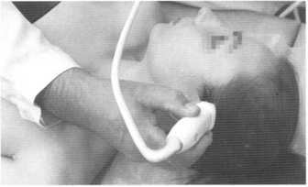

Situational task No. 2
Describe the research methodology, which vessels can be located in this area?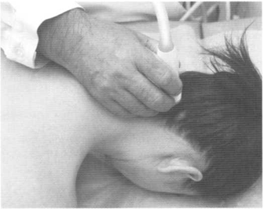

Situational task No. 3
Give a description of sonogram and angioMRI
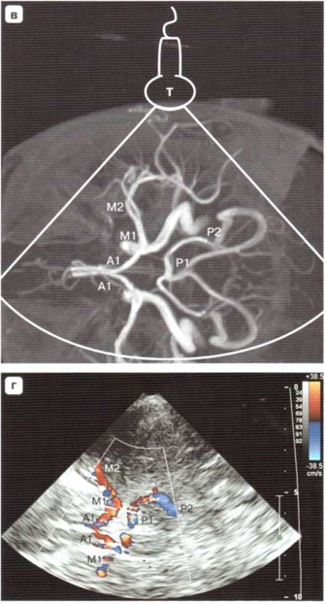

4. Discussion of theoretical issues:
- what is the normal arterial blood flow in the cerebral vessels (its characteristics).
- how to correctly examine the venous blood flow in the intracranial department.
- what are the available standard location points (accesses) for intracranial vessels.
- dopplerographic criteria of violation of venous outflow from the cranial cavity.
- Doppler spectrum of blood flow in anterior, middle, posterior cerebral arteries
- causes of dilatation of vena jugularis interna, reflux in it.
5. Topics of reports/abstracts:
- Examination of the jugular veins. Reflux in the jugular vein.
- Basic Doppler characteristics of the venous system of the brain. Signs of intracranial hypertension.
- Ultrasound examination of the main cerebral arteries and veins.
Note. When preparing a report, essay, analytical review, etc., students of higher education can, along with this, prepare didactic visual materials in the form of tables, cadograms, slides, drawings, drug schemes, etc.
6. Summary
7. List of recommended literature (main, additional, electronic information resources):
Main:
- Clark's Essential Guideto Clinical Ultrasound: Jan Dodgeon, Gill Harrison: CRC Press. – 2023. 392 р.
- Diagnostic Ultrasound, Third Edition Peter R Hoskins, Kevin Martin, Abigail Thrush CRC Press. -2019. 400 p
- Vascular ULTRASOUND HOW, WHY AND WHEN Abigail Thrush Timothy Hartshorne Colin Deane Elsevier; 4th edition. – 2022. 350 p.
- Vascular Ultrasound. B-Mode, Color Dopplerand Duplex Ultrasound, Contrast-Enhanced Ultrasound Kubale, R. — Stiegler, H. — Weskott, H. Editorial Thieme LIBRO IMPRESO. 1ª Edición Julio– 2023. 574 p.
- Naritaka H., Ishikawa M., Terao S., Kojima A., Kagami H., Inaba M., Kato S. Ultrasonographic Superb Microvascular Imaging for Emergency Surgery of Intracerebral Hemorrhage. J. Clin. Neurosci. 2020; 75:206–209. doi: 10.1016/j.jocn.2020.03.002.
- Ультразвукова детекція церебральної мікроемболії прикаротидних стенозах: досягнення та перспективи (огляд літератури) М.В. Глоба Ендоваскулярна нейрорентгенохірургія – 2020. -№ 1(31). -С. 56-67 https://doi.org/10.26683/2304-9359-2020-1(31)-56-67.
- Pellerito J., Polak J.F. Introduction to Vascular Ultrasonography, 7th Ed. Elsevier,2020, 882 p.
- Питання стандартизації протоколу ультразвукового дослідження судин шиї: огляд сучасних рекомендацій Н.М. Носенко, Д.В. Щеглов, Г.В. Друк Ендоваскулярна Нейрорентгенохірургія. – 2019. No 2(28) С.73-85.
- Sharma P, Hegde R, Kulkarni A, Sharma S, Soin P, Kochar PS, et al. Traumatic vertebral artery injury: a review of the screening criteria, imaging spectrum, mimics, and pitfalls. Pol J Radiol. - 2019;84:e307–18.https://doi.org/10.5114/pjr.2019.88023.
Аdditional,:
- Essentials of Abdomino-Pelvic Sonography: A Handbook for Practitioners Goyal Routledge: 2018: 296 p
- Yum S.K., Im S.A., Seo Y.M., Sung I.K. Enlarged subarachnoid space on cranial ultrasound in preterm infants: Neurodevelopmental implication. Sci Rep. 2019; 9(1): 19072.
- Xiaohong Chen, JialiangXu, Yumeng Zhang, Muhui Lin, Hao Wang, Ying Song, Evaluation of hemodynamic characteristics in posterior circulation infarction patients with vertebral artery dominance by color doppler flow imaging and transcranial dopplersonography, International Journal of Neuroscience, 10.1080/00207454.2020.1773820, 131, 11, (1078-1086). 2020.
- Доплерографія магістральних судин шиї / Р. Я. Абдуллаев., В. Й. Калашников. В. Г. Марченко та iн. — Навч. nociб. — X.: Нове слово. 2008. — 48с.
- Caterina Kulyk, Chiara Voltan, Marialaura Simonetto, Anna Palmieri, Filippo Farina, Francesca Vodret, Federica Viaro, Claudio Baracchini, Vertebral artery hypoplasia: an innocent lamb or a disguise?, Journal of Neurology, 10.1007/s00415-018-9004-7, 265, 10, (2346-2352). 2018.
- Nasra K, Osher M. Sonography Vascular Peripheral Arterial Assessment, Protocols, And Interpretation. [Updated 2022 Apr 30]. In: StatPearls [Internet]. Treasure Island (FL): StatPearls Publishing; 2022 Jan-. Available from: https://www.ncbi.nlm.nih.gov/books/NBK570577/
- Оцінка мозкового кровопливу в пацієнтів з вертебробазилярною недостатністю відповідно до наявності структурних змін в системі задньої циркуляції / М. В. Глоба, Л. М. Сулій, В. В. Ващенко, Т. Г. Новікова // Зб. наук. пр. Співробітників НМАПО ім. П. Л. Шупика. - 2018. - Вип. 30. - С. 557-566.

Information resources:
Information and educational environment info.onmedu https://info.odmu.edu.ua/chair/occupational diseases and functional diagnostics /files
• ultrasound.net.ua - Ukrainian portal of ultrasound diagnostics
• http://moz.gov.ua – Ministry of Health of Ukraine
• www.ama-assn.org - American Medical Association / AmericanMedicalAssociation
• www.who.int - World Health Organization
• www.dec.gov.ua/mtd/home/ - State Expert Center of the Ministry of Health of Ukraine
• http://bma.org.uk - British Medical Association
• www.gmc-uk.org - General Medical Council (GMC)
• www.bundesaerztekammer.de – German Medical Association

Practical lesson No. 9

Topic 9. Technology of transcranial duplex scanning of intracranial vessels of the head.
Purpose: To determine the indications and inexpediency of conducting a transcranial study of hemodynamics of the brain; choose the frequency of the ultrasonic sensor for cerebral vessels adequate to the research task; to be able to differentiate the main intracranial vessels (arteries, veins); choose a dopplerography mode adequate to the research task; to know the main ultrasound approaches for studying hemodynamics of cerebral vessels; study blood flow parameters in intracerebral vessels.
Basic concepts: Doppler spectrum of cerebral blood flow, linear velocity of blood flow in anterior, middle and posterior cerebral arteries, indices of vascular resistance and pulsation; the technique of adjusting the color Doppler mapping of blood vessels; the main ultrasound approaches for studying the hemodynamics of cerebral vessels.
Plan: 1. Organizational activities (greetings, verification of those present, announcement of the topic, purpose of the lesson, motivation of higher education seekers to study the topic).
2. Control of the reference level of knowledge (written work, written test, frontal survey on basic terminology, etc.) (if necessary).
3. Questions (test tasks) to check basic knowledge on the topic of the practical session:
1. The ophthalmic artery is a branch of:
a) internal carotid artery; +
b) middle cerebral artery;
c) external carotid artery;
d) superficial.
2.The main artery can be visualized through:
a) transorbital window;
b) suboccipital window; +
c) transtemporal window;
d) submandibudar window.
3. Dynamic research using transcranial dopplerography is used to diagnose:
a) emboli; +
b) hemodynamically significant stenosis;
c) intracranial hypertension;
d) changes in cardiac output.
4. The direction of blood flow in the middle cerebral artery according to transcranial examination data is normal:
a) to sensor +
b) from the sensor
5. The direction of blood flow in the anterior cerebral artery according to transcranial examination data is normal:
a) to the sensor
b) from sensor +
6. The direction of blood flow in the posterior cerebral artery according to transcranial examination data is normal:
a) to sensor +
b) from the sensor
7. The quantitative measure of flow turbulence is:
a) Reynolds number +
b) blood density
c) Purcell index
8. Normally, the direction of blood flow in the supraobiliary artery:
a) antegrade
b) retrograde
c) mixed
d) mixed with a predominance of antegrade
e) mixed with a predominance of retrograde
9. Transcranial dopplerography of the arteries of the circle of willis is performed using a sensor:
a) 2 MHz +
b) 4 MHz
c) 8 MHz
10.The trunk type of blood flow is characterized by:
a) a sharp peak in systole, reverse blood flow during early diastole and blood flow during late diastole
b) decrease and rounding of the systolic peak, slow rise and fall of the blood flow velocity curve
c) decrease and rounding of the systolic peak
d) slow rise in blood flow rate
e) slow decline of the blood flow velocity curve

Situational task No. 1
On the sonogram of which vessels is the dopplerogram shown?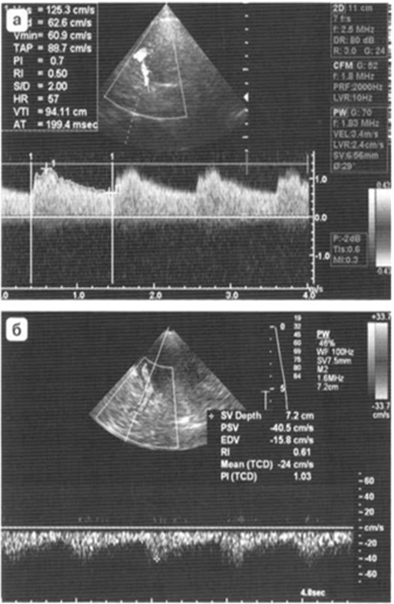

Situational problem № 2
For which vessel is this spectrum of blood flow characteristic (justify your choice)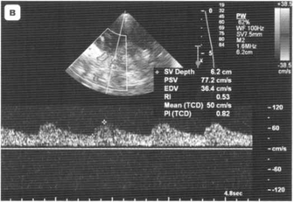

Situational task No. 3
Describe the sonogram, define the structural elements, the type of sensor used for the study.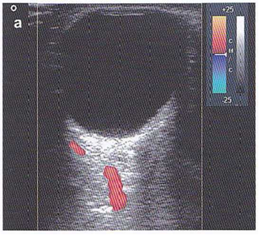

4. Discussion of theoretical issues:
– identification of anterior, middle and posterior cerebral arteries (according to the spectrum of blood flow);
– scanning from transtemporal, transorbital and transoccipital access. Visualization of connecting arteries.
- collateral blood circulation (intracranial, extracranial and extra-intracranial ways of blood supply to the brain).
– speed characteristics of blood flow and resistance index of cerebral vessels.
- anomalies of the structure of the circle of Willis;
– the advantage of a phased array sensor for scanning cerebral vessels, why it is.
5. Topics of reports/abstracts:
- Anterior circulation (research in triplex mode)
- Posterior circulation (research in triplex mode)
- Congestive-hypoxic form of venous dyscirculation, which is confirmed by dopplerography;
Note. When preparing a report, essay, analytical review, etc., students of higher education can, along with this, prepare didactic visual materials in the form of tables, cadograms, slides, drawings, drug schemes, etc.
6. Summary
7. List of recommended literature (main, additional, electronic information resources):
Main:
- Clark's Essential Guideto Clinical Ultrasound: Jan Dodgeon, Gill Harrison: CRC Press. – 2023. 392 р.
- Diagnostic Ultrasound, Third Edition Peter R Hoskins, Kevin Martin, Abigail Thrush CRC Press. -2019. 400 p
- Vascular ULTRASOUND HOW, WHY AND WHEN Abigail Thrush Timothy Hartshorne Colin Deane Elsevier; 4th edition. – 2022. 350 p.
- Vascular Ultrasound. B-Mode, Color Dopplerand Duplex Ultrasound, Contrast-Enhanced Ultrasound Kubale, R. — Stiegler, H. — Weskott, H. Editorial Thieme LIBRO IMPRESO. 1ª Edición Julio– 2023. 574 p.
- Naritaka H., Ishikawa M., Terao S., Kojima A., Kagami H., Inaba M., Kato S. Ultrasonographic Superb Microvascular Imaging for Emergency Surgery of Intracerebral Hemorrhage. J. Clin. Neurosci. 2020; 75:206–209. doi: 10.1016/j.jocn.2020.03.002.
- Ультразвукова детекція церебральної мікроемболії прикаротидних стенозах: досягнення та перспективи (огляд літератури) М.В. Глоба Ендоваскулярна нейрорентгенохірургія – 2020. -№ 1(31). -С. 56-67 https://doi.org/10.26683/2304-9359-2020-1(31)-56-67.
- Pellerito J., Polak J.F. Introduction to Vascular Ultrasonography, 7th Ed. Elsevier,2020, 882 p.
- Питання стандартизації протоколу ультразвукового дослідження судин шиї: огляд сучасних рекомендацій Н.М. Носенко, Д.В. Щеглов, Г.В. Друк Ендоваскулярна Нейрорентгенохірургія. – 2019. No 2(28) С.73-85.
- Sharma P, Hegde R, Kulkarni A, Sharma S, Soin P, Kochar PS, et al. Traumatic vertebral artery injury: a review of the screening criteria, imaging spectrum, mimics, and pitfalls. Pol J Radiol. - 2019;84:e307–18.https://doi.org/10.5114/pjr.2019.88023.

Аdditional,:
- Essentials of Abdomino-Pelvic Sonography: A Handbook for Practitioners Goyal Routledge: 2018: 296 p
- Yum S.K., Im S.A., Seo Y.M., Sung I.K. Enlarged subarachnoid space on cranial ultrasound in preterm infants: Neurodevelopmental implication. Sci Rep. 2019; 9(1): 19072.
- Xiaohong Chen, JialiangXu, Yumeng Zhang, Muhui Lin, Hao Wang, Ying Song, Evaluation of hemodynamic characteristics in posterior circulation infarction patients with vertebral artery dominance by color doppler flow imaging and transcranial dopplersonography, International Journal of Neuroscience, 10.1080/00207454.2020.1773820, 131, 11, (1078-1086). 2020.
- Доплерографія магістральних судин шиї / Р. Я. Абдуллаев., В. Й. Калашников. В. Г. Марченко та iн. — Навч. nociб. — X.: Нове слово. 2008. — 48с.
- Caterina Kulyk, Chiara Voltan, Marialaura Simonetto, Anna Palmieri, Filippo Farina, Francesca Vodret, Federica Viaro, Claudio Baracchini, Vertebral artery hypoplasia: an innocent lamb or a disguise?, Journal of Neurology, 10.1007/s00415-018-9004-7, 265, 10, (2346-2352). 2018.
- Nasra K, Osher M. Sonography Vascular Peripheral Arterial Assessment, Protocols, And Interpretation. [Updated 2022 Apr 30]. In: StatPearls [Internet]. Treasure Island (FL): StatPearls Publishing; 2022 Jan-. Available from: https://www.ncbi.nlm.nih.gov/books/NBK570577/
- Оцінка мозкового кровопливу в пацієнтів з вертебробазилярною недостатністю відповідно до наявності структурних змін в системі задньої циркуляції / М. В. Глоба, Л. М. Сулій, В. В. Ващенко, Т. Г. Новікова // Зб. наук. пр. Співробітників НМАПО ім. П. Л. Шупика. - 2018. - Вип. 30. - С. 557-566.
Information resources:
Information and educational environment info.onmedu https://info.odmu.edu.ua/chair/occupational diseases and functional diagnostics /files
• ultrasound.net.ua - Ukrainian portal of ultrasound diagnostics
• http://moz.gov.ua – Ministry of Health of Ukraine
• www.ama-assn.org - American Medical Association / AmericanMedicalAssociation
• www.who.int - World Health Organization
• www.dec.gov.ua/mtd/home/ - State Expert Center of the Ministry of Health of Ukraine
• http://bma.org.uk - British Medical Association
• www.gmc-uk.org - General Medical Council (GMC)
• www.bundesaerztekammer.de – German Medical Association

Practical lesson No. 10
Topic 10. Functional tests based on mechanical factor, chemical influence and metabolic mechanism. The concept of cerebrovascular reactivity. Conducting method.
Purpose: to study and know the concept of cerebrovascular reactivity. Know the method of conducting tests. To learn and know the parameters of assessment of cerebrovascular reactivity in normal and pathological conditions. To study functional tests for arterial and venous blood flow. The main criteria for vascular damage.
Basic concepts: compression tests, functioning of the anterior and posterior communicating arteries, Hiller's compression test, turning tests, hypercapnic test, Valsalva test.
Plan: 1. Organizational activities (greetings, verification of those present, announcement of the topic, purpose of the lesson, motivation of higher education seekers to study the topic).
2. Control of the reference level of knowledge (written work, written test, frontal survey on basic terminology, etc.) (if necessary).
3. Questions (test tasks) to check basic knowledge on the topic of the practical session:
1. Normal blood flow in the veins:
a) phase, synchronized with breathing: +
b) monophasic, synchronized with breathing
2. Normally, when the vein is compressed by the sensor:
a) the lumen of the vessel does not change;
b) the walls collapse and the lumen disappears +
3. In case of failure of the valve apparatus of the veins, the following is registered:
a) blood reflux in the retrograde direction +
b) blood reflux in the antegrade direction
4.The volume velocity of blood flow in an elastic reservoir depends on:
a) tensile strength of the tank wall
b) tank wall thickness
c) values ​​of gravitational potential energy
d) true b) and c)
e) everything is correct
5. In case of failure of the valve apparatus of the veins, the following is registered:
a) blood reflux in the retrograde direction
b) blood reflux in the antegrade direction
c) absence of reflux
d) registration is impossible
e) reflux in a mixed direction
6. Normally, when the vein is compressed by the sensor:
a) lumen of the vessel does not change
b) the walls collapse and the lumen disappears
c) the walls expand
d) the lumen expands
e) true in) and d)
7. What is the scanning depth of the convex sensor?
1) 10-15 cm;
2) 15-25 cm;
3) 25-30 cm;
4) 30-35 cm.
8. With hypocapnic stress, the following occurs:
a) expansion of resistive vessels;
b) narrowing of resistive vessels; +
c) vasospasm of the main vessel;
d) decrease in tone of the trunk vessel.

Situational task No. 1 Assess the velocity parameters of the blood flow in the middle cerebral artery during a functional test.
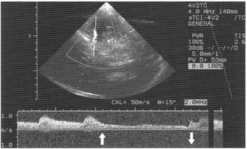

Situational task No. 2
Describe the reaction of blood flow in intracranial arteries to compression of the right common carotid artery (cross)
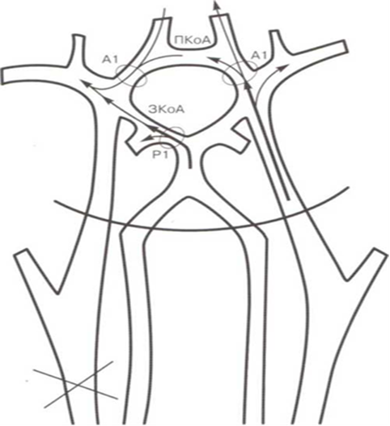
Situational task No. 3
Dopplerogram of blood flow in the middle cerebral artery during a compression carotid test to assess autoregulation of the MC (Hiler test). What is its essence, describe the changes taking place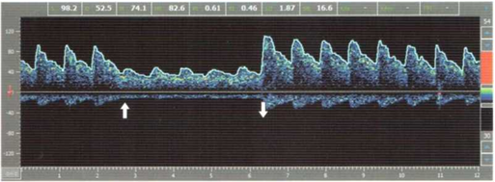
Situational task No. 4
Shown is the dopplerogram of blood flow from the middle cerebral artery during a hypercapnic test. Describe the changes in blood flow, why this happened.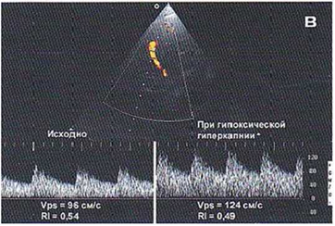

4. Discussion of theoretical issues:
- Functional tests. To evaluate the tolerance of the brain to ischemia.
- Evaluation of the functioning of the anterior and posterior communicating arteries.
- Assessment of return test results.
- Hypercapnic test.
- Functional tests for venous blood flow.
5. Topics of reports/abstracts:
- Ortho- and anti-ortho-static loads.
- Hypercapnic test (methodology, data interpretation)
- Valsalva trial. Bilateral manual compression of the left ventricle.
- Oscillator test (methodology, interpretation of final data)
- Bubble test (methodology, interpretation of final data)
Note. When preparing a report, essay, analytical review, etc., students of higher education can, along with this, prepare didactic visual materials in the form of tables, cadograms, slides, drawings, drug schemes, etc.
6. Summary
7. List of recommended literature (main, additional, electronic information resources):
Main:
- Clark's Essential Guideto Clinical Ultrasound: Jan Dodgeon, Gill Harrison: CRC Press. – 2023. 392 р.
- Diagnostic Ultrasound, Third Edition Peter R Hoskins, Kevin Martin, Abigail Thrush CRC Press. -2019. 400 p
- Vascular ULTRASOUND HOW, WHY AND WHEN Abigail Thrush Timothy Hartshorne Colin Deane Elsevier; 4th edition. – 2022. 350 p.
- Vascular Ultrasound. B-Mode, Color Dopplerand Duplex Ultrasound, Contrast-Enhanced Ultrasound Kubale, R. — Stiegler, H. — Weskott, H. Editorial Thieme LIBRO IMPRESO. 1ª Edición Julio– 2023. 574 p.
- Naritaka H., Ishikawa M., Terao S., Kojima A., Kagami H., Inaba M., Kato S. Ultrasonographic Superb Microvascular Imaging for Emergency Surgery of Intracerebral Hemorrhage. J. Clin. Neurosci. 2020; 75:206–209. doi: 10.1016/j.jocn.2020.03.002.
- Ультразвукова детекція церебральної мікроемболії прикаротидних стенозах: досягнення та перспективи (огляд літератури) М.В. Глоба Ендоваскулярна нейрорентгенохірургія – 2020. -№ 1(31). -С. 56-67 https://doi.org/10.26683/2304-9359-2020-1(31)-56-67.
- Pellerito J., Polak J.F. Introduction to Vascular Ultrasonography, 7th Ed. Elsevier,2020, 882 p.
- Питання стандартизації протоколу ультразвукового дослідження судин шиї: огляд сучасних рекомендацій Н.М. Носенко, Д.В. Щеглов, Г.В. Друк Ендоваскулярна Нейрорентгенохірургія. – 2019. No 2(28) С.73-85.
- Sharma P, Hegde R, Kulkarni A, Sharma S, Soin P, Kochar PS, et al. Traumatic vertebral artery injury: a review of the screening criteria, imaging spectrum, mimics, and pitfalls. Pol J Radiol. - 2019;84:e307–18.https://doi.org/10.5114/pjr.2019.88023.
Аdditional:
- Essentials of Abdomino-Pelvic Sonography: A Handbook for Practitioners Goyal Routledge: 2018: 296 p
- Yum S.K., Im S.A., Seo Y.M., Sung I.K. Enlarged subarachnoid space on cranial ultrasound in preterm infants: Neurodevelopmental implication. Sci Rep. 2019; 9(1): 19072.
- Xiaohong Chen, JialiangXu, Yumeng Zhang, Muhui Lin, Hao Wang, Ying Song, Evaluation of hemodynamic characteristics in posterior circulation infarction patients with vertebral artery dominance by color doppler flow imaging and transcranial dopplersonography, International Journal of Neuroscience, 10.1080/00207454.2020.1773820, 131, 11, (1078-1086). 2020.
- Доплерографія магістральних судин шиї / Р. Я. Абдуллаев., В. Й. Калашников. В. Г. Марченко та iн. — Навч. nociб. — X.: Нове слово. 2008. — 48с.
- Caterina Kulyk, Chiara Voltan, Marialaura Simonetto, Anna Palmieri, Filippo Farina, Francesca Vodret, Federica Viaro, Claudio Baracchini, Vertebral artery hypoplasia: an innocent lamb or a disguise?, Journal of Neurology, 10.1007/s00415-018-9004-7, 265, 10, (2346-2352). 2018.
- Nasra K, Osher M. Sonography Vascular Peripheral Arterial Assessment, Protocols, And Interpretation. [Updated 2022 Apr 30]. In: StatPearls [Internet]. Treasure Island (FL): StatPearls Publishing; 2022 Jan-. Available from: https://www.ncbi.nlm.nih.gov/books/NBK570577/
- Оцінка мозкового кровопливу в пацієнтів з вертебробазилярною недостатністю відповідно до наявності структурних змін в системі задньої циркуляції / М. В. Глоба, Л. М. Сулій, В. В. Ващенко, Т. Г. Новікова // Зб. наук. пр. Співробітників НМАПО ім. П. Л. Шупика. - 2018. - Вип. 30. - С. 557-566.
Information resources:
Information and educational environment info.onmedu https://info.odmu.edu.ua/chair/occupational diseases and functional diagnostics /files
• ultrasound.net.ua - Ukrainian portal of ultrasound diagnostics
• http://moz.gov.ua – Ministry of Health of Ukraine
• www.ama-assn.org - American Medical Association / AmericanMedicalAssociation
• www.who.int - World Health Organization
• www.dec.gov.ua/mtd/home/ - State Expert Center of the Ministry of Health of Ukraine
• http://bma.org.uk - British Medical Association
• www.gmc-uk.org - General Medical Council (GMC)
• www.bundesaerztekammer.de – German Medical Association

Practical lesson No. 11
Topic 11. Ultrasound data of the main vascular lesions. Violations of hemodynamics in extracranial vessels

Purpose: to learn and know the ultrasound diagnosis of abnormalities of the development of main arteries, veins of the head and neck in B-mode, PWD-mode, CD-mode, duplex and triplex mode. Know the ultrasound criteria of non-stenotic and stenotic atherosclerosis, classification of atherosclerotic plaques. Know how the spectrum of blood flow differs with different percentages of stenosis. To study and know anomalies of vascular development (aneurysms, deformations, dissections). Know what carotid sinus tumors are.
Basic concepts: atherosclerotic lesions of vessels (types of atherosclerotic plaques), determination of the degree of stenosis, aneurysms, deformations of vessels, spectrum of blood flow in various extracranial disorders in the carotid basin and vertebrobasilar basin.
Plan: 1. Organizational activities (greetings, verification of those present, announcement of the topic, purpose of the lesson, motivation of higher education seekers to study the topic).
2. Control of the reference level of knowledge (written work, written test, frontal survey on basic terminology, etc.) (if necessary).
3. Questions (test tasks) to check basic knowledge on the topic of the practical session:
1. The size of the intima-media layer of the arterial wall in the common carotid artery is normally:
a) up to 1.0 mm
b) up to 1.5 mm
c) up to 2.0 mm
d) up to 2.5 mm
e) up to 3.0 mm
2. According to ultrasound criteria, a heterogeneous atherosclerotic plaque is:
a) plaque with hemorrhage
b) a plaque with an ulcer
c) soft plaque
d) true a) and b)
e) everything is correct
3.Calcified atherosclerotic plaques are more often localized in:
a) external carotid artery
b) vertebral artery
c) iliac and femoral arteries
d) popliteal artery
e) dorsal artery of the foot
4. Heterogeneous plaques are most often localized in:
a) femoral artery
b) internal carotid artery
c) vertebral artery
d) popliteal artery
e) dorsal artery of the foot
5. According to ultrasound criteria, a homogeneous plaque is:
a) the plaque is homogeneous in structure;
b) plaque with hemorrhage;
c) a plaque with an ulcer
d) calcified plaque
e) true b) and c)
6. In laminar flow, the velocity profile is determined:
a) parabolic;
b) approaches plane-parallel
c) ellipsoidal
d) plane-parallel
e) true in) and d)
7. Hypoplasia of the vertebral artery is characterized by a decrease in the diameter of the vertebral artery to:
a) 5.0 mm
b) 4.0 mm
c) 3.0 mm
d) 2.5 mm
e) 2.0 mm and less
8. With a loop-like bend of the internal carotid artery, the Doppler picture does not differ from that with:
a) stenosis of the internal carotid artery
b) stenosis of the external carotid artery
c) stenosis of the common carotid artery
d) dilation of the external carotid artery
e) dilation of the common carotid artery
9. Hypoplasia of the common carotid artery is manifested by:
a) with occlusion of the brachiocephalic trunk
b) with occlusion of the internal carotid artery in the mouth
c) with stenosis of the subclavian artery in the mouth
d) true b) and c)
e) everything is correct
10. Deformations of arteries are more often localized:
a) above the mouths of arteries
b) during arteries
c) at the bifurcation of arteries
d) true a) and c)
e) everything is correct

Situational task No. 1
Describe the sonogram, determine the degree of stenosis.
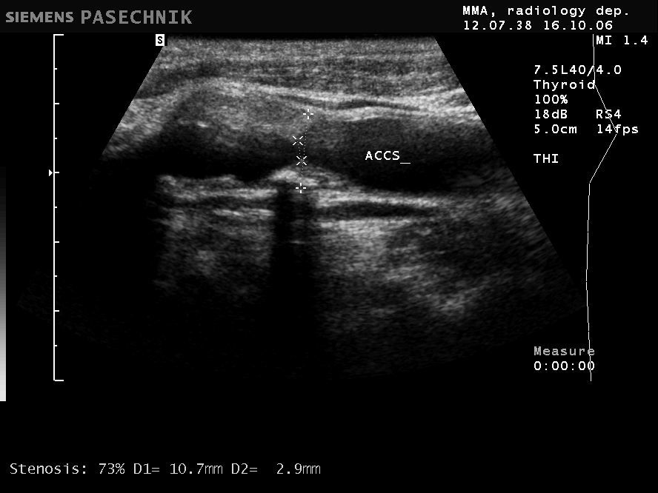
Situational task No. 2
Describe the sonogram, define the degree of stenosis.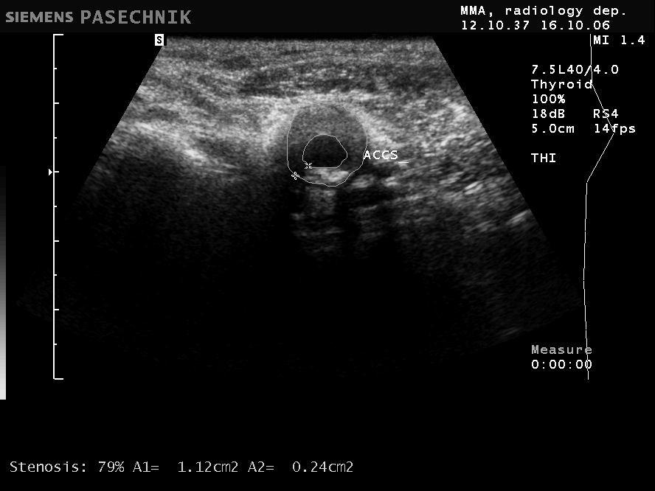

Situational task No. 3
Describe the sonogram, identify the main pathology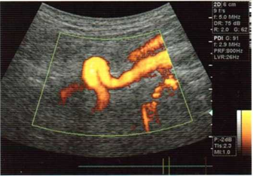
Situational task No. 4
Describe the sonogram, what is the patient's probable diagnosis.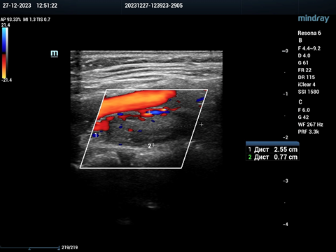
4. Discussion of theoretical issues:
- What is considered to be the earliest functional sign of atherosclerotic damage to arteries. What are the criteria for endothelial dysfunction;
- How most recommendations define atherosclerotic plaque;
- What classification of atherosclerotic plaques exists;
- How to assess the severity of brachiocephalic artery stenosis;
- What are the differences between unstable and unstable atherosclerotic plaque;
-What are the criteria for the local hemodynamic significance of internal carotid artery deformation;
- In the zone of the most pronounced deformation of the artery (angulation), how does the peak velocity of blood flow behave;
- Extravasal compression of vertebral arteries, which can be determined by dopplerography.
5. Topics of reports/abstracts:
- Criteria of endothelial dysfunction. Recommendations for the definition of atherosclerotic plaque. Three groups of atherosclerotic plaques.
- Type of plaques: stable, unstable, complicated, calcified plaque.
- Criteria for the degree of stenosis of the vertebral arteries. Brain steal syndrome. Three types of vertebral-subclavian steal syndrome.
- Aplasia, underdevelopment of arteries (hypoplasia), aneurysms). Ultrasound classification of internal carotid artery deformation. Extravasal compression of vertebral arteries.
Note. When preparing a report, essay, analytical review, etc., students of higher education can, along with this, prepare didactic visual materials in the form of tables, cadograms, slides, drawings, drug schemes, etc.
6. Summary
7. List of recommended literature (main, additional, electronic information resources):
Main:
- Clark's Essential Guideto Clinical Ultrasound: Jan Dodgeon, Gill Harrison: CRC Press. – 2023. 392 р.
- Diagnostic Ultrasound, Third Edition Peter R Hoskins, Kevin Martin, Abigail Thrush CRC Press. -2019. 400 p
- Vascular ULTRASOUND HOW, WHY AND WHEN Abigail Thrush Timothy Hartshorne Colin Deane Elsevier; 4th edition. – 2022. 350 p.
- Vascular Ultrasound. B-Mode, Color Dopplerand Duplex Ultrasound, Contrast-Enhanced Ultrasound Kubale, R. — Stiegler, H. — Weskott, H. Editorial Thieme LIBRO IMPRESO. 1ª Edición Julio– 2023. 574 p.
- Naritaka H., Ishikawa M., Terao S., Kojima A., Kagami H., Inaba M., Kato S. Ultrasonographic Superb Microvascular Imaging for Emergency Surgery of Intracerebral Hemorrhage. J. Clin. Neurosci. 2020; 75:206–209. doi: 10.1016/j.jocn.2020.03.002.
- Ультразвукова детекція церебральної мікроемболії прикаротидних стенозах: досягнення та перспективи (огляд літератури) М.В. Глоба Ендоваскулярна нейрорентгенохірургія – 2020. -№ 1(31). -С. 56-67 https://doi.org/10.26683/2304-9359-2020-1(31)-56-67.
- Pellerito J., Polak J.F. Introduction to Vascular Ultrasonography, 7th Ed. Elsevier,2020, 882 p.
- Питання стандартизації протоколу ультразвукового дослідження судин шиї: огляд сучасних рекомендацій Н.М. Носенко, Д.В. Щеглов, Г.В. Друк Ендоваскулярна Нейрорентгенохірургія. – 2019. No 2(28) С.73-85.
- Sharma P, Hegde R, Kulkarni A, Sharma S, Soin P, Kochar PS, et al. Traumatic vertebral artery injury: a review of the screening criteria, imaging spectrum, mimics, and pitfalls. Pol J Radiol. - 2019;84:e307–18.https://doi.org/10.5114/pjr.2019.88023.
Аdditional,:
- Essentials of Abdomino-Pelvic Sonography: A Handbook for Practitioners Goyal Routledge: 2018: 296 p
- Yum S.K., Im S.A., Seo Y.M., Sung I.K. Enlarged subarachnoid space on cranial ultrasound in preterm infants: Neurodevelopmental implication. Sci Rep. 2019; 9(1): 19072.
- Xiaohong Chen, JialiangXu, Yumeng Zhang, Muhui Lin, Hao Wang, Ying Song, Evaluation of hemodynamic characteristics in posterior circulation infarction patients with vertebral artery dominance by color doppler flow imaging and transcranial dopplersonography, International Journal of Neuroscience, 10.1080/00207454.2020.1773820, 131, 11, (1078-1086). 2020.
- Доплерографія магістральних судин шиї / Р. Я. Абдуллаев., В. Й. Калашников. В. Г. Марченко та iн. — Навч. nociб. — X.: Нове слово. 2008. — 48с.
- Caterina Kulyk, Chiara Voltan, Marialaura Simonetto, Anna Palmieri, Filippo Farina, Francesca Vodret, Federica Viaro, Claudio Baracchini, Vertebral artery hypoplasia: an innocent lamb or a disguise?, Journal of Neurology, 10.1007/s00415-018-9004-7, 265, 10, (2346-2352). 2018.
- Nasra K, Osher M. Sonography Vascular Peripheral Arterial Assessment, Protocols, And Interpretation. [Updated 2022 Apr 30]. In: StatPearls [Internet]. Treasure Island (FL): StatPearls Publishing; 2022 Jan-. Available from: https://www.ncbi.nlm.nih.gov/books/NBK570577/
- Оцінка мозкового кровопливу в пацієнтів з вертебробазилярною недостатністю відповідно до наявності структурних змін в системі задньої циркуляції / М. В. Глоба, Л. М. Сулій, В. В. Ващенко, Т. Г. Новікова // Зб. наук. пр. Співробітників НМАПО ім. П. Л. Шупика. - 2018. - Вип. 30. - С. 557-566.
Information resources:
Information and educational environment info.onmedu https://info.odmu.edu.ua/chair/occupational diseases and functional diagnostics /files
ultrasound.net.ua - Ukrainian portal of ultrasound diagnostics
http://moz.gov.ua – Ministry of Health of Ukraine
www.ama-assn.org - American Medical Association / AmericanMedicalAssociation
www.who.int - World Health Organization
www.dec.gov.ua/mtd/home/ - State Expert Center of the Ministry of Health of Ukraine
http://bma.org.uk - British Medical Association
www.gmc-uk.org - General Medical Council (GMC)
www.bundesaerztekammer.de – German Medical Association

Practical lesson No. 12

Topic 12. Ultrasound diagnosis of extra- and intracerebral vascular pathologies.

Purpose: to learn and know what vascular occlusion is. Know what collateral blood flow is in severe stenoses and occlusions. Know what the vertebral-subclavian table syndrome is (initial, transient, full). Learn and know the main vascular diseases of the brain. Pathogenesis and nature of cerebral circulation disorders. Stages of compensation of cerebral blood flow disorders. Autoregulation of cerebral blood circulation. To learn and know the main parameters of the assessment of blood flow through intracranial arteries. Learn and know what arteriovenous malformations are. Vasospasm in subarachnoid hemorrhages and criteria of its severity. Diagnosis of microemboli.

Basic concepts: collateral blood flow in severe stenoses and occlusions of the vessels of the neck, vertebral-subclavian table-syndrome (initial, transient, complete), violation of cerebral blood flow according to ultrasound, vasospasm of cerebral vessels, embolo detection.
Plan: 1. Organizational activities (greetings, verification of those present, announcement of the topic, purpose of the lesson, motivation of higher education seekers to study the topic).
2. Control of the reference level of knowledge (written work, written test, frontal survey on basic terminology, etc.) (if necessary).
3. Questions (test tasks) to check basic knowledge on the topic of the practical session:
1. With high (> 70%) degrees of arterial stenosis, the following are more common:
a) atherosclerotic plaques of uniform echo structure
b) atherosclerotic plaques of heterogeneous echostructure +
2.With low (<50%) degrees of arterial stenoses, the following are more common:
a) homogeneous atherosclerotic plaques +
b) heterogeneous atherosclerotic plaques
3. In case of non-specific aorto-arteritis, there are:
a) atherosclerotic plaques
b) diffuse thickening and densification of the intima-media + complex
c) no changes are observed
4. Blood flow in the vertebral arteries is not determined by color Doppler imaging:
a) with occlusion of the vertebral artery in the mouth +
b) with occlusion of the subclavian artery in the mouth
c) with occlusion of the brachiocephalic trunk.
5. With occlusion of the vertebral artery at the level of the entrance to the skull, the following is noted:
a) a decrease in the linear velocity of blood flow and an increase in peripheral resistance in the vertebral artery proximal to the site of occlusion; +
b) an increase in the linear velocity of blood flow and a decrease in peripheral resistance in the vertebral artery proximal to the occlusion site;
c) blood flow does not change proximal to the occlusion.
6. Deformations of arteries are more often localized:
a) above the mouths of arteries
b) during arteries
c) at the bifurcation of arteries
d) A and B + are correct
e) A, B and C are correct
7. Complete vertebral-subclavian steal syndrome develops with:
a) occlusion of the proximal segment of the subclavian artery +
b) occlusion of the distal part of the subclavian artery
8. Transient vertebral-subclavian stealing syndrome develops in case of:
a) subclavian artery occlusions
b) stenosis of more than 60% of the subclavian artery +
c) stenosis of less than 60% of the subclavian artery
9.The direction of blood flow in the vertebral artery with complete vertebral-subclavian steal syndrome:
a) antegrade
b) retrograde +
10. Type of blood flow in the subclavian artery with complete vertebral-subclavian steal syndrome:
a) trunk
b) collateral +
11. When the main artery is occluded, the following is noted:
a) decrease in blood flow and increase in peripheral resistance index in the vertebral artery on one side
b) a decrease in blood flow and an increase in the index of peripheral resistance in the vertebral arteries on both sides
c) decrease in blood flow in the common carotid artery
d) increased blood flow in the vertebral artery on one side
e) a decrease in the index of peripheral resistance in the vertebral artery on one side
12. The trunk type of blood flow is characterized by:
a) a sharp peak in systole, reverse blood flow during early diastole and blood flow during late diastole
b) decrease and rounding of the systolic peak, slow rise and fall of the blood flow velocity curve
c) decrease and rounding of the systolic peak
d) slow rise in blood flow rate
e) slow decline of the blood flow velocity curve
13. The collateral type of blood flow is characterized by:
a) expansion, splitting of the peak in systole, absence of reverse blood flow in diastole
b) decrease and rounding of the systolic peak, slow rise and fall of the blood flow velocity curve.
c) reduction and rounding
d) slow rise in blood flow rate
e) slow decline of the blood flow velocity curve
14. Cerebral vasospasm is characterized by:
a) a sharp increase in the linear velocity of blood flow; +
b) a sharp decrease in the linear velocity of blood flow;
c) reversal of blood flow;
d) blood flow by shunt type.
15. Dynamic research using transcranial dopplerography is used to diagnose:
a) emboli; +
b) hemodynamically significant stenosis;
c) intracranial hypertension;
d) changes in cardiac output.

Situational task No. 1
Describe the sonogram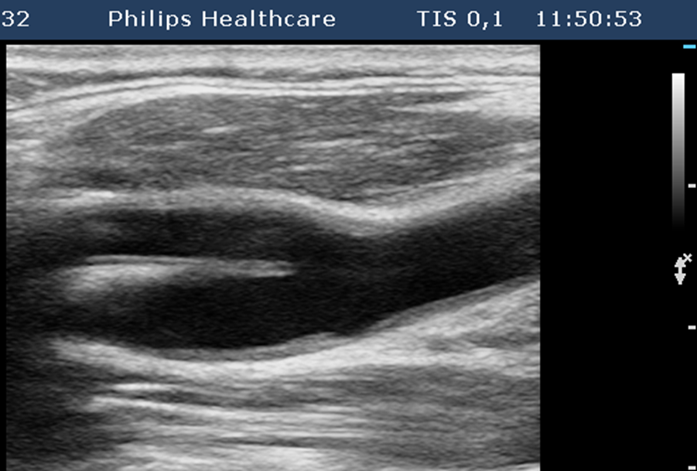

Situational task No. 2
What is shown in the schematic drawing, make a description of the components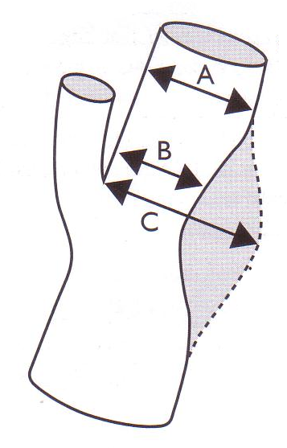

Situational task No. 3
What is the name of this spectrum of blood flow and for which disease it is characteristic?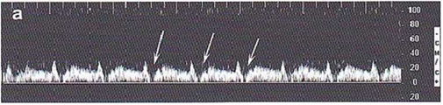
Situational task No. 4
Fragment of a duplex scan of vessels in a patient with what diagnosis? Describe the sonogram.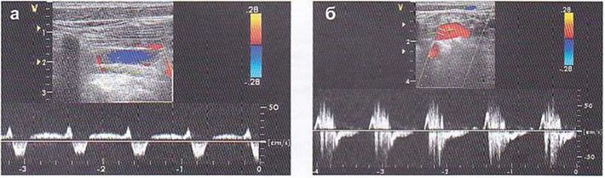

Situational problem No. 5
Give a dopplerographic assessment of blood flow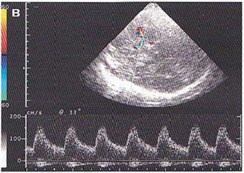

Situational task No. 6
Describe the sonogram, what worries you here?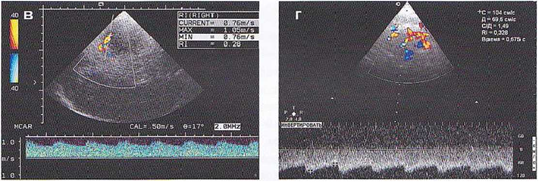

Situational task No. 7
Determine in which vessels the hypotonic and hypertensive type of angiodystonia is present.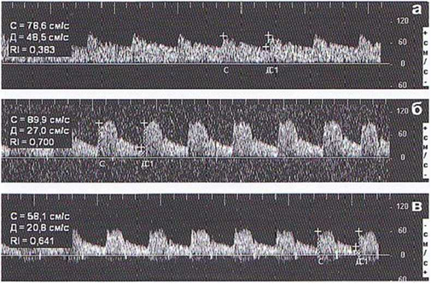

4. Discussion of theoretical issues:
- Stenosis and occlusion of the main vessels of the neck.
- Dissection of the main vessels of the neck.
- Table syndrome, its main characteristics according to the spectrum of blood flow
- AVM of cerebral vessels.
- Collateral and main blood flow in cerebral vessels
- Cerebral angiospasm
- Embolo detection using ultrasound dopplerography.
5. Topics of reports/abstracts:
- Dissection in the carotid and vertebro-basilar basins.
- Reactive hyperemia test
- Violation of cerebral hemodynamics during hemorrhages and ischemic strokes.
- Cerebral angiodystonia
- Embolo detection
Note. When preparing a report, abstract, analytical review, etc., students of higher education can, along with this, prepare didactic visual materials in the form of tables, cadograms, slides, drawings, drug schemes, etc.
6. Summary
7. List of recommended literature (main, additional, electronic information resources):
Main:
- Clark's Essential Guideto Clinical Ultrasound: Jan Dodgeon, Gill Harrison: CRC Press. – 2023. 392 р.
- Diagnostic Ultrasound, Third Edition Peter R Hoskins, Kevin Martin, Abigail Thrush CRC Press. -2019. 400 p
- Vascular ULTRASOUND HOW, WHY AND WHEN Abigail Thrush Timothy Hartshorne Colin Deane Elsevier; 4th edition. – 2022. 350 p.
- Vascular Ultrasound. B-Mode, Color Dopplerand Duplex Ultrasound, Contrast-Enhanced Ultrasound Kubale, R. — Stiegler, H. — Weskott, H. Editorial Thieme LIBRO IMPRESO. 1ª Edición Julio– 2023. 574 p.
- Naritaka H., Ishikawa M., Terao S., Kojima A., Kagami H., Inaba M., Kato S. Ultrasonographic Superb Microvascular Imaging for Emergency Surgery of Intracerebral Hemorrhage. J. Clin. Neurosci. 2020; 75:206–209. doi: 10.1016/j.jocn.2020.03.002.
- Ультразвукова детекція церебральної мікроемболії прикаротидних стенозах: досягнення та перспективи (огляд літератури) М.В. Глоба Ендоваскулярна нейрорентгенохірургія – 2020. -№ 1(31). -С. 56-67 https://doi.org/10.26683/2304-9359-2020-1(31)-56-67.
- Pellerito J., Polak J.F. Introduction to Vascular Ultrasonography, 7th Ed. Elsevier,2020, 882 p.
- Питання стандартизації протоколу ультразвукового дослідження судин шиї: огляд сучасних рекомендацій Н.М. Носенко, Д.В. Щеглов, Г.В. Друк Ендоваскулярна Нейрорентгенохірургія. – 2019. No 2(28) С.73-85.
- Sharma P, Hegde R, Kulkarni A, Sharma S, Soin P, Kochar PS, et al. Traumatic vertebral artery injury: a review of the screening criteria, imaging spectrum, mimics, and pitfalls. Pol J Radiol. - 2019;84:e307–18.https://doi.org/10.5114/pjr.2019.88023.
Аdditional:
- Essentials of Abdomino-Pelvic Sonography: A Handbook for Practitioners Goyal Routledge: 2018: 296 p
- Yum S.K., Im S.A., Seo Y.M., Sung I.K. Enlarged subarachnoid space on cranial ultrasound in preterm infants: Neurodevelopmental implication. Sci Rep. 2019; 9(1): 19072.
- Xiaohong Chen, JialiangXu, Yumeng Zhang, Muhui Lin, Hao Wang, Ying Song, Evaluation of hemodynamic characteristics in posterior circulation infarction patients with vertebral artery dominance by color doppler flow imaging and transcranial dopplersonography, International Journal of Neuroscience, 10.1080/00207454.2020.1773820, 131, 11, (1078-1086). 2020.
- Доплерографія магістральних судин шиї / Р. Я. Абдуллаев., В. Й. Калашников. В. Г. Марченко та iн. — Навч. nociб. — X.: Нове слово. 2008. — 48с.
- Caterina Kulyk, Chiara Voltan, Marialaura Simonetto, Anna Palmieri, Filippo Farina, Francesca Vodret, Federica Viaro, Claudio Baracchini, Vertebral artery hypoplasia: an innocent lamb or a disguise?, Journal of Neurology, 10.1007/s00415-018-9004-7, 265, 10, (2346-2352). 2018.
- Nasra K, Osher M. Sonography Vascular Peripheral Arterial Assessment, Protocols, And Interpretation. [Updated 2022 Apr 30]. In: StatPearls [Internet]. Treasure Island (FL): StatPearls Publishing; 2022 Jan-. Available from: https://www.ncbi.nlm.nih.gov/books/NBK570577/
- Оцінка мозкового кровопливу в пацієнтів з вертебробазилярною недостатністю відповідно до наявності структурних змін в системі задньої циркуляції / М. В. Глоба, Л. М. Сулій, В. В. Ващенко, Т. Г. Новікова // Зб. наук. пр. Співробітників НМАПО ім. П. Л. Шупика. - 2018. - Вип. 30. - С. 557-566.
Information resources:
Information and educational environment info.onmedu https://info.odmu.edu.ua/chair/occupational diseases and functional diagnostics /files
ultrasound.net.ua - Ukrainian portal of ultrasound diagnostics
http://moz.gov.ua – Ministry of Health of Ukraine
www.ama-assn.org - American Medical Association / AmericanMedicalAssociation
www.who.int - World Health Organization
www.dec.gov.ua/mtd/home/ - State Expert Center of the Ministry of Health of Ukraine
http://bma.org.uk - British Medical Association
www.gmc-uk.org - General Medical Council (GMC)
• www.bundesaerztekammer.de – German Medical Association

Practical lesson No. 13

Topic 13. Duplex examination of the abdominal aorta and its visceral branches.

Purpose: to learn and know what the technology of ultrasound scanning of the abdominal aorta with its branches in B-mode, СDC and spectral Doppler is. To study and know the pathology of the aorta (aneurysm of the aorta, traumatic injury of the aorta, atherosclerosis of the aorta). Know the normal ultrasound anatomy of kidney vessels. Research technology of renal vessels.
Basic concepts: methods of research of the abdominal aorta, main components of the abdominal aorta (abdominal trunk, hepatic, splenic, renal, mesenteric vessels); atherosclerotic changes in the vessels of the abdominal aorta and aneurysms of the abdominal aorta.
Plan:
1. Organizational activities (greetings, verification of those present, announcement of the topic, purpose of the lesson, motivation of higher education seekers to study the topic).
2. Control of the reference level of knowledge (written work, written test, frontal survey on basic terminology, etc.) (if necessary).
3. Questions (test tasks) to check basic knowledge on the topic of the practical session:
1. Normally, blood circulation with peripheral resistance is determined in the abdominal trunk:
a) high
b) low
c) unknown
d) with very high
e) mixed in physiological conditions
2. Normally, blood flow with peripheral resistance is determined in the upper mesenteric artery.
a) high
b) low
c) unknown
d) with very low
e) mixed in physiological conditions
3. Normally, the type of blood flow is determined in the abdominal aorta.
a) trunk
b) main-changed
c) collateral
d) collaterally changed
e) mixed
4.Normal values ​​of the index of peripheral resistance in the renal arteries are:
a) less than 0.7
b) 0.7-1.0
c) 1.0
d) 1.0-1.2
e) more than 1.2
5. The diameter of the aorta with an aneurysm of the abdominal aorta is:
a) 20-23 mm
b) 23-25 ​​mm
c) 25-27 mm
d) 28-30 mm
e) more than 30 mm
6. At an atherosclerotic lesion of the renal artery, the plaque is localized:
a) in the mouth and the first segment of the artery
b) in the distal department
c) in the middle department
d) in the middle and distal part
e) in all departments
7. In fibromuscular dysplasia of the renal artery, the lesion is localized:
a) in the mouth and the first segment of the artery
b) in the middle and/or distal part
c) at the mouth of the artery
d) in the distal department
e) in all departments
8. Normal values ​​of the index of peripheral resistance in intrarenal arteries:
a) less than 0.7
b) 0.7-1.0
c) 1.0
d) 1.0-1.2
e) more than 1.2
9. Normally, the ratio of the peak systolic velocity in the renal artery to the peak systolic velocity in the aorta is:
a) less than 3.5
b) 3.5
c) 3.5-4.0
d) 4.0-4.5
e) 4.5-5.0
10. With renal artery stenosis less than 60%, the ratio of the peak systolic velocity in the renal artery to the peak systolic velocity in the aorta is:
a) less than 3.5
b) 3.5
c) 3.5-4.0
d) 4.0-4.5
e) 4.5-5.0

Situational task No. 1
Describe the sonogram and define Doppler blood flow
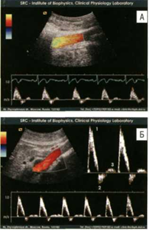

Situational task No. 2
From this ultrasound position, what components will be visualized?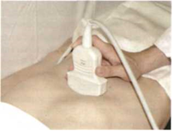

Situational task No. 3
Describe the sonogram, what worries you here?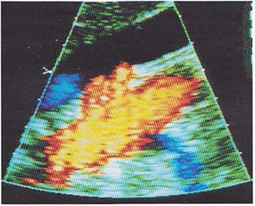

Situational task No. 4
Describe the main components shown in the sonogram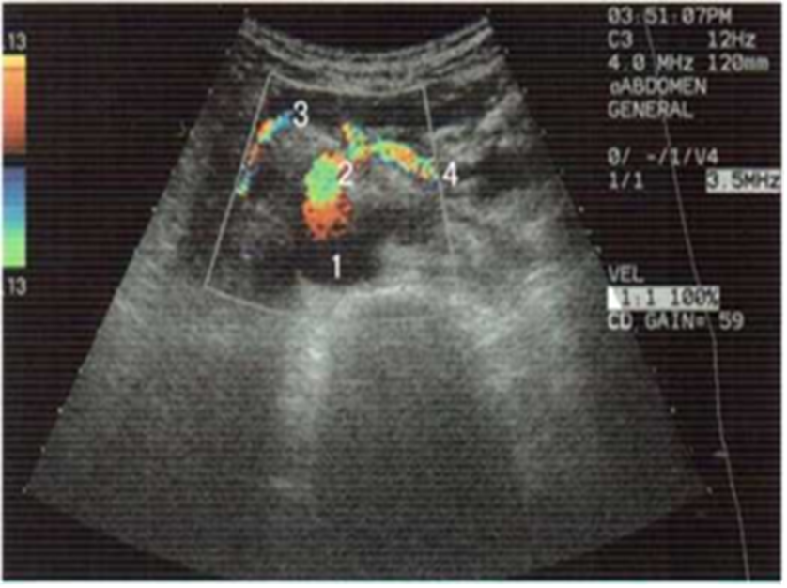

Ситуаційна задача № 5
Опишіть сонограму, які складові черевної аорти тут представлені
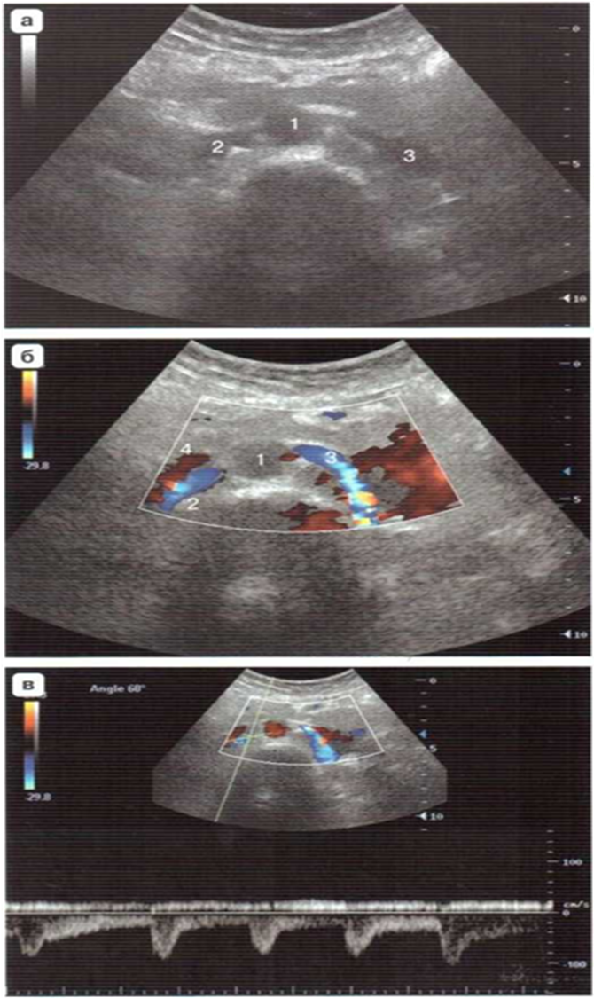

Situational task No. 6
Describe sonograms, what worries you?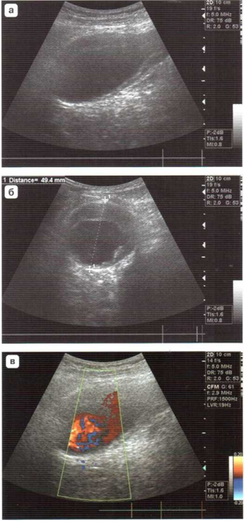

Situational task No. 7
What are the 4 types of aneurysms shown in the picture?
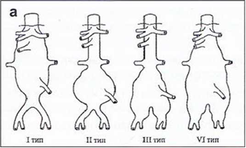

4. Discussion of theoretical issues:
- What is the purpose of examining the abdominal aorta.
- Anatomy of the abdominal aorta and its ultrasound scan.
- Ultrasound data and characteristics of blood flow in the abdominal trunk, hepatic, splenic artery.
- Ultrasound data and characteristics of blood flow in renal and mesenteric arteries.
- Anomalies of development of renal arteries
- Aneurysms of the abdominal aorta, what they are.
5. Topics of reports/abstracts:
- Clinical tasks of ultrasound examination of the abdominal aorta.
- Ultrasound diagnosis of normal abdominal aorta
- Ultrasound diagnosis of abdominal aorta pathology
- Chronic ischemia of digestive organs.
- Vasorenal hypertension
Note. When preparing a report, essay, analytical review, etc., students of higher education can, along with this, prepare didactic visual materials in the form of tables, cadograms, slides, drawings, drug schemes, etc.
6. Summary
7. List of recommended literature (main, additional, electronic information resources):
Main:
- Clark's Essential Guideto Clinical Ultrasound: Jan Dodgeon, Gill Harrison: CRC Press. – 2023. 392 р.
- Diagnostic Ultrasound, Third Edition Peter R Hoskins, Kevin Martin, Abigail Thrush CRC Press. -2019. 400 p
- Vascular ULTRASOUND HOW, WHY AND WHEN Abigail Thrush Timothy Hartshorne Colin Deane Elsevier; 4th edition. – 2022. 350 p.
- Vascular Ultrasound. B-Mode, Color Dopplerand Duplex Ultrasound, Contrast-Enhanced Ultrasound Kubale, R. — Stiegler, H. — Weskott, H. Editorial Thieme LIBRO IMPRESO. 1ª Edición Julio– 2023. 574 p.
- Naritaka H., Ishikawa M., Terao S., Kojima A., Kagami H., Inaba M., Kato S. Ultrasonographic Superb Microvascular Imaging for Emergency Surgery of Intracerebral Hemorrhage. J. Clin. Neurosci. 2020; 75:206–209. doi: 10.1016/j.jocn.2020.03.002.
- Ультразвукова детекція церебральної мікроемболії прикаротидних стенозах: досягнення та перспективи (огляд літератури) М.В. Глоба Ендоваскулярна нейрорентгенохірургія – 2020. -№ 1(31). -С. 56-67 https://doi.org/10.26683/2304-9359-2020-1(31)-56-67.
- Pellerito J., Polak J.F. Introduction to Vascular Ultrasonography, 7th Ed. Elsevier,2020, 882 p.
- Питання стандартизації протоколу ультразвукового дослідження судин шиї: огляд сучасних рекомендацій Н.М. Носенко, Д.В. Щеглов, Г.В. Друк Ендоваскулярна Нейрорентгенохірургія. – 2019. No 2(28) С.73-85.
- Sharma P, Hegde R, Kulkarni A, Sharma S, Soin P, Kochar PS, et al. Traumatic vertebral artery injury: a review of the screening criteria, imaging spectrum, mimics, and pitfalls. Pol J Radiol. - 2019;84:e307–18.https://doi.org/10.5114/pjr.2019.88023.
Additional:
- Essentials of Abdomino-Pelvic Sonography: A Handbook for Practitioners Goyal Routledge: 2018: 296 p
- Yum S.K., Im S.A., Seo Y.M., Sung I.K. Enlarged subarachnoid space on cranial ultrasound in preterm infants: Neurodevelopmental implication. Sci Rep. 2019; 9(1): 19072.
- Xiaohong Chen, JialiangXu, Yumeng Zhang, Muhui Lin, Hao Wang, Ying Song, Evaluation of hemodynamic characteristics in posterior circulation infarction patients with vertebral artery dominance by color doppler flow imaging and transcranial dopplersonography, International Journal of Neuroscience, 10.1080/00207454.2020.1773820, 131, 11, (1078-1086). 2020.
- Доплерографія магістральних судин шиї / Р. Я. Абдуллаев., В. Й. Калашников. В. Г. Марченко та iн. — Навч. nociб. — X.: Нове слово. 2008. — 48с.
- Caterina Kulyk, Chiara Voltan, Marialaura Simonetto, Anna Palmieri, Filippo Farina, Francesca Vodret, Federica Viaro, Claudio Baracchini, Vertebral artery hypoplasia: an innocent lamb or a disguise?, Journal of Neurology, 10.1007/s00415-018-9004-7, 265, 10, (2346-2352). 2018.
- Nasra K, Osher M. Sonography Vascular Peripheral Arterial Assessment, Protocols, And Interpretation. [Updated 2022 Apr 30]. In: StatPearls [Internet]. Treasure Island (FL): StatPearls Publishing; 2022 Jan-. Available from: https://www.ncbi.nlm.nih.gov/books/NBK570577/
- Оцінка мозкового кровопливу в пацієнтів з вертебробазилярною недостатністю відповідно до наявності структурних змін в системі задньої циркуляції / М. В. Глоба, Л. М. Сулій, В. В. Ващенко, Т. Г. Новікова // Зб. наук. пр. Співробітників НМАПО ім. П. Л. Шупика. - 2018. - Вип. 30. - С. 557-566.
Information resources:
Information and educational environment info.onmedu https://info.odmu.edu.ua/chair/occupational diseases and functional diagnostics /files
ultrasound.net.ua - Ukrainian portal of ultrasound diagnostics
http://moz.gov.ua – Ministry of Health of Ukraine
www.ama-assn.org - American Medical Association / AmericanMedicalAssociation
www.who.int - World Health Organization
www.dec.gov.ua/mtd/home/ - State Expert Center of the Ministry of Health of Ukraine
http://bma.org.uk - British Medical Association
www.gmc-uk.org - General Medical Council (GMC)
www.bundesaerztekammer.de – German Medical Association

Practical lesson No. 14

Topic 14. Ultrasound diagnosis by duplex scanning of the vessels of the limbs.

Purpose: to learn and know what the technology of ultrasound scanning of vessels (arteries and veins) of the lower extremities in B-mode, KDC and spectral doppler is. To study and know the main pathology of the arterial vessels of the lower extremities (atherosclerosis, aneurysms, arteriovenous shunts, vasculitis, injuries)
Basic concepts: anatomy and technique of ultrasound examination of the abdominal part of the aorta (iliac arteries), superficial and deep vessels of the lower extremities (arteries and veins); pathology of the arteries of the lower extremities (stenoses, occlusions, collateral blood flow, main-altered blood flow).
Plan:
1. Organizational activities (greetings, verification of those present, announcement of the topic, purpose of the lesson, motivation of higher education seekers to study the topic).
2. Control of the reference level of knowledge (written work, written test, frontal survey on basic terminology, etc.) (if necessary).
3. Questions (test tasks) to check basic knowledge on the topic of the practical session:
1.Echographic picture of an unchanged aorta during a transverse scan:
a) rounded, anechoic formation, the lumen is completely homogeneous, without additional inclusions, pulsation is synchronous with heart contractions
b) rounded, anechoic formation, the lumen is completely homogeneous, without additional inclusions, pulsation is synchronous with respiratory movements
c) rounded, hyperechoic formation, the lumen is completely homogeneous, without additional inclusions, pulsation is synchronous with heart contractions
d) rounded, anechoic formation, the lumen is moderately heterogeneous, without additional inclusions, pulsation is synchronous with heart contractions
e) rounded, anechoic formation, the lumen is completely homogeneous, additional inclusions are visualized in it, the pulsation is synchronous with heart contractions.
2. Deformations of arteries are more often localized:
a) above the mouths of arteries
b) during arteries
c) at the bifurcation of arteries
d) true a) and c)
e) everything is correct
3. According to ultrasound criteria, a homogeneous plaque is:
a) the plaque is homogeneous in structure;
b) plaque with hemorrhage;
c) a plaque with an ulcer
d) calcified plaque
e) true b) and c)
4. Heterogeneous plaques are most often localized in:
a) femoral artery
b) internal carotid artery
c) vertebral artery
d) popliteal artery
e) dorsal artery of the foot
5. Calcified atherosclerotic plaques are more often localized in:
a) external carotid artery
b) vertebral artery
c) iliac and femoral arteries
d) popliteal artery
e) dorsal artery of the foot
6.Normally, in the veins, a test with compression of the distal parts of the limb causes:
a) increase in blood flow
b) decrease in blood flow
c) does not change blood flow
d) spasm of arteries
e) increasing the tone of the veins
7. Normally, the blood flow in the veins of the limbs is synchronized:
a) with heart rate
b) with breathing
c) with atrioventricular conduction
d) with the force of heart contractions
e) with blood pressure
8. Normally, the blood flow in the arteries of the lower extremities has:
a) high peripheral resistance
b) low peripheral resistance
c) has no peripheral resistance
d) insignificant peripheral resistance
e) unknown peripheral resistance
9. Normally, the following type of blood flow is observed in the arteries of the lower extremities:
a) trunk
b) main-changed
c) collateral
d) collaterally changed
e) mixed
10. With isolated occlusion of the lower leg arteries, the type of blood flow in the common femoral artery:
a) trunk
b) main-changed
c) collateral
d) collaterally changed
e) mixed
11. The pulsation index in the arteries of the lower extremities in the distal direction is normal:
a) increases
b) decreases
c) increases with further decrease
d) decreases with subsequent increase
e) is accompanied by alternating increases and decreases
12. Normally, the pulsation index in the common femoral artery is:
a) over 4.0
b) less than 4.0
c) less than 3.0
d) less than 2.0
e) 2.0
13. Normal humeral bone index:
a) 1.0 or more
b) 0.8
c) 0.6
d) 0.3
e) 0.1
14. When the arteries of the aorto-femoral segment of the common femoral artery are occluded, the following type of blood flow is observed:
a) trunk
b) main-changed
c) collateral
d) collaterally changed
e) mixed

Situational task No. 1
Give a name to the standard zones of the location of vessels
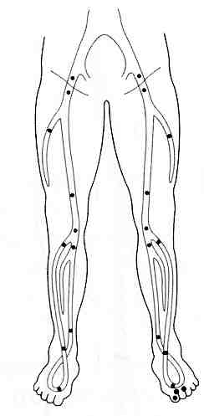

Situational task No. 2
Describe the sonogram.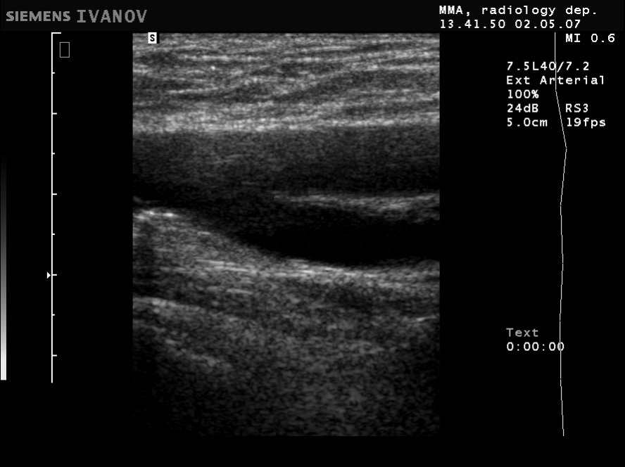

Situational problem № 3
Describe the sonogram, name the vessels of the popliteal zone.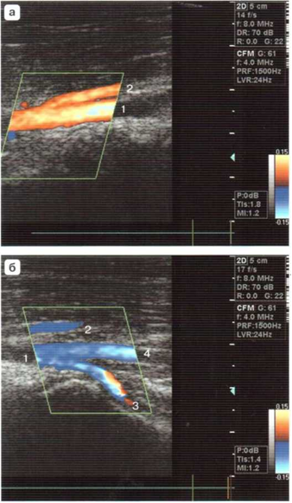

Situational task No. 4
Duplex scanning of the posterior tibial artery (PTA): on which slide is collateral blood flow in PTA with low peripheral resistance, on which slide is collateral blood flow in PTA with high peripheral resistance (justify your choice)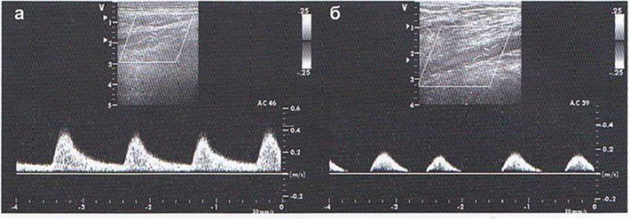
Situational problem No. 5
Describe the spectrum of blood flow in a.femoralis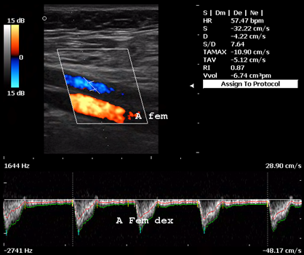

Situational task No. 6
Describe the popliteal artery.
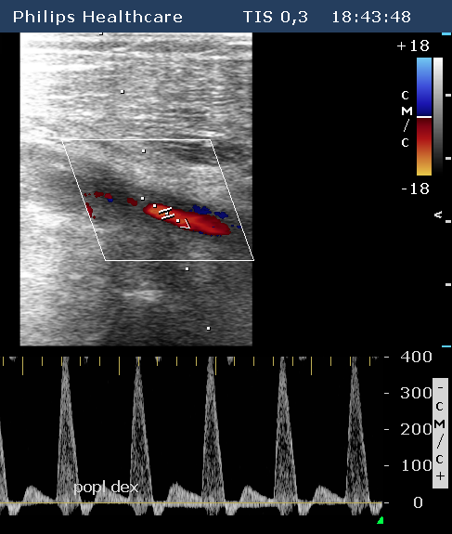

Situational task No. 7
Give a name to each vessel of the popliteal zone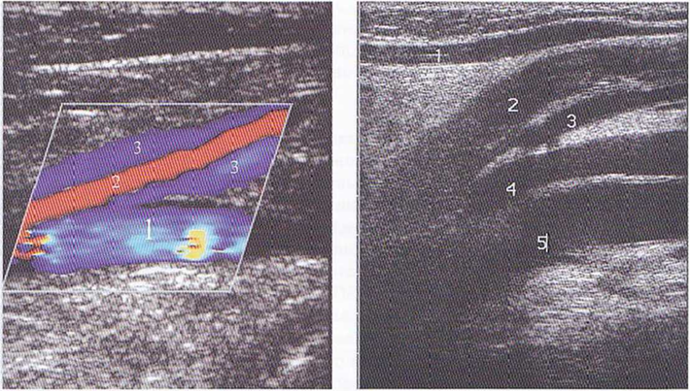

Situational task No. 8
Describe the sonogram, which vessels are represented in the picture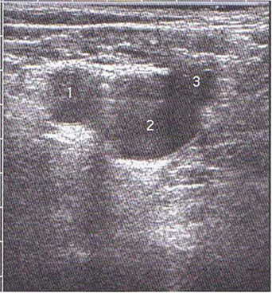

4. Discussion of theoretical issues:
- Indications for ultrasound of the vessels of the lower extremities (arteries and veins)
- Basic anatomical landmarks for scanning the arteries and veins of the lower extremities.
- Spectral characteristics of normal blood flow (arteries and veins)
- Spectral characteristics of blood flow in pathology (arteries)
- The main pathology of the arteries of the lower extremities and its manifestations on ultrasound.
- Main and collateral blood flow in the arteries of the lower extremities.
- Functional tests for vessels of the lower extremities.
5. Topics of reports/abstracts:
- Ultrasound picture of the norm of the dopplerogram in the vessels of the lower extremities, what it depends on.
- Ultrasound signs of damage to vessels of the lower extremities in the area of ​​the iliac-femoral zone.
- Ultrasound signs of damage to the vessels of the lower extremities in the area of ​​the popliteal-shin area.
- Functional tests for the arteries and veins of the lower extremities.
- Lerich syndrome (aorto-femoral shunt, ultrasound picture)
- Vasculitis (dopplerographic diagnosis)
Note. When preparing a report, abstract, analytical review, etc., students of higher education can, along with this, prepare didactic visual materials in the form of tables, cadograms, slides, drawings, drug schemes, etc.
6. Summary
7. List of recommended literature (main, additional, electronic information resources):
Main:
- Clark's Essential Guideto Clinical Ultrasound: Jan Dodgeon, Gill Harrison: CRC Press. – 2023. 392 р.
- Diagnostic Ultrasound, Third Edition Peter R Hoskins, Kevin Martin, Abigail Thrush CRC Press. -2019. 400 p
- Vascular ULTRASOUND HOW, WHY AND WHEN Abigail Thrush Timothy Hartshorne Colin Deane Elsevier; 4th edition. – 2022. 350 p.
- Vascular Ultrasound. B-Mode, Color Dopplerand Duplex Ultrasound, Contrast-Enhanced Ultrasound Kubale, R. — Stiegler, H. — Weskott, H. Editorial Thieme LIBRO IMPRESO. 1ª Edición Julio– 2023. 574 p.
- Naritaka H., Ishikawa M., Terao S., Kojima A., Kagami H., Inaba M., Kato S. Ultrasonographic Superb Microvascular Imaging for Emergency Surgery of Intracerebral Hemorrhage. J. Clin. Neurosci. 2020; 75:206–209. doi: 10.1016/j.jocn.2020.03.002.
- Ультразвукова детекція церебральної мікроемболії прикаротидних стенозах: досягнення та перспективи (огляд літератури) М.В. Глоба Ендоваскулярна нейрорентгенохірургія – 2020. -№ 1(31). -С. 56-67 https://doi.org/10.26683/2304-9359-2020-1(31)-56-67.
- Pellerito J., Polak J.F. Introduction to Vascular Ultrasonography, 7th Ed. Elsevier,2020, 882 p.
- Питання стандартизації протоколу ультразвукового дослідження судин шиї: огляд сучасних рекомендацій Н.М. Носенко, Д.В. Щеглов, Г.В. Друк Ендоваскулярна Нейрорентгенохірургія. – 2019. No 2(28) С.73-85.
- Sharma P, Hegde R, Kulkarni A, Sharma S, Soin P, Kochar PS, et al. Traumatic vertebral artery injury: a review of the screening criteria, imaging spectrum, mimics, and pitfalls. Pol J Radiol. - 2019;84:e307–18.https://doi.org/10.5114/pjr.2019.88023.
Аdditional:
- Essentials of Abdomino-Pelvic Sonography: A Handbook for Practitioners Goyal Routledge: 2018: 296 p
- Yum S.K., Im S.A., Seo Y.M., Sung I.K. Enlarged subarachnoid space on cranial ultrasound in preterm infants: Neurodevelopmental implication. Sci Rep. 2019; 9(1): 19072.
- Xiaohong Chen, JialiangXu, Yumeng Zhang, Muhui Lin, Hao Wang, Ying Song, Evaluation of hemodynamic characteristics in posterior circulation infarction patients with vertebral artery dominance by color doppler flow imaging and transcranial dopplersonography, International Journal of Neuroscience, 10.1080/00207454.2020.1773820, 131, 11, (1078-1086). 2020.
- Доплерографія магістральних судин шиї / Р. Я. Абдуллаев., В. Й. Калашников. В. Г. Марченко та iн. — Навч. nociб. — X.: Нове слово. 2008. — 48с.
- Caterina Kulyk, Chiara Voltan, Marialaura Simonetto, Anna Palmieri, Filippo Farina, Francesca Vodret, Federica Viaro, Claudio Baracchini, Vertebral artery hypoplasia: an innocent lamb or a disguise?, Journal of Neurology, 10.1007/s00415-018-9004-7, 265, 10, (2346-2352). 2018.
- Nasra K, Osher M. Sonography Vascular Peripheral Arterial Assessment, Protocols, And Interpretation. [Updated 2022 Apr 30]. In: StatPearls [Internet]. Treasure Island (FL): StatPearls Publishing; 2022 Jan-. Available from: https://www.ncbi.nlm.nih.gov/books/NBK570577/
- Оцінка мозкового кровопливу в пацієнтів з вертебробазилярною недостатністю відповідно до наявності структурних змін в системі задньої циркуляції / М. В. Глоба, Л. М. Сулій, В. В. Ващенко, Т. Г. Новікова // Зб. наук. пр. Співробітників НМАПО ім. П. Л. Шупика. - 2018. - Вип. 30. - С. 557-566.
Information resources:
Information and educational environment info.onmedu https://info.odmu.edu.ua/chair/occupational diseases and functional diagnostics /files
ultrasound.net.ua - Ukrainian portal of ultrasound diagnostics
http://moz.gov.ua – Ministry of Health of Ukraine
www.ama-assn.org - American Medical Association / AmericanMedicalAssociation
www.who.int - World Health Organization
www.dec.gov.ua/mtd/home/ - State Expert Center of the Ministry of Health of Ukraine
http://bma.org.uk - British Medical Association
www.gmc-uk.org - General Medical Council (GMC)
www.bundesaerztekammer.de – German Medical Association

Practical lesson No. 15

Topic 15. Vascular diseases of the extremities and their ultrasound verification

Purpose: to learn and know what ultrasound diagnosis of diseases of the inferior vena cava system, veins of the limbs is. Know and be able to identify thrombosis, thrombophlebitis, insufficiency of the valve apparatus of the veins of the lower extremities; perform functional tests for the veins of the lower extremities.
Basic concepts: technology of ultrasound examination of the veins of the lower extremities in pathology; pathology of the veins of the lower extremities (varicose veins, thrombosis, thrombophlebitis, failure of the valvular apparatus of veins, perforating veins).
Plan:
1. Organizational activities (greetings, verification of those present, announcement of the topic, purpose of the lesson, motivation of higher education seekers to study the topic).
2. Control of the reference level of knowledge (written work, written test, frontal survey on basic terminology, etc.) (if necessary).
3. Questions (test tasks) to check basic knowledge on the topic of the practical session:
1. Blood flow in the femoral vein is determined below the Poupart connection:
a) more medially than the femoral artery
b) lateral to the femoral artery
c) more medially than the popliteal artery
d) lateral to the popliteal artery
e) everything is wrong
2. Normally in the veins, a test with compression of the distal parts of the limb causes:
a) increase in blood flow
b) decrease in blood flow
c) does not change blood flow
d) spasm of arteries
e) increasing the tone of the veins
3. In case of failure of the valve apparatus of the veins, the following is recorded:
a) blood reflux in the retrograde direction
b) blood reflux in the antegrade direction
c) absence of reflux
d) registration is impossible
e) reflux in a mixed direction
4.Normal blood flow in the veins:
a) phase, synchronized with breathing
b) monophasic, synchronized with breathing
a) phasic, synchronized with the heart rate
b) monophasic, synchronized with heart rate
a) phasic, synchronized with the force of heart contractions
5. In the area of ​​the occluding thrombus, the blood flow signal:
a) absent
b) is registered
c) impulse
d) ellipsoidal
e) monophasic
6. Normally, when the vein is compressed by the sensor:
a) lumen of the vessel does not change
b) the walls collapse and the lumen disappears
c) the walls expand
d) the lumen expands
e) true in) and d)
7. With occlusive thrombosis, vein compression with a sensor:
a) does not cause wall recession, disappearance of vessel lumen
b) the walls collapse, the lumen disappears
c) the walls collapse, the lumen does not disappear
d) the walls do not collapse, the lumen disappears
8. Ultrasound criteria for post-thrombotic disease of the deep veins of the lower extremities are:
a) expansion of the superficial veins of the lower extremities
b) failure of the valve apparatus of the deep and superficial veins of the lower extremities
c) positive distal compression test
d) true a) and b)
e) everything is correct
9. Signs of complete thrombosis of the deep veins of the lower extremities are:
a) impossibility of complete compression of the lumen of the vein by the sensor
b) negative distal compression test
c) positive Valsalva test
d) true a) and b)
e) true a) and c)
10. Isolated insufficiency of the valvular apparatus of the great saphenous vein indicates the presence of:
a) varicose disease
b) deep vein thrombosis
c) femoral artery occlusions
d) intermittent lameness
e) popliteal artery occlusions

Situational task No. 1
Describe the sonogram. During compression, the lumen of the artery is deformed, and the vein?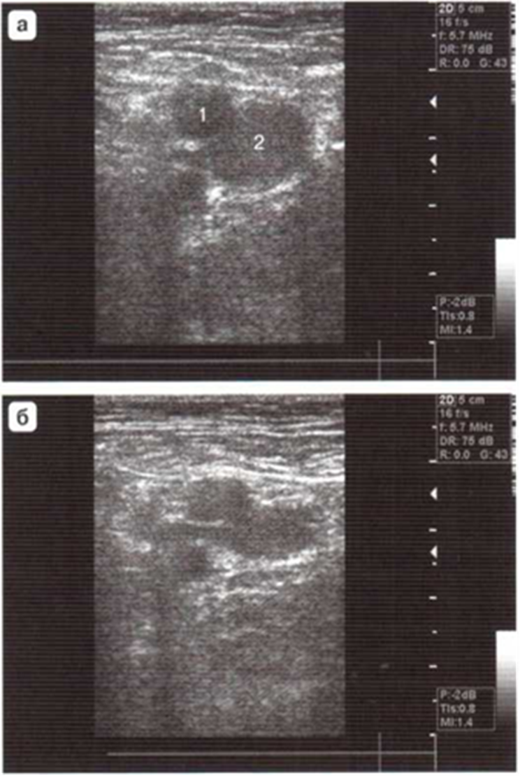

Situational problem № 2
Describe the sonogram, which clinical picture does this picture correspond to?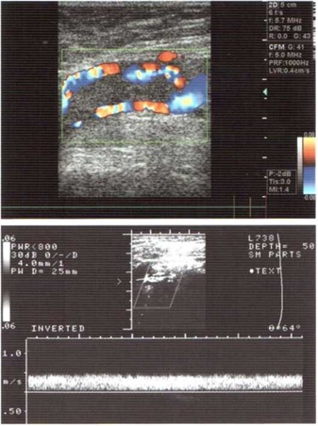

Situational task No. 3
Describe the sonogram, what makes you extremely alarmed in the picture?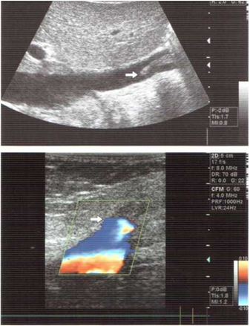

Situational task No. 4
Describe the sonogram, which variants of the venous reflex are depicted (argue).
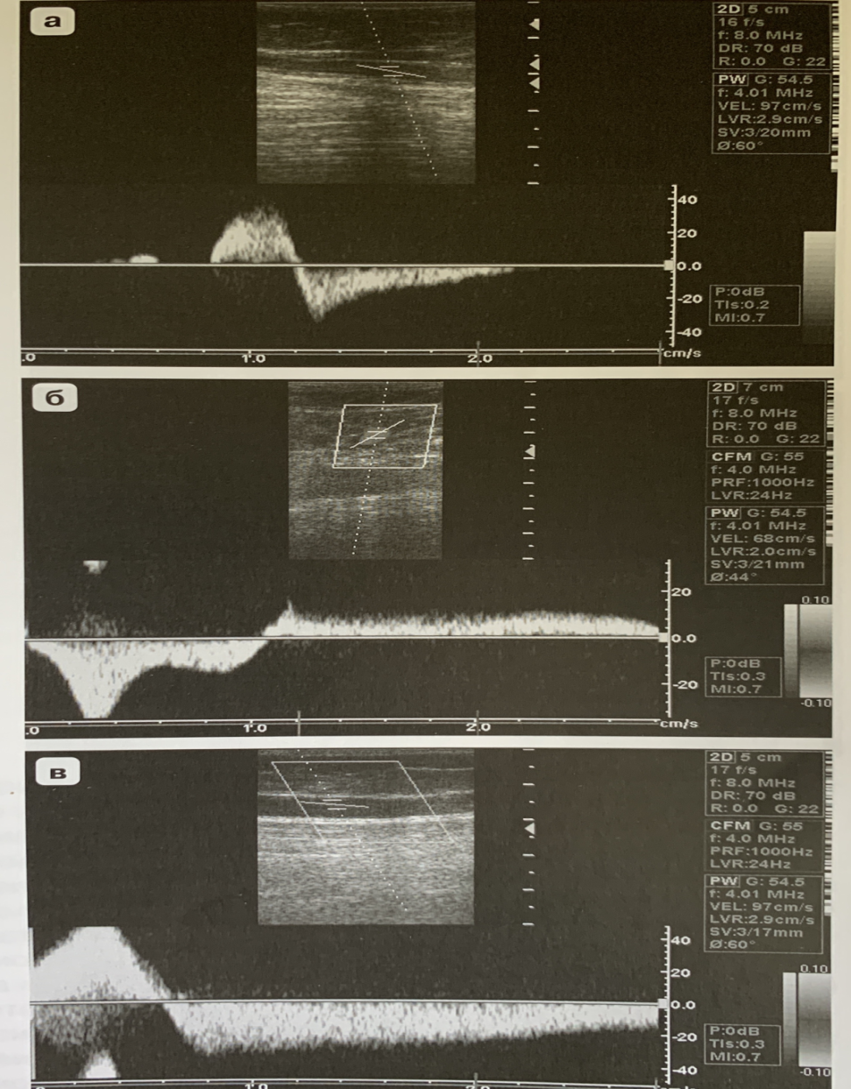

Situational problem No. 5
Describe the sonogram, what exactly is in the lumen of the vein?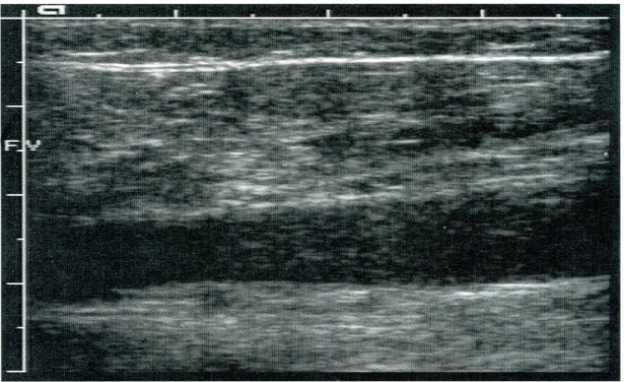
Situational task No. 6
Describe the sonogram, which vein is shown in the picture?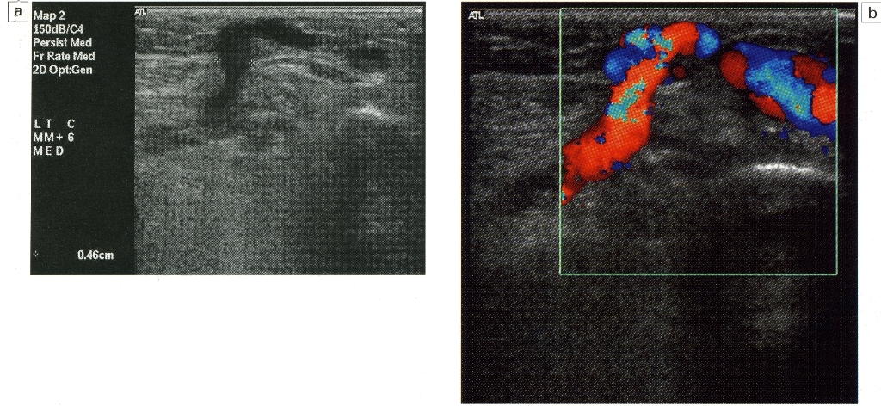

The situation is task number 7
Describe the sonogram, which clinical picture does this ultrasound scan correspond to?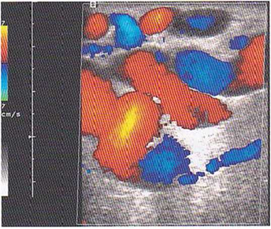

4. Discussion of theoretical issues:
- The most common pathology of the veins of the lower extremities.
- Failure of the valve apparatus of the veins, reflux.
- Ultrasound signs of acute thrombosis.
- Ultrasound signs of chronic thrombosis.
- Ultrasound signs of a floating thrombus.
- Ultrasound signs of varicose veins.
- Functional tests to detect the pathology of the veins of the lower extremities
- Cаva- filter
- CEAR classification.
5. Topics of reports/abstracts:
- Ultrasound image of varicose veins of the lower extremities.
- Ultrasound picture of a floating thrombus and solutions.
- Functional tests for verification of thrombosis, valve failure.
- Peculiarities of the ultrasound picture in acute swellings of various etiologies of the lower extremities.
- Differential diagnosis of acute venous thrombosis
Note. When preparing a report, essay, analytical review, etc., students of higher education can, along with this, prepare didactic visual materials in the form of tables, cadograms, slides, drawings, drug schemes, etc.
6. Summary
7. List of recommended literature (main, additional, electronic information resources):
Main:
- Clark's Essential Guideto Clinical Ultrasound: Jan Dodgeon, Gill Harrison: CRC Press. – 2023. 392 р.
- Diagnostic Ultrasound, Third Edition Peter R Hoskins, Kevin Martin, Abigail Thrush CRC Press. -2019. 400 p
- Vascular ULTRASOUND HOW, WHY AND WHEN Abigail Thrush Timothy Hartshorne Colin Deane Elsevier; 4th edition. – 2022. 350 p.
- Vascular Ultrasound. B-Mode, Color Dopplerand Duplex Ultrasound, Contrast-Enhanced Ultrasound Kubale, R. — Stiegler, H. — Weskott, H. Editorial Thieme LIBRO IMPRESO. 1ª Edición Julio– 2023. 574 p.
- Naritaka H., Ishikawa M., Terao S., Kojima A., Kagami H., Inaba M., Kato S. Ultrasonographic Superb Microvascular Imaging for Emergency Surgery of Intracerebral Hemorrhage. J. Clin. Neurosci. 2020; 75:206–209. doi: 10.1016/j.jocn.2020.03.002.
- Ультразвукова детекція церебральної мікроемболії прикаротидних стенозах: досягнення та перспективи (огляд літератури) М.В. Глоба Ендоваскулярна нейрорентгенохірургія – 2020. -№ 1(31). -С. 56-67 https://doi.org/10.26683/2304-9359-2020-1(31)-56-67.
- Pellerito J., Polak J.F. Introduction to Vascular Ultrasonography, 7th Ed. Elsevier,2020, 882 p.
- Питання стандартизації протоколу ультразвукового дослідження судин шиї: огляд сучасних рекомендацій Н.М. Носенко, Д.В. Щеглов, Г.В. Друк Ендоваскулярна Нейрорентгенохірургія. – 2019. No 2(28) С.73-85.
- Sharma P, Hegde R, Kulkarni A, Sharma S, Soin P, Kochar PS, et al. Traumatic vertebral artery injury: a review of the screening criteria, imaging spectrum, mimics, and pitfalls. Pol J Radiol. - 2019;84:e307–18.https://doi.org/10.5114/pjr.2019.88023.
Additional:
- Essentials of Abdomino-Pelvic Sonography: A Handbook for Practitioners Goyal Routledge: 2018: 296 p
- Yum S.K., Im S.A., Seo Y.M., Sung I.K. Enlarged subarachnoid space on cranial ultrasound in preterm infants: Neurodevelopmental implication. Sci Rep. 2019; 9(1): 19072.
- Xiaohong Chen, JialiangXu, Yumeng Zhang, Muhui Lin, Hao Wang, Ying Song, Evaluation of hemodynamic characteristics in posterior circulation infarction patients with vertebral artery dominance by color doppler flow imaging and transcranial dopplersonography, International Journal of Neuroscience, 10.1080/00207454.2020.1773820, 131, 11, (1078-1086). 2020.
- Доплерографія магістральних судин шиї / Р. Я. Абдуллаев., В. Й. Калашников. В. Г. Марченко та iн. — Навч. nociб. — X.: Нове слово. 2008. — 48с.
- Caterina Kulyk, Chiara Voltan, Marialaura Simonetto, Anna Palmieri, Filippo Farina, Francesca Vodret, Federica Viaro, Claudio Baracchini, Vertebral artery hypoplasia: an innocent lamb or a disguise?, Journal of Neurology, 10.1007/s00415-018-9004-7, 265, 10, (2346-2352). 2018.
- Nasra K, Osher M. Sonography Vascular Peripheral Arterial Assessment, Protocols, And Interpretation. [Updated 2022 Apr 30]. In: StatPearls [Internet]. Treasure Island (FL): StatPearls Publishing; 2022 Jan-. Available from: https://www.ncbi.nlm.nih.gov/books/NBK570577/
- Оцінка мозкового кровопливу в пацієнтів з вертебробазилярною недостатністю відповідно до наявності структурних змін в системі задньої циркуляції / М. В. Глоба, Л. М. Сулій, В. В. Ващенко, Т. Г. Новікова // Зб. наук. пр. Співробітників НМАПО ім. П. Л. Шупика. - 2018. - Вип. 30. - С. 557-566.
Information resources:
Information and educational environment info.onmedu https://info.odmu.edu.ua/chair/occupational diseases and functional diagnostics /files
ultrasound.net.ua - Ukrainian portal of ultrasound diagnostics
http://moz.gov.ua – Ministry of Health of Ukraine
www.ama-assn.org - American Medical Association / AmericanMedicalAssociation
www.who.int - World Health Organization
www.dec.gov.ua/mtd/home/ - State Expert Center of the Ministry of Health of Ukraine
http://bma.org.uk - British Medical Association
www.gmc-uk.org - General Medical Council (GMC)
www.bundesaerztekammer.de – German Medical Association

