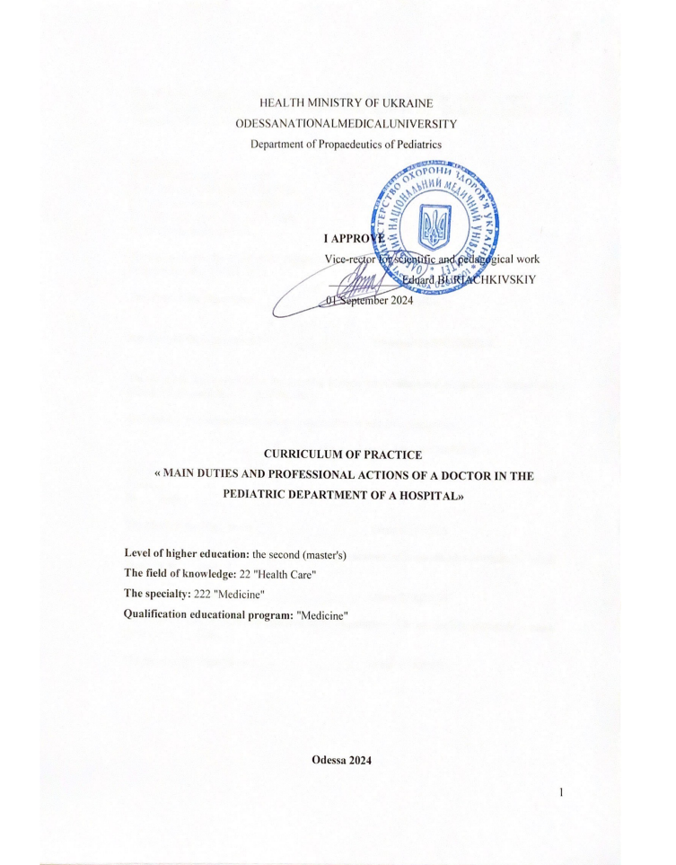

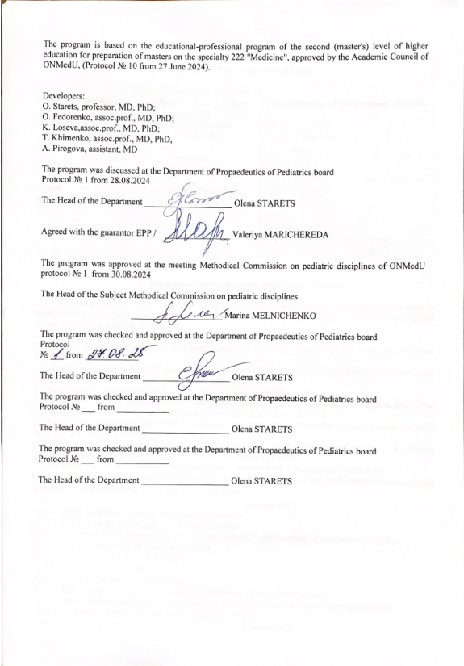
1. Description of practice

Name  indicators | Field of knowledge, specialty, specialization, level of higher education | Characteristics of practice
The total number of:  Credits: 1,5  Hours: 60 | Branch of knowledge  22 "Health care"  Specialty  222 "Medicine"  Level of higher education  second (master's ) | Full-time education  Mandatory educational component
The total number of:  Credits: 1,5  Hours: 60 |  | Year of training: 4
The total number of:  Credits: 1,5  Hours: 60 |  | Semesters VII - VIII
The total number of:  Credits: 1,5  Hours: 60 |  | Lectures (0 hours)
The total number of:  Credits: 1,5  Hours: 60 |  | Seminars (0 hours)
The total number of:  Credits: 1,5  Hours: 60 |  | Practical (30 hours)
The total number of:  Credits: 1,5  Hours: 60 |  | Laboratory (0 hours)
The total number of:  Credits: 1,5  Hours: 60 |  | Independent work (15hours)
The total number of:  Credits: 1,5  Hours: 60 |  | including individual tasks (0 hours)
The total number of:  Credits: 1,5  Hours: 60 |  | Final control form –  differential calculation

2. Purpose and tasks of practice, competences, program learning outcomes.

Purpose: Mastery by a master of higher education practical skills acquired during the study of the main clinical and theoretical disciplines and their further deepening and improvement during work in medical and preventive institutions, as well as familiarization with the work of a doctor in the conditions of future professional activity on the bases of medical and preventive institutions.
Task :
1 . Draw up an examination plan and analyze data from laboratory and instrumental examinations during the typical course of the most common somatic and non-infectious diseases of childhood .
2. Mastering the principles of treatment, rehabilitation and prevention of the most common somatic and non-infectious diseases of childhood.
3. Diagnose and provide emergency care for major emergencies in children with the most common somatic and non-infectious diseases of childhood.
4. The ability to make a preliminary diagnosis with the typical course of the most common children's non-infectious diseases.
5. Provide a prognosis for the most common somatic and non-infectious diseases of childhood.
6. To possess the moral and deontological principles of a medical specialist and the principles of professional subordination in pediatrics and in professional communication with a patient.
The process of passing industrial medical practice aimed at forming elements of the following competences :
General (GK)
GK1 – Ability to abstract thinking, analysis and synthesis .
GK3 – Ability to apply knowledge in practical situations.
GK4 – Knowledge and understanding of the subject area and understanding of professional activity .
GK5 – Ability to adapt and act in a new situation.
GK6 – Ability to make informed decisions.
GK7 – Ability to work in a team.
GK8 – Ability to interpersonal interaction.
GK11 – Ability to search, process and analyze information from various sources.
GK12 – Determination and perseverance regarding the assigned tasks and assumed responsibilities.
GK13 – Awareness of equal opportunities and gender issues.

Special (SK):
SK1 – Ability to collect medical information about the patient and analyze clinical data.
SK2 – Ability to determine the necessary list of laboratory and instrumental studies and evaluate their results.
SK3 – Ability to establish a preliminary and clinical diagnosis of the disease.
SK5 – Ability to determine the nature of nutrition in the treatment and prevention of diseases.
SK6 – Ability to determine the principles and nature of treatment and prevention of diseases.
SK7 – Ability to diagnose emergency conditions.
SK8 – Ability to determine tactics and provide emergency medical assistance.
SK10 – Ability to perform medical manipulations.
SK11 – The ability to solve medical problems in new or unfamiliar environments in the presence of incomplete or limited information, taking into account aspects of social and ethical responsibility, including early intervention.
SK13 – Ability to carry out sanitary and hygienic and preventive measures.
SK16 – Ability to maintain medical documentation, including electronic forms.
SK24 – Compliance with ethical principles when working with patients and laboratory animals.
SK26 – The ability to determine the management tactics of persons subject to dispensary supervision.

Program learning outcomes (PRL):
PLO3 - Specialized conceptual knowledge, which includes scientific achievements in the field of health care and is the basis for conducting research, critical understanding of problems in the field of medicine and related interdisciplinary problems, including early intervention.
PLO4 - Identify and identify leading clinical symptoms and syndromes (according to list 1); according to standard methods, using preliminary data of the patient's history, data of the patient's examination, knowledge about the person, his organs and systems, establish a preliminary clinical diagnosis of the disease (according to list 2).
PLO5 - Collect complaints, life anamnesis and diseases, assess the psychomotor and physical development of the patient, the state of organs and systems of the body, based on the results of laboratory and instrumental studies, evaluate information about the diagnosis (according to list 4), taking into account the age of the patient.
PLO6 - To establish a final clinical diagnosis by making a reasoned decision and analyzing the received subjective and objective data of clinical, additional examination, carrying out differential diagnosis, observing the relevant ethical and legal norms, under the control of the managing physician in the conditions of a health care institution ( according to list 2).
PLO7 - Prescribe and analyze additional (mandatory and optional) examination methods (laboratory, functional and/or instrumental) (according to list 4) of patients with diseases of organs and body systems for differential diagnosis of diseases (according to list 2).
PLO8 - Determine the main clinical syndrome or symptom that determines the severity of the condition of the victim/injured (according to list 3) by making a reasoned decision about the person's condition under any circumstances (in the conditions of a health care facility, outside its borders), including in conditions of emergency and hostilities, in field conditions, in conditions of lack of information and limited time.
PLO9 - Determine the nature and principles of treatment (conservative, operative) of patients with diseases (according to list 2), taking into account the patient's age, in the conditions of a health care institution, outside its borders and at the stages of medical evacuation, including in field conditions, on the basis of a preliminary clinical diagnosis, observing the relevant ethical and legal norms, by making a reasoned decision according to existing algorithms and standard schemes, in case of the need to expand the standard scheme, be able to justify personalized recommendations under the control of the head physician in the conditions of a medical institution.
PLO10 - Determine the necessary mode of work, rest and nutrition on the basis of the final clinical diagnosis, observing the relevant ethical and legal norms, by making a reasoned decision according to existing algorithms and standard schemes.
PLO12 - To assess the general condition of a newborn child by making a reasoned decision according to existing algorithms and standard schemes, observing the relevant ethical and legal norms.
PLO13 - Assess and monitor the child's physical and psychomotor development, provide recommendations on feeding and nutritional features depending on age, organize preventive vaccinations according to the calendar.
PLO14 - Determine tactics and provide emergency medical care in emergency situations (according to list 3) in limited time conditions according to existing clinical protocols and standards of treatment.
PLO15. To organise the provision of medical care and medical evacuation measures to the population and military personnel in emergency situations and combat operations, including in the field.
PLO17 - Perform medical manipulations (according to list 5) in the conditions of a medical institution, at home or at work based on a previous clinical diagnosis and/or indicators of the patient's condition by making a reasoned decision, observing the relevant ethical and legal norms.
PLO18. Determine the state of functioning and limitations of a person's vital activity and the duration of disability with the preparation of relevant documents, in a healthcare facility, based on data on the disease and its course, the specifics of the person's professional activity, etc. Maintain medical records for the patient and the population on the basis of regulatory documents.
PLO19. To plan and implement a system of anti-epidemic and preventive measures against the emergence and spread of diseases among the population.
PLO24. Organise the necessary level of individual safety (own and of persons under their care) in the event of typical hazardous situations in the individual field of activity.
PLO30 - Determine the management tactics of persons subject to dispensary supervision (children).
PLO31. Determine the tactics of management of patients with chronic infectious diseases subject to dispensary supervision.
PLO33. To be able to provide counselling on family planning
family planning and selection of contraceptive methods
As a result of passing industrial medical practice, the applicant of higher education must:
Know:
- modern concepts of domestic and foreign theoretical and practical pediatrics;
- the main principles of the organization of medical care for children in Ukraine;
- the basics of organizing a rational regime and treating a sick child;
- general elements of care for sick children;
- theoretical aspects of preventing the occurrence and spread of intra-hospital infection;
- classification and analysis of the typical clinical picture of the most common somatic and non-infectious diseases of childhood and newborns.
- examination plan and analysis of laboratory and instrumental examination data in the typical course of the most common somatic and non-infectious diseases of childhood;
- principles of treatment, rehabilitation and prevention of the most common somatic and non-infectious diseases of childhood.
- provision of emergency care for basic emergencies in children with the most common somatic and non-infectious diseases of childhood.
- differential diagnosis and make a preliminary diagnosis in the typical course of the most common children's non-infectious diseases.
- prognosis for the most common somatic and non-infectious diseases of childhood.
- moral and deontological principles of a medical specialist and principles of professional subordination in pediatrics.
- peculiarities of the structure of the medical chart of an inpatient.
Be able:
- to organize appropriate sanitary and epidemic conditions for various rooms of the department in the children's hospital;
- conduct anamnesis collection and objective examination of a sick child;
- assess the severity of clinical manifestations of the disease;
- draw up a survey plan and evaluate their results;
- identify and evaluate acute medical conditions;
- provide first aid;
- provide basic life support and respiratory function in accordance with current European recommendations;
- prescribe appropriate treatment;
- perform medical procedures and medical manipulations (techniques of injections , cleansing enemas, gastric probing, methods of restoring airway patency, bladder catheterization, etc.);
- apply measures to prevent the occurrence and spread of intra-hospital infection;
- issue a card for an inpatient;
- to comply with the requirements of ethics, bioethics and deontology in their professional activities.

3. Content of practice

Topic 1. Principles of organization of medical care for children in Ukraine, basics of Ukrainian legislation on children's health care, legal aspects of pediatrician's work, principles of ethics and deontology in the practice of pediatrician.
Topic 2. Provision of emergency medical care in case of urgent conditions in children.
Topic 3. Clinical and laboratory-instrumental diagnostics of major childhood diseases in a pediatric hospital: respiratory, cardiovascular, gastrointestinal, urinary system.
Topic 4. Algorithms for performing practical skills.

4. Structure of practice

Topics | Total | Pr.class | Ind.work
Topic 1. Principles of organization of medical care for children in Ukraine, basics of Ukrainian legislation on children's health care, legal aspects of pediatrician's work, principles of ethics and deontology in the practice of pediatrician | 8 | 6 | 2
Topic 2. Provision of emergency medical care in case of urgent conditions in children. | 8 | 6 | 2
Topic 3. Clinical and laboratory-instrumental diagnostics of major childhood diseases in a pediatric hospital: respiratory, cardiovascular, gastrointestinal, urinary system. | 10 | 8 | 2
Topic 4. Algorithms for performing practical skills. | 15 | 10 | 5
Preparation for CPE | 4 | - | 4
Усього годин | 45 | 30 | 15

5. Topics of lectures / seminars / practical / laboratory classes

5.1. Topics of lectures
Lectures are not provided

5.2. Topics of seminar classes
Seminar classes are not provided.

  - t topics of practical classes
№ | Topic | Hours
1 | Practical class 1. Principles of organization of medical care for children in Ukraine, basics of Ukrainian legislation on children's health care | 2
2 | Practical class 2. Legal aspects of the work of a pediatrician | 2
3 | Practical session 3. Principles of ethics and deontology in the practice of a pediatrician | 2
4 | Practical classes 4-6. Provision of emergency medical care in urgent conditions in children | 6
5 | Practical classes 7-10. Clinical and laboratory-instrumental diagnosis of major childhood diseases in a pediatric hospital. Respiratory system, cardiovascular system, gastrointestinal tract, urinary system. | 8
6 | Practical classes 11-15. Algorithms for performing practical skills. | 10
 | Total hours | 30

5.4. Laboratory topics classes
Laboratory classes are not provided.

6. Independent work master of higher education

№ | Topic | Hours
1 | Preparation for practical classes 1-3. Principles of organization of medical care for children in Ukraine, basics of Ukrainian legislation on children's health care. Legal aspects of the work of a pediatrician. Principles of ethics and deontology in the practice of a pediatrician. | 2
2 | Preparation for practical classes 4-6. Providing emergency medical care in case of urgent conditions in children | 2
3 | Preparation for practical classes 7-10. Clinical and laboratory-instrumental diagnostics of major childhood diseases in a pediatric hospital. Respiratory system, cardiovascular system, gastrointestinal tract, urinary system. | 2
4 | Preparation for practical classes 11-15. Algorithms for performing practical skills. | 5
5 | Preparation for the KPE | 4
 | Total hours | 15

7. Teaching methods
Practical classes - a type of educational class, in which masters, under the guidance of a scientific and pedagogical worker, consolidate the theoretical provisions of educational disciplines and acquire the skills and abilities of their practical application through individual performance of appropriately formulated tasks. They provide for:
  - collection of anamnesis;
  - examination of a sick child;
  - planning examination of a sick child;
  - interpretation of laboratory and instrumental research data;
  - differential diagnosis of the most common childhood diseases with their typical course;
  - determination of the previous clinical diagnosis;
  - determination of therapeutic tactics;
  - prescription of medical nutrition;
  - provision of emergency medical care;
  - solving situational problems;
  - practicing practical skills on dummies and at the bedside of a sick child;
  - maintaining medical records.
Independent work of the acquirer - preparation for practical classes and study of topics considered only in the plan of independent work of the acquirer, search and study of additional literature, creation of algorithms, structural and logical schemes, writing of medical history. The organization of independent work in the departments of the pediatric hospital should be ensured by the curator of the practice.

8. Forms of control and assessment methods
(including criteria for evaluating learning outcomes)

Current control: evaluation of the performance of practical skills and curation of profiled patients, solving situational clinical tasks (in the remote format of conducting classes), evaluation of the quality of filling in the practical diary (a sample of the diary is presented in Appendix 1).
Final control: differential assessment.
Evaluation of the current educational activity in a practical lesson :
1. Evaluation of practical skills and manipulations on the subject of the lesson:
- assessment methods: the ability to correctly perform practical skills (examination of the patient, palpation, percussion, auscultation, performing manipulations).
- maximum score - 5, minimum score - 3, unsatisfactory score - 2
2. Evaluation of work with the patient on the subject of the lesson:
- evaluation methods:
a) evaluation of communication skills of communication with the patient;
b) correctness of appointment and assessment of laboratory and instrumental studies;
c) compliance with the clinical diagnosis algorithm;
d) substantiation of the clinical diagnosis;
e) drawing up a treatment plan;
f) filling in the practice diary (Appendix 1).
- maximum score - 5, minimum score - 3, unsatisfactory score - 2
3. Evaluation of the algorithm for solving a situational clinical task (at a distance learning format)
- assessment methods: survey, solving a situational clinical problem
- maximum score – 5, minimum score – 3, unsatisfactory score – 2.

Current evaluation criteria in practical training

Rating | Evaluation criteria
Perfectly  "5" | The applicant is fluent in the material, takes an active part in discussing and solving a situational clinical problem, confidently demonstrates practical skills during patient examination and interpretation of clinical, laboratory and instrumental research data, expresses his opinion on the subject of the lesson, demonstrates clinical thinking.
Fine  "4" | The applicant has a good command of the material, participates in the discussion and solution of a situational clinical problem, demonstrates practical skills during the patient examination and interpretation of clinical, laboratory and instrumental research data with some errors, expresses his opinion on the subject of the lesson, demonstrates clinical thinking.
Satisfactorily  "3" | The acquirer does not have sufficient knowledge of the material, is unsure of participating in the discussion and solution of the situational clinical problem, demonstrates practical skills during the examination of the patient and the interpretation of clinical, laboratory and instrumental research data with significant errors.
Unsatisfactorily  "2" | The acquirer does not possess the material, does not participate in the discussion and solution of the situational clinical problem, does not demonstrate practical skills during the examination of the patient and the interpretation of clinical, laboratory and instrumental research data.

List of skills and practical skills for differential assessment

 | Skills and practical skills
1 | The ability to conduct an examination of patients, justify and formulate a diagnosis, write a medical history
2 | Measurement of blood pressure on the arms and legs
3 | Evaluation of clinical analyzes (general blood analysis in children of different ages, general urinalysis, urine analysis according to Zimnytskyi , urinalysis according to Nechiporenko, general analysis of feces, general analysis of sputum), biochemical analyzes (blood protein content and its fractions, alkaline phosphatase, cholesterol, AST, ALT , acute- phase indicators, creatinine and blood urea, blood electrolytes, urine analysis for diastasis), serological reactions in autoimmune diseases.
4 | ECG analysis
5 | Ability to perform intravenous , intramuscular , subcutaneous injections, catheterization of the urinary bladder, restoration of airway patency.
6 | Evaluation of spirometry and echocardiography data .
7 | Evaluation of X-ray data of chest organs, digestive system, genitourinary system.
8 | Diagnosis and provision of emergency care to children with convulsions, hyperthermic syndrome, dizziness, collapse, swelling of the lungs and larynx, bronchospasm , asthmatic status, heart rhythm disorders, heart failure, complications of vaccination and drug therapy (allergic reactions).

The control of masters in the pediatric department is carried out by the supervisor - teacher of practice from the specialized department of the educational institution and the supervisor of industrial practice from the base.
One of the types of activity of the applicant and his supervision by the head of practice is keeping the "Diary of production practice" (Appendix 1), which is filled out by the applicant after each day of practice and signed by the head of production practice. After completing the industrial practice, the applicant fills out the "Summary report on the work performed" (Appendix 2). The presence of the "Diary" and "Summary Report" completed and certified by the signature of the head of the practice is mandatory for the applicant to be admitted to the differential assessment.
Managers of industrial practice analyze the work of applicants in departments, taking into account their discipline (the applicant must not have missed practice days), the quality of keeping a "Diary" (justification and formulation of the diagnosis, determination of the examination and treatment plan), the quality of mastering the skills of clinical, laboratory and instrumental diagnostics, participation in the provision of emergency medical care, application of the principles of ethics and deontology in the practice of a doctor. Completing the "Final Report" on the completion of the practice makes it possible to accurately assess the applicant's activity.
Only those applicants who have no academic debt and have an average score for the current educational activity of at least 3.00 are admitted to the final certification.

Evaluation of the results of practice during differential assessment

The content of the evaluated activity | Scores
- Answer questions about instrumental research or laboratory analysis  - Provide an algorithm and calculation of the dose of drugs for providing emergency care according to nosology or syndrome  - Clinical task | 1  2  2
In general | 5

Criteria for evaluating the results of practice by masters on differential credit

Rating | Evaluation criteria
Perfectly  "5" | The master clearly demonstrates skills and practical skills at the request of the curator. Fluent in professional and scientific terminology. Thinks logically and constructs an answer, freely uses acquired theoretical knowledge when analyzing practical tasks. When solving a practical task, he strictly followed the data interpretation algorithm and freely formulated conclusions .
Fine  "4" | The master of education clearly demonstrates skills and practical skills at the request of the curator Sufficiently knows professional and scientific terminology. Thinks logically and constructs an answer, uses acquired theoretical knowledge when analyzing practical tasks. But when teaching some questions, there is not enough depth and argumentation, it makes insignificant mistakes, which are eliminated by the master himself when the teacher points them out. When solving a practical task, he made minor mistakes in the data interpretation algorithm and formulated a conclusion according to the teacher's instructions.
Satisfactorily  "3" | The master of partial education demonstrates skills and practical skills at the request of the curator, inaccurately uses professional and scientific terminology. Experiences significant difficulties in constructing an independent logical answer in the application of theoretical knowledge in the analysis of practical tasks. There are significant errors in the answers. When solving the practical task, he made significant mistakes in the data interpretation algorithm and formulated an incorrect conclusion .
Unsatisfactorily  "2" | The master did not complete the task, in most cases he did not answer additional and leading questions. He did not master the basic amount of theoretical knowledge, he showed a low level of mastery of professional and scientific terminology. Answers to questions are fragmentary, inconsistent, illogical, cannot apply theoretical knowledge when analyzing practical tasks. There are a significant number of gross errors in the answers. When solving a practical task, he did not demonstrate or made gross mistakes.

- Distribution of points received by higher education applicants

The grade for practice consists of 50% of the grade for current academic performance and 50% of the grade for differential credit.
The average score for practice is converted into a national score and converted into points on a multi-point scale ( 200-point scale).
The conversion of a traditional grade into a 200-point grade is performed by the information and technical department of the University using the "Contingent" program according to the formula:
Average score of success (current success) x 40

Table of conversion of traditional assessment to multi-point assessment

National assessment | Total points
Excellent ("5") | 185 - 200
Good ("4") | 151 - 184
Satisfactory ("3") | 120-150
Unsatisfactory ("2") | Below 120

According to the ЕСTS rating scale, the achievements of masters from the educational component who are studying in the same course of the same specialty are evaluated, according to the points they received, by means of ranking , namely:

Conversion of the traditional grade from practice and the sum of points on the ECTS scale

Evaluation on the ECTS scale | Statistical indicator
AND | Top 10% achievers
IN | The next 25% of earners
WITH | The next 30% of earners
D | The next 25% of earners
IS | The next 10% of earners

10. Methodological support
- Work program of industrial medical practice
- Syllabus
- Multimedia presentations
- Situational clinical tasks
- Methodical development of practical classes
- Methodological developments for masters' independent work
- Algorithms for performing practical skills

11. List of practical skills for CPE

1. Ventilation using an ambu bag and a mask in a child
2. Restoration of airway patency in case of choking in a conscious infant
3. Performing the Heimlich technique for a child from 1 to 5 years old
4. Cardiopulmonary resuscitation in a child under 1 year of age
5. Cardiopulmonary resuscitation in a child over 1 year old
6. Defibrillation in children using a handheld automated defibrillator

12. Recommended literature

Main:
- Pediatrics. Differential diagnosis. Emergency conditions. / edited by Aryaeva M.L., Kotova N.V. Odesa: ONMedU , 2017. 280 p.
- Pediatrics: a textbook in 2 volumes / edited by Aryaeva M.L., Kotova N.V. T. 2. Diseases of young children. Pulmonology. Allergology. Cardiology. Gastroenterology. Nephrology. HIV infection. Primary health care, 2014. 312 p.
- Pediatrics: textbook in 2 volumes / edited by M. L. Aryaeva , N. V. Kotova. T.1. Neonatology . Hematology. Endocrinology. Odesa: ONMedU , 2014. 155 p.
- Clinical examination of a child: a study guide for students of higher educational institutions: trans. from Russian / O. V. Katilov , D. V. Dmitriev, K. Yu. Dmitrieva, S. Yu. Makarov. - 2nd edition. – Vinnytsia: Nova Kniga, 2019. – 520 p. : fig.
- Nephrology of children's age: teaching . help _ / Tetyana Viktorivna Stoyeva , Tamara Leonidivna Godlevska , Oksana Pavlivna Nikytenko , Maxim Volodymyrovych Fedin, Kateryna Mykhailivna Doikova ; under the editorship Tetyana Viktorivna Stoyeva . – Odesa: Politechperiodika , 2018. – 181 p.
- Pediatric pulmonology: teaching . manual / Stoyeva T.V., Vesilyk N.L. , Soboleva K.B., Sytnyk V.V., Doikova K.M .; under the editorship T. V. Stoіevai.— Odesa: Polytechperiodika, 2020.— 222 pp.: 59 illustrations, 88 tables.— (Series "Guide to Pediatrics").
- Emergencies in pediatric practice: training . help _ for students, medical interns app . higher _ of education / Yu. V. Marushko , H. G. Shef, F. S. Glumcher , S. M. Yaroslavska. - 2nd ed., revised . and added _ - Kyiv: Medicine, 2020. - 439 p.
- Clinic and syndromic therapy of emergency conditions in children: manual / V.F. Loboda, E.F. Buzko, L.M. Slobodian [and others]. – 2nd ed., without changes. – Ternopil: Ukrmedknyga , 2018. – 207 p. – (Medical practice).
- Kryuchko T.O., Abaturov O.E. Pediatrics: national textbook / T.O. Kryuchko , O.E. Abaturov [and others] //Edited by Prof. THEN. Kryuchko , Prof. O. Ye Abaturov . - Kyiv: VSV "Medicine", 2015. - 206 p.
- Pediatrics: textbook for students . higher med. teach _ institutions of the IV level of accreditation . / edited by Prof. O. V. Tyazhkoi. - View. the 5th Ex. and added _ – Vinnytsia: Nova Kniga, 2018. – 1152 p.: illustrations.

Additional:
- Order of the Ministry of Health of Ukraine dated September 14, 2021 No. 1945 "On approval of the Unified clinical protocol of primary medical care "Integrated management of childhood diseases".
- Order of the Ministry of Health of Ukraine dated March 28, 2020 No. 722 "Organization of medical care for patients with coronavirus disease (COVID-19)".
- Order of the Ministry of Health of Ukraine dated April 23 , 2019 No. 958 "On the procedure for conducting prophylactic vaccinations in Ukraine and quality control and circulation of medical immunobiological preparations."
- Order of the Ministry of Health of Ukraine dated June 5, 2019 No. 1269 "Emergency medical care: new clinical protocol."
- Order of the Ministry of Health of Ukraine dated March 20, 2008 No. 149 "On the approval of the Clinical Protocol for the medical care of a healthy child under 3 years of age."
- Order of the Ministry of Health of Ukraine dated October 8, 2013 No. 868 "Unified clinical protocol of primary, secondary (specialized) medical care for bronchial asthma in children."
- Order of the Ministry of Health of Ukraine dated May 16, 2016 No. 449 (as amended by Order of the Ministry of Health of Ukraine dated July 2, 2016 No. 655) "Unified clinical protocol of primary, secondary (specialized) and tertiary (highly specialized) medical care "prevention of mother-to-child transmission of HIV child".
- Order of the Ministry of Health of Ukraine dated July 4, 2016 No. 670 "Unified clinical protocol of primary, secondary (specialized), tertiary (highly specialized) medical care for atopic dermatitis."
- Order of the Ministry of Health of Ukraine dated June 21, 2016 No. 613 "Unified clinical protocol of primary, secondary (specialized), tertiary (highly specialized) medical care for viral hepatitis in children."
- Order of the Ministry of Health of Ukraine dated July 18, 2016 No. 729 "Unified clinical protocol of primary, secondary (specialized), tertiary (highly specialized) medical care for viral hepatitis C in children."
- Order of the Ministry of Health of Ukraine dated July 15, 2016 No. 723 "Unified clinical protocol of primary, secondary (specialized) and tertiary (highly specialized) medical care for cystic fibrosis ."
- Order of the Ministry of Health of Ukraine dated June 8, 2015 No. 327 "Unified clinical protocol of primary medical care for cough in children aged six years and older."
- Order of the Ministry of Health of Ukraine dated December 30, 2015 No. 916 "Unified clinical protocol of emergency, primary, secondary (specialized) and tertiary (highly specialized) medical care for drug allergy, including anaphylaxis."
- Order of the Ministry of Health of Ukraine dated November 2, 2015 No. 709 "Unified clinical protocol of primary and secondary (specialized) medical care for iron deficiency anemia."
- Order of the Ministry of Health of Ukraine dated October 8, 2013 No. 866 "Unified clinical protocol of primary, secondary (specialized), tertiary (highly specialized) medical care for non-Hodgkin 's lymphoma and Hodgkin's lymphoma ."
- Order of the Ministry of Health of Ukraine dated 11.23.2011. No. 816 "Use of dialysis therapy methods in children with acute and chronic renal failure, acute poisoning with nephrotoxic substances . Adapted evidence-based clinical practice. Tertiary medical care".
- Order of the Ministry of Health of Ukraine dated July 4, 2016 No. 670 "Unified clinical protocol of primary, secondary (specialized), tertiary (highly specialized) medical care for Atopic Dermatitis." https://www.dec.gov.ua/wp-content/uploads/ 2019/11/2016_670_ykpmd_ad.pdf
- Order of the Ministry of Health of Ukraine dated 04.11. 2015 No. 723 "Unified clinical protocol of primary, secondary (specialized) medical care for adults and children with viral hepatitis C."
- FeedingGuidelinesforInfantsandYoungToddlers : A ResponsiveParentingApproach . February , 2017.
- Dzhagiashvili O.V. Age-related features of syntropic pathology in functional disorders of the digestive organs in children: thesis for obtaining the scientific degree of Candidate of Medical Sciences (Doctor of Philosophy). Odesa: ONMedU , 2019. 206 p.
- Reshetilo Olesya Valeriivna. Clinical-pathogenetic models and differentiated therapy for atopic dermatitis in children [Text]: dissertation. Ph.D. honey. Sciences: 14.01.10, 22, (222) / O. V. Reshetilo ; of science manager T.V. Stoіeva ; Odessa . national honey. Univ. - Odesa: [b. i.], 2020. - 172 p. : ill., tab. - Bibliogr .: p. 137-158.

13. Electronic information resources

- http://moz.gov.ua – Ministry of Health of Ukraine
- www.ama-assn.org - American Medical Association / http://www.facebook.com/AmericanMedicalAssociation/AmericanMedicalAssociationhttp://www.facebook.com/AmericanMedicalAssociation/
- www.oapn.od.ua - NGO "Odesa Association of Pediatricians and Neonatologists "
- www.who.int - World Health Organization
- www.dec.gov.ua/mtd/home/ - State Expert Center of the Ministry of Health of Ukraine
- http://bma.org.uk - British Medical Association
- www.gmc-uk.org - General Medical Council ( GMC )
- www.bundesaerztekammer.de – German Medical Association
- https://www.who.int/workforcealliance/members_partners/member_list/ipa/en/ - International Pediatric Association / InternationalPediatricAssociation (IPA)

