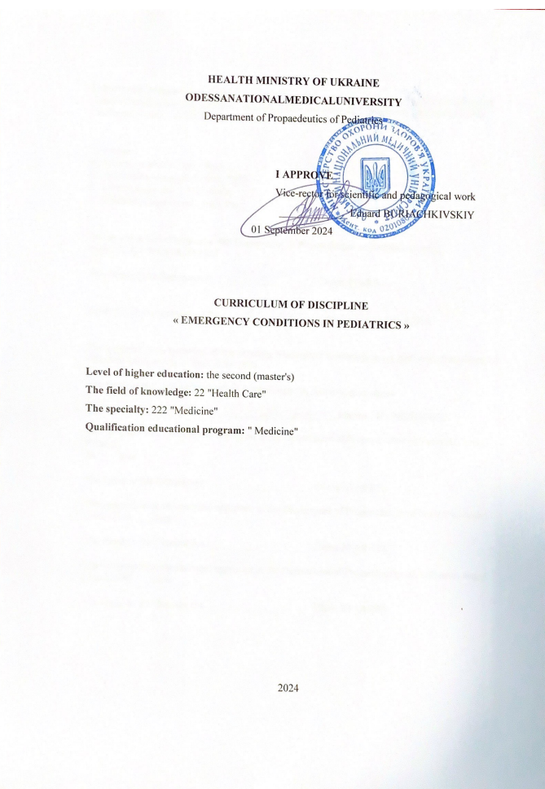

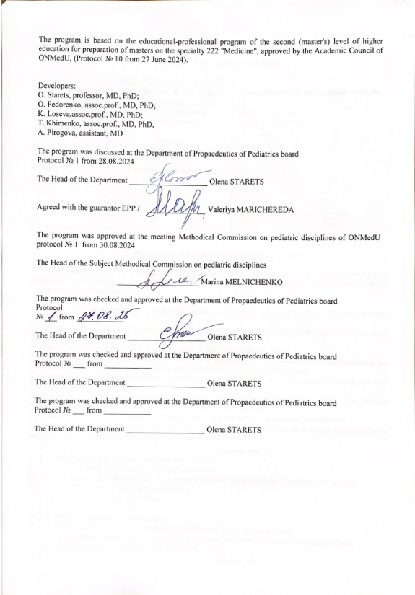

1. Description of the discipline

Name of indicators | The field of knowledge, The specialty, Level of higher education | Characteristic of the discipline
Total:  Credits – 0,5  Hours – 15  Content units– 1 | The field of knowledge:  22 "Health Care"  The specialty:  222 "Medicine"  Level of higher education: the second (master's) | Full-time education  Required discipline
Total:  Credits – 0,5  Hours – 15  Content units– 1 |  | Year of study 4
Total:  Credits – 0,5  Hours – 15  Content units– 1 |  | SemesterVІІ- VІІІ
Total:  Credits – 0,5  Hours – 15  Content units– 1 |  | Lectures (0 hours)
Total:  Credits – 0,5  Hours – 15  Content units– 1 |  | Practice(6hours)
Total:  Credits – 0,5  Hours – 15  Content units– 1 |  | Individual work(9hours)
Total:  Credits – 0,5  Hours – 15  Content units– 1 |  | Individual task (0 hours)
Total:  Credits – 0,5  Hours – 15  Content units– 1 |  | Type of control:Credit Test

2. The aim and the tasks of practice, competencies, programlearningoutcomes
The aim of the discipline "Emergency conditions in pediatrics" is to form the knowledge and skills of basic life support in emergency conditions in pediatrics.
The main task is providingemergencymedicalcareinemergenciesinlimitedtimeconditions.
According to the requirements of the standard, the discipline provides the masters of education with the acquisition of competencies:
General competencies (GC):
GC1. Abilitytoabstractthinking, analysisandsynthesis
GC 3. Abilitytoapplyknowledgeinpracticalsituations
GC 4. Knowledgeandunderstandingofthesubjectareaandunderstandingofprofessionalactivity
GC 5. Abilitytoadaptandactin a newsituation
GC 6. Abilitytomakereasonabledecisions
GC 7. Abilitytoworkin a team
GC 8. Abilitytointerpersonalinteraction
GC 11. Abilitytosearch, processandanalyzeinformationfromvarioussources
GC 12. Determinationandpersistenceinrelationtoassignedtasksandassumedresponsibilities
GC 13. Awarenessofequalopportunitiesandgenderissues
Special ( professional, subject ) competencies (SC):
SC 7. Abilitytodiagnoseemergencyconditions
SC 8. Abilitytodeterminetacticsandprovideemergencymedicalcare
Programlearningoutcomes (PLO) :
PLO 14. Determinationoftacticsandprovidingemergencymedicalcareinemergencies (accordingtolist 3) inlimitedtimeconditionsaccordingtoexistingclinicalprotocolsandstandardsoftreatment.

As a result of studing the masters of education shoud:
Know: emergency conditions in pediatrics: Pediatric Advanced Emergency Assessment, Recognition and Stabilization.
Must be ableto: perform Basic life support.

3. Structure of the program
Section 1Basic life support. Emergency conditions in pediatrics: Pediatric Advanced Emergency Assessment, Recognition and Stabilization

4. The focused structure:
Topic
Topic | Total | Pr.class  (hours) | ISW (hours)
Basic life support. Emergency conditions in pediatrics: | 5 | 2 | 3
Basic life support. Emergency conditions in pediatrics: Assessment, Recognition and Stabilizati | 5 | 2 | 3
Emergency conditions in pediatrics: Pediatric Advanced Emergency Assessment, Recognition and Stabilization | 5 | 2 | 3
In general | 15 | 6 | 9

5. Topics of lectures / seminars / practical / laboratory classes
5.1 Topics of lectures
Lectures are not provided

5.2. Topics of seminar classes
Seminar classes are not provided
5.3 Thethematicplanofpracticalclassofthediscipline.
№ | Topic | Hours
1 | Basic life suppor | 2
2 | Basic life suppor | 2
3 | Emergency conditions in pediatrics: Pediatric Advanced Emergency Assessment, Recognition and Stabilization | 2
In general |  | 6

5.4. Topics of laboratory classes.
Laboratory classes are not provided.

7.The thematic plan of individual student`s work (ISW)

№ | Topic | Hours
1. | Basic life support. Emergency conditions in pediatrics: Pediatric Advanced Emergency Assessment, Recognition and Stabilization | 9
In general |  | 9

Individual tasks are not provided.
7. Methods of education.
Practical classes: conversation, solving clinical situational problems, practicing patient examination skills. Conducted on a tape basis.
Individual student`s work: independent work with a textbook, independent solution of clinical problems.

8. Methods of control and criteria for evaluating learning outcomes
Curent control: testing, assessment of practical skills
Finalcontrol: credit test.
Thefinalcontrolisassessedon a two-pointscale"credit", "no credit":
- "credit"exhibited to the masters of education, who do not have an academic debt and have fulfilled all the tasks envisaged by the discipline;
- "nocredit"exhibitedtothe masters of education, whohave an academic debt and have not fulfilled all the tasks envisaged by the discipline;
Only those masters of education who do not have an academic debt and have fulfilled all the tasks envisaged by the discipline pass credit test.
Thecreditisgiven: atthelastlesson. Thegradeforthetestis "passed" and "failed".

9. Methods of control and criteria for evaluating learning outcomes
The average score for the practice is translated into a national grade and converted into scores on a multi-point scale.
Conversion of the traditional grade for the discipline in the 200-point is carried out by the information and computer center of the university program "Contingent", using formula:
average grade point average (current / discipline) x 40

Table for conversion of traditional assessment into multi-point:
National scale | Points
«5» | 185-200
«4» | 151-184
«3» | 120-150
«2» | <120

Points are independently converted into the ECTS scale. Further accounts are carried out by the information and computer center of the university.

Conversion of traditional assessment in the discipline and the amount of points on the ECTS scale
ECTS mark | Statistical indicator
«А» | The best 10 % of students
«В» | the next 25 % of students
«С» | the next 30 % of students
«D» | the next 25 % of students
«E» | the last 10 % of students

10. Methodical support:
- Working program of the discipline
- The syllabus of the discipline
- Multimedia presentations
- Methodical development of practical classes

11. List of questions for credit test.

1. To demonstrate basic life support of a child on the simulator.

12. Literature:
Main literature:
- Nelson textbook of pediatrics, 2 volume set. Edition: 21st, 2019.PDF format.http://pediacalls.com/e-books/nelson-textbook-of-pediatrics-21st-edition/
- Pediatrics. Differential diagnosis. Urgent conditions edited by Aryaeva ML, Kotova NV, electronic edition on CD.
- Pediatrics in two volumes, edited by Aryaev ML, Kotova NV T2, Diseases of young children. Pulmonology. Allergology. Cardiology. Gastroenterology. Nephrology. HIV infection. Primary health care textbook 2017. - 312 p.
- USMLE® STEP 2 CK: PEDIATRICS. Lecture Notes – Kaplan Vtdical, 2019. – 690 p.
Additional literature:
1. Pediatric Basic and Advanced Life Support 2020 American Heart Association Guidelines for Cardiopulmonary Resuscitation and Emergency Cardiovascular Care https://www.ahajournals.org/journal/circ2020;142(suppl 2):S469–S523. DOI: 10.1161/CIR.0000000000000901
2. European Resuscitation Council Guidelines 2021: Paediatric Life Support https://doi.org/10.1016/j.resuscitation.2021.02.015

3.Paediatric emergency triage, assessment and treatment: Care of critically ill children. – WHO. 2016
4. Essential pediatrics. O.P. Ghai,MD. – 5th edition. – MENTA PUBLISHERS. New Delhi. (India). – 2000. – 582 p.
5. EMERGENCY MEDICAL CARE: NEW CLINICAL PROTOCOL ( ORDER OF THE MOH OF UKRAINE OF 05.06.2019, №1269 ) .

13. Online resources:
- Накази МОЗ:http://www.moz.gov.ua/ua/portal/
- WHO: http://www.who.int
- UpToDate: http://www.who.int
Medscape: https://emedicine.medscape.com/pediatrics_general

