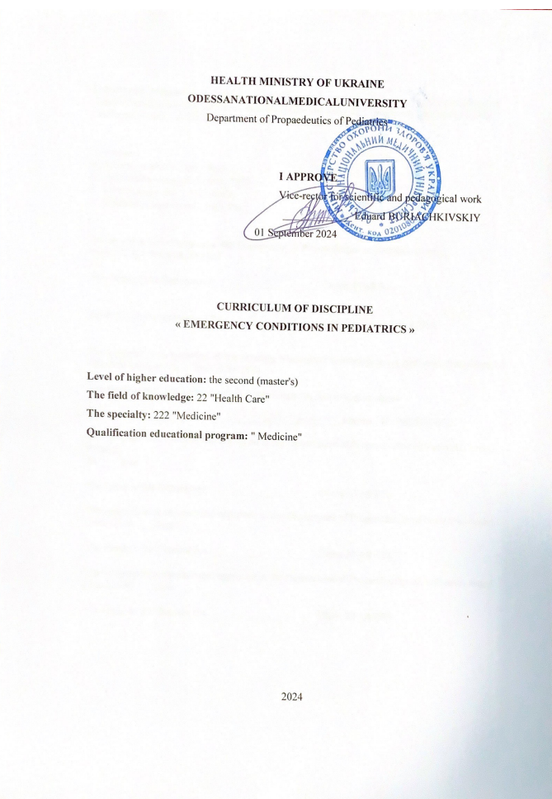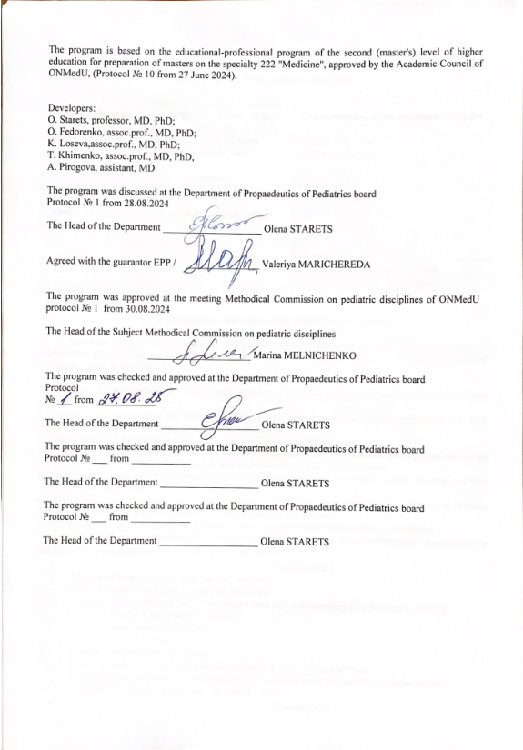
1. Description of the discipline

Name of indicators | The field of knowledge, The specialty, Level of higher education | Characteristic of the discipline
Total:  Credits – 0,5  Hours – 15  Content units– 1 | The field of knowledge:  22 "Health Care"  The specialty:  222 "Medicine"  Level of higher education: the second (master's) | Full-time education  Required discipline
Total:  Credits – 0,5  Hours – 15  Content units– 1 |  | Year of study 5
Total:  Credits – 0,5  Hours – 15  Content units– 1 |  | SemesterIX-X
Total:  Credits – 0,5  Hours – 15  Content units– 1 |  | Lectures (0 hours)
Total:  Credits – 0,5  Hours – 15  Content units– 1 |  | Practice(6hours)
Total:  Credits – 0,5  Hours – 15  Content units– 1 |  | Individual work(9hours)
Total:  Credits – 0,5  Hours – 15  Content units– 1 |  | Individual task (0 hours)
Total:  Credits – 0,5  Hours – 15  Content units– 1 |  | Type of control:Credit Test

2. The aim and the tasks of practice, competencies, programlearningoutcomes
The aim of the discipline "Emergency conditions in pediatrics" is to form the knowledge and skills of basic assistance and resuscitation of a newborn.
The main taskis to get knowledge about the algorithm of basic assistance and resuscitation of a newborn
According to the requirements of the standard, the discipline provides the masters of education the acquisition of competencies:
General competencies (GC):
GC1. Abilitytoabstractthinking, analysisandsynthesis
GC 3. Abilitytoapplyknowledgeinpracticalsituations
GC 4. Knowledgeandunderstandingofthesubjectareaandunderstandingofprofessionalactivity
GC 5. Abilitytoadaptandactin a newsituation
GC 6. Abilitytomakereasonabledecisions
GC 7. Abilitytoworkin a team
GC 8. Abilitytointerpersonalinteraction
GC 11. Abilitytosearch, processandanalyzeinformationfromvarioussources
GC 12. Determinationandpersistenceinrelationtoassignedtasksandassumedresponsibilities
GC 13. Awarenessofequalopportunitiesandgenderissues
Special ( professional, subject ) competencies (SC):
SC 7. Abilitytodiagnoseemergencyconditions
SC 8. Abilitytodeterminetacticsandprovideemergencymedicalcare
Programlearningoutcomes (PLO) :
PLO 12. Assessmentofthegeneralconditionof a newbornchildbymaking a reasoneddecisionaccordingtoexistingalgorithmsandstandardschemes, observingtherelevantethicalandlegalnorms.
PLO 14. Determinationoftacticsandprovidingemergencymedicalcareinemergencies (accordingtolist 3) inlimitedtimeconditionsaccordingtoexistingclinicalprotocolsandstandardsoftreatment.
As a result of studing the masters of education shoud:
Know: what kind of emergency medical care needs newborn baby.
Must be ableto: perform the basic assistance and resuscitation of a newborn.

3. Structure of the program
Section 1Basic assistance and resuscitation of the newborn.

4. The focused structure:

Topics | Hours
Topics | In general | Pr.class  (hours) | Ind.work  (hours)
Basic assistance and resuscitation of the newborn | 5 | 2 | 3
Basic assistance and resuscitation of the newborn | 5 | 2 | 3
Basic assistance and resuscitation of the newborn | 5 | 2 | 3
In general | 15 | 6 | 9

5. Topics of lectures / seminars / practical / laboratory classes
5.1 Topics of lectures
Lectures are not provided

5.2. Topics of seminar classes
Seminar classes are not provided
5.3 Thethematicplanofpracticalclassofthediscipline.
№ | Topic | Hours
1 | Basic assistance and resuscitation of the newborn | 2
2 | Basic assistance and resuscitation of the newborn | 2
3 | Basic assistance and resuscitation of the newborn | 2
In general |  | 6

5.4. Topics of laboratory classes.
Laboratory classes are not provided.

7.The thematic plan of individual student`s work (ISW)

№ | Topic | Hours
1. | Basic assistance and resuscitation of the newborn | 9
In general |  | 9

Individual tasks - are not provided.
7. Methods of education.
Practical classes: conversation, solving clinical situational problems, practicing patient examination skills. Conducted on a tape basis.
Individual student`s work: independent work with a textbook, independent solution of clinical problems.
8. Methods of control and criteria for evaluating learning outcomes
Curent control: testing, assessment of practical skills
Finalcontrol: credit test.
Thefinalcontrolisassessedon a two-pointscale"credit", "no credit":
- "credit"exhibited to the masters of education, who do not have an academic debt and have fulfilled all the tasks envisaged by the discipline;
- "nocredit"exhibitedtothe masters of education, who have an academic debt and have not fulfilled all the tasks envisaged by the discipline;
Only those masters of education who do not have an academic debt and have fulfilled all the tasks envisaged by the discipline pass credit test.
Thecreditisgiven: atthelastlesson. Thegradeforthetestis "passed" and "failed".

9. Methods of control and criteria for evaluating learning outcomes
The average score for the practice is translated into a national grade and converted into scores on a multi-point scale.
Conversion of the traditional grade for the discipline in the 200-point is carried out by the information and computer center of the university program "Contingent", using formula:
average grade point average (current / discipline) x 40

Table for conversion of traditional assessment into multi-point:
National scale | Points
«5» | 185-200
«4» | 151-184
«3» | 120-150
«2» | <120

Points are independently converted into the ECTS scale. Further accounts are carried out by the information and computer center of the university.

Conversion of traditional assessment in the discipline and the amount of points on the ECTS scale
ECTS mark | Statistical indicator
«А» | The best 10 % of students
«В» | the next 25 % of students
«С» | the next 30 % of students
«D» | the next 25 % of students
«E» | the last 10 % of students

10. Methodical support:
- Working program of the discipline
- The syllabus of the discipline
- Multimedia presentations
- Methodical development of practical classes

11. List of questions for credit test.

1. To demonstrate the resuscitation of the newborn on the simulator.

12. Literature:
Main literature:
- Nelson textbook of pediatrics, 2 volume set. Edition: 21st, 2019.PDF format.http://pediacalls.com/e-books/nelson-textbook-of-pediatrics-21st-edition/
- Pediatrics. Differential diagnosis. Urgent conditions edited by Aryaeva ML, Kotova NV, electronic edition on CD.
- Pediatrics in two volumes, edited by Aryaev ML, Kotova NV T2, Diseases of young children. Pulmonology. Allergology. Cardiology. Gastroenterology. Nephrology. HIV infection. Primary health care textbook 2017. - 312 p.
- USMLE® STEP 2 CK: PEDIATRICS. Lecture Notes – Kaplan Vtdical, 2019. – 690 p.

13. Online resources:
- Накази МОЗ:http://www.moz.gov.ua/ua/portal/
- WHO: http://www.who.int
- UpToDate: http://www.who.int
Medscape: https://emedicine.medscape.com/pediatrics_general

