ODESSA NATIONAL MEDICAL UNIVERSITY

DEPARTMENT OF DRUGS TECHNOLOGY

APPROVE
Head of Department
 (Borisyuk I.Yu.)
signature
«26» august 2022 y.

METHODICAL DEVELOPMENT OF PRACTICAL LESSON

Course: 5Faculty: Pharmaceutical

Course: Biopharmacy

Practical lesson №4 Topic: «Influence of dosage form on the process of drug release from drugs.»

The practical lesson was developed by:
Ph.D., Assoc.
(Fizor. N.S.)
signature
The practical lesson was discussed at the methodical meeting of the department
«29» august 2022 y.
Protocol № 1

Odesa – 2022
The purpose of the lesson: the formation of knowledge, skills, practical skills to study the impact of the dosage form on the process of release of drugs from drugs.
General goal: to get acquainted with the modern definition of bioavailability of drugs, the factors that affect it.
Educational purpose: to get acquainted with the contribution of domestic scientists in studying the problem of the influence of the dosage form on the process of drug release; be able to explain to the patient the need to take drugs in accordance with the doctor's instructions in compliance with the time frame and dietary conditions.
Basic concepts: Dosage form, pharmacokinetic curve, elimination constant.
Equipment: according to the requirements of Good Pharmacy Practice (GPP).
Study time: 2.0
Plan
I. Organizational moment.
ІІ. Control of basic knowledge
2.1. Requirements for theoretical readiness of students to perform practical classes (knowledge requirements, list of didactic units):
Requirements for theoretical knowledge:
Dosage form is a rational from a pharmacological point of view, convenient to receive and store form of the drug, which provides its optimal therapeutic effect with minimal side effects.
According to modern ideas, the dosage form is a material norm of manifestation of the dialectical unity of active and auxiliary substances, as well as technological operations that provide the optimal therapeutic effect of the drug.
The creation of a dosage form in almost all cases requires the use of an excipient. The excipients are not indifferent and in all cases they affect the release of the drug in one way or another. Milk sugar is most often used for these purposes. However, in its presence, for example, increases the absorption of testosterone, reduces the activity of isoniazid. Therefore, in each case, the choice of excipient must be individual to the particular drug substance. For example, ointments with antibiotics (particularly penicillin) made with Vaseline are ineffective due to poor resorption. In this case, you need a base that includes 6 parts of Vaseline and 4 parts of lanolin, which is now used for the manufacture of many ointments with antibiotics.
Boric acid does not have a bacteriostatic effect in the manufacture of ointments based on fat, but is effective in ointments based on hydrophilic bases, which contain large amounts of water. Iodine, on the other hand, is inactive in ointments based on large amounts of water. Thus, the introduction of substances into different types of emulsion bases makes it possible to obtain ointments with different degrees of absorption.
The rate of diffusion of drugs from ointment bases is influenced by the structural and mechanical properties of the bases. For example, the introduction of aerosil in the amount of 5-8% in hydrocarbon bases leads to an increase in the viscosity of ointment bases, resulting in a decrease in the release of salicylic acid. This confirms the need for an individual approach in the choice of excipients.
Dimethyl sulfoxide is able to easily penetrate intact skin, transport, deposit and prolong the flow of drugs into the body. Thus, the addition of DMSO in eye drops accelerates the penetration of antibiotics into the tissues of the eye, the use of MC allows you to keep drugs in the tissues for a long time, thus exerting a prolonged effect, which is important in the treatment of many chronic diseases.
A large number of LRs with molecules of complex configuration easily enter into the complexation reaction. The resulting complexes can be very strong and weaken the basic pharmacological properties of the drug. The intensity of technological processes that take place in the production of drugs can significantly affect the complexation reaction, accelerating or directing it in the appropriate direction. Particularly responsible in this respect are the stages of dissolution, filtration, recrystallization, melting, mixing, etc., in which there is a change in the physical state of drugs and excipients, the intensity and growth of the number of contacts between them.
Dosage form is a structural unit of both pharmacotherapy and industrial production.
The most important task in the development and preparation of the dosage form is to ensure optimal conditions for the release and subsequent absorption of the substance. All other requirements to which the dosage form must meet are subject to these conditions.
The pharmacy considered the dosage form as a means of transporting the drug into the body. In this regard, the convenience of administration of drugs through natural routes was mainly taken into account, and therefore 70-80% of all drugs are administered orally. Comparative studies of one or another dosage form have not been conducted, and the current practice has shown that of all dosage forms, the most popular are tablets (50% of all GLZ). In pediatric practice, up to 70% are liquid drugs. This can be explained by the fact that the oral route is the most convenient, although not always effective. With the introduction of "per os" many drugs are enzymatically broken down, lose activity, irritate the mucous membrane of the gastrointestinal tract, enter into chemical interactions at different pH from 2 to 8. The decomposition products cause various complications.
Resorption processes due to the individuality of each drug and the patient's pathology are different, so the drugs have different bioavailability. The degree of influence of the dosage form on the processes of absorption is determined by the ability to release the active substance from the oral dosage form and the possibility of contact with the mucous membranes of the stomach, intestines and interaction with their secretions. According to the degree of release and, accordingly, better bioavailability, all oral drugs can be arranged in the following order: solutions — emulsions — suspensions — powders — granules — tablets. The dosage form affects the therapeutic activity in combination with other pharmaceutical factors. This can be seen in the example of tablets and capsules "Propoltina".
№ p / p | The name of the drug | Time of complete dissolution,  min | Sampling time, min | Release of active substance,%
1 | Propoltin tablets (0.05 PHPP) | 30.5 ± 2.4 | 6 | 16.2 * 3.1
1 | Propoltin tablets (0.05 PHPP) | 30.5 ± 2.4 | 30 | 76.0 ± 4.2
2 | Propoltin capsules (0.05 PHPP) | 6.5 ± 0.64 | 6 | 78.4 ± 2.4
The maximum content of the sum of phenolic compounds in Propoltin capsules was observed in the studied samples after their complete dissolution, ie after 6 to 8 minutes. The content of the sum of phenolic compounds in tablets "Propoltin" in this period of time was 1b, 2 ± 3.1%, reaching a peak concentration in the samples after 30 min (average dissolution time of tablets).
The discrepancy in the obtained results is due to the presence of enteric-coated tablets. The shell itself dissolved under visual observation after 3 to 5 minutes In addition, the excipients in Propoltin tablets (sugar, starch, calcium stearate, magnesium carbonate basic) and in Propoltin capsules, which contain magnesium basic carbonate and Aerosil, have a significant effect on the bioavailability of PHPP. The tablets dissolve in the intestines, the capsules - in the stomach.
On the basis of numerous biopharmaceutical studies and scientific substantiation of the influence of this factor, it is possible to create drugs with specified pharmacokinetic properties, which have a certain pharmacological effect: synergism, potentiation, antagonism, prolongation, differentiated or directed action, broadening and antibacterial spectrum. Thus the set therapeutic effect is provided not only by structure of a dosage form, but also an opportunity to involve physiological features of an organism. Therefore, among modern dosage forms are widespread tablets: retard, duruli, sandwiches, duplex, enteric, perlingual, sublingual, buccal, implantation, and others. Depending on the situation, you can use different rectal forms: suppositories layered, swollen, rectioles, syringes, tampons, enemas, etc.
New dosage forms based on micro- and monocapsulation, spansulas, depot preparations, pseudopowders and pseudosuspensions, as well as liposomes, ionixens, collagen, etc. have appeared in medical practice and are successfully used in pharmacotherapy.
The choice of a rational dosage form has a positive effect on the therapeutic effect of drugs. Thus, the replacement of tablet forms of theophylline, euphylline, diprophylline, digoxin with rectal suppositories significantly increases their bioavailability. The use of rectal forms of these drugs can reduce their dose. According to VV Nagorny, VO Golovkin, IL Kechinov, suppositories can replace the introduction of these drugs in the form of injections, as the rectal route of administration is bioavailable to injectable and allows not to injure the patient. In addition, when administered intravenously, the drugs are rapidly excreted from the body, and after rectal administration of some drugs in the form of suppositories and microenemas (eg, Xan-tiverine) there is a prolongation of their action. To achieve a prolonged effect of nitroglycerin, it is recommended to use the patch "Nit-Roderm" instead of tablets. The well-known anti-ischemic drug "trinitrolong" is better to enter in the form of plates. This dosage form allows you to individually dose the drugs, providing uninterrupted and maximum therapeutic effect. According to statistics, approximately 30% of patients have difficulty taking tablets and capsules, so they grind the tablets and open the capsules. 23% of patients prefer soluble dosage forms. With this in mind, the industry is setting up the production of the latter. Thus, instead of the usual amocillin capsules (bioavailability of 75%) the drug "Flemoxina solutab" (bioavailability of 95%) is produced.
The choice of dosage form simultaneously determines the method (path) of administration of the drug into the body. Each route of administration has its advantages, but not all of them are effective. For one reason or another, sometimes even intravenous administration of the drug does not provide bioavailability. For example, in the treatment of choriogonin in the form of injections there were changes in the emotional state of the patient, allergic reactions, and the introduction of the drug in the form of suppositories did not cause side effects. In the case of cardiac decompensation, injections and rectal forms should be considered rational dosage forms of cardiac glycosides, as oral administration causes intestinal irritation (ulcer, bleeding, pain), which is associated with impaired absorption of mucous membranes in such patients. Long-term therapy of methindol in suppositories proceeds without complications with a good therapeutic effect, while the use of the drug in tablets is accompanied by dyspeptic symptoms, disorders of the central nervous system and other complications.
Thus, the dosage form should be convenient to use, advantageous and rational only in economic, aesthetic terms, but primarily in terms of pharmacodynamics of the drug and the provision of modern requirements for pharmacotherapy.

Didactic units:
Dosage form

2.2. Questions (tests, tasks, clinical situations) to test basic knowledge on the topic of the lesson:
Answer the question:
1. The concept of dosage form
2. Basics used in manufactured dosage forms.
3. The rate of diffusion of drugs from ointment bases.
4. Among modern dosage forms are widespread tablets…
5. The influence of the choice of a rational dosage form on the therapeutic effect of drugs.
6. Methods of obtaining tablets. The influence of pharmaceutical factors on the therapeutic efficacy of tablets.
7. Gelatin capsules, preparation and methods of filling. Influence of pharmaceutical factors on their therapeutic activity.
8. The concept of solubility of drugs. Pharmacopoeial test to determine solubility.
9. The influence of the dosage form on the rate of absorption of the drug, its concentration in biological fluids and the stability of drugs.
10. Calculation of the area under the pharmacokinetic curve. Absorption and elimination constants.
11. Correlation of methods "in vitro" and "in vivo" in determining the release and bioavailability of drugs.
Solve the test:
- In what order it is necessary to arrange oral dosage forms on degree of absorption
A. solutions-powders-suspensions-emulsions-granules-tablets
B. emulsions-suspensions-solutions-powders-granules-tablets
C. suspensions-emulsions-granules, solutions-powders-tablets
D. solutions-emulsions-suspensions-powders-granules-tablets
E. suspensions-emulsions-granules-tablets-solutions-powders
- Indicate which term corresponds to the following statement: "The process of transition of the drug from the place of reception to the bloodstream."
A. bioavailability
B. equivalence
C. system availability
D. biotransformation
E. absorption
- Indicate which term corresponds to the following statement: “The process by which a drug is excreted from the circulatory system through the kidneys, urine, bile and saliva into the intestines and feces, through the skin, mammary glands and sweat glands.
A. selection
B. resorption
C. biotransformation
D. distribution
E. does not have the correct answer
- Indicate which term corresponds to the following statement: "The process by which a drug substance is distributed or dispersed from the blood into one or more parts, into tissues and organs of the body."
A. distribution
B. purity
C. purity of the whole body
D. resorption
E. biotransformation
- Indicate which processes are directly related to the study of pharmacodynamics?
A. derivation, effect
B. release of the substance from the dosage form, absorption
C. metabolism, excretion
D. absorption, distribution, metabolism, excretion
E. LADMER
- Indicate which processes are directly related to the study of pharmacokinetics?
A. derivation, effect
B. release of the substance from the dosage form, absorption
C. metabolism, excretion
D. absorption, distribution, metabolism, excretion
E. LADMER
- The maximum allowable ratio when mixing powders
A. 1: 1
B. 1: 5
C. 1:20
D. 1: 2
E. 1: 7
- Some types of capsules have their own names. Select the definition that corresponds to the medulla:
A. soft gelatin capsules with an elongated neck
B. hard gelatin capsule with film-coated microcapsules
C. hard gelatin capsules with microdraggering with a fatty shell
D. individual particles of LR with a thin shell, the size of which is 1 - 5000 microns .;
E. soft elastic capsule
- Some types of capsules have their own names. Select the definition that corresponds to the nanocapsules:
A. soft gelatin capsules with an elongated neck
B. individual particles of LR with a thin shell, the size of which is less than 1 μm
C. hard gelatin capsules with microdraggering with a fatty shell
D. hard gelatin capsule with film-coated microcapsules
E. soft and elastic capsule of various shapes
- Some types of capsules have their own names. Select the definition that corresponds to the microcapsules:
A. soft gelatin capsules with an elongated neck
B. individual particles of LR with a thin shell, the size of which is 1 - 5000 microns
C. individual particles of LR with a thin shell, the size of which is less than 1 μm
D. hard gelatin capsule with film-coated microcapsules
E. soft and elastic capsule of various shapes
III. Formation of professional skills, abilities:
3.1.content of tasks:
Task № 1
To establish the influence of the dosage form on the process of releasing the phenolic hydrophilic preparation of propolis by the "in vitro" method.
Task № 2
To establish the influence of the type of dosage form on the process of absorption of streptocide into the blood of animals by the method of "In vivo".
Task № 3
Calculate the area under the pharmacokinetic curve, the elimination constant and the absorption constant of streptocide in the blood from ointments and suppositories.

3.2.recommendations (instructions) for performing tasks
Task № 1
The effect of the dosage form on the process of drug release can be traced on various dosage forms: tablets, capsules, potions, ointments, suppositories, injectable solutions, and others. For comparison, you can use 2 or more dosage forms of the same drug substance.
The object of the study are coated tablets and capsules "Propoltin" 0.05.
Preparation of tablets:
Propoltin coated tablets are used ready-made. Their prototypes were obtained on the DNCLZ by direct pressing.
Preparation of Propoltin capsules
To fill, use gelatin capsules № 4, also obtained by pressing in the factory. Capsules are filled manually with 0.1 mixture of phenolic hydrophilic preparation of propolis with excipients. The mixture contains the same excipients as in tablets. Before completing the task, get acquainted with the algorithm of experimental work for task № 1 (Appendix 1).
Appendix 1
ALGORITHM OF EXPERIMENTAL WORK FOR DETERMINATION OF SOLUBILITY OF THE TESTED TABLETS AND CAPSULES "PROPOLTIN"
Propoltin tablets of 0.05, coated,
Propoltin capsules of 0.05

Bringing the device "Rotating basket"
in working condition

Dissolution of tablets and capsules

Sampling

Determination of the concentration of active substances

Statistical processing of the obtained results

Conclusions

Determination of the dissolution rate of tablets and capsules "Propoltin"
For the experiment using the device "Rotating basket", where the dissolution medium is purified water (0.5 l) with a temperature of 37 ± 1 ° C, the speed of rotation of the basket is equal to 100 rpm The test tablet is placed in a dry basket, to which is immersed in the dissolution medium so that the distance to the bottom of the vessel was 20 ± 2 mm the vessel is closed with a lid and the basket is rotated for a long time until the tablet is completely dissolved.
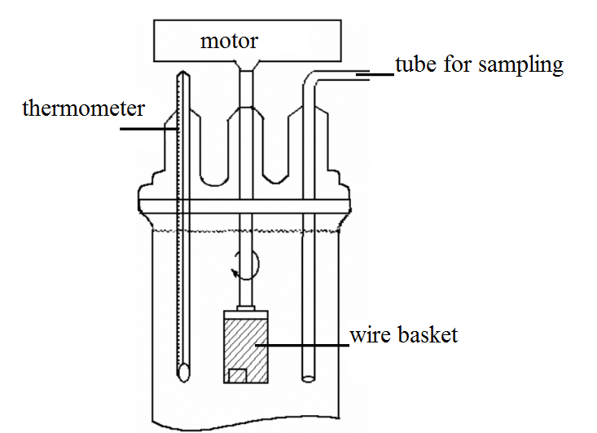
Fig.1. Diagram of the device for determining the dissolution rate
Quantitative determination of phenolic hydrophilic preparation of propolis
Propoltin tablets and capsules contain 0.05 phenolic hydrophilic drug propolis (FGPP). It consists of the sum of phenolic acids, oxycoumarins, flavones and traces of polysaccharides. When determining the amount of phenolic compounds in the selected samples using the method of determining FGPP, set out in VFS 42-2024-90.
5 ml of the resulting solution is placed in a volumetric flask of 25 ml, bring the volume of the solution with 95% ethyl alcohol to the mark and mix. Measure the optical density of the obtained filtrate on a spectrophotometer SF-46 at a wavelength of 290 nm in a cuvette with a layer thickness of 10 mm, using as a reference solution 95% ethyl alcohol.
In parallel, measure the optical density of the working standard sample (PCR) of potassium dichromate, using purified water as a reference solution.
Preparation of a solution of RCC potassium dichromate .
About 0.06 g (exact portion) of potassium dichromate is placed in a volumetric flask with a capacity of 1000 ml, dissolved in a small amount of water, add 5 ml of 1 M solution of sulfuric acid, make the volume of the solution with water to the mark and mix.
The content of phenolic compounds ( X ) in one capsule in grams is calculated by the formula:
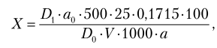
where D ₁ is the optical density of the test solution;
D ₀ - optical density of the solution of RCC potassium dichromate (in this case was 0.58);
a₀ is the weight of the sample of the standard sample, g;
0.1715 - conversion factor of potassium dichromate absorption by the sum of phenolic compounds at λ = 290 nm;
V is the volume of solution taken for analysis, ml;
a - the content of active substances in one capsule or tablet;
500, 25 - dilution of the drug, ml;
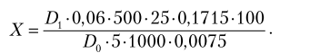
Carry out statistical processing of the results of 5 samples. To calculate the error of the average measurement result use the formula:
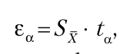
where - the error of the arithmetic mean of the measurements;
S _{X} - standard deviation of the arithmetic result of measurements, which, in turn, dorvin
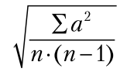,
where a is the numerical value of the deviation of the measurements from the arithmetic mean;
n is the number of observations;
ta- Student's ratio at k = n - 1 is found in table 1;
α- "confidence probability", which characterizes the reliability of the magnitude of the error.

Table 1
RATIO DEVIATION COEFFICIENT
(WITH A SMALL NUMBER OF OBSERVATIONS) Α ;
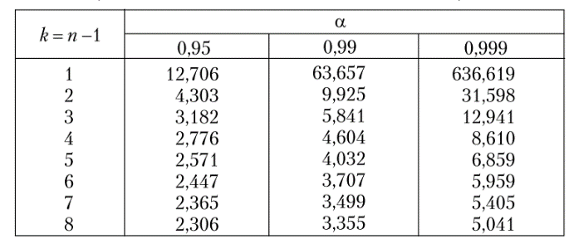
Example of calculation for tablets "Propoltin".
Time of complete dissolution (min)
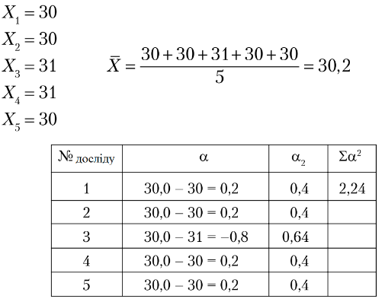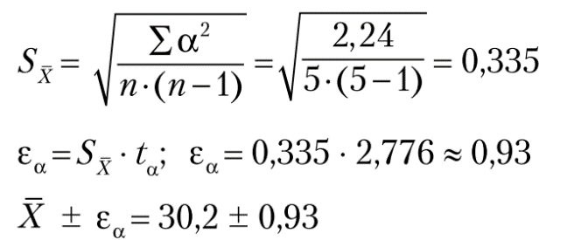
The dissolution time of solid dosage forms and the percentage of release of active substances make in table. 2.
Table 2
DYNAMICS OF DISSOLUTION OF COATED TABLETS
SHELL, AND PROPOLTIN CAPSULES
№  p / p | Name  preparation | Time of complete dissolution, min | Sampling time, min | Release of active substance,%
1. | Propoltin tablets  (0.05 PHPP)
2. | Propoltin capsules  (0.05 PHPP)
After completing the task, draw conclusions about the effect of the dosage form on the release of phenolic hydrophilic drug propolis.
Task № 2
Methodical recommendations for the task
The effect of the dosage form on the degree and nature of absorption of drugs from ointments and suppositories can be traced by determining their concentration in the blood.
The investigated dosage forms are prepared on the same chemical basis and administered to rabbits in equal doses.
The object of study are streptocidal ointment and suppositories with streptocide on polyethylene oxide bases.
Preparation of ointments
Ointment is prepared at 10% concentration. In the molten base, consisting of 80% PEO 400, and 20% PEO 1500, dissolve the streptocide with stirring with a glass rod, then the mixture is transferred into a mortar and stirred to cool.
Preparation of suppositories
Suppositories are prepared weighing 1.5 g by pouring. The dose of streptocide in suppositories is calculated based on the fact that 1 kg of rabbit weight should be administered
0.05 substance. Calculate the amount of base, the substitution rate of streptocide on a polyethylene oxide base is 1.26. Streptocide is dissolved in a molten base consisting of 80% PEO 1500 and 20% POE 400, and poured into a mold lubricated with Vaseline oil. Propoltin capsules
(0.05 FGPP). The machine is placed in the refrigerator. After cooling, the candle is wrapped in a scarf and placed in a box.
Before completing the task, get acquainted with the algorithm of experimental work for task № 2 (Appendix 2).

Annex 2
ALGORITHM OF EXPERIMENTAL WORK ON DETERMINATION OF THE INFLUENCE OF THE DOCUMENT ON THE ABSORPTION OF STREPTOCIDE BY THE "IN VIVO" METHOD
Rabbits - 2 heads

Weighing animals
Ointment streptocidal
Suppositories with streptocide
Preparation of animals for the experiment (release from the hair of the posterior lateral surface of the 1st rabbit;
release of the rectum in the 2nd rabbit)

Calculation of drug doses

Administration of drugs to animals

Blood sampling from the ear vein of rabbits in 0.5; 1; 1.5 hours from the start of the experiment

Data processing, construction of release curves
streptocide in the blood from ointments and suppositories, determination
pharmacokinetic drugs

Conclusions

The experiment is performed on 2 rabbits weighing 2.5-3 kg.
One rabbit is injected with a suppository, and the other on the freed from the area of 5 × 5 cm back of the back is applied ointment with a glass rod or a plastic spatula at a rate of 0.5 g / kg.
Blood sampling is performed after 0.5; 1; 1.5 hours after administration of drugs.
Quantitative determination of streptocide in the blood is carried out according to the method described in lesson № 2 (task № 3). Enter the results in table. 10 and use to plot the concentration of streptocide in the blood of rabbits (m kg / ml) from time (hours) (Fig. 2).
After completing the task, draw conclusions about the influence of the dosage form on the process of absorption of streptocide into the blood.

Table 3
DATA FOR DETERMINATION OF PHARMACOKINETIC PARAMETERS OF STREPTOCIDE FROM DIFFERENT PHARMACEUTICAL FORMS
Dosage form | 0.5 years | 1:00 | 1.5 years
Ointment streptocidal 10%
Suppository with streptocide
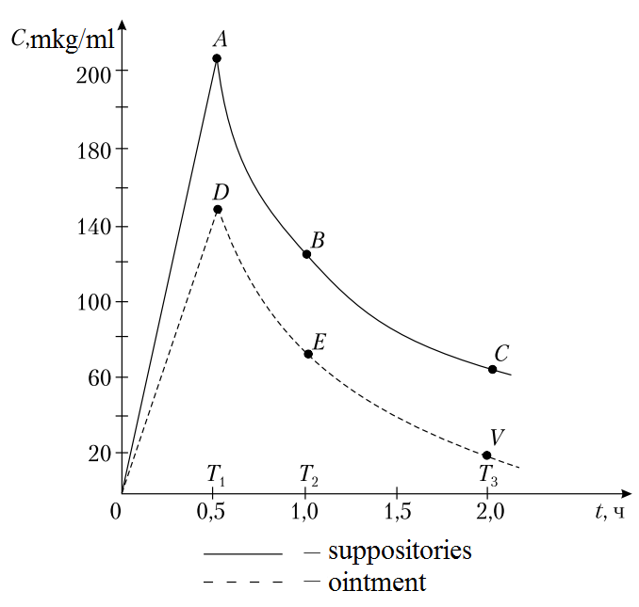
Fig. 2. Dependence of concentrations of streptocide absorbed into the blood from different dosage forms on time
Task № 3
Calculate the area under the pharmacokinetic curve, the elimination constant and the absorption constant of streptocide in the blood from ointments and suppositories.
Methodical recommendations for the task
In cases where a complete analysis of pharmacokinetic data is not possible, the degree of bioavailability of the drug in the blood can be determined by the ratio of the areas under the pharmacokinetic curves obtained by drug administration in the studied forms. Determination of bioavailability is carried out by a linear method, which involves the approximation of individual sections of the pharmacokinetic curve by segments of lines. The area under the pharmacokinetic curve ( S ) is expressed by the sum of the areas of triangles and trapezoids.
The elimination constant ( K _{el} ) is defined graphically as the tg of the angle (angular coefficient) formed by the intersection of the abscissa axis and the pharmacokinetic curve of the concentration of streptocide in the blood in semi-logarithmic coordinates. One way to determine the absorption constant is the Dosta method, which is based on the method of sequential logarithm, according to which to determine the absorption constant it is enough to know the value of the elimination constant and the time to reach the maximum concentration of the drug in the blood.
Using the table Enough by the product of elimination and the time to achieve the maximum concentration of the drug in the blood find the value of, and then calculate the value of the absorption constant.
1. Determination of the area under the pharmacokinetic curve
Based on the results of determining the concentration of streptocide in the blood of rabbits for 1.5 hours when applying the ointment and the introduction of the suppository, construct curves of the concentration of streptocide in the blood over time (Fig. 3).
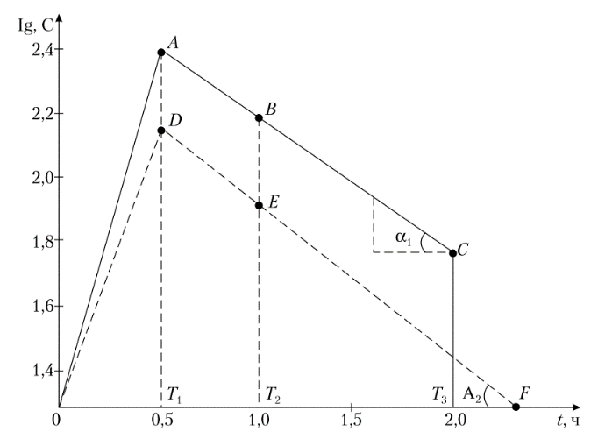
Fig . 3. The dependence of the concentration of streptocide absorbed into the blood from different dosage forms, from time to time in semi-logarithmic coordinates

The area under the pharmacokinetic curve ( S ) is determined by the sum of the areas ( S ₁ + S ₂ + S _{n} ) into which it can be divided.
According to the linear trapezoidal method, the ABC curve can be replaced by two straight lines AB , BC , and the DEF curve - straight lines DE and EF .
The area under the curve of the corresponding suppository, ie. under the curve OAVS (S) will consist of the areas of a right triangle OAT ₁ (S) and two AT ₁ T ₂ V (S) and VT ₂ T ₃ C (S) . The area of ​​a right triangle is equal to the sum of the legs. The area of ​​the trapezoid is equal to the sum of the bases of the trapezoid multiplied by the height.
Example of calculation for a suppository
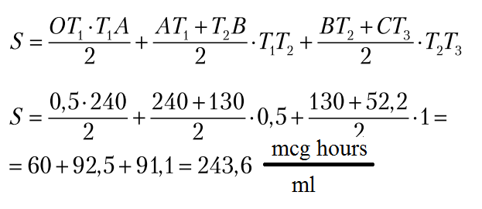
For ointments, the area of ​​the ODEF curve is determined to be similar.
2. Determination of the elimination constant
To determine the elimination constant on the segments of the lines ABC and DEF construct right triangles. The elimination constant is determined by the ratio of the length of the opposite leg to the adjacent leg of the triangle.
For the suppository:
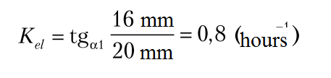
For ointment K _{el} isdetermined similarly.
3. Determination of the suction constant
The suction constant ( K ₀₁ ) is equal to the product of ξ and the elimination constant K _{el} :
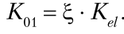
ξ is found by the value of the product of the elimination constant and the time to reach the maximum concentration of the drug in the blood (Table 4).
For the suppository:
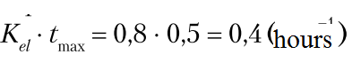
ξ = 5.0 (according to the table Enough)
K ₀₁ = 0.8-5.0 = 4.0 (hours⁻¹ )
For ointment K ₀₁ isdetermined similarly.
Table 4
DETERMINATION OF SUCTION CONSTANT BY METHOD
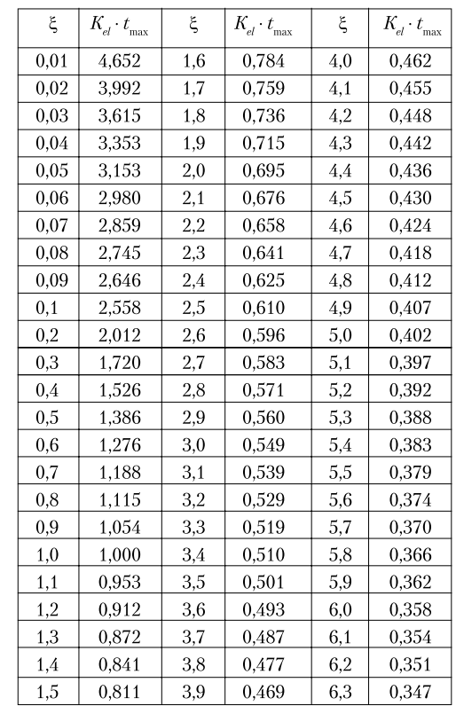
After completing the task, formulate a conclusion about the dependence of the therapeutic effect on the type of dosage form.

3.3.requirements for work results, including before registration
In accordance with the recommendations (instructions) for the tasks.
3.4.control materials for the final stage of the lesson: tasks, tasks, tests, etc .:
- In order to prolong the action of nitroglycerin it is used in the form
A. patch
B. capsules
C. suppository
D. injections
E. infusions
- A patient who needs to prepare camphor ointment went to the pharmacy. What concentration of ointment should be prepared by a pharmacist, guided by the requirements of regulatory documents?
A. 10%
B. 1%
C. 15%
D. 20%
E. 5%
- The patient must undergo treatment with methindol (indomethacin). Which dosage form will be rational:
A. tablets
B. capsules
C. suppositories
D. ointment
E. gel
- When the influence of the type of dosage form on the process of analgin release by the method of "in vitro", as the medium used:
A. water
B. acid
C. meadow
D. formalin
E. acetone
- How will the quality of gelatin capsules change if the temperature of the mass specified in the regulations is reduced during their formation by the immersion method?
A. the walls of gelatin capsules will be thick
B. the walls of gelatin capsules will be thin and brittle
C. the walls of the gelatin capsules will be with the inclusion of air
D. the walls of gelatin capsules do not dissolve
E. the walls of gelatin capsules will be very hard
- What are the acid-resistant coatings used in the manufacture of tablets and capsules:
A. plasticizers
B. enteric
C. disintegrating
D. thixotropic
E. insoluble
- What are the substances that promote deaggregation of encapsulated powder mass:
A. thixotropics
B. slippery substances
C. disintegrators
D. anti-fractional substances
E. fillers
- Excipients in the dosage form do not affect:
A. pharmacokinetic parameters
B. appearance, stability, storage
C. conditions of technological operations
D. homogeneity by weight of packaging units
E. therapeutic equivalence
- The patient needs to prepare a non-fat cream. What substances can be used as a basis for such a cream?
A. Sunflower or cottonseed oil.
B. Vaseline oil
C. Methylcellulose base
D. Vaseline-lanolin base.
E. Vaseline
- The patient needs to prepare a non-fat cream. What substances can be used as a basis for such a cream?
A. Sunflower or cottonseed oil.
B. Vaseline oil
C. Gelatin-glycerin base.
D. Vaseline-lanolin base.
E. Vaseline
IV. Summing up

List of recommended reading
Main:
1. Біофармація : підруч. для студентів закл. вищ. освіти / О. І. Тихонов [та ін.] ; за ред. О. І. Тихонова. – 2-ге вид., перероб. і допов. – Харків : НФаУ: Золоті сторінки, 2019. – 224 с
2. Настанова СТ-Н МОЗУ 4242-7.1:2005 «Лікарські засоби. Настанова з клінічних досліджень. Дослідження біодоступності та біоеквівалентності» - Київ, 2018.
3. Настанова СТ-Н МОЗУ 4242-7.1:2005 «Лікарські засоби. Настанова з клінічних досліджень. Дослідження біодоступності та біоеквівалентності» - Київ, 2018.
4. Настанова СТ-Н МОЗУ 42-7.2:2018 Лікарські засоби дослідження біоеквівалентності. – Київ, 2018. – 77 с.

