Ministry of Health of Ukraine
Odessa National Medical University
International Faculty

Department of Organization and Economics of Pharmacy
with post-diploma specialization

Discipline "The labor protection in industry"
Year of study 4 Term 8

GUIDELINES FOR INDEPENDENT WORK OF STUDENTS #13
The topic « Personal protective equipment. »

Discussed and approved
at the meeting of the
Department of Organization and
Economics of Pharmacy
with post-diploma specialization
Minutes №1 “04/09 2023
Head of the Department,
As. Prof. Oksana BIELIAIEVA


2023

Hand hygiene
  - Each pharmacy staff should perform daily checks about the availability soap and alcohol-based hand rub in their work area and rest room
  - Decontaminate hands with alcohol-based hand rub (preferentially) or soap and water (especially, when visibly soiled with blood and body fluid) in the following situations
  - Before and after handling medications equipment,
  - Before and after direct patient contact,
  - Before and after handling the medication,
  - Before and after of clean and sterile procedures,
  - Before donning sterile gloves or after removing the gloves,
  - Before and after handling medical devices. For instance, respiratory
devices, and intravascular catheters (palpating, replacing, accessing, repairing, or dressing)
9. Before eating and after using a restroom,
10. After contact with blood, body fluids, mucous membranes, non-intractable skin, and wound dressings (here hand washing is indicated),
11. After contact with inanimate objects in the patients’ immediate environment,
12. If moving from a contaminated body site to a clean body site
Hand Hygiene techniques
1. Each section of pharmacy department should contain a hand wash station and hand rub dispenser, such as a hand sanitizer (Isopropyl Alcohol 75%).
2. The pharmacists should wash before starting any work and after finishing based on above situations
3. The pharmacist should be the hand according to procedures (Figure 1) by soap and water.
4. Use the water and soap before beginning the work or each activity as mentioned above and at any location of the pharmaceutical sections such as an outpatient pharmacy, inpatient pharmacy, community pharmacy, repackage area, drug information section, clinical pharmacy section, medications safety officer, pharmacy infection unit, and pharmacy research section.

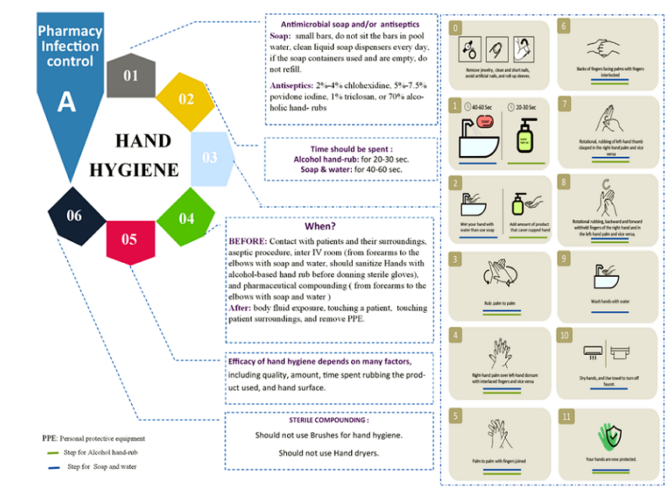
5. Use water and soap plus hand sanitizer for any pharmaceutical compounding (sterile or non-sterile)
Fig.1 Principle of Personal Protective Equipment (PPE) Procedures
Skin care
1. The pharmacy workers might use the hand lotions or creams to reduce the irritant effect of hand sanitizer and antiseptics.
2. Follow the manufacture recommendations about the lotions or creams and related effects on soaps that is being used at healthcare organization.

Personal Protective Equipment (PPE)
- There are several types of equipment the pharmacist should use in practice, Gown mask or respirator, glass or face shield, and gloves (Figure 2).
- The pharmacist should don the PPE in proper sequence after hand hygiene with soap and water or alcohol-based hand rub.
- All personal items and jewelries like watches, rings, bracelets, should be removed
- The pharmacist should finish drinking or eating food and toilet before using PPE
- The pharmacist should check all PPE material for manufacturing defect.
- To wear the gown with the seal in the back first below the head and middle of the back.
- The surgical mask or respirator should wear as secondary with a seal in the top back of the head and back crown of the head.
- The glasses or face shield should wear.
- The gloves should wear the right hand then left hand.
- Once the pharmacist finish work, all PPE should remove at the same place before going to another site (Figure 3).
- First, the pharmacist should remove gloves of the left hand, then the right hand without touching the gloves after removing.
12. The Gown should be removed by opening the two sealed and pending the Gown. Use gowns without touching the inside or opposite face of Gown. Throw the disposable Gown was used in
the waste bin. Otherwise, Gown should keep the unique basket and send it to Lennon for cleaning and sterilization
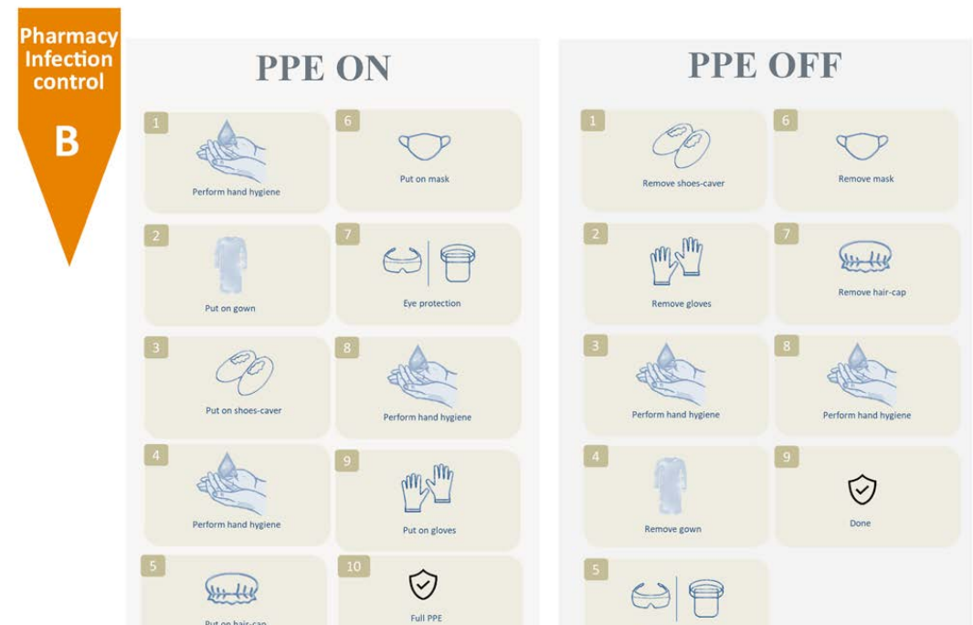
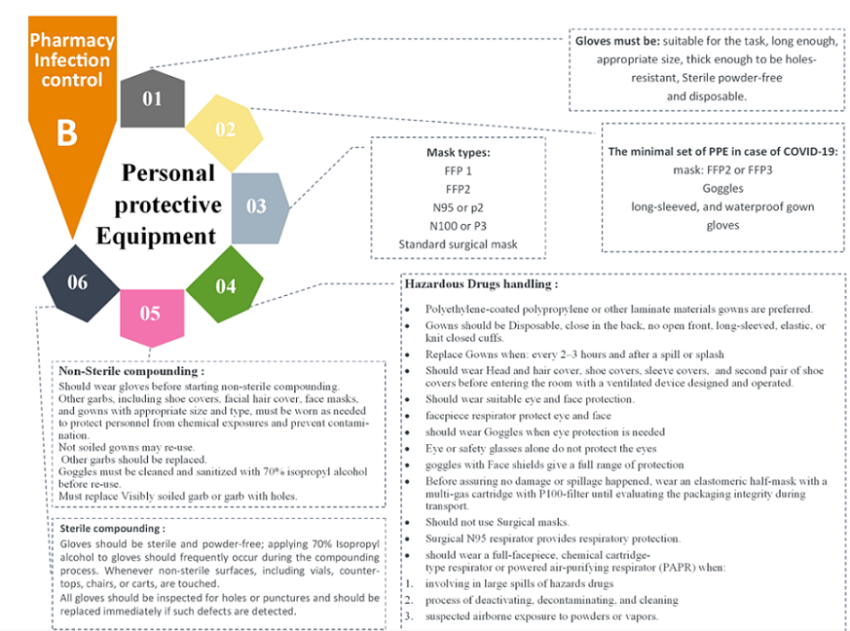
13. The glasses face mask should remove at the third one and disposable in the wastage back 14. The face mask or respirator should be removed by one side and another side without touching it and thrown in the basket
Figure 3. Principle of Personal Protective Equipment on and off techniques
Figure 2: Principle of Personal Protective Equipment on and off techniques
Figure 3: Principle of Personal Protective Equipment on and off techniques

Other hand hygiene requirements
1. Do not wear artificial fingernails or extenders when preparing the medication or have direct contact with high-risk patients such as in intensive care patients or those with chronic diseases such as diabetes mellitus.
2. Keep tips of natural nails as small as possible.
3. Do not wear the same pair of gloves if you go out from preparation area, and do not wash gloves between uses with different pharmacy preparation areas or patients.
4. Change gloves during pharmaceutical products if moving from a contaminated pharmacy site to a clean site.
5. Monitor pharmacy worker’s compliance with recommended handhygiene practices.
6. Provide pharmacy workers education and training about the hand hygiene and PPE and related activities for each type of patient to prevent transmission of microorganisms.
7. Provide hand-hygiene material for all pharmacy staff.
8. Investigate the outcome of following hand hygiene on pharmaceutical products and patients.
Hand-hygiene agents
1. Choose the most appropriate formulations for hand-hygiene products in pharmacy practice.
2. Evaluate the safety and efficacy of infection control products and materials.
3. Assess the advantages and disadvantages of hand sanitizer and antiseptics.
4. Choose a suitable device to encourage the usage and optimal application of hand-hygiene agents.
5. Choose the suitable hand lotions or creams to minimize the potential irritation associated with hand-hygiene agents

List of references
Basic literature:
  - Unguryan L. M., Bieliaieva A. I., Vishnitskaya I. V., Aleksandrova A. A. Texts of lectures on the discipline "Labor protection in the industry." Odessa: ONMedU, 2020. 111 p.
  - Unguryan L. M., Bieliaieva A. I., Aleksandrova A. A., Vishnitskaya I. V. et al. Labor protection in the industry: workshop. Odessa: ONMedU, 2019. 48 p.
  - Unguryan LM, Bieliaieva AI, Vishnitskaya IV, Aleksandrova AA and others. Labor protection in the industry: teaching aid. Odessa: ONMedU, 2019. 60 p.
  - Voinalovych O. V., Golopura S. M. Occupational Safety and Health. Practical. Kyiv: Center of Educational Literature, 2018. 448 p.
  - Reese, Charles D. Occupational Safety and Health: fundamental principles and philosophies. Crc Press, 2017. 403 p.
  - Phil Hughes, Ed Ferrett. Introduction to Health and Safety at Work: for the NEBOSH National General Certificate in Occupational Health and Safety. Routledge, 2015. 676 p.
  - Pedro M. Arezes, João S. Baptista, Mónica P. Barroso. Occupational and Environmental Safety and Health. Springer International Publishing, 2019. 765 p.
  - Thomas P Fuller. Global Occupational Safety and Health Management Handbook. CRC Press, 2019. 359 p.

Additional literature:
  - Law of Ukraine "On labor protection" No. 2694-XII. dated 14.10.1992 (as amended)
  - Law of Ukraine "Fundamentals of Ukrainian legislation on healthcare" No. 2801-XII of 19.11.1992. (As amended)
  - Law of Ukraine "On ensuring sanitary and epidemic well-being of the population" No. 4004-XII dated February 24, 1994 (As amended)
  - Law of Ukraine "On Compulsory State Social Insurance" No. 1105-XIV of 23.09.1999 (As amended)
  - Law of Ukraine "On the basic principles of state supervision of business entities" No. 877-V dated 05.04.2007. (As amended)
  - Code of Civil Protection of Ukraine No. 5403-VI dated 02.10.2012 (As amended)
  - Resolution of the Cabinet of Ministers of Ukraine "On the procedure for certification of workplaces for working conditions" No. 442 dated 1.08.92r. (With changes)
  - Resolution of the Cabinet of Ministers of Ukraine "On Approval of the Procedure for Investigation and Recording of Accidents, Occupational Diseases and Industrial Accidents" No. 337 dated April 17, 2019
  - Resolution of the Cabinet of Ministers of Ukraine No. 431 of 23.06.94r. "On the procedure for conducting state examination (verification) of technological, design, technical documentation for the manufacture of means of production for compliance with their regulations on labor protection"
  - Regulations on the Ministry of Health of Ukraine Approved by the Decree of the President of Ukraine dated March 25, 2015 No. 267.
  - Regulations on the State Drug Control Service of Ukraine. Approved by the Decree of the President of Ukraine dated April 13, 2011 N 457/2011.
  - Regulations on the State Service of Ukraine for Medicines. Approved by the Decree of the President of Ukraine dated April 8, 2011 No. 440/2011
  - Order of the Ministry of Health of Ukraine No. 275 dated 15.05.2006. "On the approval of the instructions for the sanitary and anti-epidemic regime of pharmacies."
  - CMU No. 843 dated 10.09.2001r. "On the approval of the criterion by which the degree of risk from the implementation of activities in the field of public health protection is assessed and the determination of the frequency of implementation of planned measures of state supervision (control)."
  - Resolution of the Cabinet of Ministers of Ukraine "On approval of the licensing conditions for the implementation of economic activities for the production of medicines, wholesale and retail trade in medicines, import of medicines (except for active pharmaceutical ingredients)" No. 929 dated November 30, 2016
  - NPAOP 0.00-4.35-04 "Standard regulation on the labor protection service".
  - DNAP 0.00-6.23-92 "Procedure for certification of workplaces for working conditions".
  - NAPB A.01.001-2004. Fire safety rules in Ukraine.
  - Aslan, I., & Morsunbul, D. Preferences for job life qualyty and motivation in healthcare. Marketing and Management of Innovations. №2. P. 79-93.
  - Saifullah Hakro, Li Jinshan. Workplace Employees' Annual Physical Checkup and During Hire on the Job to Increase Health-care Awareness Perception to Prevent Disease Risk: A Work for Policy-Implementable Option Globally. Safety and Health at Work. №10. 2018. P. 132-140.

Electronic resources:
https://zakon.rada.gov.ua/ - Database "Legislation of Ukraine"
http://ohoronapraci.kiev.ua/ - Site of the scientific and production monthly magazine "Labor Protection"
http://oppb.com.ua/ - Site of the monthly magazine "Labor protection and fire safety"
https://www.sop.com.ua/ - Site of the magazine "Labor Protection Service"
https://esop.mcfr.ua/ - Site of the magazine "Handbook of labor protection specialist"
https://www.dsns.gov.ua/ - Site of the State Emergency Service of Ukraine

