МИНИСТЕРСТВО ЗДРАВООХРАНЕНИЯ
Одесский Национальный Медицинский Университет
Кафедра стоматологии детского возраста

«Утверждено»
на методическом совещании кафедры
стоматологии детского возраста ОНМУ
протокол № ___ от «__»________2016 г.
Зав. кафедрой _______ проф. О.В. Деньга

METHODICAL WORKING OUT
for the teachers and students

Academic discipline | COURSE OF DENTAL DISEASES PREVENTION
Module number 1 | Basic knowledge about prevention of dental diseases.  Algorithm of exam and states of oral cavity in children.
Semantic module number 1 | Introduction of preventive course in paediatric dentistry.
Theme of lesson | Estimation of the hygienic condition of the oral cavity by Stilness-Loe, Stallard, Green-Vermilion, Fedorov-Volodkina.Use in practice.  Index of estimation of the condition of the periodontal tissue: indices РМА, СРITN, of dental calculus, bleeding, pathological dento-gingival pocket (PDGP), test of Shiller-Pisarev ) .
Course | III
Faculty | Stomatological
Hours | 20

Ass. Skorkina E.V.

Theme of lesson:

Estimation of the hygienic condition of the oral cavity by Stilness-Loe, Stallard, Green-Vermilion, Fedorov-Volodkina.
Use in practice.

Index of estimation of the condition of the periodontal tissue: indices РМА, СРITN, of dental calculus, bleeding, pathological dento-gingival pocket (PDGP), test of Shiller-Pisarev ) .

How to check for plaque - Dental Plaque Disclosing Tablets

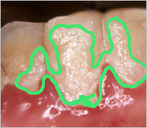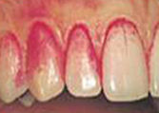

Patients often believe that they brush correctly and deny to accept that they fail in tooth plaque removal, even if their dentist tells them about dental plaque formation when examining their teeth. Plaque on teeth is usually colorless and therefore can be difficult to see it and remove it during brushing.
Dental disclosing tablets and solutions stain the plaque build up on your teeth, allowing you to see how thoroughly you are brushing and flossing your teeth. They stain the bacteria making it easier to see where you have to brush again to remove dental plaque.
Plaque disclosing tablets and solutions are available without prescription from most pharmacies and they work by dyeing tooth plaque either blue or red. The active ingredients of disclosing products are usually dyes also used as food colourings. Erythrosine is the most common dental plaque dye in disclosing tablets and solutions.

1.Index Russel



index, periodontal disease (Russell index),
n an index that measures the condition of both the gingiva and the bone individually for each tooth and arrives at the average status for periodontal disease in a given oral cavity.
index, plaque,
n an assessment tool used to evaluate the thickness of plaque at the gingival margin that may be applied to selected teeth or to the entire oral cavity.

2. Index Green-Vermillion

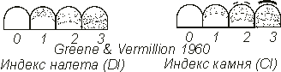

index, oral hygiene, simplified (Greene-Vermillion index),
n an index made up of two components, the debris index and the calculus index, which are based on numerical determination representing the amount of debris or calculus found on six preselected tooth surfaces.

3. Index

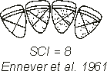

4.Index Silness- Loe

