ODESSA NATIONAL MEDICAL UNIVERSITY
Department of Obstetrics and Gynecology № 2

METHODOLOGICAL RECOMMENDATIONS

for students on
«Obstetrics and Gynecology»
Course V Faculty international

«FEMALE PELVIS. THE BABY AS AN OBJECT OF LABOR»

Authorized
At the methodical faculty meeting
August 29, 2017
Protocol № 1.
Head of the department,
professor A.A.Zelinsky

Оdessa 2017– 2018

1. Subject № 1. «Female pelvis. The baby as an object of labor»
2. Topicality. The given theme is the basical one in gynecology. It is impossible to gain future knowledge of obstetrics and on some specific themes on physiological and pathological obstetrics without knowing this theme.
3. Aims of the lesson:
II. Educational objectives.
To gain the appropriate knowledge students must know:
1. The structure of female bone pelvis.
2. Borders and sizes of true pelvis.
3. General external borders of pelvis.
4. Additional sizes of pelvis.
5. The methods of determination of the diameters of true conjugate.
6. The muscles of pelvic floor.
7. Structure of fetus cranium.
8. Location of joints and fontanels on the fetus head.
9. The diameters of fetal head, its biacromial and pelvic diameter.
10. The criteria of newborn maturity.
As the result of the training hours student must have such skills:
1. To size external borders of pelvis.
2. To size the true conjugate.
3. To measure height and weight of newborn.
4. To measure fetal head, its biacromial and pelvic diameter.
5. To determine the maturity the newborn.
III. Basic knowledge.
1.The anatomy of female genitals.
2. The structure of female bony pelvis.
3. Female union of bones and age specifics.
4. Structure of fetus cranium

ІV. Contents of the material
Parturient canals consist of bonny and soft parts. True pelvis belongs to the bonny part, cervix uteri, vagina, musculofascial system belong to the soft part. Pelvis is formed by two hip bones, sacrum and coccyx. Нip bones consist of iliac bone, gluteal and pubic bones. (Picture 1)

pubic bone;
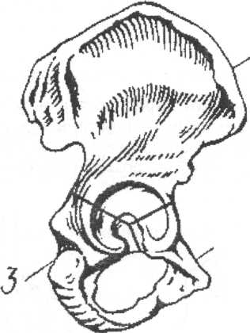
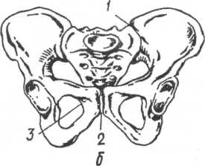

Picture 1. Hip bone
1- iliac bone;
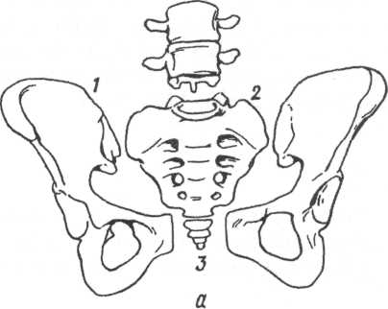
2- pubic bone; 3- gluteal bone

Picture 2. (a:1- innominate bone; 2 – sacrum; 3- coccyx) and its joints
b: 1 -sacroiliac joint, 2- pubic symphysis; 3- sacrococcygeal symphysis.
Female pelvis is gynecological divided into two parts: false and true pelvis. They are connected by the inominate line. On each side the false pelvis is measured by wings of ileum and symphysis, by back bone posterioraly, and has no anterior borders. The anterior border of true pelvis is formed by pubic ramus and symphysis, on each side by the parts of bones forming socket of the hip cup-like cavity, by gluteal bodies and tuberosities, its posterior borders are formed by sacral bone and coccyx.(Picture 2)
In the process of labour the true pelvis, as a narrow bonny tunnel, measures and forms the size, form and angle of the parturient canal, to which the fetus is expelled and has its head fitted, changing its form.The sizes of true pelvis are of great importance in obstetrics. The process and outcome of the delivery both for mother and newborn depends on it. But the majority of its sizes can’t be directly measured.
The false pelvis doesn’t play a great role in the delivery act, but its measuring can give information about approximate sizes and form of the true one. The measuring is carried out with pelvimeter.
False pelvis diameters.
Usually 4 general diameters of pelvis are measured: 3 transverse and 1 direct one. Distancia spinarum - is the distance between anterosuperior axes of iliac bones. This size is 25 cm. Distancia cristarum - is the distance between the hindermost points of iliac crests. On average it is 28 cm. Distancia trohanterica - is the distance between greater trochanters of femoral bone. The size is 31 cm. Picture 3.
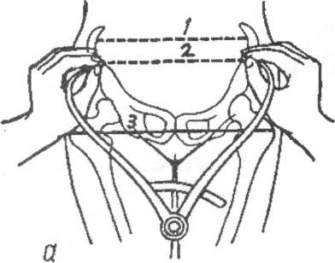
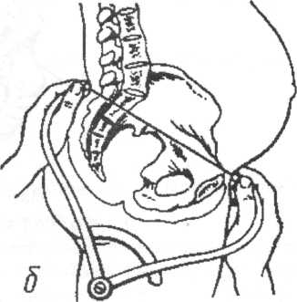
Picture 3. The external diameters of pelvis: a- transverse diameters:1 – Distancia cristarum; 2 - spinarum; 3 - trohanterica; б – conjugata exsterna

External conjugate – the direct diameter of pelvis. The woman is positioned edgewise, the leg which is in touch with surface is curved in a hip and a knee joint, another leg is straight. The edge of pelvimetr is set in the middle of exterior edge of symphysis, another edge is pressed to supersacral fossa, located between the process of the 5th lumbar vertebra and 1st sacral vertebra. The external conjugate in 20 cm long. (Picture 3.)

The cavities of true pelvis and their diameters.
The cavity of the true pelvis is an area among its walls, the area above and below is bordered by the surfaces of pelvic upper and lower openings. It has a form of a cylinder the frontal part (that is positioned towards pubis) of which is cut of in such a way that it is as much as three times lower that the back one (that is positioned towards the sacral bone). In the true pelvis cavity there are four areas: the area of brim, area of wide and narrow parts and area of pelvic outlet. There are 4 diameters.
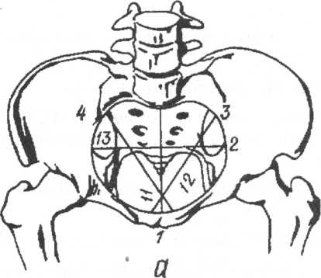
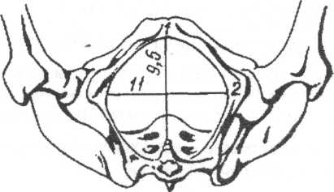

Picture 4

The diameters of the pelvic outlet can be measured directly. In order to do this the woman is put in dorsal rigid position. The procedure is carried out with measuring tape or pelvimeter. The direct diameter is measured between the markings given above. The transverse diameter is the distance between inner surfaces of ischial tuberosities(9,5 cm) plus 1,5 cm(with soft tissues).

The line in the middle of all the direct diameters and angles is the axis pelvis plane. Pubic angle is 90-100°, pelvic angle is 55-60°. Symphysis height is determined on vaginal examination and is 3,5-4 cm.
The most important diameter for the estimation of pelvis is true conjugate, which can’t be measured directly. Its diameters are based on those ones of exterior and diagonal conjugate.To size up true conjugate it is necessary to minus 8 cm from the size of external conjugate if the wrist joint perimetry is less than 14 cm, 9 cm is to be minused if wrist joint perimetry is more than 16 cm. An example – 20 cm-9 cm =11cm.
The diagonal conjugate it’s a distance from the lower edge of symphysis to the most prominent point of sacropromontory bone.
Diagonal conjugate is measured on vaginal examination. On intravaginal examination forefinger and long finger are moving along the lumbar fossula towards sacropromontory, the fingertip of the long finger would be fixed on its top, the sharp of the hand bears against lower edge of symphysis. The area where the gynecologist’s hand contacts with the lower edge of symphysis, is fixed by the finger of another hand. After the finger is out, the pelvimeter or measuring tape is taken to measure the distance from the fingertip to the point of contact of the sharp of the hand with the lower edge of symphysis. (Picture 7)

Picture 7. Diagonal conjugate measuring.
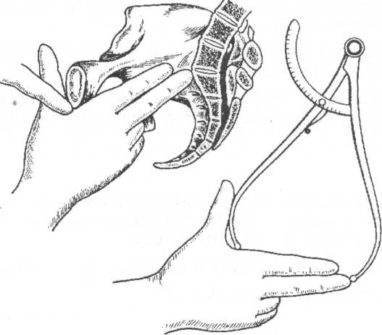
The diagonal conjugate is on average 13 cm. If the fingertip of straight finger doesn’t touch the limbos promontories, the diameter of diagonal conjugate is considered to be normal. The diameter of true conjugate it’s a diameter of diagonal conjugate minus 1,5-2 cm, depending on the diameter of wrist joint; if the diameter is 15 so 1,5 is minused, 16 and more – 2cm
Basic diameters of pelvis and diagonal conjugate are invariably measured in all the pregnant and parturient women.
If there appears an assumption of contracted pelvis or other abnormalities another measuring is carried out.
Picture 8. Rhomb of Michaelis. 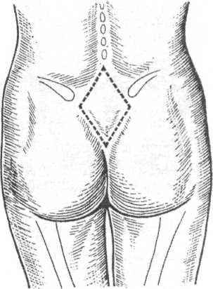

Additional pelvic measuring.
Rhomb of Michaelis – it’s a area of sacrum back surface, the upper angle of which forms the recess under spinous process of the fifth lumbar vertebra, lateral angles correspond to posteroexternal axes of iliac bones; inferior one – to the brim of sacrum. Upside and externally rhomb of Michaelis is measured by the protuberance of greater back muscles, from below and exteriorally by the ischial muscle protuberance. Rhomb of Michaelis has got two diameters: longitudinal – between its upper and low angle (11 cm), and transverse one – between its lateral angles(9cm). The sum of upper and longitudinal diameters of rhomb of Michaelis corresponds to the diameter of the external conjugate.
Lateral conjugate is measured with pelvimeter from the anterosuperior to the posteroexternal axis of the same flank, it is 14,5 cm long.
Oblique diameters of pelvis are measured for determining its asymmetry. To do this the distance between the following points is measured:
- From the middle of the exterior symphysis to the posteroexternal axis of iliac crest on the right and left, these distances are 17 cm on both sides
- From the anterosuperior axis of one side to the posteroexternal axis of the opposite one, and vice versa. It is 21 cm long.
- From the fifth spinous process of vertebra to the anterosuperior axe of right and left iliac bones. It is 18 cm.
In symmetric pelvis all oblique diameters are equal. If the difference between oblique diameters of the opposite sides is more than 1,5 cm the pelvis is considered to be asymmetrical.
Perineum.
Perineum forms pelvic floor, closing its outlet and setting its limits. The notion of perineum in obstetrics is more restricted than in anatomy, in anatomy the perineum is defined as the distance between epithalamic commissure of vulvar lips and frontal part of anus. There are two diaphragms to form the pelvic floor of true pelvis – pelvic and genitourinary.
There are three layers of pelvic floor muscles. Picture 8.

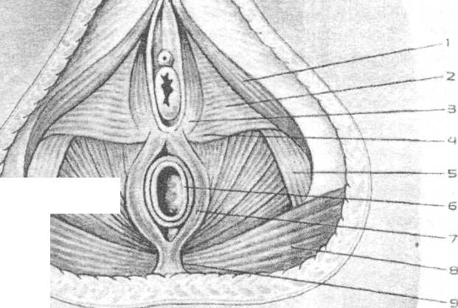
Fetal head. There are such joints of the fetal head: (frontal suture, biparietal suture, coronary suture, lambdoid suture) and fontanel (anterior fontanel, posterior fontanel, and two lateral fontanels on both sides).

Frontal suture is between frontal bones,biparietal suture is between parietal bones. Coronary suture is among both frontal and both parietal bones, and the lambdoid one is among two parietal and occipital bones.
Anterior fontanel (among the posterior parts of both frontal bones and frontal parts of both parietal bones) is a connective tissue plate in the form of rhomb.
Posterior fontanel looks like a triangle and is between the posterior parts of both parietal bones and the occipital one.
Anterior and posterior fontanels are connected by biparietal suture.
Picture 9. Fetal scull. Dorsal view. 1 – Large, 2 – small transverse diameter of the head.
Lateral fontanels are located: frontal – among frontal temporal and cuneiform bones, posterior – among temporal, parietal and occipital bones. They are closed in mature fetus.
There are such diameters and appropriate circumferences:
- Direct diameter – from bridge of the nose to the most prominent point of hind head, it is 12 cm, head circumference is 35 cm.
- Large oblique diameter – from chin to the most distant point of hind head, it is 13,5 cm. The corresponding circumference is 41 cm.
Picture 10. Newborn head circumferences according to the diameters: 1-diect;
2 –large oblique; 3 vertical, 4- small oblique diameter
---small oblique diameter -- from suboccipital fossa to the middle of anterior fontanel, it is 9,5 cm. the circumference is 32 cm.
--- medial oblique diameter – from the suboccipital fossa to the edge of hairy part of forehead. It is 10 cm long. The circumference is 33 cm.
---Vertical diameter (head height) – from the middle of anterior fontanel to the tongue bone. It is 9,5 cm, while the head circumference is 33 cm.
--- large transverse diameter --- between the most distant points of parietal protuberance. It is 9,5 cm.

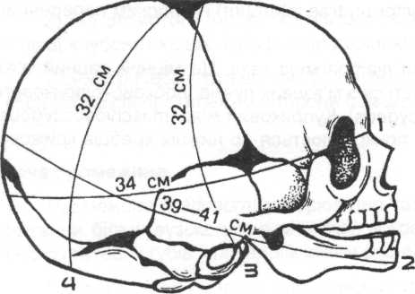

--- small transverse diameter --- between the most distant points of coronary suture -- 8 cm.
--- transverse diameter of pelvis is 9,5 cm long. The circumference is 28 cm.
--- transverse diameter of thoracic girdle is 12 cm. The circumference is 35 cm.
To determine the location of the intrauterine fetus in obstetrics the following terms are used: general physical position, position, visus and presentation.

The general physical position (habitus) - the relation of the fetus extremities, head to its thorax. During typical physical position, the fetus’s thorax is bent, the head is bent toward the thorax, the legs are bent in the hip joints and knee joints and pressed to the abdomen, the hands are crossed at the thorax.

Fetal lie (situs) - the relation of the axis of the fetus to the axis of the uterus. Fetal axis – the line which passes through the back from the occiput to the sacrum.

Variants of fetal lie:
1. Vertical lie – the fetal axis coincides with the uterus axis;
2. Transverse lie - the fetal axis and the uterus axis are crossed at an acute angle; both large parts of the fetus are over the crista iliaca;
3. Diagonal lie - the fetal axis and uterus axis cross at an acute angle, the head and pelvic end of the fetus are located at one area, lower than the crista iliaca

Fetal position (positio) - the relation of the fetal back to left (first position) or right (second position) side of the uterus during vertical lie. During horizontal and diagonal lie of the fetus, the position is determined in relation to the fetal head, if it is to the right or left side of the uterus (first position – the head is at the left wall of the uterus, second – at the right).

Type of fetal position (visus) - the relation of the fetal back to the anterior and posterior uterine wall:
1. Anterior - the fetal back is turned to the anterior uterine wall;
2. Posterior - the fetal back is turned to the posterior uterine wall;

Fetal presentation (praesentatio) - the relation of the lowest fetal part in the cervix (input to the pelvis). In vertical lie there can be either cephalic presentation (96%) or breech (pelvic) presentation (3,5%).

The location of the fetus in the uterine cavity.
The major segment of the fetal head. The major segment of the head is the circumference of the largest size of the head which it passes through the planes of pelvis at this certain fitting of presentation. For occipital presentation, when the head is inserted into the pelvis in a bent position, is the largest circumference, and that which equals the small oblique size. For an extended insertion of the head the major segment will be different (depending on the degree extension).
Minor segment of the fetal head. The minor segment is the least circumference of the head which passes through the plane of the pelvic inlet.

External obstetrical examination
Maneuvers of external obstetrical examination, (Leopold's maneuvers)

The first maneuver. Goal – determine the height of the uterine fundus and the fetal parts which are at the fundus. The doctor stands at the patient’s right side, the palms of both hands are placed on the uterine fundus, determine the height of the fundus above the pubis and which fetal parts are at the fundus.

The second maneuver. Goal – determine the lie, position and type of fetal position. Both hands are moved from the uterine fundus, to the sides of the uterus; one at a time, palpate each lateral side of the abdomen to determine the parts of the fetus turned to the lateral walls of the uterus. Find the fetal back, small parts. During abnormal positions the head will lay at one of lateral walls of the uterus.

The third maneuver. Goal – determine the presenting fetal part (presentation). With one hand, usually the right, clasp the presenting part above the pubic symphysis, after which gently moving the part from left to right (balloting). During cephalic presentation, a firm, round part which has clear contours, is determined. If the fetal head is not inserted into the pelvic input, then it easily moves ("ballots") between the thumb and index fingers. For pelvic presentation, a volumous, soft part, not round and can not be "balloted" is determined.

The fourth maneuver. Goal - to determine the prominence of the presented parts (in particular the head) in relation to the input of the pelvis and the degree of its insertion. The doctor stands to the right of the patient, face towards the patient’s legs and puts his palms on the lateral sides of the lower segment of the uterus and palpates the presented fetal parts, trying carefully to get the fingers between the presented part and the lateral parts of the input to the pelvis.
By using the fourth Leopold's maneuver, such data is obtained:
The head is mobile over the input to the pelvis - if the doctor’s fingers can be brought under the head.
The head is pressed against the input to the pelvis – if the ends of the doctor’s fingers do not meet under the head, nevertheless the occipital and facial parts are palpated above the input to the pelvis.
The minor segment of the head is in the input to the pelvis – the occipital part of the head is over the input to the pelvis by two fingers, and the facial part - completely.
The major segment of the head is in the input to the pelvis – the occipital part of the head is not palpated over the input to the pelvis, and the facial part is over it by two - three fingers
The head is in the pelvic cavity – when only the chin is palpated or no parts of the fetal head are palpated.
Methods of external examination also include measurement of the external sizes of the pelvis. It is performed during the patient’s first visit (examination) at the female consultation and at the maternity hospital. If necessary, measurement of the pelvis is repeated during labor.

Measuring the circumference of the abdomen and the height of the uterine fundus.
Circumference of the abdomen (CA) is measured with a centimetric tape measure which passes around the navel and in the back - through the middle of the lumbar area.
Height of the uterine fundus (HUF) is measured with a centimetric tape measure at the top edge of the symphysis to the most protruding point of the uterine fundus. The results of the HUF are compared to a standard gravidogram (normally by the 30 week the HUF equals 0,7-1,9 cm a week; at 30-36 weeks - 0,6-1,2 cm a week; at 36 and more - 0,1-0,4 cm. A lack in increase in size by 2 cm or the absence of increase for 2-3 weeks during dynamic supervision is the basis to suspect fetal growth retardation).
Estimated fetal weight.
The estimated fetal weight (FW) is calculated approximately with the following formula:

FW (gr) = CA х HUF. A more accurate fetal weight is determined by ultrasound.

Determining the term for maternity leave (a sign of 30 week pregnancy)
1. the fundus of the uterus is in the middle between the navel and processus xiphoideus;
2. the height of the uterus fundus when measured with a tape measure is 25-28 cm (average of 26 cm); circumference of the abdomen – 83-85 cm
3. the fetal head (in primigravida) is mobile over the input to the pelvis;
4. the vaginal part of the cervix uterus is contracted;
5. results from the ultrasound: biparietal diameter of the fetal head on average is 75-76 mm; average diameter of the thorax – 77-78 mm; average diameter of the abdomen – 79-80 mm; length of the hip - 57-58 mm.

Internal obstetrical examination
During the physiological course of a pregnancy internal (vaginal) obstetrical examination is performed during the first visit to the female consultation in the early terms of the pregnancy and at the last weeks to determine the degree of maturity of the cervix.
If necessary and there are indications for internal examination, it is performed at any time of the pregnancy.
During vaginal exam, the following should be paid attention to: processing of the doctor’s hands, the patient’s vulva and vagina; the position of the woman during a vaginal exam; the indications for the vaginal exam.
Internal obstetrical examination gives information on the features of the soft tissue of the birth canal (elasticity, ability to stretch, cervix uterus - about the form, length, effacement), fetal sac, presented part, its insertion in reference to the pelvis, about the bones of the pelvis (exostosis, deformations, if the promontory can be reached).

Sequence for internal obstetrical examination:
- examine the external genitia, their development
- determine the width of the input, vaginal walls, presence of scars, inflammation, tumours, condition of the perineum, filling of the ampoule of the rectum and bladder
- determine the form and depth of the fornix
- position of the vaginal part of the cervix, its form, size, consistency, presence of scars and ruptures
- condition of the internal and external os, its passability (effacement in cm), shortening and smoothing out of the cervix, relation of the vaginal part of the cervix to the length of the cervical canal
- determine the presence of the membrane, its form and thickness; its condition in between and during contractions: fills only during contraction, remains filled between contractions, excessively strained, weakened or does not fill at all during contractions (flat membrane) and others;
- determine the character (head, buttocks) of the presented parts, location of informative points, relation of the presented parts to this or that pelvic plane (over the input to the pelvis, the minor or major segment is in the input, or in the wide parts of the pelvis, narrow part or in the output of the pelvis); or loops of the umbilical cord, placental tissue, small parts of the fetus, etc. are not determined;
- determine the capacity of the pelvis, presence of exostosis and the size of the diagonal conjugate
- Character of vaginal discharge.

During vaginal exam, the degree of "maturity" of the cervix uterus is determined. The following degrees are determined: the cervix is mature, immature, maturing, incompletely mature.
To determine the readiness of the woman’s organism for birth according to the degree of "maturity" of the cervix, the following indicators are used: the consistency of the cervix, length of the vaginal part, degree of passage of the cervical canal, position of the cervix in relation to the pelvic axis using the Bishop scale (tab.3).

Tab. 3. Evaluating the degree of "maturity" of the cervix using the Bishop scale

Sign | Degree of "maturity"
Sign | 0 points | 1 point | 2 points
Position of the cervix | To the back | To the front | In the middle
Length of the cervix | >2 | 1-2
Consistency of the cervix | Firm | Softening | Soft
Effacement | Closed | Open 1 cm | Open >2 cm
Position of the presented fetal part | Mobile over the input of the pelvis | Pressed against the input of the pelvis | Pressed against or fixated in the input of the pelvis

0-2 points – cervix is “immature”
3-5 points – cervix is “incompletely mature”
>6 points – cervix is “mature”

Methods of examining the functional condition of the fetus

Ultrasound fetometry of the fetus is informative after 20 weeks of pregnancy (A) and includes determining the size of the head, circumference of the abdomen and length of the hip. While determining, if there is a discrepancy of one or several basic photometric indicators for the term of pregnancy, an expanded fetometry is performed, where the relation between the biparietal diameter and frontooccipital diameters of the fetal head, size of the head, circumference of the abdomen, biparietal length of the hip bone, hip bone and circumference of the abdomen are determined. The most valuable indicator is the estimated fetal weight. The basis for performing an ultrasound fetometry in late terms of the pregnancy is suspicion of fetal growth retardation according to external measurements of the height of the uterine fundus and circumference of the woman’s abdomen, and also, in special cases, to determine the term of the pregnancy with special tables, if the term is difficult to determine from anamnesis data.

Auscultation of the fetal heart tones is performed after 20 weeks of pregnancy with the help of obstetrical stethoscope, where the frequency of heart beats in one minute is determined.
- physiological normal - 110-160 bpm
- frequency of heart beats above 160 bpm and less than 110 bpm testifies of disorders in the fetal condition.
For auscultation of fetal heart beat use the following rules:
- for facial presentation – listen for the heart beat below the navel on the side where the fetal thorax is located (if first position - on the right side, if second - on the left side).
- for transverse lie - near the navel, closer to the fetal head.
- for breech presentation - above the navel, near the fetal head on the side where the back is turned.
Cardiotocography (CTG) - synchronous electronic monitoring of the fetal heart rate and uterine contractions for 10-15 minutes.
- during analysis of the CTG, such parameters are evaluated: basal frequency of heart rate (BFHR), variability of the heart rate (amplitude and frequency oscillation), presence and type of changes in BFHR in the form of acceleration or decelerations of heart rate.
- if any pathological parameters of heart rate are present, which testify of a dangerous fetal condition, continuous monitoring with the CTG during labor is recommended
- diagnostic criteria: during normal fetal condition for CTG it is characteristic: BFHR is between 110-170 bpm (normocardia), variability (width of the tape) - 10-25 bpm with frequency of oscillation 3-6 cycles per minute (wavy type), presence of accelerations and absence of decelerations.

Biophysical profile of the fetus (BPF) (at 30 weeks of pregnancy) – complex evaluation of the condition of the fetus and the sum of separate biophysical parameters (fetal respiratory movements, fetal tone, fetal activity, reactance of the fetal heart rate to non-stress test (NST), volume of amniotic fluid) (tab.4) (C)

Tab. 4. Evaluation of the results of parameters of the biophysical profile of the fetus (BPF)

Parameter | Points
Parameter | 2 | 1 | 0
Non-stress test  (reactance of the fetal heart rate after its movement by the data from the CTG) | 5 and more  Acceleration of heart beat  Amplitude no less than 15 bpm, length no less than 15 sec., in connection to fetal movement in 20 min. of observation | 2-4  Accelerations  Amplitude no less than 15 bpm, length no less than 15 sec., in connection to fetal movement in 20 min. of observation | 1 acceleration  or its absence during 20 min. of observation
Respiratory movements (RM) | No less than one episode of RM in 60 sec. and more in 30 min. of observation | No less than one episode of RM in 30 sec. and more in 30 min. of observation | RM length less than 30 sec. or their absence for 3 min. of observation
Fetal movement activity | No less than 3 generalized movements in 30 min. of observation | 1-2  generalized movements in 30 min. of observation | Absence  of generalized movements
Fetal tone | One episode or more of movement of the extremities or spine from flexion to extension in 30 min. of observation | No less than one episode of movement of the extremities or spine from flexion to extension in 30 min. of observation | The extremities are in flexion position
Amount of amniotic fluid | Fluid is present in the uterus, height of free fluid is 2 cm or more | Fluid is present in the uterus, height of free fluid is more than 1 cm, or no less than 2 cm | Small fetal parts are tightly fit, height of free fluid is less than 1 cm
Evaluation of BPF | 7-10 points – satisfactory fetal condition  5-6 points – doubtful test (repeat in 2-3 days)  4 points and less – pathological evaluation of BPF (talk about terminating the pregnancy)

Dopplerometry of the speed of blood flow in the umbilical cord artery (displays the condition of microcirculation in the fetal part of the placenta, vascular resistance which plays a main role in feto-placental to haemodynamics) (A).
Diagnostic criteria for normal blood flow: high diastolic component on the dopplerogram in relation to the isoline, the ration between amplitude of the systole and diastole is no more than 3.
Ultrasonic tomography of the fetus and pelvic organs small in late terms of pregnancy is performed when indicated for the diagnostics of multiple gestation, location of the fetus in the uterus, developmental disorders of the fetus, oligohydramnion and hydramnion, pathologies of placental positions or it’s partial detachment, development anomalies and tumours of the uterus or other pelvic and etc.

Perinatal care of the fetus.

General data:
Perinatology – a science which studies the perinatal period (from the Greek word "реri" - around, and Latin "natus" - birth).
The perinatal period includes the late fetal period (22 weeks of intrauterine development and till the beginning of birth), intranatal (during birth) and early neonatal (from birth to 6 days old). Diseases which occur during the perinatal period are called perinatal pathology. As a rule, the displays of these diseases last even in older babies, especially in the late neonatal period (till 28 days old).
A newborn is a baby who began to breathe independently. A still-born baby is a baby that at the moment of birth had not respiratory movement and it could not be gained artificially. A heartbeat in such a baby can be heard for some time.
Still-born babies and the death rate of babies in the first 7 days after birth is called perinatal death rate. To determine the perinatal death rate, it is necessary to calculate in ppm (per mille) the difference between the number of still-born babies and those that died within the first 7 days after birth and the total amount of births.
The perinatal period and of course the pathology and death rate are divided into antenatal (before birth), intranatal (during birth) and postnatal (after birth), or neonatal.
Perinatal center – a treatment and preventive establishment which gives all kinds of qualified, highly technological and expensive medical hospital care in the field of obstetrics, gynecology, neonatology and neonatal surgeries and also gives out-patient, advisory-diagnostic and medical-rehabilitation care to women and children of early age.
Perinatal diagnostics (PD) is directed on revealing congenital and hereditary pathologies (CHP). Perinatal care of the fetus should begin not with at the moment the child is born and not even at the moment the pregnancy occurred, but much earlier. It should begin at the moment a baby girl is born, who is considered as a potential mother.
The health of the future generation depends on the reproductive health of women and young women, who start the reproductive process today and who are the keepers of the gene pool of the nation. Thus, the condition of a newborn is closely connected to the condition of the mother’s reproductive health. Often times, girl teenagers enter the reproductive process being anatomically and physiologically immature, socially not adapted, which essentially reduces the health of the mother and newborn.
Questions about perinatal and newborn care are answered at the female consultations and also specialized obstetrical hospitals and branches of maternity hospitals, sanatoriums for pregnant woman, specialized therapeutic and pediatric hospitals, clinics, polyclinics for adults and children. With introduction of a family doctor into the system of public health services, they will play a big role in the decision of these problems.
Forming a healthy way of life begins with the family. The concept of "hygiene" means the hygiene of two partners – the male and the female. At the beginning of matrimonial life, the boy and girl should use good hygiene which is necessary for good health, strength and completeness of intimate relations, and also for the birth of healthy children. It is very important, that before a boy and girl before married, they have a medical examination. The man should visit the therapist and urologist, the woman - therapist and gynecologist. Planning a family – complex of social and economic, legal, medical actions directed on the birth of of healthy children, prevention of abortions, preservation of the reproductive health, achieving harmony in marriage.
Perinatal care of the fetus and newborn - system of actions toward antenatal and intranatal care and the organization of medical service for newborns, directed toward the prevention and decrease in perinatal diseases and death rates, improving the of newborn children.
women?

Control questions for the outcoming level of knowledge.
1. What is the construction of female pelvis?
2. What are the measures of false pelvis and what is its meaning in obstetrics?
3. What are the measures and areas of true pelvis, their form and diameters?
4. What are the major external and internal diameters of pelvis?
5. What are the additional measurings of pelvis?
6. What are the methods of true conjugate measuring?
7. How many muscle layers does female perineum have?
8. What are the muscles of pelvic floor?
9. What is the construction of mature fetus scull?
10. What are the diameters of mature fetus head?
11. What are the diameters of pelvis and thoracic girdle of the fetus?
12.What is the weight and the height of the mature fetus?
13. What other characteristics of fetus maturity do you know?
Recommended literature:

1. Zaporozhan V.M. Obstetrics pathology Odessa 2005.- 292 p.
2. Obstetrics (by ac. Griwenko V.I)- Charkiv 2000. P.236-245.

