ODESSA NATIONAL MEDICAL UNIVERSITY

Department of Obstetrics and Gynecology № 2

METHODOLOGICAL RECOMMENDATIONS

for students on

«Obstetrics and Gynecology»

Course V Faculty international

«Physiology of pregnancy, labor and postnatal period»

Authorized At the methodical faculty meeting “31” August, 2016 Protocol № 1 Head of the department Professor Zelinsky A.A.

Re-authorized At the methodical faculty meeting “ __” ________________ 20__ Protocol №__ Head of the department Professor Zelinsky A.A.

ODESSA 2017-2018

Subject 14. "Physiology of labour. Anesthesia during labour"
Subject 14. "Physiology of labour. Anesthesia during labour"

І. Relevance of the topic.
Labour is a sequence of uterine contractions that results in effacement and dilatation of the cervix and voluntary bearing-down efforts leading to the expulsion per vagina of the products of conception. Delivery is the mode of expulsion of the fetus and placenta. Labour and delivery is a normal physiologic process that most women experience without complications. The goal of the management of this process is to foster a safe birth for mothers and their newborns. Additionally, the staff should attempt to make the patient and her support person(s) feel welcome, comfortable, and informed throughout the labour and delivery process. Physical contact between the newborn and the parents in the delivery room should be encouraged. Every effort should be made to foster family interaction and to support the desire of the family to be together. The role of the obstetrician/midwife and the labour and delivery staff is to anticipate and manage complications that may occur that could harm the mother or the fetus. When a decision is made to intervene, it must be considered carefully, because each intervention carries both potential benefits and potential risks. The best management in the majority of cases may be close observation and, when necessary, cautious intervention.
Obstetric analgesia or anesthesia refers to the multiple techniques useful for the alleviation of pain associated with labour, delivery, or surgery. The choice of an appropriate analgesic technique must be made by the patient, the obstetrician, and the anesthesiologist and should take into consideration the patient's anatomy and physiology, the status of her fetus, the obstetric plan for delivery, and the pharmacology of the drugs to be employed.

ІІ. The goal of the lesson
Preview (ɑ = 1) acquaint with demographic birth rate in different regions of Ukraine and modern perinatal technologies.
Learn (ɑ = ІІ):
- precursors labour, preliminary period,
- onset of labour,
- methods for evaluating biological readiness body for childbirth,
- evaluation of the cervical status (scale Bishop),
- biomehanism labour at the anterior and posterior types occipital presentation,
- evaluation of labour progress,
- the clinical course of the first stage of labour,
- clinical management of the first stage of normal labour,
- the basic principles of partogram,
- the clinical course of the second stage of labour,
- clinical management of the second stage of labour,
- clinical management of the third stage of labour,
- essentials of normal newborn assessment (Apgar scores) and care,
- care and observation in the first few hours of life,
- obstetric analgesia and anesthesia.
Owning and improve skills (ɑ = ІІІ):
- - examination, the external obstetric examination, fetal palpitation of fetal heart,
- - internal obstetric examination (phantom),
- - the estimated day of the labour.
Everyone should be able to: (ɑ = ІV):
- evaluation of the cervical status (scale Bishop),
- to determine the beginning of the first period of delivery, objectively assess the character of labour activity (degree of cervical effacement, frequency, strength and duration of the contractions),
- conduct partogram,
- identify and assess fetal heart (auscultation, cardiotocogram),
- obstetric analgesia and anesthesia,
- active management of the third stage of labour (demonstration on the phantom),
- expectant management of the third stage of labour (demonstration on the phantom),
- examination of the placenta,
- determine the total blood loss during delivery,
- essentials of normal newborn assessment (Apgar scores).

ІІІ. Interdisciplinary integration.
№ | Disciplines | Know | Be able
Providing discipline
1 | Anatomy | Female structure  genitals | Characteristic female genitals
2 | Propaedeutics of internal diseases | Subjective and objective methods of examination | To obtain medical history and conduct
Provided by discipline
3 | Neonatologist | Basic principles and functional responsibilities doctor during physiological childbirth | Essentials of normal newborn assessment (Apgar scores) and care.
Inside object integration
4 | Physiology of pregnancy. Methods of examination pregnant | Topography of the fetus in the uterus  physiology of pregnancy  gravidogram | To define the topography of the fetus in the uterus. Make a plan of physiological pregnancy. Rate gravidogram character. Conduct internal and external obstetric research and auscultation of the fetus.
5 | Women pelvis and the fetus as an object of labour | The dimensions of the female pelvis, the size of the fetal head and body. The structure of the fetal head. | Measure and estimate the size of the female pelvis. Recognize the elements of the structure of the fetal head at an internal obstetrical research.

IV. CONTENT TOPICS

The course of physiology normal labour and delivery comprises a complex relationship between several dynamic parameters, including uterine contractions, cervical dilation, fetal descent, and elapsed time. The onset of labour in humans occurs around 280 days, or 37-42 weeks, from the first day of a patient's last menstrual period (LMP).
- Precursors of birth:
  - the lower the bottom of the uterus,
  - increase response of the uterine to mechanical stimuli,
  - going out mucus plug of the cervical canal,
  - loss of women weight 1-1,5 kg,
  - reduce the amount of amniotic fluid,
  - fetal position; the orientation of the presenting vertex within the maternal pelvis.
- Physiological preliminary period lasts about 6 hours and is characterized by irregular increasing in frequency, duration and intensity bouts of pain of cramping nature, mostly in the abdomen and in the groin. Pregnant women do not feel tired, their sleep is not disturbed. Irregular uterine contractions get intensified and gradually turn into regular maternity activity (contractions). In the intervals between contractions the uterine tone is not intensified, the fetal heart beat is clear and smooth, the cervix is mature, vaginal discharge is "mucous plug" mixed with blood.
3. Readiness for labour.
Labour is the physiological process by which the fetus and the placenta are expelled from the uterus through the birth canal.
Beginning of labour is an appearing of 2 contractions during 10 min. Duration of each contraction 20 seconds or more. Labour is not an even process. Within the first 4 – 5 h complex structural changes in cervix occur: it becomes shorter, smoothes, merges with lower segment of the uterus. The general length of I stage of labour during the management of labour act is 10 – 12 h in nulliparous women and 6 – 8 h in multiparous women.
4. Identifying readiness of the organism of a woman for childbirth.
Readiness of the female organism for childbirth is determined by examining the characteristic changes occurring in the cervix.
4.1. cervical conditon,
4.2. length of cervix (cm),
4.3. cervical dilatation (cm),
4.4. position of cervix,
4.5. station of presenting part.
There are 3 grades of cervical state: immature, not fully mature and mature cervix. Bishop Scoring System
Factor |  | Points
 |  | 0 | 1 | 2
1. | Position of cervix | Directed toward the symphysis | Middle | The pelvic axis
2. | Length of cervix (cm) | > 2 cm | 1-2 cm | < 1 cm
3. | Consistency of cervix | Dense | Mederate | Soft
4. | Cervical dilatation (cm) | close | 1-2 | > 2
5. | Station of presenting part | above the pelvic inlet plane | Between the superior and posterior margin of the symphysis | posterior margin of the symphysis and below.
0-2 points – «immature» cervix;
3-5 points – «not fully mature» cervix;
> 6 points – «mature» cervix.

5. Cardinal Movements of Labour
From the perspective of the fetus, labour involves movement progressively downward through the pelvis by the following cardinal movements.
5. 1. Mechanisms of labour with occiput anterior presentation. There are four moments.
First moment – flexion of the fetus head,
Second moment – descent and internal rotation,
Third moment – extension of the fetus head,
Fourth moment – external rotation.
5.2. Mechanisms of labour with occiput posterior presentation. It consists of five moments.
First moment – flexion of the fetus head,
Second moment – descent and internal rotation,
Third moment – additional flexion of the fetal head,
Fourth moment – extension of the fetus head,
Fifth moment – external rotation.
6. Regulation of labour activity
In late pregnancy and early childbirth a woman body is dominated by processes of inhibition of the cerebral cortex and increase in the excitability of the subcortical structures of the spinal cord. By this time a pregnant woman has shaped structure of the childbirth dominant, which is characterized by increased reaction to interoceptive stimili of the cervix uteri and the weakening or complete absence of reaction to extraceptive stimili, which is the prerequisite for a normal, uncomplicated course of the generic process.
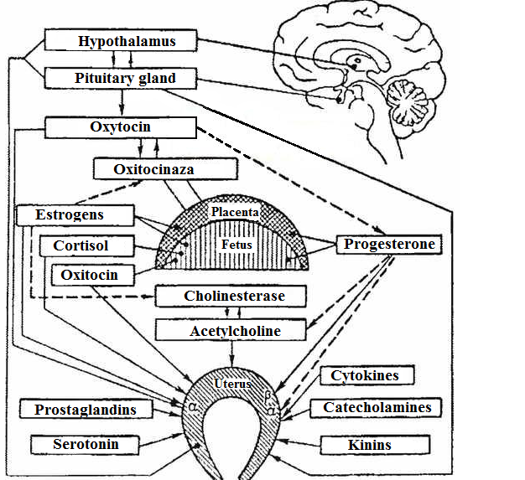

The diagram of regulation of uterine activity. solid arrows - activation (stimulation), dashed – suppression.

7. The clinical course of childbirth
There are 3 stages of labour:
I —dilation of the cervix,
II —expulsion of the fetus,
III — postnatal stage.
Diagnosis periods and phases of delivery:
Symptoms and signs | Period | Phase
Cervix not opened | False labour  / Absence of labour activity /
Cervix opened less than 3 cm in primipara, 4 cm for multiparous | First | Latent
Cervix is opened at 3-9 cm. | The rate of opening of the cervix least (or more) - 1 cm / hour.
Start descent the fetal head | First | Active
Full of cervical effacement  (10 cm). | The head of the fetus is in the pelvic cavity.
No urge to bering–down | Second | Early
Full of cervical effacement  (10 cm). | The presenting part of fetus reaching the pelvic bottom (plane of the pelvic outlet).
To start to have bering–down | Second | Late (bearing-down pains)
The third stage of labour begins after delivery of the newborn and ends with the expulsion of placenta. | Third

7.1. The first stage of labour consists of the time between the onset of regular contractions associated with cervical change and the occurrence of complete cervical dilation (10 сm).
The first stage is further divided into latent and active phases. Although the distinction between the two phases can be difficult to make, the latent phase of labour is characterized by a slower rate of cervical dilation despite strong, regular uterine contractions.

7.1.1. The latent phase can normally last up to 4-5 hours in multigravid patients and up to 6-8 hours in nulligravidas. In the active phase of labour, there is a more rapid change in cervical dilation. Patients may move extremely rapidly through active labour, although the lower limit of normal for cervical change is about 1 cm per hour for nulliparous women.
7.1.2. Active phases. In the majority of patients, the transition between the latent and active phases occurs at some time between 3 and 5 cm of cervical dilation, although it is possible, particularly in multigravid patients, to see a patient who is 5-cm dilated and still in the latent phase of labour. It is also critical for the clinician to accurately distinguish between latent phase labour, during which incremental cervical change is occurring (although slowly), and dysfunctional uterine contractions, a condition characterized by no change in cervical dilation despite strong, painful uterine contractions. Such dysfunctional contractions do not constitute labour, and treating them as such may lead to unnecessary intervention.
Characteristics contractions the active phase І period of labour:
- strength - moderate,
- lasting - 45-50 seconds
- frequency - 3-5 contractions in 10 minutes.
7.2. The second stage of labour (expulsion of the fetus).
The second stage of labour is defined as the interval between complete cervical dilation and delivery of the baby. This stage is characterized by descent of the fetal presenting part; maternal sensation of pelvic pressure as this descent progresses; and maternal expulsive efforts, which in concert with uterine contractions effect delivery of the baby. The duration of the second stage varies with parity, ethnicity, fetal size, and the presence or absence of regional anesthesia and can range from only minutes to as much as 2 hours.
Characteristics of attempts in the second stage of labour:
- strength of contractions - moderate (strong),
- duration of contractions - 55-60 seconds,
- frequency - in 1-1,5 minutes.
When the fetus passing through the labour canal its presenting part performs not only translational, but rotational motions. A presenting part of the fetus stretches the pudendal slit, perineum protrudes. In the moment of the highest strain of prelum muscles contractions insertion point of the fetal head – small fontanel is seen from the pudenadal slit; between labour pains the head hides in the pudendal slit, and during the next prelum muscles contractions it appears again (insertion of the head).
Insertion of the fetal head begins after finishing its internal turn. During each prelum muscles contractions the greater part of the head inserts, and in some time it does not disappear in the pudendal slit in the pause between the prelum muscles contractions.
Disengagement of the fetal head corresponds to the fifth moment of labour’s biomechanism — extension of the head. Occipital part of the head disengages for the first time, then — parietal tubers do. Tension of the perineum in the moment of disengagement of the parietal tubers is maximal.
After disengagement of the occiput and parietal tubers forehead and face of the fetus disengage, i. e. the whole head is delivered; during the anterior kind it is turned by its face to the back. During the next strain the internal rotation of the trunk, which corresponds with the external rotation of the head by the face, turned to the mother’s hip (in the first position - to the right, in the second - to the left), occurs.

7.3. The third stage of labour comprises that time period between delivery of the baby and delivery of the placenta and may take up to 30 minutes, although usually is much shorter.
The placenta can discharge by fetal (by Schultz) or maternal (by Duncan) surface.
Active management of the postnatal period is used when bleeding occured and the blood loss is 250 – 300 ml (0,5 % of body weight) while the signs of placental detachment are absent. Active means (manual separation and expulsion of the afterbirth) are used during inconsiderable external blood loss and in connection with the aggravation of the woman’s condition. Attempts to intensify the process of expulsion of the afterbirth by the massage of the uterus, pulling the umbilical cord are excluded, because they break the physiological process of placental detachment from the uterine wall, change the rhythm of its contractions and intensify the bleeding.

8. Management of Normal Labour:
• initial patient evaluation;
• evaluation the risk of maternal and perinatal pathology;
• determine the plan of delivery;
• monitoring of mother and fetus during labour with driving partogram;
• free position of women of the first stage of labour;
• obstetric analgesia and anesthesia;
• newborn care.

8.1. Management of the first stage of labour

8.1.1. External methods for assessing the degree of opening of the cervix.
The speed of moving of the fetal head increases as the result of extension of the dilation of cervix and is usually 1 cm/h in nulliparous women and 2 cm/h - in multiparous, and after the complete cervical dilation - 4 cm/h at the I stage of labour. During the physiological course of labour till the moment of complete cervical dilation inferior pole of the fetal head locates, as a rule, in the narrow part of the pelvic cavity.
According to the data of foreign literature, the position of the fetal head is determined by its correlation to the interspinal line (level of the ischiac spines) - position “0”

8.1.2. Internal methods of assessing the degree of opening of the cervix.

To determine the dynamics of the opening of the cervix and the location of the head of the fetus during labour performed internal obstetrical examination every 4 hours during the first stage of labour and after rupture of membranes.
Indications internal obstetrical examination:
1. Every 4 hours during the first stage of labour and every hour in the second stage of labour;
2. After ruptured of membranes;
3. Pathologic rate of the fetal heart (less than 100 and more than 180 beats / min) to determine the causes that might explain the signs of his condition;
4. Loss umbilical cord;
5. In multiple pregnancies after birth first fetus;
6. Malposition of the fetus;
7. Operative vaginal delivery;
8. Bleeding after 22 weeks gestation (in the operating conditions).

8.1.3. External obstetrical examination
Maneuvers of external obstetrical examination (Leopold's maneuvers).
Evaluation of the extent of the head fitting into the pelvic inlet during labour by palpation is performed with the fourth Leopold’s method. If the fingers of the hands can be placed under the head of the fetus and their end touch one another, it locates in the pelvic inlet, if they don’t — the head is pressed to its inlet. If the vertex part of the head overhangs the pelvic inlet by 2 cm, and facial part is palpated — the head is put to the pelvis by the minor segment. If the occipital part of the head can not be palpated in the pelvic inlet, and the facial one protrudes by 2–3 cm above the pelvic inlet, the head is put into the major segment. If the chin is palpated or it is not detected, the head is in the pelvic cavity.

Head above brim (as per abdominal palpation):
5/5 - The head is mobile over the input to the pelvis;
4/5 - The head is pressed against the input to the pelvis;
3/5 - The minor segment of the head is in the input to the pelvis;
2/5 - The major segment of the head is in the input to the pelvis;
1/5 - 0/5 - The head is in the pelvic cavity.
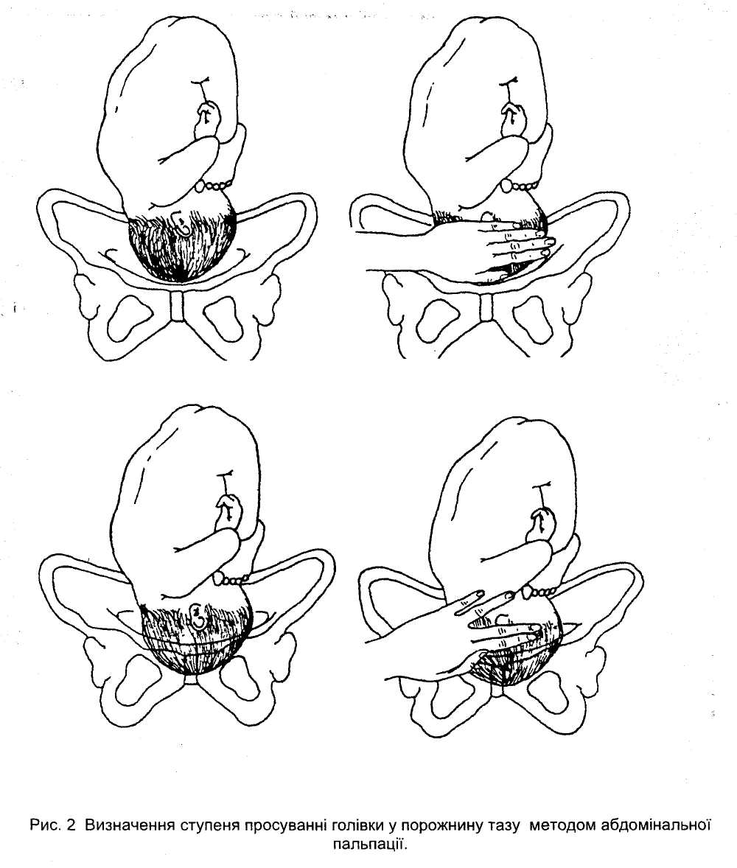
Рис1. Stations of the fetal head

8.1.4. Determination position of the fetal by internal obstetrical examination
The head is mobile over the input to the pelvis – if the doctor’s fingers can be brought under the head.
The head is pressed against the input to the pelvis – if the ends of the doctor’s fingers do not meet under the head, nevertheless the occiput and facial parts are palpated above the input to the pelvis.
The minor segment of the head is in the input to the pelvis – the occipital part of the head is over the input to the pelvis by two fingers, and the facial part - completely.
The major segment of the head is in the input to the pelvis – the occipital part of the head is not palpated over the input to the pelvis, and the facial part is over it by two - three fingers
The head is in the pelvic cavity – when only the chin is palpated or no parts of the fetal head are palpated.
Methods of external examination also include measurement of the external sizes of the pelvis. It is performed during the patient’s first visit (examination) at the female consultation and at the maternity hospital. If necessary, measurement of the pelvis is repeated during labour.
8.1.5. Cervical Examination
The level - or station - of the presenting fetal part in the birth canal is described in relationship to the ischial spines, which are halfway between the pelvic inlet and the pelvic outlet. When the lowermost portion of the presenting fetal part is at the level of the spines, it is designated as being at zero (0) station. In the past, the long axis of the birth canal above and below the ischial spines was arbitrarily divided into thirds by some and into fifths (approximately 1 cm) by other groups. Adopted the classification of station that divides the pelvis above and below the spines into fifths. Each fifth represents a centimeter above or below the spines. Thus, as the presenting fetal part descends from the inlet toward the ischial spines, the designation is –5, –4, –3, –2, –1, then 0 station. Below the spines, as the presenting fetal part descends, it passes +1, +2, +3, +4, and +5 stations to delivery. Station +5 cm corresponds to the fetal head being visible at the introitus.
If the leading part of the fetal head is at 0 station or below, most often the fetal head has engaged - thus, the biparietal plane has passed through the pelvic inlet. If the head is unusually molded or if there is an extensive caput formation or both, engagement might not have taken place although the head appears to be at 0 station (linеa interspinalis).
• mark "-" head is above the linеa interspinalis (near the pelvic plane of inlet).
• mark "+" the fetal head is below the linеa interspinalis (near the pelvic outlet).
Position of the fetal head in the pelvic plane:
-3 - head of the fetus above the inlet;
-2 - head of the fetus pressed to the inlet;
-1 - head of the fetus by the minor segment in the inlet;
-0 - head of the fetus by the major segment in the inlet;
+1 - head of the fetus in the wide part of the small pelvis;
+2 - head of the fetus in the narrow part of the small pelvis;
+3 - head of the fetus in the pelvic outlet

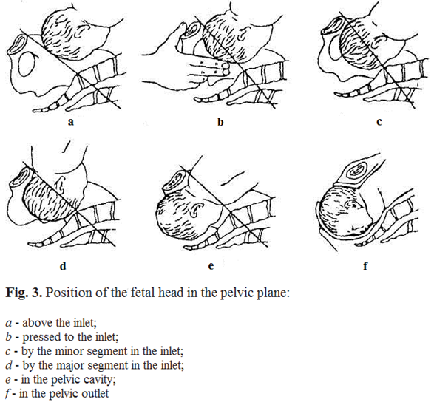

8.1.6. Methods of examining the functional condition of the fetus.
Ultrasound fetometry of the fetus is informative after 20 weeks of pregnancy (A) and includes determining the size of the head, circumference of the abdomen and length of the hip. While determining, if there is a discrepancy of one or several basic photometric indicators for the term of pregnancy, an expanded fetometry is performed, where the relation between the biparietal diameter and frontooccipital diameters of the fetal head, size of the head, circumference of the abdomen, biparietal length of the hip bone, hip bone and circumference of the abdomen are determined. The most valuable indicator is the estimated fetal weight. The basis for performing an ultrasound fetometry in late terms of the pregnancy is suspicion of fetal growth retardation according to external measurements of the height of the uterine fundus and circumference of the woman’s abdomen, and also, in special cases, to determine the term of the pregnancy with special tables, if the term is difficult to determine from anamnesis data.
• Auscultation of the fetal heart tones is performed after 20 weeks of pregnancy with the help of obstetrical stethoscope, where the frequency of heart beats in one minute is determined.
• physiological normal - 110-170 bpm
• frequency of heart beats above 180 bpm and less than 100 bpm testifies of disorders in the fetal condition.
For auscultation of fetal heart beat use the following rules:
- for facial presentation – listen for the heart beat below the navel on the side where the fetal thorax is located (if first position - on the right side, if second - on the left side).
- for transverse lie - near the navel, closer to the fetal head.
- for breech presentation - above the navel, near the fetal head on the side where the back is turned.
Cardiotocography (CTG) - synchronous electronic monitoring of the fetal heart rate and uterine contractions for 10-15 minutes.
• during analysis of the CTG, such parameters are evaluated: basal frequency of heart rate (BFHR), variability of the heart rate (amplitude and frequency oscillation), presence and type of changes in BFHR in the form of acceleration or decelerations of heart rate.
• if any pathological parameters of heart rate are present, which testify of a dangerous fetal condition, continuous monitoring with the CTG during labour is recommended
• diagnostic criteria: during normal fetal condition for CTG it is characteristic: BFHR is between 110-170 b.p.m (normocardia), variability (width of the tape) - 10-25 bpm with frequency of oscillation 3-6 cycles per minute (wavy type), presence of accelerations and absence of decelerations.
Biophysical profile of the fetus (BPF) (at 30 weeks of pregnancy) – complex evaluation of the condition of the fetus and the sum of separate biophysical parameters (fetal respiratory movements, fetal tone, fetal activity, reactance of the fetal heart rate to non-stress test (NST), volume of amniotic fluid)
• Possible rupture of membranes. In 10% of pregnancies, rupture of the membranes precedes the onset of labour. This presents as fluid leaking through the cervix and out of the vagina. The differential diagnosis includes urine leakage, vaginal infections, and passage of cervical mucus. Because prolonged rupture of the membranes is associated with higher rates of maternal and neonatal infection, optimal treatment of ruptured membranes at term is prompt induction of labour.
8.1.7. Monitoring the condition of women:
- heart rate and blood pressure (every 2 hours)
- temperature (every 4 hours)
- urine: volume; presence of protein or acetone - for displays (every 4 hours).

8.2. Management of the second stage of labour:
• measurement blood pressure, heart rate in women during labour every 10 minutes;
• monitoring of fetal palpitation every 5 minutes during the early phase;
• control by promoting fetal head through the birth canal;
• perform amniotomy if there is no timely rupture of membrane.
Physiologic position and movement.

8.3. Management of the third stage of labour
Two tactics for conducting the third period of delivery exist: active and conservative.
Immediately following delivery of the baby, the uterus begins the process of involution. Uterine contractions cause shearing of the placenta away from the uterine wall, and the placenta generally delivers shortly after the baby. Signs of spontaneous placental separation include an apparent lengthening of the umbilical cord, a gush of vaginal bleeding, and a change in shape of the uterus from discoid to globular.
Active management of the third stage of labour has been shown to be of benefit in reducing postpartum blood loss and may include draining the placenta of blood, controlled cord traction, or administration of oxytocic agents. If cord traction is employed, suprapubic pressure with the abdominal hand will lessen the potential for uterine inversion and catastrophic hemorrhage and shock. If the placenta has not delivered within 30 minutes of childbirth, or in the case of severe hemorrhage, the placenta should be manually removed.
The placenta should always be carefully inspected for abnormalities of cord insertion, confirmation of a three-vessel cord, and completeness of removal of the placenta and membranes. If any portion of the placenta or the membranes is missing, the uterine cavity should be manually explored. The uterus should be frequently palpated following delivery of the placenta to ensure that it remains well contracted. Oxytocin, administered as a dilute intravenous solution or given 10 to 20 U intramuscularly, decreases the incidence of postpartum hemorrhage due to uterine atony. The birth canal, including the cervix, vagina, and perineum, should be inspected for lacerations requiring repair. Under most circumstances, the baby can remain with the mother or immediate family and attempts at breast-feeding within the first 10 to 20 minutes should be encouraged. This first suckling stimulates endogenous oxytocin release and begins the process of milk production and successful breast-feeding.
Episiotomy is an incision in the perineum made to facilitate vaginal delivery. There is no role for routine episiotomy in modern obstetric practice, although there are some clinical indications for its use. In general, episiotomy is used to shorten the second stage of labour for fetal indications (terminal bradycardia or shoulder dystocia) or to control perineal damage when the risk of significant spontaneous laceration is high (operative vaginal delivery, previous large laceration, small perineal body, or large infant). Episiotomy should be performed with adequate local or regional anesthesia and with the verbal consent of the patient, when possible. There are two types of episiotomy techniques in common use: median and mediolateral.

8.3.1. Active conduction of the third stage
Because of a number of advantages, active conduction of the third stage of labour is the most widespread tactic and approved by the World Health Organization, International Federation of Obstetricians-Gynecologists and the International Confederation of Obstetricians.
The use of active conduction of the third stage during each labour lowers the frequency of postnatal bleeding 60% of the time caused by atonia of the uterus, and it also reduces the amount of postnatal blood loss and need for haemotransfusion.
Standard components for active conduction of the third stage include:
• introduction of uterotonics:
• birth of the placenta by controlled traction of the umbilical cord while holding the fundus of the uterus with the palm of the doctor’s hand;
• massage of the uterus through anterior abdominal wall after the birth of the placenta.

Rules for introducing uterotonics: within the first minute after the birth of the child palpate the uterus for the presence of a second child, if there is no other child – introduce 10 units of oxytocin i\m. Oxytocin is the most widespread uterotonic because it takes effect in 2-3 minutes; it can be used for all women.
If oxytocin can not be used, use ergometrin - 0,2 mg i/m. The woman should be informed about the possible side-effects of these preparations.
Ergometrin cannot be used in women with pre-eclampsia, eclampsia and hypertension.

Controlled traction by the umbilical cord:
• clamp the umbilical cord closer to the perineum; hold the clamped umbilical cord and clamp in one hand;
• put the second hand directly over the women’s pubis and hold the uterus, pulling away from the symphysis;
• slightly pull the umbilical cord and wait for a strong contraction of the uterus (usually 2-3 minutes after the introduction of oxytocin);
• simultaneously during the strong contraction, the woman should push and very cautiously pull (traction) the umbilical cord downward till the birth of the placenta; simultaneously continue with the second hand contraction in the opposite direction of traction (pushing the uterus away from the symphysis).
• if the placenta does not detach during 30-40 seconds of controlled traction, stop the traction by the umbilical cord, but continue cautiously keeping the cord in light tension; the second hand remains over the pubis, holding the uterus.
• wait for the uterus to contract again and repeat the controlled traction by the umbilical cord with contraction of the uterus.

Never use traction (pulling downwards) by the umbilical cord without contraction of a well contracted uterus over the pubis.
Using traction by the umbilical cord without contraction of the uterus can lead to prolapse or inversion of the uterus.

After the placenta is delivered, hold it with both hands and cautiously turn it, pulling the membranes out. If the membranes tear, cautiously examine the vagina and cervix in sterile gloves. If the membranes are seen, carefully use a clamp to remove it.
Attentively examine the placenta and make certain of its integrity. If an area of the maternal surface is absent, or if there is an area torn with vessels, there is reason to suspect retention of an area of the placenta and begin necessary measures.
Massage of the uterus: after the birth of the placenta immediately massage the uterus through the anterior abdominal wall until the uterus does not become firm.
Further, the uterus should be palpated every 15 minutes for the first 2 hours, to be sure that after the uterus is massaged it does not relax, but remains firm. If necessary repeat the massage.
Ice is not applied on the lower abdomen during the early postnatal period.
Active conduction of the III stage of labour should be offered to each woman as it lowers the frequency of postnatal bleedings resulting from atonia of the uterus.The parturient woman should be informed concerning active conduction of the III stage of labour, and should give voluntary written consent.

8.3.2. Passive conduction of the third stage of labour
The postnatal period of labour is the shortest (5 - 30 min). However, very important because of the possibility of appearing of postnatal bleeding. The postnatal period is accompanied by physiological blood loss (0,5 % of the woman’s weight).
The midwife, when the umbilical cord stops pulsating, but no later than one minute after the birth of the child, clamps and cuts the umbilical cord. The general condition of the woman is carefully supervised; signs of placental detachment, amount of blood loss are closely watched.
When signs of placental detachment occur (Schreder's sign, Alfred’s, Klein’s, Kustner-Chukalov’s) - it is necessary to have the woman “push” which leads to the birth of the afterbirth.
If there are no signs of placental detachment or signs of external bleeding 30 minutes after the delivery of the baby, manual detachment and delivery of the afterbirth is performed. If there are signs of bleeding - manual detachment and delivery of the afterbirth should be performed immediately with adequate anesthesia.
After the placenta is delivered, it should be carefully examined (be certain of the integrity of the placenta and membranes).
The general duration of birth on average for primipara is 8-12 hours, for secundipara - 6-8 hours.
The birth canal is examined after the delivery (with the help of vaginal mirrors) only if there is excessive bleeding, after operative vaginal delivery or if the doctor is uncertain about the integrity of the birth canal (fast childbirth, childbirth outside the hospital).

9. Partogram (Order № 624 of 03.11.2008 Ministry of Health of Ukraine).
The partogram provides a graphical illustration of the progress of labour and is considered by the World Health Organisation (WHO) to be a valuable tool for managing intrapartum women.

The partogram:
- Depicts the progress of labour at a glance,
- Enables failure to progress to be readily recognised,
- Is simple to use,
- Provides a practical teaching aid,
- Is an efficient means of exchange of technical information about labour progress between teams of caregivers.

KEY POINTS:
1. The partogram should be used for all women admitted in established labour. When the partogram is commenced at the beginning of the induction process the Alert and Action lines are drawn when the women is in the active phase of labour.
2. Established labour is defined as the presence of regular contractions, increasing in strength and
duration, leading to progressive effacement and dilatation of the cervix.
3. A rate of 1cm/hour in the active phase of labour is often accepted as normal progress in labour. Many women who show slower rates of cervical dilation will proceed to normal birth.2
4. The Alert line is a simple tool which separates women into two groups:
Women with cervical dilatation equal to / greater than 1cm/hour who are highly unlikely to
require operative intervention.
Women with cervical dilatation slower than 1 cm/hour who are more likely to require
operative intervention.
5. The WHO partogram does not differentiate between nulliparous or multiparous women’s labours.

MANAGEMENT:
A vaginal examination is performed 4 hours after the initial one or earlier if clinically warranted. If subsequent examination shows dilatation between Alert line and Action line a repeat vaginal examination is carried out in 2 hours. At this examination if the cervical dilatation is touching / crossing the Action line, the Labour and Birth Suite medical team must evaluate the woman’s progress in labour and instigate appropriate intervention.

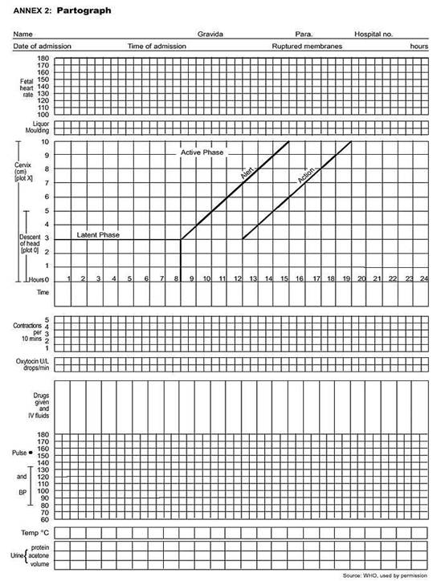

Fig. 4. Recording progress of labour.

10. Newborn Care. Immediate Assessment
In 1952, Dr. Virginia Apgar devised a 0 to 10 scale scoring system intended to focus attention on the newborn and allow the systematic assessment of its condition and immediate needs. Since that time, Apgar scores have become a mainstay in immediate newborn assessment.
To prevent the aspiration mucus is drained from the nasal part of the pharynx of the newborn immediately after the external rotation of the head, when its chest is compressed by the maternal passages and he can not make the first inhalation. After the first inhalation skin of the newborn becomes rose, he begins to move by his extremities, loudly screams.
Condition of the newborn is estimated by Virginia Apgar’s score on the 1st and 5th min of his life.
Your baby will be checked for five things:
• A – Activity; muscle tone
• P – Pulse rate
• G – Grimace; reflex (measured by placing a bulb syringe in the baby’s nose and seeing his response)
• A – Appearance; skin color
• R – Respiration
Each category is given a score ranging from 0-2. The numbers are then added up for a final score.
By the Apgar’s score the majority of newborns on the 1st minute of life has 7 - 8 points (acrocyanosis is detected as the result of transitional blood circulation and decrease in the muscular tonus); 4 - 6 points asphyxia of slight degree; 0 - 3 - severe asphyxia.
The mark 10 points on the 1st minute of life is detected only in 15% of the newborns. On the 5th minute of life estimation by the Apgar’s score in the norm rises up to 8 - 10 points.

11. Newborn Care
After 1 minute babies born:
• After the stop of pulsation of the umbilical cord two clamps are applied on it (10 cm from the umbilical ring), processed by 5% alcoholic solution of iodine and incised by aseptic scissors. During the physiological labour it is recommended to put a newborn to the breast of the mother (within first 2 h), better till the section of the umbilical cord, which contributes to its better adaptation and reduce of the length of postnatal stage of labour.
• Keep baby warm. When a baby is born, he is wet from the fluid in the womb and can easily become cold. Nurses will dry his skin, wrap him in a blanket, place a knitted hat on his head and may even use heat lamps to help him stay warm. Holding your baby close to you so that your skin touches his also helps keep him warm.
After the labour of the newborn its height (from pate to hill), weight, circumference of the head (direct diameter ) and shoulders are measured. Bracelets are put on, where the sex, mother’s surname and name, number of labour history, weight and height, date and time of delivery are written. The newborn is covered with warm wrapping clothes and blanket and put on the warm wrapping table.

12. Anaesthesia and analgesia of labour.
- Physiologic positions and movements,
- Child birth preparation:Psychoprophylaxis,
- Hydrotherapy• Hydrotherapy involve a simple shower or tubbath, or it include the use of a whirlpool orlarge tub specially equipped for pregnantpatients. Benefits of hydrotherapy includes reduced pain& anxiety, decreased BP & increased efficiencyof uterine relaxation.
- Systemic Medication for Labour Analgesia
Obstetric anesthesia encompasses all techniques used by anesthesiologists and obstetricians to alleviate the pain associated with labour and delivery: general anesthesia, regional anesthesia, local anesthesia, and analgesia. Relief from pain during labour and delivery is an essential part of good obstetric care. Unique clinical considerations guide anesthesia provision for obstetric patients; physiologic changes of pregnancy and increases in certain complications must be considered.
Obstetric analgesia or anesthesia refers to the multiple techniques useful for the alleviation of pain associated with labour, delivery, or surgery. The choice of an appropriate analgesic technique must be made by the patient, the obstetrician, and the anesthesiologist and should take into consideration the patient's anatomy and physiology, the status of her fetus, the obstetric plan for delivery, and the pharmacology of the drugs to be employed.

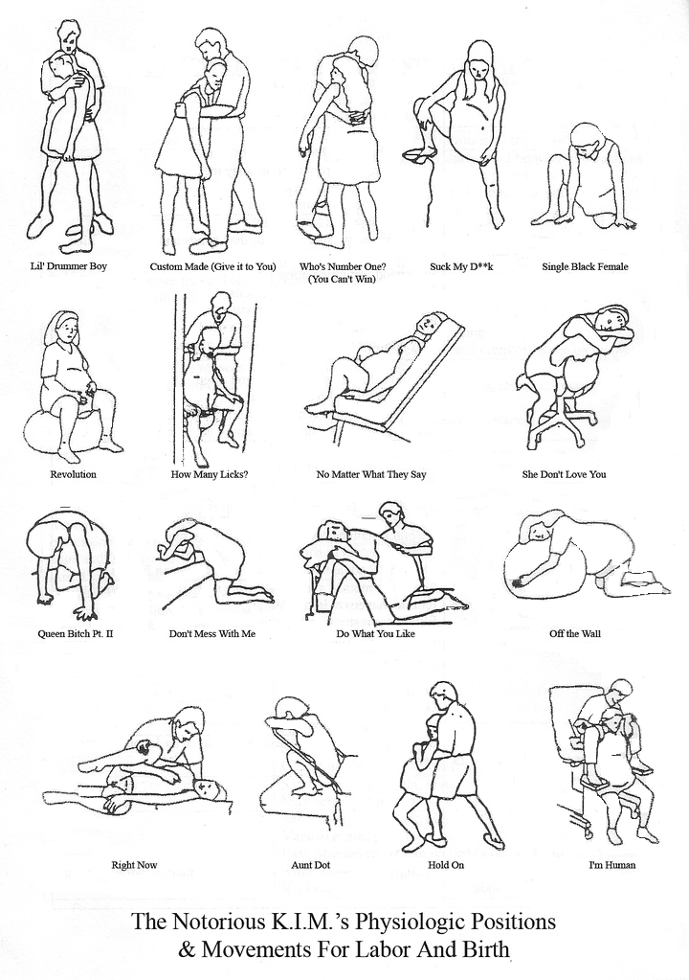

V. Supportive employment.

Theoretical questions for the class:
- Precursors birth, preliminary period.
- Evaluation of the cervical status (scale Bishop).
- Biomechanism of labour at the anterior and posterior types occipital presentation.
- The clinical course of the first stage of labour. Methods registration labour. Monitoring during delivery.
- Periods of delivery.
- Clinical management of the first stage of normal labour. The basic principles of partogram.
- The clinical course of the second stage of labour and clinical management of this stage of labour.
- The third stage of labour. The signs of placental separation. Clinical management III stage of labour (active and expectant tactics).
- Delivery of the placenta according to Abuladze, Genterʼs method and Crede-Lazarevichʼs method.
- Examination of the placenta. Physiological and pathological hemorrhage.
- Essentials of normal newborn assessment (Apgar scores) and care.
- Care and observation in the first few hours of life.
- Obstetric analgesia and anesthesia.

After studying the chapter content, the student should be able to
accomplish the following:
1. Define the key terms.
2. Describe the assessment data collected on admission to the perinatal unit.
3. Identify the measures used to evaluate maternal status during labour and birth.
4. Determine the period of delivery.
5. Maneuvers of external obstetrical examination, (Leopold's maneuvers).
Define presentation, position, type of fetus.
6. Compare and contrast the advantages and disadvantages of external and internal fetal monitoring, including the appropriate use for each.
7. Estimated date of birth, to determine if term or preterm. Fetal movement (frequency in the past few days)
8. Evaluate the course and stage of labour provided by partohram.
9. Evaluate the status of the newborn Apgar scores (in case of demonstrations delivery).
10. Demonstrate by the phantom active tactics III stage of labour.
11. Demonstrate by the phantom expectant tactics III stage of labour.
12. Care and observation in the first few hours of life.

ALGORITHM for conducting normal labour:
(Order № 624 of 03.11.2008 Ministry of Health of Ukraine).

• evaluate the degree of predicted risk of development of maternal and perinatal pathologies so as to determine the necessary level of help during labour;
• determine the plan for conducting labour and an informed conformation from the woman;
• emotional support for the parturient woman during labour (labour with partner);
• control over the condition of the mother and fetus during labour while conducting the partogram;
• free position of the parturient woman during labour;
• pain relief if indicated;
• condition of the fetus:
• frequency of fetal heart beats, performed with auscultation or manual Doppler analyzer (every 15 minutes)
• degree of configuration of the fetal head (every 4 hours)
• condition of the amniotic sac and amniotic fluid (every 4 hours)
• condition of the parturient woman:
• pulse and arterial pressure (every 2 hours)
• body temperature (every 4 hours)
• urine: amount; presence of protein or acetone – if indicated (every 4 hours).
• conducting the second period of labour:
• measurement of the woman’s BP, pulse every 10 minutes;
• control of feta heart activity every 5 minutes during the early phase, and after each contraction during the active phase;
• control of the advancement of the fetal head through the birth canal by using internal obstetrical examination each hour.
Because of increased risk of ascending infection through the birth canal additional internal obstetrical examinations during the second stage of labour are admissible only if indicated:
- performing amniotomy if the amniotic sac has not ruptured
- during multiple pregnancy after the birth of the first baby
- when deciding on operative vaginal delivery (obstetrical forceps, vacuum extraction, extraction of the fetus by the pelvic end).
• evaluate the condition of the child during birth; perform primary care of the newborn and early breast feeding, principles of "thermal chain"
• Preventive measures are taken for ophthalmi for all newborns during the first hour of life; 0,5% erythromycin or 1 % tetracycline ointments are used.
• 2 hours after the birth, the baby is changed into clean clothes and together with the mother is taken to the postnatal ward.

VІ. MATERІALI for self-control
6.1. Control questions for evaluation the initial level of knowledge
- Make definition of the «precursors birth» and «preliminary period».
- What periods of labour are distinguished?
- What are the phases of the I stage of labour?
- What are the objective signs of birth activity in the I stage of labour?
- What are the features of the mechanism of cervical dilation for primapara and secunipara?
- What is the benefit in a free position women during the childbirth?
- What are some features of conducting the I stage of labour?
- How often are vaginal exams performed during the I stage of labour; what are the reasons for it?
- What are some indications for internal obstetrical examination?
- What objective information is received during vaginal exams during the I stage of labour?
- How is determine premature, early, due time and overdue rupture of the amniotic sac determined?
- What are modern principles and ways of control of the condition of the fetus?
- What is a partogram?
- How is the II stage of labour characterized; how long is it possible for it to last?
- What are the objective signs of birth activity and its efficiency in the II stage of labour?
- What are some features for conducting the II stage of labour?
- What methods exist for determining the dynamics of advancement of the fetus’s head?
- What is the longest permitted duration for the head to be in one plane of the small pelvis, how is it validated?
- How is the III stage of labour characterized (duration)?
- What are the mechanisms of placental detachment from the uterus wall?
- What does active tactics for conducting the III stage of labour consist of?
- What does passive tactics for conducting the III stage of labour consist of?
- What is the volume of physiologic blood loss during labour; what are the methods for its control?
- What are some modern methods of analgesia (anesthesia) during labour?
- What are the principles of evaluating the condition of the newborn?
- What is the modern approach to performing primary care of the newborn?
- Why is creating “thermal chain” necessary; what is the algorithm for performing it?

6.2. Test for control of knowledge

1. One of the planes of the pelvis is limited behind sacral promontory, in front – crista iliaca and superior edge of the pubis symphysis, on each side - lin. terminalis.
What moment of the biomechanism of birth does the fetus make in the given pelvic plane?
A. It does not make any of the moments.
B. External turn of the head and internal turn of the shoulders.
C. Extension of the head.
D. Internal turn of the head.
E. Flexion of the head.

2. On the occipital area of the head of a newborn, having a dolichocephalic form, there is a patrimonial tumour with the centre at the area of the small fontanel. What head presentation did the birth occur in?
A. Frontal.
B. Anterior type, occipital presentation.
C. Facial.
D. Posterior type, occipital presentation.
E. Frontparietal.

3. During vaginal examination 6 hours after the beginning of patrimonial activity the following was revealed: the cervix is open 5 cm, the fetal head is presented and is pressed to the input of the pelvis. The sagittal suture is in the right diagonal diameter, the small fontanel is to the left, to the side. What moment of the biomechanism of birth is being described?
A. Flexion of the head.
B. Extension of the head.
C. Internal turn of the head.
D. Additional flexion of the head.
E. Internal turn the shoulders.

4. During vaginal examination, the fetal head is determined; it fills the posterior surface of the symphysis pubis and hollow of the sacrum, a inferior edge of the symphysis pubis, spines of the ischiadiac bones, sacrococcygeal joints are accessible with palpation. In what plane of the small pelvis is the head located?
A. Plane of the narrow part of the pelvic cavity.
B. Plane of the wide part of the pelvic cavity.
C. On the input to the pelvis.
D. In the input to the pelvis.
Е. In the exit of the pelvis.

5. Secundipara has been in childbirth for 8 hours. Light amniotic fluid was discharged. The fetal position is longitudinal, the fetal head is not determined over the input to the pelvis. Fetal palpitation is clear, rhythmical, 140 b.p.m., over the pubis. Internal obstetrical examination: the cervix is smooth, fully open, the fetal sac is absent. The hollow of the sacrum is completely filled with the head. Spina ischiadica is not reached. The sagittal suture is in the direct diameter of the pelvis. The large fontanel is at the pubis. Contractions have begun. What period of birth is being described?
А I period.
B. End of the I period.
C. Beginning of the II period.
D. End of the II period.
E. Beginning of the III period.

6. A woman in her first pregnancy had a live baby boy, weight 3200 g, length 50 cm. The umbilical cord was transected after pulsation of the vessels stopped. When the edge of the palm is pressed on the symphysis, the umbilical cord retreats into the vagina. What sign is used for determining whether the placenta has separated from the uterus?
A. Alfelda.
B. Kustner-Chukalova.
C. Schröeder.
D. Dovjenko.
E. Rogovina.

7. Primipara gave birth to a live mature baby boy with an estimation by the Apgar scale of 9 points. At the present moment, the umbilical cord vessels are not pulsating, the umbilical cord was cut. Bloody discharge from the genital tract are absent. Specify the period of birth:
A. Early postnatal period.
B. Opening.
C. Expulsion of fetus.
D. Placental stage.
E. Late postnatal period.

8. Data from the internal obstetrical examination of a parturient woman: the cervix uterus is smooth, open 6 cm. The fetal sac is intact. The fetal head is presented, when pressed on, it does not make push back. During palpation of the pelvic, the pubis symphysis, innominate lines, promontory are free. The sagittal suture is in the transverse diameter, the small fontanel is to the right at the pubis. In what plane is the fetal head?
A. Pressed to the input of the pelvis.
B. On the input of the pelvis.
C. Wide part of the pelvic cavity.
D. Narrow part of the pelvic cavity.
E. Exit of the pelvis.

9. I period of I due labour. Fetal position - longitudinal, the small segment of the head is in the input to the pelvis. Fetal palpitation is clear, rhythmical, 140 b.p.m., to the left below the navel. During internal obstetrical examination, the cervix is smooth, open 6 cm, the small segment of the fetal head is in the input to the pelvis. The sagittal suture is in the right diagonal diameter, the small fontanel is to the left closer to the pubis. Specify the position and type of position:
A. High direct standing of the sagittal suture.
В. I position, posterior type of position.
С. II position, anterior type of position.
D. II position, posterior type of position.
Е. I position, anterior type of position.

10. Secundipara was delivered to the maternity hospital 6 hours after the beginning of labour. Contractions are 30-35 seconds, every 4 minutes, good force. BP is 120/80 mm hg. Pulse is 80 b.p.m., rhythmical, of satisfactory properties. The fetal heart beat is 146 b.p.m. The fetal position is longitudinal, head presentation, I position, anterior type of position. The small segment of the fetal head is in the input to the pelvis. The height of the contraction ring is 5 cm over the pubis. When should internal obstetrical examination be performed?
A. Upon arrival and after amniotic discharge.
B. Every 2 hours.
C. At the beginning of the II period of birth.
D. When transferred to the postnatal ward.
E. At the end of the I period of birth.

Answers: 1Е, 2 D, 3А, 4А, 5С, 6В, 7 D, 8А, 9Е, 10А

6.3. Tests for self-control
1. In what size of the plane of the input to the pelvis is the sagittal suture during anterior position, occipital presentation, I position after performing flexion of the head?
A. Direct.
B. Left diagonal or direct.
C. Right diagonal or direct.
D. Right diagonal or transverse.
E. Left diagonal or transverse.

2. What size of the plane of the input to the pelvis is the sagittal suture in during posterior type of position, occipital presentation, I position after flexion of the head?
A. Direct.
B. Left diagonal or direct.
C. Right diagonal or direct.
D. Right diagonal or transverse.
E. Left diagonal or transverse.

3. In what plane of the pelvis does the fetus finishing making the internal turn of its head during anterior type of position, occipital presentation, II position?
A. Input to the pelvis.
B. The wide part of the pelvic cavity.
C. The narrow part of the pelvic cavity.
D. When going from the wide part of the cavity to the narrow part of the pelvic cavity.
E. The exit of the pelvis.

4. In what diameter of the plane of the exit from the pelvis is the sagittal suture during extension of the head during posterior type of position, occipital presentation, I position?
A. Direct.
B. Left diagonal or direct.
C. Right diagonal or direct.
D. Right diagonal or transverse.
E. Left diagonal or transverse.

5. In what diameter of the plane of the exit from the pelvis does the fetal shoulders cut through and are born during the anterior type of position, occipital presentation?
A. Direct.
B. Right diagonal.
C. Left diagonal.
D. Transverse.
E. Direct and transverse.

6. The head of a newborn has a dolichocephalic form, extended from the front to the back. At the occipital area, there is a patrimonial tumour located in the middle between the large and small fontanel. What head presentation did the birth occur in?
A. Frontparietal.
B. Anterior type, occipital presentation.
C. Posterior type, occipital presentation.
D. Facial.
E. Frontal.

7. Primipara, 20 years old, is in the beginning of the I period of physiological birth. Contractions are 15-20 sec., every 10-15 min., weak. Fetal palpitation is not suffering. How much in cm should the cervix be open for the amniotic discharge to be timely?
A. 6-8.
B. 8-10.
C. 4-6.
D. 2-4.
E. 1,5-2.

8. During internal obstetrical examination of a secundipara, the cervix is open 4-5 cm, when pressing with a finger on the fetal head, it pushes away and again returns to its initial position, the pelvis is free. How long is the fetal head permitted to be in this plane, in hours?
A. 5.
B. 6.
C. 4.
D. 3.
E. 2.

9. You are observing a parturient woman in the 1 period of birth. During internal obstetrical examination, the sagittal suture is in the right diagonal diameter, the small fontanel is closer to the pubis. How should the parturient woman lay in bed, so that the fetal head would be insert correctly?
A. On her left side.
B. On her back.
C. On her right side.
D. It make do difference.
E. She is only allowed to walk.

10. Secundipara with a weight of 80 kg. What is the acceptable amount of blood loss, ml:
A. 400.
B. 500.
C. 600.
D. 700.
Е. 800.

Answers: 1 D, 2Е, 3Е, 4А, 5А, 6В, 7В, 8В, 9А, 10А

A LIST OF RECOMMENDED EDUCATIONAL LITERATURE FOR OBSTETRICS AND GYNECOLOGY
Basic:
- Zaporozhan V.M., Miwenko V.P. Collection of test tasks for clinical paints: science-medical collection. - Odessa: Оdessa state medical university, 2008.- 176 p.s- Language: eng.
- Chesley's Hypertensive Disorders in Pregnancy - Lindheimer M D Roberts J - 31 Jul 2009
- Management of Unintended and Abnormal Pregnancy - Paul M Lichtenberg S - 23 Apr 2009
- Obstetrics by Ten Teachers. 15th edn. T Lewis, G Chamberlain. (pounds sterling 15.99.) Edward Arnold, 1990. ISBN 0-340-515650-X.
- Fundamentals of Obstetrics and Gynaecology. D Llewellyn Jones. (pounds sterling 15.00.) Faber, 1990. ISBN 0-571-142273.
- Illustrated Textbook of Obstetrics. G Chamberlain, C Gibbons, J Dewhurst. (pounds sterling 16.95.) Gower, 1989. ISBN 0-397-44580-6.
- Lecture Notes on Obstetrics. 6th edn. G Chamberlain, M J Pearce. (pounds sterling 12.95.) Blackwell Scientific, 1992. ISBN 0-632-02771-1.
- Student Notes on Obstetrics and Gynaecology. J Willox, J Neilson. (pounds sterling 11.50.) Churchill Livingstone, 1990. ISBN 0-443-041504.
- Oxford American Handbooks of Obstetrics and gynecology - Errol R. Norwitz, S. Arulkumaran ,1999
- Essential Obstetrics and Gynaecology (4th Edition) - E. Malcolm Symonds, Ian M. Symonds , 2008
- BENSON & PERNOLL’S handbook of OBSTETRICS & GYNECOLOGY,2008
- Robboy S.J. Anderson M.C., Russel P. Pathology of the female reproductive tract. – Churchill Livingstone, 2002.- 929 p.
- Obstetrics: підручник англійською мовою (edit by I.B. Ventskivska).- K.: Medicine,2008.-334 p.

Additional:
- Progress in Obstetrics and Gynaecology. Vol 10. Ed J Studd. (pounds sterling 26.50.) Churchill Livingstone, 1993. ISBN 0443-04754-5.
- Recent Advances in Obstetrics and Gynaecology. Vols 16 and 17. Ed J Bonnar. (pounds sterling 22.50.) Churchill Livingstone, 1993. ISBN 0-443-04402-3.
- Proactive Support of Labor - Reuwer P - 01 Feb 2009
- Creasy and Resnik's Maternal-Fetal Medicine - Creasy R K Resnik R - 08 Jan 2009
- Fetal Medicine - Rodeck C H Whittle M J - 11 Dec 2008
- High Risk Obstetrics - Funai E F Evans M - 04 Jul 2008
- Danforth's Obstetrics and Gynecology - Gibbs R S Karlan B Y - 12 Jun 2008
- Munro Kerr's Operative Obstetrics - Baskett T K Calder A A - 10 Aug 2007
- Williams Manual of Obstetrics - Leveno K Cunningham G - 09 Aug 2007
- Obstetrics: Normal and Problem Pregnancies - Gabbe S G - 01 Jul 2007
- Labour Ward Manual - Liu D T Y - 29 Jun 2007
- Manual of Obstetrics - Evans A T - 02 May 2007
- Pre-eclampsia - Lyall F Belfort M - 01 May 2007

Methodical material prepared by
Obstetrics and gynecological department № 1
MD, PhD Kozhukhar A.V.

