ODESSA NATIONAL MEDICAL UNIVERSITY
Department of Obstetrics and Gynecology №2

Methodical development
Practical classes for students

Academic discipline "Obstetrics and Gynecology"

Topic number 21 "Narrow pelvis. Anomalies of position and fetal presentation. Pregnancy and childbirth during pelvic presentation."
Course V, International Faculty

Authorized At the methodical faculty meeting “31” August, 2016 Protocol № 1 Head of the department Professor Zelinsky A.A.

Re-authorized At the methodical faculty meeting “ __” ________________ 20__ Protocol №__ Head of the department Professor Zelinsky A.A.

ODESSA 2017-2018

Pregnancy and delivery in breech presentation
Breech presentation is a presentation that is characterized by pelvic pole position of fetus over pelvic inlet.
Frequency of breech presentation in term labor with one fetus is 3-3,5%.
Classification
I. Frank breech:
- incomplete or extended breech (buttocks presentation);
- Complete or flexed breech (buttocks and feet presentation).
II. Footling breech:
- incomplete (one foot presentation);
- complete (both feet presentation);
- Kneeling presentation.
Diagnostics
Abdominal examination:
- round firm balloting head in the area of uterine fundus;
- irregularly shaped soft unballoting presenting part is palpated over/in pelvic inlet;
- Fetal heartbeat is auscultated on the left or on the right above navel depending on fetal position.
Vaginal examination during labor (Table)

Table
Differential diagnostics of different kinds of presentations based on results of vaginal examination
Presentation | Vaginal examination
Frank breech | • palpation of a big and soft presenting part  • identification of ishial tubers, sacral bone, anal orifice, genitalia  • possible identification of inguinal curve in incomplete breech, and feet near buttocks in complete breech  • ishial tubes and anus of fetus are in the same plane
Footling breech | • palpation of heel bone, short even fingers, thumb can’t be abducted and its mobility is limited  • thumb can’t be pressed down to sole
Face presentation | • identification of firm cylinders and jaws, mouth and nose of fetus  • mouth and molar crests have triangular shape
Hand falling in shoulder position or oblique lie | • thumb is easily pressed down to palm  • heel bone can’t be palpated
Ultrasound (US) examination is the most informative diagnostic method. It allows not only to identify breech presentation, but also presumed weight, position of a head (deflexion grade), placenta localization, volume of amniotic fluid, cord entanglement, abnormal development, etc. We summarize 4 variants of position of head by the size of an angle between cervical spine and occipital bone, which are very important for the choice of labor management method:
- head is flexed, angle over 110°;
- head is slightly deflexed -I grade of head deflexion, angle 100 - 110°;
- head is mildly deflexed - II grade - 90°-100°;
- Excessive head deflection - ІІІ grade of head deflexion, angle less than 90°.
Presumed diagnosis of breech presentation is stated at the term of 30 weeks and final diagnosis – at the term of 37-38 weeks.
The rate of spontaneous turn harshly lessens after the 31st week of pregnancy that is why it is wise to correct fetal position after this term.
Pregnancy care
Antenatal clinic
Necessary recommendations to pregnant women at the term of 30 weeks to induce spontaneous turn of fetus:
- edwise position on the side opposite to fetus;
- Knee-elbow position for 15 min 2-3 times a day.
Complex of corrective gymnastic exercises in one of the existent methodics is prescribed since the 32nd up to the 37th weeks.
Contraindications to gymnastic exercises:
- threatened premature labor;
- placental presentation;
- low insertion of placenta;
- Anatomically contracted pelvis of II - III grade.
External cephalic version is not performed at the antenatal clinic.
Necessity of hospitalization to maternity obstetric clinic is determined at the term of 38 weeks basing on the next indications:
- aggravated obstetric-gynecological history;
- feto-maternal disease;
- Extra genital pathology;
- Opportunity to perform external cephalic version.
Maternity obstetric service
Diagnosis specification:
- performing of ultrasound examination;
- evaluation of state of fetus (biophysical profile - BPP, Doppler sonography if necessary);
•estimation of readiness of maternal organism to delivery (Bishops scale);
•estimation of possibility of performing of external cephalic version.
Plan of labor management is formulated in concilium with anesthesiologist and neonatologist and then negotiated with a patient.
External cephalic version in full-term pregnancy leads to increasing of amount of physiological deliveries in cephalic presentation.
Indications:
- Incomplete breech in full-term pregnancy and alive fetus.

Conditions:
- presumed weight of fetus < 3700,0 g,
- normal sizes of small pelvis;
- empty urinary bladder;
- US after external version is available;
- satisfactory condition of fetus on BPP and absence of abnormal development;
- normal mobility of fetus, enough quantity of amniotic fluid;
- normal uterine tonus, unbroken fetal bladder;
- readiness of operating room to emergency care in the case of complications;
- Skilled qualified specialist acquainted with procedure of version.
Contraindications:
- Fetal-maternal disease when decision making of external version (bleeding, fetal distress, preeclampsia);
- aggravated obstetric-gynecological anamnesis (recurrent miscarriage, perinatal loss, infertility in anamnesis);
- polyhydramnios or oligohydramnios;
- multiple pregnancy;
- anatomically constricted pelvis;
- cicatrical deformity of vagina and cervix;
- III grade of head deflexion on US;
- placental presentation;
- severe extragenital pathology;
- uterine scar, peritoneal comissures;
- hydrocephaly and neck tumors in fetus;
- abnormal development of uterus;
- Tumors of uterus and annexes.
Procedure of external cephalic version:
- advise position with angle of 30-40° in direction of fetal spine;
- breech of fetus is abducted from pelvic inlet by the hands of physician that are inserted between mons pubis and breech of the fetus (а);
- breech of fetus is carefully shifted in direction of fetal position (b, c);
- head is shifted in direction opposite to fetal position (d);
- Version is finished when head is shifted to pelvic inlet and breech to uterine fundus.
If the first try was unsuccessful the second try perform is not reasonable.
Complications:
- abruption placenta;
- fetal distress;
- Rupture of uterus.

а
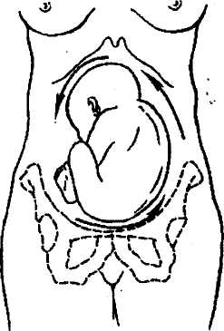
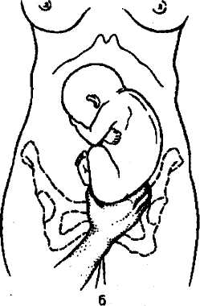

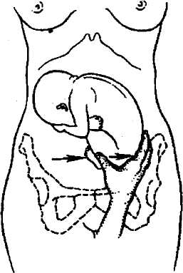
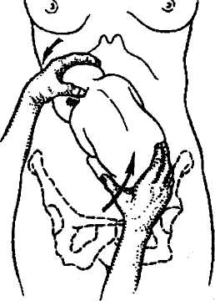
c d
Pic. ECV procedure.

Labor management
Birth in time.
Conservative labor management:
- estimate indications, make sure that there are all necessary conditions for safe vaginal delivery and no indications to caesarean section;
- follow the course of the І period of labor by filling in the partogram (do not fill in table 2 in partogram), cardiotocography registration for 15 min every 2 hours;
- in the case of breaking of waters, immediate vaginal examination should be performed to exclude prolapse of funis;
- II period should be managed with mobilized vein for intravenous infusion of 5 IU of oxytocin in 500,0 ml of normal saline (up to 20 drops per minute);
- Episiotomy if necessary; pudendal anesthesia;
- II period of delivery should be managed in presence of anesthesiologist, neonatalogist.

А. Extended and flexed breech (Tsovyanov manual aid method І)
I. Labor of breech and feet:
- woman should push during the cut of breech;
- if perineum isn’t able to spread enough, episiotomy is performed;
- breech appear by itself up to navel;
- both thumbs of physician are on the back surface of thighs, other fingers are on lumbosacral region of fetus;
- carefully hold breech but don’t pull
Don’ pull fetus for inguinal curve anticipatorily without indications (fetal distress).
Hold fetus by thighs but not by sides and abdomen because liver or kidneys can be damaged.
II. Labor of hands:
- fetus which is born up to navel is taken with the thumbs on breech and sacral region and with other fingers on front surfaces of thighs;
- body is moved down until the lower angle of shoulder blade appears;
- during down-directed traction the front hand is born from under symphisis; after substantive birth of the front hand, breech is lifted to mother’s abdomen to let the rear hand appear itself; if the hands of fetus cannot appear unassisted it is accounted to be nuchal arms and classical manual maneuver of shoulder labor should be performed.
Classical manual maneuver of hands labor:
- with one hand (when І position – left hand) grab legs of fetus in the region of pedidial joint and lift forward and slightly to the side opposite to the spine of fetus, closer to mother’s thigh (if І position – to right thigh);
- insert the second hand in vagina following the back of fetus up to mother’s sacral hollow and then follow the humerus up to the elbow and extract rear hand;
- the arm is pulled at elbow;
- the front hand is extracted after its changing to the rear position and also from the side of sacral hollow;
- grab pelvis and front surfaces of thighs of fetus with both hands (thumbs on the breech, 4 fingers of each hand on thighs; don’t touch abdomen of the fetus) and turn through 180°;
- back of the fetus is under symphisis;
- The second arm is freed similar to the first from the side of sacral hollow.
ІІІ. Labor of the head:
А. In a case of uncomplicated delivery, absence of nuchal arms the head is born in a flexed position:
- physician’s arm is put under the body of fetus, so the body lays on an arm and elbow of physician;
- assistant helps labor of the head by maintaining mild pressure over symphisis that prevents head deflexion;
- the body is lowered under the level of perineum for the formation of fixating point in suboccipital fossa with the lower border of symphisis;
- the body is lifted over perineum level;
- Head appears substantively in a flexing position around fixating point.
B. If the classical manual maneuver of hands labor was applied for labor of shoulders and arms, the head is born with the help of Mauriceau maneuver:
- physician’s arm is put under the body of fetus, so the body lays on an arm and elbow of physician;
- put index and ring fingers on the cheek-bones of fetus and middle finger into its mouth for abduction of jaw and head flexion;
- use the second hand to hold shoulders of fetus from the back side;
- carefully flex the head to sternum with index and middle fingers until the pressure on jaw results in scalp birth;
- provide traction to your side;
- assistant pushes with palmar surface of his arm over symphisis, fixating the head in flexing position;
- Carefully apply up (forward) traction for the head birth in a flexed position.

B. Footing breech:
In a case of footing breech caesarean section is performed. Vaginal birth is provided only when:
- II period of labor – Tsovyanov manual aid method II is applied to provide complete cervical dilatation and breech lowering;
- Second fetus birth in the case multiple pregnancy.
Indication to caesarean section:
- presumed weight of fetus is over 3700,0 g;
- footling breech;
- head deflexion of the III grade on US;
- Neck tumors of fetus and hydrocephaly.

Biomechanism of breech labor
I moment – internal breech version. Breech is engaged in its intertrochanterical diameter in one of the oblique diameters of pelvic inlet. Breech descends and performs internal version, intertrochanterical line is set in anterior-posterior diameter of pelvic outlet.
II moment – side flexion in lumbosacral part of spinal cord. Side flexion of fetus takes place according to direction of birth canal. Front breech (which serves as a guiding point) crowns but does not bear because the fixating point is set between anterior iliac spine of fetus and pubic symphysis. Posterior breech is born first, followed afterwards by the front breech and then fetus is born up to its navel.
III moment – internal shoulder version and external corpus version. Shoulders descend into pelvic cavity and are set in anterior-posterior diameter of pelvic outlet.
IV moment – side flexion in cervicothoracical part of spinal cord, during which hands and shoulder girdle are born.
V moment – internal head version. The head descends passing birth canal and is set with sagittal suture in anterior-posterior diameter of pelvic outlet. Suboccipital fossa is fixated under the lower edge of pubic symphysis.
VI moment – head flexion and its birth.
If the state of mother and fetus is satisfactory and sizes of pelvis and fetus are normal, vaginal birth is preferred. It is necessary to divide an act of delivery into 4 stages:
1. Fetus birth up to its navel;
- Fetus birth from navel to the lower edges of shoulder blades;
- Shoulder birth;
- Head birth.
Pregnancy and labor in pelvic bones anomaly
Contracted pelvis can be anatomically contracted when anatomy changes take place, and clinically contracted when functional inequality between the diameters of a head of fetus and mother’s pelvis is independent to their sizes.
Etiology
There are different causes of contracted pelvis formation. Amongst them are malnutrition, physical exertions, and chronic diseases in childhood and adolescence. Significant role in skeleton anomalies formation plays rickets in childhood. Rachitic bone deformations predetermine pelvic narrowing. Bone deformations occur not only when the illness is in full bloom but also during suppressed forms when changes in other parts of the skeleton are barely visible.
Tuberculosis of bones and joints also leads to pelvic deformations. Significant deformations may be caused by pelvic bones fractures, dislocations, and vicious union in lower extremities, exostosis, pelvic bones tumors, and deformations in lumbosacral articulation.
Some role is played by mother’s malnutrition during pregnancy and diseases which lead to metabolic disorders between mother and fetus.
Hormone misbalances in adolescence also contribute to pelvic bones deformation, because estrogens stimulate pelvic growth in transverse sizes and its ossification, while androgens stimulate skeleton and pelvis elongation.
Anatomically contracted pelvis is classified by form and grade of contraction.
Frequently met types of contracted pelvis:
Generally contracted pelvis:
- infantile pelvis;
- android pelvis;
- Dwarf pelvis.
Flat pelvis:
- simple flat pelvis;
- flat rachitic pelvis;
- pelvis with reduced anterior-posterior diameter in the plane with greatest pelvic dimensions;
- Generally contracted flat pelvis.
Seldom met types of contracted pelvis:
1. Obliquely displaced and obliquely contracted pelvis.
2. Dollichopellic pelvis.
3. Choanoid pelvis.
4. Osteomalacic pelvis.
5. Spondylolisthetic pelvis.
6. Pelvis contracted with exostoses, fractures, pelvic bones tumors.
7. Kyphoid pelvis.
There 4 degrees of pelvic constriction:
I degree – true conjugate is 10,5-9 cm
II degree - 9-7,5 cm
III degree - 7-5,5 cm
IV degree – less than 5,5 cm.
Frequency of occurrence of anatomically constricted pelvis is 2,6-12 %.
Diagnostics of constricted pelvis
Timely diagnostics of constricted pelvis may caution a rate of complications, which can arise during labor or rarely at the end of pregnancy.
Anamnesis, external examination and vaginal examination are of the main diagnostic significance.
We get important information about rickets, bone tuberculosis, osteomyelitis, traumas, late menarche, obstetric history from anamnesis. During external examination attention is paid to height (pelvis is usually constricted when the height is 145 cm or less), spinal curvatures (kyphosis, scoliosis, lordosis), shortening of lower extremities, immobility in joints, form of lumbosacral rhomb, pendulous abdomen in multipara, peaked abdomen in primipara, signs of infantilism (immature secondary sexual characteristics), intersexuality (tall stature, hypertrichosis, virilizing type pilosis). General pelvimetry is performed (pic. 1, 2).

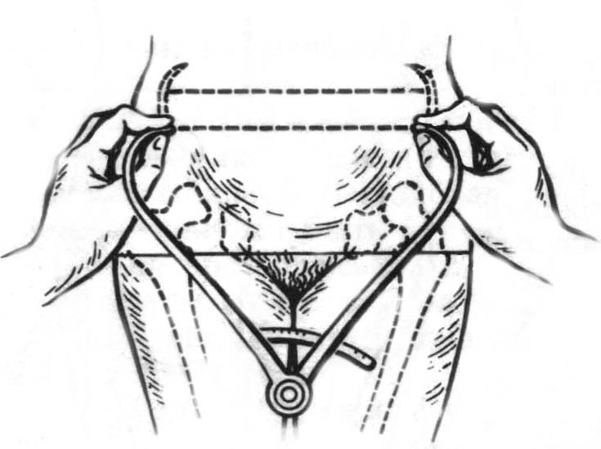
Pic. 1. Transverse diameters measurement

1. Distantia spinarum = 25-26 cm (distance between anterior superior iliac spines);
2. Distantia cristarum = 28-29 cm (distance between the most distant points of iliac crests);
3. Distantia trochanterica = 31 cm (distance between the most distant points of trochanters);
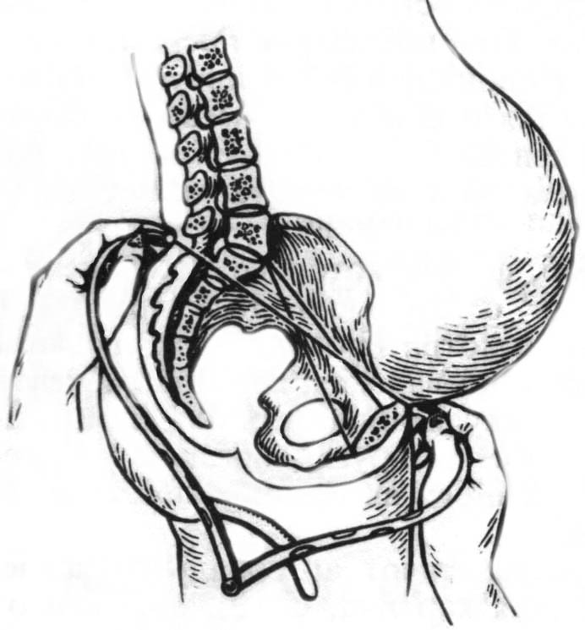
Pic. 2. External conjugate and diagonal conjugate measurement

4. Conjugata externa = 20-21 cm
5. Conjugata diagonalis is measured during vaginal examination.
If promontorium can’t be reached then conjugata diagonalis is assumed to be over 12 cm (12,5-13 cm).
6. Conjugata vera (true conjugate) is equal to anterior-posterior diameter of pelvic inlet.
Additional external measurement:
- lumbosacral rhomb, if normal it has regular shape. Vertical size is 11 cm (is equal to true conjugate), transversal size is 9 cm.
- Lateral conjugate – distance between the anterior superior iliac spine and posterior superior iliac spine of the same iliac bone (normally is 14,5-15 cm), it is decreased in contracted pelvis.
- Pelvic height – distance between ishial tuberosity and pubic symphysis (normally is less than 11 cm, if it is over 11 cm prolonged labor may take place).
- Anterior-posterior and transverse diameters of pelvic outlet.
- circumference of pelvis is measured with measuring tape pressed under sacrum, between iliac crests on both sides and in the middle of pubic on the front (normally is 85 cm and over).
- Pubic symphysis height is measured between its upper and lower edges (normally is 5-6 cm). The higher is pubic symphysis, the lesser is true conjugate.
- Oblique diameter – distance between the right anterior superior iliac spine to the left posterior superior iliac spine and opposite. Normally both this sizes are equal to 20-21 cm.
Solovjov index is estimated by measurement of the circumference of radiocarpal joint. Normally it is 14-18 cm. If it is lower pelvic bones are thin, if it is over 18 cm pelvic bones are thick.
Zangemeister’s and Vasten’s symptoms are used to estimate match of fetus head to pelvis.
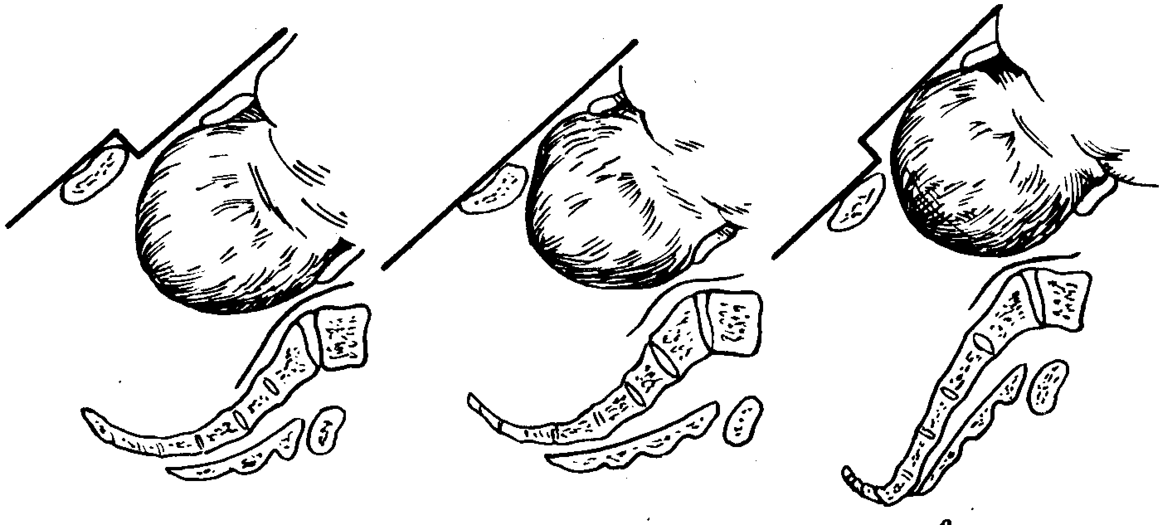
Vasten’s sigh negative, even, positive.

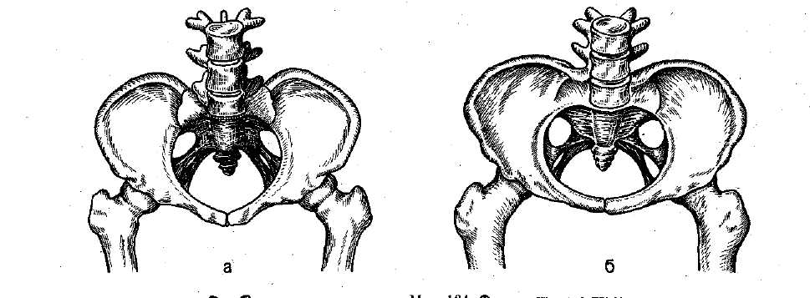
Types of flat pelvises: а – generally contracted flat pelvis; б – simple flat pelvis; в – flat rachitic pelvis.
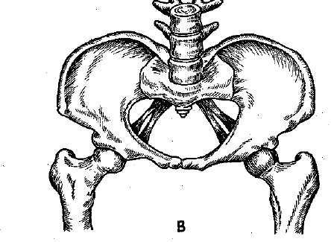

Generally contracted pelvis
It is characterized by regular shape and equal reduction (in 1-2 cm) of all sizes (anterior-posterior, oblique and transverse), pubic angle is acute (less than 90⁰), pubic and sacrum heights are reduced. Average sizes are D.sp. – 24 cm., D.cr. – 26 cm, D.tr. – 28 cm., C.ext. – 18 cm., C.diagonalis – 11 cm, C.vera – 9 cm.
There are different types of generally contracted pelvis:
- Infantile pelvis is diagnosed in infantile underdeveloped women. Pelvis has some puerile signs: sacrum is narrow and isn’t flexed enough, promontorium is high, pubic arc is narrow, pelvic inlet has round or oval form.
- Android pelvis is diagnosed in tall women with the sighs of intersexuality. Its build is alike to male pelvis: high choanoid cavity, narrow pubic arc.
- Dwarf pelvis is a marginal variant of generally contracted pelvis. It is diagnosed in women of proportional build with height of 120-149 cm.
Biomechanism of labor is like to the one in breech labor but has some peculiarities.
First peculiarity (in the I moment of biomechnism) – maximal head flexion and head set with its smallest diameter (diameter suboccipitoparietalis – 9 cm) in one of the oblique diameters of pelvic inlet depending on fetus position. Such set is cuneate and asynclitic.
Second peculiarity is significant head configuration (dolochocephalic configuration) because of reduction of all sizes of pelvis.
Third peculiarity is prolonged head deflexion.

Flat pelvis
Flat pelvis is a pelvis with reduced anterior-posterior diameters and normal transversal and oblique diameters. It has different types:
1. Simple flat pelvis is characterized by reduction of all anterior-posterior diameters due to relocation of sacrum closer to pubic. There is no deformation of pelvis and skeleton, build is normal. Sizes: D.sp. - 26 cm, D.cr. - 29 cm, D.tr. - 30 cm, C.ext. - 18 cm, C.diagonalis. – 11 cm, C.vera – 9 cm.
Labor has more favorable prognosis than in cases of any other type of flat pelvis.
Biomechanism of labor in simple flat pelvis has some peculiarities.
First peculiarity – prolonged high stand of sagital suture in transverse diameter of pelvic inlet.
Second peculiarity – big fontanel is lower than small fontanel and becomes a guiding point.
Third peculiarity – asynclitic set of a head (Nagele’s obliquity, Litzmann’s obliquity).
Forth peculiarity – head rotation cannot be performed in pelvic cavity that leads to medium or low transverse stand of a head. If the head is big, clinical discordance may occur.
a b
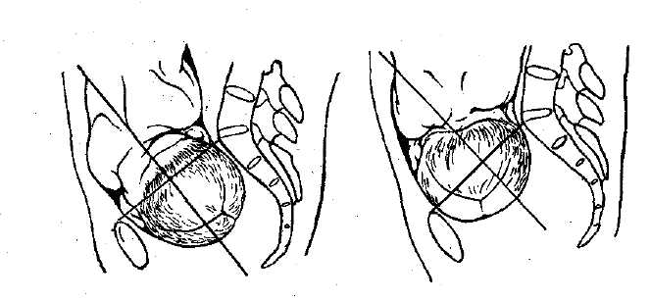
Pic 6. Asynclitism: a – anterior (Nagele’s obliquity); b – posterior (Litzmann’s obliquity).
2. Flat rachitic pelvis is characterized by deformation of the upper part of sacrum that leads to reduction of anterior-posterior diameter of pelvic inlet while other diameters are normal or slightly extended, coccyx has beaked forward inclination. Besides, iliac bones are significantly spread, that’s why D.sp. and D.cr. are almost equal, ishial tuberosities spread and pubic angle becomes obtuse (over 90°). Sizes: D.sp. – 26 cm, D.cr. – 26 cm, D.tr. – 31 cm , C.ext. – 17 cm, C.diagonalis – 10 cm, C.vera – 8 cm.
Biomechanism of labor in flat rachitic pelvis has its peculiarities.
First peculiarity – prolonged stand of sagital suture in transverse diameter.
Second peculiarity – head deflexion and big fontanel descending.
Third peculiarity – Nagele’s obliquity.
Forth peculiarity – after passing the inlet head quickly descends onto pelvic outlet, simultaneously flexes, performs internal rotation and deflexes.
3. Generally contracted flat pelvis – is a pelvis with reduction of all diameters but anterior-posterior diameters are reduced most of all. Women usually are low. Significant reduction of all diameters, especially of anterior-posterior and external is characteristical. Sizes: D.sp. - 23-24 cm, D.cr. - 24-25 cm, D.tr. - 27-28 cm, C.ext. - 15-16 cm, C.diagonalis – 9 cm, C.vera – 7 cm.
Biomechanism of labor is equal to such in generally contracted pelvis or simple flat pelvis depending on which form dominates.
4. Pelvis with reduced anterior-posterior diameter in the plane with greatest pelvic dimensions is characterized by reduction of anterior-posterior diameter in the plane with greatest pelvic dimensions. This type of contracted pelvis is diagnosed with X-ray.

Dollichopellic pelvis
It is characterized by reduction of one or more transverse diameters in 0,5 cm or more with normal or extended true conjugate.
Biomechanism of labor in dollichopellic pelvis:
First peculiarity: high direct stand of a head.
Second peculiarity: if occiput faces front, head flexes intensely and passes all pelvic dimensions without rotation and is born alike to when occipitoanterior position of vertex, if occiput faces back, head rotation may occur in pelvic cavity and delivery may end spontaneously. If the head is big, rotation may not occur and delivery is ended with caesarean section.

Pregnancy and delivery management in contracted pelvis
Pregnant women with anatomically contracted pelvises are hospitalized at the term of 37-38 weeks of pregnancy for the selection of delivery method. Delivery course in contracted pelvis depends on the grade of discordance and complications. Caesarean section is the only option in contraction of the 3rd and 4th degrees. It also can be performed if contraction of the 1st or 2nd degree is combined with other obstetric pathology.
Clinically contracted pelvis occurs during delivery as a result of inequality in diameters of fetal head and mother’s pelvis independent to their actual sizes. The main causes of that are anatomically contracted pelvis, big head of fetus, head deflexion, protracted pregnancy, miomas which prevent advance of the head, abnormal development of feminine genitalia and fetus.
Conditions of clinically contracted pelvis diagnostics:
- cervical dilatation over 8 cm;
- absence of fetal bladder;
- empty urinary bladder;
- normal uterine contractions.
Symptoms of clinical inequality during delivery:
- positive or even Vasten’s sign, positive Zangemeister’s sign;
- symptoms of urinary bladder compression;
- hyperextension of uterus, high position of contraction ring;
- absence of advance of the head whilst in full cervical dilatation and normal delivery activity;
- insufficient attachment of cervix to presenting part;
- appearance of bearing-downs whilst in high stand of fetus head;
- edema of cervix which may possibly spread onto vagina and vulva.
If two or more signs are present the diagnosis of clinically contracted pelvis is stated and caesarean section is performed. In cases of dead fetus embriotomy is chosen

Problems of macrosomia in obstetrics,
macrosomic pregnancy and delivery
Term ‘big fetus’ is used if by the end of pregnancy weight of fetus is 4000 g and more in cephalic presentation or 3700 g and more in breech presentation. Fetus weighting over 5000 g is called giant.
Frequency of macrosomic labor grows and varies between 5,2-14,4%.
Frequency of patrimonial traumatism, including rupture of uterus, hypoxia of fetus, postnatal complications increase in macrosomic labor. Perinatal lethality of big fetuses is 2-3 times higher than lethality of fetuses with normal weight. Clinically contracted pelvis occurs 6 times more frequent.
Etiology
- Acceleration which starts antenatally and is a result of influence of social and economical factors that lead to hypodynamia.
- Excessive consumption of carbonhydrates during pregnancy. Hyperglycemia in mother leads to hyperinsulinemia in fetus and increasement of tissue growth.
- Metabolic disorders in maternal organism, particularly diabetes mellitus.
- Activity of solar radiation and duration of daylight hours. In spring and summer when there are lots of daylight children are born with greater weight and height then in autumn and winter.
- Congenital and constitutional peculiarities of parents.
- Increased synthesis of chorionic somatomammotropin which regulates height of a fetus.
- Increased synthesis of progesterone or estrogens.
Big fetus diagnostics
Risk group for possible development of big fetus includes:
- tall women (170 cm and over);
- women wit sedentary lifestyles;
- women with obesity;
- women with diabetes mellitus or other endocrine diseases;
- macrosomic delivery in anamnesis;
- fundal height in term of 20 weeks of pregnancy - 21-22 cm, 28 weeks - 30 cm and more.
- Women with Rh-negative blood type.
Ultrasonography and tentative fetus weight calculation are of big diagnostic value.
Pregnancy and delivery management in big fetus
Women pregnant with big fetus have a high risk of obstetric pathology and should be specially registered in antenatal clinic. Other important issues are rational nutrition and optimal physical activity. Drug therapy is targeted on lipid balance normalization. Methionine, niacinamid, oxygen therapy are the most effective. Fetometry should be performed during ultrasonography.

Delivery management
Macrosomic deliveries are pathological, that's why special attention should be paid to control of the state of fetus, dynamic estimation of uterine contractions, evaluation of clinical equality of diameters of mother’s pelvis and head of fetus.
All women with big fetus are hospitalized 1-2 weeks preliminary to labor. In most cases delivery ends unprompted.
Neonatal period is deeply connected with complications which can occur intrapartum – birth injury (fracture of clavicle, humerus, nervous system damage, intracranial damage) and asphyxia.

Control questions:
1. What classification of breech presentation is used?
2. What are the diagnostic criteria of breech presentation?
3. What is the difference between delivery in cephalic and breech presentation?
4. What are the moments of labor biomechanism in breech presentation?
5. What hand assistance methods for breech presentation do you know?
6. How are contracted pelvises classified and diagnosed?
7. What are the peculiarities of biomechanism of delivery in different types of contracted pelvis?
8. What are the symptoms of contracted pelvis?
9. What are the causes of macrosomia?
10. What methods are used to diagnose macrosomia?
11. What are pregnancy and delivery peculiarities in big fetus?

Recommended literature

- Chesley's Hypertensive Disorders in Pregnancy - Lindheimer M D Roberts J - 31 Jul 2009
- Management of Unintended and Abnormal Pregnancy - Paul M Lichtenberg S - 23 Apr 2009
- Essential Obstetrics and Gynaecology. E M Symonds. (pounds sterling 20.99.) Churchill Livingstone, 1992. ISBN 0-443-02207-0.
- Obstetrics by Ten Teachers. 15th edn. T Lewis, G Chamberlain. (pounds sterling 15.99.) Edward Arnold, 1990. ISBN 0-340-515650-X.
- Fundamentals of Obstetrics and Gynaecology. D Llewellyn Jones. (pounds sterling 15.00.) Faber, 1990. ISBN 0-571-142273.
- 1. Obstetrics and Gynecology (in 2 books): Textbook (ed. Grishchenko V.I., Scherbyna M.O.) // book and Obstetrics. - K .: Medicine, 2011. - 422 p .; Book II Gynecology. - K. Medicine, 2011.- 375 p.
- 2. Obstetrics: Textbook (ed. B.M. Ventskovskiy, G.K. Stepankivskoyi, V.P. Lakatos). - K .: NE Medicine, 2012.- 648 p.
- 3. Gynecology: Textbook (ed. B.M. Ventskovskiy, G.K. Stepankivskoyi, N.E. Yarotskiy). - K .: NE Medicine, 2012.- 352 p.
- 4. Zaporozhan V.M., Chayka V.K, Markin L.B. Obstetrics and Gynecology (4 volumes): National tutorial 2013
- Obstetrics: English textbook (edit by I. B. Ventskivska) .- K .: Medicine, 2008. - 334 p.
- Gynecology: English textbook (edit by I. B. Ventskivska) .- K .: Medicine, 2010. - 160 p.
- Zaporozhan VM, Mischenko V.P. Obstetric pathology, atlas, tutorial. - Odessa: Odessa Medical University, 2005.- 292 p.
- V.M. Zaporozhan Operative Gynecology: Textbook. - Odessa: Odessa Medical University, 2006.- 292 p.
- Bear VI Selected lectures on extragenital pregnant. - K., 2010.- 239 p.
- Methods of contraception according to periods of life: learning posibnyk.- K., 2013.- 255 p.
- V.F. Nagornaya Patological obstetrics (Clinical Lectures). - Nezhyn: Hydromaks, 2008. - 168 c.
- Emergency conditions in obstetrics: (thematic modules on discipline "Obstetrics and Gynecology"): Teach. Guidances for stud.vysch.med.navch.zakladiv / edited by BM Ventskivkoho, AJ SENCHUK, O. Zelinsky - Publisher "TPP", 2011. - P. 83-85.
- Pathological Obstetrics: Tutorial (Ventskivskyy BM, Kaminsky VV, Grishchenko VV et al.) .- K .: Seagull Universe, 2009, 300 p.
- Paschenko SM, GI Reznichenko, Voloshin MA Diagnosis and treatment of breast disease dishormonal: Zaporozhye: Education, 2011.-152 with.
- Modern aspects of family planning, training posibnyk.- K., 2012.-307s.
- Dubossarskaya ZM, Yu Dubossarskaya Reproduktyvnaya эndokrynolohyya: Training-metodycheskoe posobye.- DA: Lyra LTD, 2008.-416 with.
- Pregnancy, Childbirth, Postpartum and Newborn Care: A guide for essential practice. WHO, Geneva, 2006.
- the Clinical Protocol "" approved by the Ministry of Health of Ukraine Obstetrics and Gynecology

Methodical development was
developed associate professor, PhD ________________________________Nadvorna O.M.

