METODIKS OF PRACTIC SCILS
TO SURGERY
STUDENTS OF THE SIX YEAR
EDUCATION

It is discussed and ratified on
to the methodical conference
of the Department of Surgery #1

29 August 2017
Protocol № 1.

Head of Department of Surgery #1
Professor Grubnik V.V.

ODESSA

I. Determination of blood groups
Financial support:
1. A set of standard sera or monoclonal antibodies Anti A
Anti B Anti AB.
2. The plate with the designation of blood groups (main, control).
3. Stirring rod.
4. Saline 0.9% sodium chloride.
5. Absorbent cotton wool.
6. Sterile needles.
7. Alcohol.

Definition of Blood typing (Cross matching; Rh-typing; ABO blood typing):
Blood typing is a method to tell what specific type of blood you have. What type you have depends on whether or not there are certain proteins, called antigens, on your red blood cells.
Blood is often grouped according to the ABO blood typing system. This method breaks blood types down into four categories:
Type A
Type B
Type AB
Type O
Мark a plate showing the location of the blood-typing serum. Pour out blood-typing serum of each group next to a drop of blood in a ratio of 10:1. Each standard serum and blood stirred separate clean glass rod. Gently shake the plate for 5 min. By the presence of agglutination in various standard serum drops are judged on blood groups:
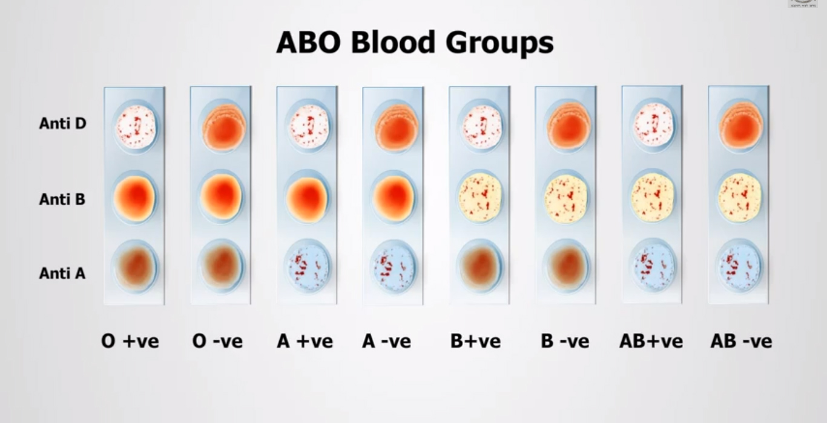
Crossmatch of the recipient's serum with the donor red cells.
Apply the serum of the recipient and donor blood at a ratio of 10:1 on a white plate or a glass slide. Expect results within 5 minutes. If no agglutination occurred, the blood donor and the recipient are compatible.
Heat blood compatibility test
Apply the serum of the recipient and donor blood in a ratio of 10:1 on a Petri dish. After mixing the blood serum Petri dish was placed in a water bath for 10 minutes at a temperature from +46⁰ to +48⁰. The appearance of agglutination indicates the inadmissibility of the transfusion of blood.
Biological compatibility test
This test involves three steps of 25 mL blood at intervals of 3-5 minutes in the first 75 ml of transfused blood. During the interval, the system is blocked. If, after 75 ml of blood transfusion did not occur signs of incompatibility (anxiety, shortness of breath, back pain, flushing or pallor, increased heart rate, reduced pressure), the blood is considered to be compatible and blood transfusions continue to drip through.
anti-A, anti B, anti A+B monoclonal
PRINCIPLE OF THE METHOD
ABO grouping is determined by testing unknown red cells against known anti A, anti B and anti A+B.
The presence or absence of agglutination of the red cells indicates the presence or absence the corresponding antigen. Blood grouping reagents made with monoclonal antibodies have the added advantage of constant identity and absolute reproducibility of their specificity.
REAGENTS
Murine monoclonal IgM antibody.
Anti A
Blue color
Cell line 9113D10
Stabilized buffer
Sodium azide 0.95 g/L.
Anti B
Yellow color
Cell line 9621A8
Stabilized buffer
Sodium azide 0.95 g/L.
Anti A+B
Colorless
Cell line 152D12+9113D10
Stabilized buffer
Sodium azide 0.95 g/L.
PRECAUTIONS
These reagents have been prepared with materials of nonhuman origin and are free of HIV and hepatitis viruses. However, it is recommended to handle the samples and reagents with due care.
STORAGE AND STABILITY
1. This reagent will remain stable until the expiration date printed on the label, when stored tightly closed at 2-8ºC and contaminations are prevented during their use.
2. This product should be clear. Turbidity may indicate microbial contamination. The reagent should not be used if it appears turbid.
ADDITIONAL EQUIPMENT
Slide Test: Slides, automatic pipettes, stirrers.
Tube Test: Hemolysis tubes, automatic pipettes, centrifuge Serofuge or similar.
SAMPLES
The blood samples can be collected with or without anticoagulant. They must be tested as soon as possible.
Samples collected into EDTA or heparin should be tested within 48 hours.
Blood collected into ACD, CPD, CPDA-1 may be typed up to 35 days from the date withdrawal.
Store at 2º-8ºC.
PROCEDURE
SLIDE TEST
1. Place 1 drop (aprox. 50 µL) of resuspended whole blood (appox. 35-40% cell concentration) to be tested on a slide.
2. Add 1 drop (aprox. 50 µL) of reagent next to the blood sample.
3. Mix the antiserum and cells over an area about 2 cm in diameter.

Temporary haemostasis (a process which causes bleeding to stop)
Support:
1. Harnesses.
2. Sheets of paper to indicate the time.
3. Handle.
4. Phantom with the designation of places pressing vessels.
Technique:
Arterial bleeding (Loss of blood from a vessel that is carrying oxygenated blood away from the heart).
Each type of vessel (artery, vein, capillary) has distinct bleeding characteristics. Arterial bleeding is characterized by spurts of bright-red blood; spurting each time the heart beats. Arterial bleeding is serious and difficult to control. Venous bleeding occurs in a steady flow, and the blood is dark-red, almost maroon, in color. Since capillaries are so small, capillary bleeding is a slow, oozing flow that carries with it a higher risk of infection than either arterial or venous bleeding.
Bleeding can be stopped by pressing the artery above the wound. There are several methods. You can compress the artery with your fingers. The most easily do it where it passes close to the bone or over it. For example, if the wound is located on the forearm, the artery can easily be pressed against the humerus to the inner side of the shoulder. It is necessary to study the pre-reception on himself or on someone realties other and learn how to quickly find the artery in her pulse. Fingers feel that the artery lies on the bone to which it if necessary, and pressing.
When arterial bleeding from the leg should press the popliteal artery. This is done with both hands. Thumbs placed on the front surface of the knee, while the remaining grope popliteal artery and pressed against the bone. The femoral artery can easily learn to find the top of the thigh, immediately below the inguinal ligament. Pinning her with his fist, you can stop arterial bleeding when injured hip.
When bleeding from the head wound can try to stop it or at least reduce, pressing temporal artery on the side of the injured. The artery that passes by 1-1.5 cm anterior to the ear, where it is easy to detect its pulsation.
Bleeding from the cheeks stop pressing on the jaw of an artery that, going from the neck to the tissues of the cheeks, leans over the edge of the lower jaw and the angle between her chin.
When bleeding from a wound positioned on the neck, the carotid artery is pressed on the side below the wound healing. Pulsation of the artery is easy to find on the side of the trachea (windpipe).
When the location of the wound high on the shoulder, near the shoulder joint or in the underarm area, you can stop the bleeding by pressure in the supraclavicular fossa artery above the clavicle. The artery is pressed against one edge.
The most convenient places clamping the artery are shown in Figure 1, 2,3,4. It should be borne in mind that tapping the artery to the bone requires considerable effort and fingers get tired fast. Even a very strong person can not carry out the pressing more than 15-20 minutes.
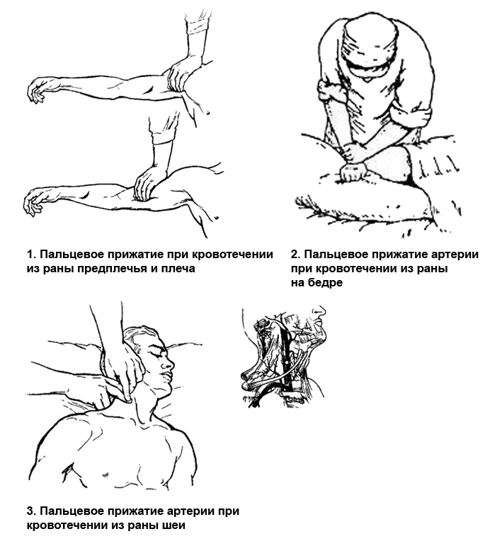
When wound limb arterial bleeding stopped applying twist or bundle, which are superimposed on the thigh or leg, shoulder or upper arm (Fig. 5) above the wound as close as possible to it.
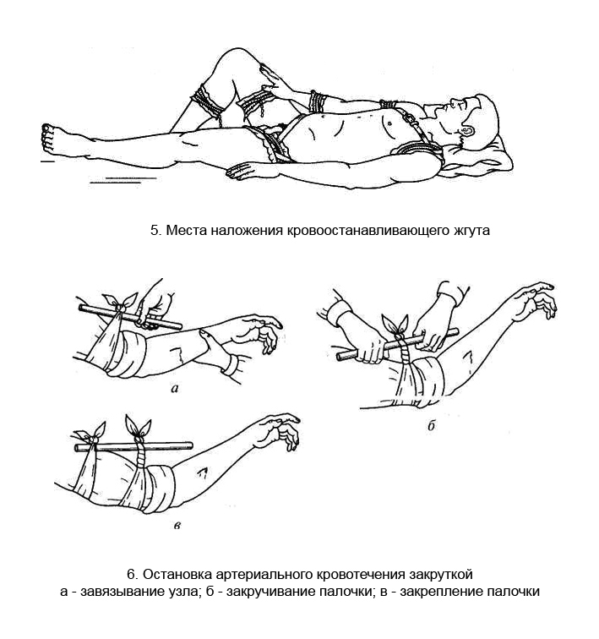
Stopping bleeding with a bandage twist is that the injured limb above the tie with a twisted handkerchief as a tow, rope, etc., and then putting her in the ring formed a stick or any object and rotate it as long as the limb will not unnecessarily tight and stop the bleeding (Figure 6.). The correctness of a tourniquet or spin is determined to stop bleeding limb distal to the twist.
Instead of a self-made bandage twist, you can use a special rubber hemostatic tourniquet is a rubber tube (Fig. 7) or the strip with a hook on one end and a chain on the other.
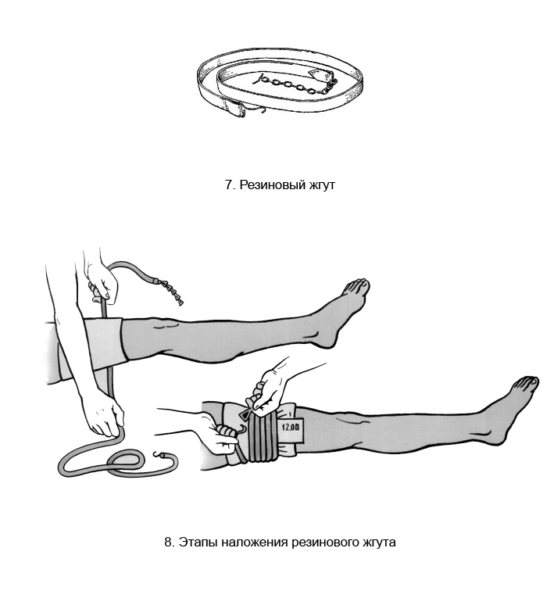
Take a rubber band at each end, a little stretch, encircle around the limb, after placing it on the tissue lining (2-3 layers) and secured one of the rings of the chain on the hook (Fig. 8). If the wound is located at the base of the limb (the upper third of the arm or thigh), tourniquet is applied in the form of "eight": 2-3 to reach the end turns of the rope, encircle it around the trunk and fixed (Fig. 5).
Trouser belt can be used as a makeshift tourniquet.
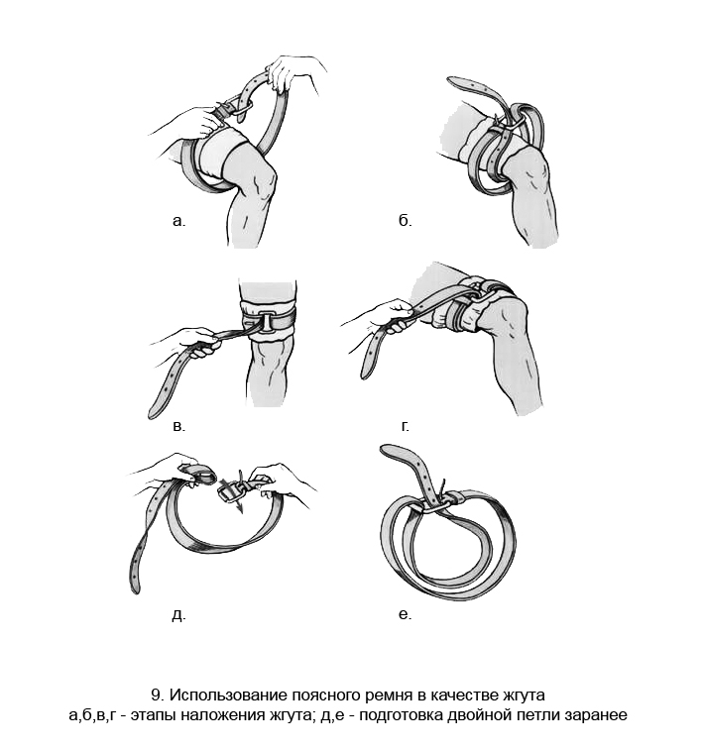
The place where you want to apply a tourniquet, encircle the end of the belt and the buckle is passed through it from top to bottom (Figure 9 a). Then encircle the end of the strap around the limb, and output through the buckle on the opposite side. It turns covering limb double loop - external and internal (Fig. 9b). Sipping at the end of the tow strap is tightened (Figure 9, c and d). You can prepare in advance of a double belt loop, as shown in Fig. 9, d and e, and then the ring formed of two loops, put on a limb and tighten. To spin or not infringed burn the skin, it must be protected with a soft lining, clothing, etc.
The wounded with a twist or braid after application to a wound dressing immediately referred to a doctor for a final stop bleeding. It should be remembered that can be dragged and dropped to keep the limb up to 1-1.5 hours, otherwise it may mortify. If after this period will not be affected provided medical care and the bleeding will not be completely stopped for a few minutes to loosen the twist or the wiring, providing blood flow to the limb, and then, if the bleeding continues, again win it. To control for the time since the tourniquet is attached to it or under it a note indicating the time of its imposition (date, hour, minute).
Bleeding may be temporarily stopped by a maximum bending limbs and fixing it in this position. So, when injured leg in the popliteal fossa put roller, made of cotton and gauze leg bent at the knee joint to capacity and in such a position fix a strap bandage, towel, scarf. The same technique is used when injured forearm, hand folded and locked at the elbow.
If bleeding spot axilla damage pressed cotton-gauze roller is pressed against the shoulder as the chest wall and fix it in this position. When wound thigh in its upper part, when a tourniquet is not possible, cotton-gauze roll placed in the groin and thigh pressed against her stomach as and fix it in position (Fig. 10.).
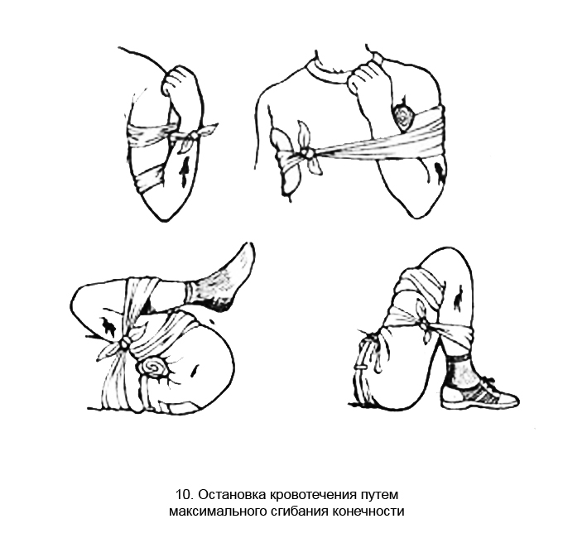
Wounds of the neck are controlled by a tourniquet placement but it must compress only injured side by fixing it to the Kramers splint or to the hand positioned on the head. Technically, the swab is placed on the wound, then the tourtiquet is applied to compress the wound, and fixated to the splint or hand which is opposite to the side of injury.
The new types of allow to regulate the degree of compression using twisting mechnism (e.g., CAT, SOFTT) and can be easily applied by an injured person himself. Some tourniquets have special marking that help to chose the degree of compression (e.g., SWAT). Also, the tourniquets with a manometer are available. The recommended preasure for upper extremity is 250 mmHg, for lower one – 500 mmHg.
When the location of the wound in the armpit or in the upper arm at the shoulder joint should be as far as possible to have more than a hand and pull her back to back.

In addition to blood, distinguish venous bleeding, which occurs when damage to the veins and capillary - in case of damage to small blood vessels (capillaries).
When capillary bleeding blood oozes on the entire surface of the wound as a sponge. Such bleeding is usually not strong and to stop it, as already mentioned, in most cases you need only to put a bandage as usual at every wound. If the injured limb should be given to her exalted position - lift for a while injured arm or leg. If the bleeding has stopped, dressing will not get wet, but if it came to a small blood stain, you need to shut it down a few extra turns of the bandage. If the bandage, although it gets wet again, and therefore, the bleeding is still going on, we have to impose the so-called pressure bandage. Without opening the wound on top of the gauze, which is closed, it should be put into a tight wad folded piece of cotton or cloth and a tight bandage the wounded area so you can lump it pressed down tightly wound.
Capillary and parenchimatous bleeding is well controller using fibrin sponges (e.g., Tachokomb) that stimulate the clotting process. It is placed on the bleeding surface just after removal of the excessive blood, and keep under preasure for 3-5 minitues. The tamponade of some channel or cavity by such spongues is also effective.
Bleeding from a vein is recognized by the dark red, cherry red color of the blood that flows from the wound jet, but without shocks. Such bleeding may be abundant, but, as a rule to stop it is quite imposing a pressure bandage and give the injured body part elevated position.
The described methods are called temporary stop bleeding. Final hemostasis is performed by a physician surgical treatment of wounds.
In addition to external bleeding, in which blood poured out, there are internal bleeding, in which flowing from the wounded vessel blood accumulates in any internal cavity, such as the chest or abdominal.
Internal bleeding recognize by suddenly appearing pale face, blanching and cooling of the hands and feet, increased heart rate, filling which is becoming weaker and weaker. There is dizziness, tinnitus, cold sweat, then comes the fainting.
Internal bleeding occurs, for example, abdominal injury due to rupture of the liver or spleen. Exterior damage this may not be. At the first sign of internal bleeding patient should be referred immediately to a hospital.

PRACTICAL SKILLS
II.Immobilization:
1. Cramer wire ladder splint.
2. Splint for hip immobilization with Diterikhs-type traction
3. A set of bandages - wide and narrow.
4. Non-sterile cotton wool.
5. Cravat bandage.
Under the transport immobilization we understand measures aimed at ensuring peace in the affected area of ​​the body and the surrounding joints to it for the period of transport victim to a hospital.
The purpose of transport immobilization - retention of fragments from further displacement, preventing injury of the neurovascular bundle and skin sharp ends of the bone fragments, as well as preventing further damage to the brain and spine fractures skull, spine and pelvis and pelvic organs (bladder, urethra, direct intestine), reducing pain and preventing the development of secondary shock.
Transport immobilization is standard (Fig. 11)
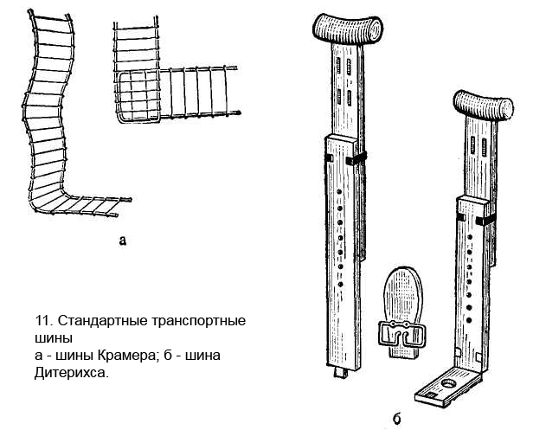
Basic rules imposing transport tires:

a) Fixing at least two joints, adjacent to the fracture site;
b) The imposition of cotton-gauze pads on the bony prominences at greatest pressure;
c) To make provision for the possibility of a physiological injured limb (balancing the opposing muscle that prevents the further displacement of the bone fragments);
d) The imposition of a preliminary wiring and aseptic pressure bandage in open fractures involving bleeding.

Transport immobilization depending on the localization of the damage

1. Transport immobilization of fractures collarbone, shoulder blades and dislocation of the shoulder is a ladder or mesh tires, Dezo bandage, triangular bandage. Properly dressing Dezo has a number of advantages compared with the tires. It prevents sagging shoulder down and captures well the injured limb to the body of the victim.
If applied in the armpit Dezo put cotton-gauze pad. The forearm is set at a right angle at the elbow, the palm refers to the abdomen, arm tightly pressed against his chest. The first tours bandage lead a healthy part of the chest to the patient. Spiral moves fix a shoulder, then a healthy axilla bandage lead obliquely up the front of the chest to the affected part of the shoulder girdle, shoulder girdle through the shift, lowered down, flex the forearm at the elbow joint, and then lead obliquely upwards to the armpit on the unaffected side. So is repeated several times. To tour the bandage is not dropped, the bandage should flash (Fig. 13).
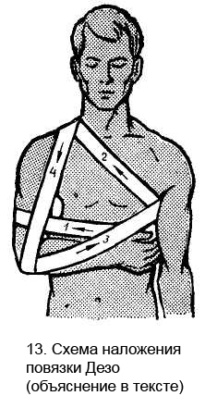
2. Immobilization of fractures of humerus made by Cramer wire ladder splint. Prior to splint it should impose a quilted cotton or cotton bedding, a bend in the chute and formed on healthy limbs. In the middle position between pronation and supination and forearm flexion at an angle of 90 ° at the elbow on the back of the injured limb is superimposed splint Kramer from the metacarpophalangeal joints of the shoulder girdle to the healthy side. Shoulder withdrawn forward 30 ° and a few moved away from the body (for this purpose in the axilla put cotton-gauze roll). The proximal end of the splint connected to the distal two gauze ribbons covering the chest on the opposite side of the fracture of the front and rear. The splint is fixed to the extremity soft gauze bandage. Additional hand hung on a headscarf or fix to the body (Fig. 14).
3. Transport immobilization of fractures of the forearm bones is as follows. Prepared and otmodelirovannuyu ladder or a visor splint impose on the rear surface of the base of the toes to the upper third of the arm. In this case, attach the forearm midway between pronation and supination, and wrist - a slight dorsiflexion. Flexion of the elbow at the turn of the coronoid process of the ulna or radial neck should be sharp and in the separation of the olecranon - at 110-120 °, with diaphyseal fractures - in 90 °. Then the splint pribintovyvayut soft bandage. According ¬ damage to the limb hung on a scarf (Fig. 15).
4. Immobilization with a broken wrist bones of the wrist joint of fingers is a ladder, mesh or plywood splint.
Brushes give a crouching position, put the ball in the palm of wool, wrapped with gauze. Pad of cotton gauze and put on all over the splint. The splint is applied to the palm or the back surface to the elbow joint and strengthen the spiral bandage tours.
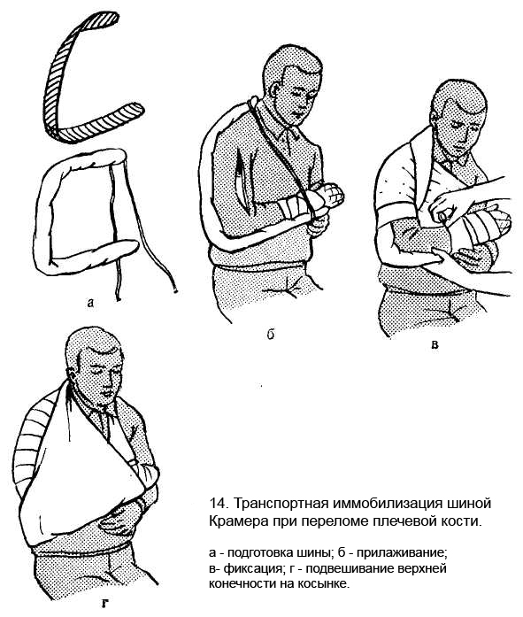
5. Transport immobilization of the fracture and dislocation of the hip, damaged hip and knee joints is achieved by applying a special tire in which the fixation combined with simultaneous traction of the limb. For this purpose, most often used transport splint Diterikhs. The splint consists of two wooden slats. The upper ends of the two strips are transverse to the beam stop in the axilla and groin. Outdoor (long) and internal (short) bars consist of two halves that way, depending on the growth of the affected lengthen or shorten the splint. Go to the inner plate on hinges attached wooden board with a hole for fastening the distal end of the slats. In addition, there is a piece of wood, shaped sole and sticks - double twist cord.
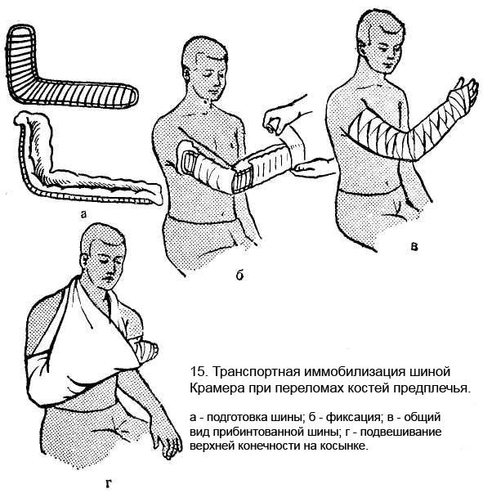
Splinting:
a) The side panels customize the size of the lower extremity damaged by clipping the two halves of the case. that the outer strip rested against the axilla and internal - crotch and so that the free ends of the foot straps favored 10-15 cm;
b) On bony prominences (the wing of the ilium, greater trochanter, femoral epicondyles, ankle) and on the back surface of the foot is applied cotton pads to prevent pressure ulcers and necrosis;
c) Wooden "sole" fix tightly to the shoe or foot circular moves bandage;
d) Impose the side plates and fix them on the chest strap or laces threaded through the holes in the bars at the bottom of the side plates fixed transverse plaque, to the foot of the splint until it is fixed;
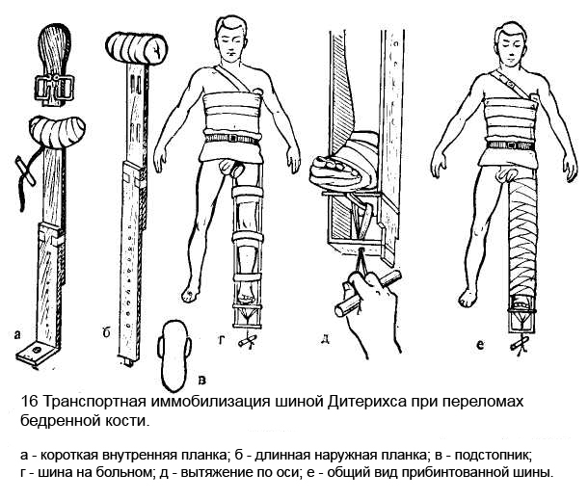
d) after the consolidation of the tire to begin to stretching of the body. This double cord fastened to the wooden "sole", passed through a hole in a board and transverse spin by spin-rods, located on the underside of the transverse strap, and this is achieved traction (Fig. 16) to produce traction until cross bars are available at the upper ends of the side panels, abut tightly in the armpit and groin, and the length of the injured limb will not be equal to the length of the other leg;
e) to prevent sagging limbs on the back of the thigh and lower leg impose Cramer plywood or splint. Tires fix tight to the leg moves in a circular bandage.
In the absence of standard transport tires to immobilize fractures of the lower extremity resort to makeshift tires or fixing a damaged leg to a healthy (Fig. 17).
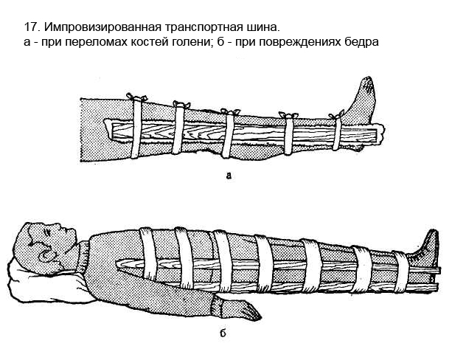
6. Immobilization of the lower leg bone fractures produced by three long Cramer’s splints. One splint, and accordingly prepared modeling the contours of the calf muscles, Achilles tendon and heel for the healthy limb, impose on the rear surface of the toes to the middle third of the thigh. Then apply two side splint or a y-shaped and fixed them with circular tours bandage. The foot should be set at a right angle. In order to prevent the formation of pressure ulcers at the ankles and heels to use cotton-gauze pad (Fig. 18).
7. Transport immobilization of fractures ankle and lower leg bones of the foot of the foot and lower leg wrapped in cotton wool, which is fixed spiral bandage tours. The bony protrusion put cotton pads. Stair rail or a visor after modeling is applied on the back of the leg from the knee to the toes, is fixed to a soft bandage the affected limb (Fig. 19).
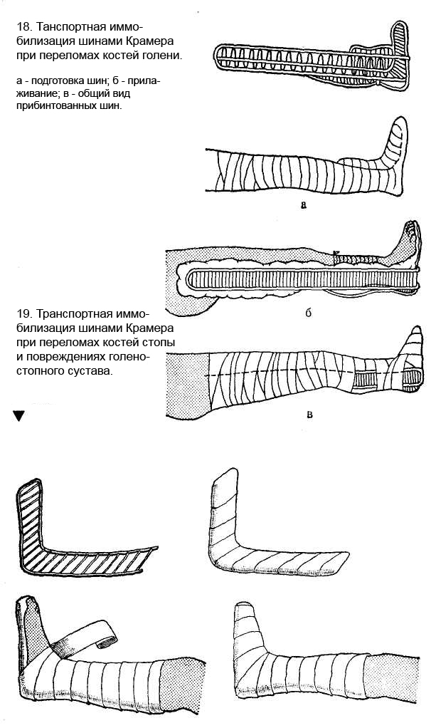
8.Immobilizatsiya for fractures of the vertebrae.
When providing first aid to the victims with fractures of the vertebrae should be very careful, avoiding bending the spine, which may cause or contribute to spinal cord compression.
Transporting a patient with a fracture of the spine, regardless of the level of damage should be lying down on her back, on flat rigid stretcher. To make the stretcher these qualities must be on top of ordinary canvas stretchers make a rug, drawing upon available material (plywood boards). On a hard liner litter should be placed in several layers of folded blanket.
If the damage of the cervical spine to immobilize the patient during transport applied to cotton, "Schantz collar", consisting of a broad, very thick layer of cotton wool, which is wrapped around the neck and circular strokes fix soft bandage (Fig. 20).
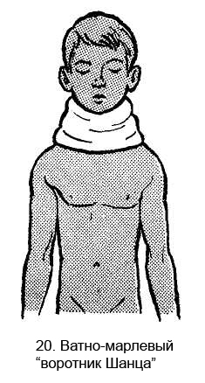
In 1961, Alexander Gerasimov proposed universal splint to transport patients with head injury and spinal column.
The splint can be applied to the victim without taking off his clothes.
Splint (Figure 21) consists of a wooden frame on which are belt, two axillary belt and wooden headgear, consisting of a circle and backfilling halter. The frame has a length of 1 m, a width of 8 cm, a thickness of 2.5-3 cm Throughout frame (as ski) extends semi-oval groove depth of 1 - 1.5 cm, width 2.5 cm This groove overlaps the frame region spinous processes of the spine.
To the front of the belt sewn on the two straps with buckles that run along the gluteal fold. Three button up front belt buckles.
Two axillary belt threaded through the holes made on the frame, enter the armpit and fastened in front of the shoulder joints.
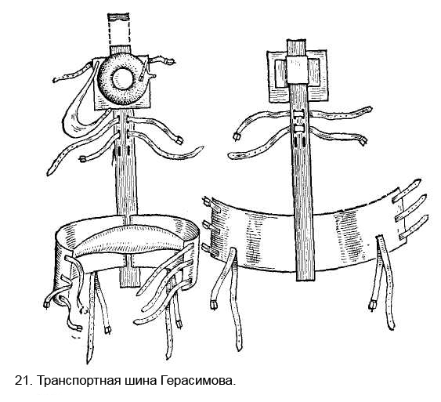
Headgear consists of a sliding wooden planks on frame size 30X30 cm This board is attached halter, and she has only the front tape covering the chin and is attached to the board headgear durable rubber. To the board, helmet mounted skid circle that inflates tires before applying. Skid circle is a good shock absorber. Fig. 22 shows the final stage splint.
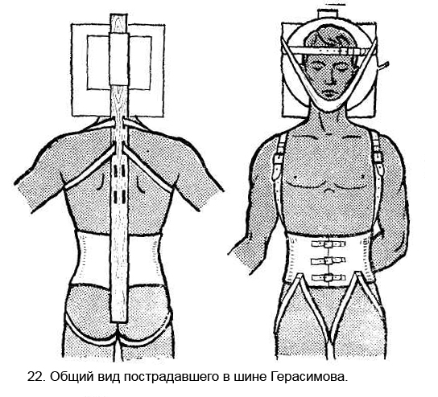
9. Transportation of patients with fractures of the pelvis in a medical institution is made on flat neprogibayuschihsya stretcher. This is usually equipped with a stretcher on the same principle as for the transport of patients with fractures of the spine. Legs victim should be bent at the knee and hip joints, putting that purpose under the knee roll (position "frog") (Fig. 23).
10. Transportation of patients with head injuries by using splint Elan (Fig. 24).
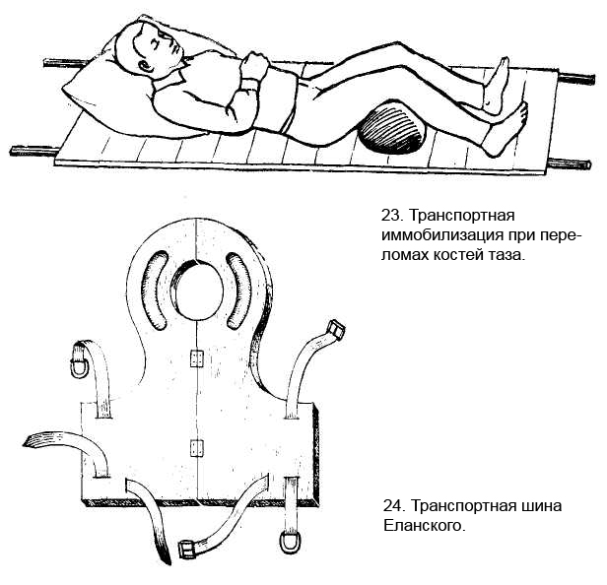
Chin splint is trought-like plastic device used for immobolization of fractured mandible (pic. 25). Its holes are used for drainage of saliva and blood, and fixation of tongue by a ligature. Side holes are used for fixation on the head.

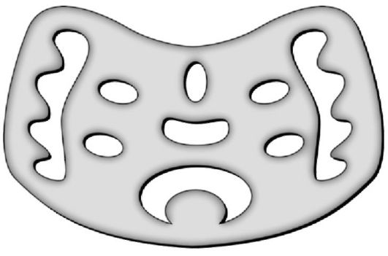
Pic. 25. Chin splint

Pneumatic splints are the most modern devices for transport immobilization. Key features of this type of splint are: perfectly fits the limb after inflation, equable pressure on the tissues, and ability to observe the condition of the limb and wounds as the splint is transparent. It cannot be used to immobolize hip and humeral joints. There is also pneumatic hand-barrow available to immobilize fractures of spine and pelvis.

Kerchief is usually used for immobolization of upper extremity (pic. 26).

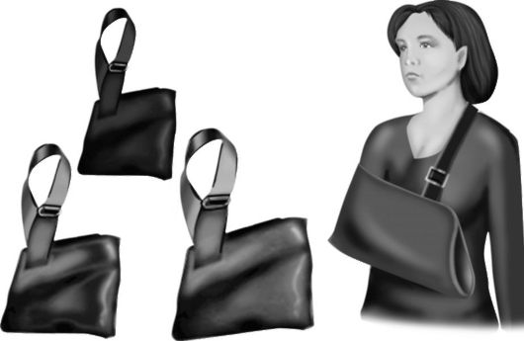
Pic. 26. Kerchief

Modern universal plastic splints have several features: effective, mobile, universal, disposable, water-resistant, X-ray negative. Ususally they are composed of several large and small blanks, or sheets, that can match any necessary form by flexing and modeling them at certain lines (which are marked).

Flexed splint kit (pic. 27) is used for fractures of upper and lower extremities.

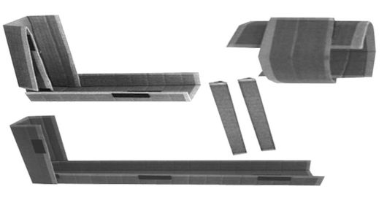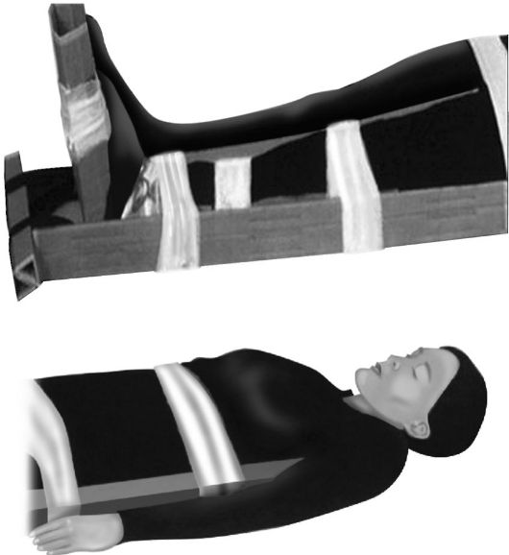
Pic. 27. Flexed splint kit

Stairs splint kit (pic. 28, 29) is also used for for fractures of upper and lower extremities.

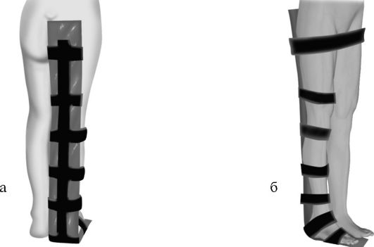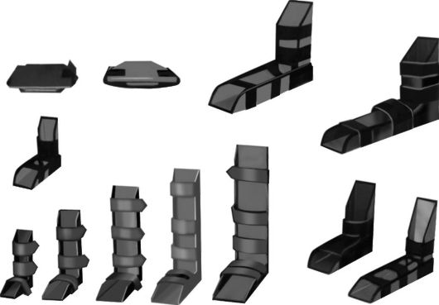
Pic. 28, 29. Stairs splint kit

Collar splint kit (pic. 30) is used for fractures of the neck.

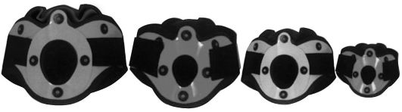
Pic. 30. Collar splint kit

Trunk splint kit (pic. 31) is used for fractures of collar and thoracic spine fractures.

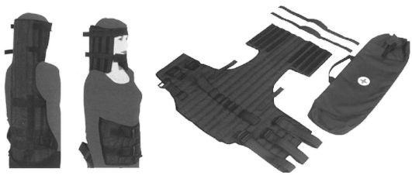
Pic. 30. Trunk splint kit

Errors and complications of transport immobilization
1. Overlay not otmodelirovannyh without a cotton lining wire tires.
2. Pribintovyvanie tires without cotton pads in the bony prominences.
3. Reduction of bone fragments in open fractures.
4. Splinting to the shoulder joint in fractures of the shoulder.
5. Remove clothing from the injured limb when applied transport immobilization.
6. Fixing the brush of fingers in extension.
7. Imposition of immobilization means to hip fractures of the femur and knee injuries.
8. Transportation of patients with damage to the spine and pelvis in the unequipped stretcher.
9. Compression of the genitals when applied Diterikhs tires.
10. The development of paresis and paralysis of brachial plexus, ulnar, radial and peroneal nerves at the wrong application of the tires.
11. The development of ischemic contracture Volkmann in a tight fix tires at shoulder level.
PRACTICAL SKILLS

ІІІ. Primary surgical treatment of wounds.

Support:
1. Phantom.
2. A set of needles.
3. Suture.
4. Instruments - forceps, needle holder.

Performed in the dressing or the operating room.
Indications: - a significant area of ​​tissue damage, swelling them, the presence of hematoma or bleeding, signs of wound infection.
Primary surgical treatment are not subject to abrasions, wounds face, hands, fingers.
Pain relief: - local infiltration anesthesia or novocaine intraosseous anesthesia with potentiation;
In the treatment of gunshot wounds or open fractures of the femur - anesthesia.
The surgical procedure: - with stab wounds in most cases, the operation begins with the dissection of tissues in the course of the wound channel. Skin dissected, usually in the longitudinal direction along the major vessels and nerves considering natural folds. When smashed and soiled edges of the skin wound them sparingly resected simultaneously with dissection. Excised also damaged and blood-soaked sc - fatty tissue, tie bleeding vessels.
Hooks bred edge of the skin wound and widely dissected with scissors along the aponeurosis of the skin incision. Smashed fragments of his excised.
Examine the wound and remove foreign bodies from it, pieces of clothing, hematoma, wound detritus, small bone fragments.
Bleeding vessels captured clip and tie. One of the critical stages of CVD - excision of nonviable muscle crush injury. Excision starting from the surface layers and make possible, in the course of the muscle fibers, taking into account also the position of the major vessels and nerves.
Nonviable muscle is usually dark red or gray in color, have a dull surface, are not reduced when cut and bleeding. Should strive to remove all dead muscle as leaving them may promote wound infections, including anaerobic. In the process of wound treatment should be disclosed as "blind pockets" branch of the wound channel, draining the hematoma.
Widely gaping wounds can be treated without skin incision and fascia. At the same time pushing the edges of the wound hooks, make her examination, resected non-viable tissue, remove foreign bodies, empty hematoma, stop the bleeding.
In the presence of gunshot fractures produce a cut to the bone tissue in the course of the wound channel. The through injury so often come from both the input and output ports. Then Remove loose small bone fragments as potential sources of purulent process. Larger fragments associated with the periosteum, you need to leave. If necessary, bite off the sharp ends of damaged bones in order to avoid damage to blood vessels and nerves.
As a result of the surgical treatment of the wound should be clean and have smooth edges and a viable free drainage discharge. To ensure the latter with deep wounds of the blind often have to do counterpuncture, outside the projection of large vessels and nerves. After debridement antiseptic solution.
It is advisable to infiltrate the wound edges with a solution of antibiotics with 0.25% solution of Novocain.
With full confidence in the treatment of wounds permitting anatomical relationship, if possible observation of the victims wounds sutured few stitches.
Besides the above techniques wound debridement in many cases includes hemostasis by ligation of the large arteries and veins in the wound (preferably) or during, processing and crosslinking tendons, nerves, joint capsule, etc. osteosynthesis
Primary-deferred seam: - apply within 5-6 days after the surgical treatment of purulent wounds before granulation.
Early secondary suture: - applied to the coated wound granulation, prior to the development of scar tissue in it for a second week, after surgical treatment.
Late secondary suture: - applied to the granulating wound, which had developed scar tissue.
Closure of the wound in these cases only after preliminary excision scar tissue after 3 to 4 weeks after injury onwards.
PRACTICAL SKILLS

ІV. Bladder catheterization
Support:
1. A set of elastic catheters.
2. The metal catheter.
3. Pp furatsilina 1:5000.
4. Sterile glycerol.
5. Phantom bladder catheterization.
Technique of:
Indications: acute urinary retention due to BPH in the postoperative period, obtaining uncontaminated urine sample for analysis in women.
Technique: Before using a sterile catheter is treated with sterile glycerol. In women before manipulation produces toilet vulva. The doctor is on the right lying on your back with knees bent and spread legs sore. Vulva and urethral opening are processed swab moistened with a solution of furatsilina (1:5000). Tweezers doctor takes the catheter at a distance of 4-5 cm from the end of the cystic and slowly effortlessly enters the urethra. Leakage of urine through the catheter is a sign that it is in the bladder.
Catheterization in men in the course of the catheter penis a few stretches on the catheter. If you experience obstacles in the path of the catheter to gently pull it and try to be repeated. If necessary rinsing the bladder attached to the catheter Janet syringe through which fluid is introduced 100-150 ml (solution furatsilina, boric acid etc.). Liquid drains or her own aspirated with a syringe.
PRACTICAL SKILLS

V. A digital rectal examination.
Financial support:
1. Gloves.
2. Vaseline.
Technique of:
Indications: complaints of pain, abnormal discharge from the rectum, some diseases of the abdominal cavity.
Technique: The study is conducted in the knee-elbow position the patient on his side with those given to the abdomen or thighs squatting. The doctor wears gloves. Examines the perineum, paying attention to the condition of the skin anal area, then pulling the skin around the anus, examines the mucous membrane of the anal canal. The second finger of his right hand in a glove smeared with Vaseline and inserted it into the anal canal. In the study point out the state of the external sphincter, the surrounding tissue, the presence of pain or seals, tumor formation, the degree of their mobility, size. In men, determine the size and consistency of the prostate, female condition uterus and appendages. After finishing manual research, examine whether there was a glove on them traces of blood, pus, mucus.

PRACTICAL SKILLS

VII. NEEDLE THORACENTESIS / CHEST TUBE INSERTION

A needle decompression and/or a chest tube should be considered if any of the following indications are present in the trauma patient:
Patients with decreased or absent breath sounds, and exam/condition consistent with pneumothorax, or tension pneumothorax. Patients with shortness of breath, air hunger, and/or respiratory distress. Subcutaneous air is present. Tracheal deviation and/or JVD is noted. Patient with known chest injury.

Needle Decompression
Assess respiratory status and perform chest exam. Maintain airway per protocol. Identify land marks – 2nd intercostal space midclavicular on the affected side of the chest. Surgically cleans area. Locally anesthetize with Lidocaine if circumstances permit. Insert a 14-gauge over-the-needle catheter into the skin and direct the needle just over the rib into pleural space. Remove needle and listen for air to escape. Secure catheter in place and dress site. Reassess patient and prepare for a chest tube insertion PRN.

Chest Tube Insertion
Assess respiratory status and perform chest exam. Provide high flow oxygen or secure airway and ventilate as necessary. Identify landmarks – 5th intercostal space anterior to the midaxillary line on the affected side of the chest. Surgically cleans area. Locally anesthetize site with Lidocaine and consider sedation / pain management if circumstances permit. Make a 3 cm transverse incision at the identified site and bluntly dissect through the subcutaneous tissue, just over the top of the rib. Puncture the parietal pleura with the tip of a clamp and place a gloved finger into incision to prevent injury to other organs and to clear adhesions, clots, etc. Using clamp on thoracostomy tube, insert tube into pleural space to a desired length. Look for fogging of tube, blood returns, and reassess patient. Connect thoracostomy tube to either drainage system or a Heimlich valve. Secure tube in place by suturing, stapling, towel clip, and/or tape. Dress site with sterile dressing. Continue to assess patient and monitor.

