CHAPTER 1. ACUTE ABDOMEN: GENERAL CONSIDERATIONS

- The acute abdomen is the term used for an episode of severe abdominal pain that lasts for several hours or longer and requires medical attention.

Table 1-1. Gastrointestinal and intraperitoneal causes of abdominal pain

Inflammation/Infection  Peritoneum  Chemical and nonbacterial peritonitis  Perforated peptic ulcer  Perforated gallbladder  Ruptured ovarian cyst  Mittelschmerz  Bacterial peritonitis  Primary peritonitis  Pneumococcal  Streptococcal  Tuberculous  Perforated hollow viscus  Stomach  Intestine  Biliary tract  Hollow intestinal organs  Appendicitis  Cholecystitis  Peptic ulceration  Gastroenteritis  Regional enteritis (Crohn’s disease)  Meckel's diverticulitis  Colitis  Ulcerative  Bacterial  Amebic  Diverticulitis  Solid viscera  Pancreatitis  Hepatitis  Hepatic abscess  Splenic abscess  Mesentery  Lymphadenitis  Pelvic organs  Pelvic inflammatory disease  Tuboovarian abscess  Endometritis | Mechanical (obstruction, acute distention)  Hollow intestinal organs  Intestinal obstruction  Adhesions  Hernia  Tumor  Volvulus  Intussusception  Biliary obstruction  Calculi  Tumor  Choledochal cyst  Hematobilia  Solid viscera  Acute splenomegaly  Acute hepatomegaly  Cardiac failure  Budd-Chiari syndrome  Mesentery  Omental torsion  Pelvic organs  Ovarian cyst  Torsion or degeneration of fibroid  Ectopic pregnancy  Vascular  Intraperitoneal bleeding  Ruptured liver  Ruptured spleen  Ruptured mesentery  Ruptured ectopic pregnancy  Ruptured aortic, splenic, or hepatic aneurysm  Ischemia  Mesenteric thrombosis  Hepatic infarction  Toxemia  Purpura  Splenic infarction  Omental ischemia  Miscellaneous  Endometriosis
From: Principles of surgery/ed., S.I. Schwartz, et al. – 7th ed. (modified)

Symptoms

Pain

- Gradual periumbilical pain indicates visceral peritoneal irritation (e.g. appendicitis, diverticulitis).
- Severe, explosive pain indicates a process that immediately soils the parietal peritoneum (e.g. perforation of a hollow viscus). The pain may be either localized or generalized.
- Progressive, severe pain suggests a worsening intra-abdominal condition.
- Localized pain that recurs as a generalized pain suggests that the inflamed organ has perforated.
- Crampy pain indicates an obstruction in the gastrointestinal tract. If crampy pain develops into constant severe pain, it suggests that the involved bowel segment is now ischemic or gangrenous.

Table 1-2. Diagnosis related to the mode of onset of abdominal pain

Sudden onset  Perforated viscus  Volvulus  Passage of stone (kidney or gallbladder)  High intestinal obstruction  Mesenteric embolism/arterial thrombosis  Ruptured aortic aneurysm  Ruptured ectopic pregnancy  Ovarian torsion/ruptured cyst  Sickle cell crisis  Myocardial ischemia/infarction  Mittelschmerz  Porphyria  Abdominal wall intramuscular hematoma  Intraperitoneal bleeding  Intussusception | Gradual onset  Appendicitis  Diverticulitis  Cholecystitis  Lower intestinal obstruction  Mesenteric ischemia/insufficiency  Leaking aortic aneurysm  Ectopic pregnancy  Gastroenteritis  Endometritis  Gastritis/peptic ulcer disease  Pancreatitis  Salpingitis  Endometriosis  Regional enteritis/ulcerative colitis  Pyelonephritis  Pneumonia  Splenic vein thrombosis  Hepatitis  Diabetic acidosis  Addisonian crisis  Herpes zoster | Intermittent pain  Peptic ulceration  Reflux esophagitis  Cholelithiasis  Crohn's disease  Diverticulitis  Endometriosis  Chronic mesenteric ischemia  Pelvic inflammatory disease  Chronic pancreatitis  Constant pain with  acute exacerbation  Pancreatitis  Alkaline reflux gastritis
From: Principles of surgery/ed., S.I. Schwartz, et al. – 7th ed.

Scheme 1-1. Scheme illustrating how the sequencing of events in the history and physical examination can suggest the right diagnosis
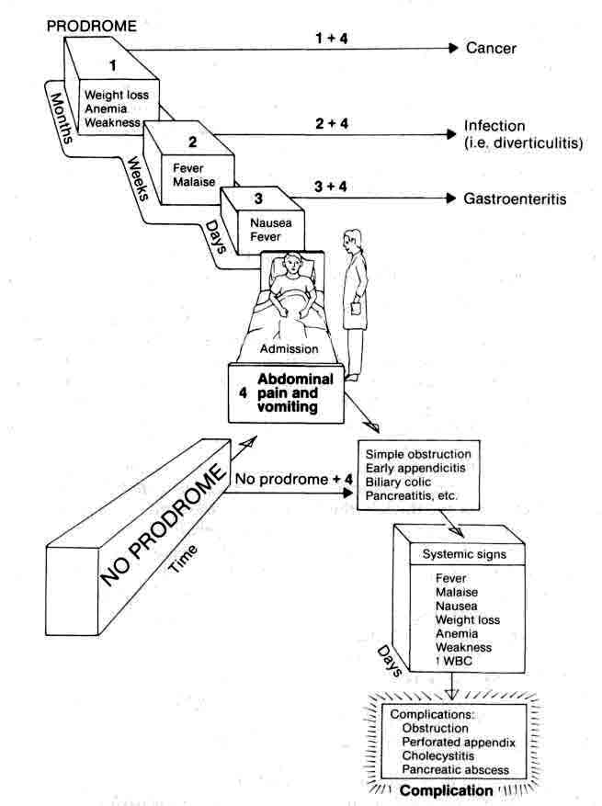
From: Basic surgery/ed., H.C. Polk, Jr., et al. – 5th ed.

Scheme 1-2. Characteristic location of abdominal pain associated with various diseases
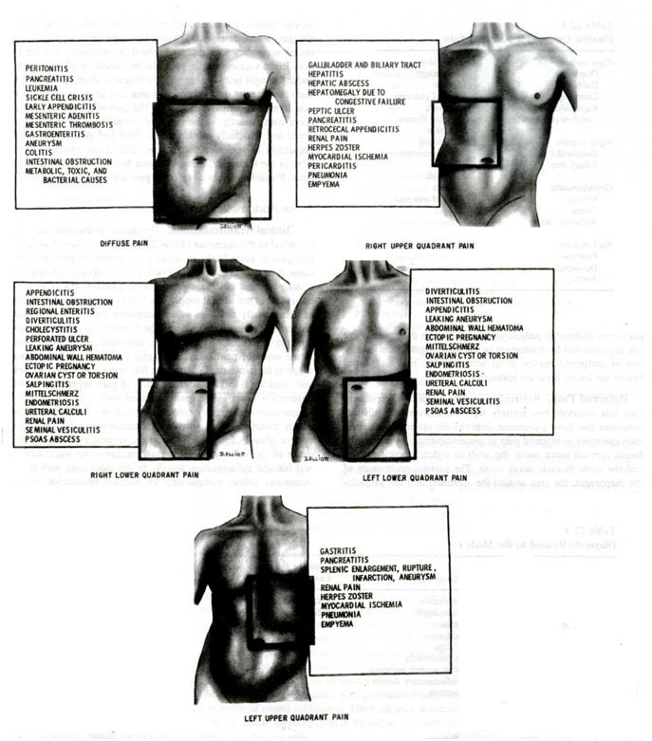
From: Principles of surgery/ed., S.I. Schwartz, et al. – 7th ed.

Anorexia, nausea and vomiting

- Anorexia, nausea, and vomiting are common accompanying symptoms in acute inflammatory abdominal processes.
- Vomiting is very frequent in obstruction of gastrointestinal tract.
- These symptoms also accompany nonsurgical diseases, in which case they often precede the pain (e.g. gastroenteritis).

Changes in bowel habits

- Changes in bowel habits are so common that they are seldom helpful unless very specific changes occur.
- Watery diarrhea suggests gastroenteritis of various origin.
- Bloody diarrhea suggests ulcerative colitis, Salmonella infestation, or colonic ischemia.
- Patients with intestinal obstruction usually pass no flatus or bowel movement for 1-2 days prior to seeking medical attention.

Symptoms of sepsis

- Symptoms of sepsis, such as chills and fever, may be nonspecific, although certain patterns are typical of certain diseases.

Specific symptoms

Previous surgery

- Adhesions may have formed within the peritoneal cavity, leading to intestinal obstruction.
- If the surgery was for malignant disease, the malignancy may have recurred, causing different complications.
- Previous removal of any organ eliminates it from consideration.
- Previous surgery may point to a specific problem (e.g. suppurative cholangitis in a patient with previous choledocholithiasis and retained common duct stone).

Previous episodes of similar pain

Characteristic maneuvers

- A patient with acute peritonitis lie very still; any movement results in excruciating pain.
- A patient with a common duct stone or a kidney stone will pace the floor, unable to find a comfortable position.
- The pain of an acute peptic ulcer may be relieved by food or antacids, whereas pain from acute cholecystitis or pancreatitis may be exacerbated by food.
- A patient with hemoperitoneum will not stay in some position for a long time (“tilting doll” sign).

Comorbidities

- Comorbidities and their signs (some of them are listed below) should be noticed as they may produce acute abdomen.
- Urinary tract: dysuria, hematuria, changes in urinary habits.
- Reproductive tract in the female: past or present vaginal discharge, dysmenorrhea, a history of pelvic inflammatory disease, time of last menstrual period.
- Cardiovascular system: atrial fibrillation, ischemiс heart disease.
- Diabetes mellitus: poorly controlled blood sugars.

Physical examination

Complete physical examination

- Changes in vital signs, particularly fever, tachypnea, hypotension or cardiac rhythm irregularities, should be noticed.
- Inspection should be done for jaundice, dehydration, feculent breath, pneumonia or mental disorientation.
- Examination of the extremities for loss of pulses is also necessary.

Abdominal examination

Overall inspection

- A distended abdomen with visible peristalsis suggests small bowel obstruction.
- Prominent muscle guarding or rigidity (signs of peritonitis) may be visible in a thin and muscular patient.
- A scaphoid abdomen may suggest herniation of the abdominal contents through the diaphragm into the thoracic cavity, particularly after blunt abdominal trauma.
- Hernias are frequently visible, particularly when the patient is standing.

Palpation of abdomen

- The inguinal area should be examined for hernias or inflammatory conditions.
- The abdomen should be examined to determine the points of maximum tenderness or the presence of referred tenderness.
- Rebound tenderness (Schetkin-Blumberg’s sign) is tenderness that occurs when the examining hand is quickly removed from the abdominal wall. It is indicative of acute peritoneal irritation.
- Muscle spasm (another sign of peritoneal irritation) is determined by gently depressing the abdominal wall muscles.
- Palpation for abdominal masses should be done systematically. A mass in a particular abdominal quadrant suggests a specific diagnosis (see Scheme 1-3). Further work-up is necessary when finding the abdominal mass.

Scheme 1-3. Location of abdominal masses according to their organ of origin

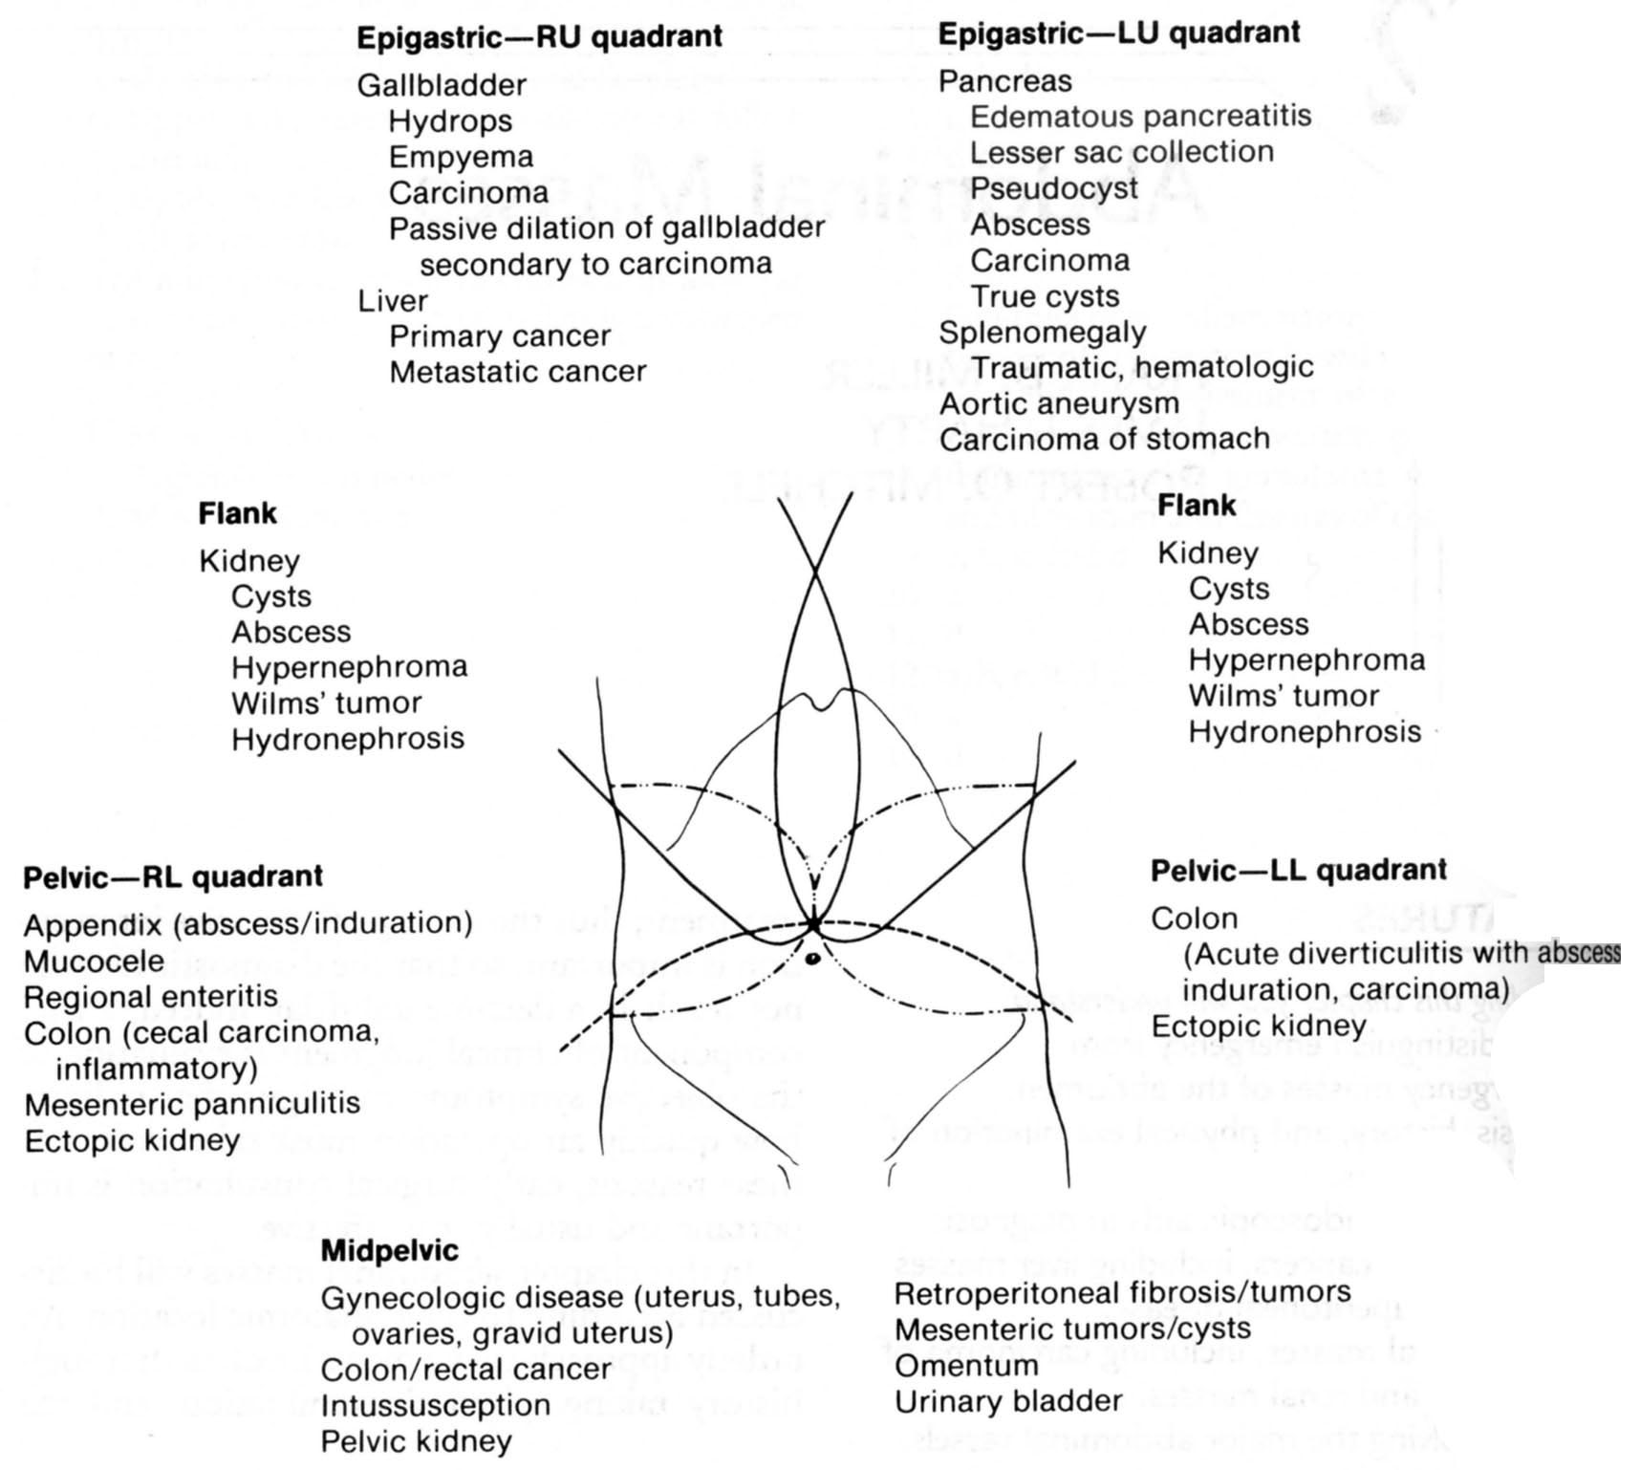
From: Basic surgery/ed., H.C. Polk, Jr., et al. – 5th ed.

Scheme 1-4. Algorithm of management of patient with abdominal mass

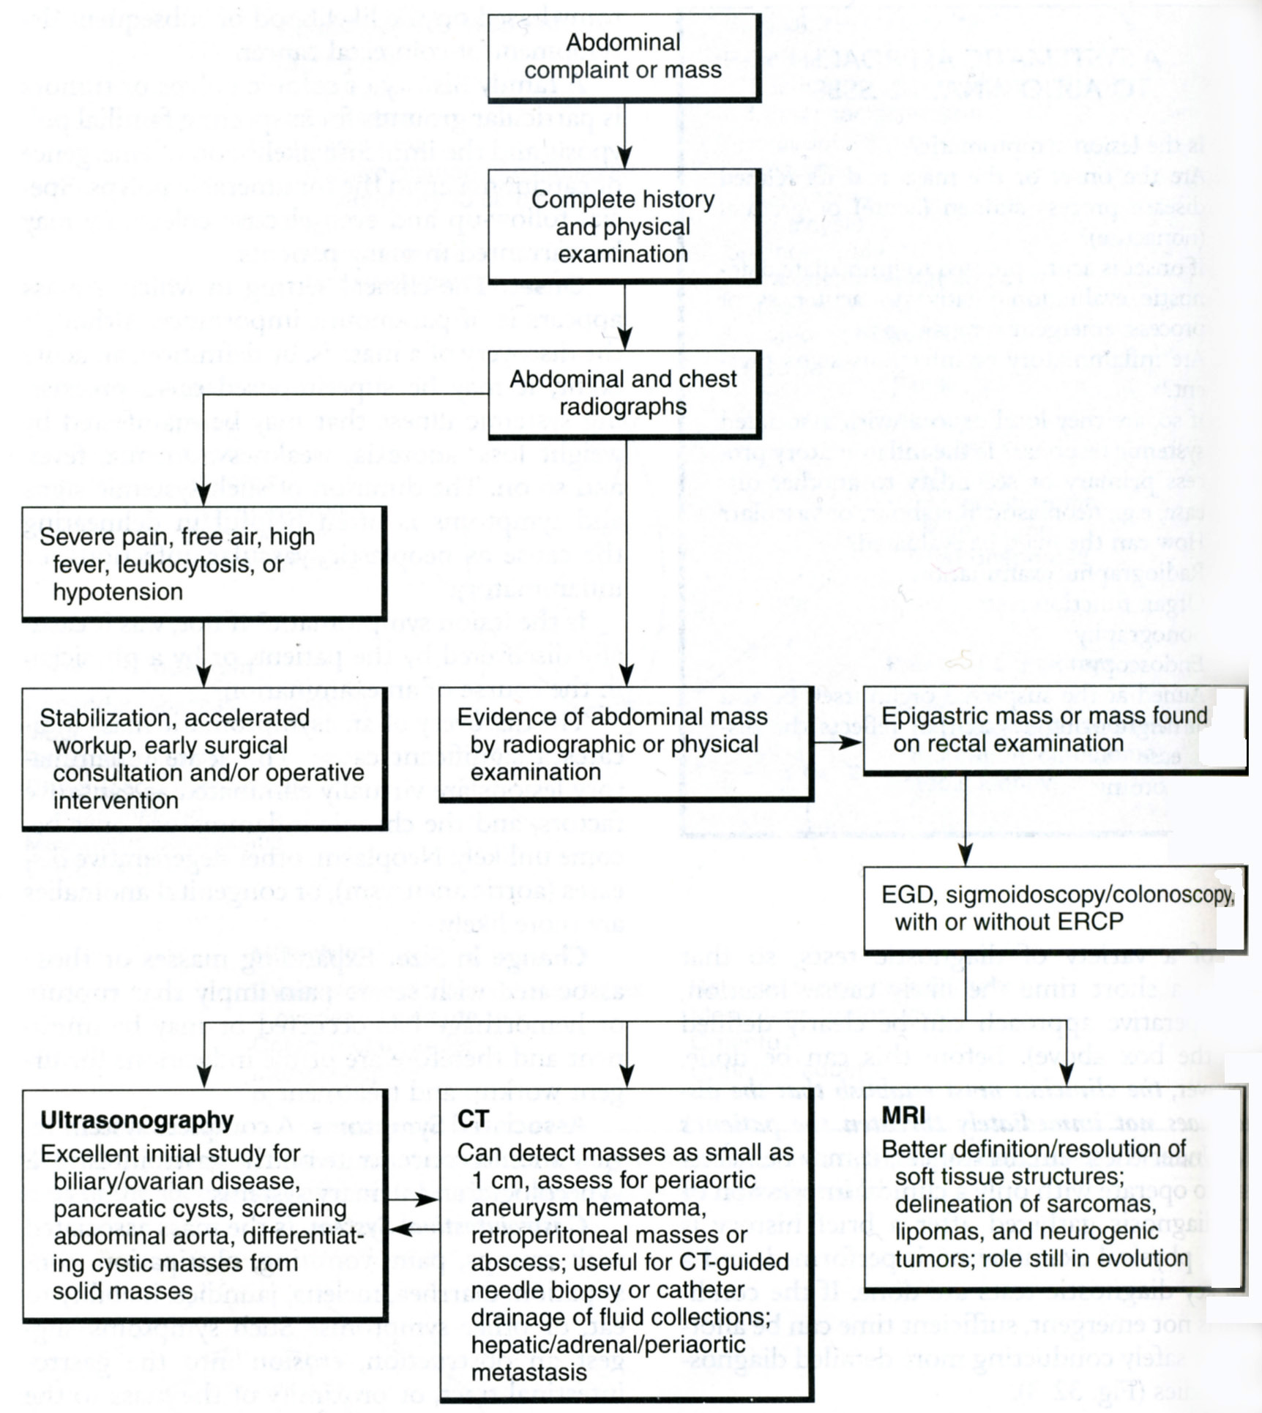
From: Basic surgery/ed., H.C. Polk, Jr., et al. – 5th ed.

Percussion of abdomen

- Percussion confirms areas of tenderness.
- The hollow sound of tympany indicates free intraperitoneal air, but it usually is present because of air in the intestine.
- Absence of hepatic dullness sugests free intra-abdominal air due to perforation of hollow organ.

Auscultation of abdomen

- Intermittent peristaltic rushes that have a crescendo followed by silence suggest an intestinal obstruction. This sign is particularly useful when the peristaltic rush coincides with the onset of episodic abdominal pain. Certain nonsurgical inflammatory conditions, such as gastroenteritis, produce high-pitched intermittent peristaltic rushes. In these cases, the pain pattern is usually not synchronous with the rushes.
- A silent abdomen indicates the absence of peristalsis, suggesting diffuse peritonitis, which occurs with major abdominal sepsis, intestinal ischemia or gangrene, prolonged (longer than 3 days) mechanical obstruction or dynamic bowel obstruction.

Rectal examination

- Rectal and gynecologic examination must be performed in any case of acute abdomen.
- A mass palpable on rectal examination may be a pelvic abscess, a sign of pelvic inflammatory disease or a malignancy.
- The presence of blood in the stools suggests either a malignancy, hemorrhoids, or an acute inflammatory gastrointestinal process, such as an ulcer or colitis.
- The colour of stool helps to determine the site of gastrointestinal bleeding (melena is produced by upper gastrointestinal tract and bloody stools is produced by lower one).
- Rectal examination also reveals pathology of prostate gland.

Gynecologic examination

- Cervical or parauterine tenderness suggests pelvic inflammatory disease.
- A uterine, ovarian, or pelvic mass suggests intrauterine pregnancy, ectopic pregnancy with rupture and hemorrhage, pelvic, ovarian, or tubal inflammatory disease with or without abscess formation, ovarian cysts, and pelvic or gynecologic malignancy.
- Cervical discharges should be examined microscopically for gonococci and other flora.

Examination of genitalia

- It should be performed in all men and boys for the torsion of the testicle.

Special signs

- Special signs are useful in diagnosing different acute abdominal pathologies (e.g. Murphy's sign for acute cholecystitis, Rovsing’s sign for acute appendicitis, Gray-Turner’s sign for necrotizing pancreatitis, ect.).

Medical illnesses that can cause acute abdomen

- Life-threatening medical illnesses, such us acute myocardial infarction, lower lobe pneumonias, diabetic ketoacidosis, should be particularly sought (see also Tables 1-3, 1-4).
- Musculoskeletal problems, particularly vertebral compression of abdominal wall nerves, usually mimic acute surgical conditions.

Table 1-3. Extraperitoneal causes of abdominal pain

Cardiopulmonary  Pneumonia  Empyema  Myocardial ischemia  Active rheumatic heart disease  Blood  Leukemia  Sickle cell crisis  Neurogenic  Spinal cord tumors  Osteomyelitis of spine  Tabes dorsalis  Herpes zoster  Abdominal epilepsy  Genitourinary  Nephritis  Pyelitis  Perinephric abscesses  Ureteral obstruction  Calculi  Tumors  Prostatitis  Seminal vesiculitis  Epidydimitis | Vascular  Aortic aneurysm (dissection, rupture or expansion)  Periarteritis  Metabolic  Uremia  Diabetic acidosis  Porphyria  Addisonian crisis  Toxins  Bacterial (tetanus)  Insect bites  Venoms  Drugs  Lead poisoning  Abdominal wall  Intramuscular hematoma  Psychogenic
From: Principles of surgery/ed., S.I. Schwartz, et al. – 7th ed.

Table 1-4. Surgical masqueraders

Cause | History | Physical examination | Special tests
Abdominal wall
Trauma, hematoma, tumor, infection | Trauma, anticoagulant use, enlarging mass, fever | Location of tenderness, mass, presence of fever, cellulitis | Biopsy if solid mass is present
Viral myositis, toxins | Viral prodrome of malaise, fever, anorexia, spider bite, snake bite | Fang marks
Trigger point, myofascial syndrome, nerve entrapment | Previous operation, parasthesias, no visceral symptoms (e.g., vomiting) | Pain exacerbated with rectus muscle tightening; single finger pressure causes pain. Fascial or muscular cord | Responds to local anesthesia
Thorax
Pneumothorax, pleural effusion | Tuberculosis, cancer, trauma | Hyperresonance to percussion with pneumothorax, flat percussion note, breath sounds ↓↓, egophony over fluid | Chest radiographs, decubitus film of chest, CT scan
Pneumonia, pulmonary infarction | Exposure, known tuberculosis, preexisting thrombophlebitis, pelvic inflammatory disease, ingestion of drugs, hemoptysis | Breath sounds ↓↓, rales, dull percussion note, friction rub | Chest radiographs, lung scan, pulmonary angiogram
Constrictive pericarditis, myocardial infarction, embolization | Symptoms of heart failure, anginal prodrome | BP ↓↓, thready pulse, pulse pressure ↓↓, venous pressure ↑↑ | ECG, chest radiographs, echocardiography
Central nervous system
Cord or nerve root compression or inflammation | Exacerbated by cough or straining, hyperesthesia, causalgia, etc. | Duplication of pain by pressure on spine; abdominal wall rigidity, guarding, or rebound  tenderness | Radiograph of spine, myelogram, MRI, or CT scan
Brain, psychogenic, abdominal migraine | Occasional vomiting, abdominal discomfort, cranial nerve symptoms, previous known psychiatric disorder, epilepsy, or migraine headaches | Muscular tenderness, abdominal guarding, etc.; neurologic abnormalities | Skull radiographs, brain scan, EEG, spinal fluid analysis, CT or MRI scan
Genitourinary
Kidney, ureter, bladder | Previous stone or infection, symptoms of infection, back pain, suprapubic pain, pain radiating to thigh or testicle | Suprapubic or costovertebral angle tenderness, fever | Urine analysis, leukocytosis, IVP or CT scan with IV contrast, cystoscopy, arteriography
Ovary, tubes, uterus | Previous infection, exposure to VD, menstrual irregularity, vaginal discharge | Pelvic tenderness, mass, vaginal discharge | Smear of discharge, culposcopy, laparoscopy, sonography
Metabolic (exogenous)
Heavy metal poisoning | Ingestion or close contact with lead, mercury, arsenicals | Lack of peritoneal signs | Smear of peripheral blood, blood or urine levels of offending agent ↑
Food poisoning | Ingestion of contaminated food, epidemic, associated  diarrhea common | Fever, lack of signs of peritoneal irritation | Stool culture, blood agglutinins
Metabolic (endogenous)
Diabetes, uremia, porphyria, collagen disease, Mediterranean fever, hemolytic diseases, lactose intolerance | Known disease, arthralgias, nerve deficits, anemia, relation to food | Lack of signs of peritonitis (unless ischemic bowel necrosis present) | Depending on underlying conditions: blood sugar ↑, blood urea nitrogen ↑, hemoglobin ↑, urine porphyrins ↑, sickled red cells, antinuclear antibody ↑, ESR ↑ , CRP ↑, LE prep +, hydrogen breath test +
From: Basic surgery/ed., H.C. Polk, Jr., et al. – 5th ed.

Immunocompromised patients

- A high index of suspicion is necessary for acute abdominal emergencies in immunosuppressed patients (HIV, transplant or steroid-dependent patients) whose symptoms and findings may be minimal (see also Table 1-5).

Table 1-5. Acute abdominal pain in the immunocompromised patient

Cytomegalovirus infection  Interstitial pneumonitis  Mononucleosis  Pancreatitis  Hepatitis  Cholecystitis  Gastrointestinal ulceration  Neutropenic enterocolitis  Pancreatitis  Pentamidine  Steroid  Azathioprine  CMV  Heptatitis  А, В, С  CMV  Epstein-Barr virus  Cholecystitis  CMV  Acalculous  Campylobacter  Hepatosplenic abscess  Fungal  Mycobacterial  Protozoal  Splenic rupture | Bowel perforation  Lymphoma, leukemia (especially after chemotherapy)  CMV  Colon ulcers  Mycobacterial  Pseudomembranous colitis  Kaposi's sarcoma  Iatrogenic  Acute graft vs. host disease  Pseudoacute abdomen  Fecal impaction  Standard abdominal processes  Appendicitis  Cholecystitis  Diverticulitis  Bowel obstruction  Ulcer disease  Pelvic inflammatory disease  Perirectal abscess  Urinary tract infection  Lymphadenitis
From: Principles of surgery/ed., S.I. Schwartz, et al. – 7th ed.

Acute abdomen in children

Table 1-6. Differential diagnoses of acute abdominal conditions in the pediatric population

Infants  Viral enteritis  Intussusception  Pyelonephritis  Gastroesophageal reflux  Bacterial enterocolitis  Appendicitis  Pneumonitis  Pyloric stenosis  Testicular torsion  Mesenteric cysts  Ruptured tumors  Pancreatitis  Meckel's diverticulitis  Hirschsprung's disease  Strangulated hernia  Poisoning  Trauma (child abuse) | Children  Meckel's diverticulitis  Cystitis  Crohn's disease  Appendicitis  Viral enteritis  Pneumonitis  Bacterial enterocolitis  Pancreatitis  Ruptured tumors  Poisoning  Trauma (child abuse)  Pyelonephritis | Adolescents  Pelvic inflammatory disease  Appendicitis  Mittelschmerz  Crohn's disease  Pancreatitis  Pneumonia  Hematocolpos  Psychosomatic  Viral enteritis  Peptic ulcer  Poisoning  Trauma  Ectopic pregnancy  Pregnancy  Cholelithiasis  Bacterial enterocolitis
From: Principles of surgery/ed., S.I. Schwartz, et al. – 7th ed.

Laboratory tests

Complete blood count

- A red cell count may reveal anemia or suggest hemoconcentration secondary to dehydration.
- Leukocytosis in the 20,000-40,000 range suggests a major septic process in need of rapid surgical intervention.
- A normal white cell count in an elderly or diabetic patient may accompany a major septic episode.
- Profound leukopenia, particularly with a lymphocytic predominance, suggests a viral illness.
- Leukemia may also be diagnosed from the complete blood count.

Urine examination

- Urine examination generally rules out urinary tract infection or kidney stone disease.
- Pelvic inflammatory processes in contact with the ureter or bladder may produce a few white cells and red cells in the urine. If there is a doubt, intravenous pyelography should be performed prior to surgery.

Blood biochemistry

- Serum amylase is usually increased in acute pancreatitis, although other surgical illnesses, such as mesenteric thrombosis and perforated ulcer, should not be overlooked.
- Bilirubin level and alkaline phosphatase are increased in jaundice of any origin and require further differential diagnostics.

Arterial blood gases

- Arterial blood gases may be very helpful in identifying a profound metabolic acidosis which suggests either septic shock, or severely ischemic or necrotic tissue.

Other laboratory tests

- Serum electrolytes, serum creatinine, coagulation profile and liver function tests are other studies that are often essential.

Radiographic studies

Upright chest radiograph

- Upright chest radiograph and flat and upright abdominal radiograph should be obtained in most cases of acute abdominal pain.
- A chest radiograph is essential to rule out other diseases, such as pneumonia, that can mimic conditions associated with an acute abdomen.

Upright (flat) abdominal radiograph

Bony structure abnormalities

- Bony structure abnormalities, such as fractures or metastatic lesions, may provide important diagnostic information in trauma or malignant disease.

Gastrointestinal gas pattern

- Paralytic ileus. Air that is evenly distributed throughout the small and large intestine usually signifies paralysis of the bowel (see Fig. 1-1). Ileus may be localized to a specific area, such as the duodenal "sentinel" loop or distension of transverse colon in acute pancreatitis.
- Acute gastric dilation is indicated by a markedly dilated gastric bubble.
- Mechanical obstruction of the intestine is revealed by the presence of distended air- and fluid-filled loops of bowel (Kloiber’s cups) proximal to the obstruction and decompressed intestine distally (see Fig. 5-18).
- Specific causes of mechanical obstruction may be diagnosed by the intestinal gas pattern (hernias may result in intestinal air located in a nonanatomic location; volvulus may appear as an isolated distended loop of bowel with tapered ("bird’s beak") margins).

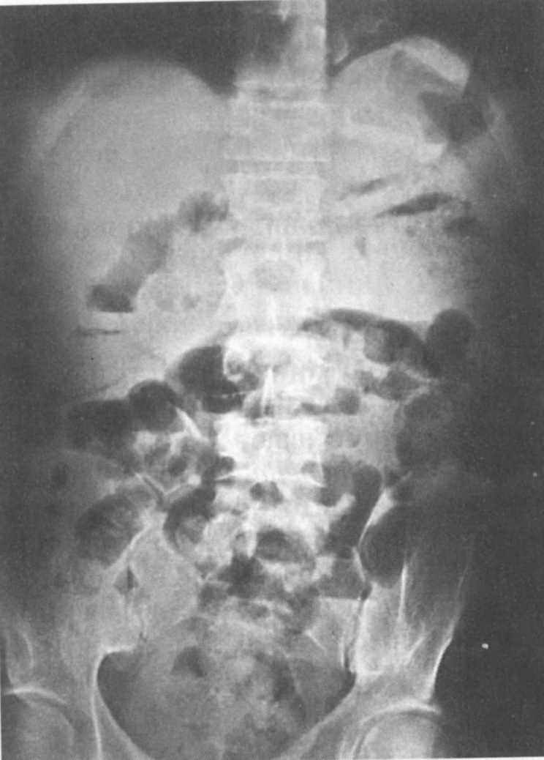

Fig. 1-1. Increased gastrointestinal gas pattern

Abnormal air collections outside the intestinal lumen

- Free air within the peritoneal cavity (most commonly, under the diaphragm in upright position of a patient) signals a perforation of a hollow viscus (see Fig. 4-25). It is present in about 80% of gastroduodenal perforations but in fewer than 25% of colonic perforations. However, it may be present in patients with open drains and for up to 1 week following a laparotomy or laparoscopy.
- Air collections within the wall of the colon, a condition termed pneumatosis cystoides intestinalis, generally indicate an isolated, walled-off intestinal perforation.
- Air stippling within soft tissue structures may indicate the dissection of air into the tissues from a thoracic source, such as a pneumothorax. It may, however, be due to a rapidly progressive, catastrophic gas-forming infection.
- Air-fluid level outside the intestinal tract is associated with a subphrenic or subhepatic abscess (see Fig. 1-2).
- Air within the biliary tree indicates biliary-digestive fistula, cholangitis or provided by biliary drainage (see Fig. 5-19).
- Air within the portal vein is seen in pylephlebitis.

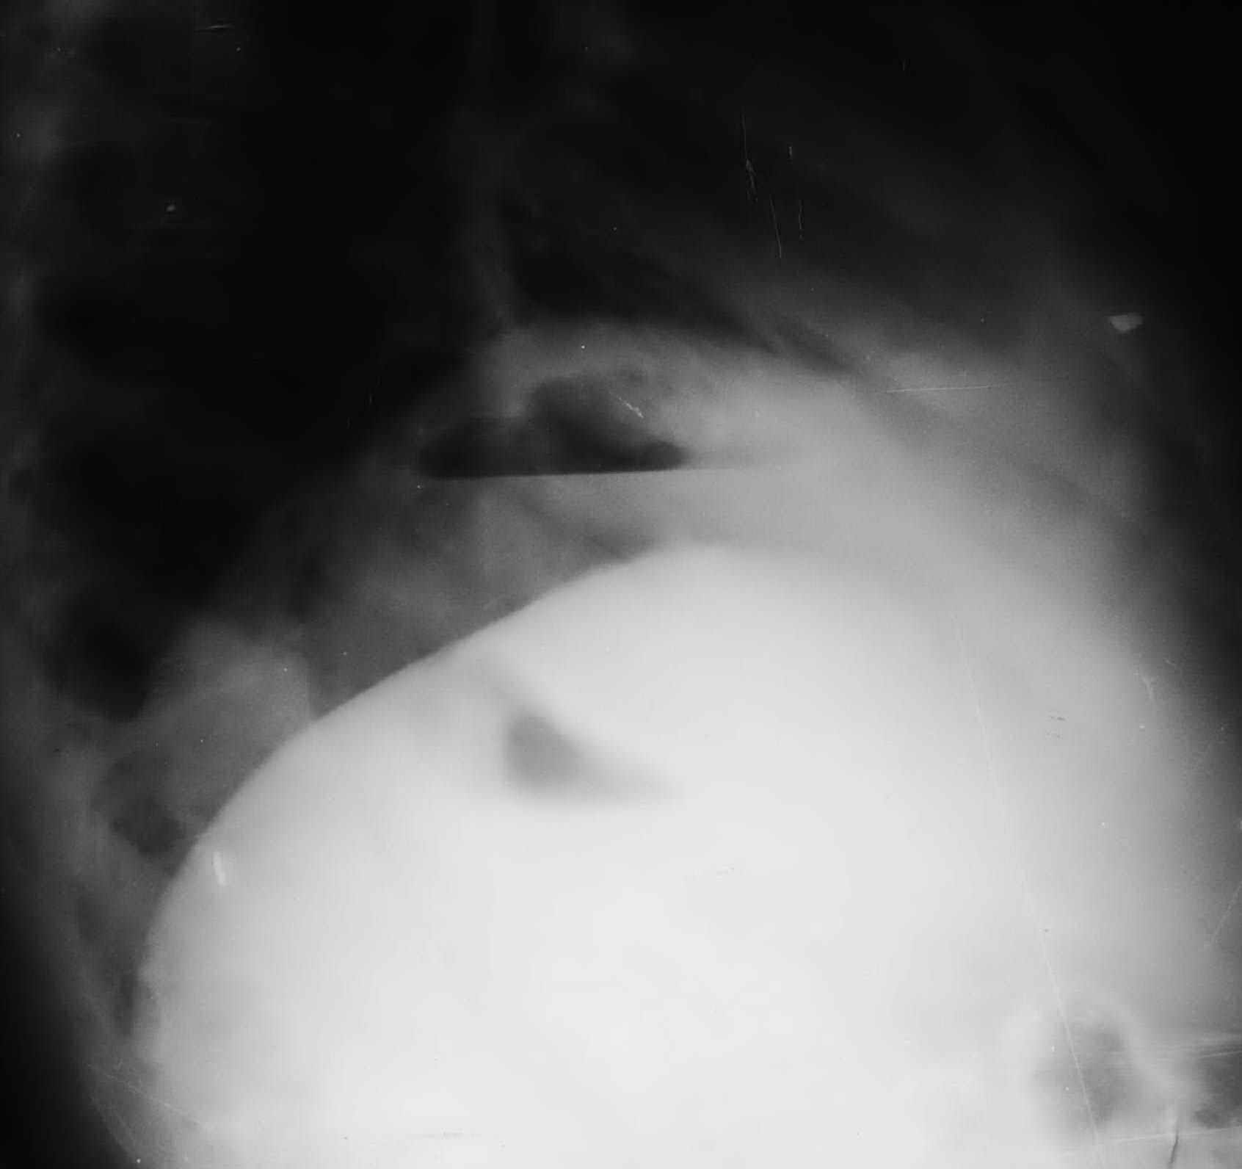

Fig. 1-2. Radilogical picture of subphrenic abscess

Abnormal calcifications

- Renal stones are calcified in up to 85% of cases and appear along the path of the
ureter.
- Fecaliths are strong evidence for acute appendicitis in patients with abdominal pain.
- Pancreatic calcification suggests chronic pancreatitis.
- Gallstones are calcified in 15% of cases.
- Heavily calcified vessels may be present in mesenteric ischemia.
- Masses, such as teratomas or malignant neoplasms, may calcify.

Soft tissue shadows

- Peritoneal fat lines and psoas muscle shadows may be lost in rapidly spreading infections, hematomas or abscesses.
- Margins of solid organs (liver, kidney, or spleen) may be displaced from their normal locations by an abnormal mass.
- A distended bladder may be visible and may be responsible for marked abdominal pain.

Contrast radiograph

- Intravenous pyelogram should be obtained if a renal or ureteral stone, acute pyelonephritis or perinephric abscess or renal infarction is suspected. When a patient suspected of having appendicitis has microscopic hematuria, the intravenous pyelogram is particularly useful to verify that the hematuria is due to the periappendiceal inflammation rather than to a renal stone.
- Barium swallow is helpful if rupture of esophagus (Boerhaave's syndrome) suspected.
- Upper gastrointestinal series should be performed if an ulcer disease of stomach or duodenum (including perforated) or gastric cancer is suspected but cannot be proven by endoscopy.
- Placing contrast materials into the colon and rectum should be done very cautiously when an inflammatory condition or a perforation is suspected, because even a small increase in pressure could easily convert into a frank perforation.
- Small bowel follow-through contrast study is useful in identifying a point of small bowel obstruction when either history, physical examination, or plain x-ray fail to verify the diagnosis of small bowel obstruction.

Abdominal ultrasonography

- Abdominal ultrasonography is usually of little diagnostic value in the patient with abdominal distention and severe pain, but it can be helpful when acute cholecystitis, cholelithiasis, biliary obstruction, pancreatitis, intra-abdominal abscess or renal disease is suspected.

Computed tomography (CT) and magnetic resonance imaging (MRI)

- CT and MRI may also be helpful but is generally reserved for the patient whose condition remains undiagnosed after other studies have been exhausted.

General principles of approach to a patient with acute abdominal pain

- Careful and systematic evaluation of the patient should be routinely followed.
- Statistically speaking, certain diagnoses are very common.
- When the diagnosis is not initially clear, continued observation and repeated visualization and laboratory studies are needed. Although this practice might be desirable in a patient with gastroenteritis, delay can be catastrophic in acute appendicitis, acute mesenteric ischemia, strangulated small bowel obstruction, volvulus, or incarcerated hernia.
- If the diagnosis is not certain, but the patient may have a potentially lethal condition that could be cured by an early operation, then an early operation should be performed.
- Analgesics, particularly narcotics, should be withheld from the patient until the diagnsis is established or until the decision to proceed to surgery has been made.
- Antibiotics should also be withheld until a diagnosis has been made and the antibiotiс therapy is needed.
- Fluid deficits and electrolyte imbalances should be corrected before surgery.
- Nasogastric tube should be placed before the induction of anesthesia to empty the stomach, thus minimizing the risk of pulmonary aspiration.

REVIEW TESTS

1. A 70-years-old man was admitted to ER with complaints of a cramping pain at all the sites of abdomen and multiple vomiting. The last bowel movement was 2 days prior to admission. While physical examination of abdomen, there is marked distention, moderate diffuse tenderness, no rebound tenderness and muscle guarding. Digital examination reveals absence of feces in the rectum. What’s the most valuable method of further investigation to make the diagnosis and chose proper tactics?

A. Abdominal ultrasonography
B. Upright abdominal radiography
C. Upper gastrointestinal series
D. Small bowel follow-through contrast study
E. Gastroduodenal endoscopy

2. A 40-years-old woman was admitted to ER with complaints of a cramping pain at right lower quadrant of abdomen irradiating to perineum, fever of 38 °C and single vomiting. There is no diarrhea and constipation. Physical examination of abdomen reveals moderate tenderness in right iliac region and right flank, no rebound tenderness and muscle guarding. Urine analysis shows increased amount of WBC and RBC. What’s the most appropriate sequence of methods of further investigation?

A. Upright abdominal radiography, ultrasonography of abdomen and kidneys, intravenous pyelography
B. Upright abdominal radiography, barium enema, CT of retroperitoneal space
C. Upright abdominal radiography, gastroduodenal endoscopy, CT of retroperitoneal space
D. Upper gastrointestinal series, small bowel follow-through contrast study, intravenous pyelography
E. MRI of retroperitoneal space, ultrasonography of kidneys, upright abdominal radiography

3. A 28-years-old man who had a history of ulcer disease was admitted to ER with complaints of intense (knife-stab) pain at upper part of abdomen and multiple vomiting. The pain appeared 30 minutes ago. Physical examination of abdomen reveals wooden-like muscle spasm, severe diffuse tenderness, and rebound tenderness at all the sites. What’s the most possible sign found at the imaging studies?

A. Abdominal ultrasonography shows fluid in right flank
B. Small bowel follow-through contrast study shows slow passage of contrast medium
C. CT of abdominal cavity shows fluid in right flank
D. Upright abdominal radiography shows free air under the right dome of diaphragm
E. Chest radiography shows high position of right dome of the diaphragm

4. A 68-years-old woman was admitted to ER with complaints of intense pain at right upper quadrant of abdomen and multiple vomiting. The pain appeared 3 days ago after ingestion of fatty food. Physical examination of abdomen reveals slight muscle spasm and severe local tenderness at right upper quadrant. What’s the most valuable method of further investigation to make the diagnosis and chose proper tactics?

A. Gastroduodenal endoscopy
B. Upright abdominal radiography
C. Upper gastrointestinal series
D. Barium enema
E. Abdominal ultrasonography

Correct answers: 1 - B, 2 - A, 3 - D, 4 - E.

