CHAPTER 2. DIFFUSE ABDOMINAL PAIN

- Diffuse abdominal pain most commonly is caused by diffuse peritonitis, acute pancreatitis (more frequently it may produce epigastric or paraumbilical pain), different variants of bowel obstruction (See Chapters 5, 6), first phase of acute appendicitis (See Chapter 3), acute mesenteric ischemia, gastroenteritis, and other diseases listed above (see Table 1-1).

PERITONITIS

Overview

Table 2-1. Classification of intraabdominal infections

Primary peritonitis  Spontaneous peritonitis in children  Spontaneous peritonitis in adults  Peritonitis in patients with CAPD  Tuberculous and other granulomatous peritonitis  Secondary peritonitis  Acute perforation peritonitis (acute suppurative peritonitis)  Gastrointestinal or biliary tract perforation  Bowel wall necrosis (intestinal ischemia)  Pelvic peritonitis (due to pelvic inflammatory  diseases)  Other forms  Postoperative peritonitis  Anastomotic leak  Leak of a simple suture  Blind loop leak  Other iatrogenic leaks  Posttraumatic peritonitis  Peritonitis after blunt abdominal trauma  Peritonitis after penetrating abdominal trauma | Tertiary peritonitis  Peritonitis without evidence for pathogens  Peritonitis with fungi  Peritonitis with low-grade pathogenic bacteria  Other forms of peritonitis  Biliary peritonitis  Enzimatic (panreatogenic) peritonitis  Urinary peritonitis  Uremic peritonitis  Granulomatous peritonitis  Drag-related peritonitis  Periodic peritonitis  Lead peritonitis  Hyperlipidemic peritonitis  Porphyric peritonitis  Foreign-body peritonitis  Talc peritonitis  Intraabdominal abscess  Associated with primary peritonitis  Associated with secondary peritonitis
From: Principles of surgery/ed., S.I. Schwartz, et al. – 7th ed.

- Most cases of peritonitis are due to an invasion of the peritoneal cavity by bacteria.
- Bacterial peritonitis is usually polymicrobial, both aerobic (Escherichia coli, Enterobacter, Staphylococci) and anaerobic organisms (Streptococci, Bacteroides, Clostridium welchii) from gastrointestinal tract being present.
- The exception is primary peritonitis (spontaneous peritonitis) in which a pure infection with Gonococcus, Streptococcs, Pneumococcs, Chlamydia or Haemophilus bacteria occurs.

Scheme 2-1. Classification of peritonitis by location

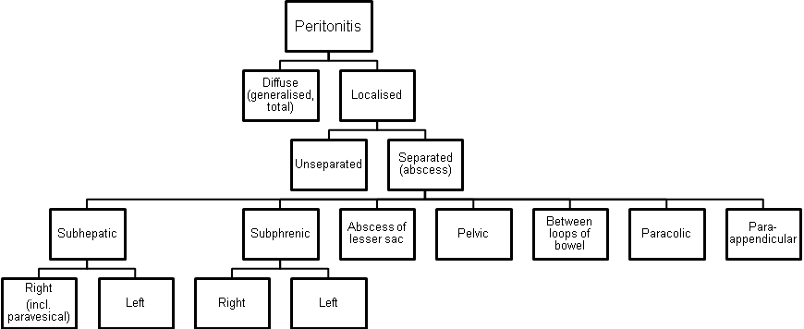

Clinical features

Localised peritonitis

- Localised peritonitis is bound up intimately with the causative condition and the initial symptoms and signs are those of that condition.
- The temperature, and especially the pulse rate, rise.
- Abdominal pain increases.
- The most important sign is local muscle guarding and rigidity of the abdominal wall with a rebound tenderness (Shetkin-Blumberg’s sign).
- If inflammation arises under the diaphragm shoulder tip pain may be felt (de Mussy sign).
- In cases of pelvic peritonitis arising from an inflamed appendix in the pelvic position or from salpingitis, the abdominal signs are often slight, deep tenderness of one or both lower quadrants alone being present, but a rectal or vaginal examination reveals marked tenderness of the pelvic peritoneum.
- A large collection of bile localised to the subhepatic space can remain dangerously “silent” until a late stage.

Diffuse peritonitis

Scheme 2-2. Phases of clinical course of diffuse peritonitis



Reactive phase

- Abdominal pain is severe and made worse by moving or breathing. The patient usually lies still.
- Vomiting may occur.
- Tenderness and rigidity on palpation along with rebound tenderness are typically found.
- Infrequent bowel sounds may still be heard for a few hours but they cease with the onset of paralytic ileus.
- The pulse rises progressively, but if the peritoneum is deluged with irritant fluid, there is a sudden rise.
- The temperature changes are variable and can be subnormal.

Toxic and terminal phase

- Abdominal pain still remains.
- Infrequent bowel sounds may still be heard for a few hours but they cease with the onset of paralytic ileus. The abdomen remains silent and increasingly distends.
- Circulatory failure ensues, with cold, clammy extremities, sunken eyes, dry tongue, thready (irregular) pulse, and drawn and anxious face (Hippocratic facies).
- Diuresis is decreasing.
- The patient finally lapses into unconsciousness.

Table 2-2. Signs of loss of extracellular fluid volume

Tachycardia
Increased respiratory rate
Dry, cool skin
Poor capillary filling of extremities
Decreased pulse volume
Decreased skin turgor
Decreased urinary output
Hemoconcentration
Increased specific gravity of urine
Hypotension
Orthostatic - early
Frank - late

From: Basic surgery/ed., H.C. Polk, Jr., et al. – 5th ed.

Laboratory studies

- A leucocytosis is usually seen in peritonitis but is often delayed for many hours.
- Serum amylase estimation may uphold the diagnosis of acute pancreatitis.

Diagnostic peritoneal lavage

- Peritoneal diagnostic aspiration (under local anesthesia, usually at the umbilical area) may be very helpful.
- Bile-stained fluid indicates perforated peptic ulcer or gallbladder; the presence of pus indicates bacterial peritonitis; blood is aspirated in a high proportion of patients with intraperitoneal bleeding.
- When aspiration fails, the introduction of a small quantity of sterile physiological saline, followed after a few minutes by peritoneal aspiration may produce fluid of diagnostic value.
- Microscopy of the fluid may show neutrophils, bacteria, and amylase level of the fluid could be determined for suspected pancreatogenic peritonitis.

Visualization data

- An upright abdomen radiography may confirm the presence of dilated gas-filled loops of bowel (consistent with a paralytic ileus) or show free gas. If the patient is too ill for an erect film to demonstrate free air under the diaphragm, a lateral decubitus film is just as useful showing gas beneath the abdominal wall.
- Ultrasound and CT, when available, may also he helpful in some patients by identifying a cause of peritonitis (e.g. perforated appendicitis, acute pancreatitis). Such knowledge may influence operative approach or contraindicate operation.

Treatment

- In any case of doubt, early surgical intervention is preferred to a “wait and see” policy. This rule is particularly true for postoperative peritonitis.

General care of the patient

Correction of circulating volume and electrolyte imbalance (see also Chapter 22)

- The plasma volume must be restored and the plasma electrolyte concentrations corrected using central venous catheterisation, pressure and diuresis monitoring.
- A fluid balance chart must be started so that daily output by gastric aspiration and urine is known.
- Additional losses are estimated. Throughout recovery, the haematocrit and serum electrolytes and urea must be checked regularly.
- If the patient’s recovery is delayed for more than 7 - 10 days, intravenous feeding (hyperalimentation or total parenteral nutrition, TPN) is required.

Gastrointestinal decompression

- A nasogastric tube aspiration is maintained until the paralytic ileus resulting from peritonitis has recovered.
- Measured volumes of water are allowed by mouth when only small amounts are being aspirated.
- If the abdomen is soft and not tender, bowel sounds return, and flatus and stools passage resumed, and oral feeding may be progressively introduced. It is important not to prolong the ileus by missing this stage.

Antibiotic therapy

- Initially parenteral broad-spectrum antibiotics active against aerobic and anaerobic bacteria should be given.

Analgesia

- Freedom from pain allows early mobilisation and adequate physiotherapy in the postoperative period which help to prevent basal pulmonary collapse, deep-vein thrombosis and pulmonary embolism.
- The patient should be nursed in the sitting-up position and must be relieved of pain before and after operation.
- Once the diagnosis has been made drug analgesics may be given.
- If appropriate expertise is available, epidural infusion may provide excellent analgesia.

Vital system support

- Administration of oxygen postoperatively can help to prevent and mitigate the effects of septic shock, especially adult respiratory distress syndrome (ARDS) which may require a period of mechanical ventilation.
- If oliguria persists despite adequate fluid replacement, both diuretics and inotropic agents (dopamine) may be needed.

Specific treatment of the cause

- If the cause of peritonitis is amenable to surgery, such as in perforated appendicitis, diverticulitis, peptic ulcer, gangrenous cholecystitis or in rare cases of perforation of the small bowel, operation must be carried out as soon as the patient is fit for anaesthesia.
- In peritonitis due to pancreatitis or salpingitis, or in cases of primary peritonitis of streptococcal or pneumococcal origin, nonoperative treatment is preferred.

Scheme 2-3. General algorithm of management of secondary diffuse peritonitis (excluding enzymatic)

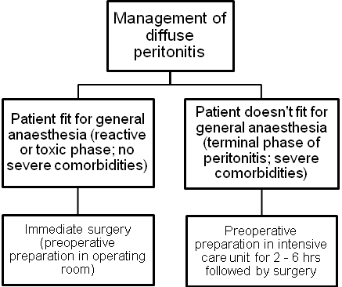

Peritoneal lavage and drainage

- In operations for general peritonitis it is essential that after the cause has been dealt with the whole penitoneal cavity should be explored with the sucker until all exudate is removed.
- The use of a large volume of saline (1 - 2 litres), which may contain dissolved antibiotic or antiseptic, is very effective.
- Wide drainage by tubes of large diameter of the site of origin of peritonitis, subphrenic, subhepatic spaces, flanks and pelvic space is essential (see Fig. 2-1).
- Postoperative lavage of these sites by antibiotic or antiseptic solutions is beneficial.

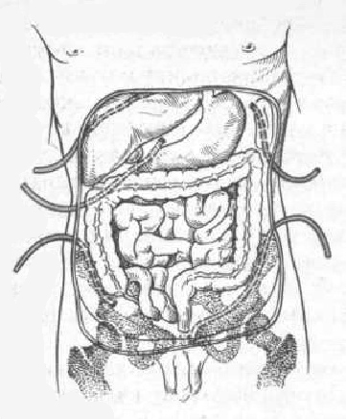
Fig. 2-1. Drainage of peritoneal cavity for diffuse peritonitis

Complications of peritonitis

Acute intestinal obstruction due to peritoneal adhesions

- This usually gives central colicky abdominal pain with evidence of small bowel gas and fluid levels sometimes confined to the proximal intestine on X-ray (see Fig. 5-18).
- Bowel sounds are increased. It is more common with localised peritonitis. It is essential to distinguish this from paralytic ileus.

Paralytic ileus

- There is usually little pain and gas-filled loops with fluid levels are seen distributed throughout the small and large intestines on abdominal X-ray.
- In paralytic ileus, bowel sounds are reduced or absent.

Abscesses

- Abscess is localized form of peritonitis. It is separated collection of infected fluid of variuos location within the abdominal cavity.
- Abscesse may be due to separation of distinct primary inflammatory process (e.g. appendicular abscess) or may be a sequela of diffuse peritonitis.

Clinical features and laboratory data

- Fever, local pain, tachycardia and leukocytosis and other signs of SIRS are present.
- The patient may have tenderness or an abdominal mass, particularly with a pelvic abscess, but often no physical findings are present.
- When there is a delay in seeking medical attention patients may present with generalized sepsis with hypotension.
- The most characteristic symptoms of a pelvic abscess are diarrhea and the passage of mucus in the stools. Rectal examination reveals a bulging of the anterior rectal wall.
- Postoperative abscesses usually produce fever during the second postoperative week.
- In the majority of cases with the aid of antibiotic treatment, small abscesses become smaller and smaller, and finally are undetectable.

Visualization data

- Computed tomography (CT) scan and ultrasound show separated fluid collection (see Fig. 2-2).
- Plain adbominal radiograph may show round-shaped cavity with horizontal fluid level (“basket” sign).

A 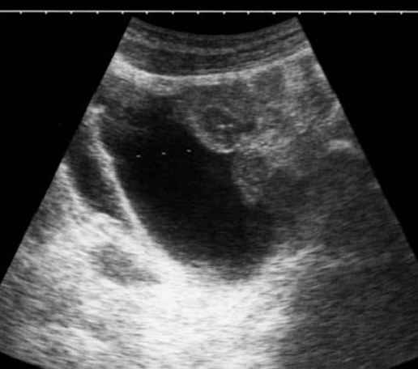 B 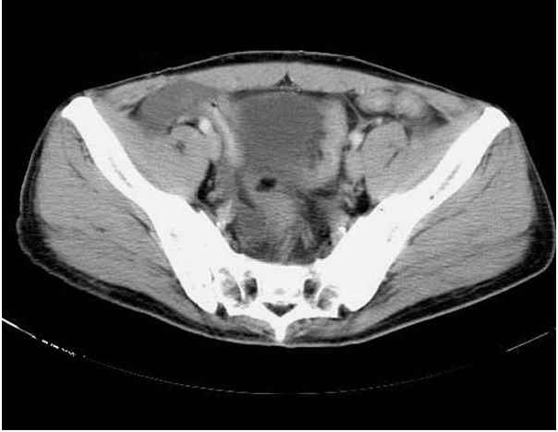

Fig. 2-2. US- and CT- pictures of pelvic abscess

Treatment

Scheme 2-4. Algorithm of surgical management of intra-abdominal abscesses

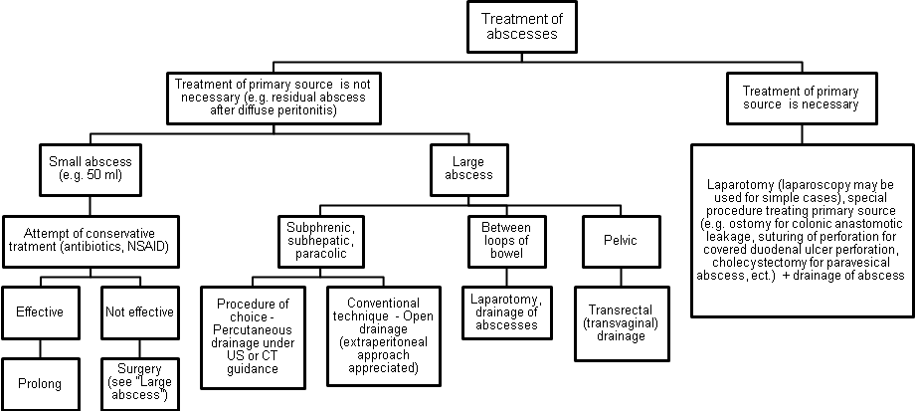

A 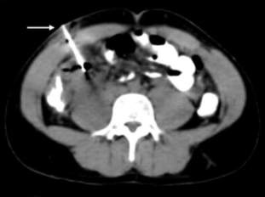 B 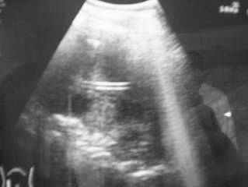

Fig. 2-3. CT- and US-guided percutaneous drainage of intra-abdominal abscess

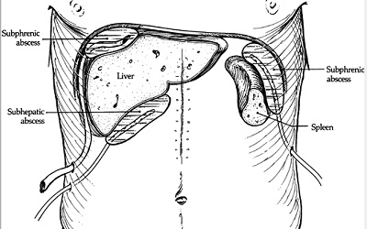

Fig. 2-4. Open drainage of subphrenic and subhepatic intra-abdominal abscesses

1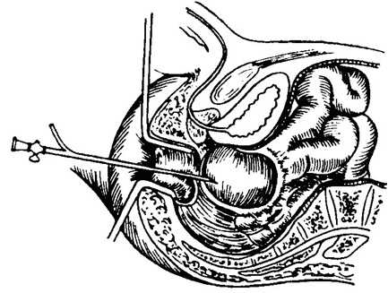 2 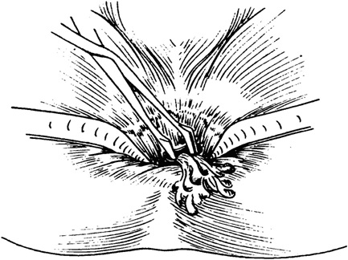

Fig. 2-5. Transrectal drainage of pelvic abscess

ACUTE PANCREATITIS

Overview

- Scheme 2-5 shows the classification of different forms of pancreatitis which differs in english and russian literature (except names of complications of acute pancreatitis).

Scheme 2-5. Classification of forms of pancreatitis

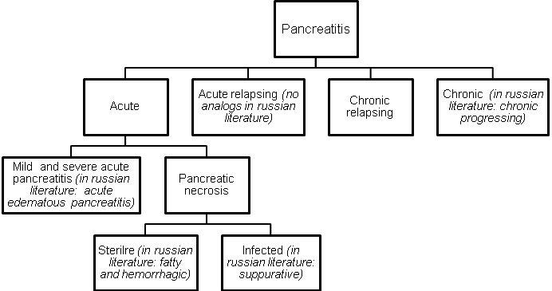

- Approximately 75% of pancreatitis cases can be explained by biliary tract disease or alcohol abuse, although the exact mechanism of pancreatitis remains theoretical.

Table 2-3. Etiological classification acute pancreatitis

Biliary

Acute cholecystitis (reactive)
Choledocholythiasis
Stenosis of sphincter of Oddi
Cholangitis

Alcoholic

Postoperative

Traumatic

Infectious

Mumps
Other

Other

Drugs (e.g. contrast medium)
Hyperparathyroidism
Malnutrition
Hyperlypidemia
Pancreas divisum
Duodenal obstruction
Ishemia
Scorpion venom

Scheme 2-6. Phases of clinical course of mild and severe acute pancreatitis

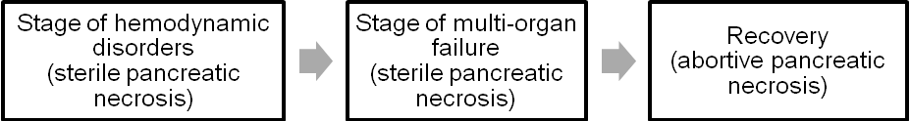

Scheme 2-7. Phases of clinical course of pancreatiс necrosis

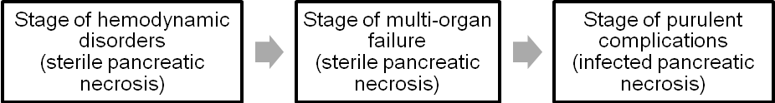

Clinical features and laboratory data

- Clinical presentation of acute pancreatitis may vary from mild abdominal discomfort to profound pain with hypotension and hypoxemia. Often the patient mentions recent consumption of a heavy meal, many times with large quantities of alcoholic beverages.
- Usually the patient presents with epigastric pain that is radiated to the back and is associated with nausea and vomiting. In severe cases, a rigid abdomen with epigastric guarding, rebound tenderness and marked abdominal pain may be present.
- Severe pancreatic inflammation and necrosis may cause retroperitoneal hemorrhage, which can lead to large third-space fluid losses, hypovolemia, hypotension, tachycardia, hypoxemia and even losing consciousness (pancreatogenic shock).
- When blood dissection extends to the flank tissues, resulting in periumbilical and flank ecchymoses, it is known as Cullen's and Turner's signs.
- Serum amylase level is elevated in 95% of patients.

Visualization data

Plain abdominal radiograph

- Calcification in the area of the lesser sac and pancreas may indicate chronic pancreatitis, which is most often seen in association with alcoholism (see Fig. 2-6).
- A gas collection in the lesser sac suggests abscess formation in or around the pancreas.
- Soft tissue shadows and gas-containing viscera may be visibly displaced by collections and edema in the lesser sac and structures adjacent to the pancreas.
- An area of colonic spasm adjacent to an inflamed pancreas causes the gas in the transverse colon to end abruptly (the "cutoff" sign).
- Focal duodenal and jejunal ileus in the area of the pancreas can cause the “reversed 3” sign.

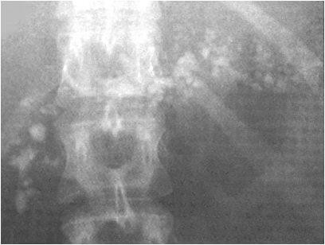

Fig. 2-6. Calcification in the area of pancreas indicating chronic pancreatitis

Upper GI series

- The duodenal C-loop may be widened by pancreatic edema.
- Hypotonic duodenography may demonstrate the "pad" sign, a smoothing out or obliteration of the duodenal mucosal folds by the edematous pancreas and the inflammatory response on the medial aspect of the C-loop.

Ultrasound examination

- Acute pancreatitis is suggested by swelling that is greater than the normal anteroposterior thickness and loss of tissue planes between the pancreas and the splenic vein (see Fig. 2-7-a).
- Lesser sac and retroperitoneal collections (acute pseudcyst and abscesses of pancreaes and lesser sac, retroperitoneal phlegmone) are easily diagnosed (see Fig. 2-8-a) as well as destruction of tissue of pancreas in infected pancreatic necrosis (see Fig. 2-9-a).
- Ultrasound may also demonstrate the presence of gallbladder pathology, such as cholecystitis, cholelithiasis or a dilated common bile duct (see Chapters 4, 10).

A 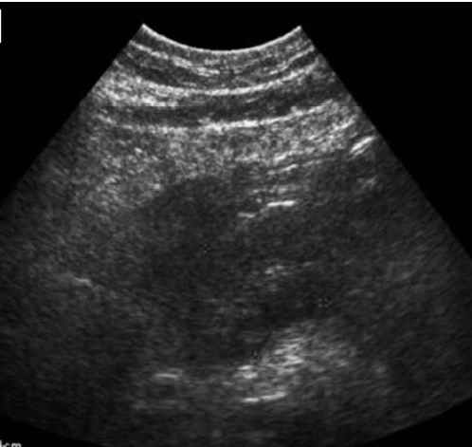 B 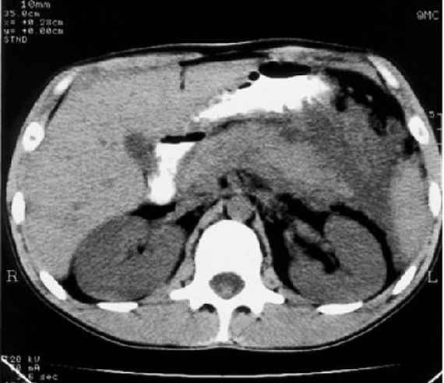

Fig. 2-7. US- and CT- pictures of acute edematous pancreatitis

A 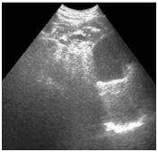 B 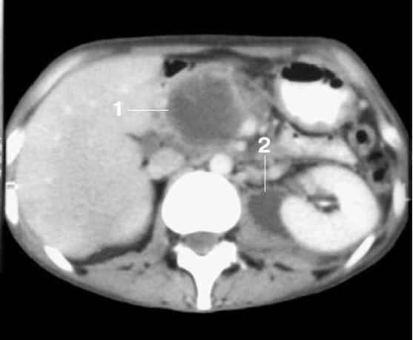

Fig. 2-8. US- and MRI- pictures of lesser sac and retroperitoneal collections

A 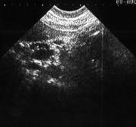 B 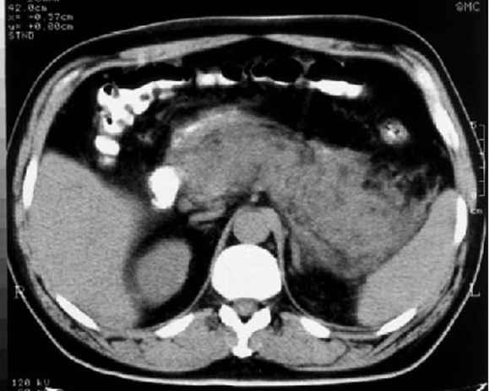

Fig. 2-9. US- and CT- pictures of infected pancreatic necrosis

CT and MRI

- CT scan of the pancreas may also be helpful. It provides higher resolution than ultrasonography, and it is not limited by the masking effect of intestinal gas (see Fig. 2-7-b, 2-8-b, 2-9-b).
- The criteria for CT findings are similar to those described for ultrasound.
- Magnetic resonance pancreatograms and cholangiograms are very useful for delineating anatomy before surgery. They can provide excellent detail of the pancreatic tissue and bile ducts, including stones in СВD that may produce biliary pancreatitis (see Chaper 10).

ERCP

- The use of endoscopic retrograde cholangiopancreatography (ERCP) in the first 5 days of severe acute pancreatitis is dangerous and is associated with an increased mortality rate.
- In early period of acute pancreatitis ERCP is indicated if biliary pancreatitis associated with CBD stone and mechanical jaundice with progressive course is present (e.g. impacted stone in papilla of Vateri) (see Chaper 10). Endoscopic sphincterotomy for extraction of stones may be performed then.

Table 2-4. Ranson's prognostic criteria for acute pancreatitis (morbidity and mortality rates correlate with the number of criteria present: 0-2 = 2% mortality; 3-4 = 15% mortality; 5-6 = 40% mortality; 7-8 = 100% mortality)

Present on admission

Age > 55 years
White blood cell count > 16,000/μL
Blood glucose > 200 mg/dL
Serum lactate dehydrogenase > 350 I.U./L
SGOT (AST) > 250 I.U./dL

Developing during first 48 hours

Hematocrit fall > 10%
Blood urea nitrogen increase > 8 mg/dL
Serum Ca²⁺ < 8 mg/dL
Arterial PO₂ < 60 mmHg
Base deficit < 4 mEq/L
Estimated fluid sequestration > 600 mL

From: Principles of surgery/ed., S.I. Schwartz, et al. – 7th ed.

Treatment of acute pancreatitis and its early complications

- The goal of surgical treatment of pancreatic necrosis is to allow the sequestration of pancreatic tissue to occur as completely as possible in order to remove more sequesters while laparotomy. Thus, if no early life-threatening complications are present (such as suppurative peritonitis, large abscess of lesser sac, large acute pseudocyst with further complications, and retroperitoneal phlegmone), there is no evidence for biliary pancreatitis and this diagnosis is quite certain, the sequestrectomy (see Fig. 2-10) should be delayed to 2 – 4 weeks from the onset of a disease.

Scheme 2-8. Algorithm of management of mild and severe acute pancreatitis

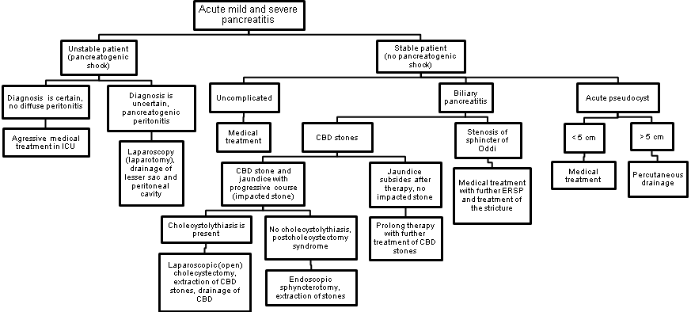

Scheme 2-9. Algorithm of management of pancreatic necrosis and its early complications

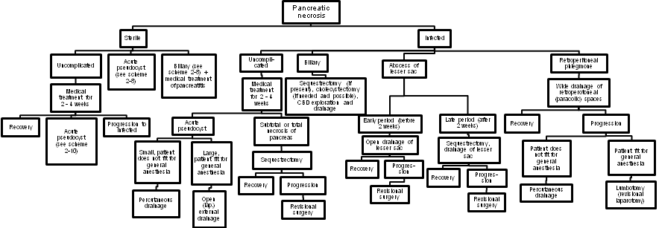

1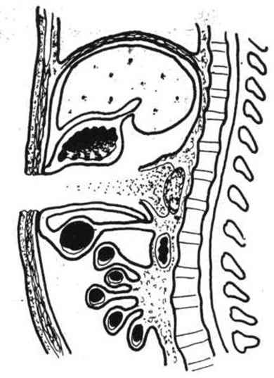 2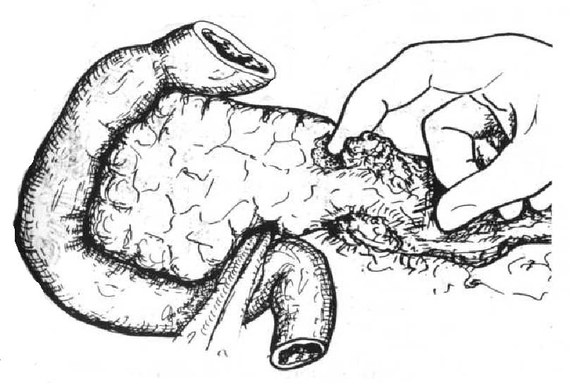 3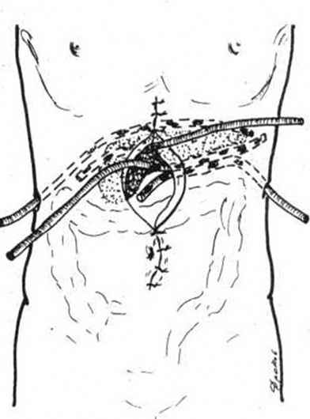

Fig. 2-10. Sequestrectomy, drainage of lesser sac and retroperitoneal space and laparostomy

Medical treatment of pancreatitis

- Nasogastric suction is used to control nausea and vomiting, decrease pancreatic stimulation, and decrease gastrointestinal distention from an ileus.
- Withhold oral feedings until laboratory test results return to normal, and pain is gone for 48 hours. In severe cases total parenteral nutrition (TPN) or enteral feeding via jejunostomy (endoscopiс percutaneous jejunostomy) may be benficial.
- Intravenous fluids are used to replace the third-space fluid loss. Crystalloid solutions are usually adequate.
- Antagonists of somatostatine and inhibitors of proteases are highly effective in early stages of pancreatitis.
- Broad-spectrum antibiotics are used in severe cases of sterile pancreatic necrosis, in infected pancreatic necrosis and in biliary pancreatitis. The early use of antibiotics is thought to promote the maturation of peripancreatic fluid collections into pseudocysts rather than abscesses.
- Blockers of H₂-hystamine receptors and proton pump inhibitors (PPIs) are also beneficial.

Late complications of pancreatic necrosis

Table 2-5. Complications of pancreatic necrosis

Early (within first 2-4 weeks)

Pancreatogenic shock
Acute renal failure
Adult respiratory distress syndrome
Miocardial depression
Pancreatogenic peritonitis
Acute pseudocyst
Abscess of pancreas
Abscess of lesser sac
Retroperitoneal phlegmone
Dynamic ileus
Acute hemorrhagic gastritis
Cholangitis

Late (within 1 – 3 months)

Intra-abdominal abscesses
Diffuse suppurative peritonitis
Pleuritis, empyema, pneumonia
Pseudocyst
Uncomplicated
Compression of CBD with jaundice
Compression of stomach or duodenum
with obstruction
Infected (with suppuration)
Bleeding
Ruptured
Arrosive bleeding
Fistula formation
Biliary
Duodenal
Colonic
Sepsis
Splenic vein thrombosis, splenic infarction
Acute acalculous (enzymatic) cholecystitis

Distant

Diabetes mellitus (III type)
Pancreatic fistula
Pancreatic insufficiency
Abdominal adhesions
Stenosis of sphincter of Oddi
Pancreatogenic ascites
Chronic sepsis

Pancreatic pseudocyst

- The pseudocyst begins as a lesser sac collection and is not lined by epithelium and consists only of the inflammatory response of the neighboring organs (stomach, duodenum, colon, and transverse mesocolon). Maturation of the pseudocyst takes 4-8 weeks.
- During the maturation phase, the patient recovers from a bout of pancreatitis but develops a persistent elevation of amylase, a low-grade fever, a minimally elevated white blood cell count, and chronic pain.
- Pseudocysts are usually diagnosed by ultrasound or CT scan.
- The goal is to allow the maturation phase to continue until the walls of the pseudocyst have matured. External drainage (see Fig. 2-11) is used if the pseudocyst is not found to be mature and if suturing of the pseudocyst wall is not safe. The external drainage results in a pancreatic fistula. Thus, if a pseudocyst is matured it’s better to drain in internally: cystojejunostomy (see Fig. 2-12) is a procedure of choise but cystogastrostomy or cystoduodenostomy may also be used if technical convenient.
- Novel approach, although currently without distinct indications, is endoscopic cystogastrostomy (see Fig. 2-13). Probably, it is indicated for small mature pseudocysts and in high risk of common anaesthesia.
- Small pseudocysts may resolve with medical treatment (see Scheme 2-10).

Scheme 2-10. Algorithm of management of pancreatic pseudocyst

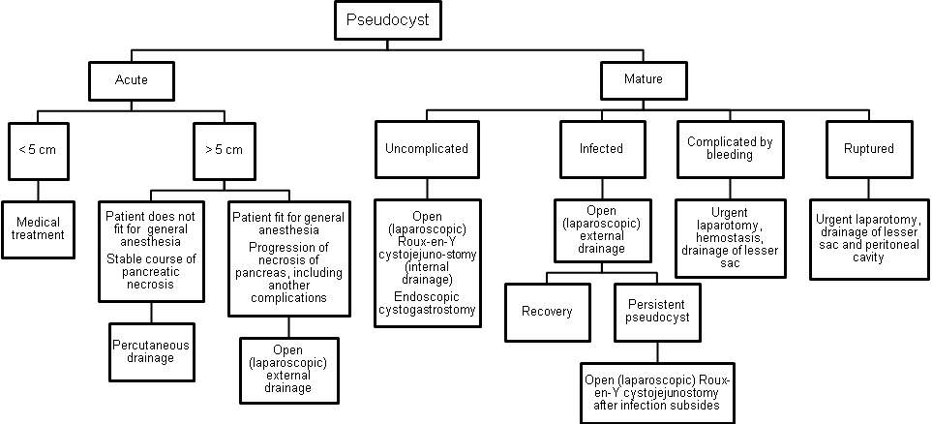
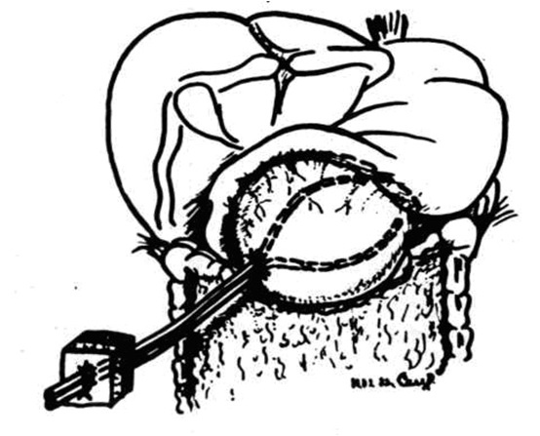

Fig. 2-11. External drainage of pseudocyst

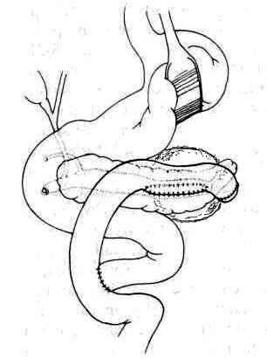

Fig. 2-12. Roux-en-Y cystojejunostomy (internal drainage of pseudocyst)

1 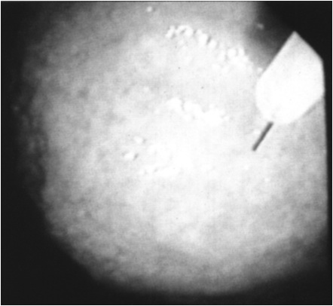 2 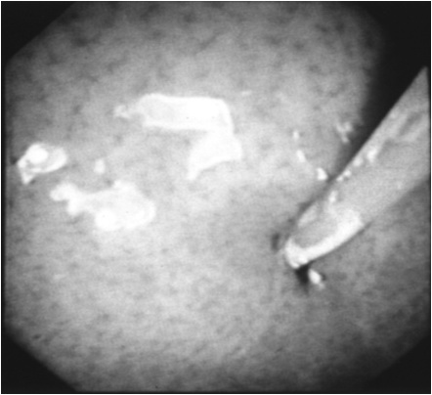

Fig. 2-13. Endoscopic cystogastrostomy

Scheme 2-11. Potential progression of lesser sac collections and surgical treatment

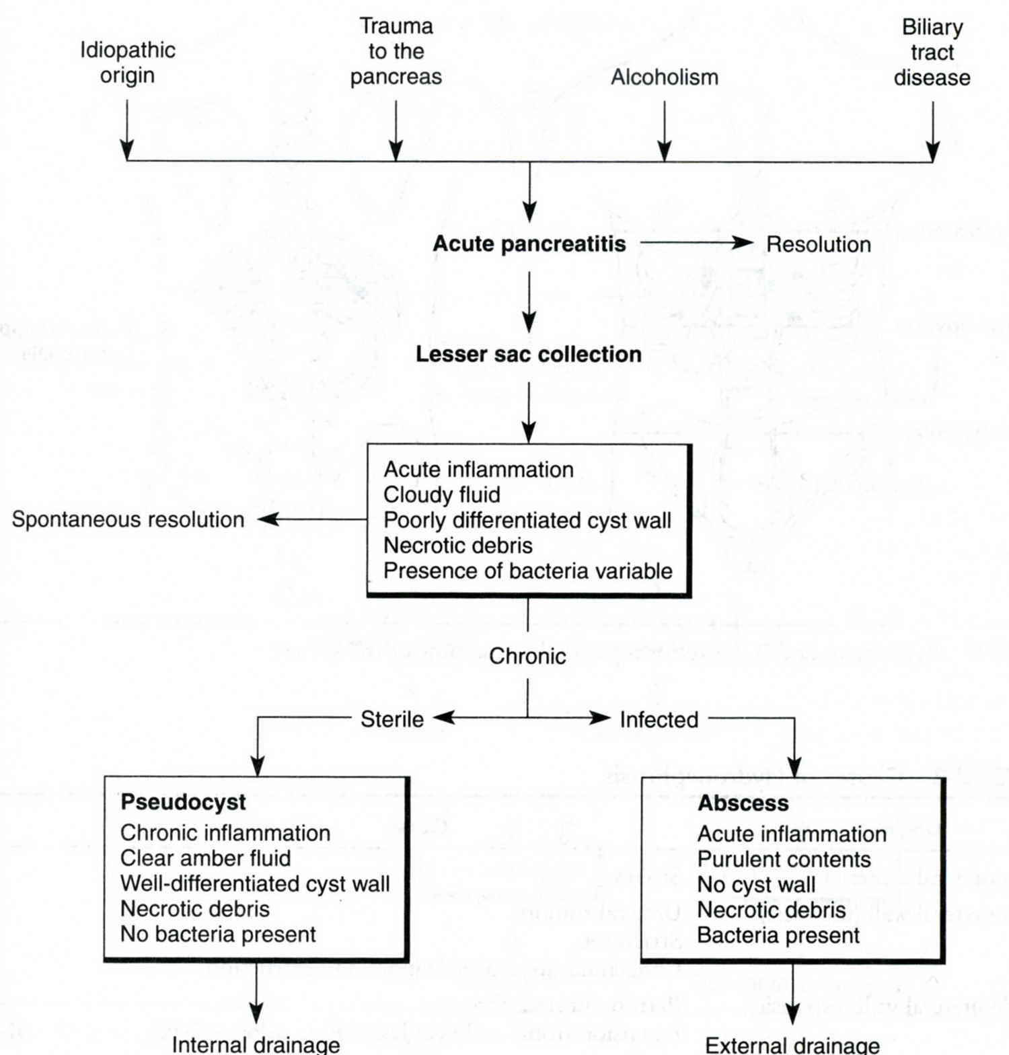
From: Basic surgery/ed., H.C. Polk, Jr., et al. – 5th ed.

Arrosive bleeding

- Arrosive bleeding usually occurs from splenic and pancreatoduodenal artery and their branches and may be massive and frequently fatal.
- Passage of fresh blood out of drains and features of acute blood loss are characteristic clinical presentation.
- In this circumstances previously performed laparostomy allowes to tamponade lesser sac and control bleeding. If there is no laparostomy, urgent relaparotomy with ligation of bleeding vessel is indicated.

Fistulas

- Fistula formation due to enzymatic lysis of tissues of CBD, duodenum and transverse colon along with its mesenterix may lead to biliary, duodenal and colonic fistulas respectively.
- Small fistulas, particularly colonic, heal spontaneously.
- Surgery for large fistulas commonly performed when the necrotic process in pancreatic tissue subsides. Large biliary fistulas require CBD drainage by T-tube or recontructive biliary-digestive anastomosis. Large duodenal fistulas may require antrumectomy. Large colonic fistulas are treated by proximal end colostomy.

Pancreatic fistulas

- Pancreatic fistulas are common sequella of external drainage of pseudocyst or abscess of lesser sac.
- If fistula doesn’t heal spontaneously after 6 months, it requires surgical treatment – an anastomosis between fistula and stomach.
- Spontaneous healing of pancreatic fistula may be accelerated by using high dosages of octreotide and topical application of ethylic alcohol.

MESENTERIC THROMBOSIS

- Mesenteric vascular disease may present as an acute life-threatening emergency or as a chronic debilitating problem.

Acute mesenteric ischemia

- Acute mesenteric ischemia is a surgical emergency with 80% mortality rate.
- Etiology includes embolization (usually to the superior mesenteric artery), thrombosis of visceral arteries (sudden occlusion of preexisting atherosclerotic lesions), and nonocclusive mesenteric ischemia (cardiogenic shock, patients following cardiopulmonary bypass and, high doses of intravenous vasoconstrictors and inotropes).

Clinical features

- The classic presentation of acute mesenteric ischemia is a sudden onset of acute abdominal pain in an elderly patient with a history of cardiac disease, such as atrial fibrillation and congestive heart failure (heart is a common source and emboli).
- These patients usually present with severe diffuse abdominal pain out of proportion to the physical findings and a history of gut emptying, usually a massive bowel movement with or without vomiting.
- Patients with mesenteric thrombosis have preexisting symptoms of weight loss and pain with eating.
- Signs of partial bowel obstruction and bloody stools are frequently present.

Diagnosis

- Salvage of these patients depends on a high index of suspicion and prompt diagnosis and treatment.
- An angiogram can be both diagnostic and therapeutic.

Treatment

- If an embolus is found, the treatment is prompt surgical embolectomy.
- If mesenteric thrombosis is found, the treatment is vascular reconstruction, which usually is a bypass to the superior mesenteric artery.
- The angiographic catheter may be left in place for direct intra-arterial infusion of a vasodilator.
- Following embolectomy or reconstruction, the bowel is assessed for viability. Overtly necrotic bowel is resected.
- A "second look" operation should be done in 24 hours to ensure viability of the residual bowel.
- If the original angiogram reveals nonocclusive mesenteric ischemia, treatment is directed toward improving cardiac function. Hydration and, if necessary, inotropic therapy are begun. The angiographic catheter is left in place, and vasodilating drugs can be infused into the mesenteric circulation after hydration has been accomplished. A repeat angiogram is done in 24 hours to assess the success of treatment. These patients may require laparotomy if peritoneal signs are present.

Scheme 2-12. Algorithm of management of acute mesenteric ischemia
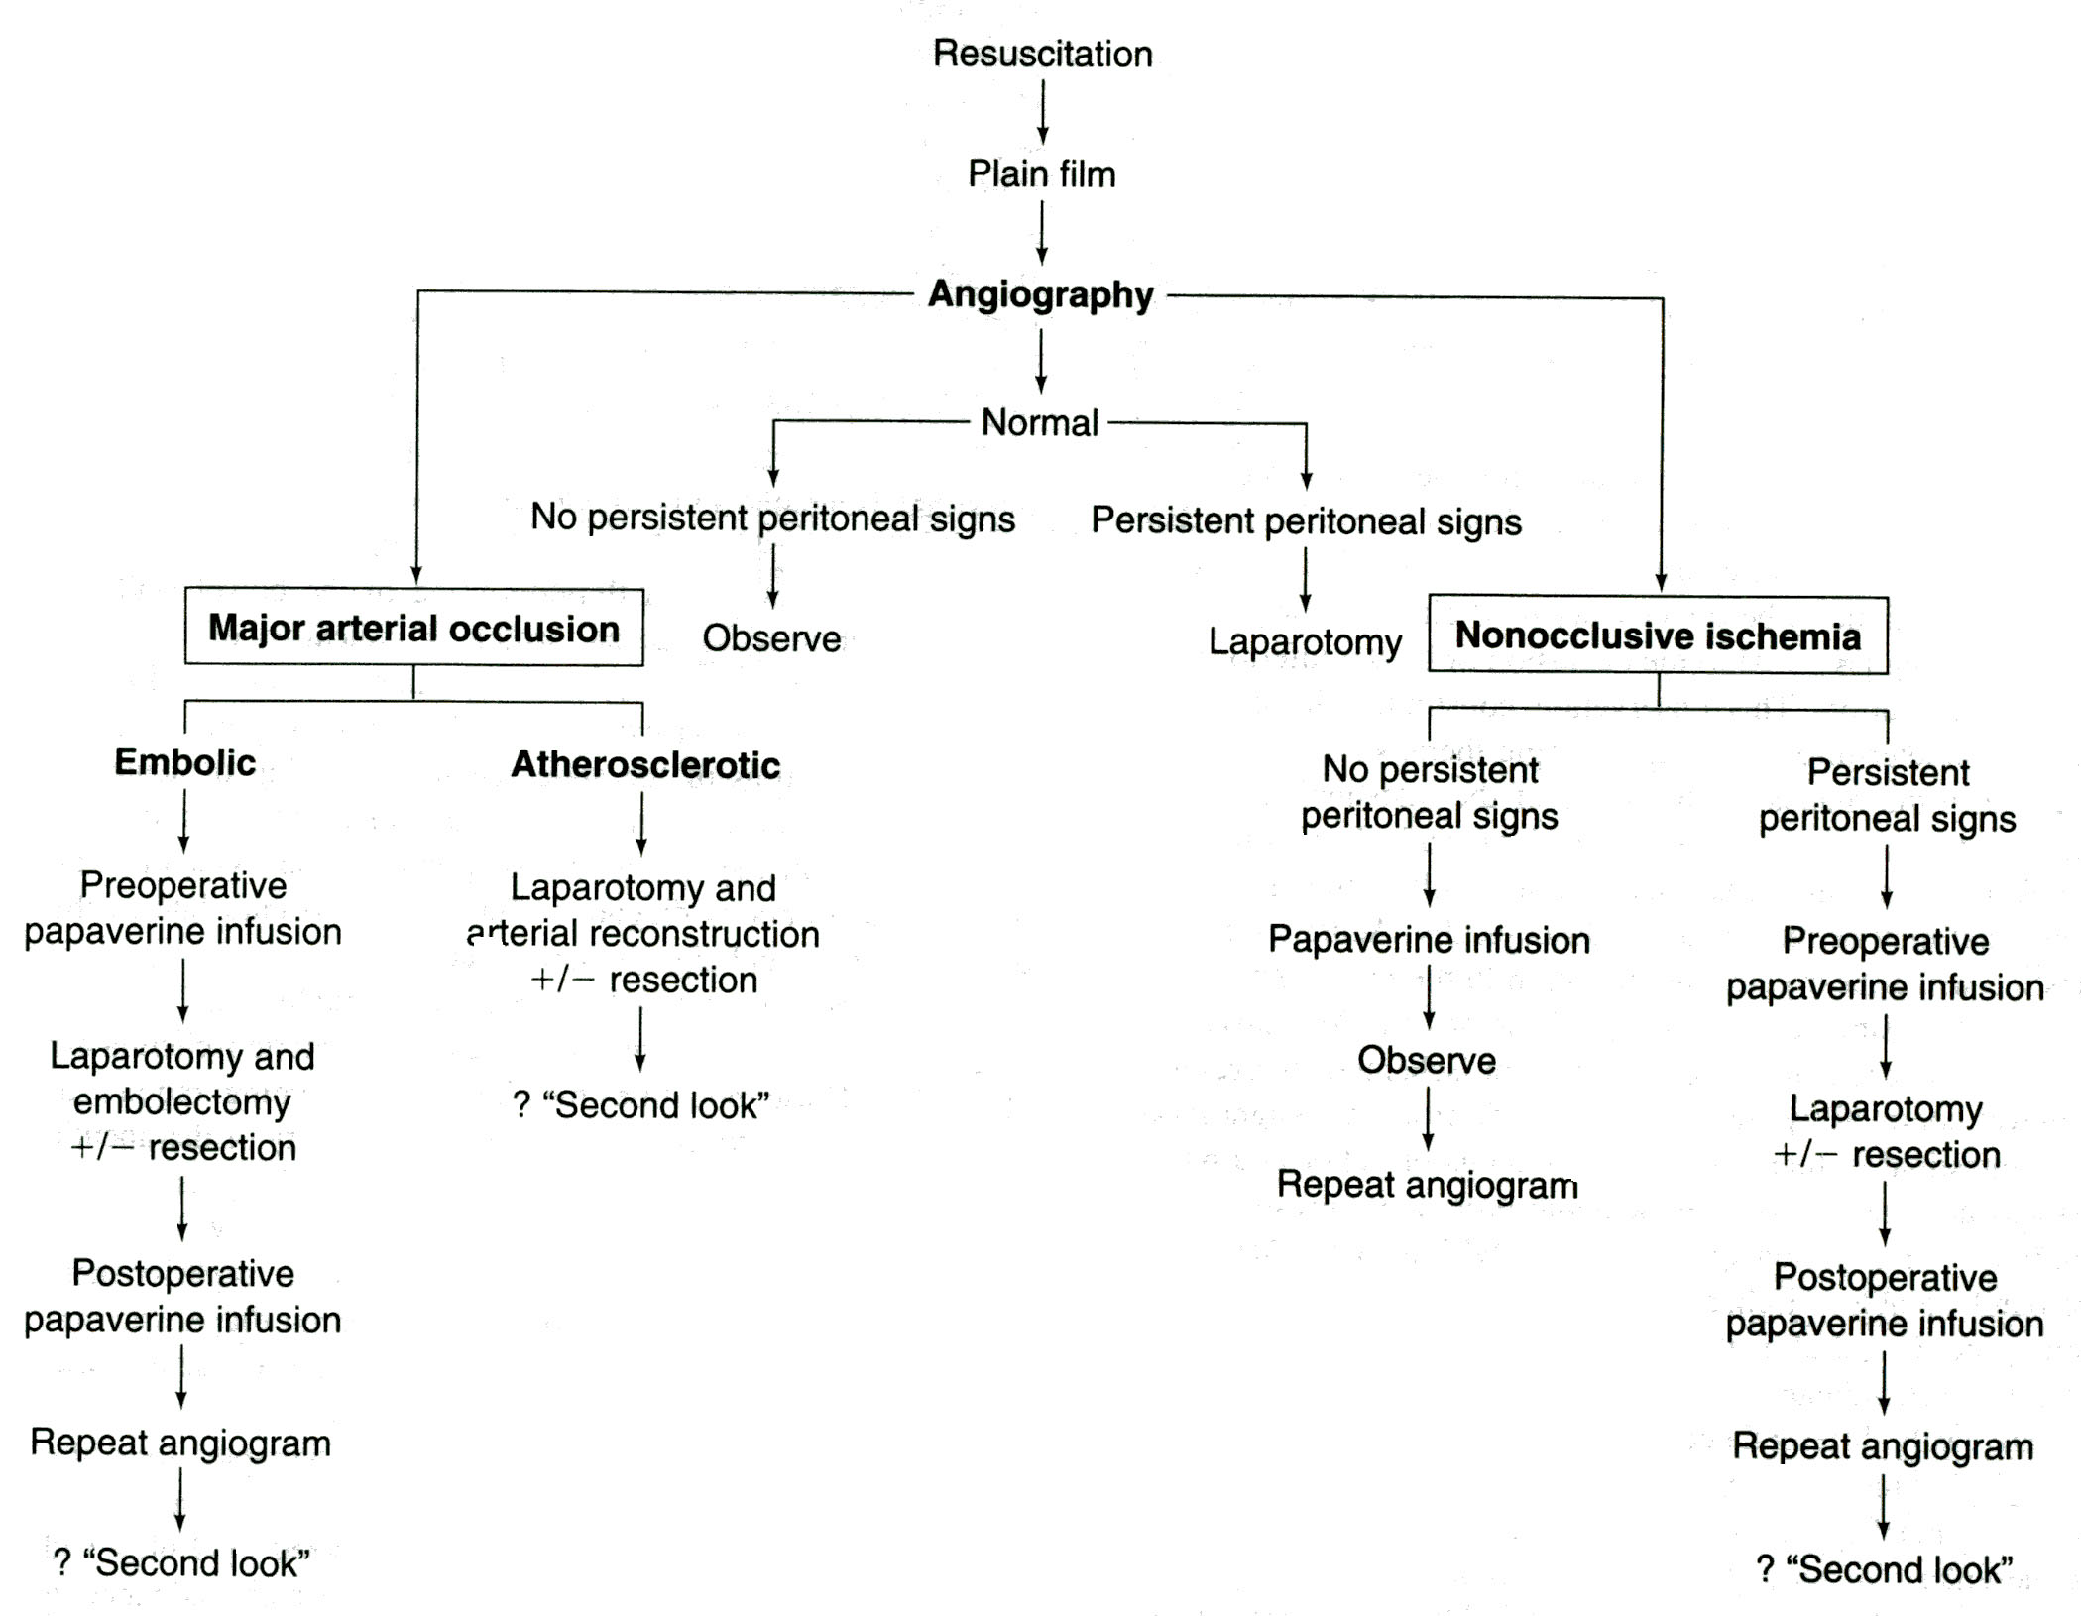
From: Principles of surgery/ed., S.I. Schwartz, et al. – 7th ed.

Chronic mesenteric ischemia

- Chronic mesenteric ischemia results from slowly progressive stenosis or occlusion of the visceral vessels (i.e., celiac, superior mesenteric artery, and inferior mesenteric artery).

Clinical features

- Abdominal pain following a meal, leading to "food fear" and weight loss.
- Slight diffuse abdominal tenderness may be present.
- An epigastric bruit may be audible.

Diagnosis

- Duplex scanning of the visceral vessels has been used to screen patients
with suspected chronic mesenteric ischemia.
- Arteriography is the most useful diagnostic study.

Treatment

- If appropriate lesions are found, operation is recommended.
- Bypass from a healthy aorta to the visceral vessels (see Fig. 2-14) or endarterectomy (see Chapter 16) of the involved visceral vessels is the preferred treatment.

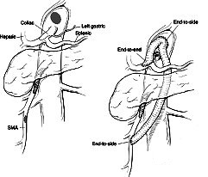

Fig. 2-14. Scheme of aorto-mesenteric bypass

Review tests

1. A 75-years-old man was admitted to ER with complaints of intense diffuse abdominal pain, multiple vomiting and abdominal distension. He is ill for 4 days. Arterial pressure is 80/40 mmHg, pulse is weak, 120 beats per minute, central arterial pressure is negative, last 24 hours urine output is 300 ml. Physical examination of abdomen reveals muscle quarding, severe tenderness, and rebound tenderness at all the sites. What’s the most appropriate tactics of managing the patient?

A. Immediate surgery - laparotomy
B. Immediate surgery – diagnostic peritoneal lavage
C. Delayed surgery – laparotomy – after preoperative preparation for 2 days
D. Delayed surgery – laparotomy – after preoperative preparation for 2-4 hours
E. Delayed surgery – laparotomy – after preoperative preparation for 20-24 hours

2. A 48-years-old woman was admitted to ER 2 weeks after appendectomy for gangrenous appendicitis, with complaints of moderate pain at hypogastric region of abdomen irradiating into the rectum and febrile temperature. The symptoms appeared 3 days ago. Physical examination of abdomen reveals slight muscle spasm at hypogastric region, no tenderness. Postoperative scar is free of inflammation. Ultrasound reveals a fluid collection 7 сm in diameter. What’s the most appropriate tactics of managing the patient?

A. Conservative treatment with antibiotics
B. Percutaneous drainage of the collection
C. Transrectal drainage of the collection
D. Conservative treatment with physiotherapy
E. Lower midline laparotomy and open drainage of the collection

3. A 50-years-old man was admitted to ER 1 week after discharge from a hospital: he underwent laparoscopic cholecystectomy for gangrenous cholecystitis. Currently he complains of moderate pain at right subcostal region of abdomen irradiating into the right shoulder, hiccups and febrile temperature. The symptoms appeared 4 days ago. Physical examination of abdomen reveals slight muscle spasm, moderate tenderness, and no rebound tenderness at right subcostal region. Ultrasound revealed a fluid collection under the right dome of the diaphragm. What’s the most appropriate tactics of managing the patient?

A. Upper midline laparotomy and open drainage of the collection
B. Percutaneous drainage of the collection
C. Laparoscopic drainage of the collection
D. Laparotomy by oblique subcostal incision and open drainage of the collection
E. Conservative treatment with antibiotics

4. A 40-years-old man was admitted to ER with complaints of an intense constant pain at epigastric region irradiating to the back, and multiple vomiting. The symptoms appeared the last morning, after a party the day before. Physical examination of abdomen reveals intense tenderness in both upper quadrants, no rebound tenderness, and slight muscle guarding at the epigastric region. Serum amylase is elevated threefold than normal. Upright abdominal radiography shows increased bowel gas pattern. What’s the most appropriate tactics of managing the patient?

A. Upper midline laparotomy, exploration of lesser sac, drainage of lesser sac
B. Percutaneous drainage of the lesser sac
C. Laparoscopic exploration of lesser sac, drainage of lesser sac
D. Conservative treatment with steroids and non-steroidal anti-inflammatory drugs
E. Conservative treatment with antispasmodics, antagonists of somatostatine and proton pump inhibitors

5. A 47-years-old man has being treated conservatively in the surgical department for 18 days for acute pancreatitis. Currently he complains of moderate pain at epigastric region of abdomen irradiating into the back, weakness, and febrile temperature for the last 4 days. Physical examination of abdomen reveals slight muscle spasm in epigastric region where a tender mass is palpated, and no rebound tenderness. CT scan shows enlarged pancreas, irregular borders of the organ and several cavities within it, and small peripancreatic fluid collections. There is leukocytosis of 20000/ml and left shift of leukogram. What’s the most appropriate tactics of managing the patient?

A. Upper midline laparotomy, exploration of abdominal cavity, drainage of subhepatic space
B. Upper midline laparotomy, exploration of lesser sac and pancreas, drainage of lesser sac
C. Upper midline laparotomy, exploration of lesser sac and pancreas, pancreatic necrectomy, laparostomy, drainage of lesser sac and abdominal cavity
D. Percutaneous drainage of the lesser sac
E. Prolong conservative treatment with combination of broad-spectrum antibiotics, switch to reserve antibiotics

6. A 50-years-old woman was admitted to ER with complaints of an intense constant pain at epigastric region irradiating to the back, jaundice, subfebrile to febrile temperature, and multiple vomiting. The symptoms appeared the last morning, after a party the day before. She experienced the same attacks previously, for the last 3 years. Physical examination of abdomen reveals intense tenderness in both upper quadrants, no rebound tenderness, and slight muscle guarding at the epigastric region. Serum amylase and bilirubin are elevated twofold than normal. Upright abdominal radiography reveals increased bowel gas pattern. Ultrasound reveals calculi in the gallbladder and common bile duct measuring 12 mm. What’s the most appropriate tactics of managing the patient?

A. Laparotomy, cholecystectomy
B. Laparotomy, cholecystectomy, exploration of common bile duct, lesser sac and pancreas, drainage of lesser sac and abdominal cavity
C. Laparotomy, exploration and drainage of common bile duct
D. Laparotomy, cholecystectomy, exploration and drainage of common bile duct
E. Percutaneous cholecystostomy under US guidance

7. A 55-years-old woman underwent laparoscopic cholecystectomy for chronic calculous cholecystitis 5 years ago. She was admitted to ER with complaints of an intense constant pain at epigastric region irradiating to the back, jaundice, subfebrile temperature, and multiple vomiting. The symptoms appeared the 2 days ago, after an ingestion of fatty food. The same attack took place 1 year ago. Physical examination of abdomen reveals moderate tenderness at right subcostal region and epigastric region, no rebound tenderness and muscle guarding. Serum amylase and bilirubin are elevated threefold than normal. Upright abdominal radiography reveals increased bowel gas pattern. Ultrasound reveals common bile duct measuring 18 mm. Endoscopy shows enlarged hyperemic papilla of Vater. What’s the most appropriate tactics of managing the patient?

A. Endoscopic shincterotomy, retrograde cholangiopancreatography
B. Laparotomy, exploration of common bile duct, drainage of common bile duct
C. Laparoscopic exploration of common bile duct, drainage of common bile duct
D. Endoscopic retrograde stenting of common bile duct
E. Percutaneous cholangiostomy under US guidance, cholangiography

8. A 50-years-old man is recovering from an episode of acute pancreatitis. Two weeks later he complains of persistent epigastric pain. Ultrasound reveals a 4 cm cystic structure situated in the lesser sac posterior to the stomach. What’s the most appropriate tactics of managing the patient?

- Laprotomy, external drainage
- Laprotomy, cystogastrostomy
- Laprotomy, cystojejunostomy
- Percutaneous external drainage under US guidance
- Medical treatment

9. Seven weeks after an attack of acute pancreatitis, the above-mentioned 50-years-old man is still complaining of epigastric pain and the repeat ultrasound shows a thick-walled cyst arising from the corpus of the pancreas and measuring 10 cm in diameter. What’s the most appropriate tactics of managing the patient?

- Laprotomy, external drainage
- Laparotomy, resection of pancreas along with the cyst
- Laparotomy, cystojejunostomy
- Percutaneous external drainage under US guidance
- Medical treatment

10. A 65-years-old woman with a long history of atrial fibrillation was admitted to ER with a history of sudden onset of severe, constant abdominal pain. After the onset of pain, she vomited once and had a large bowel movement. No flatus has been passed since that time. Physical examination reveals a mildly distended abdomen, which is diffusely tender, although peritoneal signs (rebound tenderness and muscle guarding) are absent. Ten years ago, she underwent an abdominal hysterectomy. Give your presumable diagnosis:

- Acute cholecystitis
- Perforated duodenal ulcer
- Acute diverticulitis
- Acute embolic mesenteric ischemia
- Small bowel obstruction secondary to adhesions

Correct answers: 1 - D, 2 - C, 3 - B, 4 - E, 5 - C, 6 - D, 7 - A, 8 - E, 9 - C, 10 - D.

