CHAPTER 3. PAIN IN RIGHT LOWER QUADRANT OF ABDOMEN

- Pain in right lower quadrant of abdomen most commonly is caused by acute appendicitis, gastroenteritis, mesenteric adenitis, Meckel’s diverticulitis, various gynecologic conditions, some forms of bowel obstruction and other diseases listed above (see Chapter 1).

ACUTE APPENDICITIS

Overview

- Incidence of acute appendicitis is approximately 50 cases of 100000 persons.
- It is one of the most common surgical abdominal pathology and one of the most difficult diagnosis (up to 16 % patients have normal appendix in exploration (68 % of these - females) and only 55 % patients have typical clinical presentation).
- Mortality in complicated cases (by diffuse peritonitis) may spread up to 50 %.

Table 3-1. Classification of acute appendicitis

Morphological stages

Catarrhal
Phlegmonous
Gangrenous
Perforated

Complications

Periappendicular mass
Appendicular abscess
In right iliac fossa
Pelvic
Subhepatic
Abscesses between loops of intestine
Peritonitis
Pylephlebitis
Sepsis
Fecal fistula
Wound infection

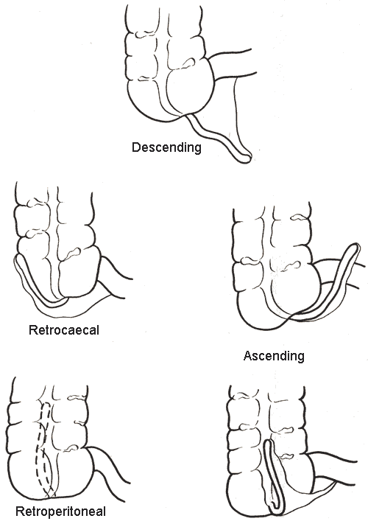

Fig. 3-1. Positions of vermiform appendix

Uncomplicated appendicitis

Clinical features and laboratory data
- Anorexia followed by diffuse (epigastric or paraumbilical) pain with further pain shift to right lower quadrant (Kocher’s sign) is the most characteristic complaint.
- Nausea, single or repeated vomiting is possible.
- In retrocaecal or retroperitoneal position of vermiform appendix: dysuria and flank pain may be present.
- Fever most commonly is subfebrile.
- Local tenderness with rebound tenderness and muscle guarding is the most characteristic sign.
- Special signs are: Razdolskyy’s – percussion tenderness in right iliac region, Sytkovskyy’s – increase of pain while lying on left side, Bartomue-Mechelson’s – palpation in right iliac region is more tender while lying on left side than lying supine, Obraztzov’s – deep palpation in right iliac region is tender while rising straight right leg, Rovsing’s – pain in right iliac region while powerful pushing the left iliac region, Voskresenskyy’s – increased skin sensitivity in right iliac region.
- Moderate leukocytosis (not mandatory in 10 – 30 % patients) and left shift of leukogram is present.
- In retrocaecal and pelvic appendix position: leukocyteuria and microhematuria are possible.

Visualization data

- Plane film may reveal fecaliths (indirect feature) and intestinal pneumatosis (nonspecific).
- Ultrasound may reveal enlargement (diameter > 6 mm) and incompressability of appendix, and pericaecal fluid or mass.
- Laparoscopy is the most accurate method which may be curative.

During pregnancy

- Local pain and tenderness are located laterally and superiorly.
- Rebound tenderness and muscle guarding may be absent or weak.
- Leukocytosis is above normal pregnancy count (15000 – 20000 / ml).

Differential diagnosis
Table 3-2. List of diseases to be differentiated with acute appendicitis

More likely in infants and children of both genders  Acute mesenteric adenitis  Viral gastroenteritis  Intussusception  More likely in girls  Primary pneumococcal peritonitis  More likely in boys  Torsion of testis (torsion of spermatic cord)  More likely in adults females  Pelvic inflammatory diseases: salpingitis (adnexitis), tubal or tuboovarian abscess  Endometritis  Ruptured Graafian follicle (mittelschmertz, ovarian apoplexy)  Ovarian cyst (uncomplicated, twisted, ruptured, with hemorrhage)  Endometriosis  Ruptured ectopic pregnancy  Ovarian tumor (uncomplicated, twisted, with hemorrhage)  Myomatous nodus with necrosis  More likely in adults males  Acute orchitis  Acute epidydimitis  Acute seminal vesiculitis  More likely in adults of both genders  Intestinal pathology:  Acute nonspecific gastroenteritis  Salmonella gastroenteritis  Acute regional enteritis  Fecal impaction  Bowel obstruction (volvulus, adhesive obstruction)  Diverticulitis or perforation of diverticula (Meckel’s, colonic diverticula)  Caecal carcinoma (uncomplicated and perforated), carcinoid of appendix  Epiploic appendagitis  Yersiniosis (incl. pseudotuberculosis)  Typhoid fever | Upper GI and biliary tract pathology:  Perforated peptic ulcer  Acute cholecystitis  Acute pancreatitis  Urinary tract pathology:  Acute pyelonephritis  Paranephritis  Renal or ureteric colic  Vascular abdominal pathology:  Mesenteric vascular occlusion (ischemia, thrombosis/embolism)  Dissecting aneurism of abdominal aorta  Pulmonary pathology:  Basilar pneumonia  Pleuritis  Metabolic/endocrine disorders:  Diabetes mellitus  Abdominal porphyria  Uremia  Addisonian crisis  Tuberculosis:  Tuberculous peritonitis  TB osteomyelitis of spine with psoas abscess  Distal ileum tuberculosis  Blood pathology:  Leukemia  Thrombocytopenic purpura  Sickle cell crisis  Rheumatic pathology:  Henoch-Schönlein purpura  Neurologic/spine pathology:  Spinal neuralgia (osteochondrosis, metastatic)  Herpes Zoster  Other pathology:  Intramuscular haematoma of abdominal wall  Lead poisoning

Surgical treatment

Scheme 3-1. Surgical tactics in acute appendicitis

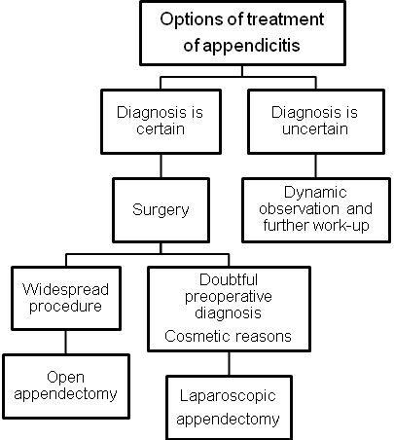

- Figures 3-1, 3-2 show the scheme of open and laparoscopic appendectomy.
- Drainage after appendectomy: for catarrhal is not required; for phlegmonous – tubular drain via the stab wound into right iliac fossa; for gangrenous and perforated – Penrose drain via laparotomy wound into right iliac fossa, and tubular drain via the stab wound into pelvic space.

1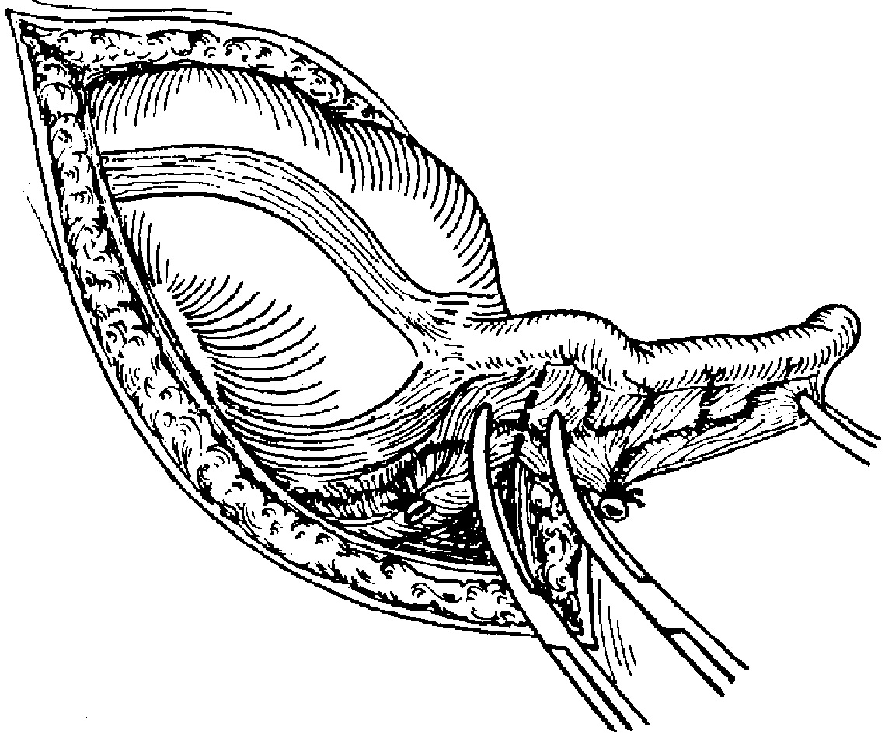 2 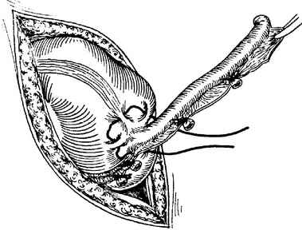 3 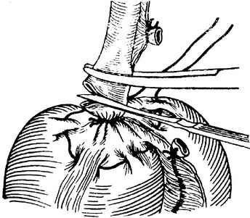

4 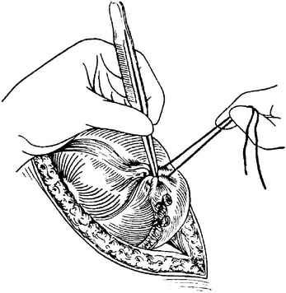 5 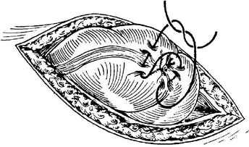

Fig. 3-2. Technique of open appendectomy

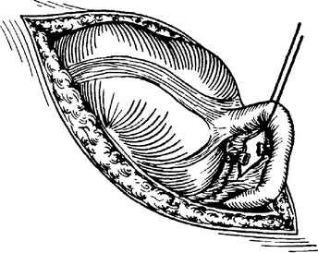

Fig. 3-3. Technique of retrograde appendectomy

Appendicular abscess

Clinical features and laboratory data

- Pain in right lower quadrant (or other region depending on abscess location) is characteristic.
- Chills, fatigue, febrile or hyperpyrexic fever, tachycardia and hypotension are always present.
- Flatulence, constipation or signs of complete intestinal obstruction may be present.
- In pelvic location: perineal pain, painful dejection, and tenesmus are possible.
- Subhepatic abscess may be complicated by right pleuritis.
- Palpable mass (excl. pelvic or multiple intraperitoneal abscesses) with local tenderness, possible rebound tenderness and muscle guarding.
- In pelvic location: digital rectal examination reveals painful bulging.
- Marked leukocytosis or hyperleukocytosis and left shift of leukogram is detected.

Visualization data

- Plane film may reveal fecaliths, “basket” sign, and intestinal pneumatosis.
- Ultrasound and CT scan show signs of abscess: rounded or irregular-shaped lesion with thick capsule and cavity filled by the heterogenous fluid (see Fig. 2-2).

Surgical treatment

Scheme 3-2. Surgical tactics in appendicular abscess

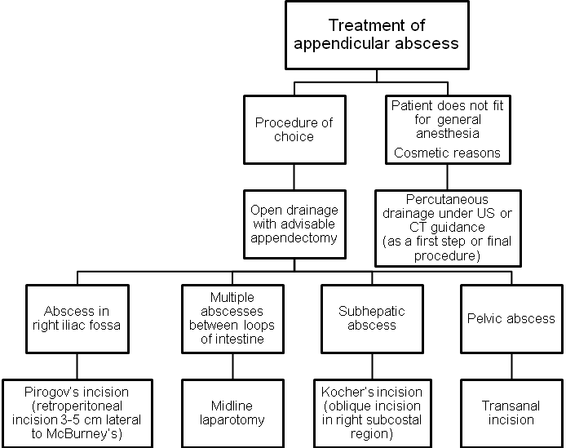

Appendicular mass

Clinical features and laboratory data

- Pain in right lower quadrant (or other regions depending on mass location) is characteristic.
- Flatulence, constipation or signs of complete intestinal obstruction may be present.
- Patients have subfebrile fever or normal body temperature.
- A mass is palpated (excluding pelvic mass). Local tenderness, and rebound tenderness may be detected.
- Moderate leukocytosis and left shift of leukogram is present.
Visualization data

- Ultrasound and CT scan show irregular-shaped dense mass without cavity.
- Appendicular mass should be differentiated with carcinoma of caecum, especially in elder patients if other signs of malignancy are present (using CT, colonoscopy and barium enema).

Treatment

Scheme 3-3. Surgical tactics in appendicular mass
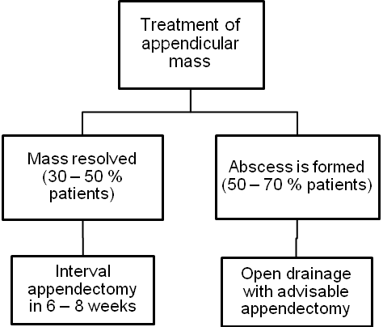
Conservative therapy regimen

- In-patient treatment.
- Antibiotics (double-therapy): cefalosporins of III generation or semisynthetic penicillins + metronidazole.
- Nonsteriodal anti-inflammatory drugs.
- The therapy continues till the mass resolves (approximately 7 – 10 days).

REVIEW TESTS

1. A 40-years-old woman was admitted to ER with complaints of a cramping pain at right lower quadrant of abdomen irradiating to perineum, fever of 38 °C and single vomiting. There is no diarrhea and constipation. Physical examination of abdomen reveals moderate tenderness in right iliac region and right flank, no rebound tenderness and muscle guarding. Give your presumable diagnosis:

A. Acute appendicitis
B. Acute gastroenteritis
C. Renal colic
D. Acute salpingitis
E. Bowel obstruction

2. A 27-years-old woman was admitted to ER with complaints of a constant pain at right lower quadrant of abdomen without irradiation, subfebrile fever and small amount of muddy vaginal discharges. There is no diarrhea and constipation. Physical examination of abdomen reveals moderate tenderness in right iliac region and pubic region, slight rebound tenderness and no muscle guarding. Menstruation was 20 days ago. Give your presumable diagnosis:

A. Acute appendicitis
B. Ruptured ectopic pregnancy
C. Salpingitis
D. Cancer of cervix of uterus
E. Pelvic appendicular abscess

3. A 20-years-old man was admitted to ER with complaints of slight constant pain at right iliac region for the last 5 days. 7 days ago he had severe pain at right lower quadrant of abdomen which had diminished with time. Currently while physical examination, the smooth, slightly tender mass is palpated in right iliac region. Patient’s body temperature is subfebrile. There is no diarrhea and constipation. Ultrasound reveals a mass without cavity in the right iliac fossa that measures 7 cm in diameter. What’s the most appropriate tactics of managing the patient?

A. Lower midline laparotomy, appendectomy
B. Laparotomy by McBurney’s incision, appendectomy
C. Laparoscopic appendectomy
D. Case monitoring
E. Conservative treatment with antibiotics and non-steriodal anti-inflammatory drugs

4. A 20-years-old man was admitted to ER with complaints of moderate constant pain at right iliac region for the last 5 days, fatigue and fever of 38 °C. 7 days ago he had severe pain at right lower quadrant of abdomen which had deminished with time. Currently, the hard tender mass and moderate rebound tenderness in right iliac region is determined. There is no diarrhea and constipation. Ultrasound reveals a mass with a cavity (fluid collection) measuring 10 сm in diameter. What’s the most appropriate tactics of managing the patient?

- Conservative treatment by antibiotics
- Conservative treatment by physiotherapy
- Surgical treatment - drainage
- Case monitoring
- Conservative treatment with antibiotics and anti-inflammatory drugs

Correct answers: 1 - C, 2 - C, 3 - E, 4 - C.

