CHAPTER 4. PAIN IN RIGHT UPPER QUADRANT OF ABDOMEN

- Pain in right lower quadrant of abdomen most commonly is caused by acute cholecystitis and other complications of gallstone disease, tumors, abscesses and cysts of liver, peptic ulcer of duodenum including perforation, hepatomegaly of various origin, right renal colic, tumors of head of pancreas, and other diseases listed above (see Chapter 1).

CHOLELITHIASIS (GALLSTONE DISEASE)

Overview

- Gallstones form as a result of biliary solids precipitating out of the solution.
- Most stones (70%) are made up of cholesterol, bilirubin, and calcium with cholesterol as the major component.

Table 4-1. Classification of gallstone disease

Cholecystolithiasis (gallbladder stones)

Asymptomatic gallbladder stones
Biliary colic
Chronic colecystitis
Uncomplicated
Complicated
Biliary-digestive fistula
Gallstone ileus
Porcelain gallbladder
Acute cholecystitis
Catarrhal
Phlegmonous
Gangrenous
Perforated
Complicated:
Acute biliary pancreatitis
Paravesical mass
Paravesical abscess
Peritonitis
Cholangitis
Compression of CBD with
mechanical jaundice
Biliary-digestive fistula

Choledocholithiasis (CBD stones)

Uncomplicated
Complicated
Acute biliary pancreatitis
Mechanical jaundice
Cholangitis
Chronic
Acute
Serous
Purulent

Cholangiolithiasis
(intrahepatic biliary ducts stones)

Scheme 4-1. Main complications of gallstone disease

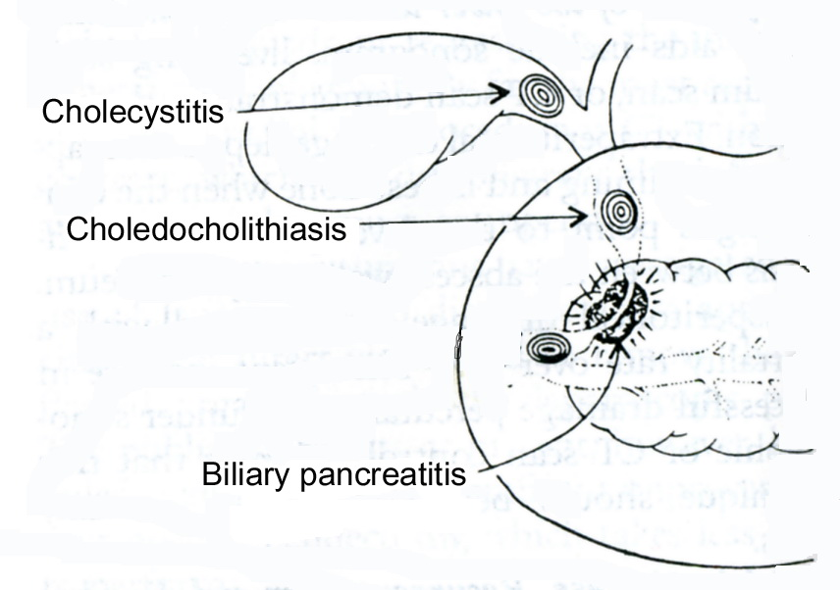
From: Basic surgery/ed., H.C. Polk, Jr., et al. – 5th ed.

Asymptomatic cholelithiasis

- The treatment of asymptomatic cholelithiasis is somewhat controversial. Each year, approximately 1-4% of patients with asymptomatic gallstones develop symptoms or complications of their disease. Most patients do develop symptoms before developing a severe complication of cholelithiasis (CBD stones, chronic pancreatitis, ect.).
- There is little evidence that prophylactic treatment is justified in the management of cholelithiasis, with the exception of calcified or porcelain gallbladder, which should be removed because the risk of malignancy exceeds 25%.

Chronic cholecystitis

Clinical features

- The patient complains of moderate intermittent pain in the right upper quadrant and epigastric region, nausea, and vomiting.
- The pain may radiate to the back or right scapular region.
- Symptoms may be associated with eating fatty foods.
- Laboratory studies are generally normal.

Diagnosis

- Ultrasonography reveals stones in the gallbladder (see Fig. 4-1).
- In a part of patients the gallstones may be detected using CT scan.

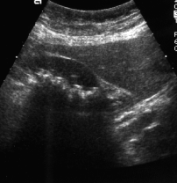

Fig. 4-1. US picture of chronic calculous cholecystitis

Treatment

- Treatment is elective laparoscopic (procedure of choice) (see Fig. 4-2) or open cholecystectomy (see Fig. 4-3). Approximately 95% of patients receiving surgery for cholecystitis secondary to cholelithiasis are completely relieved of their symptoms. Approximately 5% of patients retain mild symptoms that presumably are unrelated to the biliary tree (postcholecystectomy syndrome, see later).
- Nonoperative treatment (oral bile salts) may be appropriate for patients with small stones (up to 1 cm) and functioning gallbladders who are not operative candidates or who refuse surgery.

1 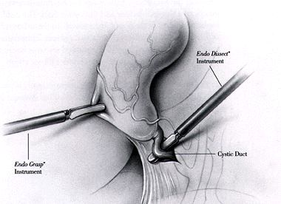2 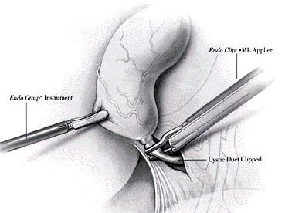 3 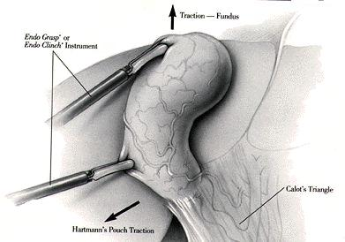

4 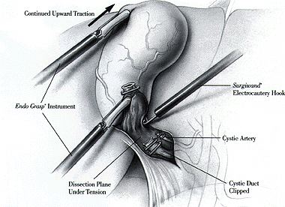 5 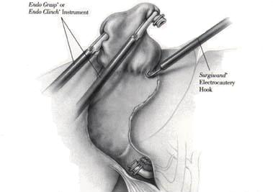

Fig. 4-2. Technique of laparoscopic cholecystectomy

1 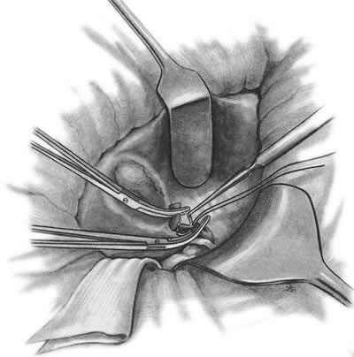 2 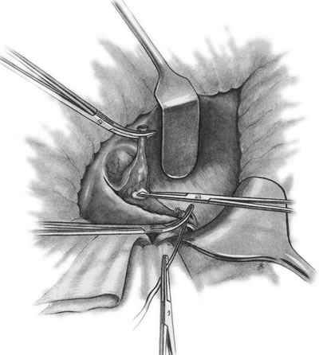 3 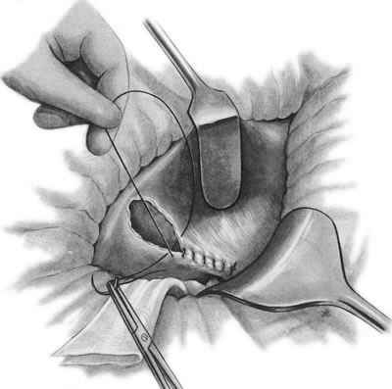

Fig. 4-3. Technique of open cholecystectomy

Acute cholecystitis

Scheme 4-2. Stages of acute cholecystitis

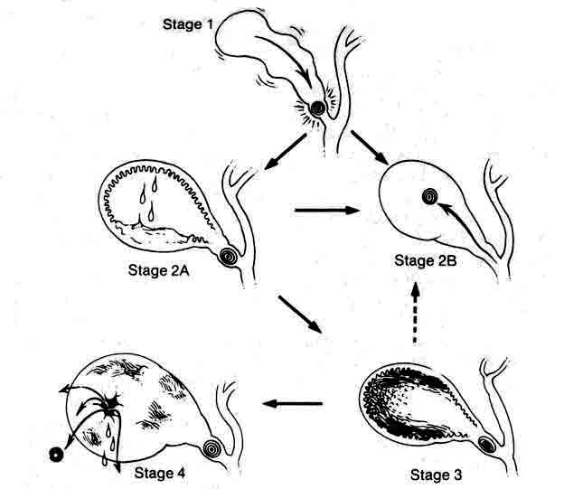
From: Basic surgery/ed., H.C. Polk, Jr., et al. – 5th ed.

Clinical features

- The greatest incidence of acute cholecystitis is in adults age 30-80; women are affected more often than men.
- Most patients give a history consistent with prior chronic cholecystitis except this episode is worse or lasts longer.
- Fever, nausea, and vomiting are characteristic symptoms.
- Right upper quadrant tenderness with or without rebound tenderness and Murphy's sign are common.
- The gallbladder may be palpable.

Laboratory data

- Normal to febrile fever (hyperpyrexic in paravesical abscess formation) is present.
- Slight to moderate leukocytosis and left shift of leukogram (hyper leukocytosis in paravesical abscess formation) is detectable.
- Levels of the following may be elevated in patients with acute cholecystitis although these are characteristic for СBD stones and acute pancreatitis: serum alkaline phosphatase in 23%, bilirubin in 45%, AST in 40%, amylase in 13%.

Diagnosis

- Ultrasonography reveals stones and enlarged gallbladder with thick walls.

Differential diagnosis

Table 4-2. List of diseases to be differentiated with acute cholecystitis

Hepatobilary pathology  Acute pancreatitis  Pancreatic pseudocyst  Cancer of head or body of pancreas  Hepatitis  Tumors of liver  Cysts of liver  Cancer of gallbladder  Urinary tract pathology  Acute pyelonephritis  Paranephritis  Renal or ureteric colic  Gastroduodenal pathology  Perforated or penetrating peptic ulcer  Hiatal hernia | Cardiac pathology  Myocardial infarction  Hepatomegaly due to congestive heart failure  Pericarditis  Pulmonary pathology  Right lower lobe pneumonia  Right pleuritis  Intestinal pathology  Acute appendicitis  Cancer of right flexure of colon  Neurologic/spine pathology  Spinal neuralgia (osteochondrosis, metastatic)  Herpes Zoster

Treatment

Scheme 4-3. Algorithm of management of acute cholecystitis
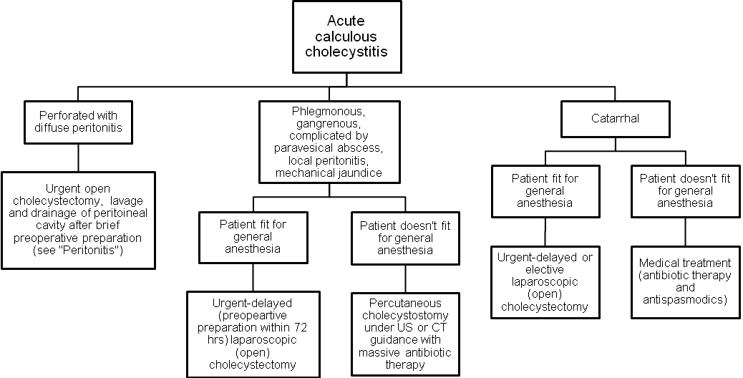
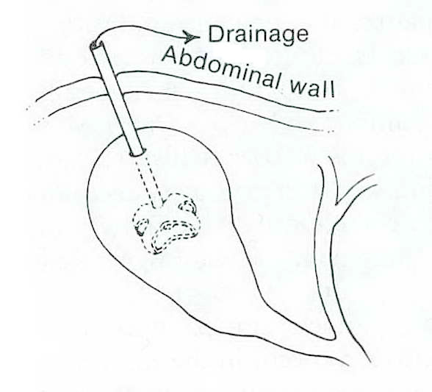
Fig. 4-4. Scheme of cholecystostomy

Acute acalculous cholecystitis

- Acute acalculous cholecystitis is acute or chronic cholecystitis in the absence of stones. Possible causes include: kinking or fibrosis of the gallbladder, thrombosis of the cystic artery, sphincter spasm with obstruction of the biliary and pancreatic ducts, prolonged fasting, dehydration, systemic disease, multiorgan failure associated with trauma, generalized sepsis.
- Treatment is cholecystectomy or percutaneous or laparoscopic cholecystostomy (see Fig. 4-4) if the patient is too ill to tolerate cholecystectomy.

Postcholecystectomy syndrome

- Postcholecystectomy syndrome is the term given to symptoms that develop after or persist despite cholecystectomy.

Table 4-3. Classification of postcholecystectomy syndrome

Biliary

Stone in the common bile duct
Uncomplicated
Complicated
Acute biliary pancreatitis
Acute relapsing pancreatitis
Mechanical jaundice
Cholangitis
Stone in the stump of the cystic duct
Stenosis of the sphincter of Oddi
Uncomplicated
Complicated
Acute biliary pancreatitis
Chronic relapsing pancreatitis
Mechanical jaundice
Cholangitis
Biliary stricture

Extrabiliary

Hiatal hernia
Peptic ulcer
Chronic pancreatitis
Irritable bowel syndrome
Food intolerance
Other gastroenterologic disorders

- Evaluation should be directed toward identifying these extrabiliary and biliary etiologies, and may include endoscopic retrograde cholangiopancreatography (ERCP) (see Chapter 10), magnetic resonance cholangiopancreatography (ERCP) (see Chapter 10) esophagogastroduodenoscopy, upper gastrointestinal series, ultrasound, and CT scan.

BENIGN TUMORS OF LIVER

- In women, oral contraceptive use has increased the incidence of benign primary liver tumors.

Hemangioma

Overview

- Grossly, there may be single or multiple masses, and microscopically, there are vascular lacunae lined with normal endothelial cells.

Clinical features and visualisation data

- Hemangioma, the most common benign hepatic tumor, is usually asymptomatic and is managed by observation.
- Usually, it is discovered as an incidental finding (i.e., calcification on abdominal radiograph or a characteristic mass on ultrasound (Fig. 4-5-a) with evidence of vasculature on duplex scan or CT scan with intravenous contrast (see Fig. 4-5-b)).
- The most accurate method, although invasive, is angiography (see Fig. 4-6)
- Hemangiomas can produce symptoms by compressing adjacent structures or by stretching the liver capsule.
- Percutaneous biopsy under ultrasound or CT guidance (fine needle aspiration, FNA) or biopsy taken laparoscopically confirms the diagnosis because the appearance of lesion (as any benign or malignant tumor of liver) may be very variable.

A 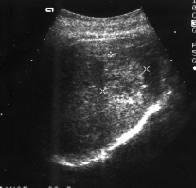 B 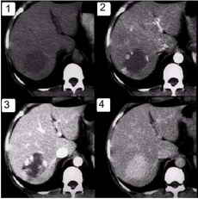

Fig. 4-5. US and CT pictures of hemangioma of liver

1 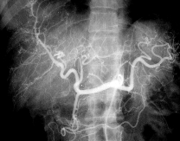 2 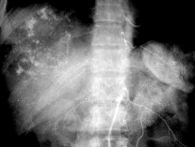

Fig. 4-6. Angiographic pictures of hemangioma of liver

Treatment

Scheme 4-4. Algorithm of management of hemangiomas of liver

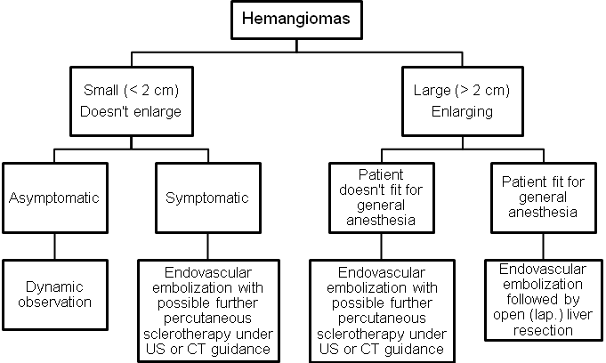

Hepatocellular adenoma

Overview

- Hepatocellular adenoma is an uncommon benign tumor usually seen in women and strongly associated with oral contraceptive use. It is also found in men and women who take anabolic (androgenic) steroids.
- Hepatocellular adenomas are soft tumors with sharply circumscribed edges but no true capsule. Histologically, normal hepatocytes are present, and there is no evidence of malignancy.

Clinical features

- There may be no symptoms or physical findings.
- Approximately 25% of patients have a palpable abdominal mass or abdominal pain.
- Up to 30% of patients present with spontaneous rupture and hemorrhage into the peritoneal cavity.

Visualisation data

- The tumor is usually suspected when a mass is seen on ultrasound or other seal of the liver.
- Angiography is useful because hypervascularity or arterial splaying is frequently present.
- FNA or operative biopsy confirms the diagnosis.

Treatment

- Oral contraceptives, anabolic steroids, and pregnancy should be avoided, and if the absence of these, the tumor frequently regresses. If the diagnosis is confirmed and the lesion is small, intrahepatic, and associated with oral contraceptive use it may be safely observed.
- Occasionally, if the tumor is exophytic on a narrow pedicle it can be easily excised (see Fig. 4-11) (laparoscopic technique is preferable).
- If the tumor is large and superficial or if a woman anticipates pregnancy in the near future, it should be resected because of the risk of spontaneous rupture and hemorrhage.
- In cases of spontaneous rupture with hemorrhage into the peritoneal cavity, the patient should initially be resuscitated. The recommended procedure is hepatic artery ligation. This frequently controls the bleeding and is associated with only minor aberrations in liver function when the liver is not cirrhotic. Hepatic resection in the presence of acute rupture has a high mortality rate. Elective resection should, however, be performed at a later date.
- If the patient is very unstable after rupture in spite of major resuscitative efforts, open packing or angiographic embolization of the hepatic artery may control the hemorrhage.
- The above described tactics may also be used for ruptured hemangiomas (see above).

Focal nodular hyperplasia

Overview

- Focal nodular hyperplasia is the third most common benign liver tumor. It occurs most often in women and has a weak association with oral contraceptive use.
- Single or multiple lesions with a nodular appearance externally and a central scar with radiating septa on cut section are seen. The tumors are composed of hyperplastic hepatocytes with inflammatory cells. Bile duct epithelium is a prominent finding in contrast to hepatocellular adenoma. Overall, the lesions resemble regenerating nodules of cirrhosis.

Clinical features

- Symptoms and physical findings, when they occur, are similar to those seen with hepatocellular adenoma; however, focal nodular hyperplasia is usually asymptomatic and discovered as an incidental finding.
- Spontaneous rupture is rare.

Diagnostics and treatment are similar to those for hepatocellular adenoma.

MALIGNANT TUMORS OF LIVER

Overview

- Primary malignant tumors of the liver account for 0.7% of all cancers.
- In men 90% of primary liver tumors are malignant; in women only about 40% are malignant.

TNM-classification

T - primary tumor
TX Primary tumor cannot be assessed
T0 No evidence of primary tumour
T1 Solitary tumor without vascular invasion
T2 Solitary tumor with vascular invasion or multiple tumours, none more than 5 cm in greatest
dimension
T3 Multiple tumors more than 5 cm or tumor involving a major branch of the portal or hepatic vein(s)
T4 Tumor(s) with direct invasion of adjacent organs other than the gallbladder or with perforation of
visceral peritoneum
N - regional lymph nodes
NX Regional lymph nodes cannot be assessed
N0 No regional lymph node metastasis
N1 Regional lymph node metastasis
M - distant metastasis
MX Distant metastasis cannot be assessed
M0 No distant metastasis
M1 Distant metastasis

Stage grouping

Stage I | T1 | N0 | M0
Stage II | T2 | N0 | M0
Stage IIIA | T3 | N0 | M0
Stage IIIB | T4 | N0 | M0
Stage IIIC | Any T | N1 | M0
Stage IV | Any T | Any N | M1

Hepatocellular carcinoma

Overview

- Hepatocellular carcinoma (hepatoma) is the most common primary malignant liver tumor.
- Incidence of hepatocellular carcinoma varies geographically, being highest in Africa and Asia and lowest in the Western world.
- Men are affected twice as often as women.
- The average age of affected individuals is 50 years, but hepatocellular carcinoma can occur at any age.
- Hepatocellular carcinoma occurs as a solitary mass or as multiple masses. Local invasion, especially into the diaphragm, is common, as are distant metastases
with the lung being most commonly involved (in up to 45% of cases).

Associations

- Chronic hepatitis B virus (HBV) infection (present in as many as 80% of cases worldwide). The risk of developing hepatocellular carcinoma is increased 200-fold for chronic HBV carriers. The risk in male carriers is as high as 50%. Hepatocellular carcinoma is also associated with chronic hepatitis C infection.
- Cirrhosis of the liver (present in approximately 60%-90% of patients), especially macronodular cirrhosis.
- Hemochromatosis with iron overload and cirrhosis.
- Schistosomiasis and other parasitic infestations.
- Environmental carcinogens: industrial substances, including polychlorinated biphenyls; chlorinated hydrocarbon solvents, such as carbon tetrachloride; nitrosamines; vinyl chloride and polyvinyl chloride; organochloride pesticides; organic materials, including anatoxins (produced by Aspergillus flaws or A. fumigatus and found on foods, such as peanuts).

Clinical features

- Hepatocellular carcinoma often presents as a dull aching pain in the right upper quadrant; malaise, fever, and jaundice may also be present.
- Physical examination reveals hepatomegaly (present in 88% of cases), weight loss (in 85%), a tender abdominal mass (in 50%), or findings associated with cirrhosis (60%).
- About 10%-15% of patients present with acute hemorrhage into the peritoneal cavity with resultant shock.
- Paraneoplastic syndromes also may occur in which tumor cells secrete hormone-like substances that cause unusual syndromes, such as Cushing's syndrome.

Laboratory and visualization data

- Liver function tests are usually abnormal, but there is no particular diagnostic pattern.
- Alpha-fetoprotein is elevated in 70%-90% of cases.
- Hepatic ultrasound, CT scan, angioportography, and MRI are the most reliable studies to determine the presence and operability of the lesions (see Fig. 4-7). These studies are positive in up to 90% of cases and can detect lesions as small as 1 cm in diameter. Appearance of lesions may be
- FNA (see Fig. 4-8) or biopsy taken laparoscopically confirms the diagnosis.

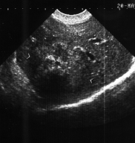

Fig. 4-7. US picture of hepatocellular carcinoma

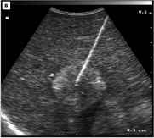

Fig. 4-8. US-guided FNA of hepatic tumor

Treatment

- The only treatment of solitary tumor is surgical resection (see Fig. 4-11). Hemihepatectomy may be used for multiple tumors located in one lobe of liver. Currently, due to introducing of endoscopic vascular staplers, powerful bipolar coagulators, harmonic scalpel, and laparoscopic argon plasma coagulator, these procedures may be performed laparoscopically.
- Chemotherapy (used for multiple masses) has been ineffective when given systemicaily, but administration of drugs into the hepatic artery has given some promising preliminary results.
- To increase the potential for resectability, high-risk individuals (e.g., those with chronic HBV) should be periodically screened by measuring alpha-fetoprotein.
- If lesions are resectable, the average survival is approximately 3 years; the 5-year survival rate is about 20%. The operative mortality rate is as high as 20% but can be nearly 60% in patients with coexistent cirrhosis. If lesions are unresectable, patients have a mean survival time of 4 months.

Cholangiocarcinoma

Overview

- Cholangiocarcinoma is a tumor that arises from the bile duct epithelium; it represents 5%-30% of all primary hepatic malignancies.
- Associated conditions include parasitic infections (e.g., Clonorchis sinensis), primary sclerosing cholangitis.
- A hard greyish mass is found that microscopically shows adenocarcinoma of the biliary epithelium. Metastasis occurs initially to the regional lymph nodes or to the liver.

Clinical features

- Signs and symptoms include right upper quadrant pain, jaundice, hepatomegaly, and occasionally a palpable mass.
- Patients are usually 60-70 years of age.

Diagnostics is similar to those for hepatocellular carcinoma.

Treatment

- Treatment of intrahepatic tumors is resection (see Fig. 4-11) when feasible.
- Overall survival is poor.

Angiosarcoma

Overview

- Angiosarcoma, or malignant hemangioendothelioma is a highly malignant liver tumor composed of irregular spindle cells lining the lumina of hepatic vascular spaces.
- Most cases (85%) occur in men, and there is a high association with chemical agents, especially vinyl chloride, arsenicals, and organochioride pesticides.

Clinical features

- Clinical presentation is similar to that for hepatocellular carcinoma.
- The tumor commonly spreads locally to the spleen (80% of cases) and distantly to the lungs (60% of cases).

Diagnostics is similar to those for described above malignant tumors.

Treatment

- Treatment is resection when feasible, but patients rarely survive 1 year.

Sarcomas other than angiosarcoma are rare but are highly malignant and frequently not curable.

Metastatic tumors of liver

Overview

- Metastatic tumors of the liver are much more common than primary tumors (ratio 20:1).
- The liver is the second most common site of metastasis (exceeded only by regional lymph nodes) for all primary cancers of the abdominal viscera. Over two-thirds of all colorectal cancers ultimately involve the liver, and up to 50% of cancers outside the abdomen metastasize to the liver. Fully one-third of all cancers ultimately spread to the liver, which is the most common site of hematogenous spread.

Clinical features and laboratory data

- Diagnosis may be difficult because liver metastases are often asymptomatic.
- In advanced cases they are mainly presented by jaundice and ascites.
- No single laboratory blood test could predict liver metastases in more than 65% of patients with subclinical disease. This percentage can only be raised by using imaging techniques. Testing for carcinoembryonic antigen has been valuable for predicting the presence of liver metastasis in colorectal cancer as it is positive in over 85% of patients with proven disease. Unfortunately, this test lacks specificity.

Visualization data

- CT scan and MRI are the most accurate imaging techniques, but they are expensive as a screening tests.
- Ultrasonography is almost as reliable as a CT scan, and it provides a reasonable screening test. The appearance of lesions may be quite different depending of the type of primary tumor and age of metastases. More often they are hypoechogenic or hypodensive lesions with regular borders (see Fig. 4-9, 4-10).
- Laparoscopic ultrasound is very beneficial for both diagnostics and staging of the malignant process (see Fig. 4-9-c).
- FNA or operative biopsy confirms the diagnosis.

A 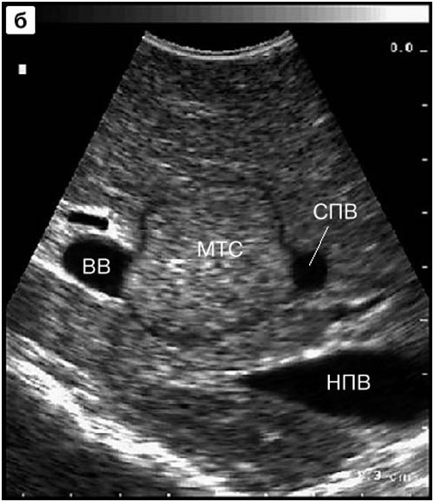 B 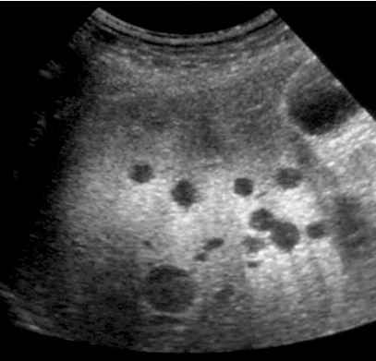 C 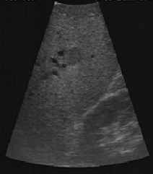

Fig. 4-9. Transabdominal (A,B) and laparoscopic (C) US picture of liver metastases

A 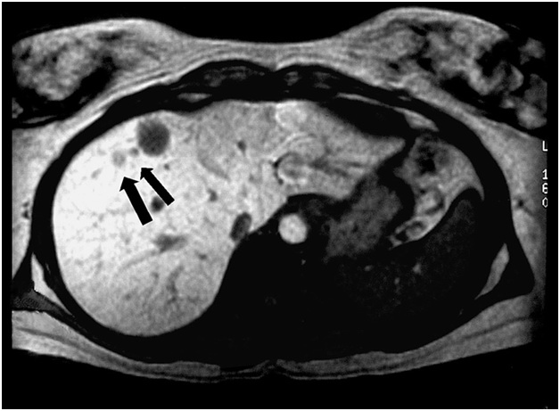 B 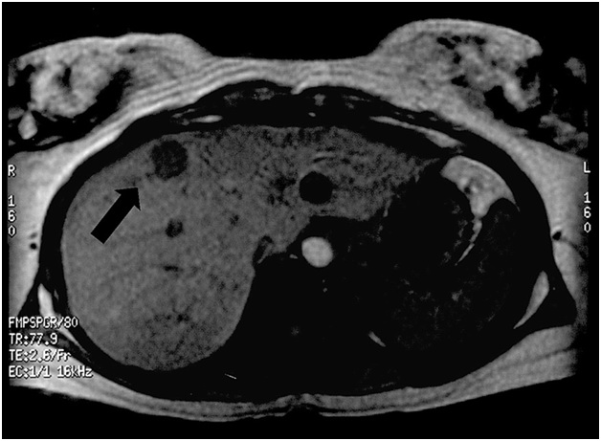

Fig. 4-10. CT picture of liver metastases

Treatment

- Treatment for metastatic disease to the liver depends on the type of primary tumor.
- Chemotherapy for liver metastasis from colorectal cancer has been disappointing.
- Radiation therapy is poorly tolerated by the liver but may be palliative for painful liver metastases.
- Various methods of percutaneous (ultrasound or CT-guided) or operative (open or laparoscopic) ablation of lesions located superficially and deeply in liver tissue, including criogenic destruction, lazer ablation, argon plasma ablation, radiofrequency ablation, ect. show contraversial benefits.
- Surgical resection (see Fig. 4-11) is the most effective mode of therapy but is limited to the few patients who have unilobar liver lesions and no evidence of extrahepatic disease. The incidence of liver metastasis at the time of surgery for primary colorectal cancer is 8%-25%, and approximately one-fourth of these lesions are solitary and resectable, so that about 5% of patients are potential resection candidates. The 5-year survival rate approaches 20%-30% in patients with these criteria. The operative mortality rate is less than 6%, an acceptable risk.
A 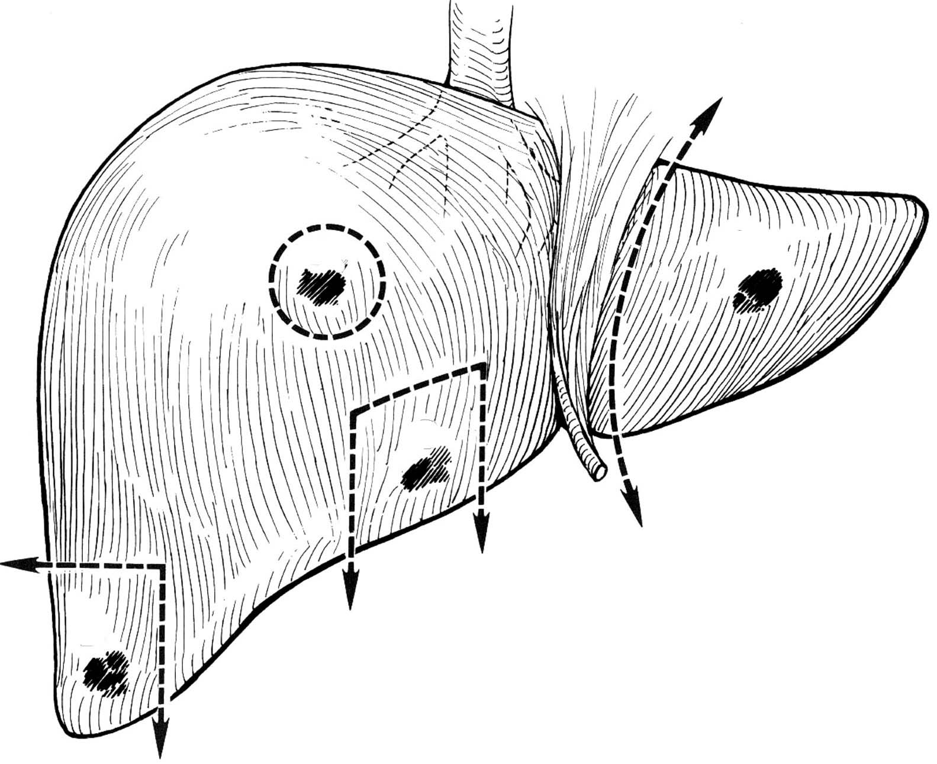 B 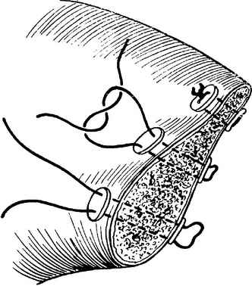 C 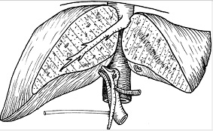 D 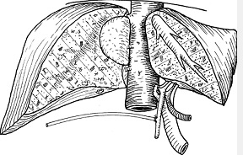

Fig. 4-11. Variants of liver resections

HEPATIC ABSCESSES AND CYSTS

Bacterial abscesses

Overview

- Bacterial abscesses are the most common hepatic abscesses in the Western world.
- These are most commonly secondary to infectious processes in the abdomen, particularly cholangitis, appendicitis, or diverticulitis. They may also result from seeding from a distant infectious source, such as endocarditis.
- In 10%-50% of cases, no source can be identified.
- The infecting organism is related to the primary source. When the source is abdominal, the most common organisms are gram-negative rods (especially Escherichia coli); anaerobes (typically a Bacteroides species); and anaerobic Streptococci (Enterococci), when the source is extra-abdominal, gram-positive organisms predominate.

Clinical features and laboratory data

- Clinical presentation includes sepsis, fever and chills, leukocytosis, and anemia.
- The patient may have right upper quadrant pain, and the liver may be tender or enlarged. Large abscesses may lead to the jaundice.
- On occasion, sepsis may be overwhelming.
- Hemobilia may also occur due to erosion of the abscess into the biliary tree.
- Liver function studies show elevated enzyme levels, particularly alkaline phosphatase.

Visualization data

- Ultrasound and CT scan reveal round-shaped cavity filled by heterogeneous fluid with irregular boards.
- Angiography and FNA may be helpful for differential diagnosis with tumors of liver.

Treatment

- The standard surgical treatment for hepatic abscess is surgical drainage (open and if possible - laparoscopic) and antibiotic therapy, which have good results.
- Hepatic abscesses also are well managed by percutaneous drainage, guided by ultrasound or CT imaging. This closed procedure may be curative, particularly for small abscesses with minimal accompanying necrotic debris and in patients with high risk of general anaesthesia.
- Multiple abscesses are difficult to manage and rely heavily on appropriate antibiotic coverage. It is important to determine the antibiotic sensitivity of the infecting organisms and to administer a full course of antibiotics to reduce the risk of recurrent or persistent infection.
- Mortality rate for hepatic abscess may be as high as 40% in difficult cases.

Amebic abscess

Overview

- Amebic abscess is the second most common hepatic abscess in the Western world and is more common than bacterial abscesses in third world countries.
- Amebic abscess is due to infection with the protozoan Entamoeba histolytica, which typically reaches the portal vein from intestinal amebiasis.

Clinical features

- Clinical presentation includes fever, leukocytosis, hepatomegaly, and right upper quadrant pain.
- The abscess is usually solitary and affects the right lobe of the liver in 90% of patients.
- The pus within the abscess is usually sterile and has the appearance of anchovy paste. Trophozoites are occasionally present in the periphery of the abscess.
- Complications include secondary bacterial infection of the cavity and rupture into adjacent structures, such as the pleural, pericardial, or peritoneal spaces.

Visualization data

- Ultrasound and CT scan reveal a cavity filled by heterogeneous fluid with irregular boards. The cavity may appear like honeycombs.
- Angiography and FNA may be helpful for differential diagnosis with tumors of liver.

Laboratory data

- Occasionally, liver enzyme levels are elevated.
- Indirect hemagglutination titers for Entamoeba are elevated in up to 85% of patients with intestinal infestation and in 98% of patients with hepatic abscess.

Treatment

- Treatment of choice is parenteral antibiotics, particularly metronidazole.
- The abscess is aspirated if it is large or adjacent to important structures, but surgical drainage is not usually necessary.

Hydatid cysts of the liver

Overview

- Hydatid cysts result from infection with the parasite Echinococcus granulosus. Dogs are the definitive host, shedding ova in the feces, which infect intermediate hosts, such as man, sheep, and cattle.
- This infection is endemic in Southern Europe, the Middle East, Australia, and South America – all areas where sheep are raised.
- Hydatid cysts can develop anywhere in the body, but two-thirds occur in the liver followed by lungs, kidneys and spleen (thus, if the hydatid cyst of liver is detected, the chest radiograph and abdominal ultrasound examination are necessary).
- The cyst and cyst lining contain parasites fully capable of spreading the infection. The adjacent compressed liver tissue and scar form the ectocyst, which is not infective and should be retained when evacuating the cyst.
- The most common complication of large cyst is suppuration which is cased by the death of the parasite.
- Hydatid cysts undergo progressive enlargement and may rupture. Cysts may rupture into bile ducts, where the debris can cause biliary obstruction. Cysts may rupture into the free peritoneal cavity, resulting in urticaria, eosinophilia, or anaphylactic shock, and with implantation into other viscera.
- Implantation within the peritoneal cavity and even abdominal wall may appear postoperatively when the surgical technology (while opening the cyst, isolation of operative field by pads moistened by hypertonic saline) was violated.
- About 30% of patients develop cysts in the lungs or other extrahepatic organs.

Clinical features and laboratory data

- Symptoms include liver enlargement and right upper quadrant pain in a patient with a history of exposure to an endemic area.
- The jaundice and ascites may appear when large cyst presents.
- Eosinophilia is present in 40% of patients, and serum tests for the parasite antigen are diagnostic.
- The suppuration is presented by severe abdominal pain, fever and other symptoms of sepsis. These cysts require more rapid term of surgical drainage then those for uncomplicated cases.

Visualization data

- In uncomplicated cases, ultrasound and CT scan reveal a cavity filled by homogeneous fluid with regular boards (see Fig. 4-12, 4-13).
- The characteristic sign of hydatid cyst (unlike solitary, i.e. nonparasytic, cysts) is the presence of well-differentiated capsule (see Fig. 4-14). Solitary cysts are usually located superficially within the liver and rarely suppurate.
- In the case of suppuration of hydatid cyst, ultrasound and CT scan show a cavity filled by heterogeneous fluid and debris, poor differentiation of the capsule, and irregular boards of the cyst (see Fig. 4-12-a).
- FNA with cytological study show elements of the parasite.

A 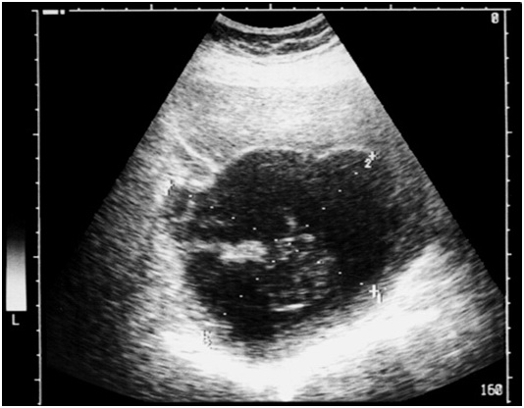 B 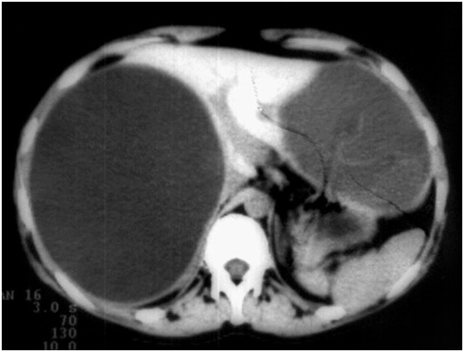

Fig. 4-12. US- and CT picture of hydatid cyst of liver

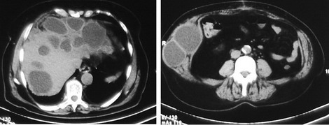

Fig. 4-13. CT picture of multiple recurrent hydatid cysts of liver, and abdominal wall (within drain channels)

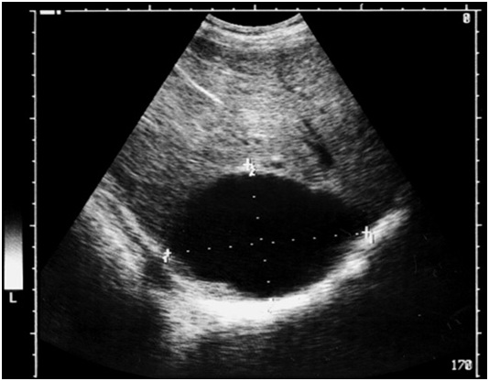

Fig. 4-14. US picture of solitary cyst of liver

Treatment

Scheme 4-5. Algorithm of management of hydatid cysts of liver

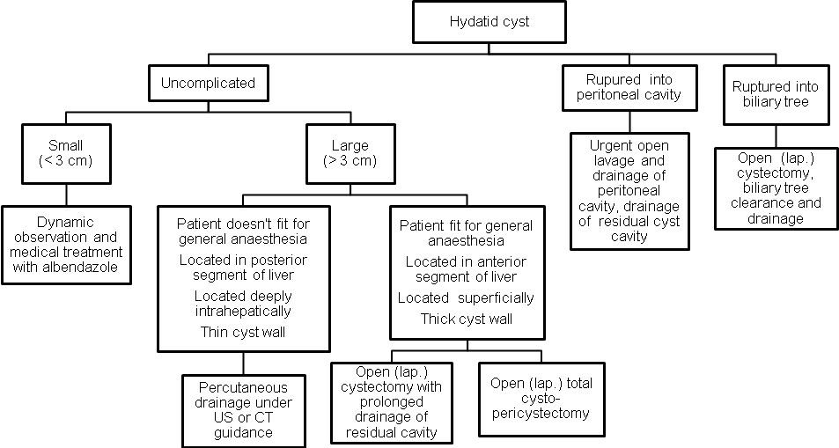

UNCOMPLICATED PEPTIC ULCER DISEASE

Diagram 4-1. Rough structure of etiology of duodenal ulcers

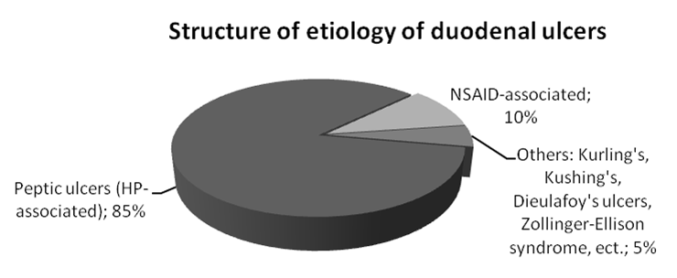

Diagram 4-2. Rough structure of etiology of gastric ulcers

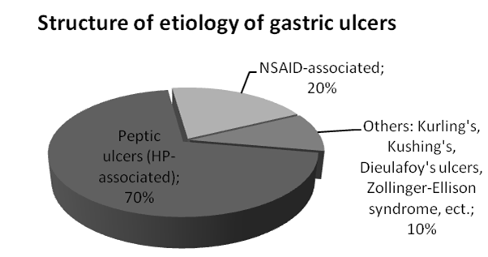

- Peptic ulcers may be found in duodenum or stomach.
- Duodenal ulcers are twice as common as gastric ulcers. Gastric ulcers are more common in men, in the elderly, and in lower socio-economic groups.
- The etiology of peptic ulcer and its treatment depend on its location. According to Johnson classification, there are 4 types of peptic ulcers: I type – ulcer of cardia, fundus, or body of stomach, II type – ulcer of stomach and duodenum, III type – ulcer of antral part of stomach and IV type – duodenal ulcer.

Duodenal ulcers

Overview

- Most duodenal ulcers are found in the first portion of the duodenum, as often on the posterior as the anterior wall.
- About 5% of duodenal ulcers are postbulbar, located in the more distal duodenum.
- Pyloric channel ulcers occur in duodenal mucosa and are treated like duodenal ulcers although they are anatomically located in the stomach. They frequently do not respond to medical therapy and often require surgery, largely because of the development of gastric outlet obstruction.
- Peptic ulceration occurs when imbalance develops between mucosal integrity and acid production.
- Most, though not all, duodenal ulcer patients experience acid hypersecretion. This condition may be related to an increased mass of acid-secreting cells which is strongly related chronic antral gastritis due to Helicobacter pylori infection. This gram-negative rod is found in the antrum of 95% of duodenal ulcer patients. Many patients without ulcer disease may have H. pylori, but eradication of this organism in patients with ulcers may be therapeutic. The parietal cells in duodenal ulcer patients are also more sensitive to gastrin secretion. The feedback inhibition of gastrin release by acid also may be impaired in these patients. Mucosal resistance may also be altered by H. pylori.

Clinical features, laboratory and visualization data

- History of epigastric pain that may radiate to the back is the usual presentation. The pain is relieved by food; however, the period of relief becomes shorter as symptoms progress. The pain typically wakes the patient at night.
- Upper gastrointestinal endoscopy is the major diagnostic tool that can reveal an ulcer lesion with edematous regular boards (see Fig. 4.15), and may be used for biopsy with subsequent histology and quick urease test for detecting H. pylori.
- Upper gastrointestinal radiographs may also be used to diagnose ulcer disease showing a niche in the wall of duodenum (see Fig. 4.16).
- Gastric secretion analysis may be used to provide data on acid output in planning for surgery.
- Serum gastrin levels are obtained in patients with recurrent ulceration after surgery, in those who fail to respond to medical management, and in those with suspected endocrine disorders, such as the Zollinger-Ellison syndrome (gastrinoma). Normal serum gastrin levels are less than 200 pg/ml.

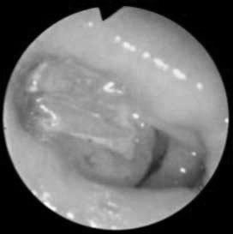

Fig. 4-15. Endoscopic picture of duodenal ulcer

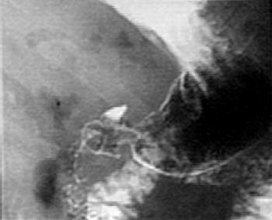

Fig. 4-16. Radiographic picture of duodenal ulcer

Treatment

- Surgical treatment is necessary for patients with frequent recurrences and complications.
- However, patients with high risk of common anaesthesia recurrent cases should be treated conservatively with individual schemes of medical therapy.

Scheme 4-6. Algorithm of management of uncomplicated duodenal ulcers

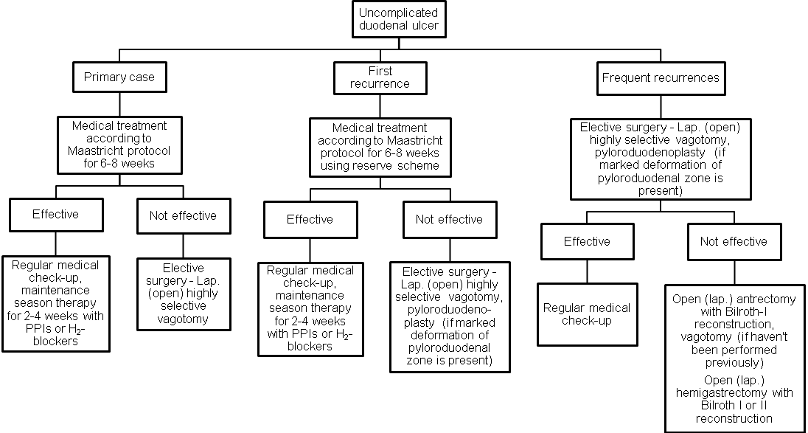
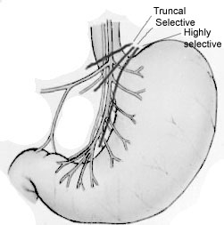

Fig. 4-17. Types of vagotomy

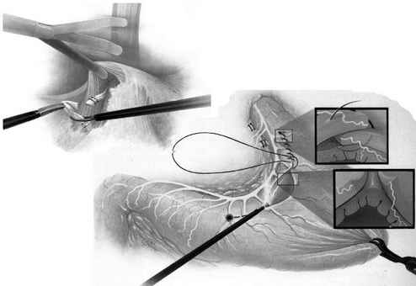

Fig. 4-18. Scheme of laparoscopic Taylor’s procedure - posterior truncal and anterior seromyotomy (the lattest is analoque of highly selective vagotomy) – the procedure of choice for treatment of uncomplicated duodenal ulcers

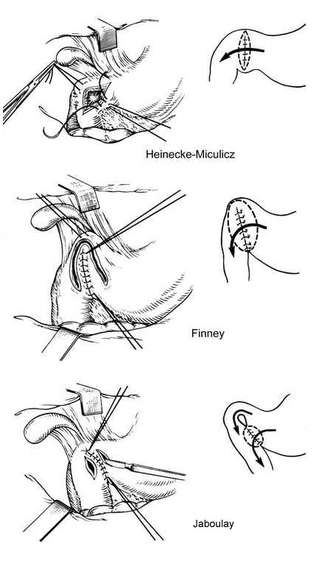
Fig. 4-19. Common types of pyloroduodenoplasty

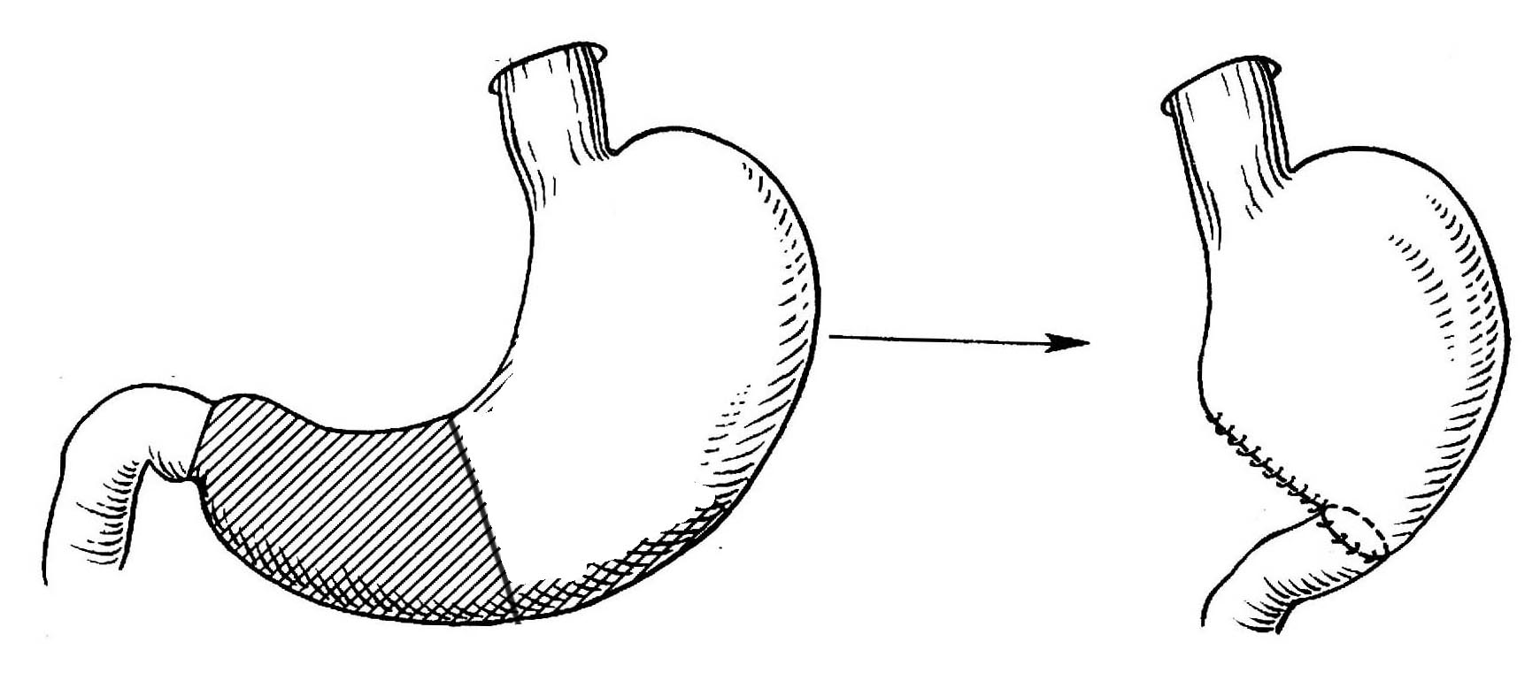

Fig. 4-20. Scheme of antrectomy with Billroth I reconstruction

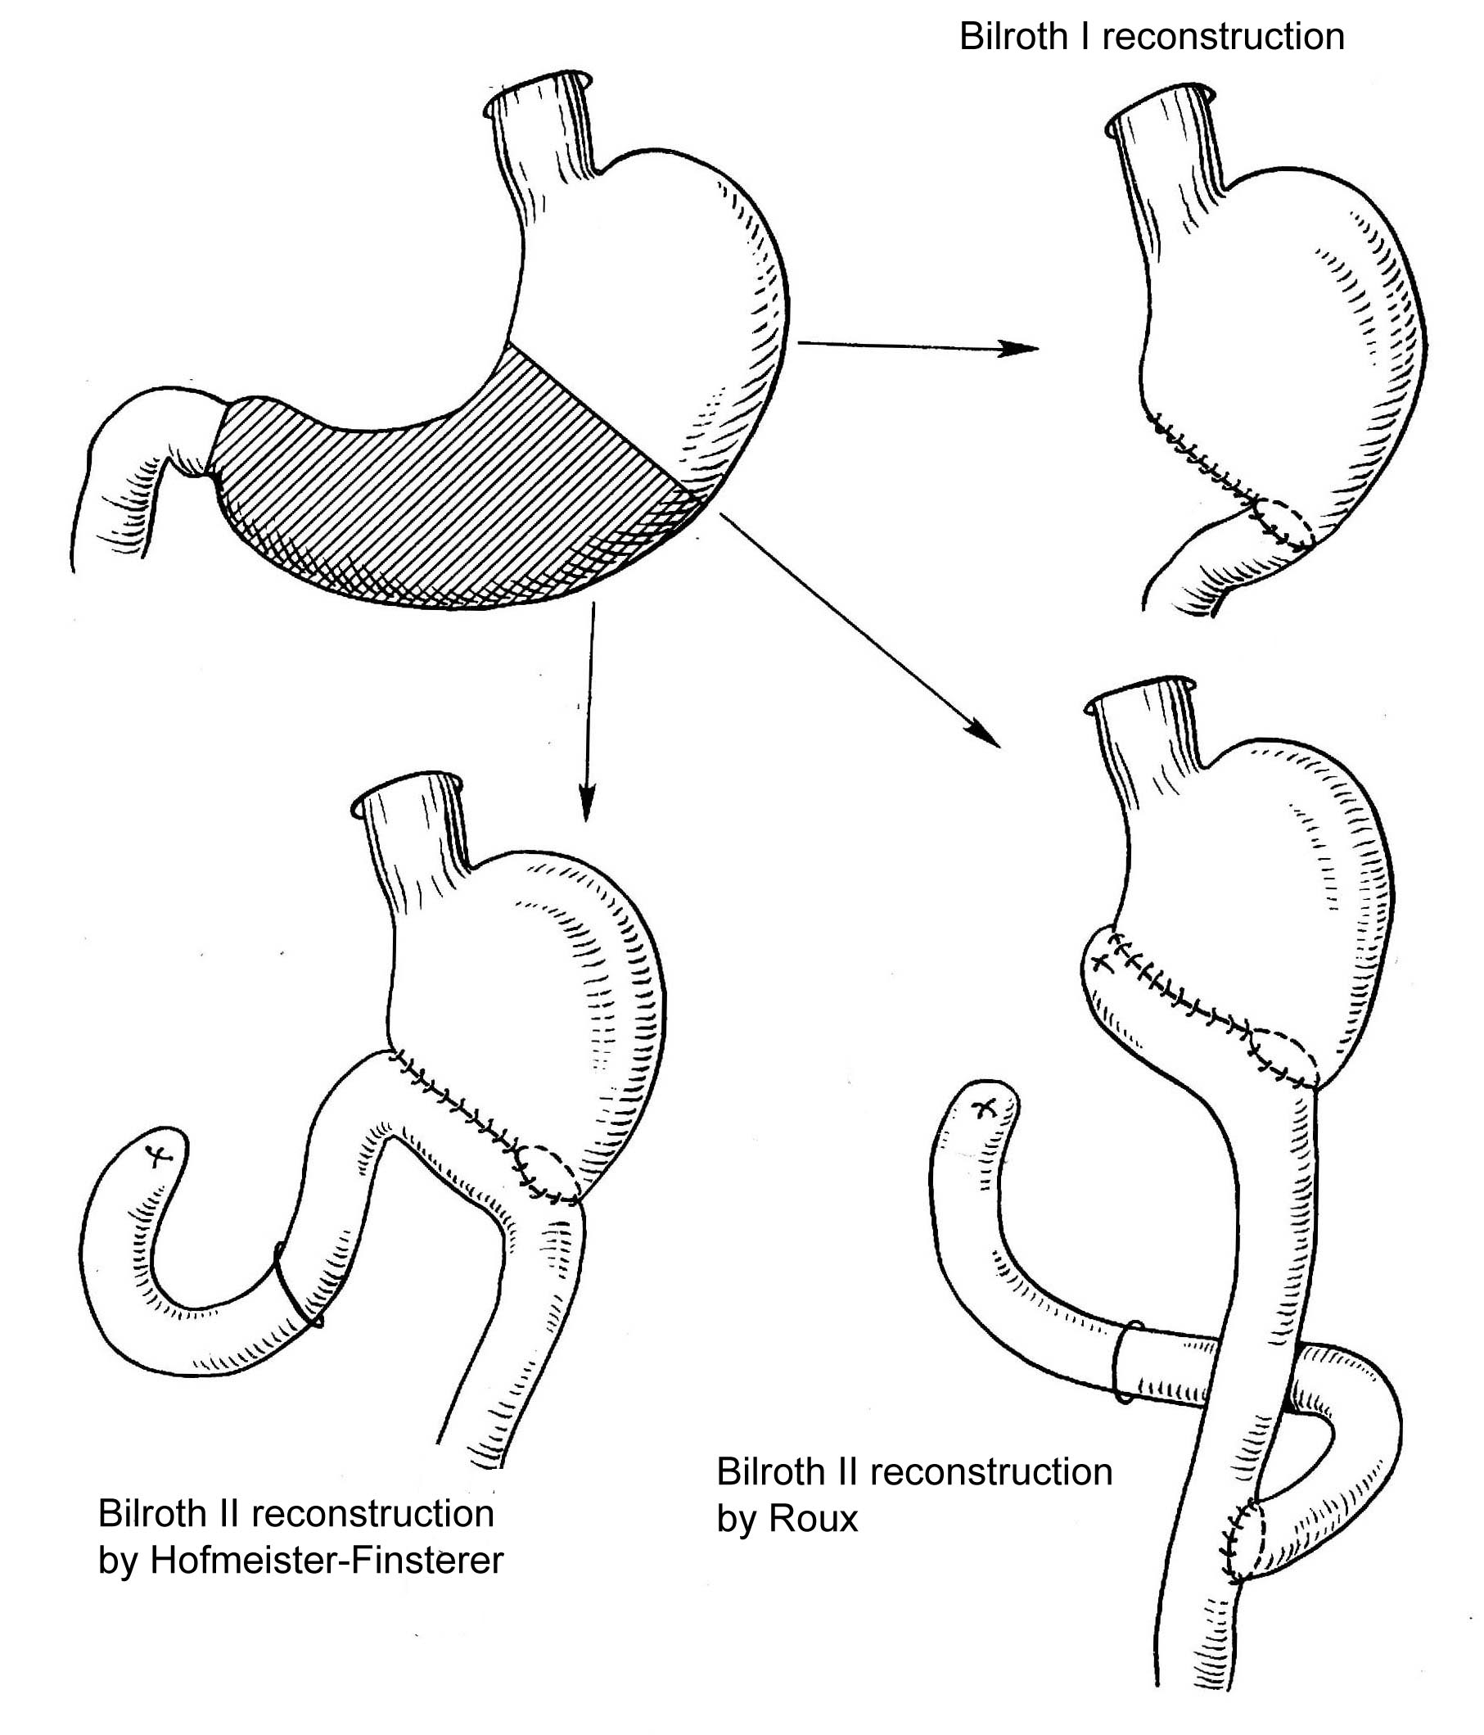

Fig. 4-21. Common variants of hemigastrectomy

Gastric ulcers

Overview

- Most gastric ulcers occur within the body of the stomach, in the angle of stomach (the histologic transition zone between the parietal cells of the body and the gastrin-secreting cells of the antrum).
- Ulcers can occur near the gastroesophageal junction, high on the lesser curve. The surgical approach is different with ulcers in this location since a distal resection would not include the ulcer. They are usually locally excised using atypical resection or proximal hemigastrectomy.
- Pyloric channel ulcers are gastric ulcers that occur near the pylorus. They tend to act like duodenal ulcers and are treated as such.
- The etiology of gastric ulcers is multifactorial and not completely delineated but is clearly different than the acid hypersecretion associated with duodenal ulcer disease. Damage to the gastric mucosal barrier, usually associated with H. pylori infection, appears to be the most important factor.
- Reflux of bile into the stomach is thought to change the mucosal barrier, allowing gastric acid to enter the mucosa and injure it.
- Drugs can alter the mucosal barrier to hydrogen ion. Nonsteroidal anti-inflammatory drugs (NSAIDs), such as indomethacin and salcylates, are common causative agents. Steroids and ethanol have also been implicated. The combination of smoking and salicylate ingestion is strongly implicated in the development of gastric ulcers.
- Persons with gastric ulcers tend to have lower than normal rates of acid secretion, both basal and stimulated. Their serum gastrin levels are аррroximately twice the normal levels.

Gastric ulcers and cancer

- The suggestion that gastric ulcer degenerate into carcinoma now is still controversial. Most authors advocate this because chronic atrophic H.pylori-associated gastritis which predisposes to gastric ulcers may also lead to gastric cancer.
- However, gastric cancer will ulcerate in 25% of cases, and it is, therefore, mandatory to prove histologically that suspicious or non-healing gastric ulcers are not carcinoma. Approximately 10% of gastric ulcers are malignant.

Clinical features, laboratory and visualization data

- History of burning epigastric pain that is relieved by food but recurs 30 to 90 minutes later is the usual presentation of gastric ulcers.
- The initial diagnostic studies include endoscopy (see Fig. 4-22) and upper gastrointestinal radiographs (see Fig. 4-23). Endoscopy, which allows multiple biopsies through the endoscope, is necessary to rule out malignancy.
- Gastric secretion analysis uses a stomach probe to monitor the gastric pH for a 24-hour period.

A 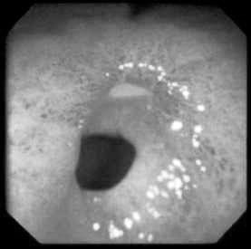 B 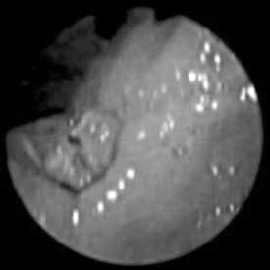

Fig. 4-22. Endoscopic pictures of gastric ulcers

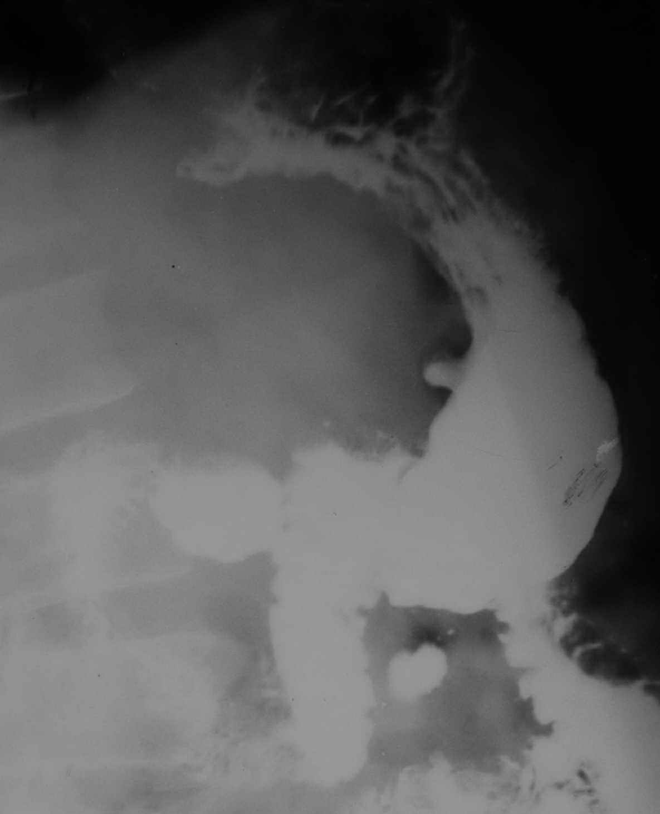

Fig. 4-23. Radiographic picture of ulcer of body of stomach

Treatment

- Surgical treatment is necessary for patients with frequent recurrences, complications and suspected malignancy or high risk of its development (severe metaplasia, or dysplasia).
- For patients who doesn’t fit for common anaesthesia recurrent cases should be treated conservatively with individual schemes of medical therapy.

Scheme 4-7. Algorithm of management of uncomplicated gastric ulcers

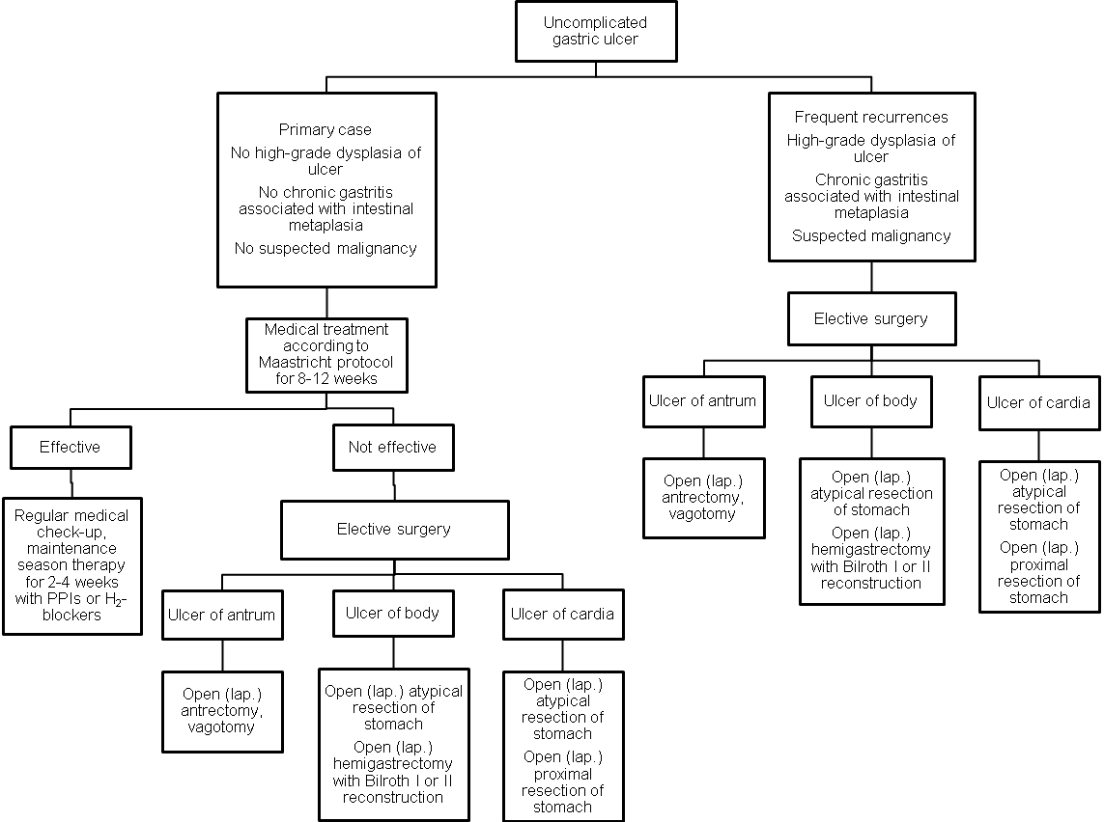

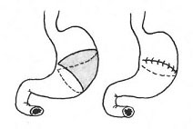

Fig. 4-24. Atypical resection of stomach

Medical treatment of ulcer disease according to Maastricht protocol

- Avoidance of aspirin, caffeine, alcohol, and tobacco is recommended. Stress reduction may be beneficial. Antacid therapy has also been demonstrated its effectiveness.
- Diet should be excluding rough, spicy and fatty food, with graduate food intake.
- Anti-Helicobacter pylori antibiotic therapy includes: amoxicillin (clarythromicin) 500 mg twice a day + metronidazole (tinidazole) 500 mg twice a day, 7 – 10 days course.
- Proton pump inhibitors (PPIs): omeprazole (rabeprazole, ezomeprazole) 20 mg twice a day, 6 – 8 weeks course for duodenal ulcers and 8 – 12 weeks course for gastric ulcers.

Complications specific to gastric surgery

Alkaline reflux gastritis

- Alkaline reflux gastritis is the most common problem after a hemigastrectomy, occurring about 25% of all patients.
- Symptoms are postprandial epigastric pain/nausea, vomiting, and weight loss.
- Endoscopy demonstrates reflux-gastritis and a free reflux of bile.
- Treatment is conversion of the Billroth I or II hemigastrectomy to Roux-en-Y anastomosis.

Afferent loop syndrome

- Afferent loop syndrome is caused by intermittent mechanical obstruction of the afferent loop of a gastrojejunostomy.
- Symptoms include early postprandial distention/pain, and nausea, which are relived by vomiting of bilious material not mixed with food.
- Treatment consists of providing good drainage of the afferent loop, usually by conversion to a Roux-en-Y anastomosis.

Dumping syndrome

- Dumping syndrome affects most postgastrectomy patients but is a significant problem in only a few. It is caused by the release of hypertonic chyme into the small bowel which causes rapid accumulation of fluid and consequent jejunal distention.
- Symptoms may include epigastric fullness or pain, nausea, palpitations, dizziness and diarrhea.
- Signs include tachycardia and elevated blood pressure.
- Conservative measures control most patients' symptoms. They are advised to eat high-carbohydrate diet and not to drink fluids with meals.
- Surgical treatment is used to delay gastric emptying, including interposition of antiperistaltic jejunal loop between the stomach and small bowel and other reconstruction surgery.

Postvagotomy diarrhea

- Postvagotomy diarrhea is common in its mild form but seldom is a disabling problem.
- Symptoms usually improve during the first year after surgery.

Marginal ulcers

- Marginal ulcers are located at the anastomosis between stomach and jejunum (after Billroth II reconstruction), or stomach and duodenum (after Billroth I reconstruction).
- They may be complicated by severe gastrointestinal bleeding and lead to the obstruction of anastomosis.
- Most commonly, treatment include aggressive medical therapy. In advanced cases, including above-mentioned complications with failure to be controlled by conservative measures (endoscopic hemostasis, or balloon dilation, respectively), they require re-resection of stomach along with the anastomosis.

PERFORATED PEPTIC ULCER

Overview

- Perforations of peptic ulcers occur most commonly with ulcers on the anterior surface of the duodenum.
- Gastric perforations are less common.
- Occasionally, ulcers can perforate posteriorly into the lesser sac (covered perforation).

Diagram 4-3. Rough structure of causes of gastrointestinal perforations

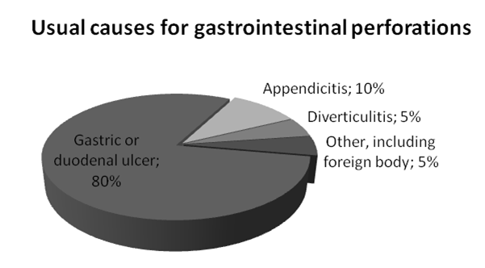

Clinical features and visualization data

- Typical symptoms of perforation include sudden onset of severe abdominal pain, radiation of pain to the shoulder, nausea, and vomiting.
- Signs include a rigid abdomen, symptoms of peritoneal irritation, and shock.
- Liver dullness determined by percussion usually is absent.
- An upright abdominal chest radiograph frequently demonstrates air under the diaphragm (see Fig. 4-25).
- If free air is absent in plane film (in covered perforation), endoscopy may be used to reveal deep ulcer. It may be followed by repeated plane film that will detect air confirming the diagnosis.
- Long-term covered perforation may produce subhepatic abscess with respective clinical presentation and imaging data (see Chapter 2).

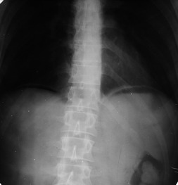

Fig. 4-25. Free air in peritoneal cavity

Treatment

Scheme 4-8. Algorithm of management of perforated duodenal ulcer

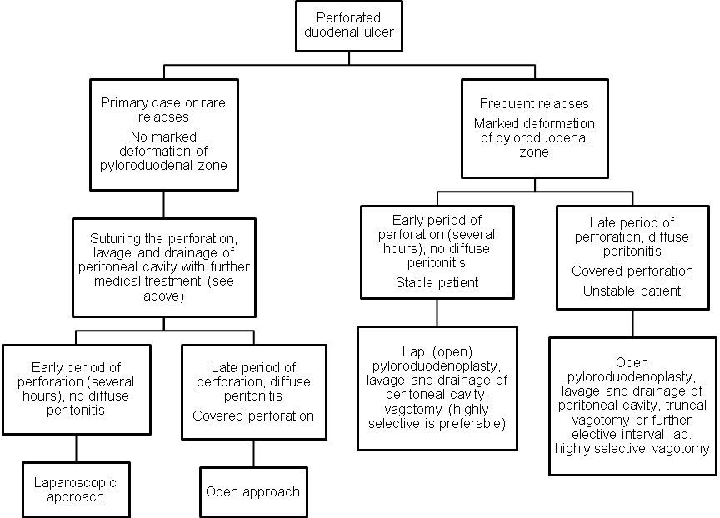

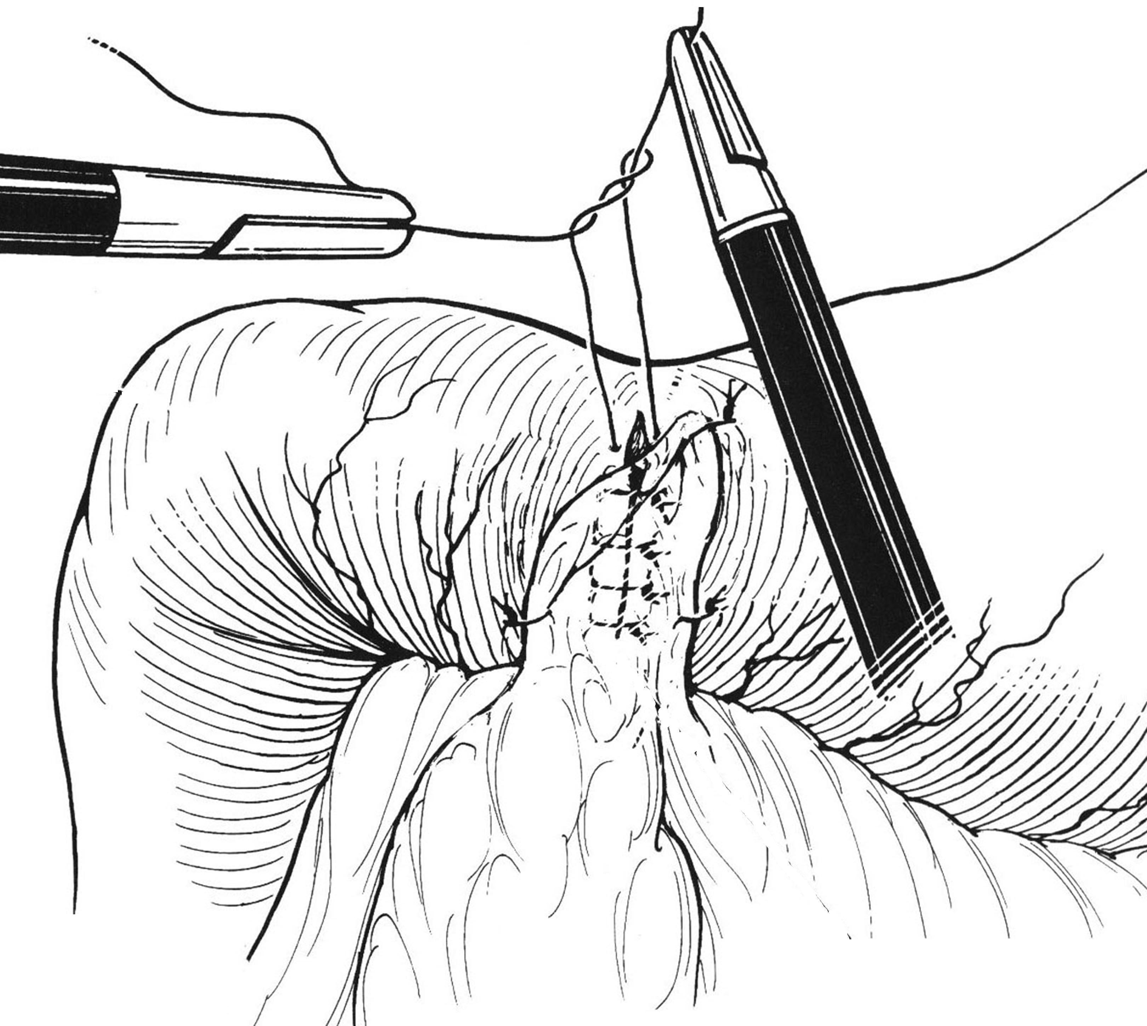

Fig. 4-26. Technique of laparoscopic suturing the perforated peptic ulcer

Scheme 4-9. Algorithm of management of perforated gastric ulcer
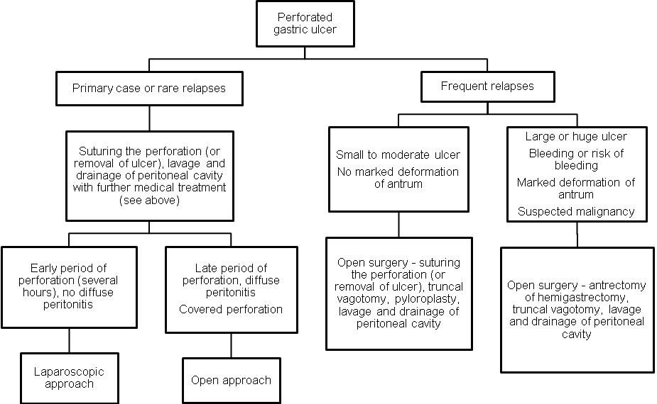

REVIEW TESTS

1. A 46-years-old woman was admitted to surgical department with complaints of a moderate periodical pain at right subcostal region, and periodical nausea. The symptoms appear every months for the last 1 year, after ingestion of fatty and spicy food. Physical examination of abdomen reveals slight tenderness at the right subcostal region, no rebound tenderness and muscle guarding. There is no history of jaundice. Blood and urine analyses are normal. Ultrasound shows calculi in the gallbladder which is not enlarged, common bile duct measuring 5 mm in diameter, and slight enlargement of pancreas. What’s the most appropriate tactics of managing the patient?

A. Open cholecystectomy
B. Laparoscopic cholecystectomy
C. Endoscopic retrograde cholangiopancreatography
D. Laparoscopic cholecystectomy, exploration and drainage of common bile duct
E. Percutaneous cholecystostomy under US guidance

2. A 82-years-old woman was admitted to ER with complaints of an intense constant pain at right subcostal region, fatigue, subfebrile temperature, and nausea. The symptoms appeared 3 days ago after ingestion of fatty food. The same attack took place last year. The patient has history of angina pectoris, a dypnea at rest, and peripheral edema. Pulse is irregular, ECG reveals atrial fibrillation. Physical examination of abdomen reveals pronounced tenderness at the right subcostal region, moderate rebound tenderness and muscle guarding. There is no jaundice. There is leukocytosis of 12000/ml and left shift of leukogram. Ultrasound reveals multiple calculi in the gallbladder which is enlarged, with thickened wall, common bile duct measuring 7 mm in diameter, and slight enlargement of pancreas. What’s the most appropriate tactics of managing the patient?

A. Laparoscopic cholecystectomy
B. Open cholecystectomy
C. Percutaneous cholecystostomy under US guidance
D. Endoscopic retrograde cholangiopancreatography
E. Laparoscopic cholecystectomy, exploration and drainage of common bile duct

3. A 34-years-old woman in previous good health was admitted to ER with clinical presentation of a spontaneous intraperitoneal hemorrhage. Her only medication is an oral contraceptive that she has been taking for the past 5 years. During resuscitation a bedside ultrasound reveals a large amount of intraperitoneal blood and a 3-cm mass in the right lobe of the liver. What is the likely cause of her hemorrhage?

- Hepatoma
- Hemangioma
- Focal nodular hyperplasia
- Hepatic cell adenoma
- Metastatic neoplasm

4. A 55-years-old man was operated 2 years ago for cancer of sigmoid colon pT₂N₁M₀: the sigmoidectomy was performed. During regular examination, a hyperechogenic node of 3,5 cm was found in the 4th segment of liver. Contrast-enhanced MRI show increased uptake of the medium by the node, and doesn’t reveal any other nodes, lymphadenopathy and local recurrence of the tumor. US-guided biopsy shows cells of moderately-differentiated adenocarcinoma. The examination of abdomen showed no pathological changes. The patient has no concomitant pathology. What’s the most appropriate tactics of managing the patient?

A. Percutaneous radiofrequency ablation of the node
B. Laparoscopic radiofrequency ablation of the node
C. Open liver segmentectomy
D. Open left hemihepatectomy
E. Open criogenic destruction of the node

5. A 35 -years-old man, a sheepman, was admitted to surgical department with complaints of a moderate periodical pain at right subcostal region which appeared 2 weeks ago. While physical examination of abdomen, there is slight tenderness at the right subcostal region, no hepatomegaly. There is no history of jaundice. Blood and urine analyses are normal. Ultrasound reveals unechogenic lesion with regular boards measuring 8 cm in diameter, located deeply in liver parenchima in the 6th and 7th segments. The patient has no concomitant pathology. What’s the most appropriate tactics of managing the patient?

A. Percutaneous drainage of the lesion
B. Laparoscopic drainage of the lesion
C. Open drainage of the lesion
D. Open right hemihepatectomy
E. Conservative treatment

6. A 32-years-old man was admitted to surgical department with complaints of a moderate periodical pain at right subcostal and epigastric region, which is more pronounced on an empty stomach, and periodical nausea. The symptoms appear every spring for the last 10 years. The patient is 1 pack of cigarette smoker. He was treated for his disease several times with antibiotics and proton pump inhibitors. Physical examination of abdomen reveals slight tenderness at the right subcostal region, no rebound tenderness and muscle guarding. Ultrasound doesn’t reveal any pathology. Endoscopy shows an ulcer of posterior wall of the duodenum measuring 2 cm in diameter, with deep bottom and dense infiltrated borders, marked deformation of the duodenal bulb. What’s the most appropriate tactics of managing the patient?

A. Highly selective vagotomy, pyloroduodenoplasty
B. Truncal vagotomy, pyloroplasty
C. Prolong conservative treatment
D. Antrectomy, Bilroth-I reconstruction
E. Hemigastrectomy, Bilroth-I reconstruction

7. A 25-years-old patient is being treated for uncomplicated ulcer disease of duodenum. What should the treatment protocol include EXCEPT?

- Metronidazole
- Amoxicilin
- Pantoprazole
- Klarithromicin
- Imodium

8. A 41-years-old man was admitted to surgical department with complaints of a moderate periodical pain at right subcostal and epigastric region, which is more pronounced on an empty stomach, and periodical vomiting. The symptoms appear every spring for the last 8 years. The patient is poor smoker. Physical examination of abdomen reveals slight tenderness at the epigastric region, no rebound tenderness and muscle guarding. Ultrasound doesn’t reveal any pathology. Endoscopy shows an ulcer of prepyloric part of stomach, measuring 2 cm in diameter, with deep bottom and dence infiltrated borders. The endoscopically defined recurrence is third in his life. Biopsy of ulcer shows chronic ulcer associated with H.pylori with high degree of dysplasia of gastric mucosa. What’s the most appropriate tactics of managing the patient?

A. Highly selective vagotomy, pyloroplasty
B. Truncal vagotomy, antrectomy, Bilroth-I reconstruction
C. Gastrectomy, esophagojejunostomy
D. Subtotal distal hemigastrectomy
E. Truncal vagotomy, pyloroplasty

9. A 28-years-old man was admitted to ER with complaints of intense (knife-stab) pain at right lower quadrant of abdomen and multiple vomiting. The pain appeared 30 minutes ago. Tonight he ingested a lot of spicy food and alcohol. Previously he had a periodical pain at the epigastric region and intense heartburn which appear every spring. The same exacerbation began 1 week ago. Physical examination of abdomen reveals wooden-like muscle spasm, severe tenderness, and rebound tenderness at the right lower quadrant and right flank. Also, there is a moderate tenderness (without muscle guarding and rebound tenderness) in the right subcostal region. The last bowel movement was yesterday. Urination is quite normal. Give your presumable diagnosis:

A. Acute appendicitis
B. Perforated duodenal ulcer
C. Acute cholecystitis
D. Bowel obstruction
E. Renal colic

Correct answers: 1 - B, 2 - C, 3 - D, 4 - C, 5 - A, 6 - A, 7 - E, 8 - B, 9 - B.

