CHAPTER 5. VOMITING

- Vomiting most commonly is caused by gastric outlet obstruction due to peptic ulcer, cancer of stomach, different forms of small and large intestine obstruction and various surgical and non-surgical gastrointestinal and extra-abdominal diseases listed below (see Table 5-1).
- Vomiting most commonly is associated with nausea and constipation.

Table 5-1. List of diseases that produce vomiting

Gastrointestinal tract obstruction

Mechanical obstruction (diseases producing vomiting rather than obstipation)
Intraluminal
Intussusception
Gallstone ileus
Impactions
Bezoars
Worms
Foreign bodies
Intramural
Congenital
Atresia and stenosis
Duplications
Meckel's diverticulum
Neoplastic
Benign
Malignant
Inflammatory
Gastric outlet obstruction due to peptic ulcer
Strictures due to Crone’s disease
Diverticulitis
Radiation stricture of small intestine
Extraluminal
Adhesive band obstruction
Hernia and wound dehiscence
Extrinsic abdominal masses
Cysts (including pancreatic pseudocyst)
Neoplasms (including carcinomatosis)
Abscesses
Hematomas
Volvulus
Congenital
Annular pancreas
Anomalous vessels
Dynamic obstruction
Paralytic ileus
Abdominal causes
Postoperative (thoracic or abdominal operations)
Peritonitis
Retroperitoneal lesions
Edematous pancreatitis
Cysts
Neoplasms
Abscesses (including pancreatogenic)
Hematomas
Ascites
Following trauma (abdominal or remote)
Spinal cord injury
Head injury
Abdominal wall or retroperitoneal injury
Pelvic or lumbar spine fracture
Long bone fracture
Systemic causes
Collagen vascular disease
Multiple sclerosis
Scleroderma
Amyloidosis
Electrolyte imbalance
Hypercalcemia
Hypokalemia
Endocrine causes
Hypothyroidism
Hyperparathyroidism
Glucagonoma
Somatostatinoma
Panhypopituitarism
Pheochromocytoma
MEN IIa, IIb
Diabetic ketoacidosis
Addisonian crisis
Metabolic diseases
Porphyria
Amyloidosis
Uremia
Neuromuscular defects
Congenital megacolon (Hirshprung’s disease)
Aquired megacolon (Chagas' disease)
Acute mesenteric ischemia
Pseudoobstruction (Ogilvie's syndrome)
Spastic ileus (e.g., lead poisoning)

Gastrointestinal inflammatory diseases

Hollow intestinal organs
Appendicitis
Cholecystitis
Peptic ulceration
Gastroenteritis
Crone’s disease
Meckel's diverticulitis
Colitis
Diverticulitis
Solid viscera
Pancreatitis
Hepatitis
Hepatic abscess
Mesentery
Lymphadenitis

Pelvic inflammatory diseases

Tuboovarian abscess
Endometritis
Ruptured ectopic pregnancy
Ovarian cyst
Torsion or degeneration of fibroid

Neuroinfections

Head trauma

Renal colic / acute pyelonephritis

Drug effects / toxemias

Narcotics
Psychotropic agents
Antidepressants
Calcium-channel blockers
Antispasmodics
Metal intoxication (mercury, lead, arsenic)

Psychologic, psychiatric, anorexia nervosa

Postsurgical abnormalities (e.g. asceding loop syndrome, anastomotic stricture)

GASTRIC OUTLET OBSTRUCTION

- Gastric outlet obstruction can be caused by prepyloric ulcers and by chronic scarring of the pyloric channel in patients with frequent recurrences.

Clinical features, laboratory and visualization data

- Obstruction causes symptoms of crampy upper abdominal pain, nausea, and vomiting.
- The stomach is usually markedly dilated with delayed evacuation of gastric contents that could be determined by upper gastrointestinal series (see Fig. 5-1) and by endoscopy (see Fig. 5-2). These investigations may reveal ulcer with marked and even total scar stenosis of the gastric outlet.
- Endoscopic biopsy is necessary to rule out malignancy.
- Prolonged vomiting due to obstruction can lead to electrolyte disorders (see Table 2-2), particularly hypokalemic metabolic alkalosis from the large hydrochloric acid losses.

Scheme 5-1. Stages of gastric outlet obstruction
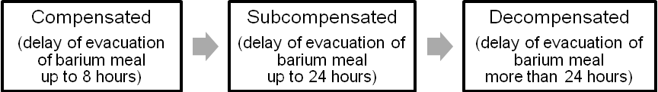

A 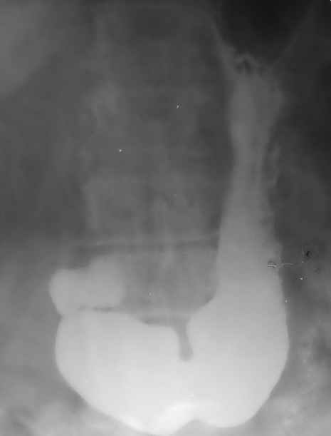 B 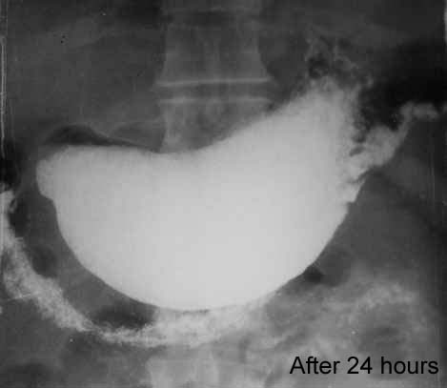

Fig. 5-1. Radiologic picture of gastric outlet obstruction

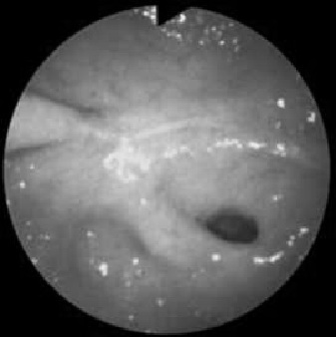

Fig. 5-2. Endoscopic picture of gastric outlet obstruction

Treatment

- Initial treatment consists of several days to weeks of nasogastric suction, intensive total parenteral nutrition (TPN), usage of high dosages of PPIs and feeding jejunostomy in severe cases.
- If the obstructed segment is passable for the endoscope (i.e., partial stenosis) the feeding tube may be inserted into jejunum after the endoscopic percutaneous gastrostomy (see Fig. 5-13)
- Surgical tactics is based on stages of obstruction (see Scheme 5-1) and other patient’s characteristics (see Scheme 5-2).

Scheme 5-2. Algorithm of management of gastric outlet obstruction due to peptic ulcer

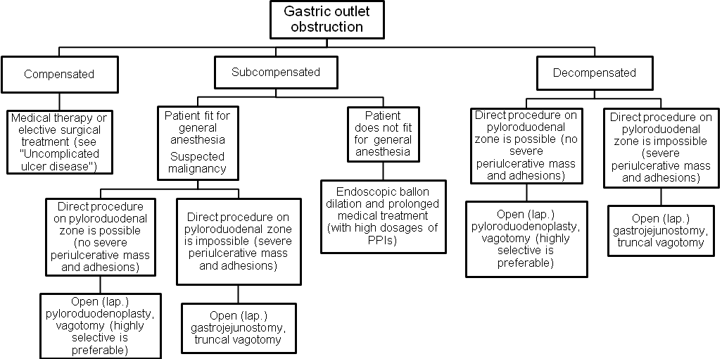

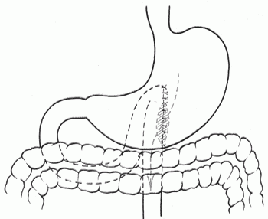

Fig. 5-3. Scheme of Hacker gastrojejunostomy

GASTRIC TUMORS

- Approximately 90%-95% of gastric tumors are malignant and of the malignancies, 95% are carcinomas.

Gastric cancer

Overview

- The incidence of gastric cancer has been decreasing for many years and is now stabilizing.
- The trend is increasing toward lesions more proximally located in the stomach.
- Involvement beyond the stomach can include direct spread to adjacent organs (e.g., spleen, diaphragm, colon); "drop metastases" (to the ovary (Krukenberg's tumor), the pouch of Douglas, right supraclavicular lymph nodes (Virchov’s metastasis) and to umbilicus (sister Joseph’s metastasis); and to distant organ (e.g., to liver, lung).

Classification

- Gastric cancer is subdivided into early (within the mucosa and submucosa) (see Scheme 5-3) and late.

Scheme 5-3. Classification of early gastric cancer

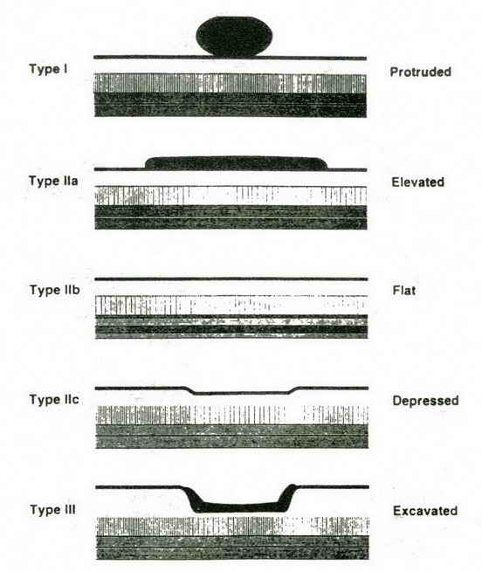
From: Principles of surgery/ed., S.I. Schwartz, et al. – 7th ed.

Scheme 5-4. Classification of late gastric cancer

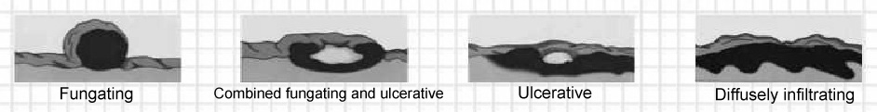

- Late gastric carcinoma is classified according to its gross characteristics (see Scheme 5-4). Fungating (exophytic) lesions are the least common and have a better prognosis. Ulcerating lesions are most common (endophytic). Diffusely infiltrating (linitis plastica) tumors cause extensive submucosal infiltration with the worst prognosis.
- Tactics of surgical treatment is based on stage according to TNM-classification.

TNM staging of gastric cancer

TX Primary tumor cannot be assessed
T0 No evidence of primary tumor
Tis Tumor limited to the mucosa without penetration through the basement membrane into the lamina
propria (carcinoma in situ)
T1 Tumor limited to the mucosa or mucosa and submucosa
T2 Tumor extending into the muscularis propria and may extend into but not through the serosa.
T2a Tumour invades muscularis propria
T2b Tumour invades subserosa
T3 Tumor penetrates the serosa without invading contiguous structures
T4 Tumor invading adjacent structures

NX Regional lymph nodes cannot be assessed
N0 No metastases to regional lymph nodes
N1 Involvement of 1-6 regional lymph nodes
N2 Involvement of 7-15 regional lymph nodes
N3 Involvement of more than 15 regional lymph nodes

MX Distant metastases cannot be assessed
M0 No distant metastases
M1 Distant metastases present

Stage 0 | Tis | N0 | M0
Stage IA | T1 | N0 | M0
Stage IB | T1 | N1 | M0
Stage IB | T2a/b | N0 | M0
Stage II | T1 | N2 | M0
Stage II | T2a/b | N1 | M0
Stage II | T3 | N0 | M0
Stage IIIA | T2a/b | N2 | M0
Stage IIIA | T3 | N1 | M0
Stage IIIA | T4 | N0 | M0
Stage IIIB | T3 | N2 | M0
Stage IV | T4 | N1. N2. N3 | M0
Stage IV | T1, T2, T3 | N3 | M0
Stage IV | Any T | Any N | M1

Clinical features and visualization data

- Symptoms include pain, anorexia, and weight loss.
- Symptoms tend to occur late in the course of the disease.
- Diagnosis is made via upper endoscopy and biopsy (see Fig. 5-4).
- Radiological study of stomach may be as accurate as endoscopy (see Fig. 5-5), even in detecting early cancer, especially in experienced hands using double contrast (see Fig. 5-6).
- Preoperative evaluation may include CT scan to look for distant metastases and spreading into adjacent structures (see Fig. 5-7). The latter is necessary for planning the volume of surgery.
- Spreading of early gastric cancer within the wall of stomach should be assessed by endoscopic ultrasound (EUS) (see Fig. 5-8) to ascertain whether it is suitable for endoscopic mucosectomy (see later).
- Endoscopic ultrasound has been shown to be useful in determining the depth of penetration and in detecting nodal metastases.

A 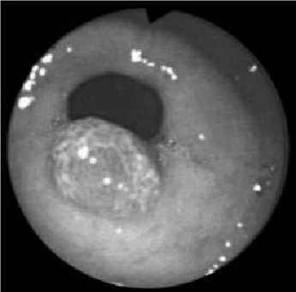 B 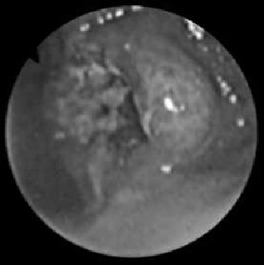

Fig. 5-4. Endoscopic picture of early (protruded) (A) and late (combined fungating and ulcerative) (B) cancer of antrum of stomach

A 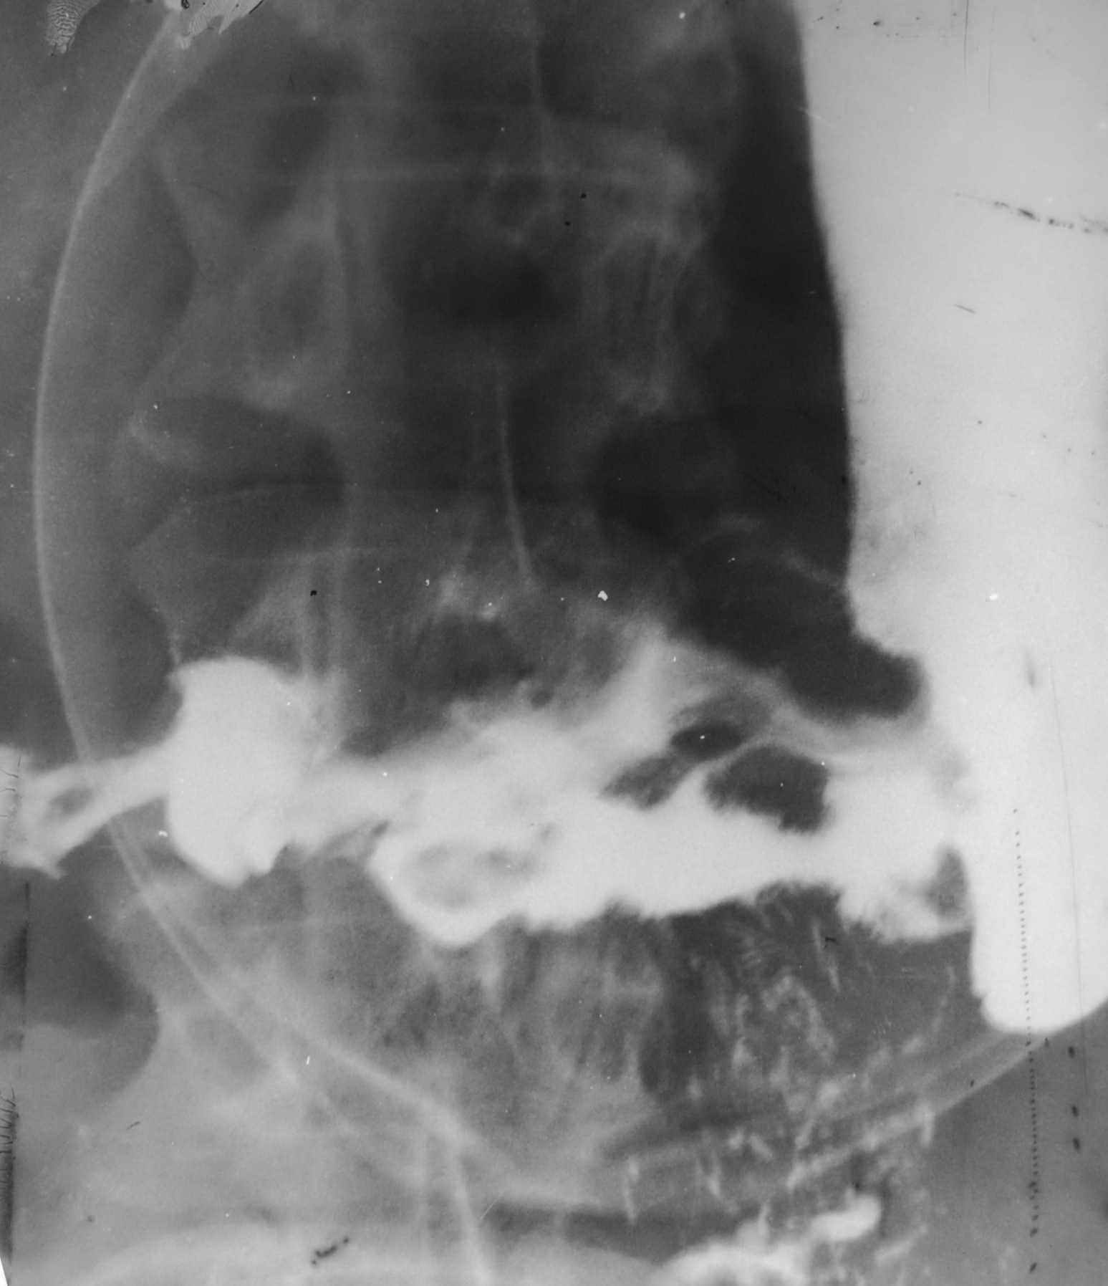 B 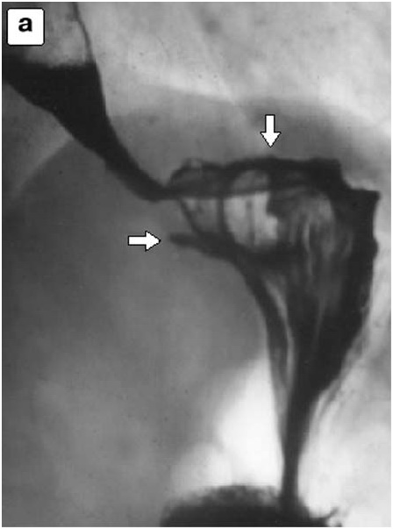

Fig. 5-5. Radiologic picture of late cancer of antrum of stomach (advanced) (A) and cardia (infiltrating) (B)

A 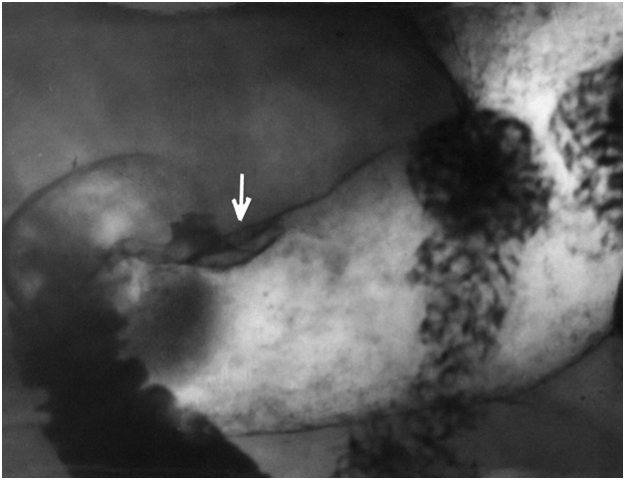 B 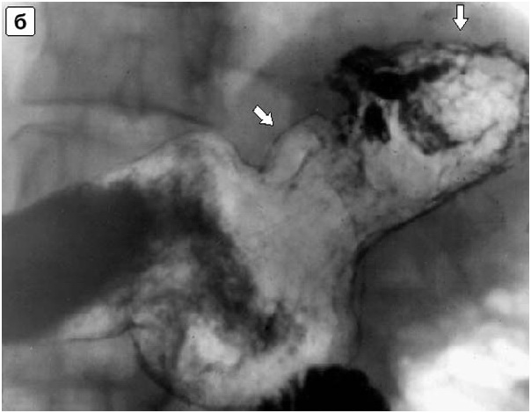

Fig. 5-6. Radiologic pictures of early cancer of antrum of stomach (A) and cardia (B)

A 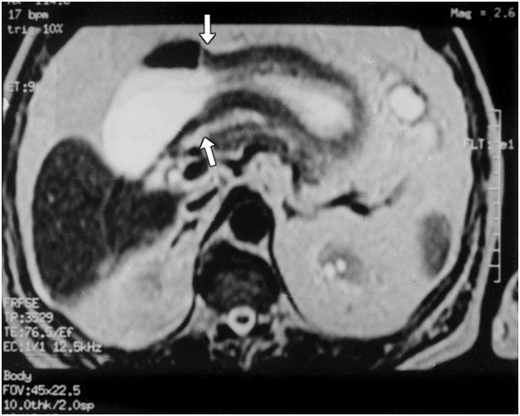 B 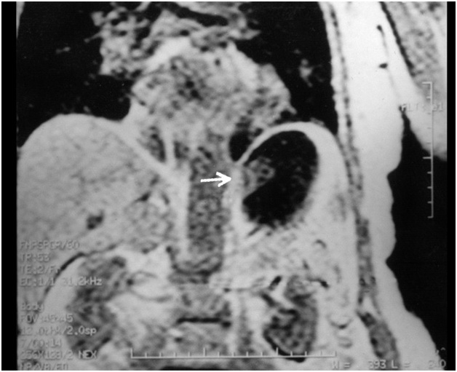

Fig. 5-7. CT scan of late cancer of body of stomach (A) and cardia (B)

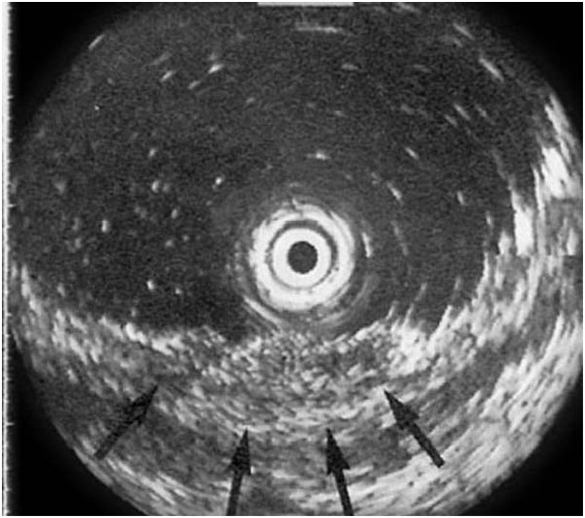

Fig. 5-8. EUS picture of gastric cancer

Scheme 5-5. Scheme of diagnostic evaluation of gastric cancer
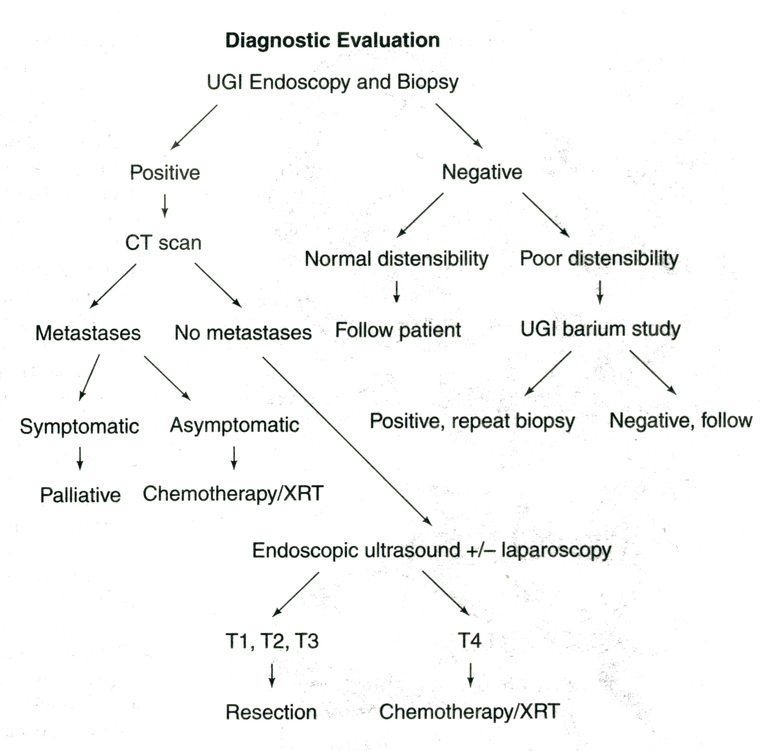
From: Principles of surgery/ed., S.I. Schwartz, et al. – 7th ed.

Treatment

Scheme 5-6. Algorithm of management of cancer of cardia of stomach
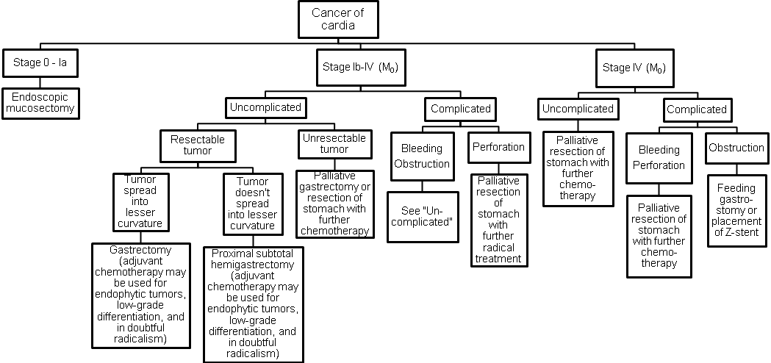

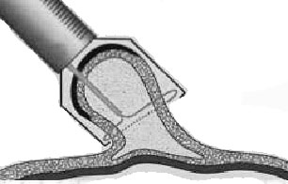

Fig. 5-9. Scheme of endoscopic mucosectomy

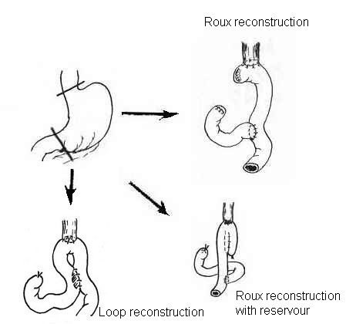

Fig. 5-10. Variants of total gastrectomy

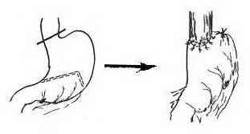
Fig. 5-11. Scheme of proximal hemigastrectomy

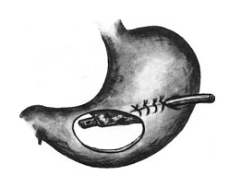

Fig. 5-12. Scheme of Whitzel gastrostomy

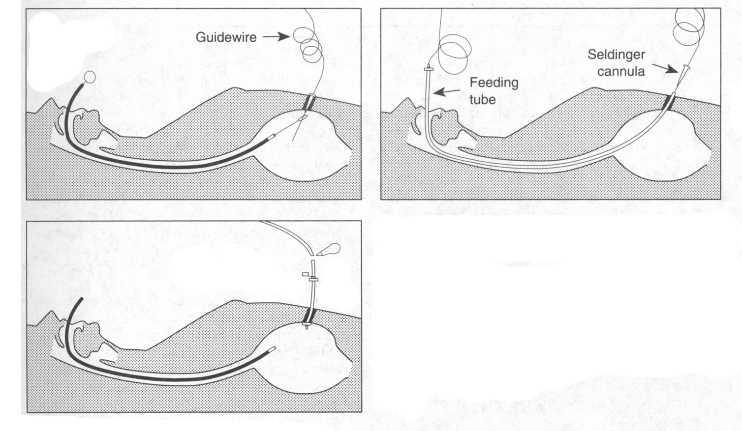

Fig. 5-13. Scheme of percutaneous endoscopic gastrostomy

A 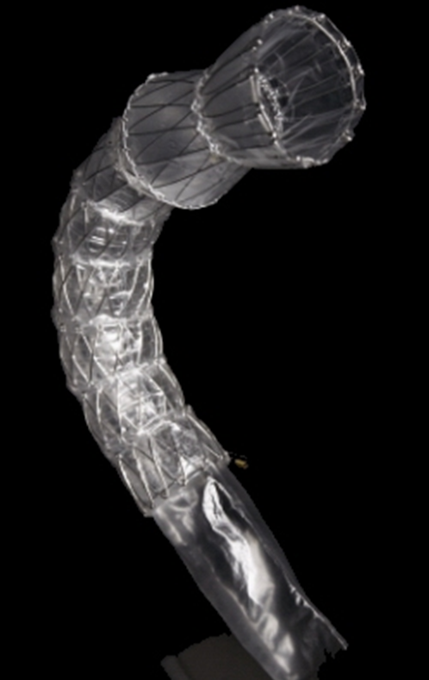 B 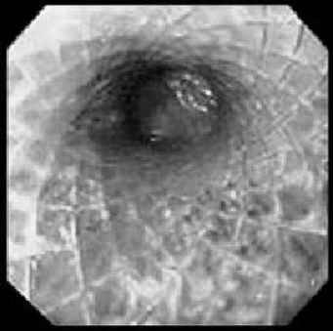

Fig. 5-14. Self-expandable esophageal stent (Z-stent)

Scheme 5-7. Algorithm of management of cancer of body of stomach

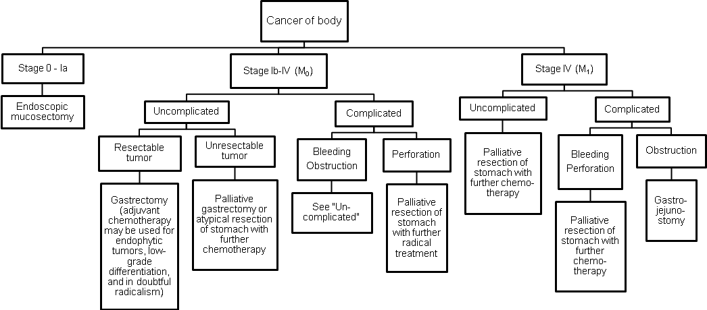

Scheme 5-8. Algorithm of management of cancer of antral part of stomach

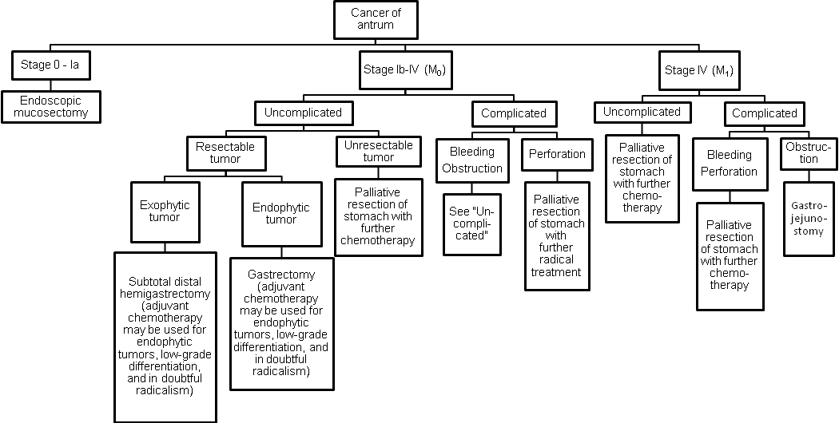

A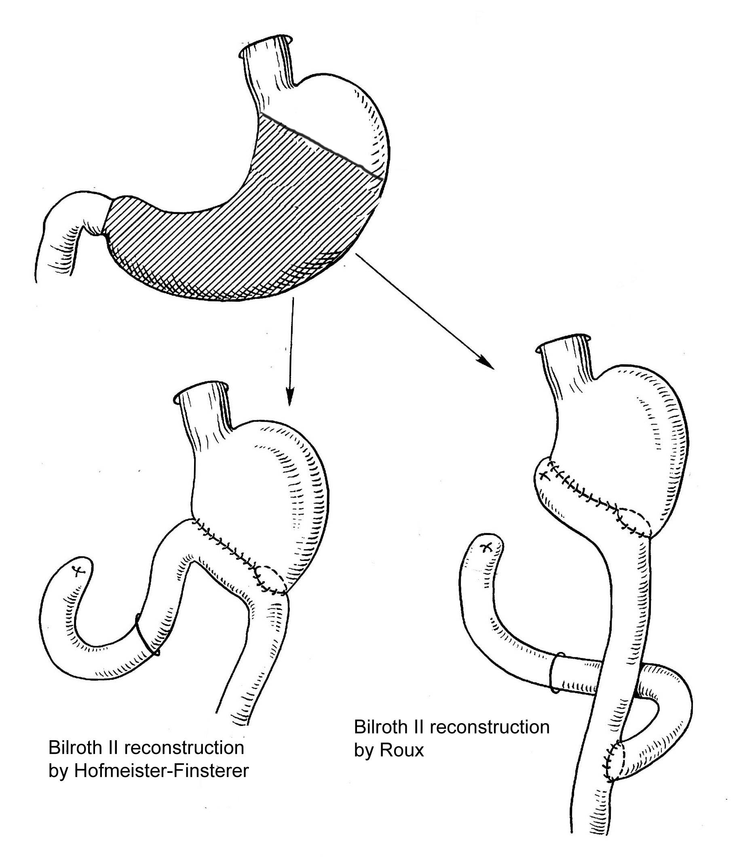 B 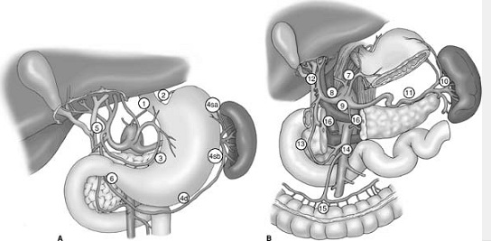

Fig. 5-15. Scheme of distal subtotal hemigastectomy (A) and map of regional lymph nodes (B) for D1 (a) and D2, D3 (b) lymphadenectomy

- Potentially curable lesions are treated with subtotal (see Fig. 5-15-a) or total gastrectomy (see Fig. 5-10), depending on tumor location. Wide margins on the stomach are necessary since extensive submucosal tumor spread can occur. Lesions of the fundus and cardia may require resection of the spleen.
- The role of lymphadenectomy (D1, D2, rarely D3) (see Fig. 5-15-b) is controversial, but for favorable lesions, there is some advantage to removing the draining nodes. Removal of the omentum and its nodes is included.
- Laparoscopic treatment of early stages of gastric cancer may be performed in special centers. Accurate maping of sentinel lymph nodes (coloration by endoscopic injection of tincture into the tumor) and their complete removal along with the primary tumor achieve as good results as conventional open surgery.
- Adjuvant chemotherapy after potentially curative resection remains unproven, but some benefit is suggested. Unresectable tumors may show some response to chemotherapy. The addition of radiation therapy may improve results.
- Prognosis depends largely on the depth of invasion of the gastric wall, involvement of regional nodes, and the presence of distant metastases but still remains poor. Tumors not penetrating the serosa and not involving regional nodes are associated with a 5-year survival rate of approximately 70%. This number drops dramatically if the tumor is through the serosa or into regional nodes. Only 40% of patients have potentially curable disease at the time of diagnosis.
- Endoscopic screening programs are necessary to diagnose early cancer of stomach and to treat it by endoscopic mucosectomy (see Fig. 5-9).

Gastric lymphoma

- Gastric lymphoma can be primary or can occur as part of disseminated disease. The stomach is the most common site of primary intestinal lymphoma, which has a better prognosis than other gastrointestinal lymphomas.
- Presentation may be similar as for gastric cancer, mainly with bleeding and partial or total obstruction (see Fig. 5-16). Endoscopically the tumors may be bulky with central ulceration.
- Diagnosis preoperatively is important to distinguish lymphoma from adenocarcinoma of the stomach because less radical resections are usually indicated with lymphomas. Operative urgent biopsy is helpful.
- Surgical treatment involves local resection (partial gastrectomy). The goal is to remove all gross disease. Radiation therapy, chemotherapy, or both are often added, especially in diffuse disease or as adjuvant therapy.
- Prognosis is good, with a 5-year survival rate of up to 90% when disease is localized to the stomach.

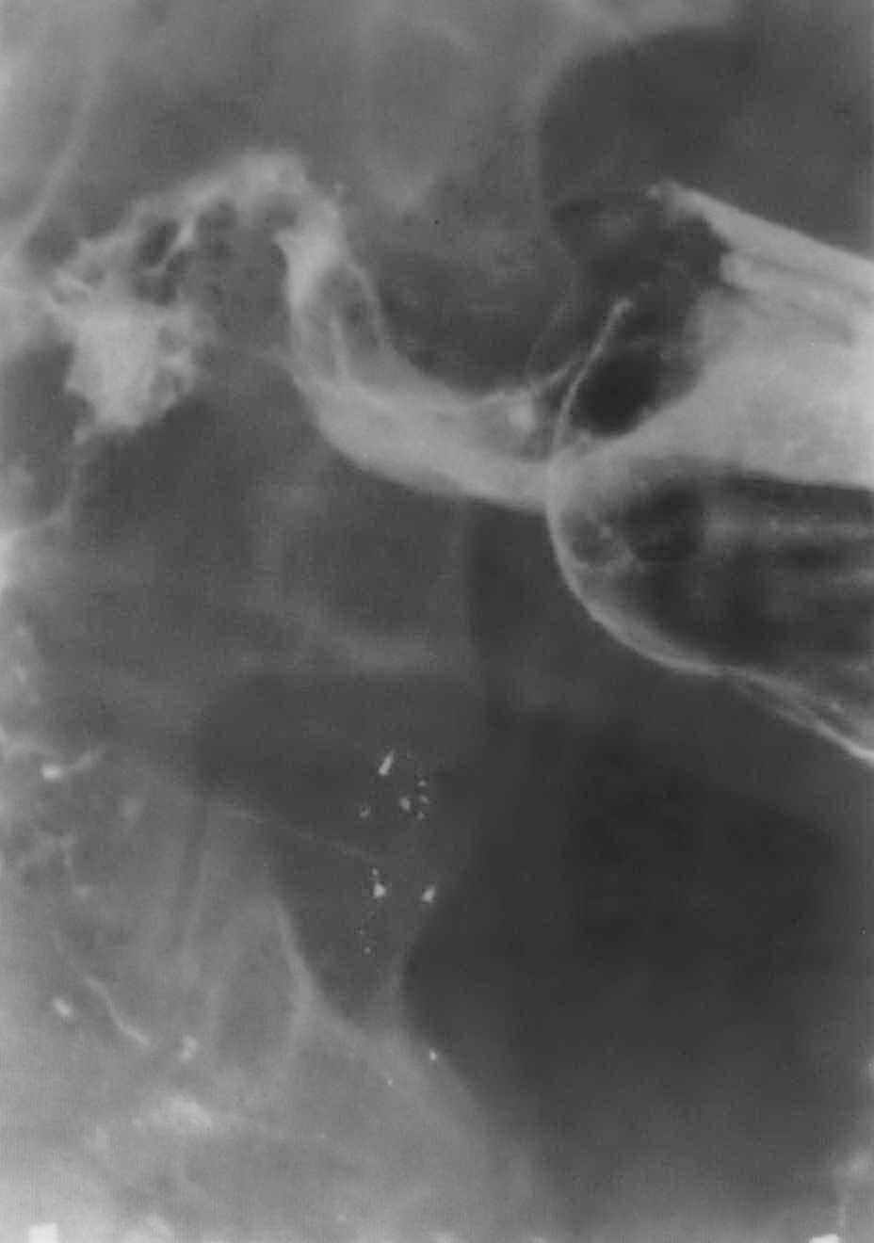

Fig. 5-16. Radiological picture of obstructing lymphoma of antrum of stomach

Leiomyosarcoma

- Leiomyosarcomas are bulky, well-localized tumors. They are slow to metastasize and can be treated with partial gastrectomy.

Benign tumors

- Benign tumors are uncommon.
- Leiomyomas are the most common benign gastric tumors. They are usually asymptomatic but may undergo hemorrhage or cause obstruction and mass effect, thus requiring surgical removal, most commonly, enucleation. They are submucosal and well encapsulated (enucleation may be performed laparoscopically or endoscopically).
- Gastric polyps are of two types. They often can be excised via the endoscope. Hyperplastic polyps (see Fig. 5-17, A) are the most common and are not premalignant. Adenomatous polyps are associated with a high risk of malignancy, especially those greater than 1.5 cm, thus requiring polypectomy (see Fig. 5-17, B).
- Other benign tumors are fibromas, neurofibromas, aberrant pancreas, and angiomas.

A 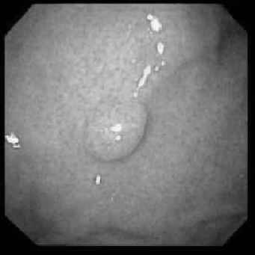 B 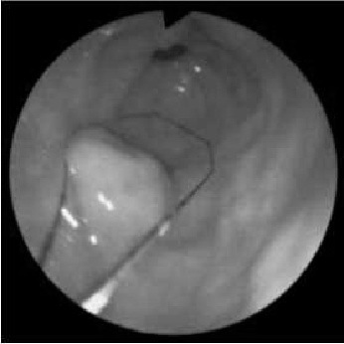

Fig. 5-17. Endoscopic picture of hyperplastic (A) and adenomatous (B) polyps of stomach

INTESTINAL OBSTRUCTION

Overview

- The normal flow of intestinal contents can be blocked by a mechanical obstruction or by a functional obstruction (adynamic ileus) that occurs because of impaired intestinal motility (see Table 6-1).
- Mechanical obstructions are common and have various benign and malignant causes (see Scheme 5-9, Table 6-1). If not treated expeditiously (usually by surgical removal of the cause), mechanical obstructions can rapidly become lethal. Acute obstruction occurs over hours to days and has a rapidly evolving course, whereas chronic obstruction may have a slow course with malnutrition, constipation, and other signs of chronic illness.
- There are several types of mechanical obstruction by clinical course: simple obstruction (no complicating factors, such as ischemia or perforation); strangulating obstruction (the blood supply to the involved segment of bowel significantly impaired; the ischemia may result from a twisting of the intestinal blood supply upon itself (volvulus) or from a constriction of the blood flow by a tight adhesive band or hernial opening); closed loop obstruction (both limbs of the bowel are obstructed, therefore, gas and liquid cannot pass in either direction); perforating obstruction (the bowel proximal to the obstruction overdistends and perforates; the most common area of perforation when the colon is obstructed is caecum).

Scheme 5-9. Types of mechanical intestinal obstruction: hernias (A), adhesions (B), tumors (C), volvulus (D), strictures (E), foreign bodies (F).

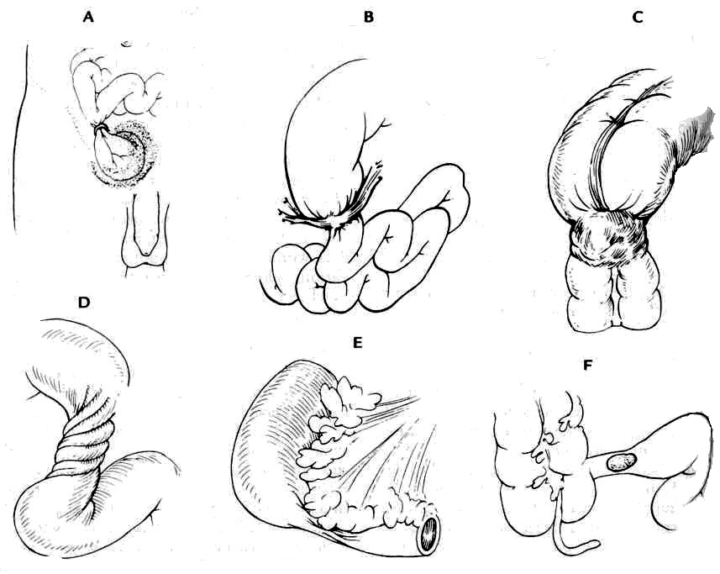

Clinical characteristic of most common variants of mechanical intestinal obstruction

- Table 5-2 summarizes clinical features of mechanical obstruction.

Table 5-2. Symptoms and signs of mechanical obstruction

Symptoms

Colicky pain
Vomiting
Lethargy
Lack of flatus or defecation

Signs

Hyperactive bowel sounds
Abdominal distention
Lack of peritoneal signs (in simple obstruction)
Signs of extracellular fluid loss (see Table 2-2)

Look for

Abdominal mass (tumors)
Groin hernia
Surgical scars (adhesions)

From: Basic surgery/ed., H.C. Polk, Jr., et al. – 5th ed.

Intestinal adhesions

- Intestinal adhesions are the most common cause of obstruction. Usually they involve small intestine.
- They may result from a previous surgical exploration, particularly when talc was used to lubricate the surgeon's gloves, or their etiology may be obscure.
- They may be diffuse, involving all peritoneal structures, or solitary, blocking only one area of the intestine.
- The main symptoms include vomiting, intensive crampy pain, and abdominal distension.
- In the case of complete obstruction that is usually indication for intervention, plain abdominal radiograph reveals multiple distended air- and fluid-filled loops (Kloiber’s cups) (see Fig. 5-18). If plain film reveals only severe intestinal pneumatosis without Kloiber’s cups, the patient have a chance to respond to medical treatment.

A 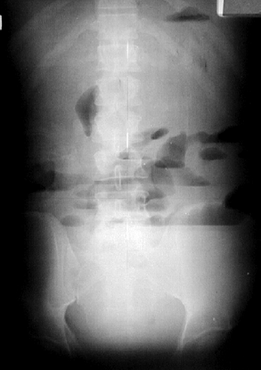 B 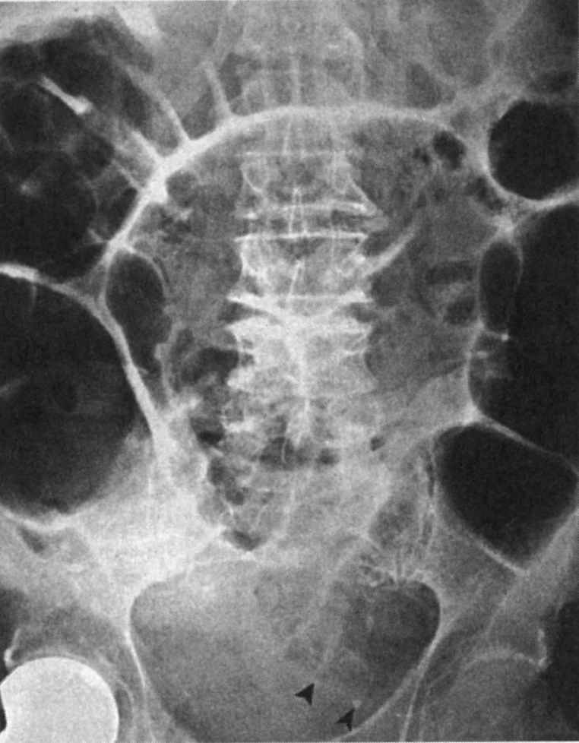

Fig. 5-18. Radilogical picture of small (A) and large (B) intestinal obstruction

Hernias

- Hernias (see Chapter 12) are the second very common cause of intestinal obstruction.
- A segment of intestine migrates through a defect in the abdominal wall (external hernia) or through a mesenteric or omental defect (internal hernia) and becomes blocked by the narrow ring that is present at the peritoneal communication of the hernia.

Tumors

- Intestinal tumors are the third most common cause of obstruction.
- The most common obstructing tumor is an adenocarcinoma of the colon or rectum (see Chapter 6).
- Benign lesions of the small bowel and colon, such as lipomas, can become the leading point of an intussusception.
- Other malignant tumors, such as carcinoid or lymphoma, can obstruct the intestinal lumen.

Other lesions

- Other intrinsic lesions within the bowel wall or the lumen can cause acute obstruction.
- The most common from them are: congenital lesions (webs, malrotations, and atresias), inflammatory lesions (Crohn's disease, diverticulitis, ulcerative colitis, and infections, such as tuberculosis), luminal foreign bodies (bezoars, parasites, and gallstones), radiation injury, other trauma, and endometriosis.
- Other extrinsic lesions can compress the intestinal lumen, such as large intra-abdominal tumors or abscesses.

Gallstone ileus

- Gallstone ileus is complication of cholelithiasis, due to adhesions to the surrounding viscera, perforation, fistula formation, and passage of the stone into the bowel.
- The site of fistula with the gallbladder is most commonly the duodenum, but the colon or stomach may be involved. As the stone travels in the gastrointestinal lumen, the terminal ileum is the most common site of obstruction as this is the narrowest portion of the small bowel. Stones smaller than 2-3 cm are usually passed per rectum.
- If a stone is passed free into the peritoneal cavity, extraluminal obstruction secondary to inflammation and adhesions can occur anywhere.
- The patient presents with symptoms of small bowel obstruction (i.e., nausea, vomiting, obstipation, crampy pain, and abdominal distention).
- The correct diagnosis is made preoperatively in fewer than 25% of cases. It is suggested by the history and by plain films of the abdomen that may show small bowel obstruction accompanied by air in the biliary tree (see Fig. 5-19), or a radiopaque stone in the right lower quadrant.

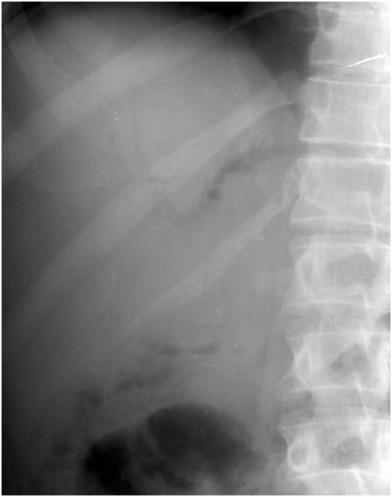

Fig. 5-19. Aerobilia due to biliary-digestive fistula

Treatment

Adhesive band obstruction

- Since surgery for adhesive band obstruction has great morbidity and mortality (due to high rate of strangulation requiring resection of the intestine or injury to the bowel, with possible leakage and fistula formation), initial treatment, as a rule, conservative if there is no suspection of strangulation (i.e., long hystory of obstruction, severe abdominal distension and pain, signs of peritonitis).
- It includes starvation, nasogastric tube placement with prolonged suction, massive infusion therapy, administration of antispasmodics, hypertonic enemas and mild laxatives.
- If patient doesn’t respond to medical treatment or disease progresses, open (less commonly laparoscopic) surgery is indicated.
- Intestinal adhesions are treated by lysis of the obstructing bands. Necrotized segment of bowel must be resected (see Fig. 5-20). Intubation of the entire small intestine is necessary.

1 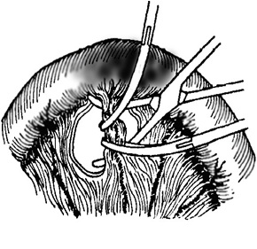 2 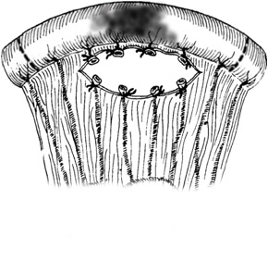 3 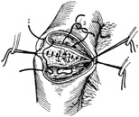 4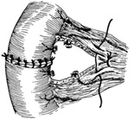

Fig. 5-20. Technique of resection of necrotized segment of small bowel with end-to-end anastomosis

Hernias

- Hernias are treated by a reduction of the contents of the hernia and subsequent repair (see Chapter 12).
- The bowel must always be examined for necrosis.
- Necrotized segment must be resected (see Fig. 5-20).

Tumors (see Chapter 6)

Treatment of gallstone ileus

- As these patients are often extremely ill, emergency laparotomy may permit only localization of the stone, proximal enterotomy, stone extraction, and closure of the enterotomy. Intubation of small intestine is stronly recommended.
- The whole small bowel, common bile duct, and gallbladder must be palpated for stones as recurrent gallstone ileus (due to other stones) develops in 5%-9% of patients.
- Cholecystectomy and closure of the biliary fistula can be performed either concomitantly or after an interval, depending on the patient's condition.

Adynamic ileus

- Functional obstructions are blockages in the intestinal flow that result from impaired motility (paralytic or adynamic ileus) (see Table 6-1). These are usually treated by observation, fluid, electrolyte and nutritional support, and measures of aggressive stimulation of peristalsis (repeated hypertonic enemas, high dosages of cholinomimetics, physiotherapy) until the causal agent that requires specific treatment resolves.
- The most common causes are: direct irritation of the intestine (such as generalized peritonitis), postoperative adynamic ileus (that can last for 3-7 days following surgery), and extraperitoneal causes (such as retroperitoneal hematoma or retroperitoneal lesions in acute pancreatitis with nerve root compression).

REVIEW TESTS

1. A 47-years-old man was admitted to ER with complaints of multiple vomiting with the food and fluid ingested yesterday and the day before yesterday, and moderate periodical pain at the epigastric region. The symptoms appeared 2 weeks ago. There is a history of chronic relapsing course of ulcer disease of the duodenum. The patient is emaciated, skin turgor is markedly decreased, arterial pressure is 100/70 mmHg, pulse is weak, 100 beats per minute, last 24h urine output is 400 ml. Physical examination of abdomen reveals moderate tenderness at the right subcostal region, no rebound tenderness and muscle guarding, positive “splash” sign at the epigastrium. Ultrasound doesn’t reveal any pathology. Endoscopy shows an ulcer of pyloric channel, measuring 2 cm in diameter, with deep bottom and dense infiltrated borders; there is marked stenosis of pyloric channel which is not passable for the endoscope. Biopsy of ulcer shows no data for malignancy. Upper GI series reveals retention of barium meal in the stomach 24 after ingestion of the medium. What’s the most appropriate tactics of managing the patient?

A. Highly selective vagotomy, pyloroplasty
B. Truncal vagotomy, antrectomy, Bilroth-I reconstruction
C. Truncal vagotomy, gastroenterostomy
D. Gastrectomy, esophagojejunostomy
E. Truncal vagotomy, pyloroplasty

2. A 54-years-old man was admitted to surgical department with complaints of a moderate periodical pain at epigastric region, periodical nausea, vomiting and belching, progressive weakness, and weight loss. The symptoms appeared 6 months ago. There is a history of chronic gastritis. Physical examination of abdomen reveals slight tenderness at the epigastric region, no rebound tenderness and muscle guarding. Endoscopy shows a large ulcer of the angle of stomach measuring 4 cm in diameter, with irregular bottom and borders, with rigid gastric wall around it. Biopsy conclusion is moderately differentiated adenocarcinoma. Abdominal and pulmonary CT doesn’t reveal distant metastases, and spreading into the major vessels. What’s the most appropriate tactics of surgical managing the patient?

A. Truncal vagotomy, gastroenterostomy
B. Truncal vagotomy, antrectomy, Bilroth-I reconstruction
C. Gastrectomy, esophagojejunostomy
D. Subtotal distal hemigastrectomy, Bilroth-II reconstruction
E. Hemigastrectomy, Bilroth-II reconstruction

3. A 60-years-old man was admitted to surgical department with complaints of a multiple vomiting with the food and fluid ingested yesterday and the day before yesterday, moderate periodical pain at epigastric region, progressive weakness, and weight loss. The pain appeared 4 months ago, and vomiting began 2 weeks ago. There is a history of chronic gastritis. The patient is emaciated, skin turgor is markedly decreased, arterial pressure is normal, last 24 hours urine output is 600 ml. Physical examination of abdomen reveals slight tenderness at the epigastric region, no rebound tenderness and muscle guarding, positive “splash” sign at the epigastrium. Endoscopy shows a large ulcer of the pyloric channel, measuring 3.5 cm in diameter, with irregular bottom and borders, with rigid gastric wall around it; there is marked stenosis of pyloric channel which is not passable for the endoscope. Biopsy conclusion is poorly differentiated adenocarcinoma. Abdominal CT reveals multiple liver metastases, spreading of the tumor into retroperitoneal space and encasement of the celiac trunk. What’s the most appropriate tactics of surgical managing the patient?

A. Gastrectomy, esophagojejunostomy
B. Gastroenterostomy
C. Hemigastrectomy, Bilroth-II reconstruction
D. Subtotal distal hemigastrectomy, Bilroth-II reconstruction
E. Truncal vagotomy, antrectomy, Bilroth-I reconstruction

4. A 65-years-old woman was admitted to ER with complaints of a cramping pain at all the sites of abdomen and multiple vomiting. The last bowel movement was 2 days prior to admission. She has bowel movements ones in 3 or 4 days for the last year, and weight loss of 10 kg for the last 2 months. Patient is anemic. Physical examination of abdomen reveals marked distention, moderate diffuse tenderness, no rebound tenderness and muscle guarding. The “splash” sign is positive; the peristalsis is increased. Digital examination reveals absence of feces in the rectum. There are no hernias and postoperative scars. Upright abdominal radiography shows 2 large Kloiber’s cups along with horizontal fluid-gas levels in the left half of abdomen. Give your presumable diagnosis:

A. Ulcer disease, gastric outlet obstruction
B. Adhesive band obstruction of small intestine
C. Obstructing carcinoma of proximal part of colon
D. Obstructing carcinoma of distal part of colon
E. Adynamic ileus

5. A 45-years-old man was admitted to ER with complaints of a cramping pain at all the sites of abdomen and multiple vomiting. The last bowel movement was 3 days prior to admission. 5 years ago he was operated for blunt abdominal trauma with intraperitoneal bleeding from ruptured spleen, the spleenectomy was performed. The same attack took place 1 year ago after massive meals. He has bowel movements daily, and stable weight. Physical examination of abdomen reveals marked distention, moderate diffuse tenderness, no rebound tenderness and muscle guarding. The “splash” sign is positive; the peristalsis is increased. Digital examination reveals absence of feces in the rectum. There are no hernias, including within the postoperative scar (upper midline laparotomy). Upright abdominal radiography shows multiple Kloiber’s cups along with horizontal fluid-gas levels within all sites of abdomen. Give your presumable diagnosis:

A. Adynamic ileus
B. Ulcer disease, gastric outlet obstruction
C. Adhesive band obstruction of small intestine
D. Obstructing carcinoma of proximal part of colon
E. Obstructing carcinoma of distal part of colon

6. A 75-years-old man was admitted to ER with complaints of intense diffuse abdominal pain, multiple fecal vomiting and abdominal distension. He is ill for 4 days. Arterial pressure is 80/40 mmHg, pulse is weak, 120 beats per minute, central arterial pressure is negative, last 24h urine output is 300 ml. He has bowel movements every 3 to 5 days for the last year, and weight loss of 15 kg for the last 2 months. Patient is anemic, cahectic. Physical examination of abdomen reveals marked distention, moderate diffuse tenderness, no rebound tenderness and muscle guarding. The “splash” sign is positive; the peristalsis is very weak. Digital examination revealed absence of feces in the rectum. There are no hernias and postoperative scars. Upright abdominal radiograph shows several large Kloiber’s cups along with horizontal fluid-gas levels in the left half of abdomen. What’s the most appropriate tactics of managing the patient?

A. Delayed surgery – laparotomy – after preoperative preparation for 20-24 hours in ICU
B. Immediate surgery – laparotomy
C. Immediate surgery – diagnostic peritoneal lavage
D. Delayed surgery – laparotomy – after preoperative preparation for 2-6 hours in ICU
E. Further diagnostic procedures (CT, followed by upper GI endoscopy, followed by barium enema) to establish the distinct diagnosis with subsequent delayed surgery after preoperative preparation for 2-6 hours in ICU

Correct answers: 1 - C, 2 - C, 3 - B, 4 - D, 5 - C, 6 - D.

