CHAPTER 6. OBSTIPATION

- Constipation and obstipation most commonly are caused by different forms of small (see Chapter 5) and large intestine obstruction and varoius surgical and non-surgical gastrointestinal and extra-abdominal diseases listed below.
- Obstipation usually is associated with nausia, vomiting and abdominal distension.

Table 6-1. List of diseases producing obstipation

Mechanical obstruction (diseases producing obstipation rather than vomiting)
Intraluminal
Meconium
Impactions
Fecal
Barium
Intramural
Congenital
Imperforate anus
Duplications
Neoplastic
Benign
Malignant
Inflammatory
Strictures due to Crone’s disease
Diverticulitis
Chronic ulcerative colitis
Extraluminal
Extrinsic masses
Cysts
Neoplasms
Abscesses
Hematomas
Volvulus
Anorectal diseases
Anorectal abscess
Fissura-in-ano
Rectal prolapse
Rectocele
Dynamic obstruction
Paralytic ileus
Abdominal causes
Postoperative (thoracic or abdominal operations)
Peritonitis
Retroperitoneal lesions
Edematous pancreatitis
Cysts
Neoplasms
Abscesses (including pancreatogenic)
Hematomas
Ascites
Following trauma (abdominal or remote)
Spinal cord injury
Head injury
Abdominal wall or retroperitoneal injury
Pelvic or lumbar spine fracture
Long bone fracture
Systemic causes
Collagen vascular disease
Multiple sclerosis
Scleroderma
Amyloidosis
Electrolyte imbalance
Hypercalcemia
Hypokalemia
Endocrine causes
Hypothyroidism
Hyperparathyroidism
Glucagonoma
Somatostatinoma
Panhypopituitarism
Pheochromocytoma
MEN Ia, IIb
Diabetic ketoacidosis
Addisonian crisis
Metabolic diseases
Porphyria
Amyloidosis
Uremia
Neuromuscular defects
Congenital megacolon (Hirshprung’s disease)
Aquired megacolon (Chagas' disease)
Pregnancy
Pseudoobstruction (Ogilvie's syndrome)
Drug effects / toxemias
Narcotics
Aluminum (antacids)
Psychotropic agents
Ganglionic blockers
Calcium (antacids, supplements)
Sucralfate
Anticholinergics
Antidepressants
Calcium-channel blockers
Barium sulfate
Diuretics
Iron supplements
Antihypertensives
Vinca alkaloids
Antispasmodics
Metal intoxication (mercury, lead, arsenic)
Ischemic colitis
Irritable bowel syndrome
Idiopathic slow transit
Inadequate fiber
Psychologic, psychiatric, anorexia nervosa
Following painful illness, such as myocardial infarction
Spastic ileus (lead poisoning)

BENIGN COLORECTAL TUMORS

Polyps

- A polyp may be defined as any projection from the surface of the intestinal mucosa.

Classification and clinical characteristic

- Pedunculated polyps are attached to the bowel wall by a stalk. Sessile polyps are flat growths with no stalk.
- Hyperplastic polyps are small (usually < 5 mm) lesions of thickened mucosa without cellular atypia. They are present in 50% of adults, which makes them the most common type of polyp. There is no malignant potential, and treatment is usually unnecessary.
- Hamartomatous polyps are nonneoplastic growths composed of an abnormal mixture of normal tissue (see Fig. 6-1). Juvenile polyps are hamartomas that most frequently occur in children and may cause gastrointestinal bleeding or intussusception.
- Inflammatory polyps are growths resulting from tissue reaction to inflammation, such as pseudopolyps in ulcerative colitis or benign lymphoid polyps. They have no neoplastic potential.
- Adenomatous (neoplastic) polyps are by definition benign, but they have the potential to develop into cancer. These polyps are classified by histology into three types: tubular adenomas (75% of adenomas) have a smooth, firm surface and are often on a stalk (see Fig. 6-2); villous adenomas (10% of adenomas) are soft, sessile lesions with frond-like projections (see Fig. 6-3); tubulovillous adenomas (15% of adenomas) have elements of both tubular and villous adenomas.

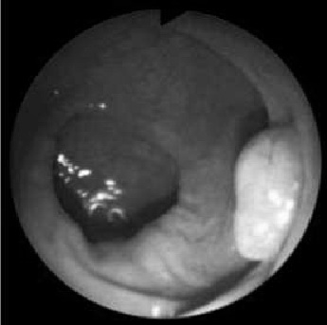

Fig. 6-1. Colonoscopic picture of hamartomatous polyp

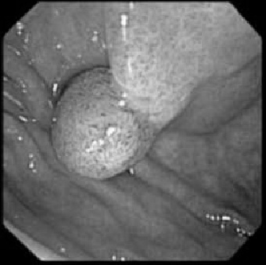

Fig. 6-2. Colonoscopic picture of tubular adenoma

A 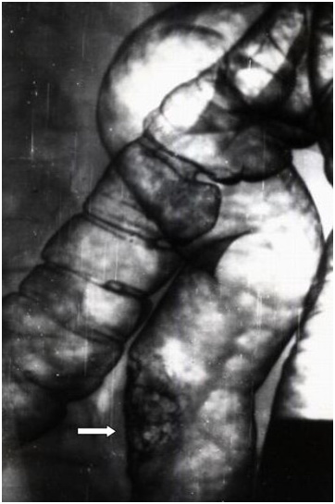 B 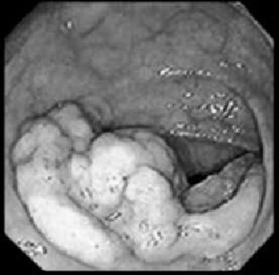

Fig. 6-2. Radiological and colonoscopic picture of villous adenoma

The adenoma-carcinoma sequence

- Cumulative evidence suggests a progression from benign neoplasia to malignancy in colorectal polyps.
- Patients with colorectal cancer often have synchronous adenomatous polyps.
- Histopathologic studies have shown transition from adenoma to carcinoma in polyps. Peak incidence for discovery of colon polyps is age 50 years; peak incidence for development of cancer is age 60 years. This fact suggests a 10-year span for adenomas to transform to cancer.
- Patients with familial adenomatous polyposis invariably develop colon cancer if not treated.
- Polypectomy has been shown to reduce the risk of colorectal cancer.
- Probably more than 95% of colorectal cancers arise from neoplastic polyps. At least three characteristics of polyps are associated with malignancy: polyps 1-2 cm in size 10% malignant, polyps greater than 2 cm in size 50% malignant; tubular polips 5% malignant, tubuiovillous polips 20% malignant, villous polips 40% malignant.

Treatment

- Neoplastic polyps should be removed because of their malignant potential.
- Endoscopic polypectomy (see Fig. 6-4) (excision with a colonoscope or sigmoidoscope) is ideal for pedunculated polyps. Small, superficial, sessile polyps are often amenable to piecemeal removal by this technique.
- Transanal polypectomy. Rectal polyps may be surgically removed through the anus.
- Segmental colectomy is required both for sessile polyps that cannot be excised with an endoscope and for most polyps that are malignant or suspected to be malignant.
- A malignant polyp may be treated by endoscopic polypectomy if all of these characteristics are present: the polyp is pedunculated, the cancer is confined to the head, there is no venous or lymphatic invasion, the polyp is moderately differentiated or well differentiated histologically.
- Scheme 6-1 shows the treatment and follow-up algorithm.

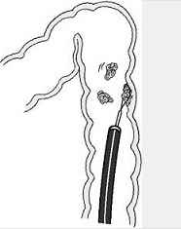

Fig 6-4. Scheme of colonoscopic polypectomy

Scheme 6-1. Management of polyps
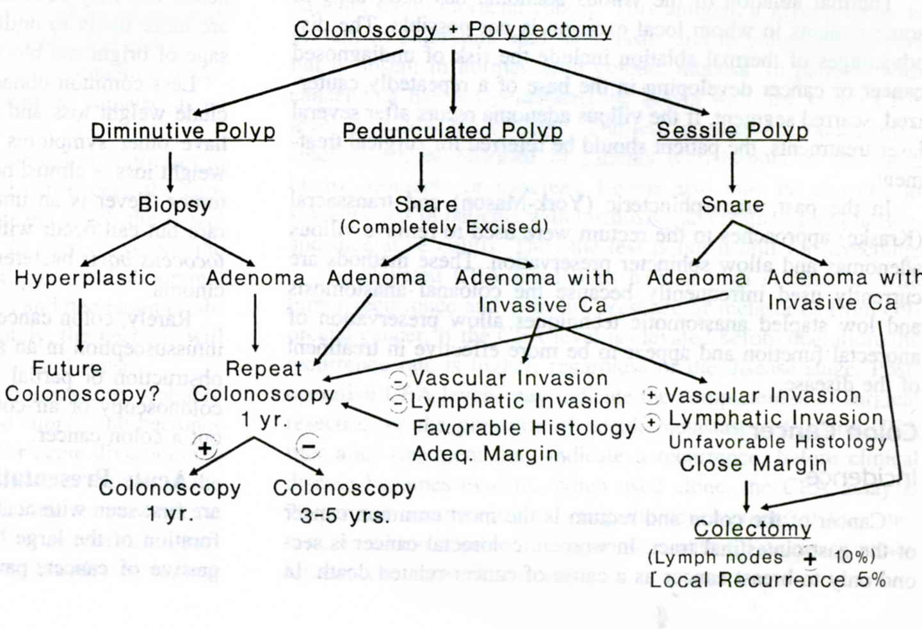
From: Principles of surgery/ed., S.I. Schwartz, et al. – 7th ed.

Polyposis syndromes

Peutz-Jeghers syndrome

- Peutz-Jeghers syndrome is an autosomal dominant disorder characterized by hyperpigmented spots on the lips, buccal mucosa, face, and digits and hamartomas throughout the gastrointestinal tract.
- The polyps may cause gastrointestinal bleeding and intussusception.
- There is an increased risk of malignancy of the intestine and other organ systems.
- Symptomatic polyps should be removed, with a goal of preservation of intestine.

Diffuse juvenile polyposis

- Diffuse juvenile polyposis is an autosomal dominant disease characterized by a heterogeneous population of polyps, both hamartomas and adenomas.
- Intussusception, diarrhea, and protein loss may occur.
- There is at least a 10% risk of developing colon cancer.
- Treatment is most commonly subtotal colectomy and ileorectal anastomosis (see Fig. 6-5, B). Proctoscopy of the remaining rectum should be done every 6 months, and any new rectal polyps should be excised. If there are diffuse rectal polyps, total protocolectomy with either an ileostomy or preferably an ileal pouch-anal anastomosis (see Fig. 6-5, D) is indicated.

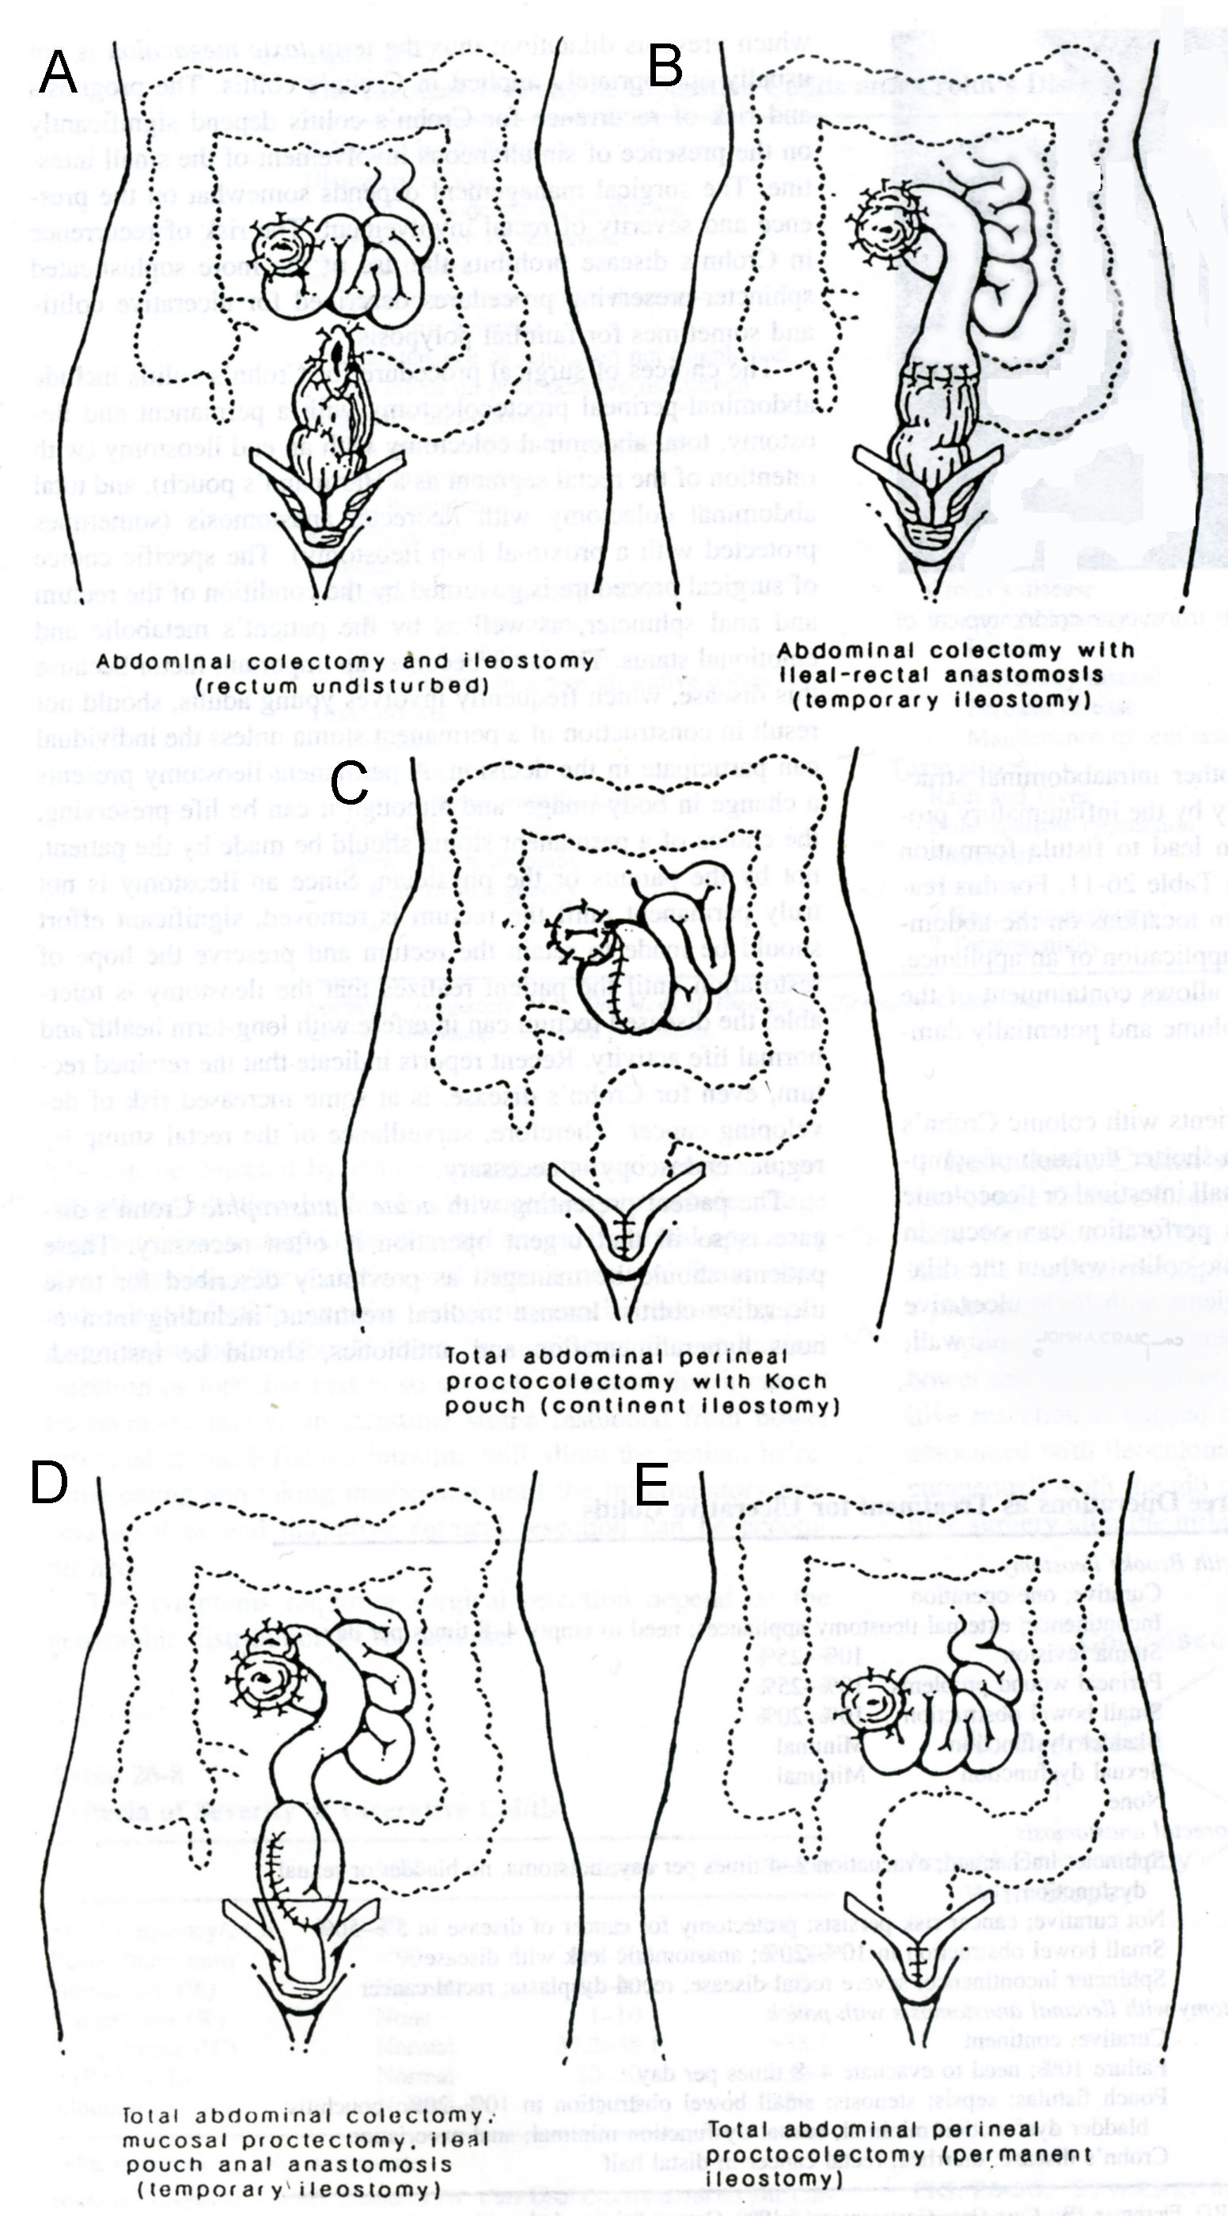

Fig 6-5. Variants of colectomy

Cowden syndrome

- Cowden syndrome is an autosomal dominant disorder characterized by hamartomas throughout the gastrointestinal tract, mucocutaneous abnormalities (e.g., facial and oral papules, keratotic growths on the hands and feet), and breast, thyroid, or uterine cancer.
- Treatment is not usually required for the polyps but is directed toward the extraintestinal malignancies.

Cronkhite-Canada syndrome

- Cronkhite-Canada syndrome is a non-inherited syndrome characterized by generalized intestinal hamartomas in association with alopecia, cutaneous pigmentation, and atrophy of the finger nails and toe nails.
- Symptoms include vomiting, diarrhea, malabsorption, and protein-losing enteropathy.
- Mortality is usual, but there have been reports of spontaneous remission.
- Treatment is reserved for complications, such as intestinal obstruction.

Familial adenomatous polyposis

Clinical characteristic

- Familial adenomatous polyposis (FAP) is characterized by more than 100 adenomatous polyps throughout the colon and rectum. If untreated, almost 100% of patients develop colon cancer by the fifth decade of life.
- Fifty percent of offspring of affected patients develop the disease. FAP is an autosomal dominant syndrome with high penetrance. One-third of patients with FAP have no family history of the disease: they represent spontaneous mutations. Although the disease is inherited, polyps are not present at birth, and they rarely appear before puberty.
- The polyps may cause bleeding or, rarely, intussusception.
- Extraintestinal expressions are common and include: epidermoid cysts, osteomas, cutaneous fibromas, desmoid tumors of the abdomen and mesentery, gastrointestinal polyps, retinal pigmentation, periampullary carcinoma, thyroid carcinoma.
- Diagnosis is made by confirming the numerous polyps by endoscopy (see Fig. 6-5) and obtaining a biopsy to ensure the adenomatous nature of the polyps.

A 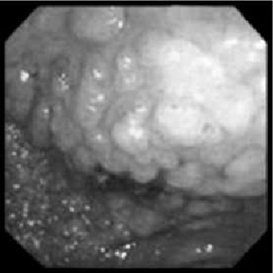 B 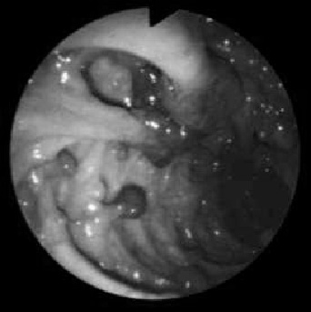

Fig. 6-6. Endoscopic picture of familial adenomatous polyposis

Treatment

- Treatment is aimed toward removing the colon before cancer develops.
- Total proctocolectomy with ileostomy (see Fig. 6-5, E). This procedure removes all colorectal mucosa, but the patient must wear an appliance.
- Total proctocolectomy and continent ileostomy (see Fig. 6-5, C). A reservoir is fashioned from the ileum to prevent outflow; the ileostomy must be intubated several times a day for elimination. The patient does not have to wear an appliance, but the operation is technically difficult with a high incidence of complications.
- Colectomy with ileorectal anastomosis (see Fig. 6-5, B). This operation is the most common for this condition. The colon is excised and the ileum is anastomosed to the rectum, which leaves only 15 cm of bowel at risk for cancer. Patients must be examined by proctoscopy every 6 months, and all rectal polyps are destroyed when they appear.
- Total protocolectomy with ileal pouch-anal anastomosis (see Fig. 6-5, D). This operation is especially attractive for patients with “carpeting” of the rectum by polyps too numerous to remove. This procedure removes all colorectal mucosa at risk for cancer and therefore requent proctoscopic examinations not required. But complications more likely with this procedure (including sepsis, impotence, fistula), stools is more frequent and there is higher incidence of anal incontinence and nocturnal seepage.

Gardner's syndrome

- Gardner's syndrome is FAP with osteomatosis, epidermoid cysts, and skin fibromas.

Turcot's syndrome

- Turcot's syndrome is FAP associated with central nervous system malignancies (e.g., medulloblastoma of the spinal cord, glioblastoma of the cerebrum).

MALIGNANT COLORECTAL TUMORS

Carcinoma of colon and rectum

Overview

- Colorectal cancer is the most common malignancy of the gastrointestinal tract.
- It is the third most lethal cancer in women (after lung and breast) and in men (after lung and prostate).
- An American has approximately a 5% probability of developing colorectal cancer during a 70-year life span.
- Most cancers are detected after the age of 50; incidence rises with age.
- During the past 50 years, there has been a shift in the location of carcinomas from the rectum and left colon toward the right colon (see Scheme 6-2). This fact suggests that methods for detecting early large-bowel cancer should be directed at the entire colon, rather than the rectosigmoid.
- Neither the cause nor the pathogenesis is well understood. The polyp-cancer sequence has been discussed previously. Patients with ulcerative colitis have an increased risk of colorectal cancer, estimated to be more than 40% 25 years after the onset of pancolitis. Patients with Crohn's colitis have a lower risk of cancer than those with ulcerative colitis, but a higher risk than the general population.
- There is an increased incidence of first-degree relatives of patients with colorectal cancer. The genetic transmission in FAP was described previously. Two types of hereditary nonpolyposis colorectal carcinoma have been recognized. Site-specific nonpolyposis colorectal carcinoma (Lynch syndrome I) characterized by autosomal dominant inheritance, predominance of proximal colon cancers, increased synchronous colon cancers, early age of onset (average age is 44 years) and increased risk of metachronous cancers. Cancer family syndrome (Lynch syndrome II), in addition to the above features, is associated with increased incidence of other carcinomas, including endometrium, ovary, breast, stomach, and lymphoma; increased incidence of mucinous or poorly differentiated carcinomas and increased incidence of skin cancers.
- People who consume diets high in saturated fats have an increased risk of colorectal cancer. People who consume a high-fiber diet have a decreased risk of colorectal cancer. Increased dietary calcium decreases the incidence of colorectal cancer. Heavy beer drinkers have a twofold increased risk of colorectal cancer.

Scheme 6-2. Distribution of colorectal cancer

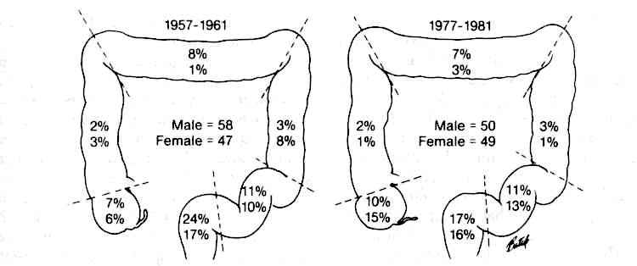
From: Basic surgery/ed., H.C. Polk, Jr., et al. – 5th ed.

TNM-staging of cancer of colon and rectum
TX Primary tumor cannot be assessed
T0 No evidence of primary tumor
Tis Carcinoma in situ: intraepithelial or invasion of lamina propria
T1 Tumor invades submucosa
T2 Tumor invades muscularis propria
T3 Tumor invades through muscularis propria into subserosa or into non-peritonealized pericolic or
perirectal tissues
T4 Tumor directly invades other organs or structures and/or perforates visceral peritoneum
NX Regional lymph nodes cannot be assessed
N0 No regional lymph node metastasis
N1 Metastasis in 1 to 3 regional lymph nodes
N2 Metastasis in 4 or more regional lymph nodes
MX Distant metastasis cannot be assessed
M0 No distant metastasis
M1 Distant metastasis

Stage 0 | Tis | N0 | M0
Stage I | T1, T2 | N0 | M0 | Dukes’ A
Stage IIA | T3 | N0 | M0 | Dukes’ B
IIB | T4 | N0 | M0 | Dukes’ B
Stage IIIA | T1, T2 | N1 | M0 | Dukes’ C
IIIB | T3, T4 | N1 | M0 | Dukes’ C
IIIC | Any T | N2 | M0 | Dukes’ C
Stage IV | Any T | Any N | M1 | Dukes’ D

Clinical features and visualization data

- Clinical presentation depends on the location, size, and extent of the tumor. Right-sided cancer is characterised by melanotic stools, iron deficiency anemia and right-sided abdominal mass. Left-sided cancer is characterised by change in bowel habits, passage of red blood per rectum and cramping abdominal pain (caused by partial obstruction). Complete obstruction (see Chapter 5) may develop in left-sided lesion.
- Digital examination is useful to assess the location, size, and extent of invasion of a tumor in the distal rectum. Hard areas in a tumor suggest carcinoma, whereas soft polyps are more likely benign. If a tumor feels fixed to the adjacent pararectal tissues, malignant invasion of the bowel wall is likely.
- Rigid proctosigmoidoscopy is useful to determine the exact location of a rectal tumor in relation to the anal verge.
- Endorectal ultrasound provides information concerning the depth of invasion into the bowel wall by a rectal tumor (see Fig. 6-7).
- Colonoscopy with biopsy of the lesion and inspection of the remaining colon is necessary to exclude synchronous lesions (see Fig. 6-8).
- A barium enema (see Fig. 6-9) is often not required if the colonoscopic examination is satisfactory. If the colonoscope does not reach the cecum, a barium enema should be obtained to evaluate the entire colon.
- CT scan and MRI are used to evaluate spreading of tumor to the adjacent structures, assess the liver and abdomen for metastases and both kidneys for ureteral obstruction (see Fig. 6-10).
- Computed reconstruction of CT scans of colon may create images of lumen of bowel like in colonoscopy (the so called virtual colonoscopy), which is a future technology for screening of large lesions (see Fig. 6-11).

Table 6-2. Comparison of symptoms associated with right and left colon cancers

Symptom | Right colon | Left colon
Abdominal pain | Frequent | Uncommon
Altered bowel habits | Diarrhea frequent | Obstructive: ↓ stool caliber
Palpable mass | Often present | Usually present
Rectal bleeding | Occult | Visible
Anemia | Frequent | Uncommon

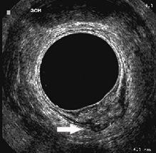

Fig. 6-7. EUS picture of early rectal cancer

A 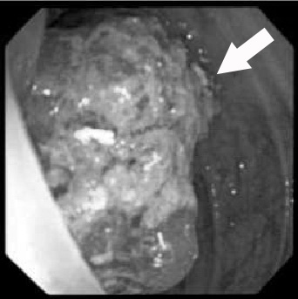 B 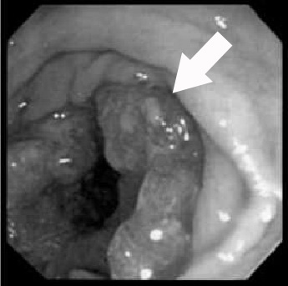

Fig. 6-8. Endoscopic pictures of cancer of colon

A 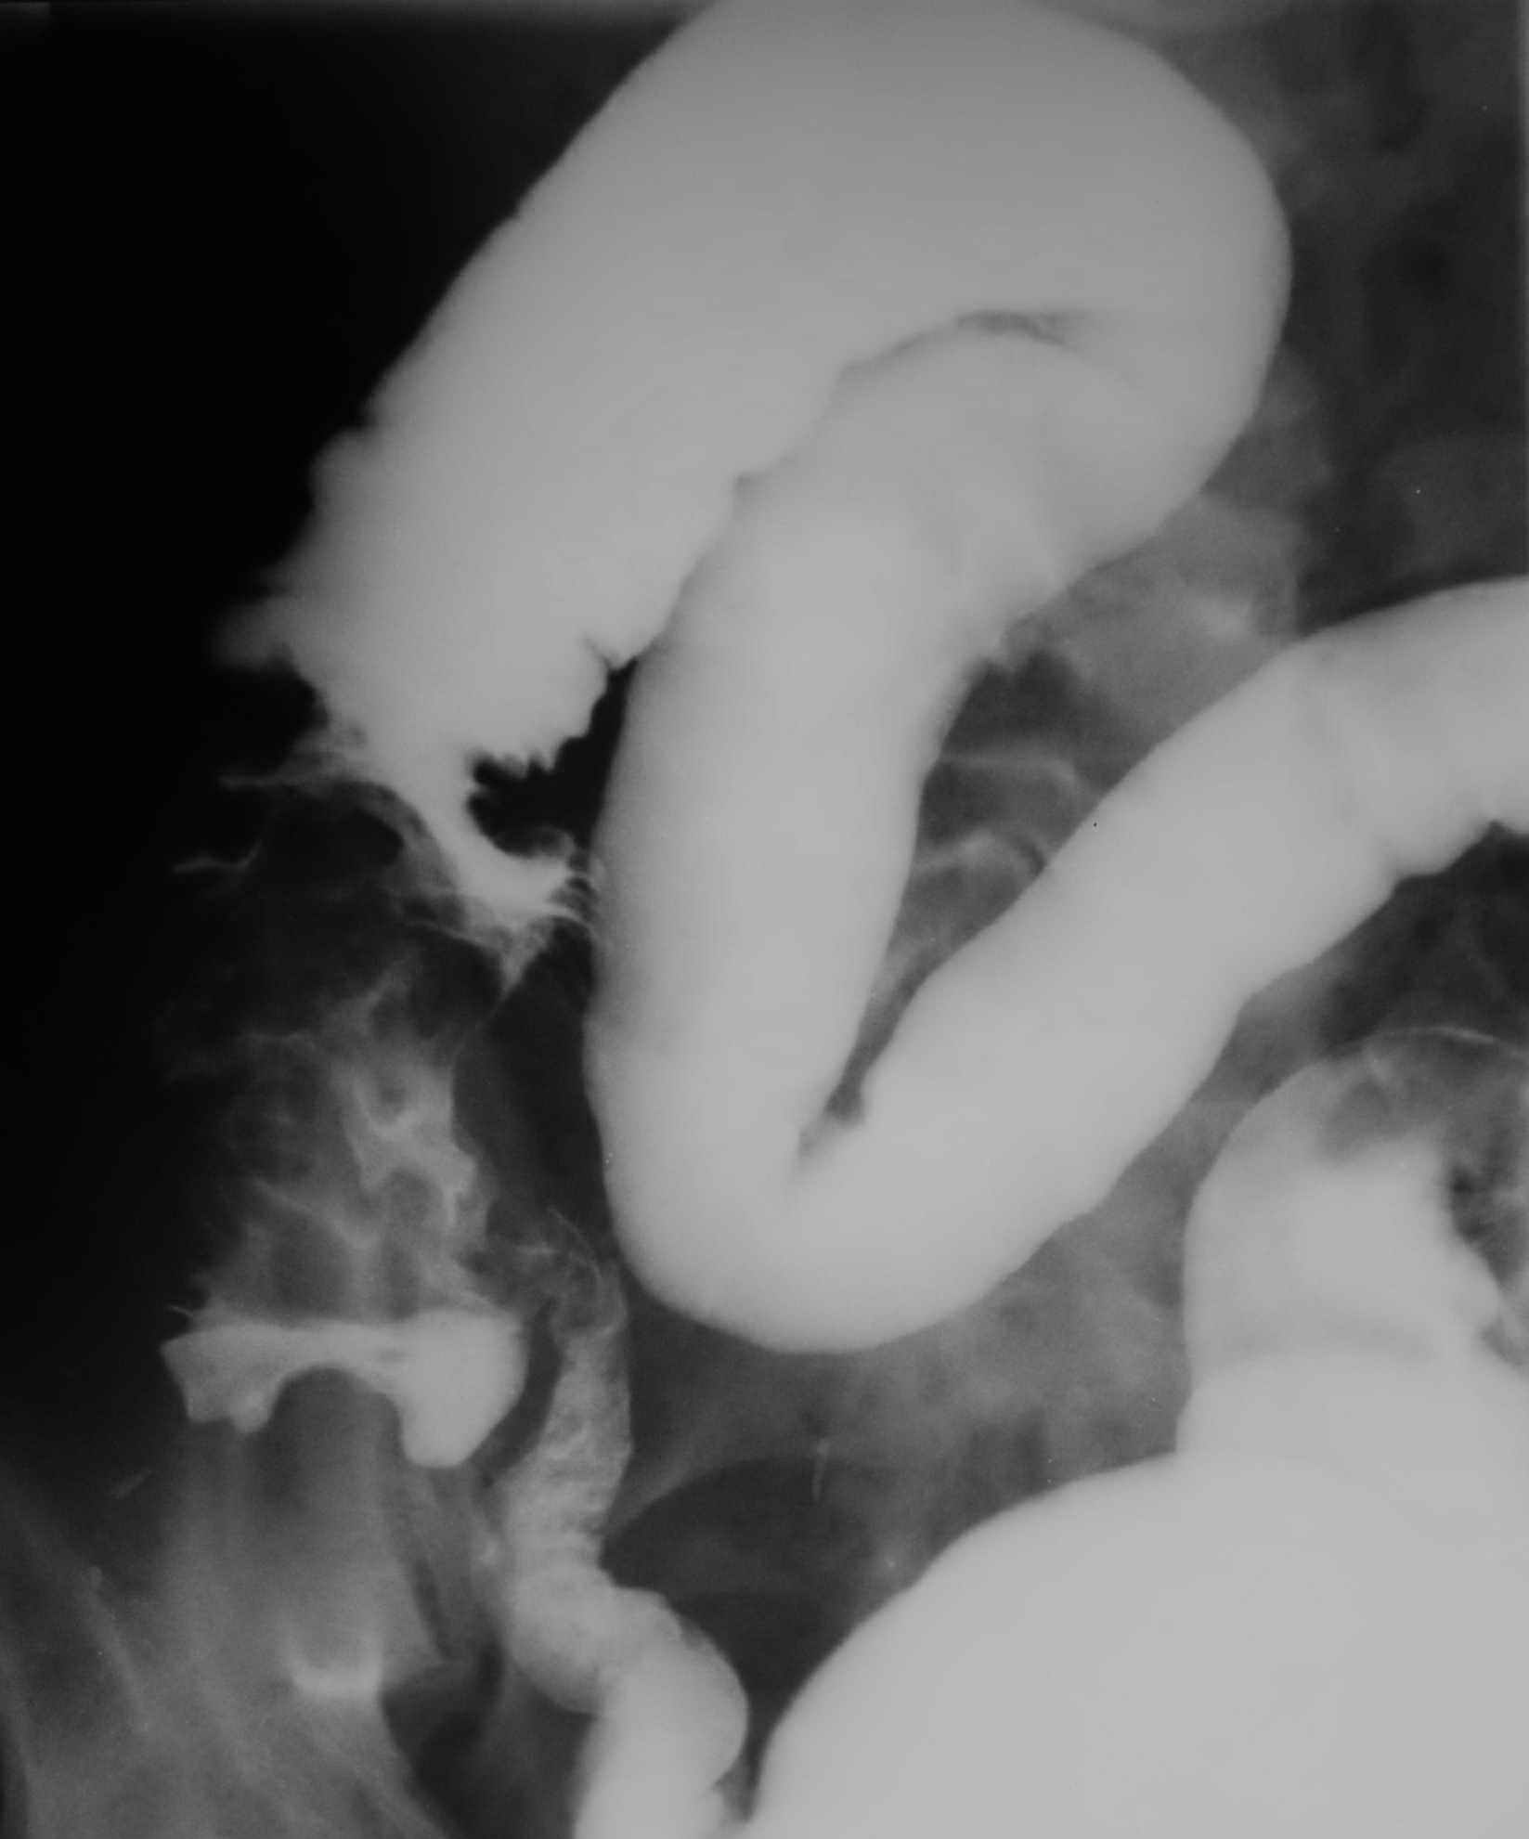 B 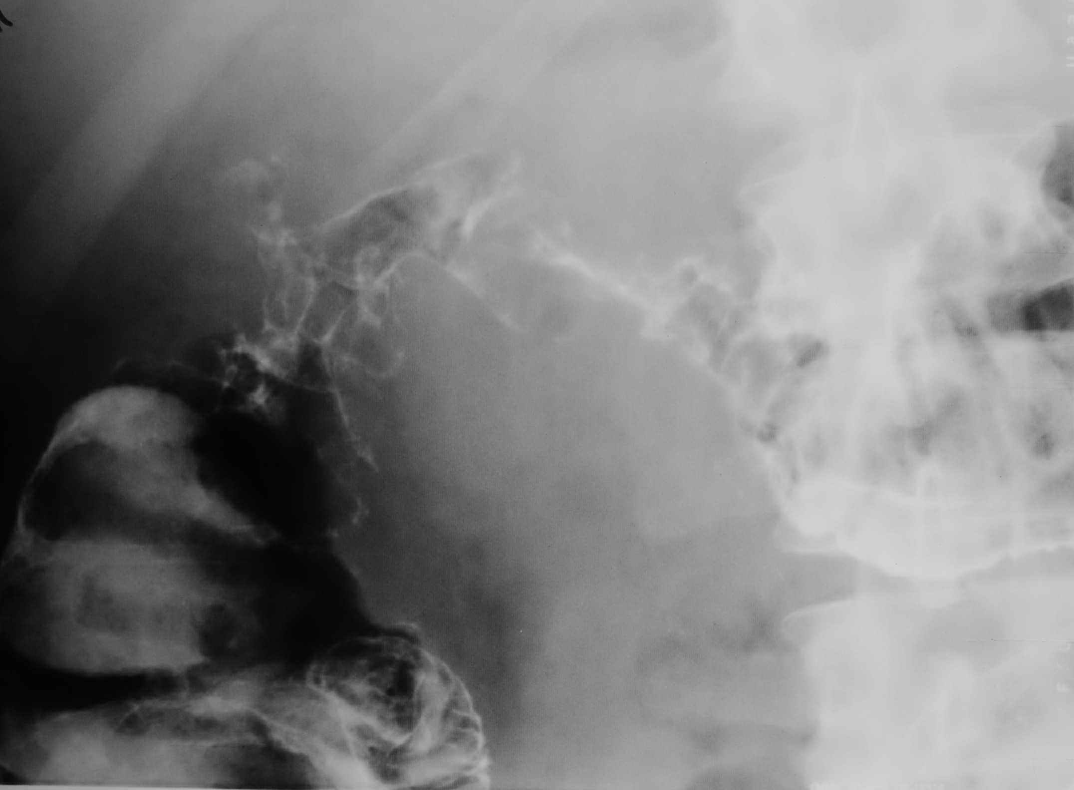 C 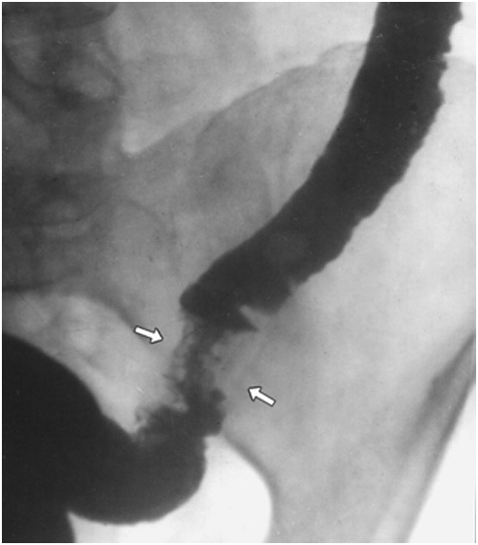

D 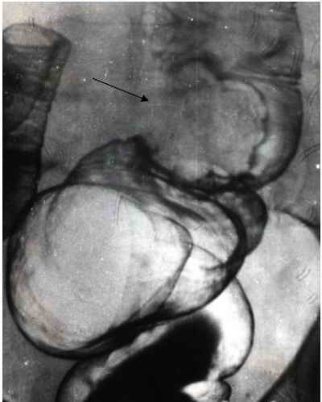 E 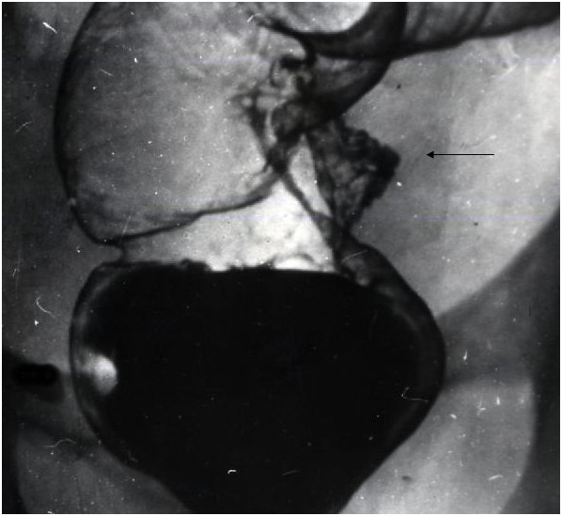

Fig. 6-9. Radilogical pictures of cancer of caecum (A), hepatic angle (B), descending colon (C), rectosigmoid (D) and rectum (E).

A 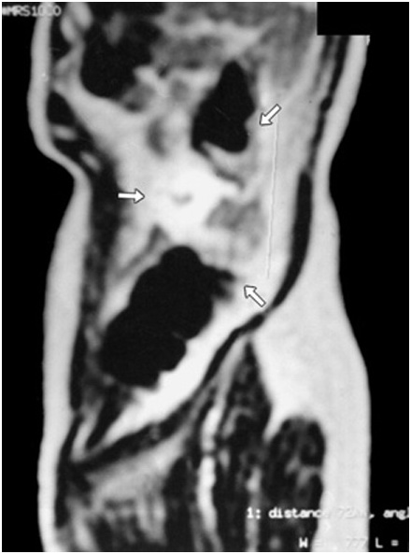 B 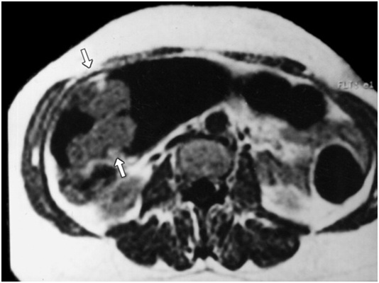

Fig. 6-10. MRI pictures of cancer of descending (A) and transverse (B) colon

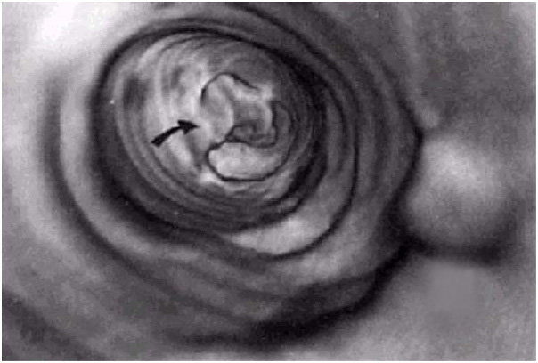

Fig. 6-11. Cancer of colon on virtual colonoscopy

Treatment

Scheme 6-3. Algorithm of management of cancer of right half of colon
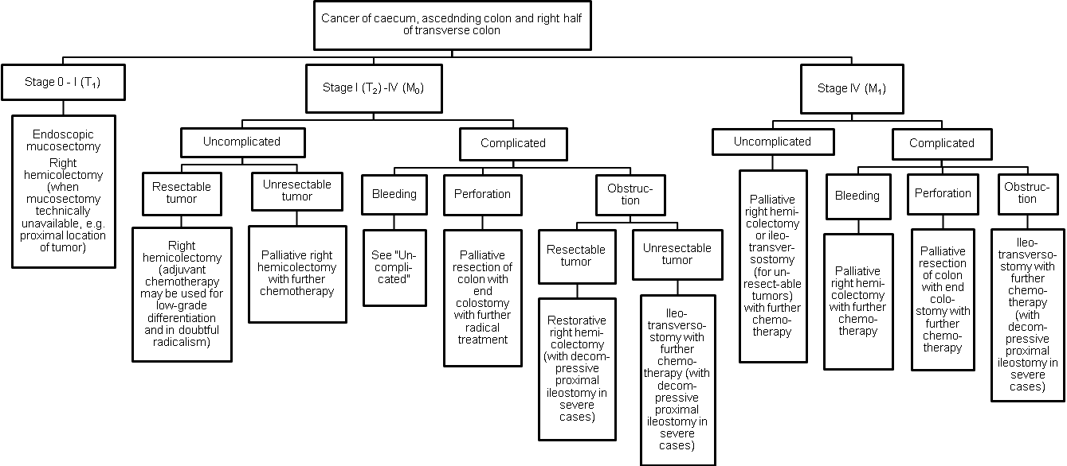
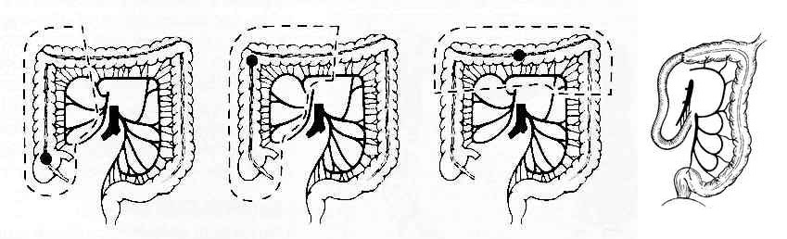
Fig. 6-12. Schemes of resections of colon for right-sided tumors

Scheme 6-4. Algorithm of management of cancer of left half of colon

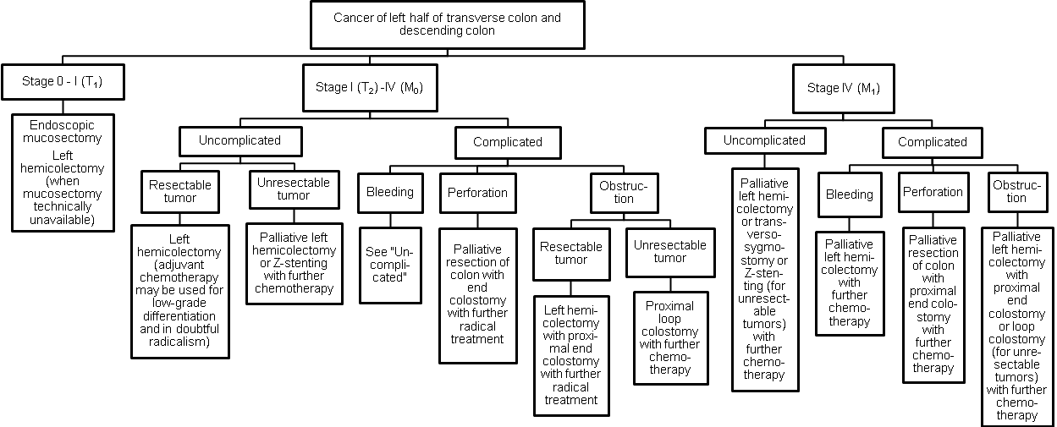
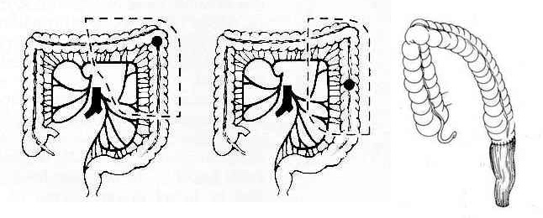
Fig. 6-13. Schemes of resections of colon for left-sided tumors

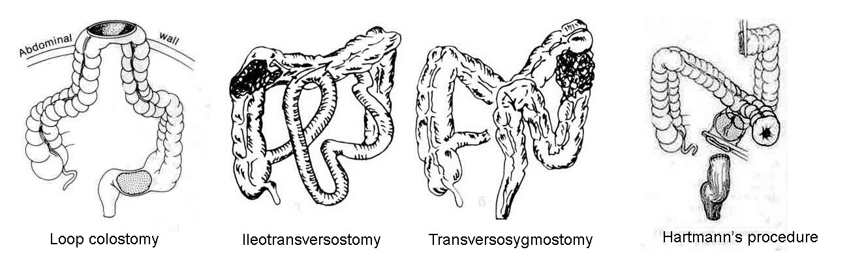

Fig. 6-14. Schemes of operations for obstructing tumors of colon

Scheme 6-5. Algorithm of management of cancer of sigmoid colon

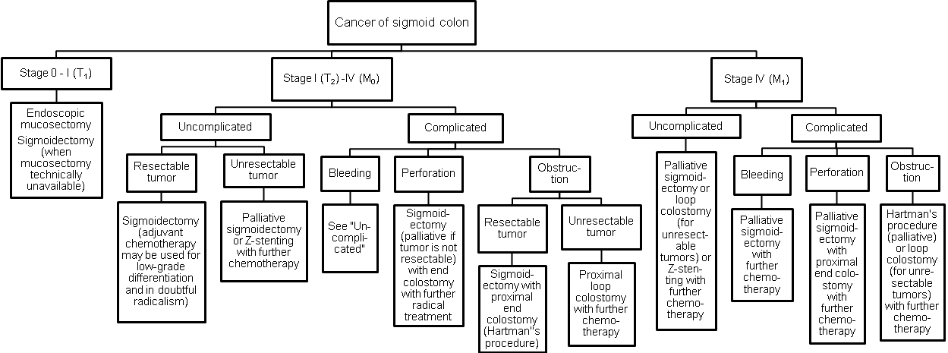
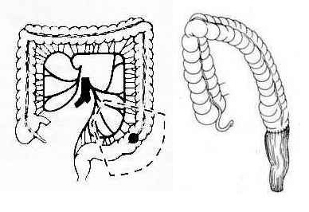
Fig. 6-15. Scheme of sigmoidectomy

Scheme 6-6. Algorithm of management of cancer of rectosigmoid junction segment and upper third of rectum

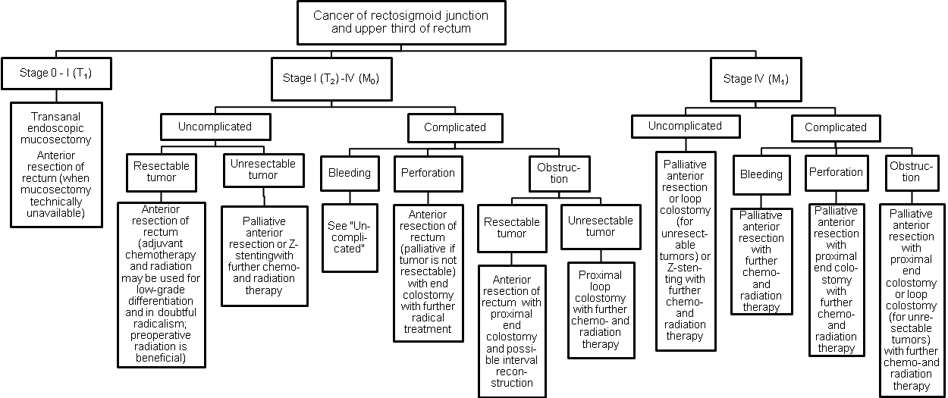
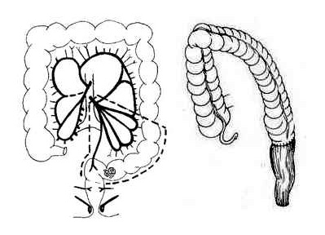
Fig. 6-16. Scheme of anterior resection

Scheme 6-7. Algorithm of management of cancer of middle third of rectum

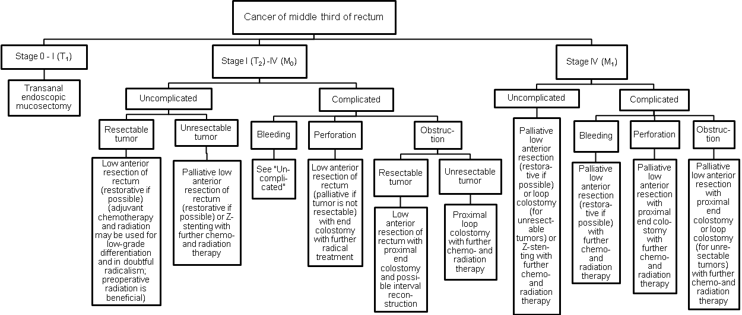

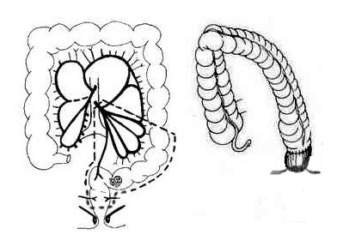

Fig. 6-17. Scheme of low anterior resection

Scheme 6-8. Algorithm of management of cancer of lowel third of rectum and anal channel

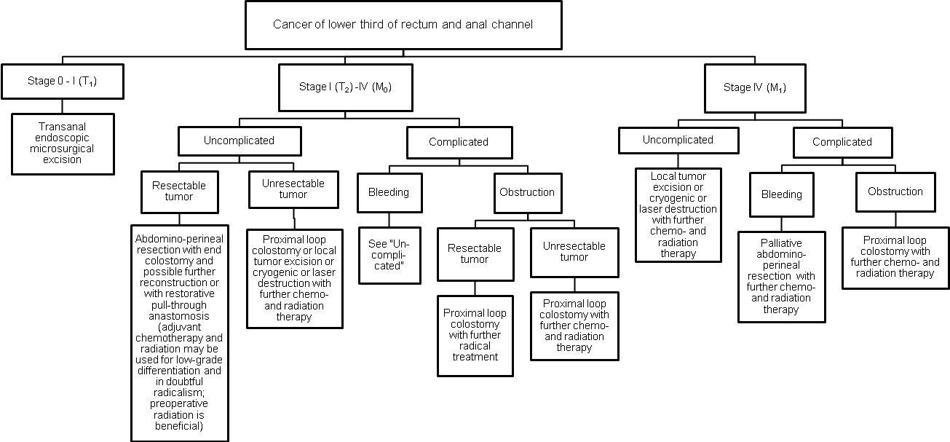

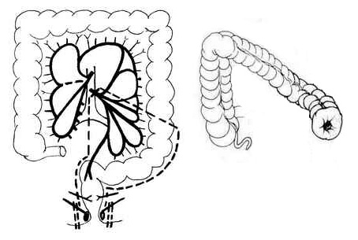

Fig. 6-18. Scheme of abdominoperineal resection

- Surgical resection is the preferred treatment for most cases of colorectal cancer. For unresectable tumors, especially with distant metastases, the placement of self-expandable metallic stents (Z-stents) currently become the procedure of choice.
- Important aspects of surgery include proper preparation of the patient, including bowel preparation; thorough exploration of the abdomen to search for metastases; removal of the segment of colon containing the tumor and the lymphovascuiar pedicle; anastomosis without tension between segments of bowel with satisfactory blood supply.
- Operations for rectal cancer require special considerations. Upper-third lesions can be treated by resection through the abdomen with anastomosis between the left colon and the remaining rectum (anterior resection). Middle-third lesions are usually amenable to low anterior resection, using circular stapling instruments to fashion the anastomosis. For lower-third lesions several options may be considered. Resection of the rectum, anus, and anal sphincters by a combined abdominal and perineal approach requires construction of a colostomy (abdomino-perineal resection, also called Miles procedure). Resection of the distal rectum using a transanal approach, resection of the proximal rectum using an abdominal approach, or anastomosis between the colon and distal rectum through the anus can be performed. There are several modifications of these technically difficult operations, and they may be referred to as pull-through operations. In almost all patients, a temporary colostomy is fashioned to allow the anastomosis to heal without the danger of anastomotic leak and sepsis.
- Local excision, fulguration, and contact radiotherapy may be used for select, very favorable rectal cancers in which the chance of metastases is small, for example: superficial lesions, freely moveable by digital examination; those that are not poorly differentiated histologically; those that are confined to the rectal wall, as detected by endorectal ultrasound; those in which there are no palpable retrorectal lymph nodes; nonulcerated, exophytic lesions.
- Adjuvant chemotherapy is currently recommended postoperatively for patients shown to have lymph node metastases.
- Radiation therapy given preoperatively to patients with advanced rectal cancer has been shown to shrink the cancer and reduce local recurrence. Adjuvant radiation is also beneficial.

Prognosis, follow-up and screening

- Prognosis, determined by 5-year survival, is clearly related to the stage of disease, as
demonstrated in Diagram 6-1.
- Physical examination seldom reveals early tumor recurrences.
- Colonoscopy should be performed 1 year after surgery to detect any new lesions (polips). If polyps are found and removed, the colonoscopy should be repeated yearly until there are no polyps. After a negative colonoscopy, the examination should be repeated every 3 to 5 years, to detect any new polyps.
- Carcinoembrionic antigen (CEA) is the most sensitive indicator of recurrent colorectal cancer. CEA may be elevated in patients with cirrhosis, pancreatitis, renal failure, ulcerative colitis, and other types of cancer, so measuring the CEA level is a nonspecific test. Most surgeons recommend obtaining CEA levels: every 3 months during the first 2 postoperative years, every 6 months during the third, fourth, and fifth postoperative years. A rising CEA level is an indication for chest radiograph and abdominal CT scan.
- There is sufficient reason to attempt to detect early recurrence: isolated hepatic metastases may be resected with a 25% 5-year survival, solitary pulmonary metastases may be resected with a 20% 5-year survival.
- Occult blood test obtained yearly after the age of 50 is very beneficial as a screening test for cancer and other diseases of colon and rectum.

Diagram 6-1. Survival in colon cancer

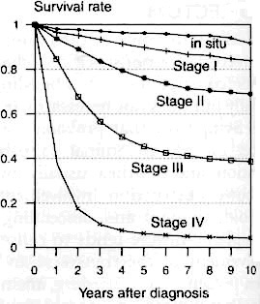
From: Principles of surgery/ed., S.I. Schwartz, et al. – 7th ed.

Carcinoid tumors

- Carcinoid tumors arise from neuroectodermal cells. They have the ability to incorporate, store and metabolize amine precursors, which produces several biologically active amines (APUD tumors). The gastrointestinal tract is the most common site, and (in decreasing order of frequency) carcinoids arise in the appendix, ileum, rectum, stomach, and colon (see Scheme 6-9).
- The tumors are usually small, submucosal nodules.
- Colon carcinoids account for less than 2% of gastrointestinal carcinoids; they may be multicentric, and they may cause the carcinoid syndrome from liver metastases.
- Rectal carcinoids account for 15% of gastrointestinal carcinoids. They are usually solitary, and they do not cause the carcinoid syndrome.
- Treatment is related to size of the tumor. Tumors smaller than 2 cm seldom metastasize and can be locally excised. Tumors larger than 2 cm are usually malignant and should be treated by radical resection.

Scheme 6-9. Incidence of carcinoids of gastrointestinal tract

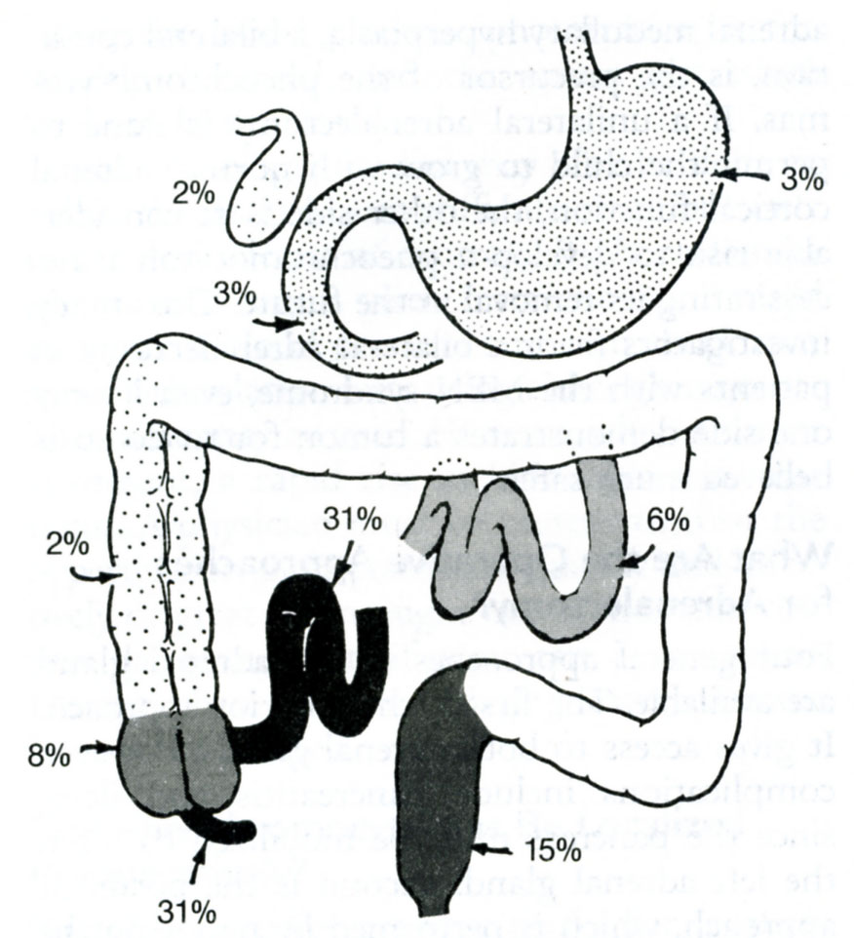

Other neoplasms

- Other neoplasms may arise from normal colorectal tissues but are rare, including: lymphoid tissue (lymphoma and lymphosarcoma), adipose tissue (lipoma and liposarcoma), muscle tissue (leiomyoma and leiomyosarcoma).

VOLVULUS

Overview

- Volvulus is a twist or torsion of an organ on a pedicle.
- Symptoms are produced by occluding the bowel lumen (obstruction) or occluding the blood supply (ischemia).
- The incidence is low in the Western World: diverticulitis and cancer are more common causes of colon obstruction, volvulus is the most common cause of colon obstruction in Africa.

Sigmoid volvulus

Overview

- Sigmoid volvulus accounts for more than 80% of cases of colonic volvulus. Patients with this condition are often from nursing homes or mental institutions. Sigmoid volvulus is most common in men, and it occurs more often in blacks. The average age of a patient with this condition is 60 years.
- Predisposing conditions are long, freely movable sigmoid colon and its mesentery.
- The sigmoid colon usually twists counterclockwise around the axis of the mesentery.

Clinical features and visualization data

- History usually indicates increasing abdominal distention, discomfort, and obstipation.
- Physical examination reveals abdominal distention and tympany.
- Abdominal radiographs usually show a massively distended loop of bowel, with both ends in the pelvis and the bow near the diaphragm (see Fig. 6-19).
- Barium enema reveals the pathognomonic obstructing twist (i.e., ace of spades or bird's beak deformity).

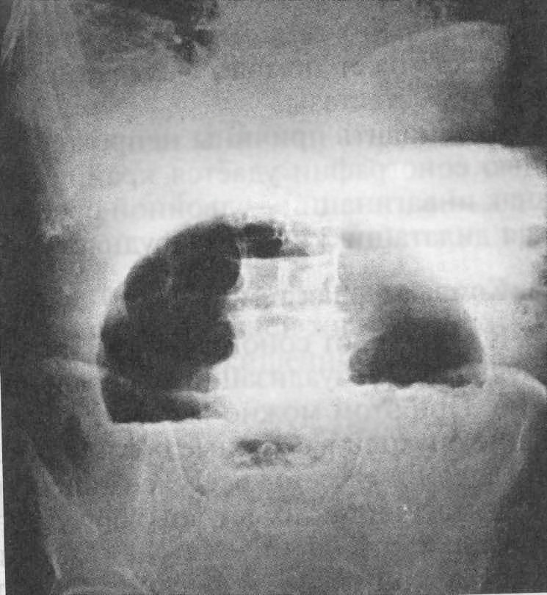

Fig. 6-19. Radiological picture of volvulus

Treatment

- Sigmoidoscopic decompression is indicated for nonstrangulated sigmoid volvulus. This procedure should be terminated if necrotic mucosa is observed or if the volvulus cannot be reduced by gently inserting a rubber tube through the sigmoidoscope past the point of torsion. If the tube successfully reduces the volvulus, it should be left in the sigmoid and taped to the skin of the thigh to prevent immediate recurrence.
- If decompression cannot be achieved, surgical operation is indicated immediately. If there is a gangrenous bowel, sigmoidectomy with colostomy (Hartmann's operation) is indicated. If a bowel is viable, detorsion with intubation of bowel through the anus may be performed.
- Elective sigmoidectomy with colorectal anastomosis is recommended after the bowel has been decompressed and prepared as usual for colonic resection.

Caecal volvulus

Overview

- Caecal volvulus occurs much less frequently than sigmoid volvulus. It occurs most commonly in women, and patients are often younger than 40 years.
- A congenital anatomic anomaly is required for caecal volvulus. Incomplete peritoneal fixation of the right colon is required for the caecum and right colon to have the mobility to form a volvulus.
- Other contributing factors may include: cancer of the distal colon, midgut nonrotation, adhesions from previous surgery.
- The caecum and ascending colon usually twist in a clockwise direction.

Clinical features and visualization data

- History usually indicates increasing abdominal pain. Diarrhea may have occurred initially. Obstipation follows.
- Physical examination reveals abdominal distention and tympany. Rebound tenderness suggests gangrenous bowel.
- Abdominal radiographs reveal a large, distended caecum that may occupy the left upper quadrant.
- Barium enema reveals the ace of spades or bird's beak deformity.

Treatment

- Right colectomy with ileotransverse colonic anastomosis and intubation of small intestine is generally indicated.
- Colonoscopic decompression has been successfully performed, but right colectomy is still indicated to prevent recurrence.
- Caecopexy is an alternative to right colectomy, but recurrence rates have been high in some reports.

REVIEW TESTS

1. A 45-years-old woman underwent colonoscopic examination. Pedunculated tubular adenoma was found within the sigmoid colon. After polypectomy, histological conclusion was: tubular adenoma with high grade dysplasia, no dysplastic cells within the margin. The patient is free of concomitant pathology. What’s the most appropriate tactics of managing the patient?

A. No further measures
B. Colonoscopic monitoring in 1 year, then every 3 years
C. Colonoscopic monitoring every 5 years
D. Occult blood test yearly
E. Restorative sigmoidectomy

2. A 45-years-old man whose father was operated for colonic cancer, underwent colonoscopic examination. Multiple adenomatous polips were found within the ascending and transverse colon. No sigmoid and rectum involvement presents. The patient is free of concomitant pathology. What’s the most appropriate tactics of managing the patient?

A. Total proctocolectomy with ileostomy
B. Subtotal colectomy with ileorectal anastomosis
C. Endoscopic removal of polips
D. Total proctocolectomy with continent ileostomy
E. Total proctocolectomy with pouch-anal anastomosis

3. A 60-years-old man was admitted to surgical department with complaints of constipation (bowel movement once in 3 – 4 days), slight diffuse abdominal pain, periodical abdominal distension, and weight loss of 10 kg for the last 2 months. Patient is slightly anemic. He is ill for 7 months. Physical examination of abdomen reveals slight distention, moderate tenderness in the left iliac region, no rebound tenderness and muscle guarding. Digital rectal examination revealed no pathology. Colonoscopy shows a large fungating tumor of the sigmoid colon (23 cm proximal to anal verge), unmovable, partially obstructing the lumen of bowel, with rigid bowel wall around it. Biopsy conclusion is moderately differentiated adenocarcinoma. Abdominal and pulmonary MRI doesn’t reveal lymphadenopathy, liver metastases, and spreading of the tumor into adjacent structures. What’s the most appropriate tactics of surgical managing the patient?

A. Sigmoidectomy, descendorectostomy
B. Low anterior resection, transversorectostomy
C. Right hemicolectomy, transversorectostomy
D. Abdominoperineal resection, end colostomy
E. Loop transversostomy

4. A 80-years-old woman was admitted to surgical department with complaints of constipation (bowel movement once in 4 – 5 days), moderate pain in left lower quadrant, periodical abdominal distension, and 20 kg weight loss. The patient has history of angina pectoris, a dyspnea at rest, and peripheral edema. Pulse is irregular, ECG revealed atrial fibrillation, the woman is anemic. He is ill for 8 months. Physical examination of abdomen reveals slight distention, moderate tenderness in the left iliac region, where a mass is palpated, no rebound tenderness and muscle guarding. Digital rectal examination reveals internal hemorrhoids of 1st degree. Colonoscopy shows a large infiltrating tumor of the descending colon (38 cm proximal to anal verge), partially obstructing lumen of the bowel. Biopsy conclusion is poorly differentiated adenocarcinoma. Abdominal MRI reveals retroperitoneal lymphadenopathy, and 8 metastatic nodes in liver. What’s the most appropriate tactics of surgical managing the patient?

A. Transversosigmostomy
B. Right hemicolectomy, end colostomy
C. Right hemicolectomy, transversorectostomy
D. Loop transversostomy
E. Placement of self-expandable stent

5. A 70-years-old woman, a nursing home resident, was brought to ER with complaints of abdominal pain and distention. The patient has not passed stool or flatus for 36 hours. On examination, his abdomen is greatly distended and tympanitic. Mild diffuse tenderness is present with no rebound tenderness and muscle guarding. Upright abdominal radiogram is suggestive of a sigmoid volvulus. What’s the most appropriate tactics of surgical managing the patient?

- Barium enema
- Gastrografin enema
- Laparotomy, detorsion
- Endoscopic decompression
- Continued observation

Correct answers: 1 - B, 2 - B, 3 - A, 4 - E, 5 - D.

