CHAPTER 7. GASTROINTESTINAL BLEEDING

UPPER GASTROINTESTINAL HEMORRHAGE (OVERVIEW)

Causes of bleeding

Table 7-1. Complete list of causes of acute and chronic blood loss from gastrointestinal tract

Esophagus  Reflux-esophagitis (including peptic ulcer)  Mallory-Weiss tears  Esophageal varices  Tumors  Benign  Malignant  Diverticula  Stomach  Peptic ulcer  Acute NSAID-associated ulcer  Telangiectasia (Dieulafoy’s ulcer)  Acute ulcer following thermal burn (Curling's ulcer)  Stress ulcer (Cushing’s ulcer)  Acute hemorrhagic (erosive) gastritis  Tumors  Benign  Malignant  Duodenum  Peptic ulcer  Acute NSAID-associated ulcer  Telangiectasia (Dieulafoy’s ulcer)  Acute ulcer following thermal burn (Curling's ulcer)  Stress ulcer (Cushing’s ulcer)  Diverticula  Acute hemorrhagic (erosive) duodenitis  Hemobilia  Pancreatic carcinoma with invasion into the duodenum  Carcinoma of papilla of Vater | Small intestine  Diverticula (including Meckel’s)  Teleangiectasia (Dieulafoy’s ulcer)  Acute NSAID-associated ulcer  Acute ulcer following thermal burn (Curling's ulcer)  Stress ulcer (Cushing’s ulcer)  Kaposi's sarcoma  Tumors  Benign  Malignant  Large intestine  Diverticula  Acute hemorrhagic (erosive) colitis  Ulcerative colitis  Crohn’s disease  Ischemic colitis  Telangiectasia  Tumors  Benign  Malignant  Hemorrhoids  Fissura-in-ano  Stress ulcers  Postoperative causes  Anastomotic suture line  Marginal ulcer  Aortoenteric fistula  Erosion of pancreatic pseudocyst into stomach or  small intestine  Miscellaneous  Metastatic tumors  Cirsoid aneurysm  Blood dyscrasias  Hemoptysis  Rhinolaringeal causes  Epilepsy

Diagram 7-1. Rough structure of causes of upper gastrointestinal bleeding
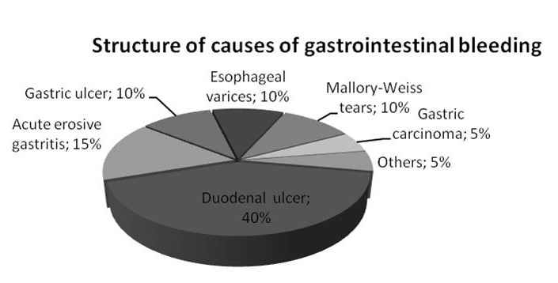
Types of bleeding

- The diagnosis of hemorrhage is generally obvious, but locating the place of bleeding may be difficult. The type of gastrointestinal bleeding may give a clue to its source.
- Hematemesis is the vomiting of blood, either bright red or resembling coffee ground appearance. Hematemesis usually indicates a bleeding source proximal to the ligament of Treitz. Coffee-grounds hematemesis indicates that the blood has been in contact with gastric acid long enough to become converted from hemoglobin to methemoglobin.
- Hematochezia is the passage of bright red blood by rectum. Although it indicates the distal portions of large intestine as a source of bleeding, it does not entirely specify the level within the gastrointestinal tract.
- Melena is the passage of black, usually tarry, stools. Although the melena signifie longer time within the gastrointestinal tract than bright red blood and, thus, an upper gastrointestinal tract as a source of bleeding, it does not completely guarantee that the bleeding is not from the lower tract.
- Blood mixed with stool and mucus can produce a characteristic jelly-like or “currant-jelly” stool. This may originate from a Meckel's diverticulum, particularly in children, or from a source in proximal parts of large intestine.

History and physical examination

- The history should include information about previous episodes of gastrointestinal bleeding, current medications (e.g., aspirin use), and related diseases (e.g., hematologic disorders, alcoholism, peptic ulcer disease, and recent episodes of vomiting).
- Physical examination should specifically include a search for evidence of nasopharyngeal bleeding, portal hypertension, weight loss, malignancy, or systemic diseases, such as chronic hepatic or renal failure.
- Leucosis and other hematological diseases with chronic anemia should not been overlooked.

Diagnosis

- The cause and the location of the bleeding must be confirmed unless imminent exsanguination calls for immediate measures (see Scheme 7-1). In less urgent circumstances, once the patient has been stabilized, one may continue with diagnostic procedures.
- Endoscopy of the upper gastrointestinal tract has become the optimal diagnostic procedure because it allows direct visualization of the lesion in over 80% of cases (see Table 7-2). Endoscopy allows to determine the size and number of lesions in most cases (lesions are multiple in 15% of cases), to assess which site is actively bleeding, to assess the rate of bleeding. If, for example, an arterial vessel is visibly bleeding in the base of a large duodenal ulcer, then there is a good chance that it will not stop bleeding. Distinction between an ulcer, varices, gastritis, and Mallory-Weiss tears and determination of whether a lesion is benign or malignant is easily performed by endoscopy.
- Endoscopy is only safe if the patient's vital signs are relatively stable. Sedation is dangerous because it increases the risk of vomiting followed by aspiration of the gastric contents into the pulmonary bed.
- Upper gastrointestinal series helps to define anatomy or pathology more completely, but unfortunately it sheds little light on the relationship of a particular lesion to the hemorrhage.
- Passage of a nasogastric tube aids considerably in determining that the source of bleeding is proximal to the ligament of Treitz.
- Angiography and radionuclide scanning may occasionally help to locate the site of bleeding, but both procedures are more useful in lower gastrointestinal hemorrhage.
- In the case of chronic iron-deficiency anemia suspected to be associated with lesion within the gastrointestinal tract, the complex of diagnostic tools should be used (see Scheme 7-2).

Scheme 7-1. Algorithm of management of patient with gastrointestinal bleeding
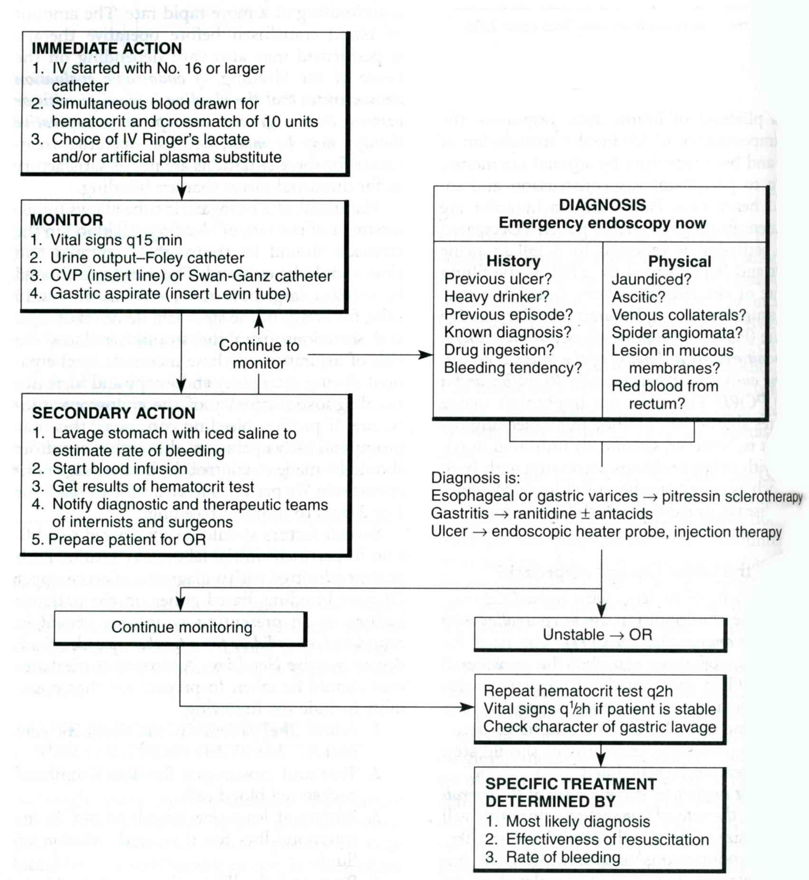

Table 7-2. Partial list of various specific lesions responsible for chronic intestinal blood loss, which are often missed radiographically

Esophagitis (including reflux-esophagitis)
Gastritis
Duodenitis
Marginal ulcers
Drug-induced ulcers
Neoplasms (early)
Vascular malformations (e.g., hemangioma, telangiectasia)
Polyp (small)
Diverticula (small intestinal)
Circular stricture (small intestinal)
Enteric cysts (duplication)
Internal hemorrhoids
Nonspecific ulcers (small intestinal)

From: Principles of surgery/ed., S.I. Schwartz, et al. – 7th ed. (modified)

Scheme 7-2. Diagnostic algorithm for chronic iron-deficiency anemia

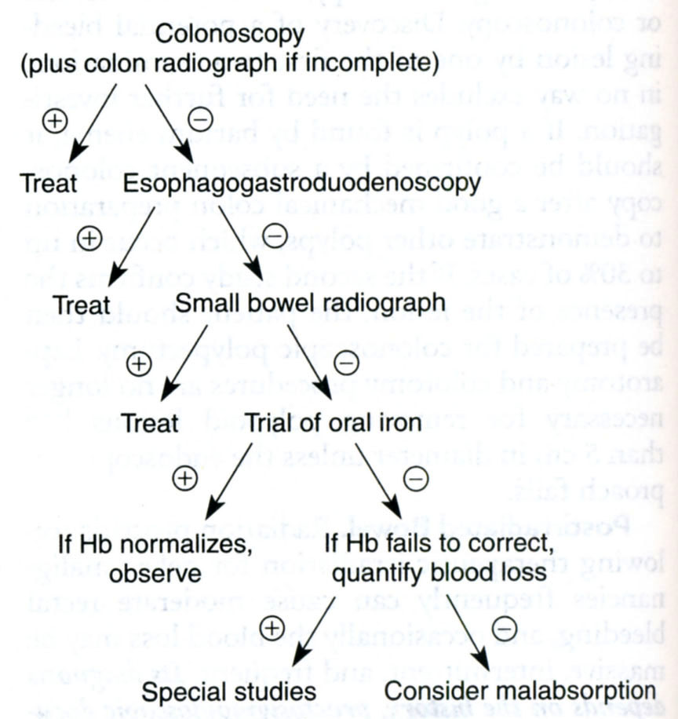
From: Principles of surgery/ed., S.I. Schwartz, et al. – 7th ed.

Medical treatment

- If treated expeditiously in a systematic fashion, the patient with upper gastrointestinal hemorrhage has an excellent chance for recovery. Treatment is aimed at supporting the patient's vital signs as well as stopping the hemorrhage. Resuscitation measures should begin immediately when the patient is first seen (see Scheme 7-1). Medical treatment of aggravating factors can then begin.
- A nasogastric tube is inserted, and the residual thrombus in the stomach is removed with an iced saline solution.
- Any clotting abnormalities are corrected with appropriate factors: fresh frozen plasma if the prothrombin time is abnormal, platelets if thrombocytopenia is present, vitamin K if bleeding is from esophageal varices.
- An aggressive antacid regimen is begun. Hourly antacid therapy with gastric pH monitoring is probably the most effective method of stopping hemorrhage.
- Proton pump inhibitors and H₂-receptor antagonists are highly effective in stopping a hemorrhage. Vasopressin, a powerful vasoconstrictor, may be useful. It can be infused through a peripheral vein at a rate of up to 1 unit a minute, or it can be infused directly into the bleeding vessel by means of angiography. Vasopressin temporarily controls bleeding in 75% of patients; by contrast, bleeding was stopped in 30% of patients treated conventionally without vasopressin. However, vasopressin is contraindicated in patients with significant coronary artery disease.
- Endoscopy, in addition to being a diagnostic procedure, may also be useful when esophageal varices are to be sclerosed or small bleeding sites are to be coagulated.
- Angiography similarly may be a therapeutic aid. It allows bleeding from small vessel to be controlled either by embolization of the bleeding vessel or by intra-arterial administration of vasopressin.
- Balloon tamponade can be important in controlling bleeding from varices.

Surgical treatment

- The patient's cardiovascular status, as well as the amount and duration of bleeding, is particularly important. For example, a patient with heart disease may tolerate continued bleeding poorly and, thus, may need early surgery.
- Only about 10% of patients will require surgery.
- Indications for surgery are as follows: exsanguinating hemorrhage; profuse bleeding, especially in association with hypotension (patients should be treated surgically if more than 4 units of blood are required for initial resuscitation, if bleeding continues at a rate greater than 1 unit every 8 hours, if a brief hypotensive episode could have catastrophic results, as in patients with coronary artery disease or cerebrovascular disease or in patients older than 60 years of age); continued hemorrhage despite resuscitation and other treatment (the mortality rate of upper gastrointestinal bleeding is low among patients who need less than 6-7 units of blood; the rate rises dramatically with requirements above 7 units); recurrent bleeding after its initial cessation (about one-fourth of patients rebleed); pathologic features of the bleeding site that increase the risk of recurrent bleeding (a posterior duodenal ulcer with the gastroduodenal artery visible in its base, a giant gastric ulcer).
- Special situations may call for a modification of the usual routines of management: a patient with a rare or hard-to-find blood type should be operated upon while blood is still available; a patient who refuses blood transfusion for any reason should be explored early; a patient with a coagulopathy should have the disorder corrected, if possible, prior to surgical exploration.
- The prognosis for patients who are bleeding from a source other than esophageal varices is as follows: some 25% - 50% will have a recurrence of bleeding during the next 5 years, and about 20% will require surgery. The mortality rate is low (about 3%) if the bleeding stops spontaneously, whereas it is high as 33% in patients who soon rebleed.

BLEEDING GASTRIC AND DUODENAL PEPTIC ULCERS

- Hemorrhage occurs in approximately 15%-20% of patients with ulcers.
- Medical management controls the hemorrhage in most cases.
- Endoscopy is necessary to evaluate the site of the hemorrhage (see Fig. 7-1, 7-2). A "visible vessel" in the ulcer crater is an ominous sign, with a higher risk of rebleeding and a need for surgical intervention. Thermal techniques performed through the endoscope may be effective. These techniques include electrocoagulation (see Fig. 7-3), laser, argon plasma coagulation, and clipping (see Fig. 7-4). Injection of sclerosing or vasoconstrictive agents may also be used. Currently, the most effective technique is combination of injection therapy with argon plasma coagulation (along with appropriate medical treatment).
- Surgical intervention is usually needed to control massive hemorrhage, defined as blood loss that requires transfusion of more than 1500 ml of blood products without stabilization of vital signs, or continued blood loss, requiring more than 6 units of transfused blood in a 24-hour period.
- If the site of bleeding is a duodenal ulcer oversewing of the bleeding point is done via a longitudinal opening through the pylorus. If this fails to control the vessel, it is necessary to isolate and ligate the gastro-duodenal artery. The incision through the pylorus is then closed transversely, which is known as a pyloroplasty, or widening of the pylorus. A truncal vagotomy is also done.
- Vagotomy with antrectomy or atypical resection of stomach is an option for ulcers of stomach.
- Current indications for using of endoscopic and surgical techniques are based on Forrest classification and statistically proved (see Table 7-3, Schemes 7-3, 7-4).

Table 7-3. Forrest classification of ulcer bleeding

Acute hemorrhage

Forrest I a (Spurting hemorrhage)
Forrest I b (Oozing hemorrhage)

Signs of recent hemorrhage

Forrest II a (Visible vessel)
Forrest II b (Adherent clot)
Forrest II c (Hematin on ulcer base)

Lesions without active bleeding

Forrest III (Lesions without signs of recent hemorrhage)

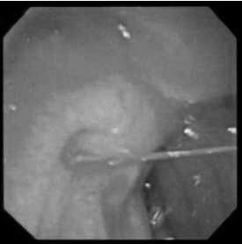

Fig. 7-1. Bleeding duodenal ulcer (Forrest Ia)

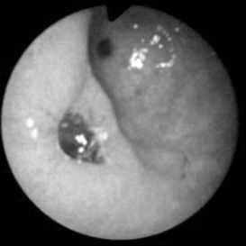

Fig. 7-2. Gastric ulcer with recent bleeding (Forrest IIb)
Scheme 7-3. Algorithm of management of bleeding peptic ulcers of duodenum

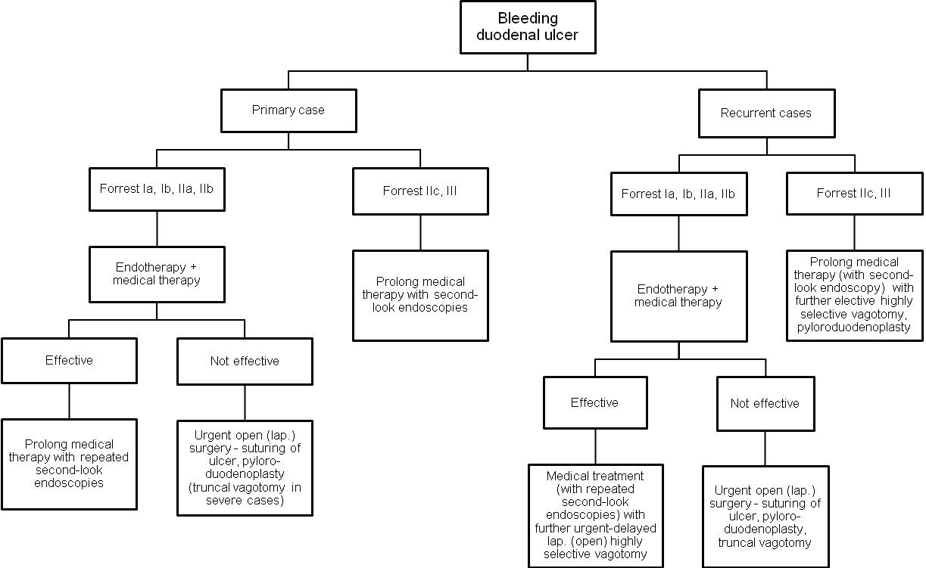

Scheme 7-4. Algorithm of management of bleeding peptic ulcers of stomach

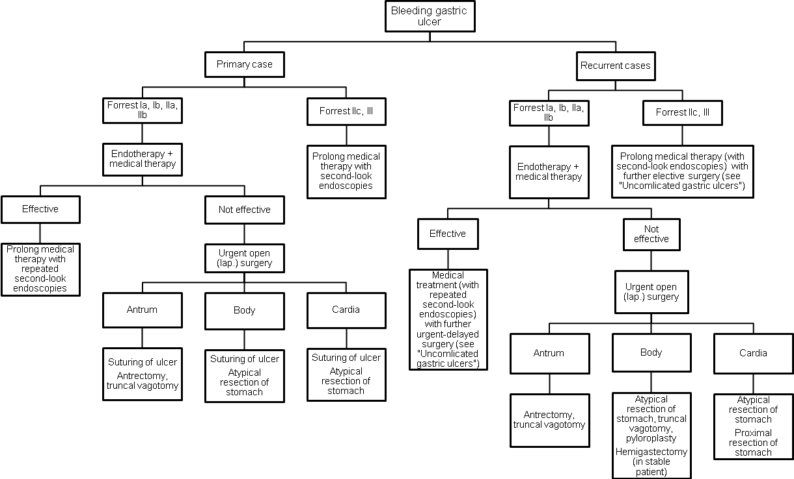
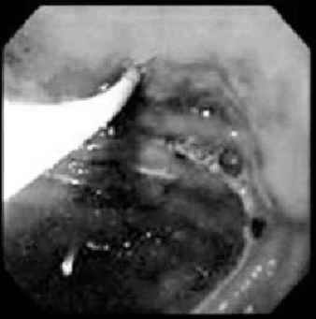

Fig. 7-3. Endoscopic electrocoagulation of bleeding ulcer

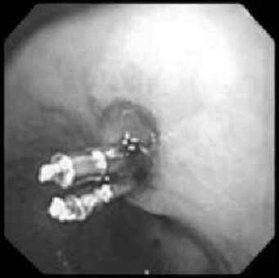

Fig. 7-4. Endoscopic clipping of bleeding ulcer

MALLORY-WEISS SYNDROME

- This condition presents as acute massive upper gastrointestinal hemorrhage.
- The bleeding occurs in the lower esophagus, usually near the gastroesophageal junction, and is secondary to a partial thickness tear in the lower esophagus, which follows a prolonged period of severe vomiting and retching. The tear usually extends into the stomach and may involve the greater curvature of the cardia.
- Diagnosis is made by endoscopy (see Fig. 7-5), which is performed to locate the tear and rule out other causes of bleeding.
- Treatment is by supportive measures, such as blood volume replacement, PPIs, antacids, and gastric lavage.
- In most cases the bleeding subsides spontaneously. If bleeding doesn’t stop, endoscopic hemostasis may control hemorrhage.
- If after repeated endotherapeutic attempts bleeding persists, laparotomy is performed with gastrotomy and suturing the tears of the esophagus from within the stomach. Recurrence is extremely rare.

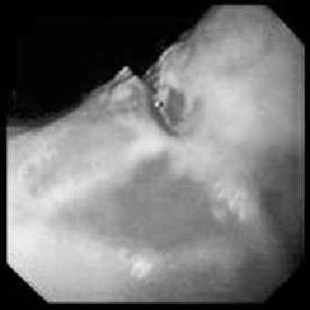

Fig. 7-5. Endoscopic picture of Mallory-Weiss syndrome

ESOPHAGEAL VARICES IN PORTAL HYPERTENSION

Overview

- Portal hypertension is an abnormal elevation in portal venous pressure (normal is 5-6 mm Hg).
- The increase in pressure stimulates the development of venous collaterals, which attempt to decompress the portal system into the systemic venous system (connections between the portal system and the inferior vena cava or the superior vena cava via the azygos system). When the varices form in a submucosal location, such as at the gastroesophageal junction, they are subject to rupture and hemorrhage.

Table 7-4. Etiology of portal hypertension

Intrahepatic causes

Cirrhosis of the liver
Chronic viral hepatitis
Alcohol abuse
Postnecrotic cirrhosis (toxic)
Biliary cirrhosis
Mixed
Schistosomiasis
Wilson's disease
Hepatic fibrosis
Hemochromatosis

Prehepatic causes

Portal vein thrombosis
Splenic vein thrombosis
Congenital atresia or stenosis of portal vein
Extrinsic compression of portal vein
Tumors
Chronic pancreatitis

Posthepatic causes

Budd-Chiari syndrome (hepatic vein thrombosis)
Idiopathic
Hypercoagulation
Tumors
Hematologic disorders
Oral contraceptive
Constrictive heart failure
Constrictive pericarditis

Increased portal venous flow

Primary splenic disease
Splenic arteriovenous fistulas or shunts

Clinical features

- Encephalopathy is secondary to portosystemic collaterals (with shunting of portal blood around the liver), anemia, and hepatic insufficiency. It may be related to elevated serum levels of ammonia in some patients, but the correlation is unreliable.
- Gastrointestinal hemorrhage is most frequently from gastroesophageal varices and complicated by impaired coagulation.
- Malnutrition, particularly in alcoholic cirrhosis, usually presents.
- Ascites is present secondary to hepatic sinusoidal hypertension, hypoalbuminemia, and hyperaldosteronism.
- Other manifestations of collateral venous development are present, such as a periumbilical caput Medusae (see Fig. 7-6) or hemorrhoids.
- Splenomegaly is also usually present, which may be associated with hypersplenism.

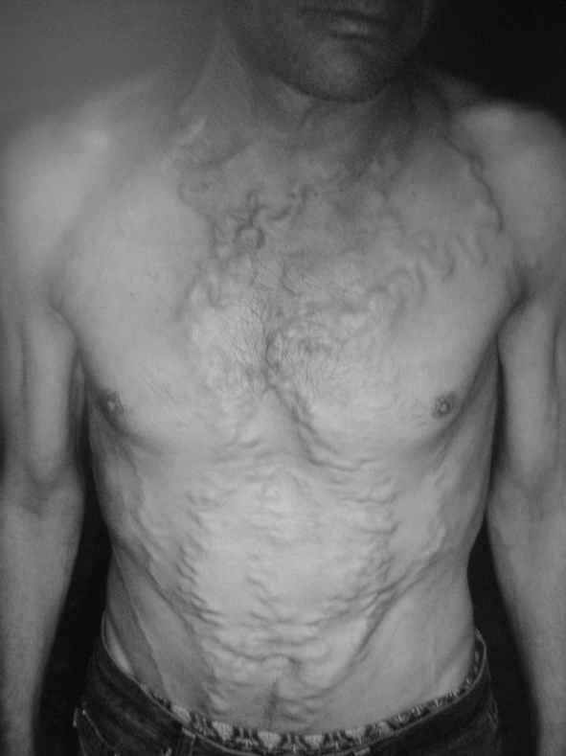

Fig. 7-6. Caput Medusae

Treatment of acute variceal hemorrhage

- Variceal hemorrhage is life-threatening and is the principal complication of portal hypertension that requires emergency intervention.
- Gastroesophagoscopy should be performed as soon as possible to find the site of bleeding and determine the presence of varices (see Fig. 7-7).
- The cause of an upper gastrointestinal hemorrhage in cirrhotic patients is varices in 20%-50%, erosive gastritis in 20%-60%, peptic ulcer disease in 6%-19%, and esophageal tears (Mallory-Weiss syndrome) in 5%-18%. Up to 8% of patients have two bleeding sites.

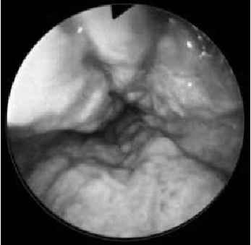

Fig. 7-7. Endoscopic picture of esophageal varices

Non-surgical measures for controlling acute variceal bleeding

Table 7-5. Methods of control of acute bleeding from esophageal varices

Nonoperative

Direct: control of bleeding site
Tamponade
Esophagoscopic injection of sclerosing
solution
Esophagoscopic banding (ligation)
Indirect: reduction of portal pressure
Vasopressin
Propranolol
Somatostatin
Paracentesis
TIPS (transjugular intrahepatic portal-
systemic shunt)

Operative

Direct: control of bleeding site
Transesophageal ligation/esophageal
transection
Devascularization (Sugiura procedure)
Gastroesophageal resection: colon or
jejunum interposition
Indirect: reduction of variceal pressure
Portal-systemic shunt

From: Basic surgery/ed., H.C. Polk, Jr., et al. – 5th ed.

- Endoscopic sclerotherapy or ligation of esophageal varices (see Fig. 7-8) controls bleeding temporarily in 80%-90% of patients; it is associated with a mortality rate of 1%-2%. Injection sclerotherapy has a complication rate of approximately 20%-40%, which includes esophageal perforation, worsening of hemorrhage, and more minor complications such as esophageal ulceration, fever, retrosternal chest pain, and pleural effusions.
- Vasopressin, a potent vasoconstrictor, lowers portal pressure by splanchnic vasoconstriction, which results in diminished mesenteric blood flow. Vasopressin is useful only for short-term hemorrhage control; it does not improve patient survival rates.
- Nitroglycerin lowers portal pressure independently and helps counteract some of the systemic side effects of vasopressin (e.g., myocardial ischemia, limb ischemia, and bowel necrosis).
- Antagonists of somatostatin (e.g., octreotide) cause splanchnic vasoconstriction and decreases portal pressure with fewer side effects than vasopressin.
- Balloon tamponade by the Sengstaken-Blakemore tube (see Fig. 7-9) controls bleeding in up to 80% of patients, but bleeding may resume in approximately 20%-50% of patients when the balloon is deflated. Pneumonia, due to the inability to clear salivary secretions, is common unless a proximal suction tube is placed above the esophageal balloon. Esophageal rupture may result from mechanical disruption or ischemia of the esophagus. To minimize these complications, this tube should be used for a limited time, such as 48 hours.
- Transjugular intrahepatic portosystemic shunt (TIPS) is the newest procedure for controlling variceal bleeding (see Fig. 7-10). Using angiographic techniques, the physician creates an 8- to 12-mm shunt between one of the hepatic veins and a branch of the portal vein and inserts a stent to maintain patency. The rate of postoperative encephalopathy is approximately the same as the surgical shunts - 10% - 30%. Complications include early rebleeding, shunt stenosis, and thrombosis. Its role in the management of patients with portal hypertension is not yet well defined.

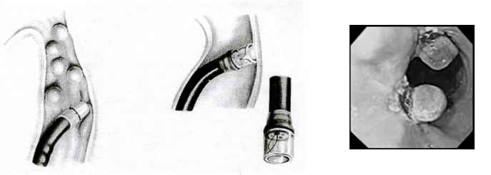

Fig. 7-8. Scheme of endoscopic ligation of esophageal varices

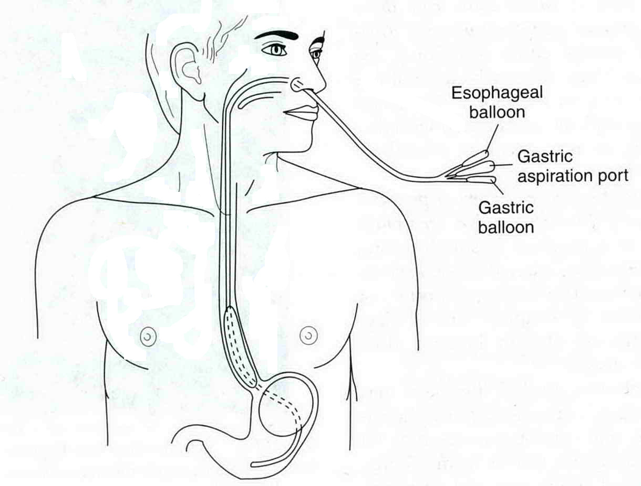

Fig. 7-9. Placement of Sengstaken-Blakemore balloon tube

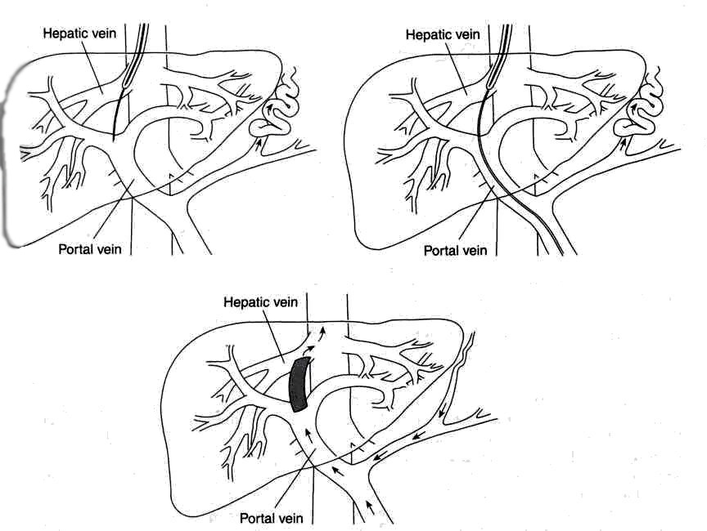

Fig. 7-10. Scheme of TIPS

Surgical management of acute variceal bleeding

- Acute massive bleeding that fails to respond to nonsurgical maneuvers requires emergency surgery, especially if hypotension is present. Surgery is not advisable in the presence of pneumonia, moderate or severe encephalopathy, severe coagulopathy, alcoholic hepatitis, or severe liver failure.
- Emergency portacaval shunting, although very effective in controlling hemorrhage (over 95% of patients stop bleeding), has a high operative mortality related to the Child's classification of the patient (see Table 7-6), thus, it should not be used in Child C patients and TIPS should be used.

Table 7-6. Child’s classification of hepatic failure

 | Child A | Child B | Child C
Serum bilirubin (mg/dl) | <2 | 2-3 | >3
Serum albumin (g/dl) | >3.5 | 3-3.5 | <3
Presence of ascites | Absent | Easily controlled | Refractory
Presence of encephalopathy | Absent | Minimal | Severe
Presence of malnutrition | Absent | Mild | Severe
Operative mortality rate | 2% | 10% | 50%

- The usual procedure performed is an end-to-side portacaval shunt or a meso-caval shunt (see Fig. 7-11). The acute reduction of portal blood flow to the liver following shunting may lead to hepatic failure, accounting for two-thirds of the perioperative deaths. Pneumonia, renal failure, and delirium tremens are contributing lethal factors.
- Ligation of varices, either direct (including devascularization of stomach and esophagogastric junction – the Sugiura procedure (see Fig. 7-12)) or by esophageal transection using a stapling device (see Fig. 7-13), usually stops the bleeding. Ligation is associated with an operative mortality rate of up to 30%. Bleeding recurs within several months in up to 80% of survivors. In most patients, ligation probably offers no advantage over shunt procedures.

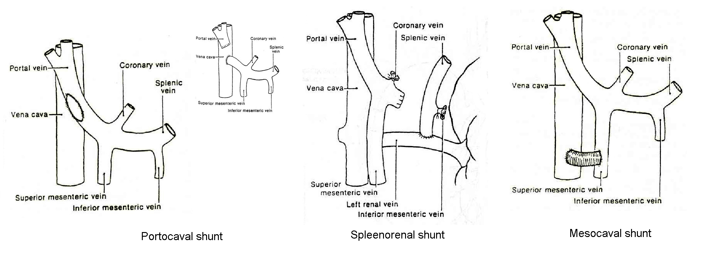
Fig. 7-11. Common variants of portosystemic shunts

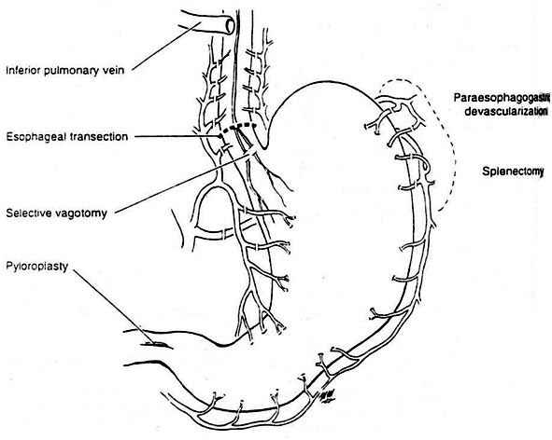

Fig. 7-12. Scheme of Sugiura procedure

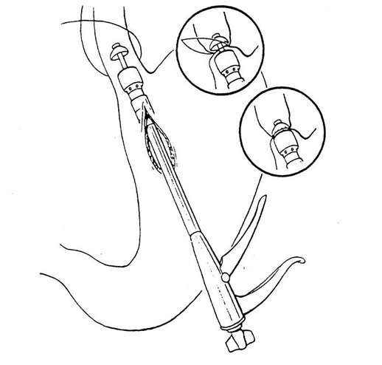

Fig. 7-13. Scheme of devascularization of esophagogastric junction using circular stapler

Elective management of esophageal varices

- Elective management of esophageal varices is used when patients are not actively bleeding. The goal of this type of surgery is to prevent rebleeding with its concomitant risk of death.
- Endoscopic variceal sclerotherapy or ligation is initially effective in up to 80% - 90% of patients and has become the principal initial method of management for esophageal varices. Many patients require repeated procedures because nothing has been done to lower the portal pressure.
- Shunting procedures and TIPS are used less commonly in elective cases because of development of encephalopathy.
- Splenic artery endovascular embolization significantly decreases risk of bleeding, stabilizes ascites and improves hypersplenizm.
- Liver transplantation is the only therapy that addresses the underlying liver disease and restores the patient's hepatic functional reserve to normal.
- Scheme 7-5 summarizes the tactics of management of bleeding esophageal varices.

Scheme 7-5. Algorithm of management of esophageal varices bleeding

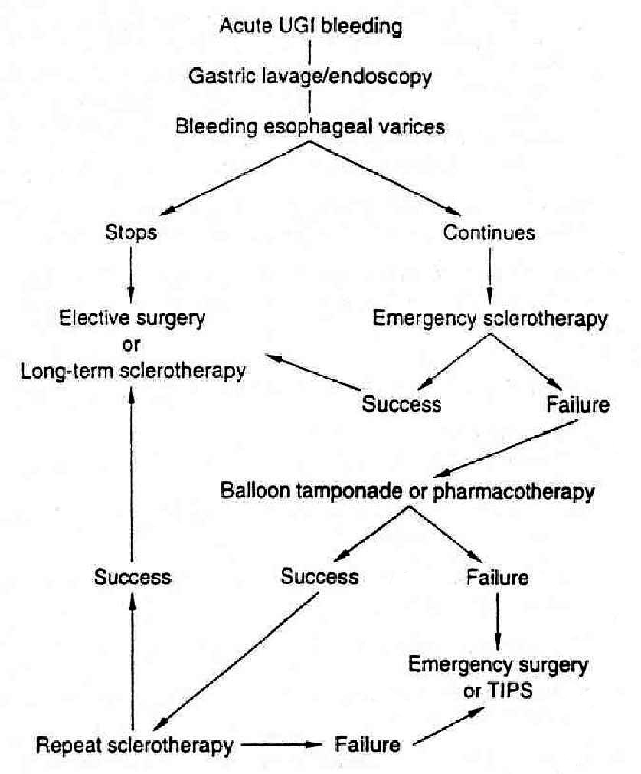
From: Principles of surgery/ed., S.I. Schwartz, et al. – 7th ed.

LOWER GASTROINTESTINAL HEMORRHAGE (OVERVIEW)

Table 7-7. Causes of lower gastrointestinal bleeding by age group, in order of frequency

Infants and children

Meckel's diverticulum
Polyps
Ulcerative colitis
Duplications

Adolescents and young adults

Meckel's diverticulum
Inflammatory bowel disease
Polyps

Adults to 60 years

Diverticulosis
Inflammatory bowel disease
Polyps
Malignancy
Congenital arteriovenous malformations

Adults over 60 years

Vascular ectasias
Diverticulosis
Malignancy
Polyps

From: Principles of surgery/ed., S.I. Schwartz, et al. – 7th ed.

Diagnosis

- Anorectal examination is performed to determine if the source of bleeding is a hemorrhoid, anal fissure, anal carcinoma, or other anorectal lesion.
- A bleeding site in the upper gastrointestinal tract must be ruled out. A nasogastric tube is passed to ascertain that no bleeding is present in the gastroduodenal region. On occasion, however, duodenal bleeding will not reflux into the stomach because of a closed pyloric sphincter. Endoscopy is, therefore, required to rule out upper gastrointestinal bleeding with absolute certainty.
- Once the upper tract has been eliminated as a source of bleeding, the lower tract should be investigated, including the distal small bowel, colon, and anorectal area.
- Sigmoidoscopy should be performed. The presence of a mass lesion, such as rectal carcinoma, is visualized in about 3% of patients with massive lower gastrointestinal bleeding. Discrete bleeding sites from ulcers (ulcerative colitis) or hemorrhoids may be seen. A diffusely hemorrhagic mucosa suggests colitis, a platelet deficiency, or a hematologic disorder. Even if no lesion is visualized, it is important to make certain that the lower 15 cm of the rectum is normal, because this region is inaccessible intraperitoneally if laparotomy is necessary. Additionally, if it is normal, it gives presumptive evidence that the bleeding is coming from a more proximal site.
- Anoscopy is frequently overlooked, but should be routinely performed because bleeding lesions in the anal canal may be missed on sigmoidoscopy.
- Subsequent diagnostic tests will depend upon whether the bleeding stops or continues. About 75% of the patients will spontaneously stop bleeding without further intervention.
- If bleeding stops, the following steps are taken. A barium enema, a colonoscopy, or both procedures should be performed to identify or rule out diverticulosis or colon carcinoma, to provide indirect evidence for colonic mucosal ischemia. The patient should be monitored thereafter.
- If bleeding continues, further diagnostic studies should be done to identify the source more precisely in preparation for surgery if it becomes necessary: radionuclide scanning usually followed by angiography are useful. Radionuclide scan, which uses red blood cells labeled with technetium (^{99m}Tc), is sensitive enough to detect a bleeding site when the rate is as low as 0.1 ml/min. Selective mesenteric angiogram will identify the bleeding site (or sites) in up to 80% of patients when the rate of bleeding exceeds 0.5 ml/min. Angiography is also highly useful for identifying angiodysplastic lesions of the colon.
- Colonoscopy is unsatisfactory and may be dangerous when lower gastrointestinal bleeding is rapid: visualization is poor, and there is a risk of colon perforation.

Treatment

- Indication for surgery is persistent bleeding.
- The surgical procedure is aimed at removing the underlying cause of the bleeding.
- On occasion, the precise point of bleeding cannot be established while exploration. In these instances, the stomach, duodenum, and small intestine should be carefully examined. Meckel's diverticulum, Crohn's disease, and other inflammatory or malignant lesions should not be overlooked. A "blind" total colectomy may be necessary if no other source of the bleeding is found.
- The mortality rate for lower gastrointestinal bleeding is currently about 10%.

DIVERTICULAR DISEASE

Overview

- Diverticulosis is a disease of modern times. Its appearance seems related to processing wheat flour in a roller mill and reducing fiber in the diet. It is common in Western societies and rare in unindustrialized nations.
- The incidence of this acquired disorder increases with age. Diverticulosis is rare before 30 years of age. It is present in 75% of people older than 80 years.
- Diverticula are herniations of mucosa through the colonic wall. They occur at sites where arterioles traverse the wall. These herniations lack a muscular layer: they are false diverticula.
- The sigmoid colon is the most common site for diverticula. Diverticula occur with decreasing frequency in the descending, transverse, and ascending colon. It is extremely rare for diverticula to occur in the rectum.
- The diverticula are in close proximity to arterioles which traverse the colon wall that causes bleeding. Diverticulitis is caused by a perforation of one or more diverticula. The perforation occurs in the sigmoid colon in more than 90% of cases. Extravasation of colonic bacteria results in a pericolic infection. A wide spectrum of disease is possible: localized cellulitis, which is a pericolic phlegmon; an intra-abdominal abscess; generalized purulent peritonitis (from ruptured abscess); feculent peritonitis (persistent leakage of feces from the perforation); fistula formation, including fistulas from the colon to the bladder, vagina, or skin.

Bleeding

Clinical features

- Abdominal pain is rare; patients usually pass large amounts of bright-red blood per rectum.
- Rapid blood loss may result in shock.

Visualization data

- A nasogastric tube is passed to rule out gastroduodenal hemorrhage.
- Proctoscopy is done to rule out anorectal hemorrhage (from hemorrhoids).
- A nuclear scan (labeled red blood cell scan) is obtained if the patient's condition permits.
- A mesenteric arteriogram is indicated if the nuclear scan indicates the site of bleeding.
- In stable patients (and in non-bleeding patients) barium enema and/or colonoscopy should be done.
- Barium enema shows multiple diverticula which probably are the source of bleeding (see Fig. 7-14).
- Colonoscopy is informative in localization of a bleeding source only in actively bleeding patients. In this case it reveals the multiple orifices of the diverticula, from one of which the fresh blood is passing. If the bleeding has stopped, the investigation only confirms the presence of diverticula (see Fig. 7-15), which probably were sources of bleeding.

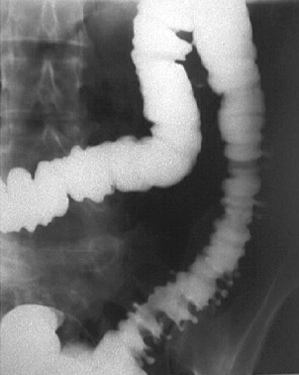

Fig. 7-14. Radiologic picture of colonic diverticula
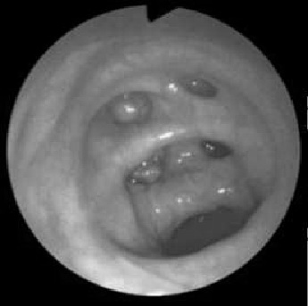

Fig. 7-15. Colonoscopic picture of colonic diverticula

Treatment

- If the mesenteric arteriogram shows the site of bleeding, vasopressin can be infused through the mesenteric catheter to constrict the mesenteric artery and lower portal pressure. This infusion stops 90% of diverticular hemorrhages.
- If bleeding persists and the mesenteric arteriography has shown the site of hemorrhage, segmental colectomy is indicated.
- If bleeding persists and the site cannot be detected while laparotomy, total abdominal colectomy with ileostomy is indicated.

Diverticulitis

Clinical features and laboratory data

- Left lower abdominal pain is the most common symptom. Pain may radiate to the suprapubic area, groin, or back.
- Abdominal or pelvic mass may be caused by a phlegmon or abscess.
- Fever and leukocytosis are common.
- Associated ileus may cause small bowel distention and vomiting.
- Generalized peritonitis may be present in severe cases.
- Pneumaturia, dysuria, pyuria, or fecaluria may be caused by colovesical fistula.
- The leukocyte count should be obtained initially as a baseline, and serially to evaluate the response to treatment.
- Frequent abdominal examinations are necessary to determine the activity of the disease.

Visualization data

- Abdominal and pelvic CT scan is the most helpful test to confirm the suspected diagnosis of diverticulitis by detecting the pericolic mass or abscess (see Fig. 7-16).
- If intravenous contrast is given before the CT scan, the kidneys and ureters can be evaluated simultaneously, and intravenous pyelography is usually not necessary.
- Air in the bladder is highly suggestive of colovesical fistula.
- Contrast enema should generally be avoided if diverticulitis is suspected; hydrostatic pressure can worsen the situation by causing extravasation of contrast and feces through the perforation.
- Chest radiography: subdiaphragmatic air is detected in fewer than 3% of cases of diverticulitis.
- After the patient's condition has stabilized and signs of sepsis have subsided, further evaluation may be necessary.
- Colonoscopy may be indicated to exclude a sigmoid cancer.
- Cystoscopy should be done if a colovesical fistula is suspected, to determine the probable site of the fistula.

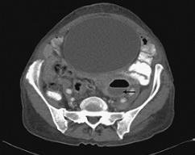

Fig. 7-16. CT picture of pericolic abscess due to perforation of diverticulum

Treatment

Scheme 7-6. Algorithm of management of diverticular disease

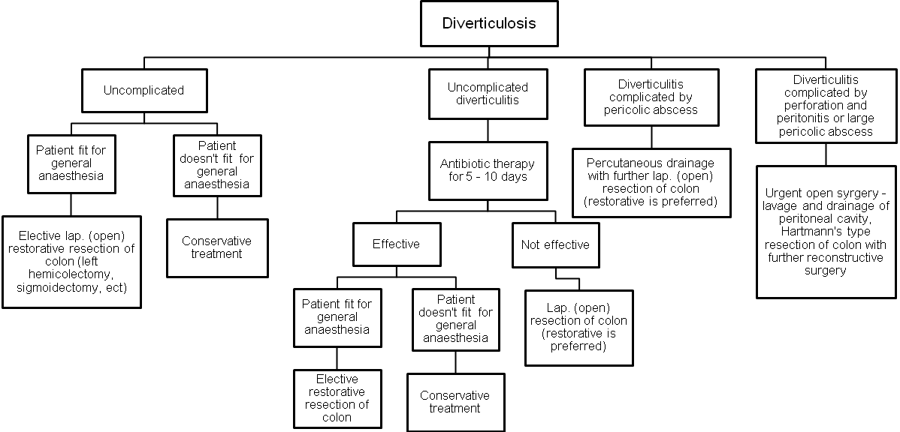
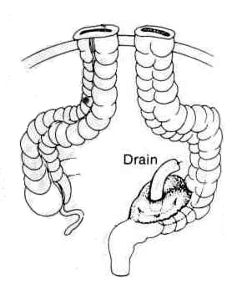
Fig. 7-17. Scheme of operation for perforated colonic diverticulum

ANGIODYSPLASIA

- This acquired vascular lesion joins diverticulosis as a major cause of colonic hemorrhage. These lesions occur most commonly in the right colon.
- They rarely occur before the age of 40 years, and they increase in frequency with age.
- It has been suggested that the lesions are the result of chronic, intermittent obstruction of the submucosal veins. Why some lesions bleed, whereas most do not, remains unknown.
- Hemorrhage from angiodysplasia tends to be slower than that from diverticulosis. Stools
may be melanotic or bright red, depending on the rate of hemorrhage.
- Some angiodysplastic lesions can be detected by colonoscopy as "cherry-red spots" on the mucosa (see Fig. 7-18). These lesions may be eradicated by endoscopic electrocoagulation.
- If the bleeding persists or recurs and can be isolated to a colonic segment by nuclear scans, arteriography, or colonoscopy, then segmental colectomy is indicated.
- If the bleeding persists and the site cannot be identified, total abdominal colectomy with ileostomy may be required as a lifesaving measure.

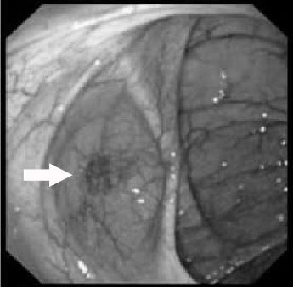

Fig. 7-18. Colonoscopic picture of colonic angiodysplasia

REVIEW TESTS

1. A 32-years-old man was admitted to ER in a poor condition, in stupor, with complaints of a multiple massive vomiting by coffee-ground-like gastric contents, and melena. The symptoms appeared this morning. There is a history of chronic relapsing course of ulcer disease of duodenum. Arterial pressure is 80/30 mmHg, pulse is weak, 140 beats per minute, skin is extremely pale. Physical examination of abdomen reveals no pathological findings. What’s the most appropriate algorithm of patient’s emergency work-up?

A. Abdominal ultrasound, gastroduodenal endoscopy, blood group, visceral angiography
B. Upright abdominal radiography, abdominal ultrasound, gastroduodenal endoscopy
C. Upright abdominal radiography, gastroduodenal endoscopy, complete blood cell count, blood group
D. Gastric lavage, complete blood cell count, blood group, gastroduodenal endoscopy
E. Gastric lavage, upright abdominal radiography, gastroduodenal endoscopy, blood group

2. A 32-years-old man was admitted to ER in a poor condition, in stupor, with complaints of a multiple massive vomiting by coffee-ground-like gastric contents, and melena. The symptoms appeared this morning. There is a history of chronic relapsing course of ulcer disease of duodenum. Arterial pressure is 80/30 mmHg, pulse is weak, 140 beats per minute, skin is extremely pale. Physical examination of abdomen reveals no pathological findings. 300 ml of coffee-ground-like gastric contents were aspirated via the nasogatric tube. Hb level is 50 g/l, RBC count is 1´700´000/ml. Endoscopy shows an ulcer of posterior wall of the duodenum, measuring 2 cm in diameter, with deep bottom and dense, infiltrated borders, with Forrest Ia bleeding. Patient is apparently free of concomitant pathology. What’s the most appropriate tactics of managing the patient?

A. Immediate surgery - suturing of ulcer, truncal vagotomy, pyloroduodenoplasty
B. Endoscopic hemostasis with delayed surgery (suturing of ulcer, truncal vagotomy, pyloroduodenoplasty) after preoperative preparation for 2-3 days (packed red blood cells, fresh frozen plasma, crystalloids, ect.)
C. Endoscopic hemostasis with delayed surgery (suturing of ulcer, truncal vagotomy, pyloroduodenoplasty) after preoperative preparation for 2-4 hours (packed red blood cells, fresh frozen plasma, crystalloids, ect.)
D. Endoscopic hemostasis with further conservative treatment (packed red blood cells, fresh frozen plasma, proton pump inhibitors, antagonists of somatostatine, ect.)
E. Endoscopic hemostasis, conservative treatment (packed red blood cells, fresh frozen plasma, proton pump inhibitors, antagonists of somatostatine, ect.), with further elective surgery (highly selective vagotomy, pyloroduodenoplasty) 2-3 weeks later

3. A 35-years-old man was admitted to ER with complaints of a melena which was twice this morning. There is a history of chronic relapsing course of ulcer disease of duodenum. Patient’s condition is moderate. Arterial pressure is 120/70 mmHg, pulse rate is 90 beats per minute, skin is slightly pale. Physical examination of abdomen reveals moderate tenderness in the right subcostal and epigastric regions. Hb level is 100 g/l, RBC count is 3´200´000/ml. Endoscopy shows an ulcer of posterior wall of the duodenum, 1.5 cm in diameter, with visible thrombosed vessel in its bottom, i.e. Forrest IIa bleeding. Patient is apparently free of concomitant pathology. What’s the most appropriate tactics of managing the patient?

A. Immediate surgery - suturing of ulcer, truncal vagotomy, pyloroduodenoplasty
B. Endoscopic hemostasis with delayed surgery (suturing of ulcer, truncal or highly selective vagotomy, pyloroduodenoplasty) after preoperative preparation for 2-3 days
C. Endoscopic hemostasis with delayed surgery (suturing of ulcer, truncal vagotomy, pyloroduodenoplasty) after preoperative preparation for 2-4 hours
D. Endoscopic hemostasis with further conservative treatment (packed red blood cells, fresh frozen plasma, proton pump inhibitors, antagonists of somatostatine, ect.)
E. Endoscopic hemostasis, conservative treatment (packed red blood cells, fresh frozen plasma, proton pump inhibitors, antagonists of somatostatine, ect.), with further elective surgery (highly selective vagotomy, pyloroduodenoplasty) 2-3 weeks later

4. A 50-years-old man was admitted to ER in a poor condition, in stupor, with complaints on a multiple massive vomiting by dark fresh blood. The symptoms appeared this morning. There is a history of chronic hepatitis B. Arterial pressure is 80/45 mmHg, pulse is weak, 120 beats per minute, 24h urine output is 300 ml, skin is jaundiced and pale. Physical examination of abdomen reveals caput Medusae, ascites; liver is not palpable, spleen is enlarged. Hb level is 55 g/l, RBC count is 1´400´000/ml, prothrombin index is 60 %. Endoscopy shows large esophageal varices with slow continued bleeding, stomach is filled by fresh venous blood, no pathological findings are in the gastric and duodenal mucosa. An attempt to perform emergency endoscopic sclerotherapy of varices is not effective. What’s the most appropriate tactics of managing the patient?

A. Immediate surgery – Sugiura procedure
B. Delayed surgery – Sugiura procedure – after preoperative preparation in ICU for 2-4 hours (packed red blood cells, fresh frozen plasma, crystalloids, procoagulants, ect.)
C. Further attempts of endoscopic sclerotheraphy
D. Placement of Sengstaken-Blakemore balloon tube
E. Emergency TIPS

5. A 37-years-old man was admitted to ER with complaints of single massive vomiting by fresh blood this morning. Patient is alcoholic. Yesterday there was multiple vomiting with ingested food after alcohol abuse. Patient’s condition is moderate. Arterial pressure is 120/70 mmHg, pulse rate is 88 beats per minute, skin is slightly pale. Physical examination reveals no pathological findings. Hb level is 105 g/l, RBC count is 2´900´000/ml. Endoscopy shows 2 tears at the esophago-gastric junction with the red clots covering them, i.e. no continued bleeding. Patient is apparently free of concomitant pathology. What’s the most appropriate tactics of managing the patient?

A. Conservative treatment (fresh frozen plasma, proton pump inhibitors, procoagulants, antacids, ect.)
B. Endoscopic laser coagulation of tears
C. Immediate surgery – suturing the esophago-gastric junction
D. Placement of Sengstaken-Blakemore balloon tube
E. Delayed surgery – resection of abdominal part of esophagus – after preoperative preparation in ICU for 2-3 days (fresh frozen plasma, crystalloids, procoagulants, antacids, ect.)

6. A 57-years-old woman was admitted to ER with complaints of 2 episodes of hematochezia, tonight and this morning. There is a history of constipation for 10 years. Patient’s condition is moderate. Arterial pressure is 140/80 mmHg, pulse rate is 78 beats per minute, skin is slightly pale. Physical examination reveals slight tenderness in left lower quadrand, muscle guarding and rebound tenderness. Hb level is 98 g/l, RBC count is 2´800´000/ml. Upper gastrointestinal endoscopy reveals no pathological findings. Colonoscopy shows multiple diverticula in descending and sigmoid colon, and no continued bleeding. The women has no severe concomitant pathology. What’s the most appropriate tactics of managing the patient?

A. Conservative treatment (fresh frozen plasma, crystalloids, procoagulants, ect.)
B. Delayed surgery – restorative left hemicolectomy – after preoperative preparation in ICU for 2-4 hours (fresh frozen plasma, crystalloids, procoagulants, ect.)
C. Immediate surgery – left hemicolectomy, end transversostomy
D. Conservative treatment (fresh frozen plasma, procoagulants, ect.) with further elective surgery – restorative left hemicolectomy
E. Immediate surgery – end transversostomy – with further restorative left hemicolectomy

7. A 58-years-old woman was admitted to ER with complaints of sudden intense pain at left lower quadrant of abdomen which appeared 12 hours ago, and temperature of 38 °C. There is a history of constipation for 10 years. While physical examination of abdomen, a tender mass is palpated at the left lower quadrant of abdomen; there is moderate muscle spasm, and no rebound tenderness here. Upright abdominal radiograph doesn’t reveal abnormalities. CT reveals thickening of the wall of sigmoid colon, and a cavity (fluid collection) around it, 7 cm in diameter. Water-soluble contrast study of bowel shows diverticula of sigmoid and descending colon. Woman is apparently free of concomitant pathology. What’s the most appropriate tactics of managing the patient?

A. Conservative treatment with antibiotics, no further surgery
B. Percutaneous drainage of collection with further elective surgery – restorative left hemicolectomy
C. Immediate surgery – sigmoidectomy, drainage of collection, end descendostomy
D. Colonoscopic placement of self-expandable stent into the sigmoid colon
E. Percutaneous drainage of collection with further treatment with antibiotics, no further surgery

Correct answers: 1 - D, 2 - C, 3 - B, 4 - D, 5 - A, 6 - D, 7 - B.

