CHAPTER 8. DIARRHEA

- Diarrhea most commonly is caused by acute bacterial and viral gastroenteritis, alteration of normal bacterial flora, bowel inflammatory diseases (ulcerative colitis and Crohn’s disease), different variants of maldigestion and malabsorbtion, gluten-sensitive enteropathy, irritable bowel syndrome, radiation colitis, ischemic colitis, pseudomembranous colitis, tumors of small intestine, and other diseases of small and large intestine listed below (see Table 8-1).
- Severe diarrhea is associated with signs of water and electrolyte losses (see Table 2-2) and other symptoms of respective diseases.

Table 8-1. Diarrheal and steatorrheal states

Lesions affecting small intestine  Radiation enteritis  Gluten-sensitive enteropathy  Crohn's disease  Tuberculous enteritis  Tropical sprue  Amyloidosis  Macroglobulinemia  Neoplastic lesions  Lymphoma  Carcinoid  Lymphogranuloma venereum  Endometriosis  Intestinal lipodystrophy  Lesions affecting large intestine  Mucous colitis  Crohn's disease  Irritable bowel syndrome  Radiation colitis  Ulcerative colitis  Ischemic colitis  Toxic colitis  Arsenic  Mercury  Alcohol  Diverticulitis  Neoplastic lesions  Polyposis  Villous adenoma  Carcinoma  Carcinoid  Endometriosis  Infections  Viral  Bacterial  Shigellosis  Staphylococcal  Cholera  Typhoid  Salmonella  Clostridium difficile  Alteration in bacterial flora  Antibacterial drugs (overgrowth of pathogenic organisms)  Gastric hyperacidity  Gastric hypoacidity  Parasitic infestations  Amebiasis  Leishmaniasis  Ascariasis  Liver flukes  Schistosomiasis  Trichinosis  Whipple's disease | Maldigestion  Biliary ducts obstruction or dyskinesia  Chronic pancreatitis  Cystic fibrosis (pancreas)  Pancreatic resection  Pancreatic duct obstruction (carcinoma)  Gastric factors  Hyperchlorhydria  Peptic ulcer disease  Chronic hyperacidic gastritis  Zollinger-Ellison syndrome  Hypochlorhydria  Chronic atrophic gastritis  Biochemical (hormonal)  Diabetes mellitus  Thyroid  Thyrotoxicosis  Medullary carcinoma (calcitonin)  Hyperparathyroidism  Villous adenoma  Vagotomy  Zollinger-Ellison syndrome  Carcinoid syndrome  Pancreaticogenic watery diarrhea syndrome (VIPoma)  Uremia  Addison's disease  Drugs  Cathartics  Sympatholytic  Propranolol  Parasympathomimetic  Urecholine  Neostigmine  Acetylcholine  Postsurgical problems  Dumping syndrome  Afferent loop syndrome  Gastrojejunocolic fistula  Inadvertent gastroileostomy  Postvagotomy diarrhea  Blind loop syndrome  Short bowel (from extensive or multiple resections)  Bowel fistulas  Vascular deficiency  Mesenteric occlusion  Polyarteritis

CROHN'S DISEASE OF SMALL INTESTINE

Overview

- Crohn's disease (regional enteritis; granulomatous ileitis) is a chronic, transmural granulomatous inflammatory disease that can involve any area of the gastrointestinal tract. Its cause is unknown.
- The small bowel alone is involved in 25% of patients, both the small and the large bowel in 50%, and the colon alone in almost 25%. The distal ileum, the most common site, is involved in 70% of all cases, which accounts for the older name, terminal ileitis.
- Peak age of onset is between the second and fourth decades.
- Prognosis is only fair. Roughly 50% of patients who require surgery will require it again within 5 years. The likelihood of recurrence after each reoperation is again approximately 50%.

Scheme 8-1. Incidence of Crohn's disease in gastrointestinal tract
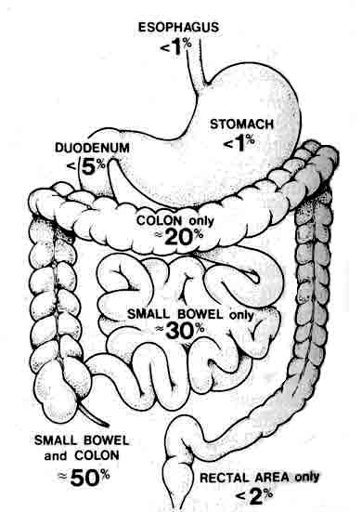
From: Basic surgery/ed., H.C. Polk, Jr., et al. – 5th ed.

Clinical features and visualization data

- Symptoms include diarrhea (usually not bloody), abdominal pain, lethargy, fever, weight loss, and anorectal disease.
- Anal fissures, fistulas, ulcers, or perirectal abscesses, are seen in 50% of patients with colonic involvement and 20% of patients with small bowel disease.
- Signs include an abdominal mass, anemia, and malnutrition.
- Extraintestinal manifestations include inflammatory ocular, joint, skin, and biliary disease (see Table 8-2).
- Barium gastrointestinal series characteristically reveal segmental areas of stricture separated by "skip areas" of uninvolved bowel, cobblestone appearance of the mucosa, and fistulas (see Fig. 8-1).
- Different endoscopic techniques (duodenoscopy with inspection of initial parts of jejunum, colonoscopy with inspection of terminal parts of ileum, and the most beneficial technique - double-balloon enteroscopy), if possible, may reveal the same findings.
- Differential diagnosis mainly includes ulcerative colitis, lymphoma, and infectious enteritides (tuberculosis, amebiasis, and Yersinia, Campylobacter, and Salmonella infections).

Table 8-2. Extraintestinal nonhepatic manifestations of idiopathic inflammatory bowel disease

Musculoskeleton  Ankylosing spondylitis and sacroiliitis  Peripheral arthritis  Pelvic osteomyelitis  Skin and mouth  Erythema nodosum  Pyoderma gangrenosum  Aphthous stomatitis  Eye  Uveitis (iritis)  Episcleritis | Blood and vascular system  Anemia  Iron loss  Vitamin В₁₂ or folate deficiency  Hemolytic  Thrombocytosis  Leukocytosis  Hypercoagulable state  Kidneys and genitourinary tract  Nephrolithiasis  Obstructive uropathy  Fistulas to genitourinary tract  Other  Bronchopulmonary vasculitis  Pleurocarditis
From: Principles of surgery/ed., S.I. Schwartz, et al. – 7th ed.

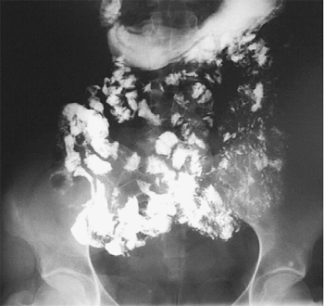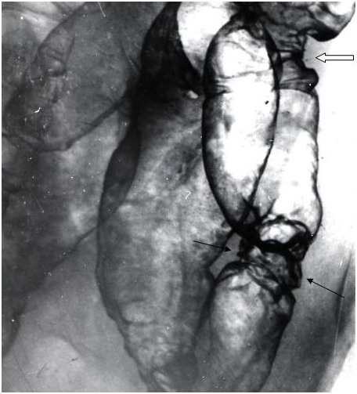

Fig. 8-1. Radiological picture of Crohn’s disease of small intestine

Treatment

- Medical treatment is preferred and can include a low-residue diet, sulfasalazine, prednisolone, oral antibiotics (metronidazole), sedatives, antispasmodics, and, when necessary, total parenteral nutrition (TPN). Although antibiotics and steroids are helpful in acute active disease, their effectiveness in preventing relapse of symptoms has not been established. See also Table 8-6.
- Surgical treatment, which is reserved for complications of the disease, ultimately becomes necessary in most cases (see Table 8-3). Surgical therapy is resecting as little bowel as necessary. If resection is hazardous, bypass or exclusion of the involved segment may be necessary.
- Intestinal obstruction, usually due to stricture and inflammation, is the most common indication.
- Abscesses and fistulas are also common. Abscesses may be intra- or retroperitoneal. Fistulas form from bowel to skin, to bladder, to vagina, to urethra or to other loops of bowel.
- Perianal disease is best treated with oral metronidazole. Perirectal abscesses require drainage. Anal fistulas and fissures may need surgery if they are multiple or severe. In general, surgery for perianal disease should be as limited as is practical, because wound healing in these patients is poor and recurrence is common.
- Perforation, hemorrhage, intractable symptoms, cancer, and growth retardation (in children) are less common indications for surgery.

Table 8-3. Indications for surgery in Crohn's disease of small intestine

Intractability
Obstruction
Internal fistula
Enterocutaneous fistula
Intra-abdominal abscess
Massive hemorrhage
Free perforation
Cutaneous and systemic complications
Severe anal and perianal involvement

INFLAMMATORY BOWEL DISEASE

Overview

- Two major types of idiopathic inflammatory bowel disease may involve the large bowel: Crohn's colitis and ulcerative colitis.
- There is considerable overlap in the presentation of these diseases (see Table 8-4). In approximately 15% of patients with idiopathic colitis, a distinction between the two cannot be made on pathological or clinical grounds. In such situations, the disease is called indeterminate colitis.
- Etiology of either disease remains unknown. Genetic, environmental, infectious, and autoimmune mechanisms have been suggested, but a clearly defined cause has not been identified. Both diseases can occur at any age, but they tend to be diseases of young adults.

Table 8-4. Common differences between Crohn's disease and ulcerative colitis

 | Crohn's disease | Ulcerative colitis
Usual location | Entire GI tract | Confined colon/rectum
Bowel wall involvement | Transmural inflammation | Mucosal inflammation
Fistulas | Common | Rare
Rectal bleeding | Uncommon, intermittent | Common, continuous
Rectal involvement | Rare | Almost always
Ulcers | Linear with transverse fissures  ("cobblestone") | Shaggy, irregular, continuous distribution
Bowel stricture | Rare (suspect carcinoma) | Common
Perineal disease | Common | Rare
Toxic megacolon | Occurs in both
Cancer risk | Increased in both (with predominance of ulcerative colitis)
From: Principles of surgery/ed., S.I. Schwartz, et al. – 7th ed. (modified)

Ulcerative colitis

Overview

- Mucosal inflammation (as opposed to transmural inflammation) occurs, as does rectal inflammation. The rectum is virtually always involved, with inflammation extending proximally for variable distances. Inflammation is continuous; that is, there are no skipped areas of normal mucosa between inflamed segments.
- There usually is no anal or perianal disease in patients with ulcerative colitis. There is no involvement of the small bowel.
- Crypt abscesses may be present but not granulomas. Pseudopolyps may be present.
- Extraintestinal manifestations of the disease may be present, including: ankylosing spondylitis and sacroileitis, peripheral arthritis, erythema nodosum and pyoderma gangrenosum, aphthous stomatitis, iritis and episcleritis, sclerosing cholangitis.
- Risk for colon cancer occurs in patients with chronic disease. The risk is minimal until after 10 years of onset, and then it increases by approximately 2% each year thereafter. The risk is minimal in patients with disease limited to the rectum, and is highest in patients with pancolitis. Dysplasia of the mucosa is associated with an increased risk of cancer. Patients who have had ulcerative colitis for longer than 10 years should have yearly surveillance colonoscopy with multiple mucosal biopsies to search for dysplasia (see Scheme 8-2). Cancers in patients with ulcerative colitis are flat, invasive lesions and are not readily identified by barium enema.

Scheme 8-2. Surveillance for extensive, chronic mucosal ulcerative colitis

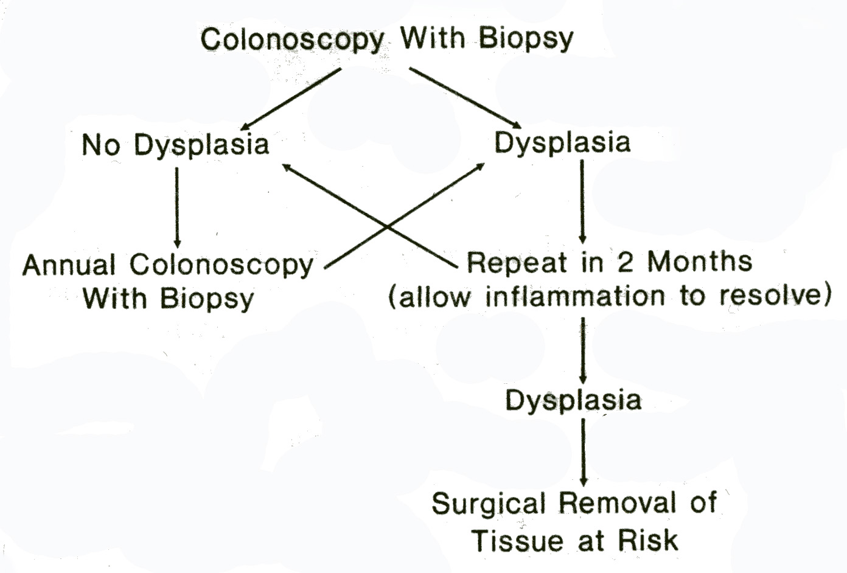
From: Principles of surgery/ed., S.I. Schwartz, et al. – 7th ed.

Clinical features

- Bloody diarrhea is the most common symptom. Rarely, bleeding may be massive and life-threatening.
- Mucus and pus may accompany the passage of loose stools.
- Cramping abdominal pain often occurs.
- Malaise, fever, weight loss, and anemia are common.
- Severity of disease ranges from occasional episodes of diarrhea to fulminant colitis with toxic megacolon, which is characterized by dilatation of the transverse colon; abdominal pain, tenderness, and distention; fever, leukocytosis, hypoalbuminemia; significant risk of colonic perforation.
- Stool samples should be cultured for pathogens and examined for ova and parasites.
- Evaluation depends on the severity of the disease. Mild cases can be evaluated on an outpatient basis, whereas fulminant colitis with toxic megacolon is a life-threatening situation requiring hospitalization; intensive medical treatment, and emergency surgery if medical treatment fails.

Visualization data

- Proctoscopy is the most valuable test to establish the diagnosis. Mucosal inflammation beginning at the level of the dentate line is highly suggestive of ulcerative colitis.
- In the presence of fulminant colitis, colonoscopy and barium enema should be avoided because these tests may worsen the condition and lead to toxic megacolon.
- Mucosal biopsies should be taken to confirm the diagnosis. Such biopsies are also helpful in distinguishing ulcerative colitis from Crohn's colitis and infectious colitis.
- Abdominal radiographs should be obtained if abdominal tenderness is present and symptoms are severe, to rule out colonic dilation.
- If symptoms are mild, the entire colon should be evaluated by colonoscopy (see Fig. 8-2) and barium enema (see Fig. 8-3).
- Small-bowel contrast studies should be obtained to rule out small-bowel involvement, which would indicate Crohn's disease.

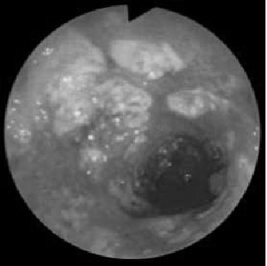

Fig. 8-2. Colonoscopic picture of ulcerative colitis
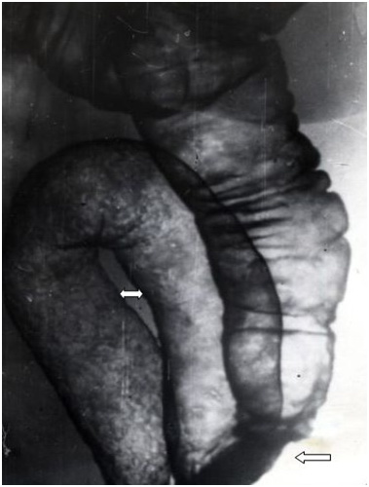

Fig. 8-3. Radiological picture of ulcerative colitis

Table 8-5. Criteria of severity of ulcerative colitis

 | Mild | Moderate | Severe
Stool frequency/24 h | <4 | 4-6 | >6
Pulse (beats/min) | <90 | 90-100 | >100
Hematocrit (%) | Normal | 30-40 | <30
Weight loss (%) | None | 1-10 | >10
Temperature (°C) | Normal | 37.2-38.1 | >38.1
ESR (mm/h) | Normal | 20-30 | >30
Albumin (g/l) | Normal | 30-35 | <30
From: Principles of surgery/ed., S.I. Schwartz, et al. – 7th ed.

Treatment

Medical treatment

- Steroids are effective for short-term treatment, but side effects prevent their long-term use.
- Sulfasalazine remains the main therapeutic agent. It is recommended even if disease is in remission, because it decreases the incidence and severity of recurrence.
- Aminosalicylates are beneficial to patients who are allergic to sulfasalazine.
- Immunosuppressive agents include: 6-mercaptopurine, azathioprine, methotrexate, intravenous cyclosporine.
- Broad-spectrum antibiotics are indicated for patients with fulminant colitis and toxic megacolon.
- TPN may be required for patients with severe debilitating disease, usually to prepare the patient for surgery.

Table 8-6. The medical therapy of ulcerative colitis and Crohn's disease of colon

Sulfasalazine

Ulcerative colitis
Mild to moderate active disease
Maintenance of remission
Crohn's disease
Mild to moderate active disease (colitis > ileitis)
Maintenance of remission not established
No effect on postoperative recurrence
Pregnancy and nursing
No adverse effect on pregnancy
No teratogenicity
No kernicterus

Metronidazole

Crohn's ileocolitis and colitis
Crohn's ileitis alone (?)
Perineal Crohn's disease
Not effective in active ulcerative colitis
Toxic effects: nausea, anorexia, furry tongue, metallic taste, monilial infections, peripheral neuropathy, risk of malignancy (?)

Corticosteroid

Topical
Proctitis and left-sided colitis
Oral
Mild to moderate active ulcerative colitis and Crohn's disease
No role as maintenance therapy
Parenteral
Severe or toxic ulcerative colitis or Crohn's disease

Immunosuppressive agents

Ulcerative colitis
Steroid sparing
Refractory disease
Crohn's disease
Steroid sparing
Fistulas
Refractory disease
Perineal disease
Maintenance of remission
Toxic effects: rash and fever, bone marrow depression, pancreatitis, hepatitis, risk of malignancy (?), teratogenicity

From: Principles of surgery/ed., S.I. Schwartz, et al. – 7th ed.

Surgical treatment

Table 8-7. Indications for surgery in ulcerative colitis

Intractability
Obstruction
Massive hemorrhage
Fulminating colitis
Toxic megacolon
Cutaneous and systemic complications
Severe mucosal dysplasia

- Total proctocolectomy with permanent ileostomy (see Fig. 6-5, E) is the simpliest and most radical surgery for complicated ulcerative colitis and rectal involvement.
- Abdominal colectomy (see Fig. 6-5, A) with closure of rectal stump is indicated for patients with fulminant colitis. This procedure is helpful in patients with indeterminate colitis because it allows examination of the entire colon to distinguish between Crohn's disease and ulcerative colitis. Restorative proctectomy with ileal pouch-anal anastomosis (see Fig. 6-5, D) can be performed at a later date.
- Proctocolectomy with ileorectal anastomosis (see Fig. 6-5, B) or with anal sphincter preservation and ileal pouch-anal anastomosis (see Fig. 6-5, D) (restorative proctocolectomy) are the most common elective procedures for ulcerative colitis. They are usually accompanied by a temporary ileostomy, which is closed 10 weeks after the initial operation.
- Total proctocolectomy and continent ileostomy (Koch pouch) (see Fig. 6-5, C). The main indication for this procedure is a patient who has already had a total proctocolectomy and is allergic to the ileostomy appliance.

Table 8-8. Comparison of three operations as treatment for ulcerative colitis

Proctocolectomy with Brooke ileostomy
Advantages
Curative
One operation
Disadvantages
Incontinence; external ileostomy
appliances; need to empty 4-8 times per
day
Complications
Stoma revision 10%-25%
Perineal wound problems 10%-25%
Small bowel obstruction 10%-20%
Bladder dysfunction - Minimal
Sexual dysfunction - Minimal
Contraindications
None

Colectomy with ileorectal anastomosis

Advantages
Sphincter unchanged
Evacuation 2-4 times per day
No stoma
No bladder or sexual dysfunction
Disadvantages
Not curative
Cancer risk persists
Protectomy for cancer or disease in 5%-50%
Complications
Small bowel obstruction in 10%-20%
Anastomotic leak with disease
Contraindications
Sphincter incontinence
Severe rectal disease
Rectal dysplasia
Rectal cancer

Total proctocoloectomy with ileoanal anastomosis with pouch
Advantages
Curative
Continent
Disadvantages
Failure 10%
Need to evacuate 4-8 times per day
Complications
Pouch fistulas
Sepsis
Stenosis
Small bowel obstruction in 10%-20%
Pouchitis
Bladder dysfunction minimal
Sexual dysfunction minimal
Anal excoriation
Contraindications
Crohn's disease
Diarrhea
Rectal cancer in distal half

From: Principles of surgery/ed., S.I. Schwartz, et al. – 7th ed.

Crohn's colitis

Overview

- The full thickness of the bowel wall is inflamed.
- "Skip areas" of normal bowel may separate inflamed regions (another term for this disease is segmental colitis).
- Disease does not always involve the rectum. The small bowel is frequently involved (especially terminal ileum). Anal or perianal disease (e.g., fistulas, abscesses, fissures) may be present. Approximately one-third of all patients with Crohn's disease develop anal disease. Anal disease is more common in patients with colon disease (50%) than in patients with small bowel disease (25%).
- Granulomas are present in 30% to 50% of cases. Linear ulcers may join transverse fissures to give a "cobblestone" appearance to the mucosa.
- Extraintestinal manifestations are generally the same as for ulcerative colitis, except that sclerosing cholangitis is less common than with ulcerative colitis.
- Risk for cancer in the diseased segments is increased, but less than with ulcerative colitis.

Clinical features

- Diarrhea (with diffuse colonic disease) is common.
- Cramping abdominal pain and right lower quadrant tenderness (with ileocolic disease) are common.
- Malaise, fever, weight loss, and leukocytosis are common.
- Abdominal abscess (usually right lower quadrant) may occur.
- Fistulas may occur between the involved bowel and the bladder, vagina, skin, or other segments of intestine.
- Anal abscess or fistula is a presenting symptom in 5% of cases.
- Fulminant colitis may be as severe as ulcerative colitis. The colon usually does not dilate ("megacolon") with fulminant Crohn's disease, which is thought to be due to the transmural inflammation with thickening of the wall. Patients with fulminant colitis must be treated as vigorously as patients with ulcerative colitis and megacolon. Risk of perforation is the same as in those conditions.
- Abdominal examination is important to evaluate areas of tenderness or mass.
- Anorectal examination should detect abscesses, fissures, or fistulas.
- Stool samples should be cultured and examined for ova and parasites.

Visualization data

- As with ulcerative colitis, evaluation depends on the severity of the disease.
- Proctoscopy is important. If rectal mucosa is not involved, ulcerative colitis is essentially excluded as a diagnostic possibility.
- Barium studies of the small bowel and colon (see Fig. 8-4) are indicated to determine the extent of disease.
- Colonoscopy is helpful to evaluate the extent of colonic involvement (see Fig. 8-5).
- A CT scan or MRI is helpful if abdominal or pelvic abscess is suspected.

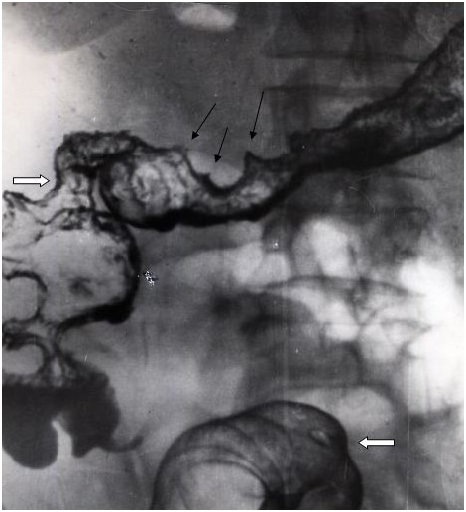

Fig. 8-4. Radiological picture of Crohn’s disease of colon

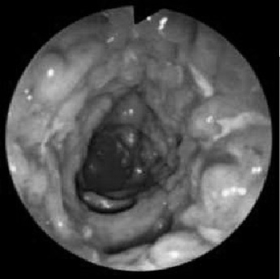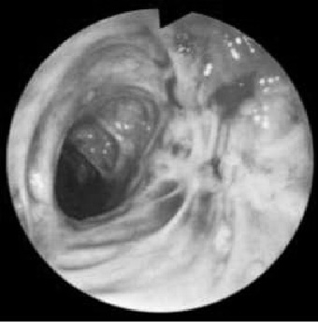

Fig. 8-4. Colonoscopic picture of Crohn’s disease of colon

Treatment

Medical treatment

- Steroids are helpful for acute disease.
- Immunosuppressive agents appear to provide clinical improvement, steroid sparing, and fistula healing in patients with active Crohn's disease.
- TPN permits bowel rest and induces remission in some patients with significant Crohn's disease. TPN and bowel rest for 7 to 10 days preoperatively will promote resolution of intra-abdominal inflammation and will reduce the risk of injury to adjacent, secondarily inflamed bowel.
- Broad-spectrum antibiotics are beneficial to decrease luminal bacterial concentrations, tissue invasion and cellulitis, and bacterial translocation.
- Metronidazole appears to be beneficial for treatment of anal disease.
- See also Table 8-6.

Surgical treatment

Table 8-9. Indications for surgery in Crohn's disease

Intractability
Obstruction
Internal fistula
Colo- or enterocutaneous fistula
Intra-abdominal abscess
Massive hemorrhage
Fulminating colitis
Toxic megacolon
Free perforation
Cutaneous and systemic complications
Severe anal and perianal involvement
Severe mucosal dysplasia

From: Basic surgery/ed., H.C. Polk, Jr., et al. – 5th ed.

- A goal of surgery is to conserve bowel. Wide margins of normal bowel are not required; only grossly involved bowel should be resected. To conserve bowel, stricture plasty may at times be indicated to relieve obstruction (rather than intestinal resection). In most instances, the plan of surgery should be to resect the involved bowel and to fashion a primary anastomosis. A high recurrence rate (50% within 5 years) follows intestinal resection. The most likely site of recurrence is at the anastomosis from the previous operation.
- Total proctectomy with ileostomy (see Fig. 6-5, C,E) is required for severe rectal disease. Ileal pouch-anal anastomosis is contraindicated because of the high incidences of anal disease and recurrent bowel disease in the pouch.
- Abdominal abscesses should be drained percutaneously prior to laparotomy.

BENIGN TUMORS OF THE SMALL INTESTINE

- Benign neoplasms are usually asymptomatic. They are 10 times more common than malignant tumors (autopsy data).
- Surgery is indicated for bleeding, obstruction, intussusception or, rarely, malignant degeneration.
- Adenomatous polyps are rare in the small intestine. They may be seen in the familial polyposis syndromes (see Chapter 6) and have malignant potential in this setting.
- Hamariornatous polyps are found in patients with Peutz-Jeghers syndrome (mucocutaneous pigmentation accompanied by widespread intestinal polyposis). There is little malignant potential in this syndrome.
- Juvenile (retention) polyps are benign hamartomas and not true neoplasms. They are more common in the rectum and usually autoamputate.
- Other benign tumors include leiomyomas, lipomas, adenomas, hemangiomas, fibromas, and neurofibromas (in descending order of frequency).

MALIGNANT TUMORS OF THE SMALL INTESTINE

Overview

- The most common tumors are adenocarcinoma (40%), carcinoid (30%), lymphoma (20%), sarcoma, and metastases from distant malignancies.
- Malignant tumors constitute 75% of symptomatic small bowel tumors and usually present with bleeding, diarrhea, perforation, or obstruction (which may be due to intussusception).
- Diagnosis is frequently made late in the course of disease as symptoms are often subtle and insidious in onset.
- Treatment is segmental resection, including adequate margins proximaily and distally and as much mesentery as possible without compromising the blood supply to the remaining small intestine.

TNM-classification

T - primary tumor
TX Primary tumor cannot be assessed
T0 No evidence of primary tumor
Tis Carcinoma in situ
T1 Tumor invades lamina propria or submucosa
T2 Tumor invades muscularis propria
T3 Tumor invades through muscularis propria into subserosa or into non-peritonealized perimuscular
tissue (mesentery or retroperitoneum) with extension 2 cm or less
T4 Tumor perforates visceral peritoneum or directly invades other organs or structures (includes other
loops of small intestine, mesentery, or retroperitoneum more than 2 cm and abdominal wall by way of
serosa; for duodenum only, invasion of pancreas)
N - regional lymph nodes
NX Regional lymph nodes cannot be assessed
N0 No regional lymph node metastasis
N1 Regional lymph node metastasis
M - distant metastasis
MX Distant metastasis cannot be assessed
M0 No distant metastasis
M1 Distant metastasis

Stage grouping

Stage 0 | Tis | N0 | M0
Stage I | T1, T2 | N0 | M0
Stage II | T3, T4 | N0 | M0
Stage III | Any T | N1 | M0
Stage IV | Any T | Any N | M1

Adenocarcinoma

- Adenocarcinoma is most common in the duodenum and proximal jejunum.
- Metastases are present in a large percentage of patients at operation.
- Patients with resectable tumors have a 25% 5-year survival rate. Patients with Crohn's disease are at higher risk.

Carcinoid tumors

- Carcinoid tumors are derived from enterochromaffin cells. These cells are part of APUD cells and, hence, carcinoid tumors are classified as apudomas.
- Carcinoid tumors are most common in the appendix, then the small bowel (usually the ileum), then the rectum (see Scheme 6-9). Other sites are uncommon.
- Prognosis is related to size (i.e., diameter). Both carcinoid tumors and metastases
are slow growing. Tumors less than 1 cm in size (75% of total) have a 2% incidence of metastases. Tumors 1-2 cm in size (20% of total) have over a 50% rate of metastases. Tumors over 2 cm in size (5% of total) have an 80%-90% rate of metastases.
- Only small bowel carcinoids have a tendency to multicentricity (30%).

Carcinoid syndrome

- Carcinoid syndrome includes flushing, diarrhea, bronchoconstriction, and tricuspid and pulmonary valvular disease which is caused by serotonin and other vasoactive substances secreted by the tumor. These substances are cleared by the liver, so only liver metastases, which drain into the systemic veins, or primary extraintestinal carcinoids (e.g., bronchial carcinoids), cause the syndrome.
- About 10% of patients with small bowel carcinoids develop the syndrome.
- Diagnosis is made by finding elevated levels of 5-hydroxyindoleacetic acid, the breakdown product of serotonin, in the urine.
- Treatment includes resection of the primary tumor and resection or "debulking" of metastases. Liver metastases can be resected (when solitary) but usually require palliative therapy with (intra-arterial) chemotherapy or hepatic arterial ligation or endovascular embolization to decrease the blood flow to the metastases.
- The overall 5-year survival rate for small bowel carcinoid patients is 70%. If liver metastases are present, the 5-year survival rate is 20%.

Other malignant tumors

- Primary small bowel lymphomas usually arise in the ileum. Perforation is a frequent presentation; however, lymphomas can also present with fever of unknown origin, malabsorption, or abdominal pain.
- Leiomyosarcoma is the most common of the small bowel sarcomas.
- Metastases to the small bowel are present in 50% of malignant melanoma patients at autopsy. Other cancers can metastasize to the small bowel.

SHORT BOWEL SYNDROME

- Short bowel syndrome is a complication of extensive small bowel resection. The length of bowel necessary to avoid the syndrome is variable, but patients with less than 100 cm of small bowel are most susceptible. An intact ileocecal valve, colon, or both, decreases the amount of residual small bowel needed.
- It is characterized by malabsorption with diarrhea and excessive loss of fat and protein in the stool. Inadequate absorption of water, electrolytes, minerals, and vitamins also invariably occurs.
- TPN is essential postoperatively. The small bowel will hypertrophy with time, and most patients can be weaned from parenteral nutrition gradually. For refractory cases, long-term parenteral nutrition (home TPN) is available.
- Ensuring that oral nutrition is adequate requires attention to several points. The total calories ingested must increase. A low-residue or elemental diet is needed (medium- and short-chain triglycerides, mono- and disaccharides, and mono- and dipeptides). Antiperistaltic agents should be given. Reflex gastric hypersecretion should be controlled with PPIs or H₂-receptor antagonists. Fat- and water-soluble vitamin supplementation is needed. Parenteral vitamin B₁₂ is needed if the distal ileum has been resected. Calcium and magnesium supplementation should be given.
- Surgical therapy is available, consisting of reversal of a short segment of distal small bowel to slow the intestinal transit time if adequate oral nutrition cannot be attained.

RADIATION ENTRITIS

- Radiation injury to the small bowel occurs in two phases.
- Acute phase injury is due to mucosal injury. Symptoms, which include nausea, vomiting, and diarrhea, are transient. Rarely, bleeding or perforation occurs and requires surgery.
- Chronic effects appear months to years later and are due to an obliterative vasculitis. The symptoms and signs are similar to those associated with recurrent malignancy and, indeed, this possibility must always be fully evaluated.
- Minor symptoms - abdominal pain, malabsorption, and diarrhea - require symptomatic therapy only. Major complications that require surgery include bowel obstruction (unrelieved by decompression with a nasogastric or long tube), perforation, abscess, fistula, and hemorrhage. Hemorrhage may be from mucosal erosion or an enteroarterial fistula.
- Surgery is technically difficult due to fibrosis and scarring. With resection or bypass, unirradiated bowel must be used for any anastomosis. Even so, the anastomosis or surgical wound is likely to break down with subsequent fistula formation or other complications.
- The perioperative mortality rate is less than 15%, but the long-term mortality rate is high. The 5-year survival rate is less than 50%.

PSEUDOMEMBRANOUS COLITIS (ANTIBIOTIC-ASSOCIATED COLITIS)

Clinical characteristic

- Acute diarrhea associated with the use of antibiotics is the main presentation. In 25% of cases, antibiotic has been discontinued before the development of diarrhea.
- This syndrome is common in hospitals and nursing homes.
- This syndrome may occur after intestinal operations, especially after antibiotic bowel preparation.
- Clostridium difficile has been shown to be the causative organism. Yellow plaques composed of fibrin and cellular debris, or pseudomembranes, may cover the mucosa. The absence of pseudomembranes does not rule out this syndrome.

Diagnosis

- A history of diarrhea following antibiotic treatment is suspicious.
- Proctoscopy or colonoscopy may reveal pseudomembranes (see Fig. 8-6), which are virtually diagnostic if present.
- A stool sample should be sent for C. difficile toxin titer.

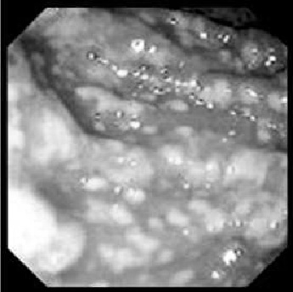

Fig. 8-6. Colonoscopic picture of pseudomembranous colitis

Treatment

- The causative antibiotic should be stopped.
- Metronidazole is the treatment of choice, and may be given orally or intravenously. Oral vancomycin is also effective.
- Recurrence is common (25%) and requires retreatment.
- Abdominal colectomy with ileostomy has been required for rare cases of fulminant pseudomembranous colitis.

ISCHEMIC COLITIS

Overview

- Points of communication between collateral arteries are theoretically at increased risk for ischemia. These points include the splenic flexure and the mid-sigmoid colon. However, any segment of the colon may be involved (rectal involvement is very rare).
- Predisposing factors include: surgery, especially ligation of the inferior mesenteric artery during aortic surgery; atherosclerosis, vasculitis, collagen vascular diseases; polycythemia vera; congestive heart failure; digitalis, oral contraceptives, antihypertensive medications, and vasopressors; low-flow states (myocardial infarction, sepsis).

Clinical features and visualization data

- Three phases of ischemic colitis may be recognized.
- Transient ischemia (mucosal involvement). Symptoms are usually mild abdominal pain and passage of maroon-colored stool. Barium enema may reveal "thumbprinting" (mucosal hemorrhage). Colonoscopy reveals dusky, hemorrhagic mucosa.
- Partial thickness ischemia with late stricture. Symptoms are more severe and include abdominal tenderness, fever, and leukocytosis.
- Gangrenous ischemia. Symptoms of an acute abdomen are present with abdominal pain, peritonitis, and signs of sepsis.

Treatment

- Transient ischemia is treated symptomatically. Hospitalization and observation are indicated until the severity of disease is determined. Any causative factors should be corrected, if possible.
- Partial-thickness ischemia is managed by close observation, intravenous fluids, and broad-spectrum antibiotics. If a stricture develops and is asymptomatic, no treatment is required. Symptomatic strictures require resection.
- Gangrenous ischemia requires emergency resection of nonviable bowel is required. Anastomosis usually is not safe in such circumstances, so colostomy is required.

REVIEW TESTS

1. A 30-years-old man was admitted to ER with complaints of frequent diarrhea, multiple vomiting, and cramping pain at all the sites of abdomen. He is ill for 2 days. Patient’s body temperature is 37,8 °C. While physical examination of abdomen, there is moderate diffuse tenderness, no rebound tenderness, muscle guarding and distension. Upright abdominal radiography reveals no pathological findings. Give your presumable diagnosis:

A. Bowel obstruction
B. Acute appendicitis
C. Acute non-specific enterocolitis
D. Irritable bowel syndrome
E. Acute pancreatitis

2. A 48-years-old woman was admitted to surgical department with complaints of intense constant diffuse abdominal pain, abdominal distention, fatigue, and febrile temperature. There is a history of Crohn’s disease of large intestine for 10 years. Last exacerbation began 3 week ago. Patient’s condition is progressively worsening, medical therapy with parenteral and oral steroids give no effect. Patient’s condition is poor. Physical examination of abdomen reveals pronounced abdominal distension due to markedly dilated colon, diffuse tenderness, and diffuse slight rebound tenderness. Upright abdominal radiograph shows extreme dilation of the entire colon. Proctoscopy shows a picture of chronic Crohn’s colitis (ulcers, pseudopolips) in sigmoid colon without rectal involvement. WBC count is 25’000/L. What’s the most appropriate tactics of managing the patient?

A. Total proctocolectomy with ileostomy
B. Subtotal colectomy with ileorectal anastomosis
C. Subtotal colectomy with ileostomy with further ileorectal anastomosis
D. Total proctocolectomy with continent ileostomy
E. Total proctocolectomy with pouch-anal anastomosis

3. A 39-years-old woman was admitted to ER with complaints of multiple bloody diarrhea, moderate lower abdominal pain, and bloating. The symptoms appeared 4 days ago. The same condition was 1 year ago. Patient’s condition is moderate. Physical examination reveals slight tenderness in left lower quadrant and left flank, no muscle guarding and rebound tenderness. Hb level is 108 g/l, RBC count is 3´000´000/ml. Upper gastrointestinal endoscopy reveals no pathological findings. Colonoscopy shows pathological findings in descending, sigmoid colon, and upper rectum: hyperemic and edematous mucosa, multiple flat ulcers distributed continuously within the involved bowel segment, some of them are slightly bleeding. Give your presumable diagnosis:

A. Crohn’s disease of colon
B. Ulcerative colitis
C. Pseudomembranous colitis
D. Radiation colitis
E. Ischemic colitis

4. A previously healthy 43-years-old man was admitted to surgical department with a 6-month history of non-bloody diarrhea, fever, and 10-pound weight loss and now develops urosepsis. On retrograde contrast vesicogram, an enterovesical fistula is found. At laparotomy, findings include inflammation and "fat wrapping" of three separate segments of ileum. Each segment is approximately 20 cm in length and is separated by less than 20-cm segments of normal-appearing bowel (skip areas). The distal-most of the three segments is more severely inflamed than the others and involves the terminal ileum all the way to the caecum. This segment of ileum is densely adherent to the right superior aspect of the bladder. What’s the most appropriate tactics of managing the patient?

- Resection of all of the abnormal-appearing bowel
- Drainage of the peritoneal cavity and conservative treatment of the lesions
- Resection of all of the bladder wall involved in the inflammatory process along with the adjacent segment of ileum
- Extensive resection of all the involved segments of ileum
- Closure of the fistula and resection of the involved bowel

5. The above mentioned 43-years-old man returns to the surgical department 3 years later complaining of abdominal pain, abdominal distention, bloating after meals, and intermittent constipation interspersed with diarrhea. He has lost 10 kg during the last 3 months, which he ascribes to the aforementioned abdominal symptoms. A small bowel follow-through study reveals one area of tight stricture in the distal small bowel. The stricture appears to be 10 cm in length. What’s the most appropriate tactics of managing the patient?

- Resection of the stricture
- Bypass of the involved segment
- Extensive small bowel resection
- Conservative treatment of the lesion
- Strictureplasty

6. Drugs that are effective in treating both Crohn's colitis and ulcerative colitis are:

- Metronidazole
- Corticosteroids
- Azathioprine and 6-mercaptopurine
- All of the above

7. A 60-years-old man who is finishing a course of antibiotic therapy for bacterial pneumonia develops cramping abdominal pain and profuse watery diarrhea. A diagnosis of pseudomembranous or antibiotic-associated colitis is suspected. What would the initial treatment involve?

- Metronidazole
- Vancomycin
- Imodium
- Cephalexin
- Total abdominal colectomy

Correct answers: 1 - C, 2 - C, 3 - B, 4 - E, 5 - A, 6 - D, 7 - A.

