CHAPTER 9. ANAL COMPLAINTS

- The most common complaints are anal and perianal pain and problems with defecation that are caused by several functional, inflammatory and neoplastic lesions.

DYSFUNCTION OF THE ANORECTUM

Table 9-1. Conditions causing abnormal defecation

Obstructed defecation

Sphincter stenosis
Postsurgical
Posttraumatic
Radiation injury
Inflammatory strictures
Lymphogranuloma venereum
Tuberculosis
Sphincter spasm due to anal fissure
Nonrelaxation of the puborectalis
Internal intussusception

Tenesmus

Inflammatory disease of the anorectum
Tumors of the anorectum

Incontinence

Defects in sphincter control
Postsurgical
Posttraumatic
Neurogenic cases
Systemic disease
Tumor invasion

Rectal prolapse

Incontinence

Etiology

- Mechanical defects of the anal sphincter: episiotomy injuries, previous anal fistulotomies, anorectal trauma (impalement injuries).
- Neurogenic causes: pudendal nerve injury due to prolonged labor, pudendal nerve injury due to perineal descent, systemic neurologic disease (multiple sclerosis).
- Systemic disease: scleroderma, diabetes mellitus.
- Causes unrelated to the anal sphincter: severe diarrhea, severe proctitis with decreased rectal capacity, fecal impaction with overflow incontinence, large rectal tumors.

Diagnosis

- History and anorectal examination often suffice to establish the diagnosis.
- Anterior sphincter defect and patulous anus after midline episiotomy usually require no tests other than confirmation by examination.
- Physiologic evaluation may be helpful if the cause of incontinence is not obvious.
- Anal manometry can document the resting pressure, squeeze pressure, sphincter length, and minimal sensory volume of the rectum.
- Pudendal nerve terminal motor latency can be tested to determine if the cause of incontinence is neurogenic in nature.

Surgical treatment

- Sphincter defects, such as those caused by obstetrical injuries, may be corrected by anal sphincter repair (see Fig. 9-1) with excellent results.
- More extensive loss of the anal sphincter may be treated by muscle transposition, which mobilizes the muscle to encircle the anus (see Fig. 9-2).
- Colostomy may be required for severe sphincter injuries or for neurogenic or systemic causes of incontinence.

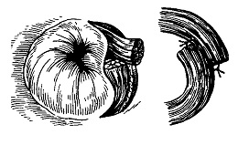
Fig. 9-1. Scheme of anal sphincter repair

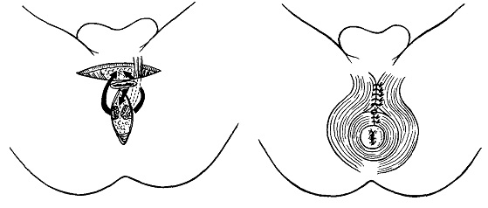

Fig. 9-2. Muscle transposition for anal sphincter repair

Obstructed defecation (pelvic-floor-outlet obstruction)

Anal stenosis

- Anal stenosis may be caused by circumferential hemorrhoidectomy (Whitehead deformity), trauma, or radiation.
- It may result in the inability to evacuate formed stool, with resulting abdominal bloating, intestinal dilation, and discomfort.
- Treatment generally entails plastic procedure - advancing full-thickness pedicles of skin to the anal canal (see Fig. 9-3).
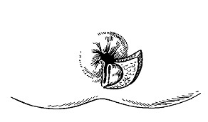

Fig. 9-3. Plastic procedure for anal stricture

Nonrelaxation of the puborectalis

- Nonrelaxation of the puborectalis is a functional disorder characterized by the inability to relax the puborectalis muscle at the time of defecation. The syndrome occurs in women nine times more often than in men.
- Symptoms include the need for digital maneuvers to eliminate stool, pelvic pain, a sense of incomplete evacuation, and severe straining during defecation.
- Normal function of the colon is demonstrated by colonic transit time, which is demonstrated by following radiopaque markers through the colon.
- Diagnosis may be confirmed by defecography, which demonstrates the failure of the muscle to relax appropriately. Another simple diagnostic test reveals the inability of the patient to expel an air-filled balloon from the rectum.
- Treatment is nonsurgical. Biofeedback to develop cognitive aspects of defecation is the treatment of choice.

Internal intussusception

- Internal intussusception (internal prolapse of the rectum) is characterized by the distal bowel telescoping into itself to cause partial obstruction to defecation.
- A solitary rectal ulcer is now recognized as the cause for this syndrome. The ulcer is usually located in the anterior rectal wall. Colitis cystica profunda, which is characterized by glandular tissue beneath the mucosa, may accompany this condition. It is important to distinguish this benign lesion from cancer (for which it may be confused by histologic appearance). Internal intussusception is accompanied by abnormal rectal fixation, which permits the rectum to descend toward the perineum.
- Patients complain of an urgency to defecate, a feeling of rectal fullness, and pelvic pain.
- Medical treatment suffices for most patients and consists of: increased dietary fiber, stool softeners, glycerine suppositories or small enemas.
- Indications for surgical treatment include: debilitating symptoms despite maximum medical therapy and psychological counseling; impending anal incontinence due to stretch injury to the pudendal nerves caused by constant straining (and subsequent perineal descent); chronic bleeding from a solitary rectal ulcer.
- Surgical treatment is low anterior resection of the sigmoid and proximal rectum, with colorectal anastomosis and rectal fixation.

Rectal prolapse

Overview

- Rectal prolapse is the protrusion of the full thickness of the rectum (and occasionally the sigmoid colon) through the anus.
- This condition should be distinguished from mucosal prolapse, which is the protrusion of only the rectal mucosa through the anal orifice. Full-thickness prolapse has concentric mucosal folds. Mucosal prolapse has radial folds in prolapsing mucosa.
- Rectal prolapse may be the result of long-term internal intussusception. There is an increased incidence in: patients in mental institutions, women who have had a hysterectomy, elderly women. There is no increased incidence in women who have had multiple deliveries.

Clinical features

- Mucosa-lined bowel protrude through the anus.
- Bleeding, anal pain, mucous discharge are present.
- Anal incontinence is of varying degree, caused by stretch of the anal sphincters or caused by stretch injury to the pudendal nerves (from perineal descent that is associated with the prolapse).

Treatment

- Treatment is surgical. The prolapse may become incarcerated and strangulated if not reduced.
- Patients in satisfactory health and with satisfactory anal continence should be treated by low anterior resection with rectopexy. An alternative treatment is to fix the rectum to the sacrum with a synthetic sling (Ripstein procedure). This operation may increase the difficulty of evacuation.
- Patients who are poor surgical risks may be treated by perineal proctectomy with low colorectal (or coloanal) anastomosis. An abdominal incision is avoided, but recurrence is higher. Anal encircling procedures are at times advocated for poor-risk patients. A band of synthetic material (wire or mesh) is placed subcutaneously around the anus. Encircling procedures are often complicated by infection, and results are generally unsatisfactory.
- Patients with total incontinence may require treatment by anterior resection of the rectum and colostomy (low Hartmann's procedure).

BENIGN ANORECTAL DISEASE

Hemorrhoids

Overview

- Anal cushions are engorged vascular and connective tissue complexes normally located in the right anterolateral and posterolateral positions and the left lateral position in the anal canal.
- Prolonged straining during defecation and increased abdominal pressure are thought to contribute to formation of hemorrhoids.
- Hemorrhoids are classified to internal and external.
- Internal hemorrhoids are more frequent and located above the dentate line and are covered by rectal mucosa. First-degree hemorrhoids bleed but do not prolapse. Second-degree hemorrhoids bleed and prolapse through the anus but spontaneously reduce. Third-degree hemorrhoids bleed and prolapse and can be manually reduced. Fourth-degree hemorrhoids protrude through the anus and cannot be manually reduced.
- External hemorrhoids reside below the anal verge and are lined by squamous epithelium. A thrombosis within an external hemorrhoid may cause acute swelling and anal pain.

Clinical features

- Bleeding, mucous discharge, prolapse, and pruritis are symptoms of internal hemorrhoids.
- Internal hemorrhoids seldom cause pain unless acutely prolapsed and incarcerated. Anal pain should not be attributed to thrombosed internal hemorrhoids. Another source must be sought to explain the pain.

Treatment

- Treatment of hemorrhoids depends on the symptoms.
- Medical therapy consists of addition of dietary fiber and stool softeners, rectal suppositoria, and education of the patient to avoid prolonged straining.
- Rubber-band ligation can provide satisfactory treatment for first- and second-degree hemorrhoids, and selected cases of third- and fourth-degree hemorrhoids (see Fig. 9-4). External hemorrhoids are not amenable to this form of treatment.
- Sclerotherapy may be used for first- and second-degree hemorrhoids.
- Infrared photocoagulation has been reported to be successful for first- and second-degree hemorrhoids.
- Hemorrhoidectomy (Milligan-Morgan procedure) (see Fig. 9-5), the excision of all hemorrhoidal tissue, may be required to relieve the symptoms of third- and fourth-degree hemorrhoids.
- The alternative procedure is resection of segment of anal mucosa bearing hemorrhoids and located above them using circular stapler (Longo procedure).
- Thrombosed hemorrhoids may require hemorrhoidectomy for relief of pain. However, most cases resolve within 2 weeks without surgery using medical therapy (rectal suppositoria, phlebotonics).

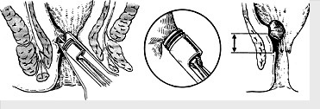

Fig. 9-4. Technique of rubber-band ligation

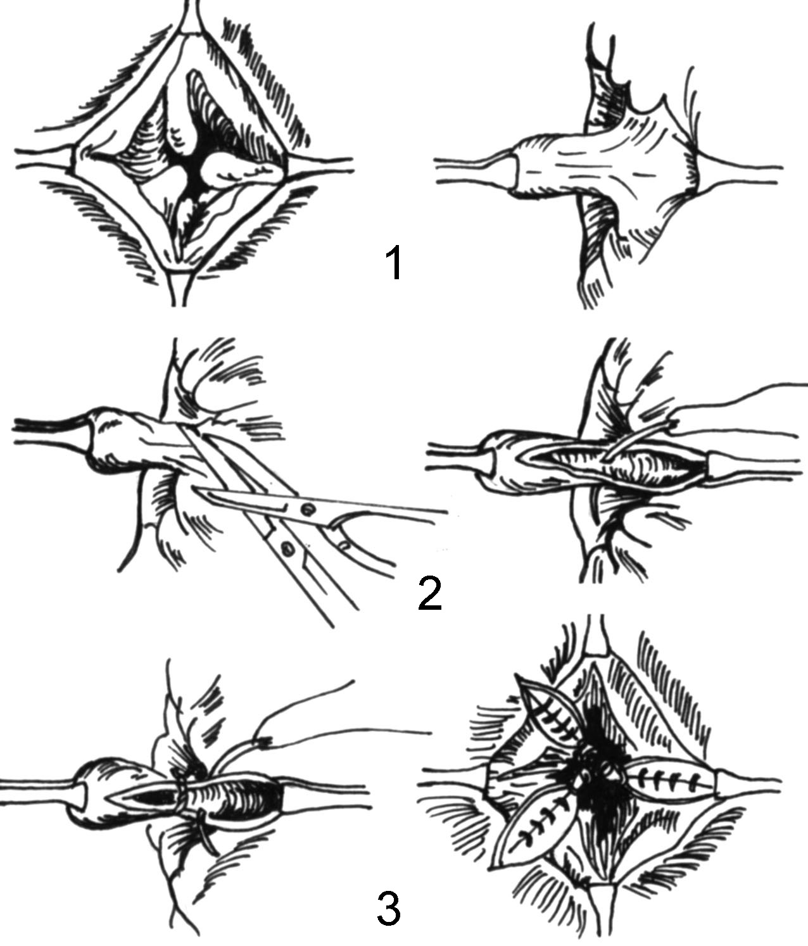

Fig. 9-5. Technique of Milligan-Morgan procedure

Anal fissure

Overview

- Anal fissure is a tear in the anoderm, usually caused by passage of hard stool.
- The fissure is located near the posterior midline of the anus 98% of the time in men, and 90% of the time in women.

Clinical features

- Symptoms are anal pain and bleeding associated with defecation.
- Fissure or ulcer is located distal to the dentate line.
- Sentinel skin tag at the anal verge adjacent to the distal edge of fissure is always present.
- Hypertrophied anal papilla is at the proximal edge of the fissure.
- Spasm of the internal sphincter (in chronic cases) is also present.

Treatment

- Most fissures will heal with medical treatment: stool softeners, increased dietary fiber, and warm sit baths are beneficial. Suppositories are usually not beneficial.
- Surgery is indicated for persistent symptoms despite medical treatment and includes excision of fissure along with lateral internal sphincterotomy (see Fig. 9-6). This procedure may be done by either an open or a closed technique and is highly curative.

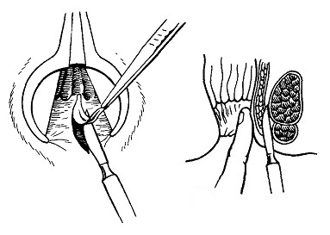

Fig. 9-6. Scheme of excision of fissure and lateral internal sphincterotomy

Anorectal abscess and fistula (cryptoglandular disease)

Overview

- These infections are cryptoglandular in origin. Thus, communication between bowel lumen and cavity of abscess nearly always persists.
- An abscess is the acute stage, a fistula the chronic stage of the same disease process.
- Most abscesses originate between the internal and external sphincters, and are thus called intersphincteric abscesses.
- Downward extension results in perianal abscess. Lateral extension through the low external sphincter results in ischiorectal fossa abscess. Upward extension (rare) results in supralevator (pelviorectal) abscess.

Clinical features

- Anorectal pain is constant in nature but is not associated with defecation.
- Swelling and fluctuance are late signs.
- Drainage of pus and blood signifies spontaneous rupture of the abscess and is usually associated with pain relief.
- Fever and leukocytosis are present.

Treatment of anorectal abscess

- Treatment is incision and drainage, and should be done when the diagnosis is made (see Fig. 9-7).
- Incision and drainage are curative 50% of the time; the other 50% of patients will develop anorectal fistula. Therefore, finding of internal orifice of fistula and passage of thread through it with subsiquent gradual tying it is necessary for prevention of chronic fistula formation.

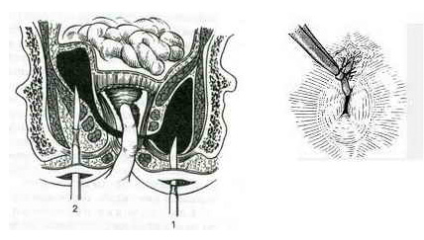
Fig. 9-7. Scheme of drainage of ischiorectal (1) and pelviorectal (2) abscess

Anorectal fistula

Clinical characteristic

- Anorectal fistula is a communication between an anal crypt (internal opening) and the perianal skin (external opening).
- It may be transsphincteric (tracks through the anal shincter) or extrasphincteric (tracks above the external sphincter)
- The internal opening must be identified to allow proper treatment.
- The most common site of the internal opening is the posterior anal crypt. Goodsall's rule states that external openings posterior to a transverse line that bisects the anus will connect to the posterior midline crypt; external openings anterior to this line will communicate to an anterior crypt by a short, direct tract. Exception to Goodsall's rule: an anterior external opening greater than 3 cm from the anal margin usually communicates with the posterior midline crypt.

Treatment

- Treatment of simple anal fistula is to identify both openings and open the tract by fistulotomy (see Fig. 9-8).
- An extrasphincteric fistula may require a procedure that eradicates the internal opening using a flap of rectal mucosa (see Fig. 9-9): fistulotomy can cause incontinence in these rare instances.

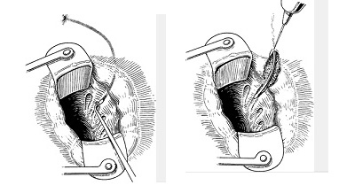

Fig. 9-8. Technique of fistulotomy

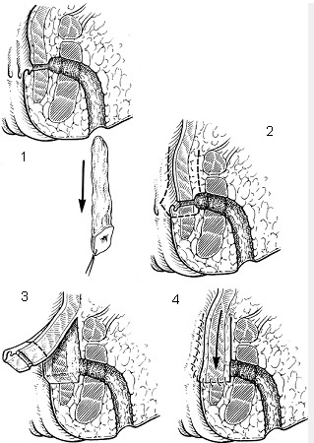

Fig. 9-9. Technique of plastic procedure for extrashincteric fistula

Pilonidal disease

- Pilonidal disease is characterized by hair from the skin of the post-sacral superior gluteal cleft that drills below the skin level, causing foreign body reaction and localized infection.
- Treatment of acute abscesses is incision and drainage. Treatment of chronic disease is excision of sinus tracts with healing by secondary intention. Healing may be promoted by marsupialization of the sinus.
- Excision and primary closure of the sinus are accompanied by a high incidence of recurrence.

Hidradenitis suppurativa

- Hidradenitis suppurativa is an infection of the apocrine sweat glands. The infected gland form subcutaneous sinus tracts that can spread to the perineum, scrotum, or labia.
- The disease should be distinguished from cryptoglandular disease: hidradenitis suppurativa does not involve the anal canal because there are no apocrine glands in anoderm, while the cryptoglandular disease originates in the anal canal.
- Clinical presentation is numerous, often complicated fistulas and sinus tracts around the anus.
- Treatment is excision of involved skin, with healing by contracture. Recurrence is common and should be treated by prompt excision.

Condyloma acuminatum (genital warts)

Overview

- The causative agent is the human papillomavirus.
- Transmission is usually sexual, with increased incidence in patients who practice receptive anal intercourse. There is an increased incidence in male homosexuals.
- Certain viral strains found in condyloma are associated with an increased risk of anal cancer.

Clinical features

- The lesions vary from tiny excrescences to cauliflower-like masses.
- They may be sessile or pedunculated, and they are usually located in the anal canal, on the perianal skin, penis, vulva, or vagina.
- Pruritis, anal wetness, discomfort, and the presence of a mass are the usual symptoms.

Treatment

- Bichloroacetic acid is applied topically to lesions every 7 days.
- Local excision and electrocoagulation with local anesthesia may also be performed.
- Interferon has been suggested for refractory warts.
- Patients should be followed closely because of the risk of associated cancer if carcinogenic viral strains are identified.

MALIGNANT PERIANAL AND ANAL CANAL TUMORS

Anal margin (below dentate line) neoplasms

Squamous cell carcinoma

- Features: polypoid, fungating, or ulcerated mass.
- Treatment is local excision or radiation; abdominal perineal resection is used for advanced lesions. Currently, local excision of benign and malignant tumors is performed by the novel low-invasive technique – transanal endoscopic microsurgery (TEM) which uses videoendoscopic device and special instruments similar to laparoscopic ones.

Basal cell carcinoma

- Features: central ulceration with irregular, raised edges.
- Treatment is local excision for most lesions; radiation or abdominal perineal resection for rare, advanced lesions.

Bowen's disease

- Appearance: carcinoma in situ (erythematous, crusty, scaly plaques).
- Clinical features include itching, burning, bleeding; 10% develop squamous cell carcinoma.
- Treatment is wide local excision.

Perianal Paget's disease

- Appearance: erythematous, eczematous rash.
- Clinical features include intractable pruritus; hystologically - intraepithelial adenocarcinoma; high incidence of visceral carcinoma presents.
- Treatment is wide local excision; abdominal perineal resection if underlying cancer presents.

Anal canal (above dentate line) neoplasms

TNM-classification

T - primary tumor
TX Primary tumor cannot be assessed
T0 No evidence of primary tumor
Tis Carcinoma in situ
T1 Tumor 2 cm or less in greatest dimension
T2 Tumor more than 2 cm but not more than 5 cm in greatest dimension
T3 Tumor more than 5 cm in greatest dimension
T4 Tumor of any size invades adjacent organ(s), e.g., vagina, urethra, bladder
Note: Direct invasion of the rectal wall, perirectal skin, subcutaneous tissue, or the sphincter muscle(s) alone is not classified as T4.
N - regional lymph nodes
NX Regional lymph nodes cannot be assessed
N0 No regional lymph node metastasis
N1 Metastasis in perirectal lymph node(s)
N2 Metastasis in unilateral internal iliac and/or unilateral inguinal lymph node(s)
N3 Metastasis in perirectal and inguinal lymph nodes and/or bilateral internal iliac and/or bilateral inguinal
lymph nodes
M - distant metastasis
MX Distant metastasis cannot be assessed
M0 No distant metastasis
M1 Distant metastasis

Stage grouping

Stage 0 | Tis | N0 | M0
Stage I | T1 | N0 | M0
Stage I | T2 | N0 | M0
Stage I | T3 | N0 | M0
Stage IIIA | T1, T2, T3 | N1 | M0
Stage IIIA | T4 | N0 | M0
Stage IIIB | T4 | N1 | M0
Stage IIIB | Any T | N2, N3 | M0
Stage IV | Any T | Any N | M1

Epidermoid carcinoma

- Epidermoid carcinoma includes squamous cell, basaloid, cloacogenic, and mucoepidermoid carcinoma.
- Clinical presentation may be bleeding, pain, or anal mass.
- Diagnosis and evaluation include assessment of tumor size, depth of invasion, presence of ulceration, examination for retrorectal and inguinal lymph nodes. Anoscopy, proctoscopy, biopsy, and endorectal ultrasound is performed to settle the diagnosis. CT scan of pelvis and liver, chest radiograph is used for determination of presence of local or distant expansion.
- Treatment is combined chemotherapy and pelvic radiation.
- Abdominal perineal resection is performed for treatment failures.
- The effectiveness of combined modality therapy depends on the size of the primary lesion. Tumors larger than 6 cm seldom respond completely. Overall, combined treatment has a response rate of 90% and a 5-year survival rate higher than 80%.

Adenocarcinoma

- Adenocarcinoma is most commonly an extension from cancer in the distal rectum.
- Cancer arises from anal glands and ducts. It may arise from outside the lumen of the anal canal and may present as an anal fistula that does not respond to fistulotomy.
- Treatment is, in general, similar to that for rectal cancer, using preoperative radiation therapy followed by abdomino-perineal resection.

Melanoma

- The anal canal is the third most common site (after skin and eyes).
- Most anal melanomas are not darkly pigmented (i.e., they are amelanotic).
- Anal mass, pain, and bleeding are the most common symptoms. Regional lymphatic and distant metastases are common at the time of diagnosis.
- Treatment: abdomino-perineal resection is recommended if no metastases are detected.
- The 5-year survival rate is less than 15%.

REVIEW TESTS

1. Rectal prolapse is associated with which of the following complications?

- Pain
- Bleeding
- Incontinence
- All of the above

2. A previously healthy 24-years-old man was referred to proctologist with complaints of painless rectal bleeding after bowel movements. A rectoscopy reveals the presence of 1st degree internal hemorrhoids and no other lesions. Initial management of this patient should include which of the following?

- Dietary modification
- Rubber band ligation of the lesions
- Sclerotherapy of the lesions
- Hemorrhoidectomy
- Photocoagulation of the lesions

3. Which of the following is the least acceptable treatment for symptomatic 2nd degree internal hemorrhoids?

- Rubber band ligation
- Conservative treatment
- Hemorrhoidectomy
- Sclerotherapy
- Cryosurgery

4. The most common cause of painful defecation is:

- Anal cancer
- Anorectal abscess
- Anal fissure

5. Classically, the morphologic triad of an anal fissure is:

- Anal ulcer, pain, rectal bleeding
- Anal ulcer, hypertrophic papillae, sentinel pile
- Anal ulcer, thrombosed hemorrhoid, anal pain
- Anal ulcer, sentinel pile, thrombosed hemorrhoid

6. A 45-years-old woman with diabetes was admitted to surgical department with a 2-day history of acute perirectal pain. On examination, a tender fluctuant mass is present to the left of the anus. What’s the most appropriate tactics of managing the patient?

- Conservative treatment with broad-spectrum antibiotics
- Abscess drainage and excision of the fistulous tract
- Incision and drainage of the abscess
- Continued observation
- Conservative treatment with physiotherapy

7. Anal cancer is most commonly:

- Basal cell cancer
- Adenocarcinoma
- Squamous cell cancer

8. A 58-years-old man was admitted to surgical department with complaints of constipation (bowel movement once in 3 – 4 days), slight anal pain, periodical abdominal distension, and weight loss of 10 kg for the last 3 months. Patient is slightly anemic. He is ill for 6 months. Physical examination of abdomen doesn’t reveal any pathological findings. Digital examination of rectum reveals a rigid partially movable mass measuring about 3 cm in diameter. Rectoscopy shows a fungating tumor of the middle ampullary part of rectum (12 cm proximal to anal verge), partially movable and obstructing the lumen of bowel, with rigid bowel wall around it. Biopsy conclusion is moderately differentiated squamous cell carcinoma. Abdominal, pelvic and pulmonary CT scans don’t reveal lymphadenopathy, liver metastases, and spreading of the tumor into adjacent structures. What’s the most appropriate tactics of surgical managing the patient?

A. End colostomy (descendostomy)
B. Low anterior resection, transversorectostomy
C. Right hemicolectomy, transversorectostomy
D. Abdominoperineal resection, end colostomy
E. Placement of self-expandable stent

9. A 45-years-old woman underwent colonoscopic examination. A flat mucosal lesion of lower ampullary part of rectum measuring 2 cm in diameter is found. Transanal endoscopic ultrasound reveals hypoechogenic lesion involving mucosal and submucosal layers of the rectal wall. After forceps biopsy, histological conclusion was: well-differentiated squamous cell carcinoma. The patient is free of concomitant pathology. What’s the most appropriate tactics of managing the patient?

A. Transanal cryogenic ablation of the lesion
B. Endoscopic monitoring every 3 months
C. Abdominoperineal resection, end colostomy
D. Transanal endoscopic mucosal resection
E. Argon plasma ablation of the lesion

Correct answers: 1 - D, 2 - A, 3 - E, 4 - C, 5 - B, 6 - C, 7 - C, 8 - D, 9 - D.

