CHAPTER 13. DYSPHAGIA

- Dysphagia may be a main symptom of different functional disorders of esophageal motility and subsequent esophagitis (see Table 13-1); and such “non-functional” diseases of esophagus as scar stricture (complication of acid or alkaline burn), peptic stricture, esophageal and cardio-esophageal carcinoma, hiatal hernia, esophageal diverticula, esophageal polips, webs and rings; a result of compression of esophagus by lesions of mediastinum (tumors, cysts, enlarged heart chambers, retrosternal goiter, lymphadenopathy, anomalous vessels); and couple of inner diseases (different specific types of esophagitis, some infectious and rheumatic diseases, Plammer-Winson syndrome, ect.).

DISORDERS OF ESOPHAGEAL MOTILITY

Table 13-1. List of esophageal motility disorders

Primary esophageal motility disorders

Cricopharyngeal achalasia
Achalasia, "vigorous" achalasia
Diffuse esophageal spasm
Segmental esophageal spasm (Nutcracker esophagus)
Hypertensive lower esophageal sphincter
Nonspecific esophageal motility disorders

Secondary esophageal motility disorders

Collagen vascular diseases
Scleroderma
Progressive systemic sclerosis
Polymyositis and dermatomyositis
Systemic lupus erythematosus
Mixed connective tissue disease
Result of central nervous system (CNS) trauma
CNS tumors
Results of CNS infections
Encephalitis
Poliomyelitis
Result of other infections
Botulism
Diphtheria
Alcoholism
Diabetes mellitus

Cricopharyngeal dysfunction

Overview

- Cricopharyngeal dysfunction is caused by a failure of the upper esophageal sphincter to relax properly.
- The problem may be an incoordination between relaxation in the upper esophageal sphincter and simultaneous contraction of the pharynx, which may result in a pharyngoesophageal (Zenker's) diverticulum. This is a false diverticulum composed only of mucosa that herniates posteriorly between the fibers of the cricopharyngeal muscle.

Clinical features and visualization data

- Symptoms include dysphagia; reflux of undigested food; and, if a Zenker's diverticulum has developed, a mass in the neck, usually on the left side, which occasionally causes tracheal compression.
- The history and physical examination are usually adequate to diagnose cricopharyngeal dysfunction.
- Radiographs, which include a barium swallow, are helpful in delineating a diverticulum (see Fig. 13-1).
- Endoscopy is indicated to rule out other esophageal disorders, including gastroesophageal reflux or neoplasm.

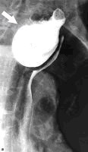

Fig. 13-1. Radiological picture of Zenker's diverticulum

Treatment

- Cricopharyngeal myotomy is the treatment of choice for cricopharyngeal dysfunction.
- Diverticulectomy (see Fig. 13-2) or diverticulostomy may be combined with the myotomy.

1 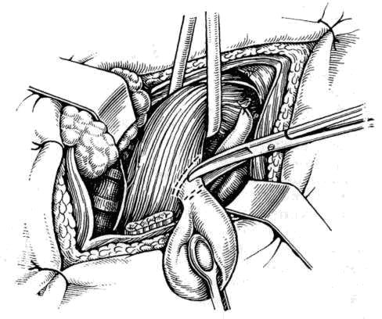 2 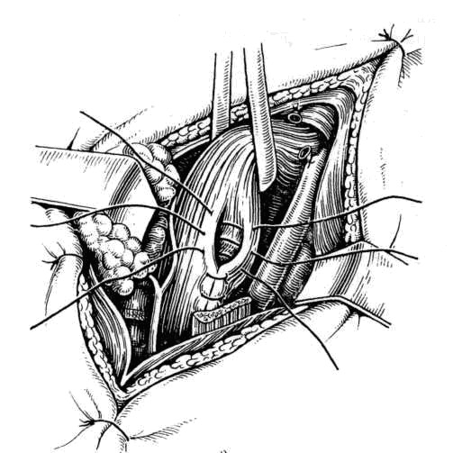

Fig. 13-2. Technique of diverticulectomy

Achalasia

Overview

- Achalasia is an esophageal disease of unknown etiology, although it may be secondary to ganglionic dysfunction. It consists of abnormal peristalsis in the body of the esophagus and lack of relaxation of lower esophageal sphincter, which causes high resting lower esophageal sphincter pressure. The body of the esophagus becomes dilated (see Scheme 13-1).
- The disease may be associated with gastroesophagreal reflux.
- A similar symptom complex can be caused by Chagas disease, which is due to the organism Trypanosoma cruzi.
- Carcinoma of the esophagus is 10 times more common in patients with achalasia than in the general population.

Clinical features and visualization data

- Symptoms of achalasia include dysphagia, followed by regurgitation and weight loss.
- Frequently, respiratory symptoms are present due to aspiration.
- Radiographic studies reveal a dilated esophagus with a beak-like extension into the lower narrowed segment at the lower esophageal sphincter (see Scheme 13-1).
- Esophageal manometry reveals the high resting lower esophageal sphincter pressure, failure of relaxation during swallowing, and lowered pressure in the body of the esophagus (see Table 13-2).
- Esophagoscopy is required to rule out neoplasia and to document the extent of esophagitis (see Fig. 13-3).

Scheme 13-1. Stages of esophageal achalasia
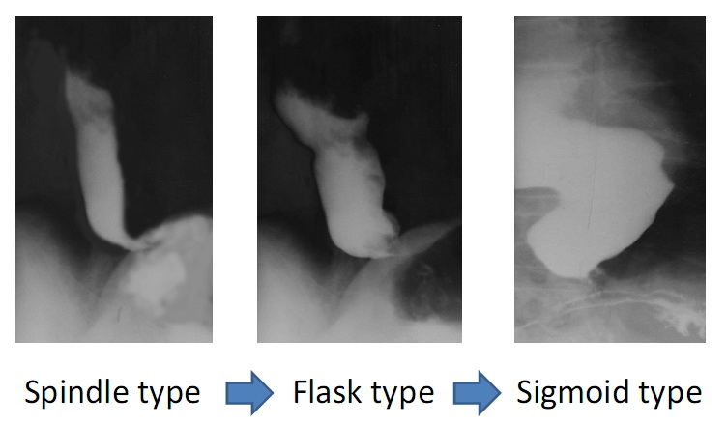

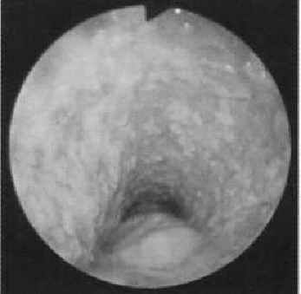

Fig. 13-3. Endoscopic picture of esophageal achalasia

Treatment

- Nonsurgical treatment consists of forceful pneumatic dilatation of the contracted lower esophageal stricture (see Fig. 13-4), which is just above the gastroesophageal junction. It is used in spindle type lesions.
- In flask and sigmoid types of lesion the treatment of choice is surgery - Heller esophagocardiomyotomy (laparoscopic or open) followed by Dor or Toupet fundoplication (see Fig. 13-5). Surgical results with the Heller procedure are generally better than with pneumatic dilatation for relief of dysphagia.
- Medical therapy (antispasmodics, calcium channel blockers, nitrates) and intrasphincteric endoscopic injection of botulotoxin has poor long-term results.

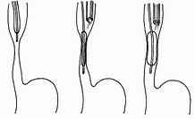

Fig. 13-4. Scheme of pneumatic dilatation of lower esophageal sphincter

1 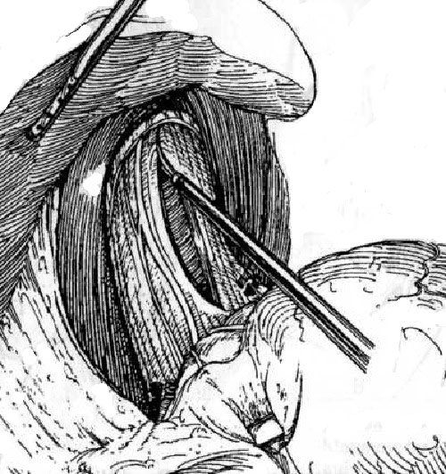 2 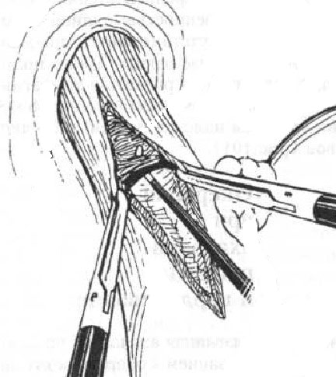 3 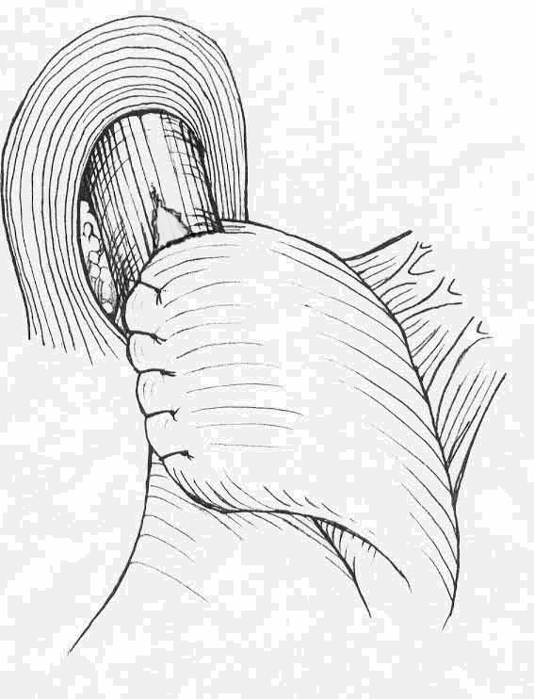

Fig. 13-5. Technique of laparoscopic Heller-Dor procedure

Diffuse esophageal spasm

Overview

- Diffuse esophageal spasm is a disorder of esophageal motility that consists of strong nonperistaltic contractions within the entire esophagus.
- Unlike achalasia, this condition has normal sphincteric relaxation. The disease may be associated with gastroesophagreal reflux.

Clinical features and visualization data

- Symptoms consist of chest pain, which can radiate to the back, neck, ears, jaw, or arms, and may be confused with typical angina pectoris.
- The pain usually occurs spontaneously, and many patients are considered to have a psychoneurosis.
- Manometry reveals high-amplitude repetitive contractions with a normal sphincteric response to swallowing (see Table 13-2).
- Radiographs are normal in half of cases but may reveal diverticula, segmental spasm, and a corkscrew-appearance of the esophagus (see Fig. 13-6).

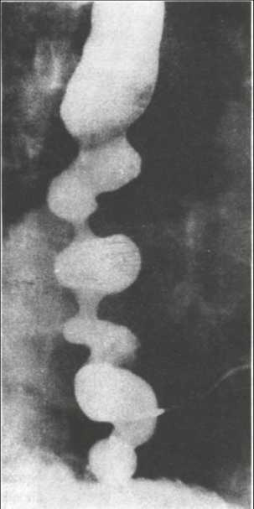

Fig. 13-6. Radiological picture of diffuse esophageal spasm

Treatment

- Surgery is moderately effective with good results obtained in over two-thirds of the patients. The best results are obtained in emotionally stable patients with severe disease and without associated lower gastrointestinal problems. It consists of a long esophagomyotomy that extends from the arch of the aorta to just above the lower esophageal sphincter.
- If significant gastroesophageal reflux is present, an antireflux procedure is performed.
- Calcium channel blockers and nitrates may ameliorate symptoms.

Table 13-2. Manometric characteristics of the primary esophageal motility disorders

Achalasia

Incomplete lower esophageal sphincter (LES) relaxation (<75% relaxation)
Aperistalsis in the esophageal body
Elevated LES pressure (> 26 mmHg)
Increased intra-esophageal baseline pressures relative to gastric baseline

Diffuse esophageal spasm

Simultaneous (non-peristaltic contractions) (>10% of wet swallows)
Repetitive and multi peaked contractions
Spontaneous contractions
Intermittent normal peristalsis
Contractions may be of increased amplitude and duration

Nutcracker esophagus

Mean peristaltic amplitude (10 wet swallows) in distal esophagus >180 mmHg
Increased mean duration of contractions (>7.0 s)
Normal peristaltic sequence

Hypertensive lower esophageal sphincter

Elevated LES pressure (>26 mmHg)
Normal LES relaxation
Normal peristalsis in the esophageal body

Nonspecific esophageal motility disorders

Decreased or absent amplitude of esophageal peristalsis
Increased number of non-transmitted contractions
Abnormal waveforms
Normal mean LES pressure and relaxation

From: Principles of surgery/ed., S.I. Schwartz, et al. – 7th ed.

GASTROESOPHAGEAL REFLUX DISEASE (GERD) AND HIATAL HERNIAS

Overview

- Esophageal reflux is secondary to dysfunction of the lower esophageal sphincter and esophagogastric junction, which results in reflux of the gastric contents into the lower esophagus.
- GERD is strongly associated with hiatal hernias (up to 90 % of patients has hiatal hernias) which lead to abnormal gastroesophageal reflux.
- There are 4 types of hiatal hernias (see Scheme 13-). Type I is axial hernia (cardia or fundal part of stomach slide through the hiatal opening of diaphragm upwards into the posterior mediastinum), type II is paraesophageal hernia (position of esophagogastric junction is normal but fundal part of stomach passes through the hiatal opening parallel to esophagus), type III (mixed hernia that has features of both axial and paraesophageal hernia) and type IV (paraesophageal hernia when herniation contains intraabdominal organs other than stomach, i.e. large bowel, great omentum, ect.). However, many patients with this type of hiatal hernia have no evidence of reflux; from other hand, many patients without hiatal hernia suffer from gastroesophageal reflux.
- Lower esophageal sphincter weakness may also be related to: decreased endogenous gastrin production, operations on or near the esophageal hiatus (e.g., vagotomy), exogenous causative agents, including tobacco and alcohol, ect.

Scheme 13-2. Classification of hiatal hernias

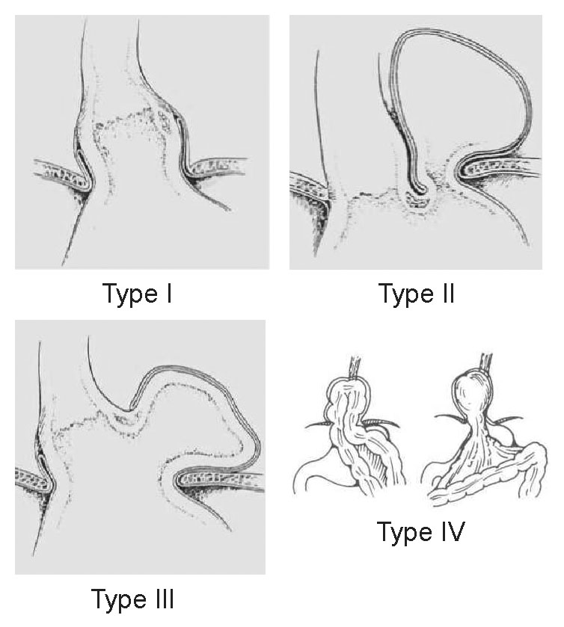

Clinical features and visualization data

- Symptoms of esophageal reflux and hiatal hernia are substernal pain, heartburn, and regurgitation, all of which may worsen with bending and lying down.
- Esophagoscopy reveals varying degrees of reflux-esophagitis (see Fig. 13-7) and signs of decreased tone of lower esophageal sphincter and presence of hiatal hernia (see Fig. 13-8, A).
- Radiography shows presence, type and degree of hiatal hernia and retrograde passage of barium into esophagus (see Fig. 13-8, B).
- If the hernia and esophagitis are absent the diagnosis of GERD couldn’t be excluded. The proton pump inhibitor (PPI) test (oral usage of 40 mg of omeprazole for 2 weeks) may confirm the diagnosis of GERD (i.e. endoscopic negative).
- If a patient’s response to PPI test is poor the diagnosis of GERD couldn’t be ultimately excluded and 24 hour pH-testing is needed.
- Twenty-four hour pH measurements in the lower esophageal area in GERD patients demonstrate increased acidity with DeMeester score more than 14,7.
- Manometry is an additional diagnostic tool which reveals decreased lower esophageal sphincter pressure.

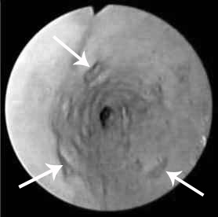

Fig. 13-7. Endoscopic picture of erosive reflux-esophagitis

A 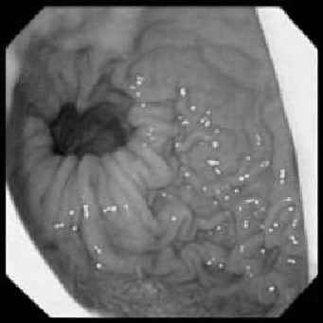 B 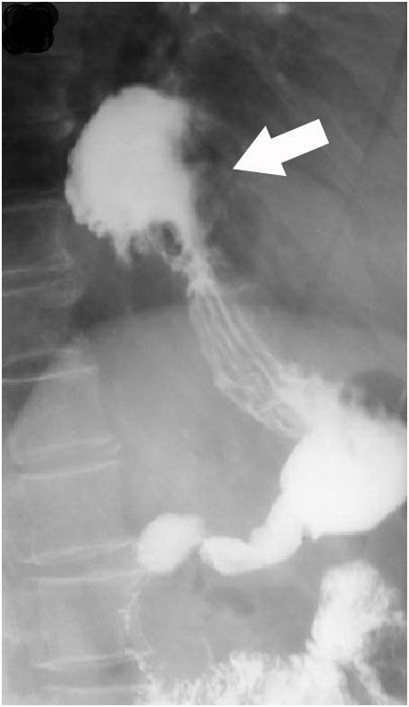

Fig. 13-8. Endoscopic (A) and radiographic (B) pictures of sliding hiatal hernia

Treatment

Scheme 13-3. Algorithm of management of GERD and hiatal hernias

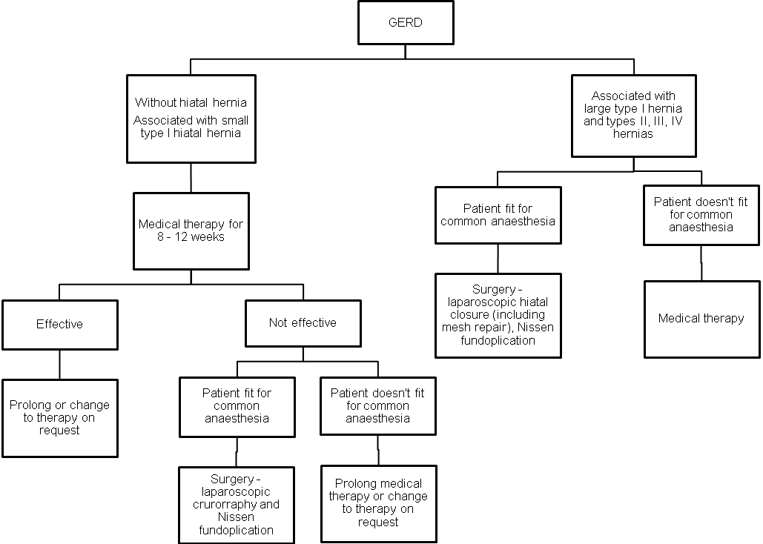

1 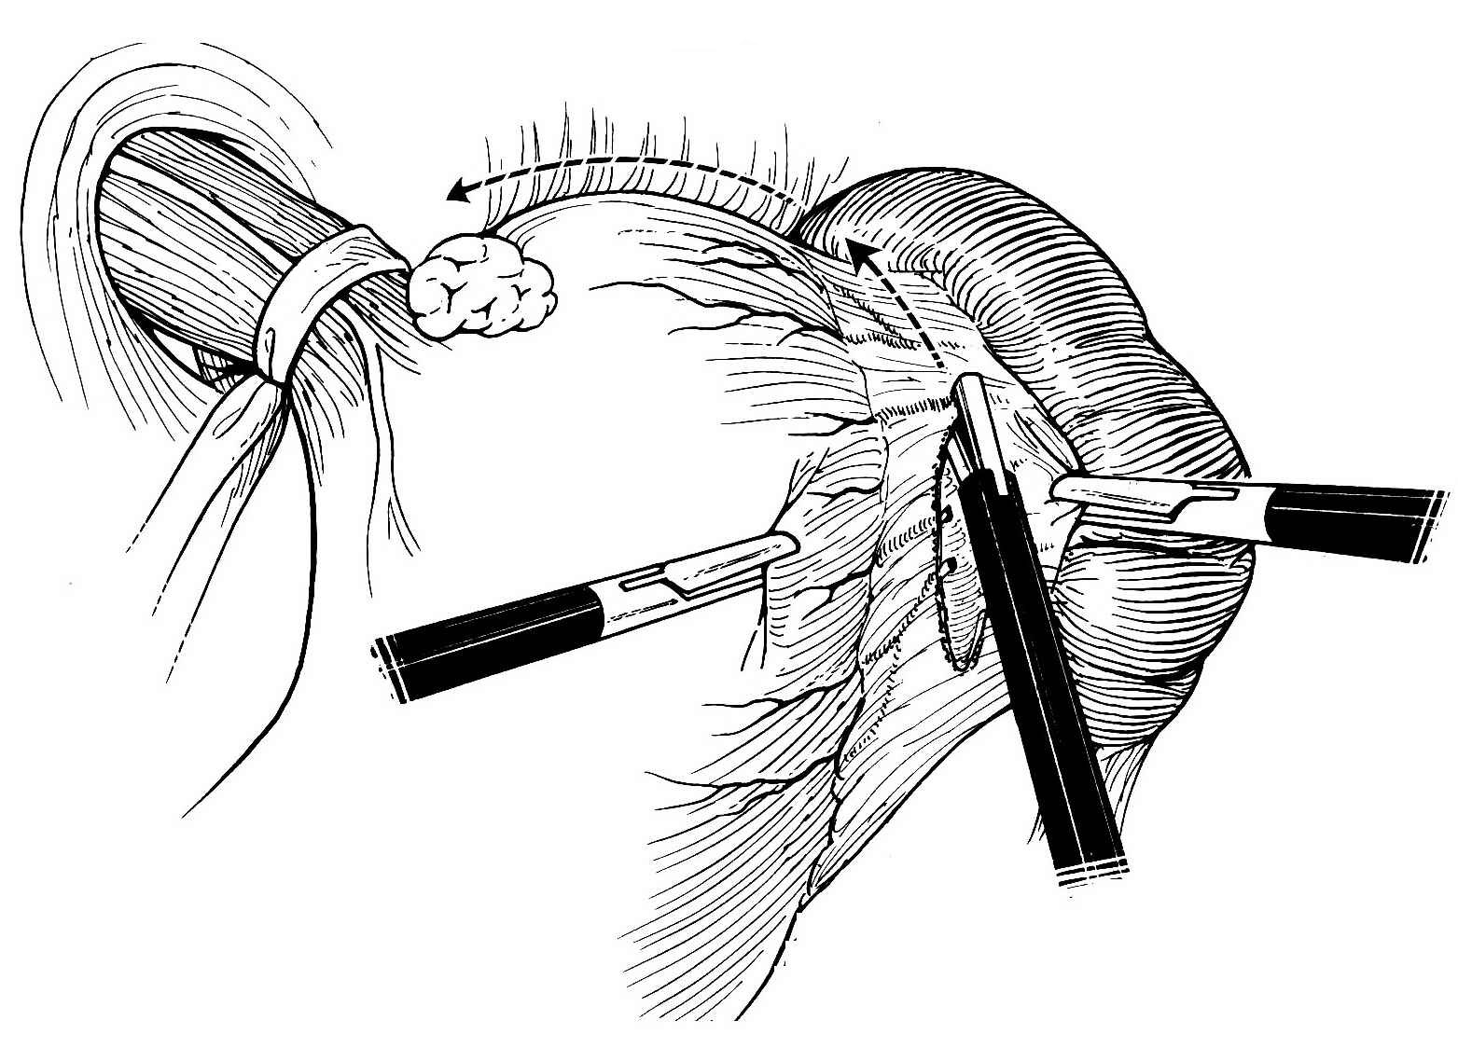 2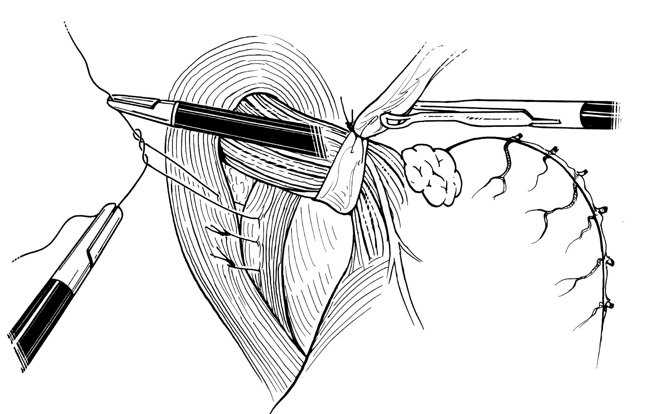 3 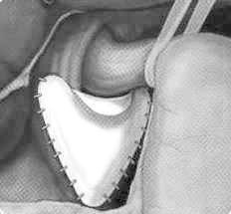 4 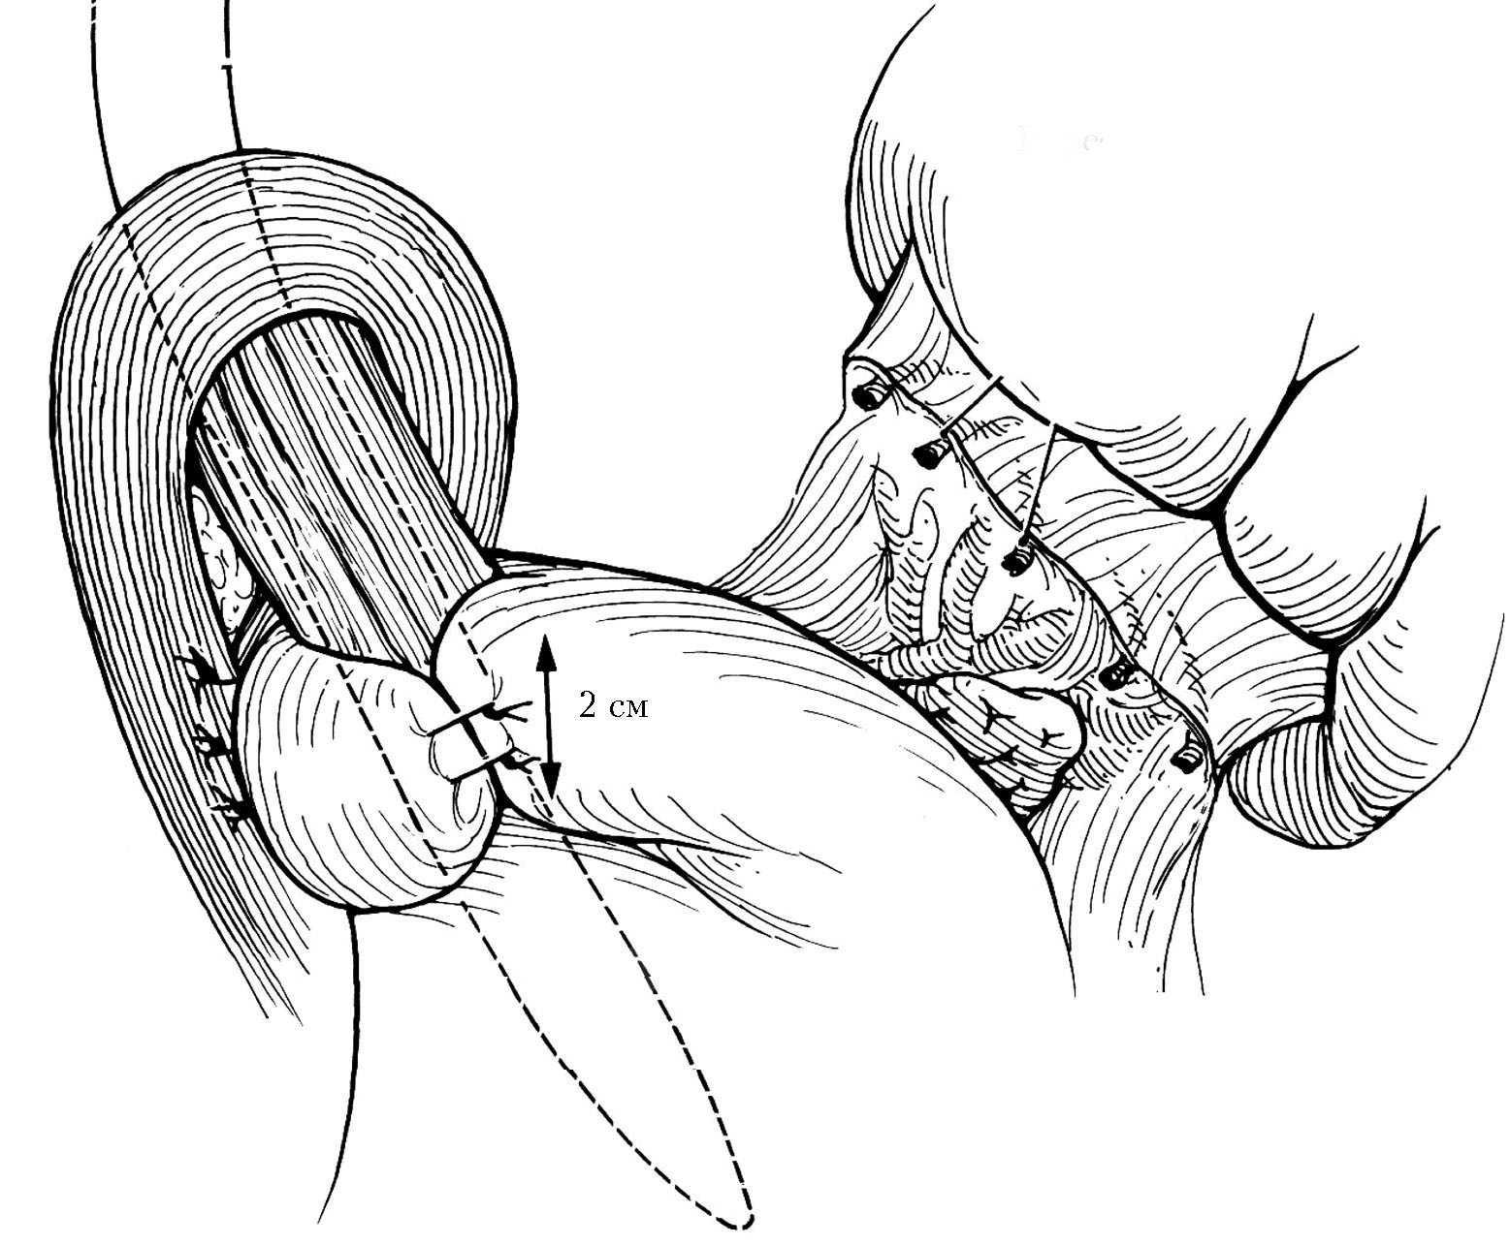

Fig. 13-9. Technique of laparoscopic repair of hiatal hernia and fundoplication

- Medical treatment of GERD first of all include chaning of dietary habits (removal of coffee and alcohol, fatty and spicy food, ect.; graduate food intake; avoiding of late dinner and lying just after meals).
- The basic mediactions for treatment of GERD are PPIs (omeprazole or its analogues).
- Prokinetics (metoclopramide or domperidone) increase both lower esophageal sphincter pressure and gastric motility, thus are also effective in GERD therapy.
- Antacids and Histamine-2-receptor antagonists are additional effective mediactions.

Columnar lined esophagus (Barrett's esophagus)

- Barrett's esophagus is replacement of the normal epithelial lining with columnar epithelium in the lower esophagus secondary to esophagitis, particularly duodenal alkaline reflux.
- Barrett’s esophagus has approximately 1-2% of malignant patency.
- Diagnosis is confirmed by characteristic endoscopic picture (see Fig. 13-10) and histology.
- The treatment is endoscopic radiofrequency (see Fig. 13-11) or argon plasma ablation of affected areas followed by antireflux surgery.

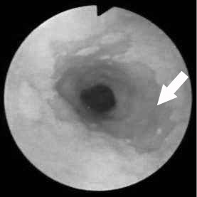

Fig. 13-10. Endoscopic picture of Barrett's esophagus

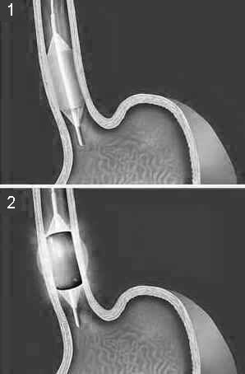

Fig. 13-11. Scheme of endoscopic radiofrequency ablation for Barrett's esophagus

Peptic strictures of esophagus

- These strictures are caused by a recurrent alternating pattern of mucosal destruction secondary to gastric acid reflux and subsequent healing. The strictures most often occur at the gastroesophageal junction. In severe cases, a long stricture may result.
- A history of reflux symptoms and dysphagia is suggestive of strictures.
- Radiograph of the esophagus confirms the diagnosis (see Fig. 13-12).
- Esophagoscopy is important to determine the extent of the disease and to rule out malignancy (see Fig. 13-13).
- Treatment is dilatation of the esophagus is attempted first, and then an antireflux operation or prolonged medical treatment is used.
- If these measures do not relieve the esophageal obstruction, reconstructive procedure, using either the stomach or colon for esophageal replacement, may be necessary to restore adequate swallowing function.

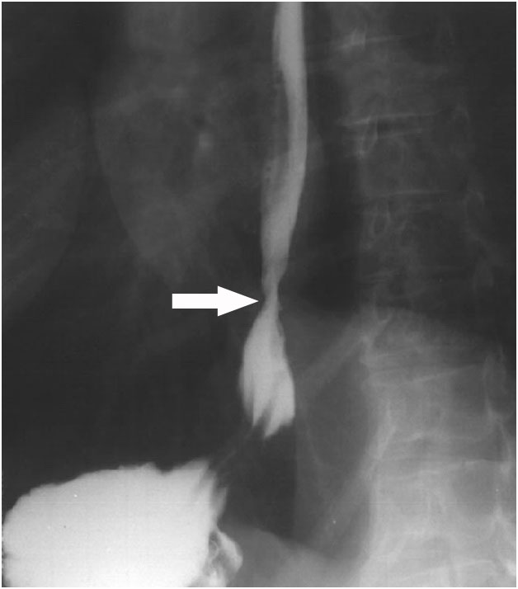

Fig. 13-12. Radiographic picture of peptic stricture of esophagus

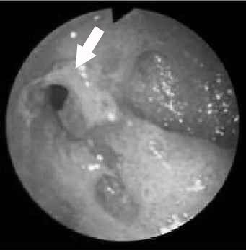

Fig. 13-13. Endoscopic picture of peptic stricture of lower esophagus

BENIGN TUMORS OF ESOPHAGUS

Leiomyomas

- Leiomyomas account for two-thirds of all benign tumors of the esophagus.
- Dysphagia occurs when leiomyomas exceed a diameter of 5 cm as they grow within the muscular wall, leaving the overlying mucosa intact.
- A barium swallow reveals a localized smooth filling defect in the esophageal wall.
- Esophagoscopy is performed to confirm the diagnosis (see Fig. 13-14).
- In symptomatic patients, the tumor is enucleated from the esophageal wall without violating the mucosa (it may be performed thoracoscopically).
- A limited esophageal resection is indicated if the tumor lies in the lower esophagus and cannot be enucleated.

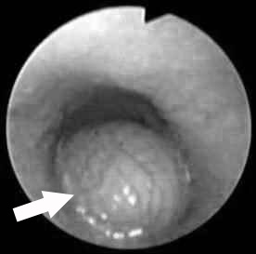

Fig. 13-12. Endoscopic picture of leiomyoma of esophagus

Benign intraluminal tumors

- Benign intraluminal tumors are usually mucosal polyps, lipomas, fibrolipomas, or myxofibromas.
- Symptoms are dysphagia, occasionally regurgitation, and weight loss.
- Radiographs of the esophagus suggest the diagnosis.
- Esophagoscopy is performed to confirm the diagnosis and to rule out malignancy.
- Endoscopy may be used to remove these tumors.
- For large tumors esophagotomy, removal of the tumor, and repair of the esophagotomy comprise the surgical treatment (it may be performed thoracoscopically).

MALIGNANT TUMORS OF ESOPHAGUS

Overview

- In the United States, the incidence of esophageal carcinoma ranges from 3.5/1,000,000 for whites to 13.5/100,000 for blacks.
- The exact cause is unknown. Associated factors are tobacco use, excessive alcohol ingestion, nitrosamines, poor dental hygiene, and hot beverages. Certain preexisting conditions also increase the likelihood of developing esophageal cancer, including achalasia, esophagitis, and Barrett's esophagus.
- Squamous cell carcinoma is the most common form.
- Adenocarcinoma, the next commonest, is the type that occurs in patients with Barrett's esophagus. Rare tumors of the esophagus include mucoepidermoid carcinoma and adenoid cystic carcinoma.

TNM-classification

T - Primary tumor
TX Primary tumor cannot be assessed
T0 No evidence of primary tumor
Tis Carcinoma in situ
T1 Tumor invades lamina propria or submucosa
T2 Tumor invades muscularis propria
T3 Tumor invades adventitia
T4 Tumor invades adjacent structures
N - Regional lymph nodes
NX Regional lymph nodes cannot be assessed
N0 No regional lymph node metastasis
N1 Regional lymph node metastasis
M - Distant metastasis
MX Distant metastasis cannot be assessed
M0 No distant metastasis
M1 Distant metastasis
For tumors of lower thoracic esophagus:
M1a Metastasis in coeliac lymph nodes
M1b Other distant metastasis
For tumors of upper thoracic esophagus:
M1a Metastasis in cervical lymph nodes
M1b Other distant metastasis
For tumors of mid-thoracic esophagus:
M1a Not applicable
M1b Non-regional lymph node or other distant metastasis

Stage Grouping

Stage 0 | Tis | N0 | M0
Stage I | T1 | N0 | M0
Stage IIA | T2, T3 | N0 | M0
Stage IIB | T1, T2 | N1 | M0
Stage III | T3 | N1 | M0
Stage III | T4 | Any N | M0
Stage IV | Any T | Any N | M1
Stage IVA | Any T | Any N | M1a
Stage IVB | Any T | Any N | M1b

Clinical features and visualization data

- A history of dysphagia and weight loss is almost always present.
- Esophagoscopy is essential for tissue diagnosis and determination of the extent of tumor (see Fig. 13-15).
- Contrast study of the esophagus demonstrates the location and extent of tumor (see Fig. 13-16).
- Bronchoscopy is performed to assess the possibility of invasion of the tracheobronchial tree.
- Computed tomography (CT) scan of the chest and abdomen is done to evaluate local and lymphatic spread, and a thorough search is made for distant metastases.

A 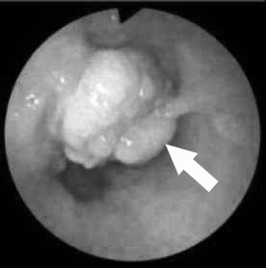 B 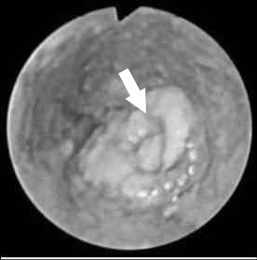 C 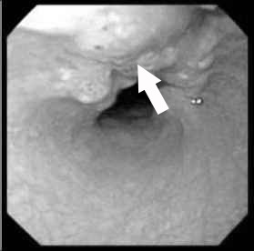

Fig. 13-15. Endoscopic pictures of polypoid (A), ulcerative (B) and infiltrating (C) types of esophageal carcinoma

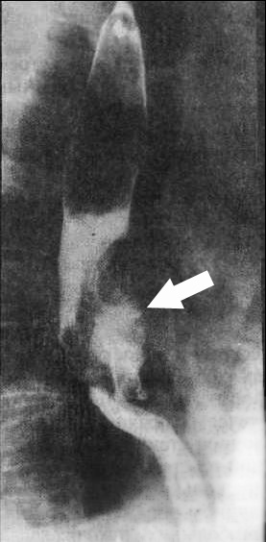

Fig. 13-16. Radiographic picture of carcinoma of middle third of esophagus

Treatment

Scheme 13-4. Algorithm of management of cancer of cervical part of esophagus

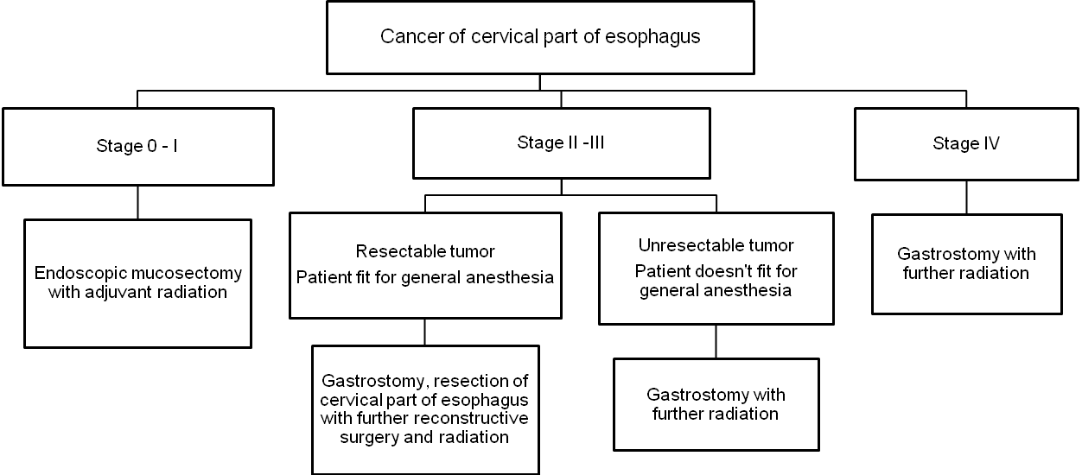

Scheme 13-5. Algorithm of management of cancer of upper and middle thoracic part of esophagus

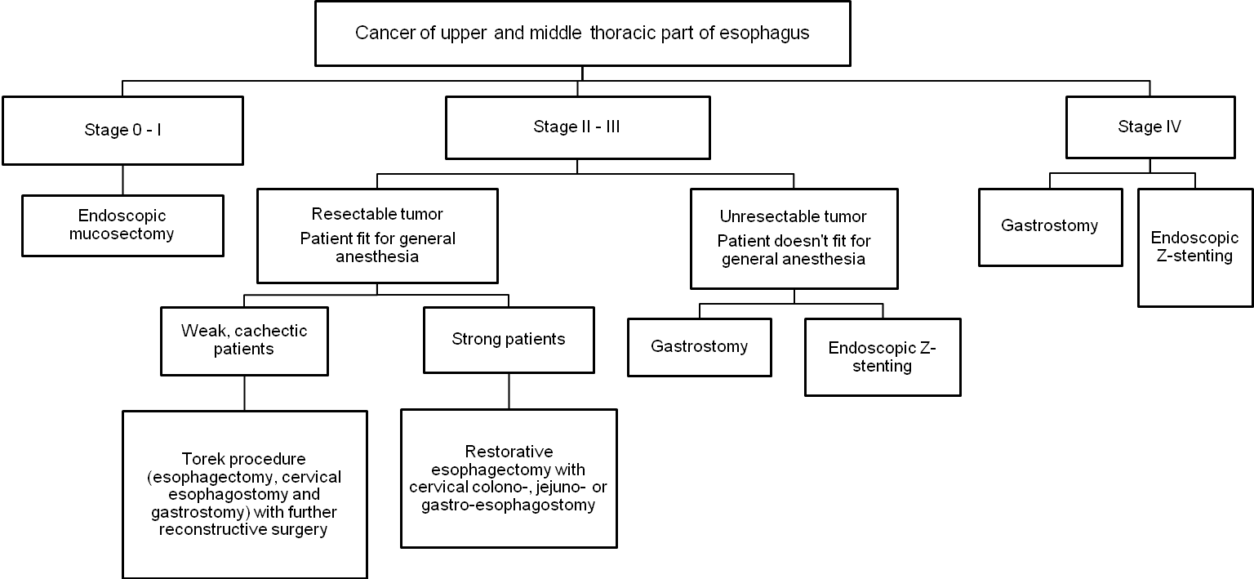

1 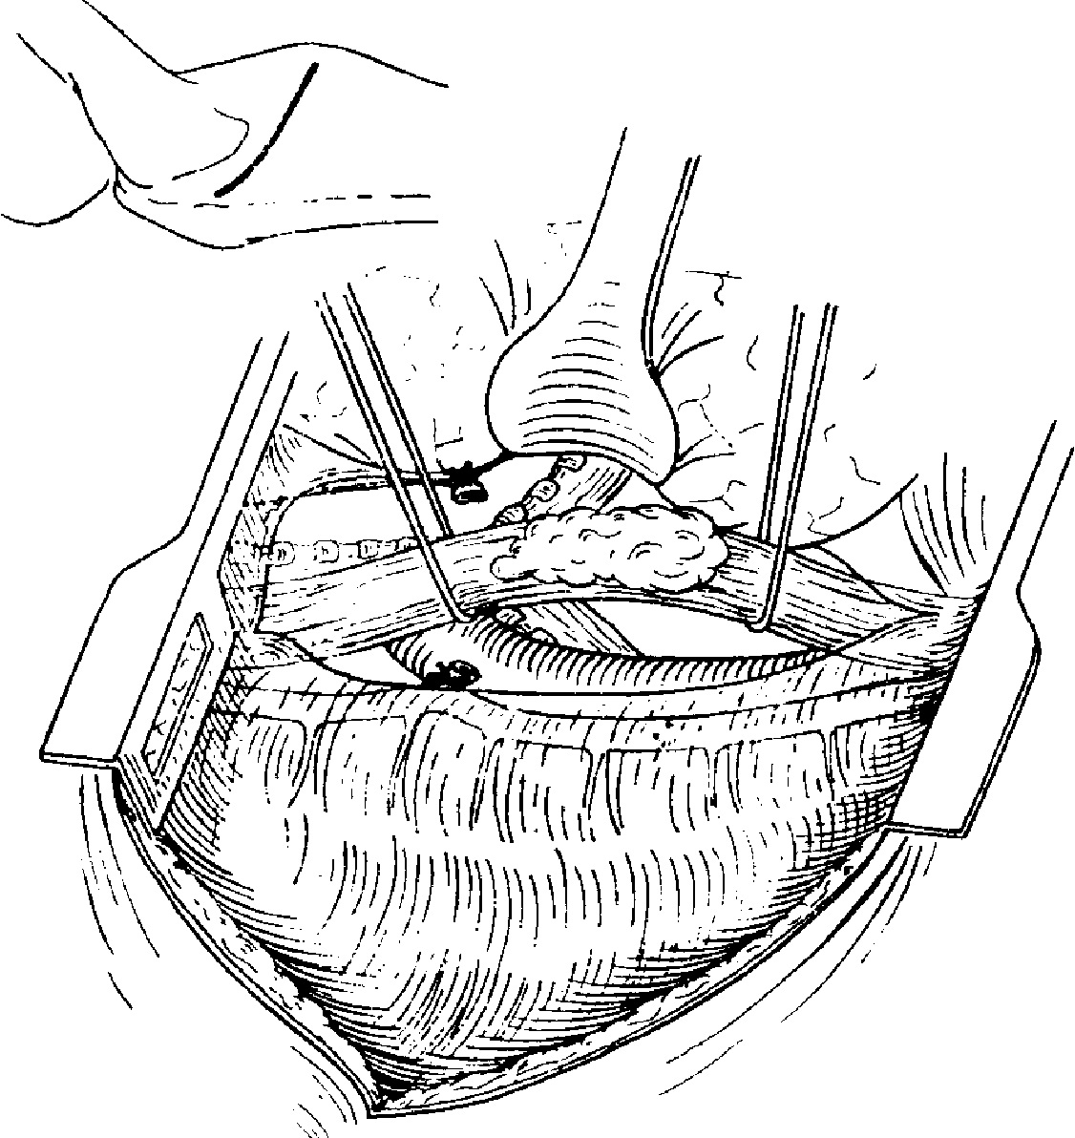 2 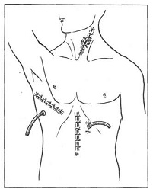

Fig. 13-17. Scheme of Torek procedure

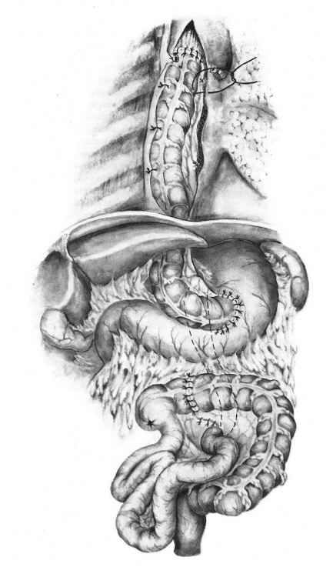

Fig. 13-18. Scheme of replacement of esophagus with colon

Scheme 13-6. Algorithm of management of cancer of lower thoracic and abdominal part of esophagus

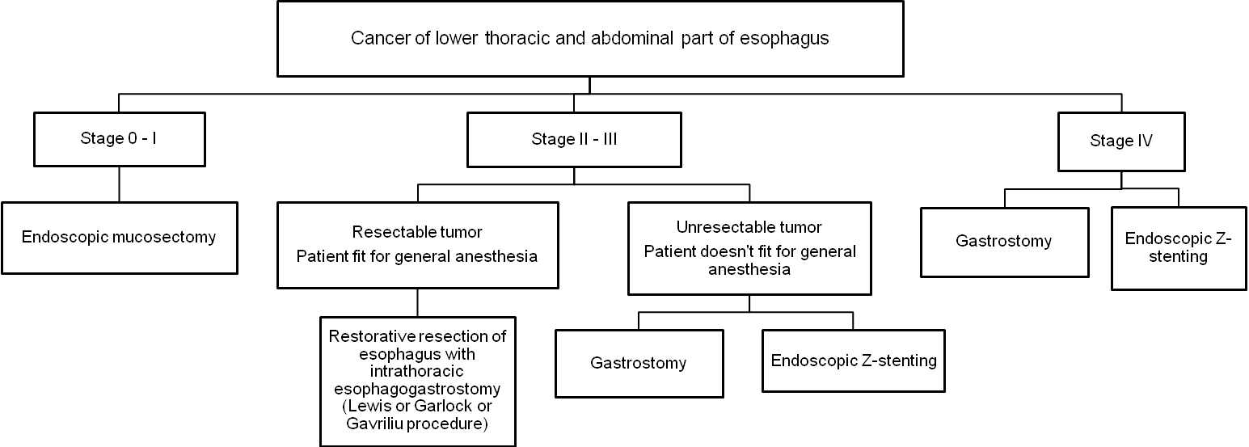

1 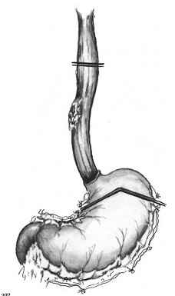 2 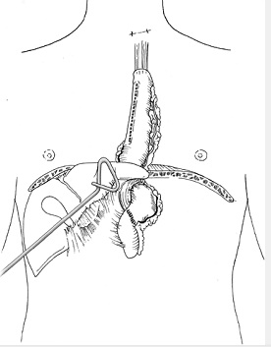

Fig. 13-19. Scheme of Lewis procedure

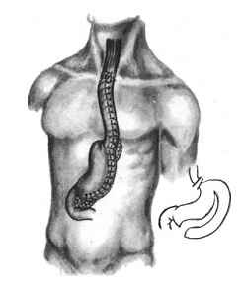

Fig. 13-20. Scheme of Gavriliu procedure

- The most of tumors of cervical part of esophagus are not resectable, thus basic method of treatment for carcinomas of this location is radiotherapy.
- For thoracic and abdominal part of esophagus surgical treatment provides the only cure. Most commonly, the operation consists of total thoracic esophagectomy with reconstruction of
gastrointestinal continuity with either the stomach or colon (see Fig. 13-18, 13-19, 13-20).
- Overall, surgical therapy is associated with a 5%-15% 5-year survival rate. As high as a 30% 5-year survival rate has been reported for patients who are in early stages of disease with no demonstrable lymph node metastases.
- For unresectable tumors of thoracic and abdominal parts of esophagus the best option is endoscopic Z-stenting, which could be also used for tumors complicated by esophagotracheal fistula.

CAUSTIC ESOPHAGEAL STRICTURES

Clinical characteristic

- Caustic stricture is caused by the ingestion of caustic agents, such as lye, drain openers, and oven cleaners.
- A history of caustic ingestion and the presenting symptoms, which may be mild or very severe, including shock from severe burning of the esophagus, are sufficient to make the diagnosis. It is important to identify the etiologic agent.
- Endoscopy is indicated as soon as possible to determine the extent of damage (see Fig. 13-21).

A 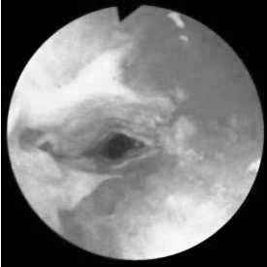 B 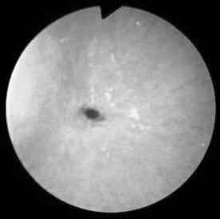

Fig. 13-21. Endoscopic picture of early (A) and late (B) changes in esophagus following caustic burn

Treatment

- A neutralizing agent (usually milk) is given as soon as possible to counteract the effects of the caustic agent.
- Corticosteroids and broad-spectrum antibiotics are administered for 3-6 weeks.
- Radiographs of the esophagus are performed at 10-14 days to determine if strictures are developing (see Fig. 13-22).
- Strictures occur in 5%-10% of patients who have ingested lye.
- If strictures have formed, a program of dilatation, using esophageal dilators (see Fig. 13-23), is begun 3-4 weeks after ingestion.
- Esophageal replacement with stomach or colon may be necessary.

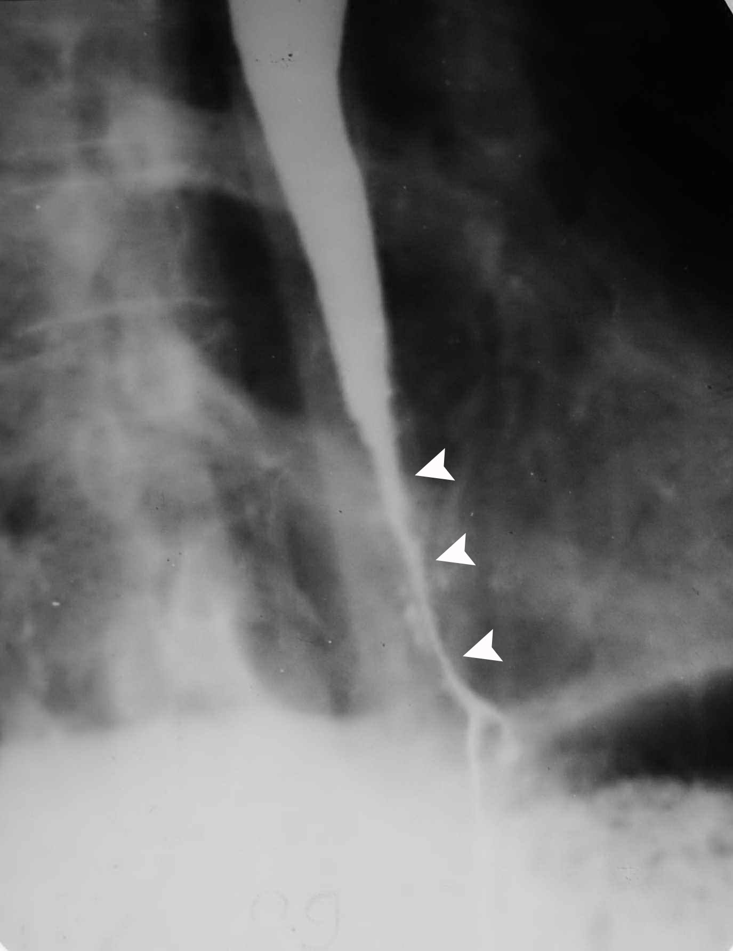

Fig. 13-22. Radiographic picture of carcinoma

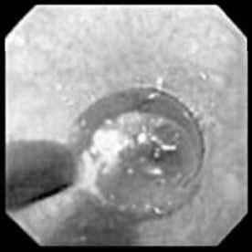

Fig. 13-22. Endoscopic hydrostatic balloon dilatation of esophageal stricture

Table 13-3. Diagnostic points in representative disorders of deglutition

Pertinent characteristic | Carcinoma | Complicated hiatal hernia | Achalasia | Cervical diverticulum
Duration | Weeks to months | Months to years | Months to years | Months to years
Characteristics | Rapidly progressive | Intermittent | Persistent | Slowly progressive
Aggravated by | Nothing | Reclining flat | Anxiety | Nothing
Alleviated by | Nothing | Antacids | Antispasmodics | Nothing
Dysphagia | Severe, progressive | Late, if ever | Marked | Uncommon
Regurgitation | Only late | Frequent, acid | Frequent, food | With neck compression
Heartburn | Absent | Prominent | Absent | Absent
Weight loss | Marked | Absent | Mild | None
Anemia | Frequent | Occasional | Uncommon | Rare
Location | Variable | Perixiphoid | Xiphoid | Neck
Comorbidity | Absent | Obesity,  pregnancy | Psychologic trauma | Aspiration
Masqueraders | Globus hystericus | Angina pectoris, aspiration | Globus  hystericus | None
Typical age | 60+ | 40+ | 20+ | 60+
Predispositions | Black | Female | Asthenia | Distal obstruction
From: Basic surgery/ed., H.C. Polk, Jr., et al. – 5th ed.

REVIEW TESTS

1. A 45-years-old woman was referred to thoracic surgeon with complains of periodical dull pain in the left half of neck just after meals, and bulging appearing here and disappearing after manual compression. This maneuver leads to passage of food into the pharynx and appearance of murmur. The disease began 4 years ago. The symptoms progress slowly. Endoscopy reveals the additional foramen in upper cervical part of esophagus. Radiography reveals the sacciform cavity originating from upper cervical part of esophagus. The cavity compresses the cervical part of esophagus. What’s the most appropriate tactics of managing the patient?

A. Esophagectomy
B. Cardiomyotomy
C. Diverticulectomy
D. Cervical esophagostomy
E. Conservative treatment

2. A 40-years-old woman was referred to thoracic surgeon with complains of periodical dysphagia with some distinct dishes, periodical retrosternal pain, regurgitation at night. The disease began 3 years ago after stressful accident. Endoscopy reveals esophagus containing a lot of food, presence of esophagitis, narrowing of gastroesophageal junction; endoscope passes into the stomach with slight resistance. Radiography reveals marked dilation of esophagus, decreased peristalsis, narrowing of gastroesophageal junction which has regular boards; the medium passes slowly into the stomach. What’s the most appropriate tactics of managing the patient?

A. Esophagectomy
B. Cricopharingeal myotomy
C. Heller cardiomyotomy and Dor fundoplication
D. Hottstein cardiomyotomy
E. Placement of self-expandable stent

3. A 64-years-old woman was referred to thoracic surgeon with complains of constant heartburn, periodical retrosternal pain, constant regurgitation after meals. She is ill for 2 years. PPIs and antacids partly relive the symptoms. Endoscopic data: the mucosa of terminal third of esophagus is hyperemic, the tone of gastroesophageal sphincter is decreased. Radiographic data: the fundus and part of corpus of stomach passes into the mediastinum in Trendelenburg’s position. What’s the most appropriate tactics of managing the patient?

A. Endoscopic injection of Botox
B. Hiatoplasty with Nissen fundoplication
C. Stretta procedure
D. Usage of Plicator
E. Conservative treatment with proton pump inhibitors

4. A 50-years-old man complains of constant rapidly progressing dysphagia, moderate constant retrosternal pain, regurgitation just after meals. He is ill for 3 months. Initially, dysphagia appeared only with solid food, now it presents even with liquid food. Patient lost 15 kg. Radiography reveals the filling defect in the middle part of esophagus, the narrowing has irregular boards, the medium passes distally with narrow stream. Endoscopy reveals obstructing tumor in the middle third of esophagus. Biopsy of the lesion demonstrates squamous cell carcinoma. CT scan doesn’t reveal spreading of the tumor into major vascular structures and distant metastases; mediastinal lymph nodes are positive. What’s the most appropriate tactics of managing the patient?

A. Restorative esophagectomy with esophageal replacement by colon
B. Endoscopic placement of Z-stent
C. Restorative resection of middle part of esophagus
D. Cervical esophagostomy
E. Irradiation

5. A 45-years-old man complains of constant progressing dysphagia, regurgitation just after meals. 6 months ago he drank an unknown liquid, then intense retrosternal pain was being presented. He refused medical aid at that time. For the last 2 months, the pain is absent but the progressing dysphagia is present. Patient lost 15 kg. The body temperature is normal and abdominal pain is absent. Endoscopy reveals concentric narrowing of the middle part of esophagus which is not passable by the endoscope. Biopsy of the lesion for malignancy is negative. Radiography reveals narrowing of the middle and lower third of esophagus with irregular boards. What’s the most appropriate tactics of managing the patient?

A. Endoscopic placement of Z-stent
B. Conservative treatment with antispasmodics
C. Restorative resection of middle part of esophagus
D. Balloon dilation
E. Endoscopic injection of Botox

Correct answers: 1 - C, 2 - C, 3 - B, 4 - A, 5 - D.

