CHAPTER 14. PULMONARY SYMPTOMS

GENERAL CONSIDERATIONS

Symptoms

- Main symptoms of pathology of respiratory system organs are dyspnea, cough, hemoptysis, chest pain, and various symptoms of SIRS. Tables 14-1, 14-2, 14-3 show the possible causes of these symptoms including ones produced by non-surgical diseases.

Table 14-1. Causes of dyspnea

Airway obstruction

Tumor
Bronchitis
Asthma
Laryngitis
Epiglottitis
Trauma
Foreign body
Extrinsic compression

Deficit in gas exchange

Pulmonary edema
Atelectasis
Pneumothorax
Pleural effusion
Pneumonia
Pulmonary interstitial disease
Diffuse alveolar disease
Anemia

Abnormality in pulmonary blood flow

Congenital heart disease
Pulmonary embolus
Congestive heart failure

Other

Pain
Neuromuscular disorder

From: Basic surgery/ed., H.C. Polk, Jr., et al. – 5th ed. (modified)

Table 14-2. Causes of cough

Bronchogenic carcinoma

Laryngeal cancer

Infection

Viral bronchitis
Bacterial pneumonia
Tuberculosis
Lung abscess

Acute tracheobronchitis

Laryngitis
Diffuse lung disease

Asthma
Emphysema
Other

Gastroesophageal reflux

Mediastinal mass

Aortic aneurysm
Lymphadenopathy
Tumor
Cyst

Foreign body

Chronic bronchitis

Postnasal drip

From: Basic surgery/ed., H.C. Polk, Jr., et al. – 5th ed. (modified)

Table 14-3. Causes of hemoptysis

Bronchogenic carcinoma

Infection

Tuberculosis
Pneumonia (bacterial, viral)
Mycosis
Lung abscess
Parasite

Bronchitis

Diffuse pulmonary disease

Goodpasture's (hemolytic-uremic) syndrome
Wegener's granulomatosis
Pulmonary fibrosis
Sarcoidosis
Cystic fibrosis

Bronchiectasis

Cardiovascular

Aortic aneurysm
Congenital heart disease
Mitral stenosis
Congestive heart failure
Pulmonary embolus
Hypertension

Miscellaneous

Coagulopathy
Epistaxis
Head/neck cancer
Broncholithiasis

From: Basic surgery/ed., H.C. Polk, Jr., et al. – 5th ed. (modified)

Diagnostic tools

Radiologic diagnostic procedures

- The standard procedures are chest radiograph and tomography of a lesion.
- Computed tomography (CT scan) has been shown to be extremely useful in localizing a process anatomically as well as in delineating cavitation, calcification, lymphadenopathy, or multiple lesions.
- Magnetic resonance imaging (MRI) may be used when a vascular lesion is suspected or if vascular involvement is anticipated.

Endoscopy

Laryngoscopy

- Laryngoscopy is occasionally an important procedure when carcinoma of the lung is suspected.
- Tumor involvement of the recurrent laryngeal nerves (signifying inoperability) can be diagnosed via laryngoscopy when suspicion is raised by vocal cord paralysis with resultant hoarseness.

Bronchoscopy

- Bronchoscopy is useful in many diseases of the tracheobronchial tree for both diagnostic and therapeutic purposes.
- Diagnostic uses include: to confirm a lung or tracheobronchial tumor suggested by history, physical examination, or chest radiograph; to identify the source of hemoptysis; to obtain specimens for culture and cytologic examination from an area of persistent pulmonary atelectasis or pneumonitis.
- Biopsy for suspicion of endobronchial or parenchymal tumor may be performed transbronchially via the bronchoscope in approximately one-third of cases.
- Therapeutic uses include: to remove a foreign body; to remove retained secretions (e.g., after administration of general anesthesia or from aspiration of gastric contents); to drain lung infections, such as abscesses.

Mediastinoscopy

- Mediastinoscopy is a procedure in which a lighted hollow instrument is inserted behind the sternum at the tracheal notch and directed along the anterior surface of the trachea in the pretracheal space.
- It allows to perform direct biopsy of paratracheal and subcarinal lymph nodes. Positive nodes in this area usually (but not always) indicate unresectability.
- It is also useful for diagnosing other pulmonary problems, such as sarcoidosis, lymphoma, Hodgkin’s disease, and infections.
- Complications include hemorrhage, pneumothorax, and injury to the recurrent laryngeal nerves, with a mortality rate about 0.1%.

Scalene node biopsy

- The scalene node-bearing fat pad is located behind the clavicle in the region of the sternocleidomastoid muscle. This area should be palpated in patients suspected of having lung tumors and should be biopsied if nodes are palpable.
- Tumor is found in 85% of patients with palpable nodes but in less than 5% of patients with nonpalpable nodes.
- The scalene nodes are surrounded by important structures, including the pleura, subclavian vessels, the thoracic and other large lymph ducts, and the phrenic nerves. The principal complications of scalene node biopsy result from injury to these structures, for example, pneumothorax, hemorrhage, chyle leak, and diaphragmatic paralysis.

Diagnostic pleural procedures

Thoracentesis

- Pleural effusions are examined for organisms in suspected infections and are examined cytologically in suspected malignancies (see Fig. 14-8). Positive cytologic findings prove a tumor to be inoperable.
- Pneumothorax is the principle complication of this procedure.

Lung biopsy

- Percutaneous lung biopsy may be used for either a localized peripheral lesion or a diffuse parenchymal process.
- Needle biopsy is an excellent means for obtaining tissue tor tumor diagnosis. It is also useful for the diagnosis of infections and inflammatory processes.
- The needle can be guided by ultrasonography, fluoroscopy, or CT.
- Complications of needle biopsy are pneumothorax and hemorrhage.

Videothoracoscopy

- Videothoracoscopy (see Fig. ) has recently become a frequently performed and well-tolerated procedure for numerous pleural and pulmonary diseases.
- Common indications include diagnosis or management of: idiopathic exudative pleural effusion; known malignant pleural effusion; diffuse interstitial lung disease; recurrent pneumothorax or persistent air leak; indeterminate peripheral solitary pulmonary nodules; dediastinal cyst.

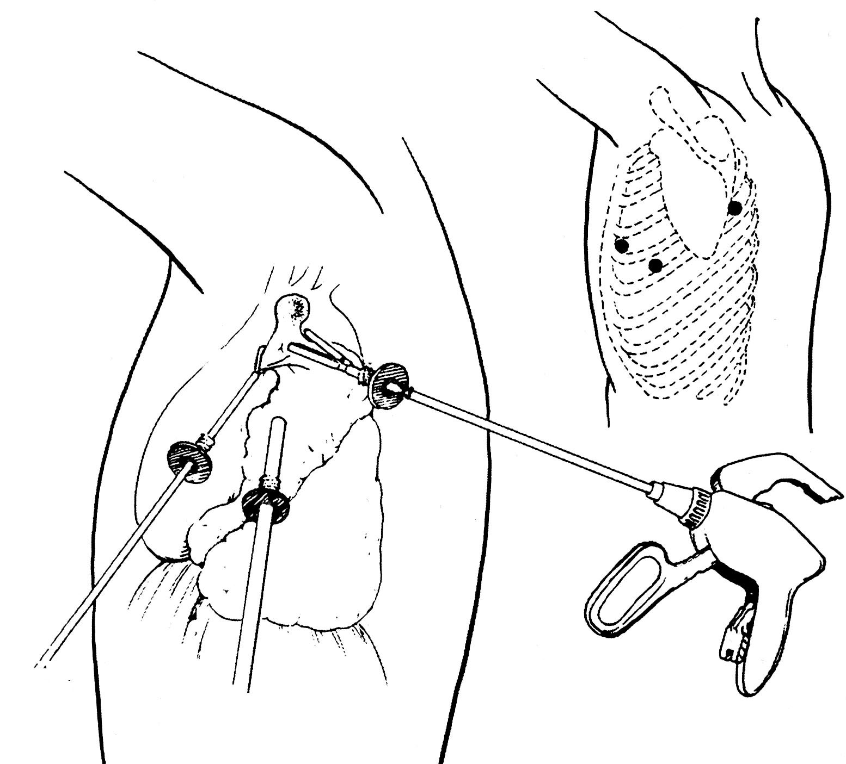

Fig. 14-1. Scheme of videothoracoscopic biopsy of lesion of lung

Thoracotomy

- Thoracic exposure for various diseases is provided by different thoracic
incisions.
- Median sternotomy (see Fig. 14-2) for exposure of the heart, pericardium, and structures in the anterior mediastinum.
- Posterolateral thoracotomy for exposure of the lung, esophagus, and posterior mediastinum.
- Axillary thoracotomy for limited exposure of the upper thorax during such procedures as upper lobe biopsy or sympathectomy.
- Anterolateral thoracotomy (see Fig. 14-3) for rapid exposure in patients with thoracic trauma or in patients with a very unstable cardiovascular status who cannot tolerate a lateral incision. This type of procedure also allows for excellent control of the airway during the incision.
- Anterior parasternal mediastinotomy (Chamberlain procedure), a 2-3 cm parasternal incision that allows insertion of a mediastinoscope into the mediastinum or, more commonly, direct visualization and biopsy of mediastinal lymph nodes.

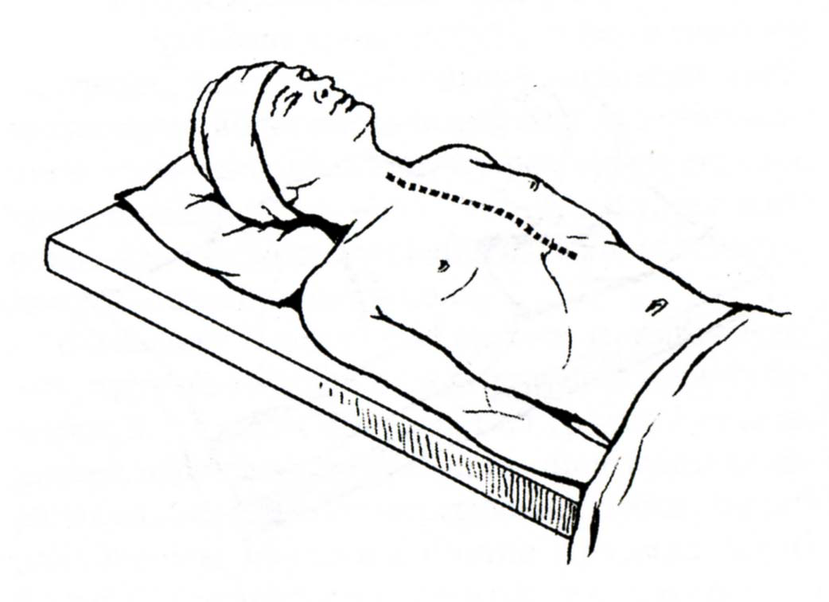

Fig. 14-2. Median sternotomy

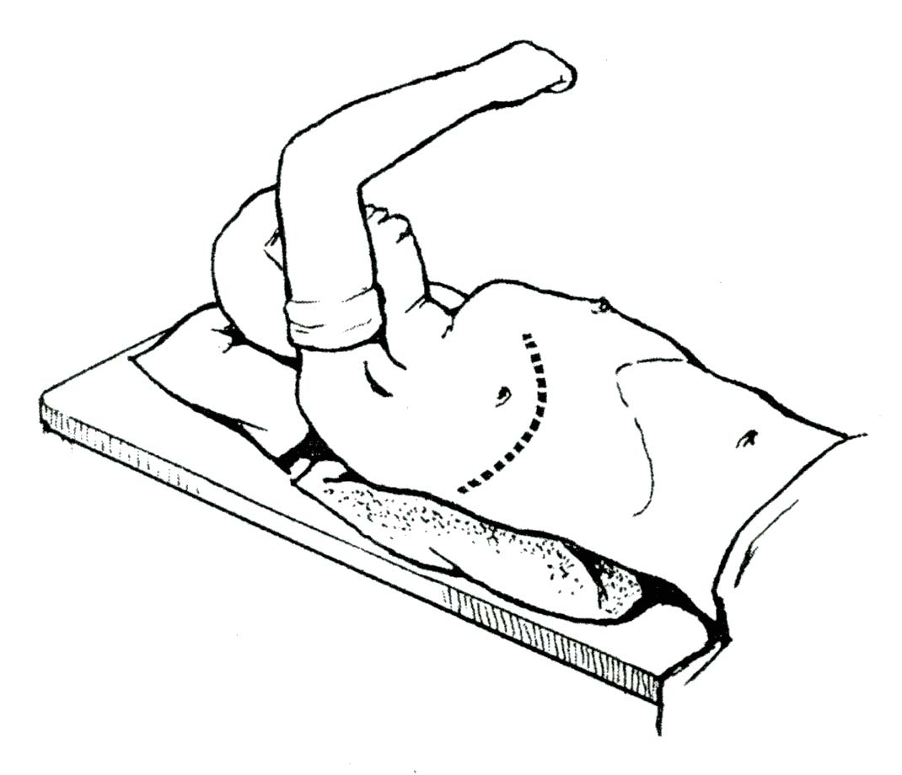

Fig. 14-3. Anterolateral sternotomy

DISORDERS OF THE PLEURA AND PLEURAL SPACE

Spontaneous pneumothorax

Overview

- Spontaneous pneumothorax occurs when a subpleural bleb ruptures into the pleural space with resultant loss of negative intrapleural pressure, allowing the lung to collapse.
- Young adults 18-25 years of age are most commonly affected, although older
persons with asthma or chronic obstructive pulmonary disease are also susceptible.

Clinical features and visualization data

- Symptoms include rapid chest pain, cough, and dyspnea and range from mild to severe.
- Diagnosis is made by physical examination (absence or decrease of breath sounds at the affected side) and chest radiograph (partially or completely collapsed lung and shift of the mediastinal structures to the healthy side) (see Fig. 14-4).

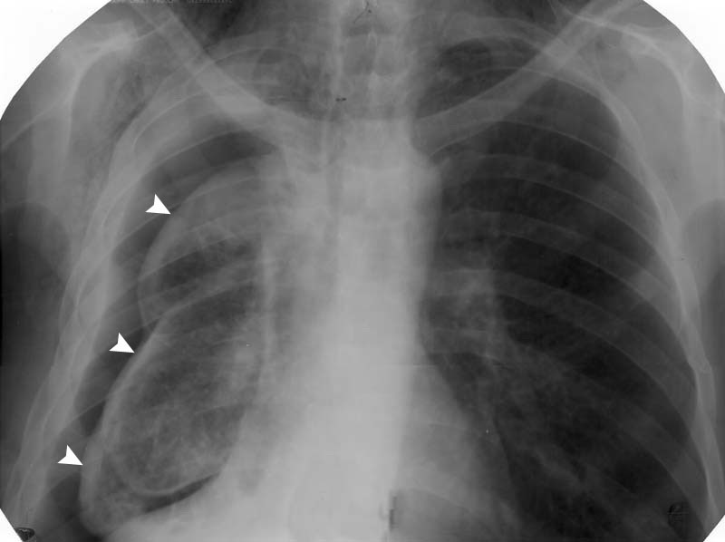

Fig. 14-4. Radiological picture of subtotal spontaneous pneumothorax

Treatment

- Initial treatment is by chest tube drainage of the pleural space placed at the midclavicular line at second or third intercostal space (see Fig. 14-5).
- Indications for surgery include: recurrent pneumothorax (ipsilateral or contralateral); persistent air leak for 7-10 days; incomplete lung expansion (according to control chest radiographs).
- Procedure is stapling of apical blebs (see Fig. 14-6) and pleural abrasion. This is an excellent indication for videothoracoscopic approach.

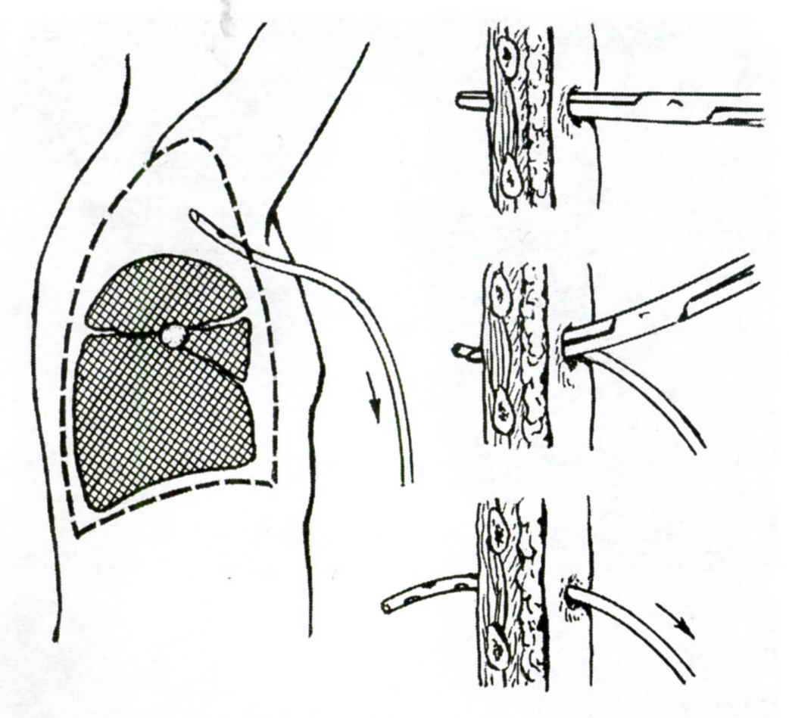

Fig. 14-5. Technique of drainage of pleural space for spontaneous pneumothorax

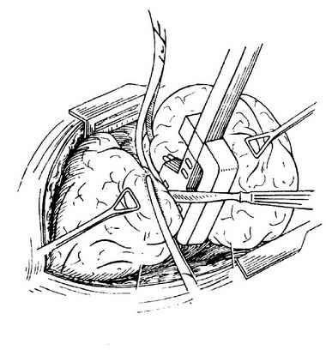
Fig. 14-6. Technique of resection of lung

Pleural effusions (pleuritis)

- Causes of pleural effusions are congestive heart failure, infection, and malignant neoplasms.
- Symptoms include dyspnea, cough, dull chest pain, and subfebrile temperature.
- Auscultation reveals decreased breath sounds at the affected side.
- Chest radiograph reveals fluid collection with characteristic oblique level (see Fig. 14-7).
- Treatment is aimed at the underlying cause and includes thoracocentesis (for either diagnostic or therapeutic purposes) (see Fig. 14-8) or pleural drainage (see Fig. 14-9) for advanced cases.

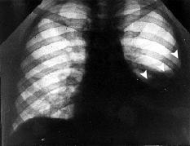

Fig. 14-7. Radiological picture of pleural effusion

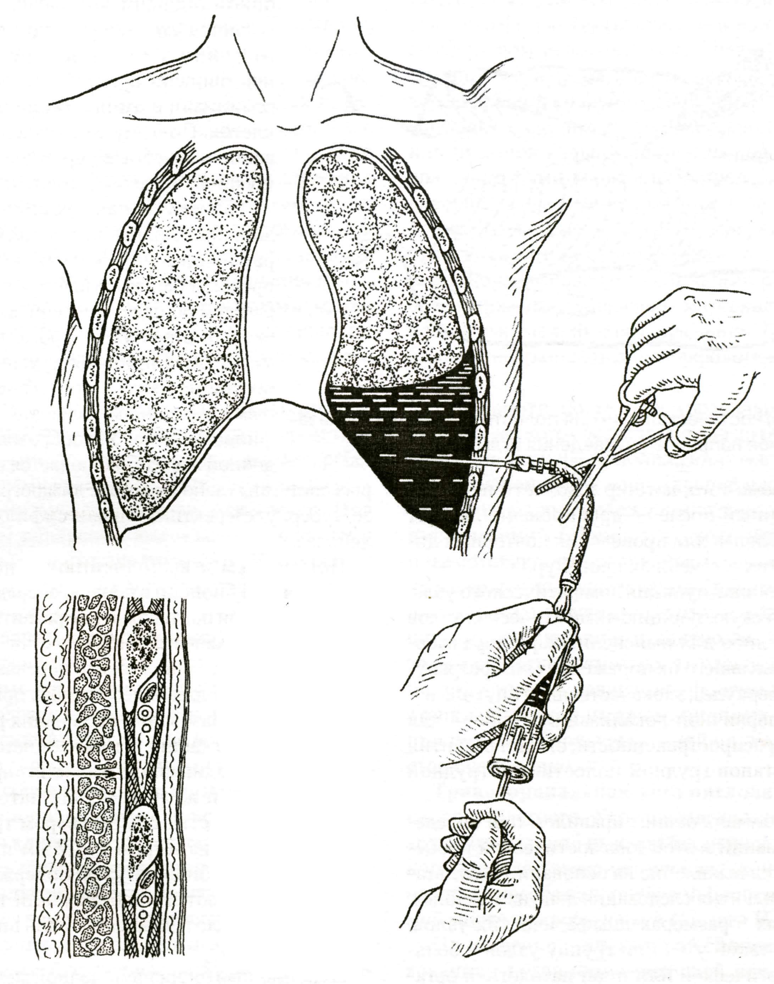

Fig. 14-8. Technique of thoracocentesis

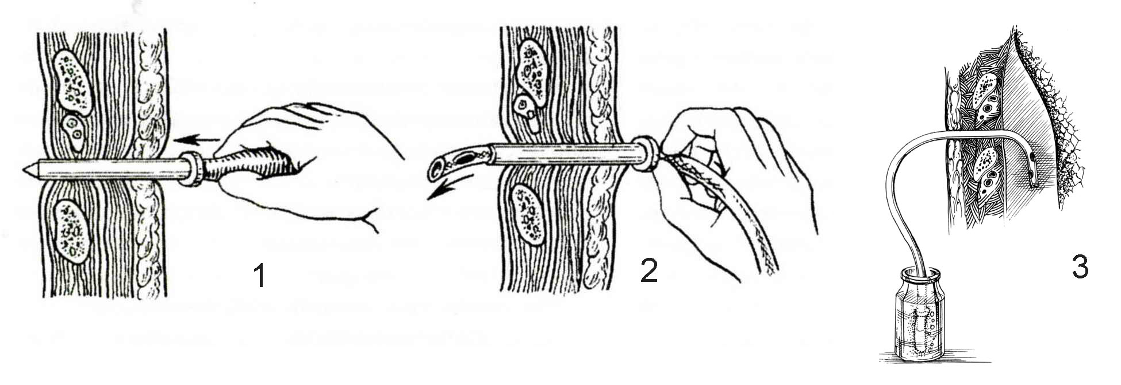
Fig. 14-9. Technique of drainage of pleural space for pleural effusion

Pleural empyema (suppurative pleuritis)

Overview

- Pus in the pleural space usually accumulates secondary to pulmonary infection or infection due to penetrating thoracic trauma.
- Pathophysiology of empyema evolves in three stages. Acute or serous phase (onset to 7 days) during which pleural fluid is initially produced. Transitional or fibrinopurulent phase (7-21 days) during which fluid gravitates to dependent areas and undergoes septation and loculation. Chronic or organized phase (> 21 days) in which fibrin and pleura fuse and thicken around the periphery of the fluid, resulting in frank abscess formation.
- The pleural abscess (loculated empyema) may be located apically (see Fig. 14-10, 1,5; Fig. 14-11, A), interlobularly (see Fig. 14-10, 2), paracostally (see Fig. 14-10, 3; Fig. 14-11, B), basally (see Fig. 14-10, 4), and paramediastinally (see Fig. 14-10, 6).

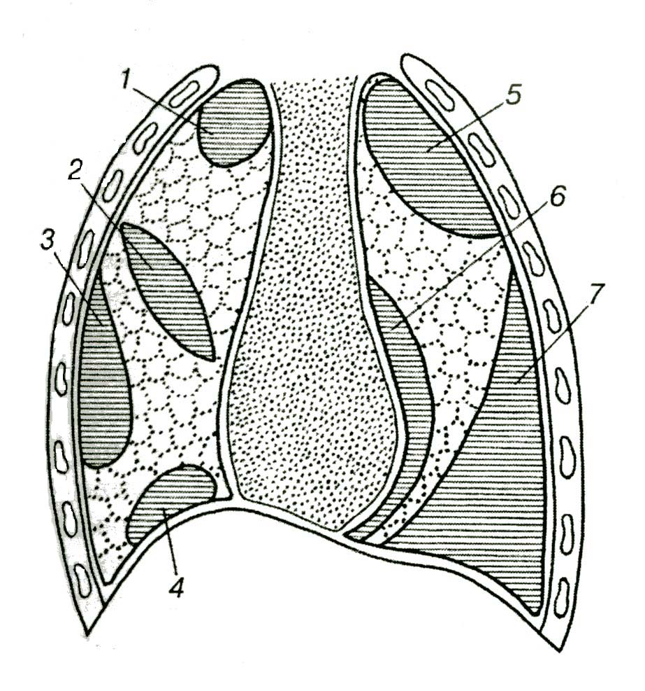
Fig. 14-10. Variants of position of loculated empyema

Clinical features

- Symptoms include dyspnea, cough, chest pain, and febrile to hyperpyrexic temperature and other symptoms of sepsis.
- Auscultation reveals decreased or absent breath sounds at the affected side depending on the extent of the disease.

Visualization data

- Chest radiograph reveals unseparated (see Fig. 14-11) or separated fluid collection.
- Diagnosis is made by thoracentesis (see Fig. 14-8) in a patient with pleural effusion and fever.
- The aspirated fluid is sent for laboratory studies.
- On gross examination, if the fluid is very cloudy or is foul-smelling, an empyema is quite likely.

A 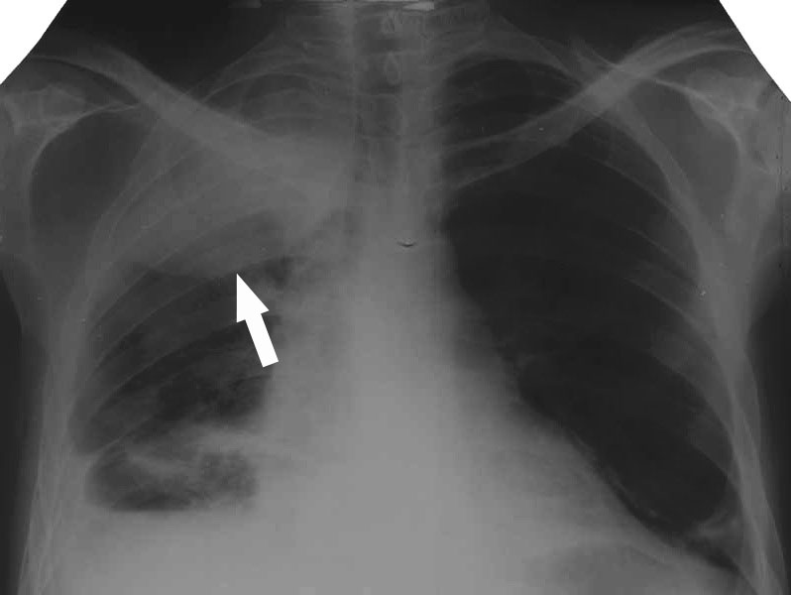 B 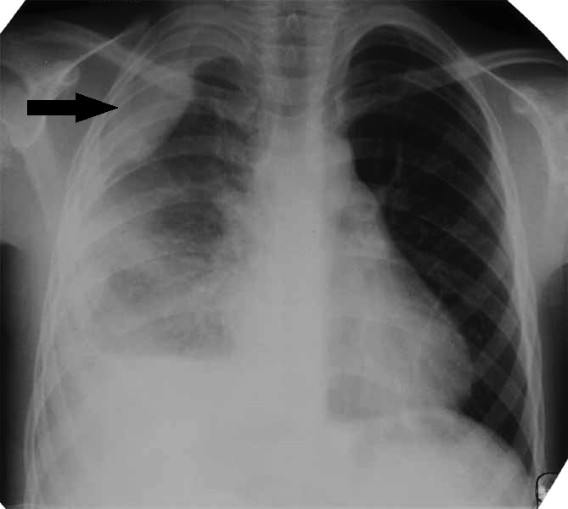

Fig. 14-11. Radiological pictures of loculated empyema

Treatment

- Early empyemas associated with pneumococcal pneumonia may be treated with repeated aspiration (see Fig. 14-8) and antibiotics.
- Established empyemas, which usually have thicker fluid, need continuous closed drainage (see Fig. 14-9). If the empyema is loculated and, therefore, not completely drained by the intercostal tube, then thoracotomy, debridement, and decortication (removal of thickened visceral pleura) are necessary.
- Small, dependent empyemas that do not respond to chest tube drainage need open drainage via localized rib resection, especially in poor-risk patients.

Pleural tumors

- Mesothelioma is related to asbestos exposure.
- Localized mesotheliomas usually arise from the visceral pleura and are treated by local excision.
- Malignant mesothelioma presents with a pleural effusion, and it is almost always a fatal disease. The role of surgery is primarily for diagnosis and palliation of symptomatic malignant effusion, usually by way of thoracoscopy.

PULMONARY INFECTIONS

Lung abscess, necrotizing pneumonia and lung gangrene

Overview

- Abscess of the lung usually occurs secondary to aspiration or pneumonia.
- Abscesses may be multiple when necrotizing (e.g. staphilococcal) pneumonia occurs.
- When secondary to aspiration it occurs in the dependent segments of the lung (i.e., the posterior segment of the upper lobe or the superior segment of the lower lobe). These are most often anaerobic infections.

Clinical features

- Symptoms include severe dyspnea, cough with purulent or bloody sputum, chest pain, and febrile to hyperpyrexic temperature, and other symptoms of sepsis.
- Auscultation reveals decreased or absent breath sounds at the affected side depending on the extent of the disease.

Visualization data

- Abscess is revealed by chest radiograph or CT scan that show a mass when an abscess have not been already drained into the adjacent bronchus (see Fig. 14-12, A), or a cavity with characteristic horizontal level when an abscess have already been drained (see Fig. 14-12, B,C; Fig. 14-13, left).
- In the case of necrotizing pneumonia abscesses may be multiple and lung tissue is severely infiltrated (see Fig. 14-13, right).
- In lung gangrene, the lung tissue is severely destroyed demonstrating total or subtotal irregular infiltration on chest radiograph (see Fig. 14-14).
- Secondary pleural effusion or empyema may be present.

A 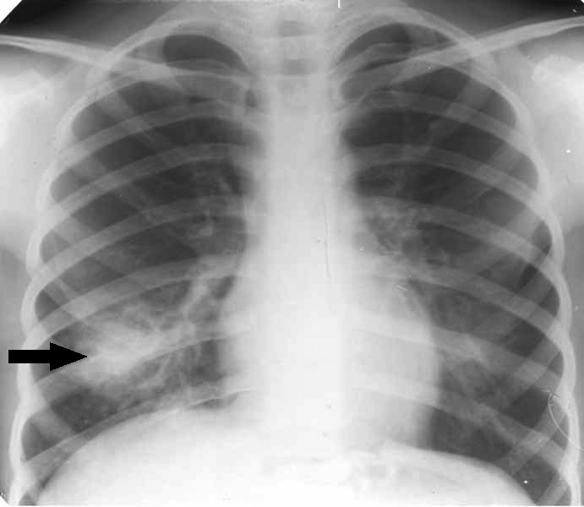 B 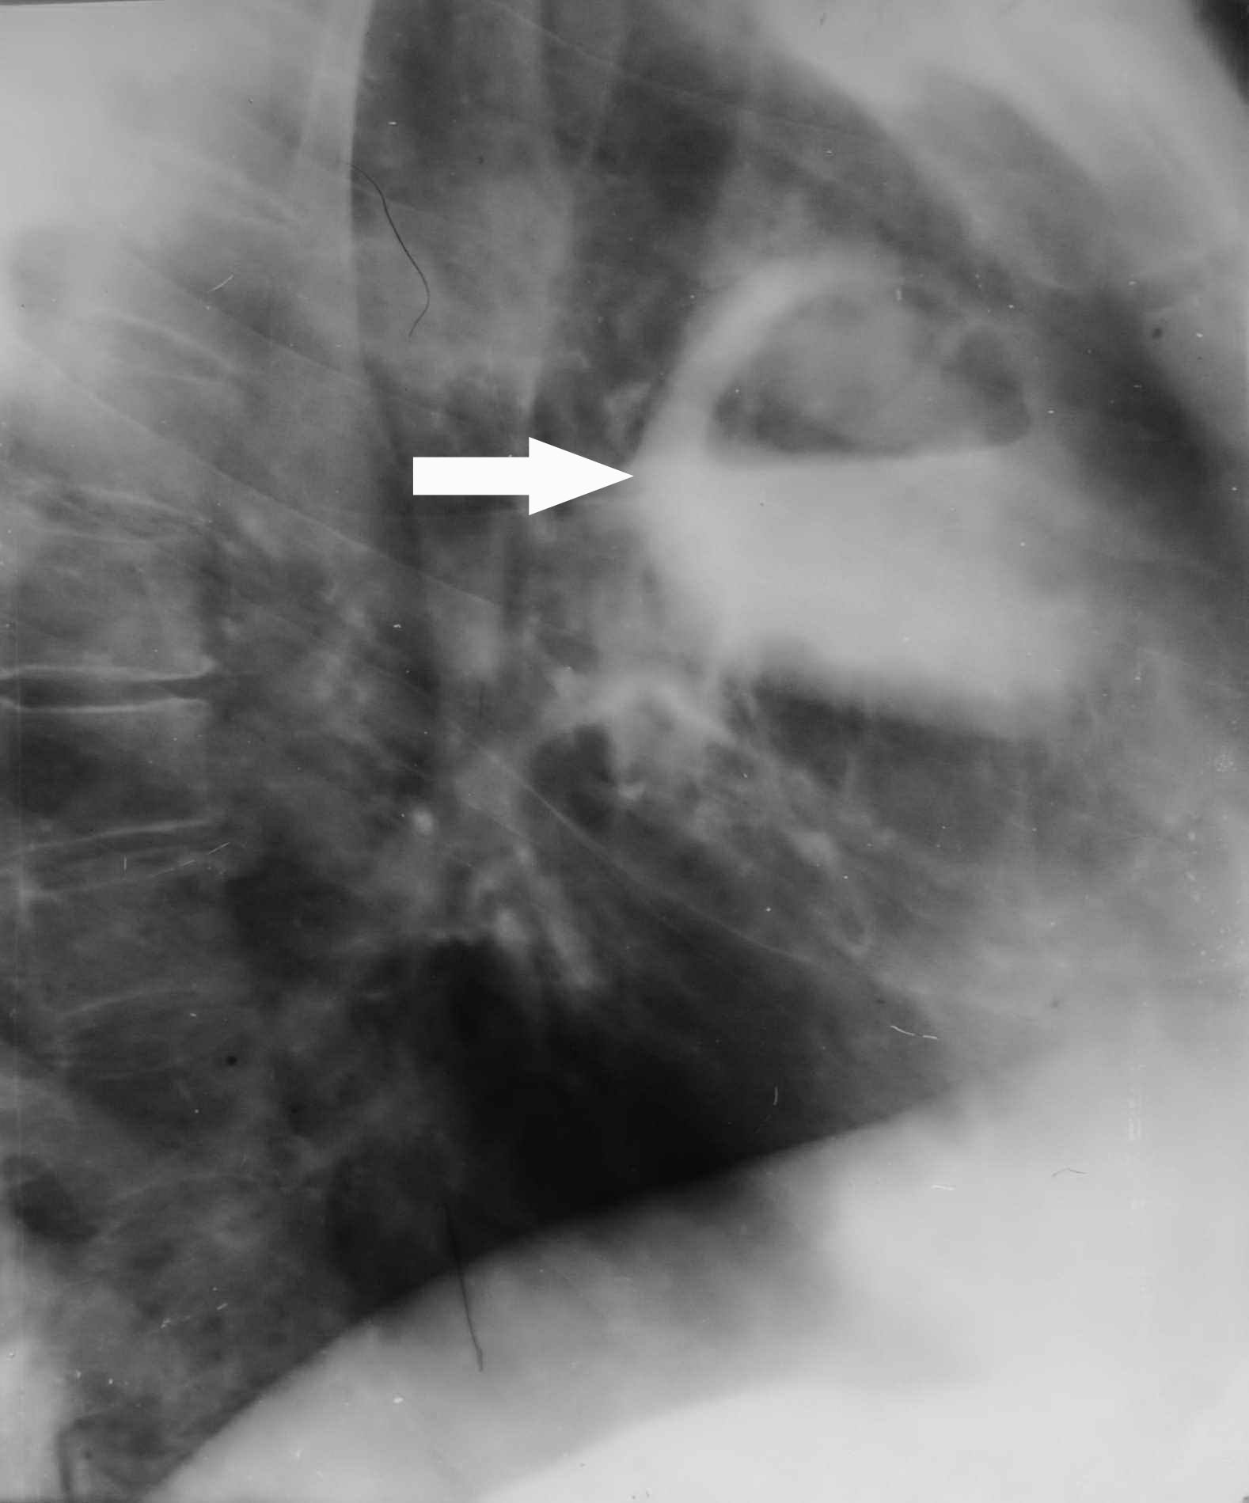 C 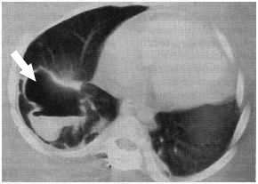

Fig. 14-12. Radiological pictures of lung abscess before (A) and after (B, C) drainage into the bronchus

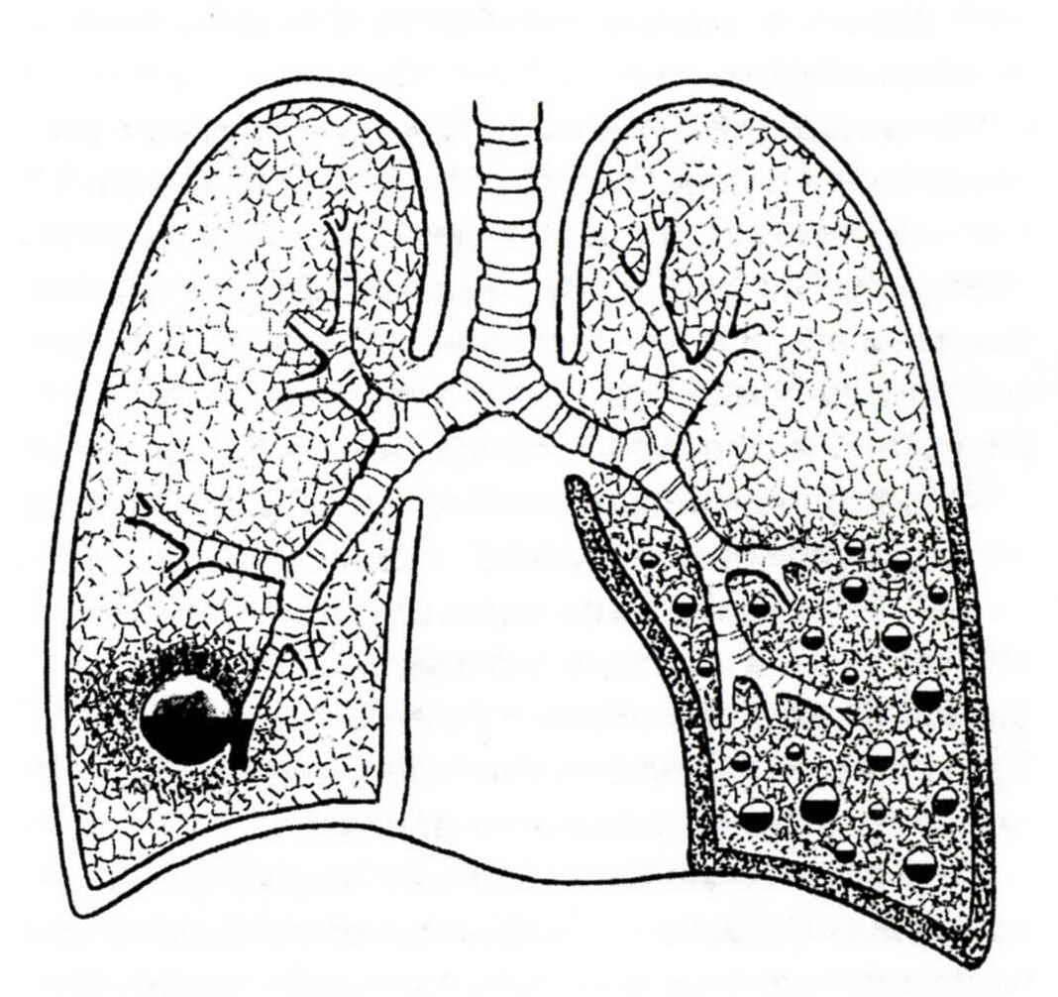

Fig. 14-13. Scheme of radiological pictures of lung abscess (left) and necrotizing pneumonia (right)

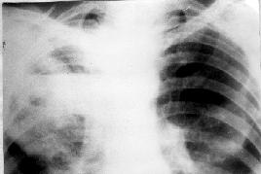

Fig. 14-14. Radiological picture of lung gangrene

Treatment

- Intravenous broad-spectrum antibiotics are the usual treatment; over 90% of acute lung abscesses resolve with antibiotic therapy.
- Microtracheostomy (see Fig. 14-15) is fashioned for intratracheal instillation of antibiotics solutions mainly for stimulation of cough and natural drainage. It is also used in necrotizing pneumonias.
- The approach for drainage of lung abscess depends on its location and ability to be drained into the lumen of bronchus. If the abscess is well drained into the bronchus, brochoscopic drainage is beneficial (see Fig. 14-16). Peripheral abscess may be drained via thoracocentesis or intercostal tube (see Fig. 14-17).
- Indications for surgery (open drainage of abscess, resection of lung (see Fig. 14-6), lobectomy, or pneumonectomy, depending on the extent of the disease) include: failure of the abscess to resolve with adequate therapy; hemorrhage; inability to rule out carcinoma; giant abscess; rupture with a resulting pyopneumothorax (see Fig. 14-18, Fig. 14-19). The latter can be treated initially by chest tube drainage of the pleural space but may require open drainage and decortication with or without actual resection. Lung tissue resections are mainly indicated for lung gangrene complicated by hemorrhage.
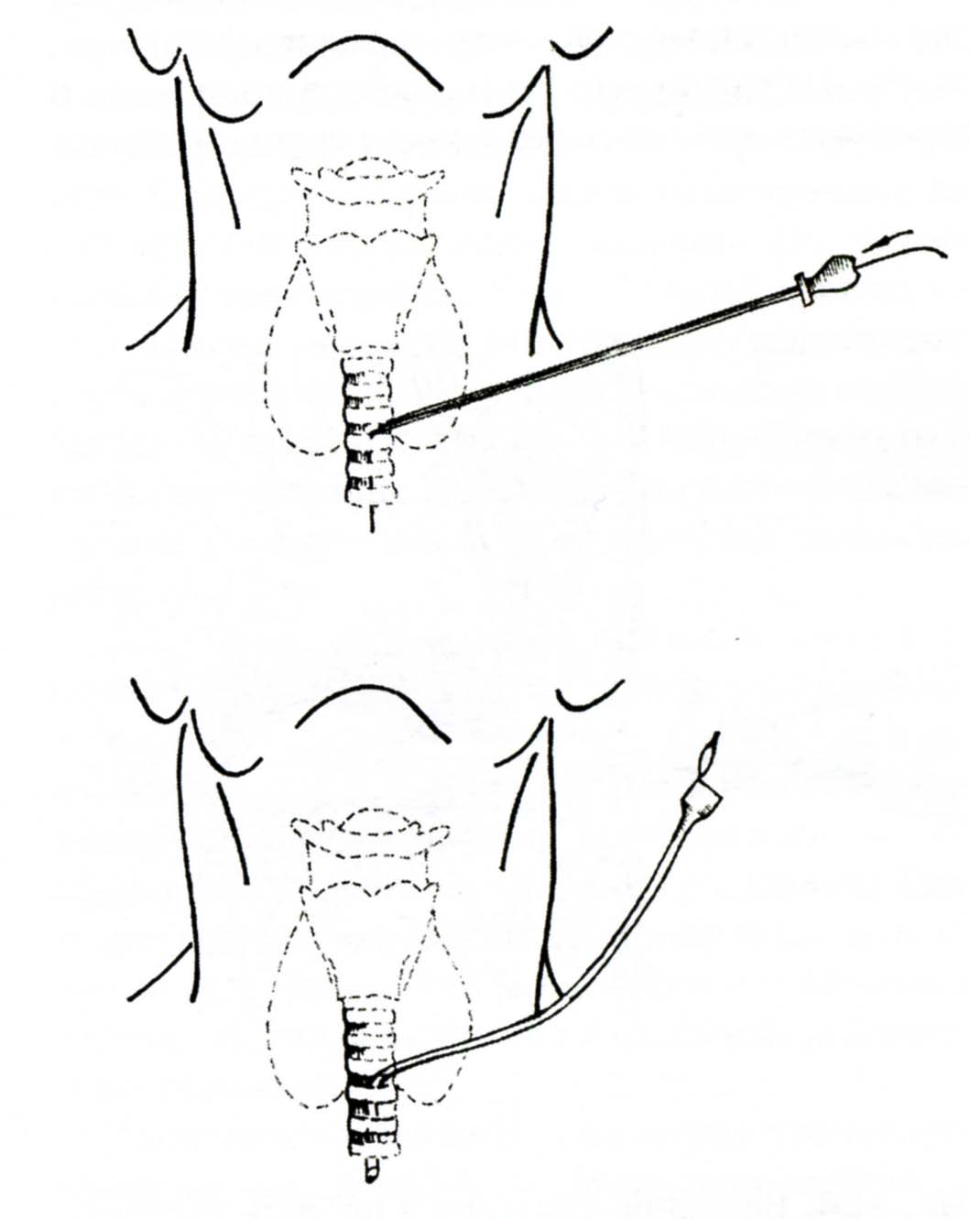

Fig. 14-15. Technique of microtracheostomy

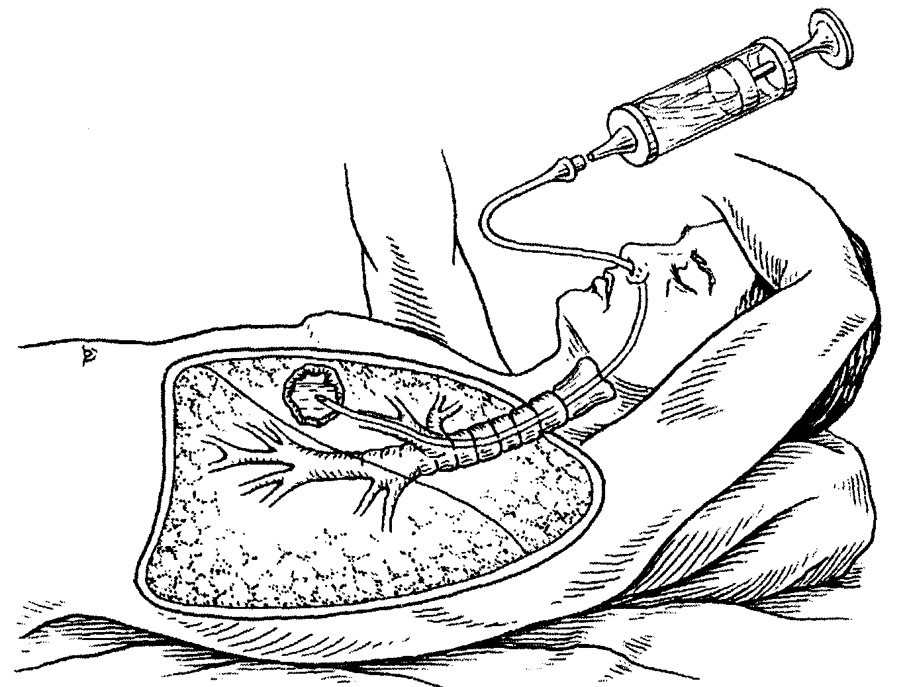

Fig. 14-16. Scheme of brochoscopic drainage of lung abscess

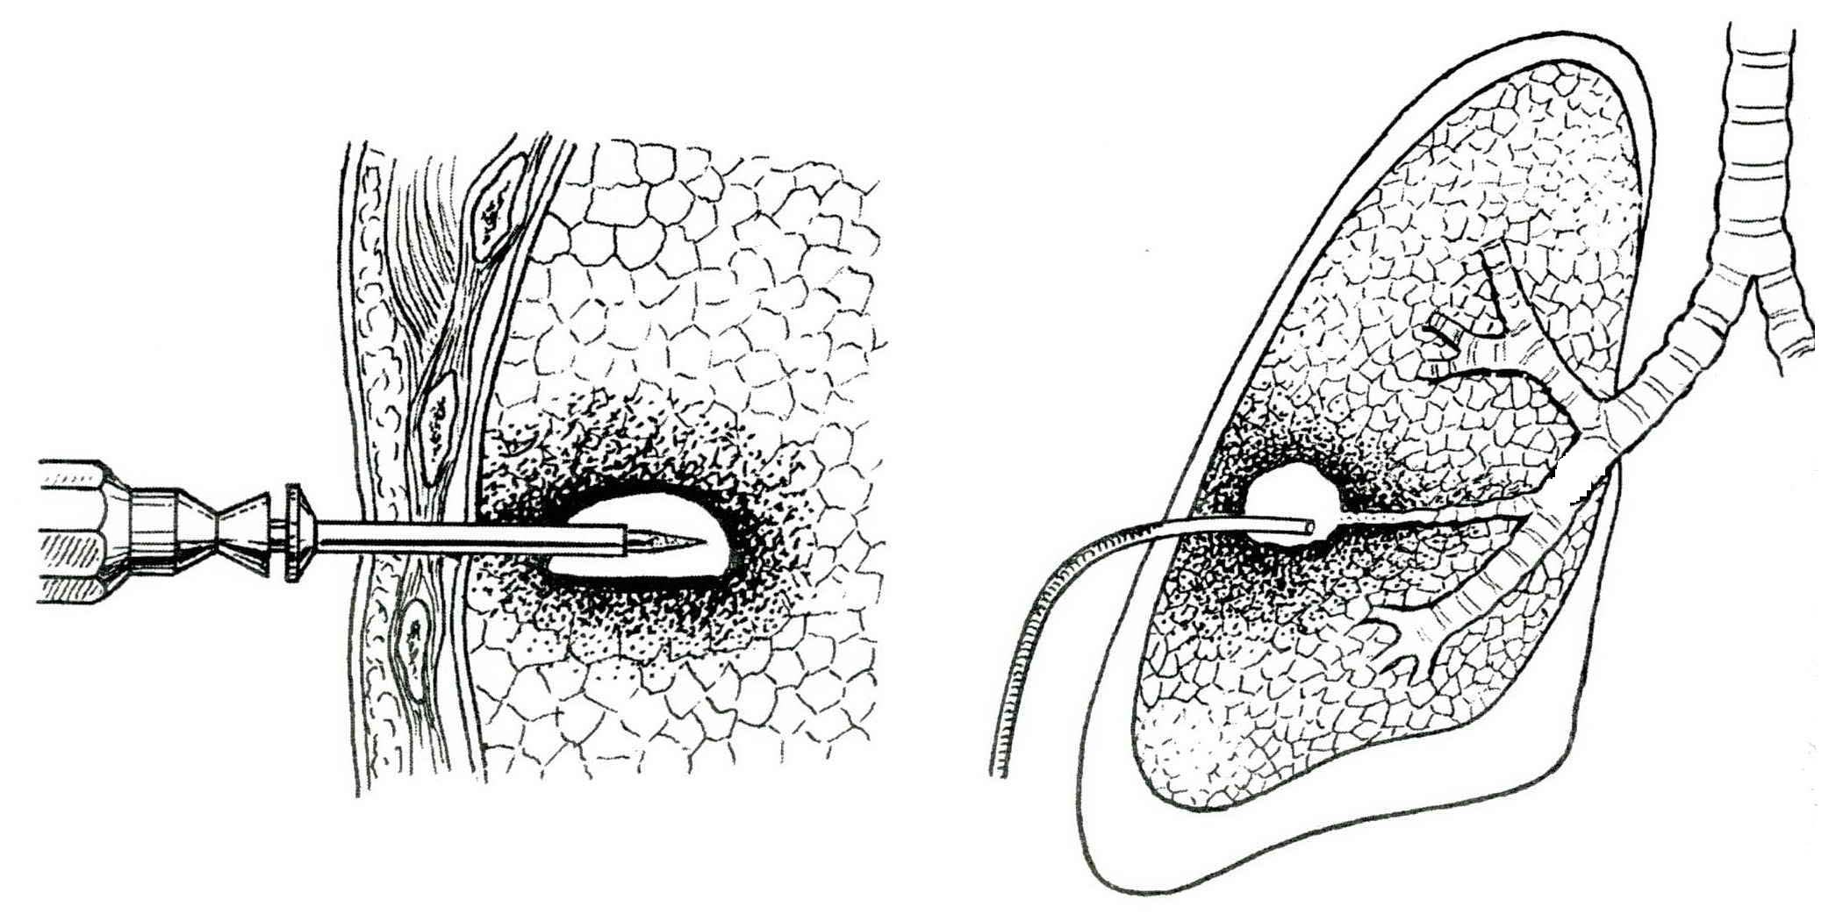

Fig. 14-17. Technique of transthoracic drainage of lung abscess

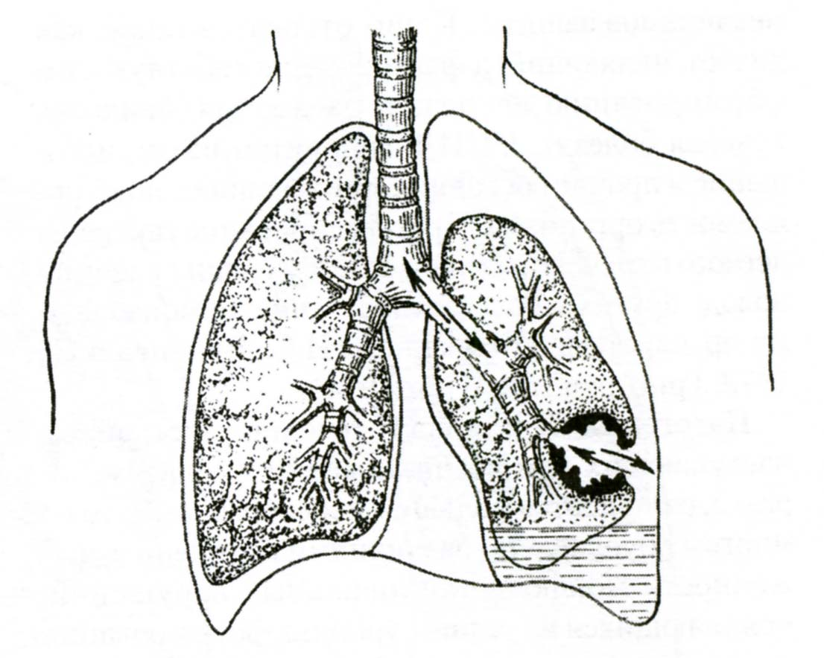

Fig. 14-18. Scheme of evolution of lung abscess to pyopneumothorax

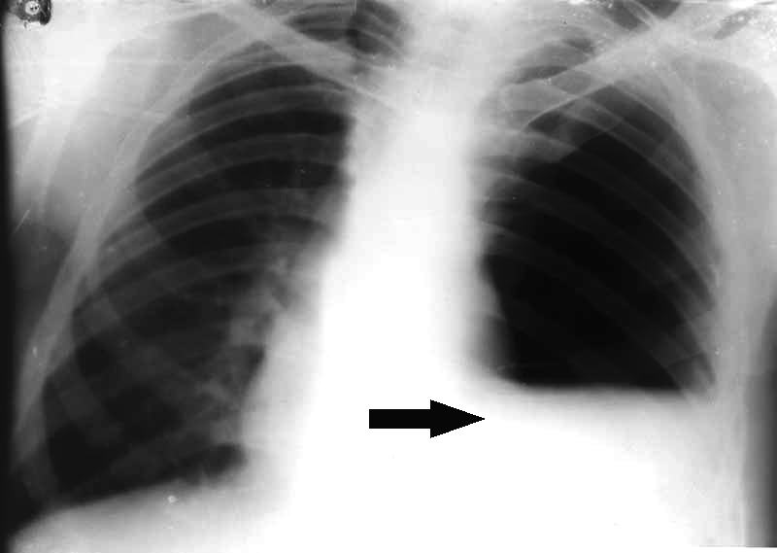

Fig. 14-19. Radiological picture or pyopneumothorax

Bronchiectasis

- Bronchiectasis is a complication of repeated pulmonary infections which causes bronchial dilatation. The disease usually affects the lower lobes. It occurs in adults and children who present with a chronic illness accompanied by excessive sputum production.
- Bronchography is the definitive diagnostic study (see Fig. 14-20). Bronchoscopy may also bу helpful to determine the specific segmental location of secretions and to rule out foreign bodies, bronchial stenosis, or neoplasms.
- Treatment initially is medical. Antibiotics and pulmonary toilet (including bronchscopic) resolve most cases.
- Surgical treatment involves segmental resection of the affected area (see Fig. 14-6); and best results are obtained in patients with localized disease.
- Surgery is also indicated in the disease complicated by bleeding.

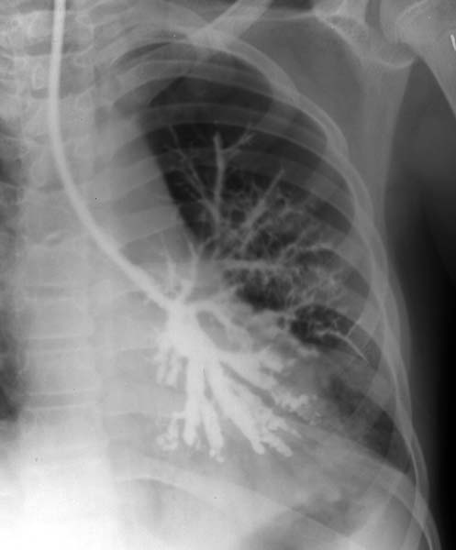

Fig. 14-20. Bronchgraphic picture or bronchiectasis

Tuberculosis

- Chemotherapeutic agents are used to treat this disease.
- Fewer than 5% of patients require pulmonary resection as part of their therapeutic regimen, and this is usually performed after a course of chemotherapy.
- Indications for surgery include: bronchopleural fistula with empyema; destroyed lobe or lung; persistent open cavities with positive sputum (tuberculous cavern) (see Fig. 14-21); post-tubercular bronchial stenosis; pulmonary hemorrhage; suspected carcinoma; bronchiectasis. See also Table 14-4.

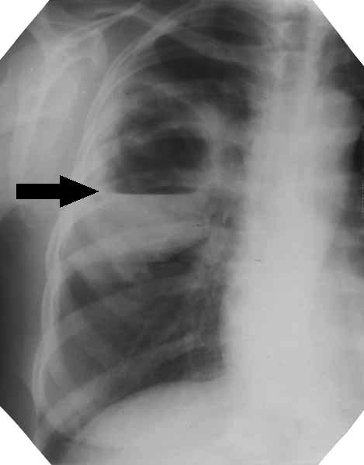

Fig. 14-21. Radiological picture or cavernous tuberculosis

Table 14-4. Indications for surgical resection in tuberculosis
Lesion | Comment
Residual cavity, positive sputum | After at least 3 months of treatment with drug therapy
Residual cavity, negative sputum | Usually large cavities that show no sign of regression  with adequate drug therapy; seen mainly in younger patients
Closed cavity, nodular disease | Bronchial obstruction resulting from caseous necrosis or nodular disease; acid-fast bacilli usually present in cavity although sputum tests yield negative results
Multiple-drug-resistant localized disease | Becoming more common, especially in endemic areas
Bronchiectasis | Secondary to healing of tuberculosis process; may be associated with recurrent infection or hemoptysis
Unstable nodular disease or destroyed lung | Especially in patients who develop recurrent infections in destroyed lobes or lungs
Massive hemorrhage or hemoptysis | Usually from cavities or bronchiectasis
From: Basic surgery/ed., H.C. Polk, Jr., et al. – 5th ed.

LUNG TUMORS

Solitary pulmonary nodules

Overview

- Solitary pulmonary nodules (coin lesions) are well-circumscribed, peripheral nodules (see Fig. 14-22), which may be manifestations of neoplastic disease (e.g., bronchogenic carcinoma, metastasis), benign tumor (e.g., hamartoma), granulomatous, infectious processes (e.g., tuberculoma), or cyst (e.g., hydatid cyst).
- They occur more often in men than in women.
- Benign versus malignant etiology priniples: When no other tumor is known to be present, the solitary pulmonary nodule is rarely asign of metastatic disease. If the patient is younger than 40 years of age, there is a two-thirds chance that the lesion is benign. The likelihood of cancer is higher in men than in women.

A 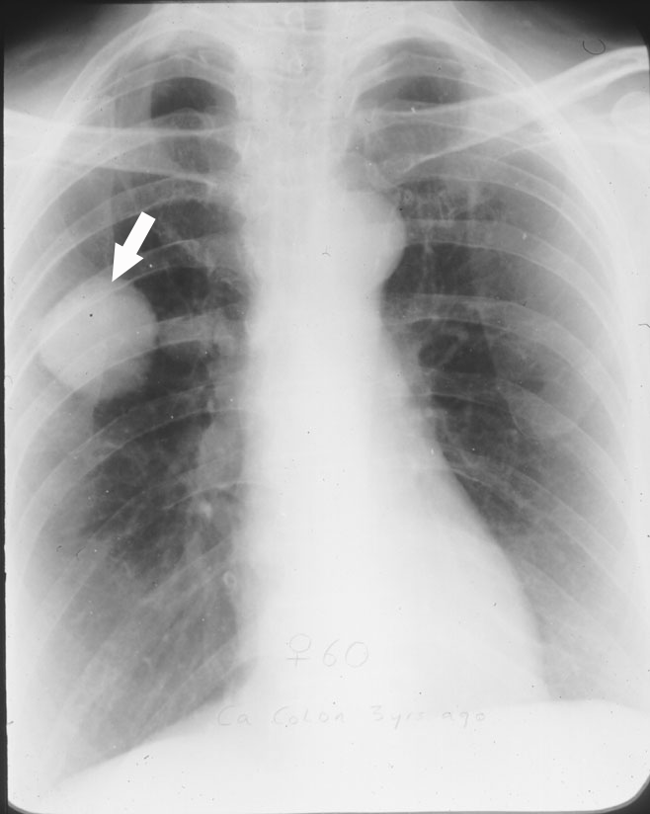 B 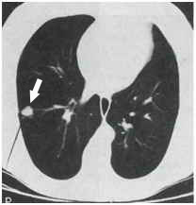

Fig. 14-22. Radiological and CT appearance of typical coin lesion (actually – peripheral carcinoma)

Table 14-5. Incidence of solitary pulmonary nodules

Lesion | Percent
Malignant tumor | 36
Primary carcinoma | 32
Metastatic carcinoma | 3
Miscellaneous | <1
Granuloma | 53
Histoplasmosis | 18
Tuberculosis | 14
Coccidiomycosis | 11
Unidentified | 9
Cryptococcosis | <1
Actinomycosis | <1
Aspergillosis | <1
Blastomycosis | <1
Hamartoma | 7
Pleural or chest wall lesion | 1
Mesothelioma, fibroma, etc.
Miscellaneous | 3
Cysts, nodes, A-V fistula, infarct, etc.
From: Basic surgery/ed., H.C. Polk, Jr., et al. – 5th ed.

Clinical presentation, visualization data and tactics

- Solitary pulmonary nodules are usually asymptomatic.
- Radiographic evidence of a benign lesion includes the following:
- Calcification is present, particularly concentric, heavy, or popcorn-like (if the calcification appears as small flecks, a malignant lesion should be suspected).
- Radiographs taken at least 2 years apart show no growth in the size of the lesion.
- The lesion size is less than 1 cm in diameter (the larger the lesion, the greater the chance of malignancy).
- CT scan demonstrates a well-circumscribed lesion. Multiplу lesions that are demonstrated on CT but are not seen on plain film suggest either metastatic disease or satellite lesions from carcinoma or granulomas.
- Because no radiographic characteristic that indicates a benign lesion is absolute, tissue biopsy (percutaneous, thoracoscopic, or open) is mandatory for diagnosis.

Bronchogenic carcinoma

Overview

- Bronchogenic carcinoma is the leading cause of cancer death in the United States.
- Approximately 130,000 new cases are diagnosed each year in this country.
- About 95% of lung cancers occur in patients who are over 40 years of age.
- Seventy-five percent of all lung carcinomas are related to smoking; affected individuals usually have a history of smoking one or more packs of cigarettes daily for 20 years.
- There is no known environmental cause. However, chronic exposure to various substances may play a role: nickel, asbestos, arsenic, radioactive materials, and petroleum products have all been implicated.

Histological classification

Adenocarcinoma

- Adenocarcinoma is now the most common lung carcinoma, representing 30% - 45% of all malignant lung cancers. It is less strongly associated with smoking and occurs more commonly in women.
- Histology reveals distinct acinar formation of cells, which arise from the subsegmental airways in the periphery of the lung.
- Growth may be slow, but the cancer metastasizes readily by a vascular route. It may spread diffusely throughout the lung via the tracheobronchial tree.
- Bronchoalveolar carcinoma is a variant of adenocarcinoma, which represents a highly differentiated form that spreads along alveolar walls.
- Its three forms are: solitary nodule, multinodular, and diffuse/pneumonic.
- It has the best prognosis of all the cell types.

Squamous cell carcinoma

- Squamous cell carcinoma is the second most common carcinoma of the lung, representing 25% - 40% of all malignant tumors. It is associated with smoking.
- Histology reveals intercellular bridge formation and cell keratinization. It is thought to arise from squamous metaplasia of the tracheobronchial tree.
- Approximately two-thirds of squamous cell carcinomas occur centrally in the lung fields.
- The tumor is bulky and is associated with bronchial obstruction. The tumor may grow endobronchially or extrabronchially.
- It is characterized by slow growth and late metastasis.

Small cell carcinoma

- Small cell anaplastic (oat cell) carcinoma, which is highly malignant, represents approximately 15% - 25% of all malignant lung tumors.
- Histology reveals clusters, nests, or sheets of small, round, oval or spindle-shaped cells. Electron microscopy reveals the presence of neurosecretory cytoplasmic granules. This, together with observed production of biologically active substances, has led to their classification as tumors of APUD system.
- It is usually centrally located.
- It metastasizes early by the lymphatic and vascular routes.
- It may be curable (small peripheral stage I) if it is resected at early stage. If unresectable, it usually responds to combination chemotherapy.
- Prognosis is quite poor.

Undifferentiated large cell carcinoma

- Undifferentiated large cell carcinoma is the rarest of the major cell types of lung cancer.
- It may be located either centrally or peripherally.
- It is a highly malignant lesion, which spreads early.
- It has a poorer prognosis than the more differentiated non-small cell carcinomas.

Table 14-6. Cell types and characteristics of carcinoma of the lung

Category | Incidence (%) | Growth characteristics
Non-small-cell cancers
Squamous cell cancer | 30-35 | Occurs in major bronchi, causing distal atelectasis
Adenocarcinoma | 30-35 | Majority occur in periphery of lung; more common in women
Large cell cancer | 5 | Located peripheral from hilus of lung
Bronchoalveolar | 5 | Occurs as a diffuse, patchy pneumonia or as a slow-growing, well-circumscribed local lesion
Small-cell cancer | 20 | Very cellular and largely extrabronchial, causing little or no atelectasis; early lymphatic and hematogenous spread
Carcinoid | 5 | Endobronchial location; infrequent nodal metastases; low-grade malignancy
Other | <5
From: Basic surgery/ed., H.C. Polk, Jr., et al. – 5th ed.

TNM-classification

T - Primary tumor
TX Primary tumor cannot be assessed, or tumor proven by the presence of malignant cells in sputum
or bronchial washings but not visualized by imaging or bronchoscopy
T0 No evidence of primary tumor
Tis Carcinoma in situ
T1 Tumor 3 cm or less in greatest dimension, surrounded by lung or visceral pleura, without bronchoscopic evidence of invasion more proximal than the lobar bronchus (i.e., not in the main bronchus)
T2 Tumor with any of the following features of size or extent:
- More than 3 cm in greatest dimension
- Involves main bronchus, 2 cm or more distal to the carina
- Invades visceral pleura
- Associated with atelectasis or obstructive pneumonitis that extends to the hilar region but does not involve the entire lung
T3 Tumor of any size that directly invades any of the following: chest wall (including superior sulcus tumors), diaphragm, mediastinal pleura, parietal pericardium; or tumor in the main bronchus less than 2 cm distal to the carina, but without involvement of the carina; or associated atelectasis or obstructive pneumonitis of the entire lung
T4 Tumor of any size that invades any of the following: mediastinum, heart, great vessels, trachea, oesophagus, vertebral body, carina; separate tumor nodule(s) in the same lobe; tumor with malignant pleural effusion
N - Regional lymph nodes
NX Regional lymph nodes cannot be assessed
N0 No regional lymph node metastasis
N1 Metastasis in ipsilateral peribronchial and/or ipsilateral hilar lymph nodes and intrapulmonary nodes, including involvement by direct extension
N2 Metastasis in ipsilateral mediastinal and/or subcarinal lymph node(s)
N3 Metastasis in contralateral mediastinal, contralateral hilar, ipsilateral or contralateral scalene, or supraclavicular lymph node(s)
M - Distant metastasis
MX Distant metastasis cannot be assessed
M0 No distant metastasis
M1 Distant metastasis, includes separate tumour nodule(s) in a different lobe (ipsilateral or contralateral)

Stage grouping

Occult carcinoma | TX | N0 | M0
Stage 0 | Tis | N0 | M0
Stage IA | T1 | N0 | M0
Stage IB | T2 | N0 | M0
Stage IIA | T1 | N1 | M0
Stage IIB | T2 | N1 | M0
Stage IIB | T3 | N0 | M0
Stage IIIA | T1, T2 | N2 | M0
Stage IIIA | T3 | N1, N2 | M0
Stage IIIB | Any T | N3 | M0
Stage IIIB | T4 | Any N | M0
Stage IV | Any T | Any N | M1

- In surgical practice the classification of lung cancer to 2 groups - central and peripheral tumors – is considered.
- Central tumors invade principal, lobar, segmentary bronchi, and intermediate bronchus.
- Peripheral tumors affect subsegmental and lesser bronchi or lung parenchima.

Clinical features

- Pulmonary symptoms include cough, dyspnea, chest pain, fever, sputum production, and wheezing. Patients may be asymptomatic, the only clue to the cancer being an abnormal chest radiograph.
- Metastatic extrapulmonary manifestations include weight loss, malaise, symptoms referable to CNS, and bone pain.
- Nonmetastatic extrapulmonary manifestations (paraneoplastic syndromes) are secondary to hormone-like substances that are elaborated by the tumor. These include Cushing's syndrome/hypercalcemia, myasthenic neuropathies, hypertrophic osteoarthropathies, and gynecomastia.
- A Pancoast tumor involving the superior sulcus may produce symptoms related to brachial plexus involvement, sympathetic ganglia involvement, or vertebral collapse secondary to local invasion. This may result in pain or weakness of the arm, edema, or Horner's syndrome (i.e., ptosis, miosis, enophthalmos, and anhidrosis).

Visualization data

- Abnormal chest radiograph is the most common finding. The tumor may present as a nodule (see Fig. 14-22, A), an infiltrate (see Fig. 14-23, A; 14-25), an atelectasis (see Fig. 14-26, B), or a cavity (see Fig. 14-27). An abnormal chest radiograph is more likely to represent carcinoma in patients older than age 40.
- CT scan assesses the extension of the tumor and evaluates the possibility of mediastinal
metastasis (see Fig. 14-22, B; 14-25; 14-26; 14-27).
- Bronchoscopy (see Fig. 14-24) assesses the bronchial involvement and the resectability and obtains tissue for cytologic examination.
- Mediastinoscopy or mediastinotomy obtains mediastinal lymph nodes for pathologic examination and aids in the staging of the disease. Positive findings may or may not preclude a curative resection, depending on the pathologic cell type, the extent of nodal involvement, and the condition of the patient.
- Percutaneous or endoscopic transbroncheal needle biopsy also may be used to obtain tissue for cytologic examination.

A 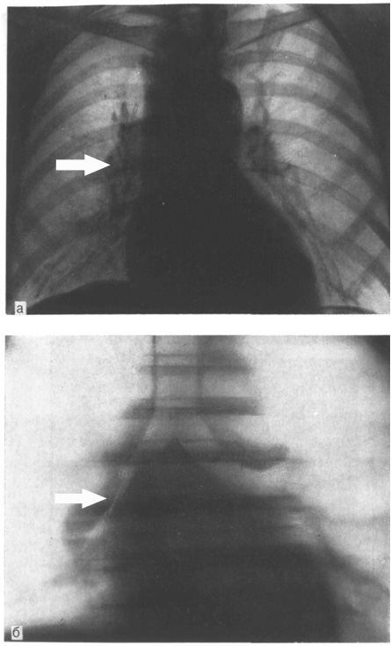 B 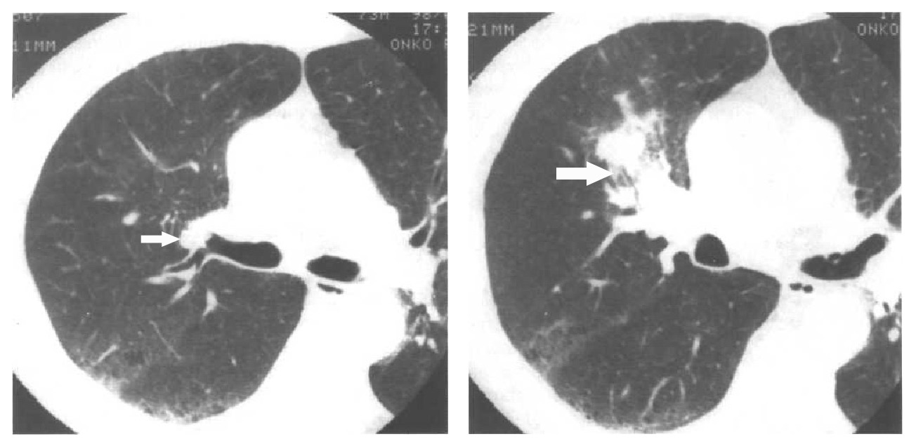

Fig. 14-23. Radiological and CT pictures of central endobronchial carcinoma (affecting right intermediate bronchus)

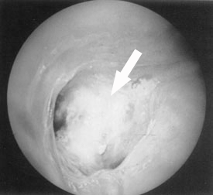

Fig. 14-24. Endobronchial picture of endobronchial carcinoma of lobar brochus

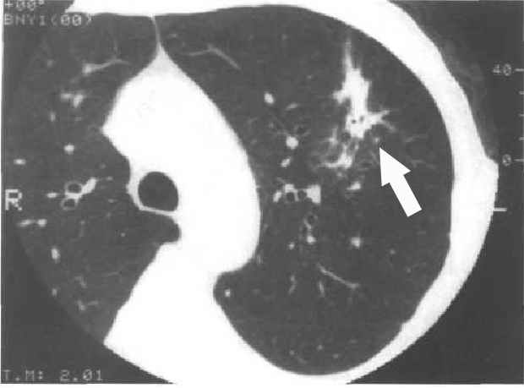

Fig. 14-25. CT picture of peripheral carcinoma (affecting left upper lobe)

A 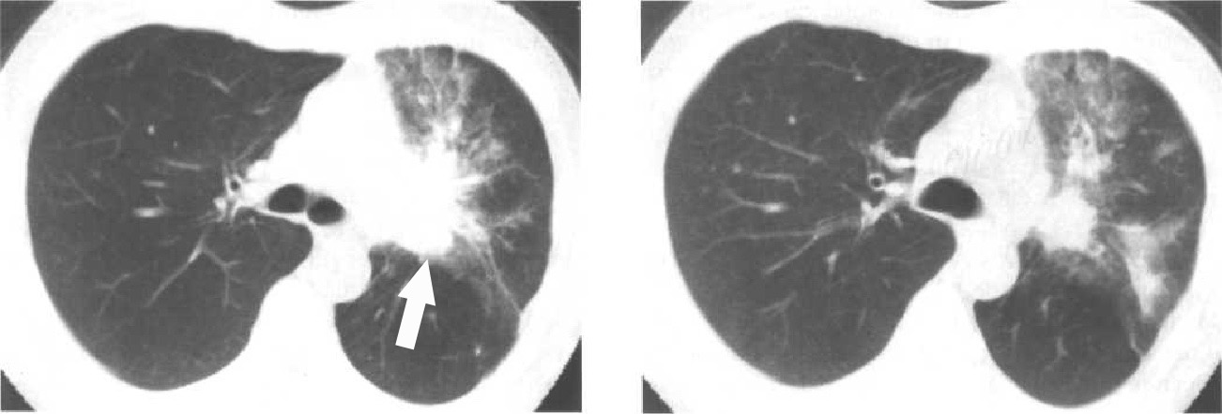 B 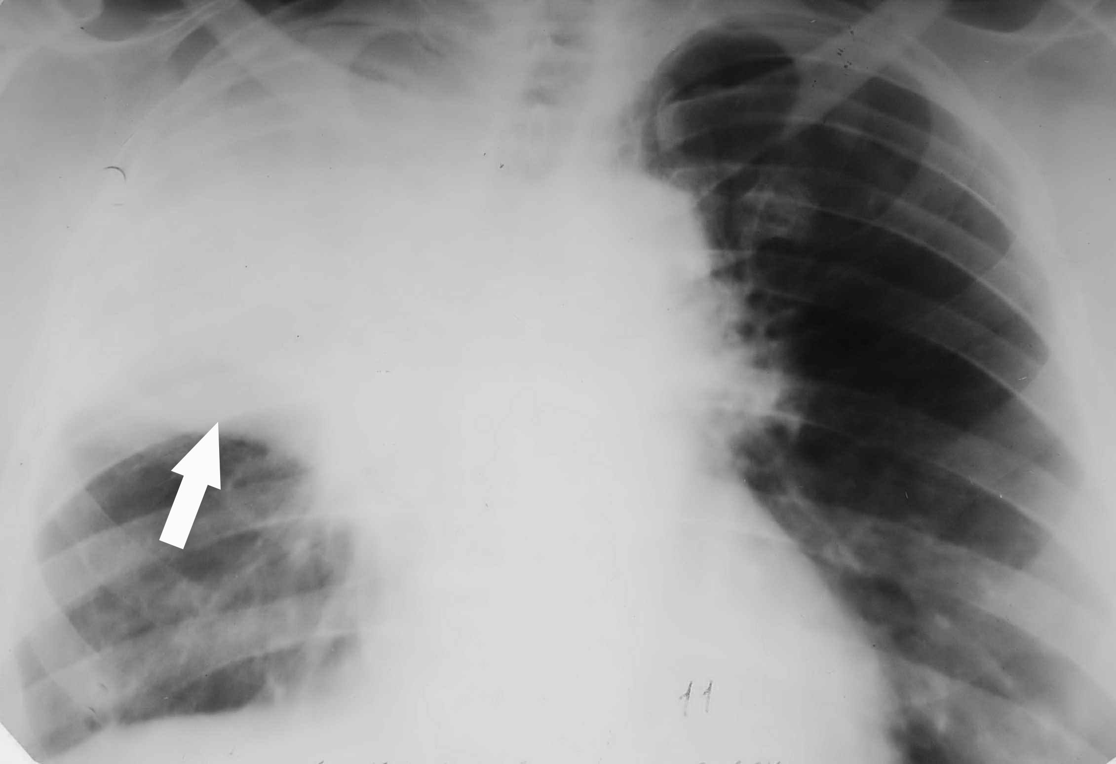

Fig. 14-26. CT and radiological pictures of left-sided (A) and right-sided (B) central extrabronchial carcinoma (affecting upper lobar bronchi, producing atelectasis of parenchyma of upper lobes)

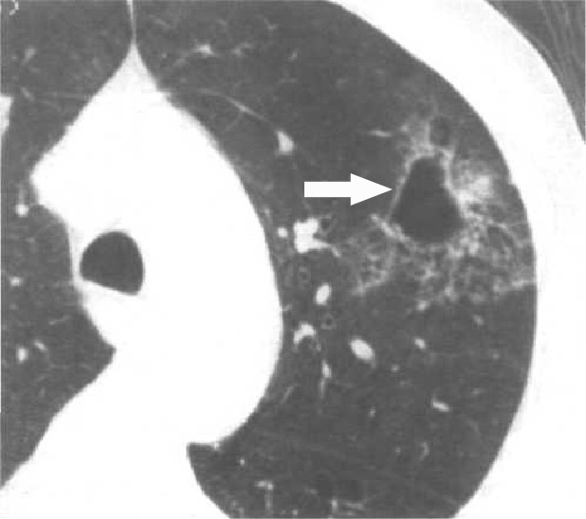

Fig. 14-27. CT picture of peripheral carcinoma (affecting left upper lobe, presented as a cavity)

Treatment

Scheme 14-1. Algorithm of management of lung cancer

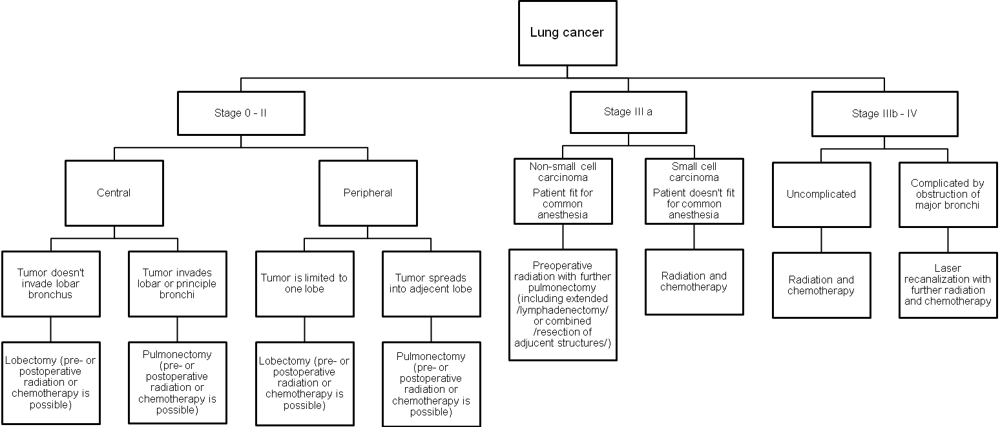
- One-half of all patients with lung carcinomas are not candidates for thoracotomy at the time of diagnosis. Thus, diagnostic thoracotomy is not indicated if these conditions are present: extensive ipsilateral mediastinal lymph node involvement (N2 disease), particularly high paratracheal and subcarinal; any contralateral mediastinal lymph node involvement (N3 disease); distant metastases; malignant pleural effusion; superior vena cava syndrome; recurrent laryngeal nerve involvement; phrenic nerve paralysis; poor pulmonary function (relative contraindication).
- Radiotherapy is particularly helpful in patients with Pancoast's tumors. It has been helpful in the treatment of other tumors, but it is generally indicated as preoperative course and in postoperative treatment of patients with positive mediastinal metastasis.
- Chemotherapy with multiple agents has shown some success in controlling small cell carcinoma, particularly when combined with radiation therapy. Preoperative chemotherapy (with or without radiation therapy) in patients with stage IIIA (N2) disease has recently been used in an attempt to convert advanced local disease into a resectable lesion.
- Prognosis depends primarily on cell types and stage of disease at the time of diagnosis.
- Five-year survival based on cell type: bronchoalveolar carcinoma - 30%-35%, squamous cell carcinoma - 8%-16%, adenocarcinoma - 5%-10%, small cell carcinoma - < 3%.
- Five-year survival based on postoperative pathologic stage: stage I - 60%-80%, stage II - 40%-55%, stage IIIA - 10%-35% (see also Scheme 14-2).

Scheme 14-2. Survival of patients operated for lung cancer

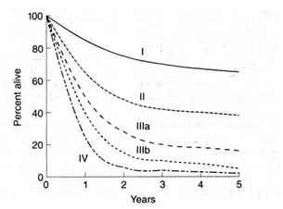

Bronchial adenomas

- The term adenoma is an unfortunate misnomer since these lesions are all malignant neoplasms, although relatively low grade in character. They arise from the epithelium, ducts, and glands of the tracheobronchial tree and include the carcinoid tumor, adenoid cystic carcinoma (cylindroma), and mucoepidermoid carcinoma.

Carcinoid tumors

Overview

- Carcinoid tumors, which comprise 80% - 90% of bronchial adenomas, occur mainly in the proximal bronchi (20% main stem bronchi, 60% lobar or segmental bronchi, 20% peripheral parenchyma).
- Carcinoid tumors arise from basal bronchial stem cells, which, in the process of malignant transformation, differentiate in the direction of Kulchitsky-type cells and are seen most commonly in the fifth decade of life.
- They are slow-growing and protrude endobronchially, often causing some degree of bronchial obstruction.
- Regional lymph node metastases occur in 10% of patients, mostly those with the atypical variant of carcinoid tumors. Of these patients, 70% present with metastases.

Clinical features and visualization data

- Signs and symptoms include cough (47%), recurrent infection (45%), hemoptysis (39%), pain (19%), and wheezing (17%).
- Approximately 21 % are asymptomatic.
- Chest radiograph may reveal evidence of atelectasis or pulmonary nodule (see above).

Treatment

- Treatment for carcinoid tumor is surgical excision.
- Lobectomy is the most commonly performed procedure.
- Wedge excision or segmentectomy can occasionally be used for peripheral typical carcinoids.
- Pneumonectomy should rarely be required, especially since the introduction of bronchoplastic techniques, which allow sleeve resection of lesions involving the main stem bronchi or bronchus intermedius.
- Prognosis should be more than 90% 5-year survival for typical carcinoid tumors, decreasing to less than 50% for the atypical variant.

Adenoid cystic carcinoma

- Adenoid cystic carcinoma (cylindroma) comprises approximately 10% of bronchial adenomas.
- They occur more centrally in the lower trachea/carina area and in the orifices of the main stem bronchi.
- Although considered a low-grade malignancy, the adenoid cystic carcinoma is more aggressive than is the carcinoid tumor. Metastases tend to occur late, but about one-third of patients present with metastasis commonly along perineural lymphatics to regional lymph nodes, but also distantly to liver, bone, and kidneys.
- Treatment is by generous en bloc excision of the tumor, including peribronchial tissue and regional lymph nodes. This may require lobectomy, sleeve resection, or both. Radiation therapy should be considered in all inoperable patients, and in those in whom residual tumor remains after resection.
- Prognosis is less favorable than in carcinoid tumor, 5-year survival being approximately 50%.

Mucoepidermoid carcinoma

- Mucoepidermoid carcinoma accounts for less than 1% of bronchial adenomas.
- Location and distribution in the tracheobronchial tree similar to carcinoid tumors.
- High-grade and low-grade variants exist, although the latter type predominates.
- Treatment principles as outlined for carcinoid tumors apply to low-grade mucoepidermoid carcinoma. High-grade variants should be approached and managed like other bronchial carcinomas.

Hamartomas

- These pulmonary tumors are benign and histologically are classified as adenochondromas.
- They occur within the substance of the lung and usually present as solitary pulmonary nodules.
- Treatment involves enucleation during a diagnostic thoracotomy or videothoracoscopy for evaluation of the solitary nodule.

Metastatic tumors

- Metastatic tumors (see Fig. 14-) are common to the lung, which may be the only site of metastases from a non-pulmonary primary tumor.
- Single or multiple metastatic tumors can be removed from the lung as part of the treatment protocol.
- The best treatment results are obtained with tumors for which there is effective chemotherapy. This combination approach has been used frequently in patients with pulmonary metastases from osteogenic sarcoma and in some patients with metastases from colon carcinoma.

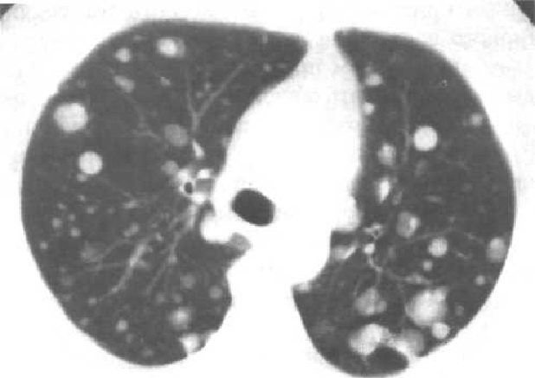

Fig. 14-28. CT picture of multiple pulmonary metastases

Neoplasms of the trachea

Overview

- Primary neoplasms are rare.
- Squamous cell carcinomas are the most common neoplasms of the trachea. They may be exophytic, may cause superficial ulceration, or may be multiple lesions with interposed areas of normal trachea. The tumor spreads through the regional lymph nodes and by direct extension to mediastinal structures.
- Adenoid carcinoma is slow-growing with a prolonged course. It infiltrates airways beyond the gross tumor, and it spreads paratracheally.
- Other primary tracheal neoplasms include carcinosarcomas, pseudosarcomas, mucoepidermoid carcinomas, squamous papillomas, chondromas, and chondrosarcomas.
- Secondary tumors to the trachea are usually from the lung, the esophagus, or the thyroid gland.

Clinical features and visualization data

- Main symptoms of tumors of trachea are cough and wheezing.
- Radiographic studies include chest radiograph, tracheal tomogram, CT scan and fluoroscopy for evaluation of the larynx that show tumor mass.
- Bronchoscopy is deferred until the final operation because the biopsy may be hazardous due to bleeding or obstruction of the airway.
- Pulmonary function testing is mandatory if carinal or pulmonary resection is contemplated.

Treatment

- Treatment is by tracheal resection.
- High-frequency ventilation may be helpful, and it may be possible to pass a small tube beside the tumor.
- In the resection procedure, up to one-half of the trachea may be removed. Adequate mobilization can usually be obtained by simply flexing the patient's neck, although laryngeal or hilar release techniques are occasionally necessary. An end-to-end anastomosis is performed.
- A cervical incision is used for resection of the upper half of the trachea. A posterolateral thoracotomy is used for the lower portion of the trachea. The entire trachea can be exposed via a combined cervical incision and medial sternotomy.
- Prognosis is similar to that for resectable carcinoma of the lung.

MEDIASTINITIS AND PERFORATION OF THE ESOPHAGUS

Overview

- The most common causes of mediastinitis are esophageal perforation, spreading of the infection from neck (including odontogenic neck phlegmon), and penetrating trauma.
- Mediastinitis, if not corrected, is almost always fatal.
- Perforations of the esophagus have two basic causes: instrumentation (e.g., esophagoscopy or dilatation), and Boerhaave's syndrome (postemetic rupture of the esophagus).

Clinical features

- Patients give a recent history of instrumentation of the esophagus or severe vomiting. All patients complain of severe chest pain, which usually is most prominent in the area of the rupture.
- Physical examination reveals crepitation in the neck resulting from the mediastinal air.
- Occasionally, a crunching sound can be heard over the heart (Hamman's sign) due to air in the mediastinum behind the heart.
- Septic shock also can occur.

Visualization data

- Chest radiograph and CT scan reveal air in the mediastinum (see Fig. 14-29, A) and, possibly, a widened mediastinum (see Fig. 14-29, B).
- If the perforation is in the lower esophagus, air may be present under the diaphragm within the abdomen.
- If the pleura has been violated, a pneumothorax may be present.
- A contrast medium swallow should be performed if perforation is suspected. This study is better than esophagoscopy for identifying a perforation.

A 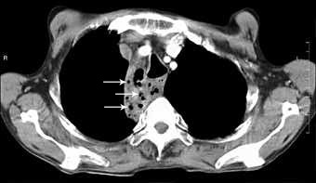 B 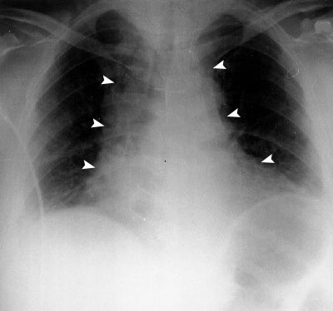

Fig. 14-29. CT (A) and radiological (B) pictures of mediastinitis

Treatment

- Treatment is primarily an attempt to provide wide drainage of the mediastinum and is best approached by a thoracotomy (see Fig. 14-30).
- If diagnosed early (within 6 hours), perforation can be treated with simple drainage, esophageal repair (see Fig. 14-30), and appropriate antibiotic coverage.
- If the diagnosis is delayed, the esophagus is impossible to repair because of the massive inflammation and tissue edema in the area. In this case, drainage and esophageal diversion and gastrostomy (see Fig. 14-31) are performed with the hope that esophageal reconstruction can be performed later.

A 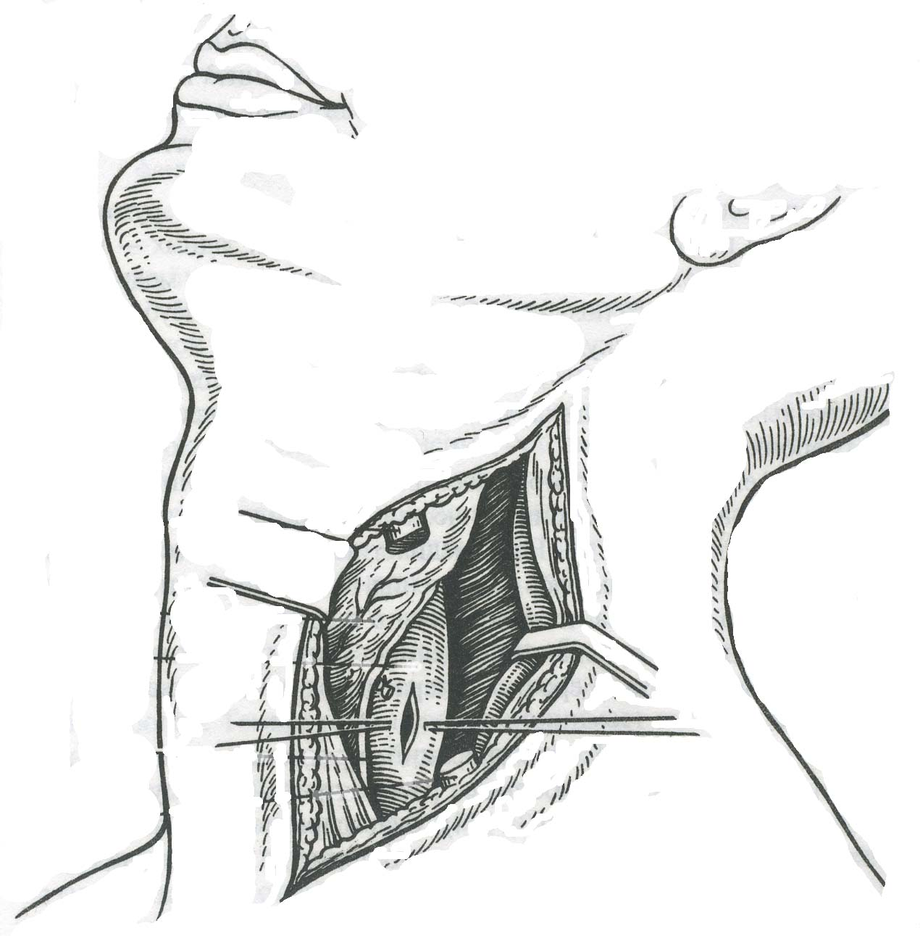 B 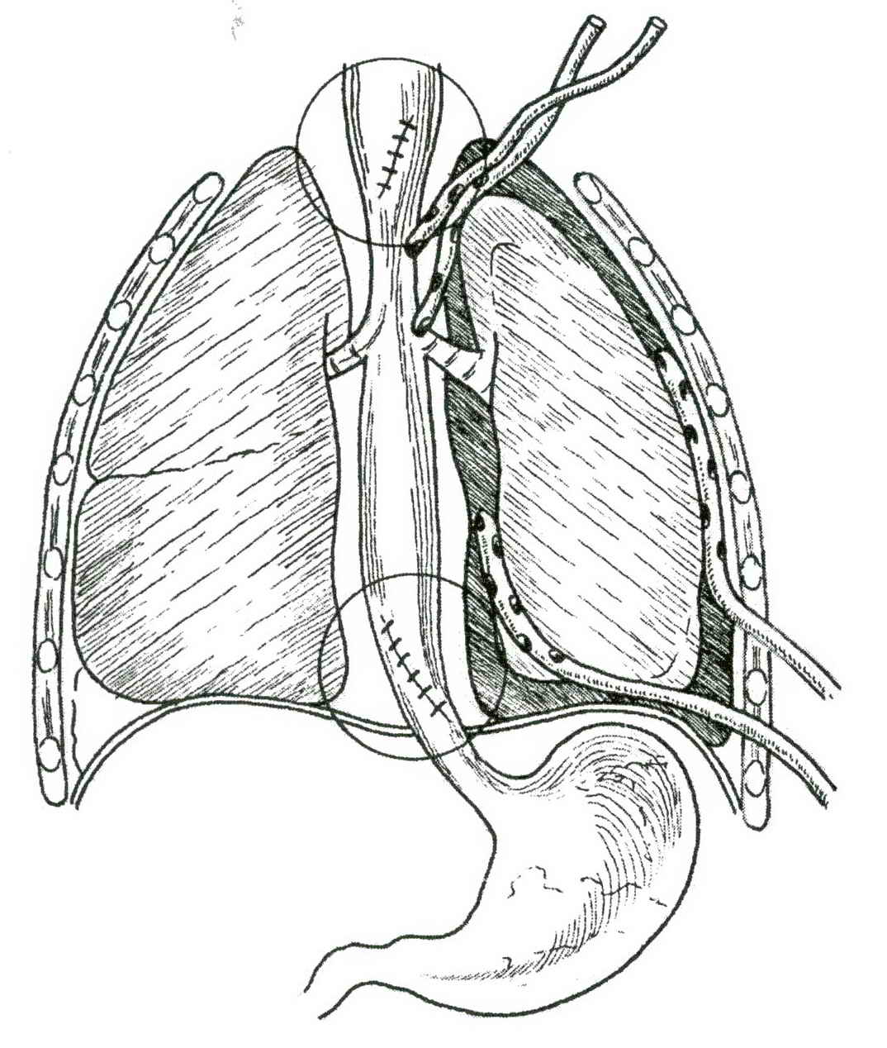 C 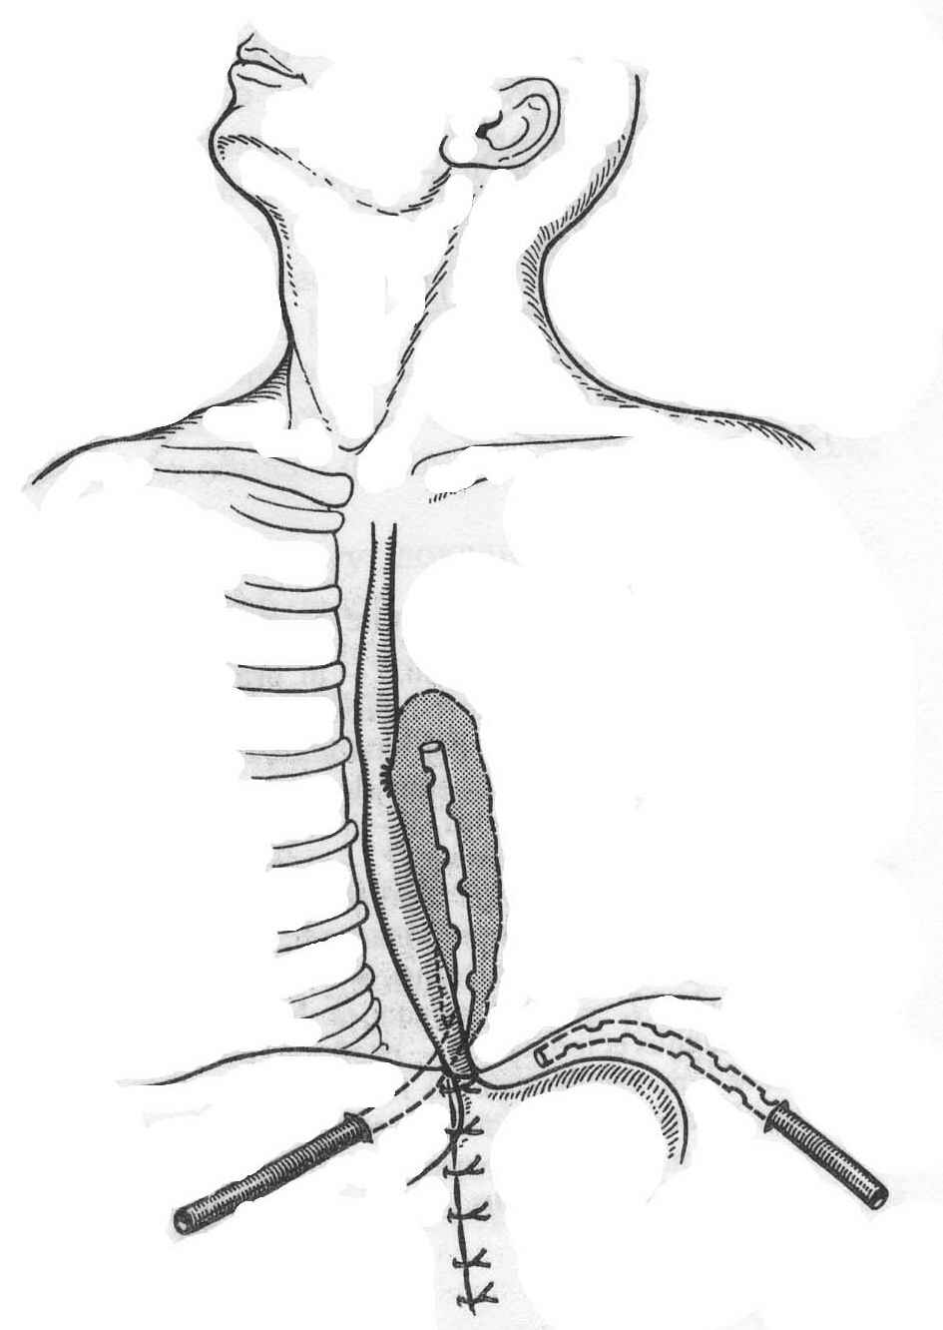

Fig. 14-30. Approaches for drainage of mediastinum for different variants of esophageal perforation

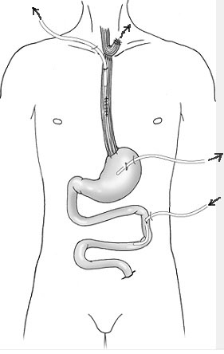

Fig. 14-31. Scheme of esophageal diversion for perforation

TUMORS AND CYSTS OF MEDIASTINUM

Scheme 14-3 Mediastinal regions and tumors that commonly occur within them

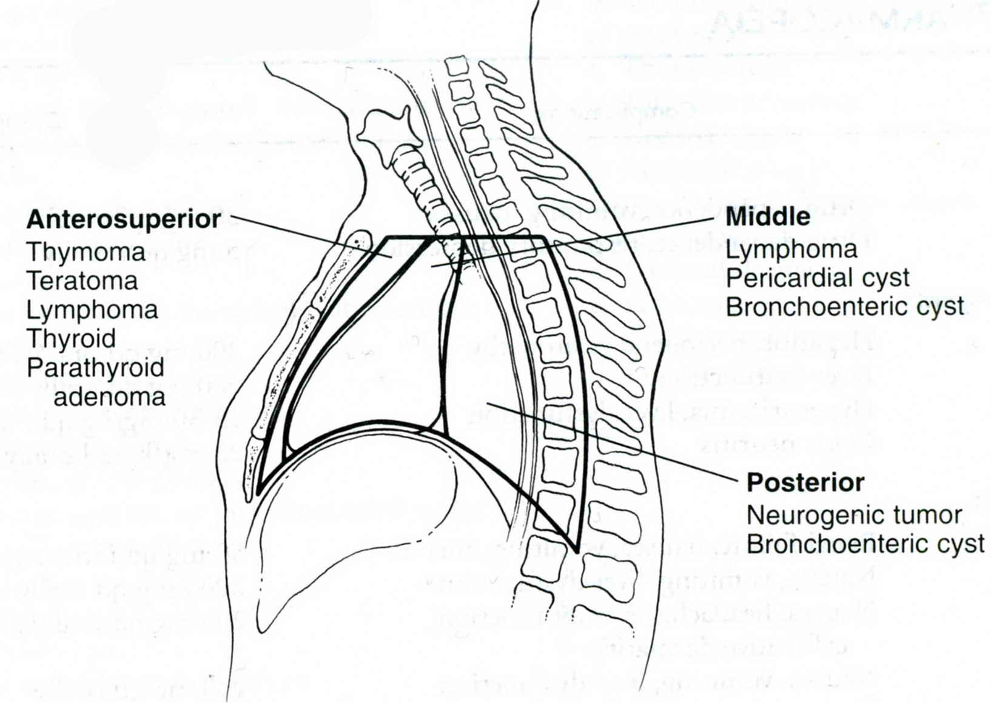
From: Basic surgery/ed., H.C. Polk, Jr., et al. – 5th ed.

Anterior mediastinal lesions

Thymomas

- This is the most common mediastinal tumor accounting for 25% of the total.
- These are tumors of the thymic epithelial cells of Hassall's corpuscles and are sited in the anterior and superior compartments.
- They generally occur after childhood and present as lobulated, occasionally calcified, masses in the anterior mediastinum.
- They may appear encapsulated (see Fig. 14-32) and are often associated with the autoimmune disease myasthenia gravis. The tumors vary in their behaviour from completely benign to aggressively invasive. The only reliable indicator of malignancy is capsular invasion.
- Diagnosis and treatment are best achieved by complete thymectomy, but radiotherapy may be the only treatment option if the lesion is advanced.
- Eighty per cent of thymomas are benign and the prognosis is good. There is, however, a small risk of recurrence. A rarer type of thymoma has similar histological appearance to the benign thymoma, but it has capsular invasion and is occasionally aggressive with widespread metastases. Rarer still is the thymic carcinoma. This is not associated with myasthenia and resembles a small-cell carcinoma or an undifferentiated large cell tumor. The prognosis is generally poor in spite of combination treatment of excision, radiotherapy and cytotoxic therapy.

A 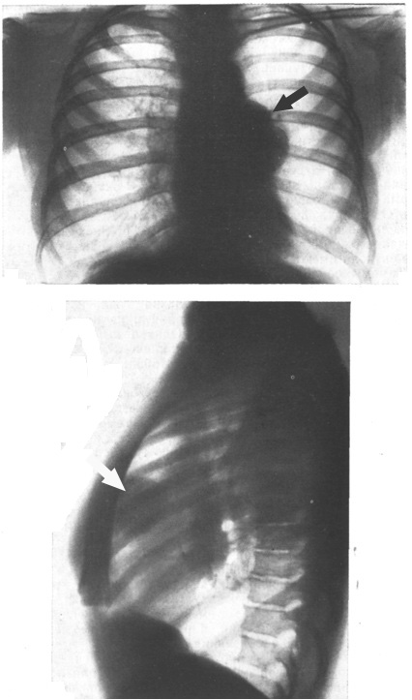 B 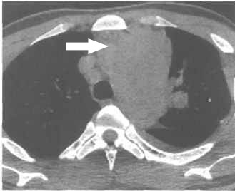

Fig. 14-32. Radiological (A) and CT (B) pictures of thymoma

Retrosternal goiter – see Chapter 21

Teratomas

- Teratomas occur most frequently in adolescents, and 80% of these tumors are benign.
- They originate from the branchial cleft pouch in association with the thymus gland. All tissue types are present in these tumors, including ectodermal, endodermal, and mesodermal elements.
- Teratomas are diagnosed radiographically and may appear as smooth-walled cystic lesions or as tabulated solid lesions (see Fig. 14-33). Calcification is often present.
- Treatment is total surgical excision.

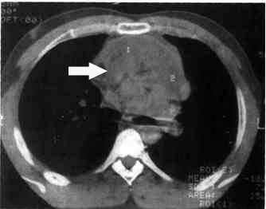

Fig. 14-33. CT picture of teratoma

Lymphomas

- Fifty per cent of patients with lymphomas (including those with Hodgkin's disease) have mediastinal lymph node involvement; however, only 5% of patients with lymphomas have only mediastinal disease.
- Symptoms of mediastinal lymphoma include cough, chest pain, fever, and weight loss.
- Diagnosis is by chest radiograph or CT (see Fig. 14-34) and lymph node biopsy, using either mediastinoscopy or anterior mediastinotomy.
- Treatment is non-surgical.

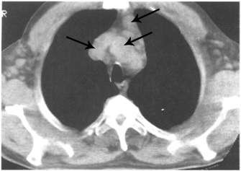

Fig. 14-34. CT picture of mediastinal lymphoma

Retrosternal (abdomino-mediastinal) lypoma

- This tumor is the most common lesion of lower anterior mediastinum.
- The main clinical presentation is retrosternal pain.
- Diagnosis is made by chest radiograph or CT (see Fig. 14-35).
- Treatment is surgical excision, most commonly via lower median sternotomy.

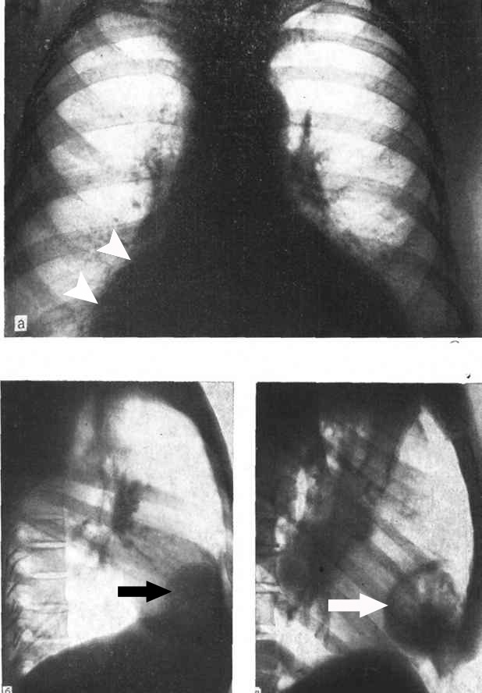

Fig. 14-35. Radiological pictures of retrosternal lypoma

Germ cell tumors

- These tumors are very rare, occurring as less than 1 % of all mediastinal tumors. They metastasize to pleural lymph nodes, the liver, bone, and retroperitoneum.
- Histologic types include seminoma, embryonal cell carcinoma, teratocarcinoma, choriocarcinoma, and endodermal sinus tumor.
- Symptoms include chest pain, cough, and hoarseness due to invasion of the vagus
nerves.
- They are diagnosed radiographically or by CT scan.
- Treatment is by as complete surgical excision as possible.
- Adjuvant therapy: seminomas are very radiosensitive, and the other cell types may benefit from chemotherapeutic agents.

Middle mediastinal lesions

- Middle mediastinal lesions are usually cystic in nature. The two most common are pericardial cysts and bronchogenic cysts.
- Pericardial cysts are usually asymptomatic and are found on chest radiograph. They are smooth-walled and most commonly occur in the cardiodiaphragmatic angle. Surgery is usually performed as a diagnostic procedure to identify the lesion.
- Bronchogenic cysts generally arise posteriorly to the carina (see Fig. 14-36). They may be asymptomatic, or they may cause pulmonary compression, which can be life-threatening, particularly in infancy. The usual treatment is surgical excision.
- Ascending aortic aneurysms are also included as middle mediastinal masses due to the location of the great vessels in this compartment.

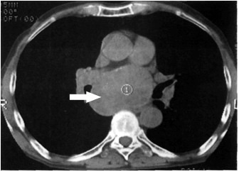

Fig. 14-36. CT picture of bronchogenic cysts

Posterior mediastinal lesions

Overview

- Posterior mediastinal lesions are neurogenic tumors located in the paravertebral gutter. About 10% - 20% are malignant.
- Seventy-five percent of these neurogenic tumors occur in children under 4 years of age. Malignancy is most likely to occur if the tumor arises in childhood.
- Histologic types include neurilemomas (which arise from the Schwann cells of the nerve sheath), neurofibromas (which can degenerate into neurosarcomas), neurosarcomas, ganglioneuromas (which originate from sympathetic ganglia), neuroblastomas (which also arise from the sympathetic chain; they may metastasize to bone, liver, and regional lymph nodes by the time diagnosis is made; also, direct extension to the spinal cord may occur).

Clinical features and visualization data

- Symptoms include chest pain secondary to compression of an intercostal nerve.
- If the tumor grows intraspinally, it may cause symptoms of spinal cord compression.
- Rarely, these tumors have an endocrine function and can secrete catecholamines.
- The symptoms of neuroblastoma include fever, vomiting, diarrhea, and cough.
- Diagnosis is by chest radiograph and CT scan (see Fig. 14-37).

A 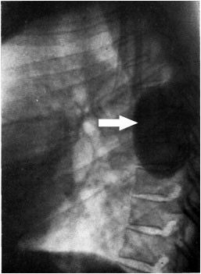 B 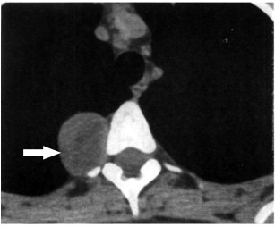

Fig. 14-36. Radiological (A) and CT (B) pictures of neurogenic mediastinal tumor

Treatment

- Treatment is by surgical excision.
- Postoperative radiation is helpful in the treatment of malignant tumors.

REVIEW TESTS

1. The most important test used in the evaluation of hemoptysis is:

- Chest CT scan
- Bronchoscopy
- Arterial blood gas
- Angiography of pulmonary arteries
- Chest radiograph

2. A 49-years-old homeless, debilitated, alcoholic man was admitted to thoracic surgery department producing foul-smelling sputum with high temperature. Auscultation reveals coarse moist rales at the right lower chest. White blood cell count is elevated. A chest radiograph demonstrates a cavitary right lower lobe lesion. Give your presumable diagnosis:

- Lung abscess
- Tuberculosis
- Lung cancer
- Fungal pneumonia
- Lobar emphysema

3. A 60-years-old man with alcoholism was admitted to thoracic surgery department with complaints of high fever and cough productive of purulent sputum. Auscultation reveals coarse moist rales at the right upper chest. Chest radiograph reveals a cavity measuring 3 cm with air-fluid level in the upper lobe of the right lung. What’s the most appropriate tactics of managing the patient?

- Thoracotomy and upper lobectomy
- Transthoracic drainage of the abscess
- Microtracheostomy and conservative treatment with antibiotics
- Thoracentesis
- Thoracoscopy

4. Which procedure is not indicated for management of empyema?

- Thoracentesis
- Chest tube drainage
- Decortication of lung
- Mediastinotomy

5. The most common cause of a coin lesion is:

- Bronchogenic carcinoma
- Tuberculosis
- Hamartoma
- Metastatic cancer

6. A routine chest radiograph for a 55-years-old man with a 2 pack-day smoking history shows a peripherally located 1.5-cm, non-calcified lesion of the upper lobe of the left lung. No evidence of this lesion appeared on a chest radiograph 5 years earlier. What’s the most valuable method of further investigation?

- Observation with serial chest radiographs
- Chest CT scan
- Bronchoscopy
- Thoracotomy, biopsy
- Sputum cytology

7. A 32-years-old man was referred to thoracic surgeon with a 1.0-cm lesion of the right upper lobe of the lung revealed on chest radiograph. The lesion appears calcified. Previous chest radiograph taken 1 year prior demonstrates the lesion to be present at the same size. What’s the most appropriate tactics of managing the patient?

- CT scan guided biopsy
- Radiation therapy
- Surgical excision
- 2-week course of antibiotics
- Observation with repeat chest radiographs

8. A 57-years-old man with a 1 pack-day smoking history was referred to thoracic surgeon with a 1.5 cm solitary mass in the right upper lobe. CT scan demonstrates no evidence of lymph node involvement. The patient has no concomitant diseases. What’s the most appropriate tactics of managing the patient?

- Radiation therapy
- Open lung biopsy
- Pulmonectomy
- Right upper lobectomy
- Repeat chest x-ray in 6 months

9. A 40-years-old man undergoes a right upper lobectomy and lymphadenectomy for a 3.5-cm squamous cell cancer of the lung. Final pathology reports reveal positive hilar and mediastinal lymph nodes. The stage of this patient's cancer is IlIa. What’s the most appropriate tactics of managing the patient?

- Close observation
- Chemotherapy
- Radiation therapy
- Combination of chemotherapy and radiation therapy
- Immunotherapy

10. Match the appropriate lesion with each clinical description:

- Adenocarcinoma
- Bronchoalveolar carcinoma
- Squamous cell carcinoma
- Small cell carcinoma
- Undifferentiated large cell carcinoma

- Slow-growing, centrally located tumor
- Highly malignant with early metastasis
- Currently, the most common form of lung cancer
- May present as a solitary nodule, multiple nodules or as a pneumonia
- Large cells with no apparent differentiation

11. Lung cancer is generally considered unresectable in the presence of:

- Malignant pleural effusion
- Hilar nodal involvement
- Obstruction of a lobar bronchus
- Visceral pleural involvement

12. A 45-years-old previously healthy man was admitted to ER 2 hours after sudden appearance of severe chest pain with repeated episodes of vomiting. A chest radiograph demonstrates a left pleural effusion. Emergent barium swallow reveals extravasation of contrast into the left chest. What’s the most appropriate tactics of managing the patient?

- Case monitoring
- Emergent surgical intervention – thoracotomy
- Chest tube drainage
- Conservative treatment with broad-spectrum antibiotics
- Videoendoscopic drainage of mediastinum

13. The most proper treatment of the majority of mediastinal tumors is:

- Surgery
- Chemotherapy
- Radiation therapy
- Combined chemo-radiation therapy
- Surgery followed by chemotherapy

14. The most common mass of the middle mediastinum is:

- Thymoma
- Neurolemmoma
- Intrathoracic goiter
- Pericardial cyst
- Retrosternal lypoma

15. A 22-years-old woman was referred to thoracic surgeon for evaluation of a 2 cm posterior mediastinal mass discovered on routine chest radiograph. Give your presumable diagnosis:

- Bronchogenic cyst
- Lymphoma
- Neurogenic tumor
- Thymoma
- Lung adenocarcinoma

Correct answers: 1 - B, 2 - A, 3 - C, 4 - C, 5 - A, 6 - D, 7 - E, 8 - D, 9 - C, 10: 1-C, 2-D, 3-A, 4-B, 5-E; 11- A, 12 – B, 13 – A, 14 – D, 15 – C.

