CHAPTER 15. HEART MURMURS AND PAIN

ACQUIRED HEART DISEASES

General considerations

Overview

- Approximately 3 million myocardial infarctions are recorded annually in the United States, with an accompanying mortality rate of 10% - 15%.
- Acquired valvular disease is less frequent than coronary artery disease but still accounts for significant morbidity and mortality.

Table 15-1. Classification of the pathophysiologic causes of congestive heart failure

Mechanical abnormalities  Resistance load  Hypertension  Aortic stenosis  Pulmonary stenosis  Flow load (primary and secondary)  Aortic regurgitation  Mitral regurgitation  Left-to-right shunts  Resistance to inflow  Constrictive pericarditis  Cardiac tamponade  Restrictive myocardial disease  Scleroderma  Amyloidosis  Mitral stenosis  Primary myocardial (muscle) failure  Cardiomyopathy  Hereditary  Alcoholic  Ischemic  Ischemia (coronary heart disease)  Inflammation  Rheumatic myocarditis  Viral myocarditis  Metabolic  Metal poisons  Myxedema | Venous congestive states (high output failure)  Renal failure with fluid retention  Intravenous fluid or blood overload  Chronic severe anemia  Arteriovenous fistula  Cirrhosis  Arrhythmia  Severe prolonged tachycardia  Metabolic failure (exhaustion)  Greatly decreased time for filling  Severe bradycardia  Asystole  Ventricular or atrial fibrillation
From: Basic surgery/ed., H.C. Polk, Jr., et al. – 5th ed. (modified)

Signs and symptoms

- Dyspnea is due to pulmonary congestion, which is the result of increased left atrial pressure.
- Peripheral edema may be the result of significant right-sided congestive heart failure.
- Chest pain may be caused by angina pectoris, myocardial infarction, pericarditis, aortic dissection, pulmonary infarction, or aortic stenosis.
- Palpitations may indicate a serious cardiac arrhythmia.
- Hemoptysis may be associated with mitral stenosis or pulmonary infarction.
- Syncope may result from mitral stenosis, aortic stenosis, or heart block.
- Fatigue is the result of decreased cardiac output.

Classification of patients with diseases of the heart (New York Heart Association, NYHA)

I - Patients with cardiac disease but without resulting limitation of physical activity. In these patients, ordinary physical activity does not cause undue fatigue.
II - Patients with cardiac disease resulting in a slight limitation of physical activity. These patients are comfortable at rest. Ordinary physical activity results in fatigue, palpitation, dyspnea, or anginal pain.
III - Patients with cardiac disease resulting in limitation of physical activity. These patients are comfortable at rest. Less than ordinary activity causes fatigue, palpitation, dyspnea, or anginal pain.
IV - Patients with cardiac disease resulting in an inability to undertake any physical activity without discomfort. Symptoms of cardiac insufficiency or of the anginal syndrome occur even at rest. If any physical activity is undertaken, discomfort increases.

Physical examination

- Blood pressure should be measured in both arms and legs.
- Peripheral pulses. Pulsus alternans is a sign of left ventricular failure. Pulsus parvus et tardus may be seen with aortic stenosis. A wide pulse pressure with a "water-hammer pulse" is seen with increased cardiac output or decreased peripheral vascular resistance, as in aortic insufficiency or patent ductus arteriosus.
- Neck veins. Central venous pressure may be indirectly inferred from the height of the internal jugular vein filling.
- Inspection and palpation of the precordium. Normally, the apical impulse is appreciated at the midclavicular line, fifth intercostal space. In left ventricular hypertrophy, the apical impulse is increased and displaced laterally. With right ventricular hypertrophy, a parasternal heave is appreciated. Thrills from valvular disease may be felt.
- Auscultation. The quality of heart tones, type of rhythm, murmurs, rales, and gallops are all important.

Preoperative management

- Laboratory studies should include such specific to cardiac pathology tests as creatine phosphokinase, lactate dehydrogenase, troponins, ect.
- Chest radiograph, electrocardiogram and echocardiogram (see Fig. 15-1) are minimal necessary diagnostic tools. CT scan is also beneficial in terms of assessment of lungs, pulmonary arteries, heart and coronary arteries (CT angiography) (see below).
- Cardiac catheterization (see Fig. 15-2) is the definitive preoperative study to measure a pressure in heart chambers and to perform coronary angiography
- Pulmonary function studies are important in patients with known pulmonary disease.
- Psychological preparation of the patient is an important aspect and should include familiarizing the patient with the postoperative procedures in the ICU.
- Perioperative antibiotics play an important role in the prevention of sepsis.

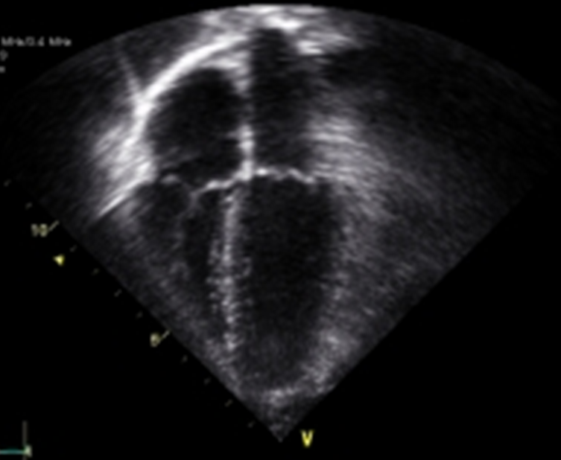

Fig. 15-1. Picture of 2D-echcardiography

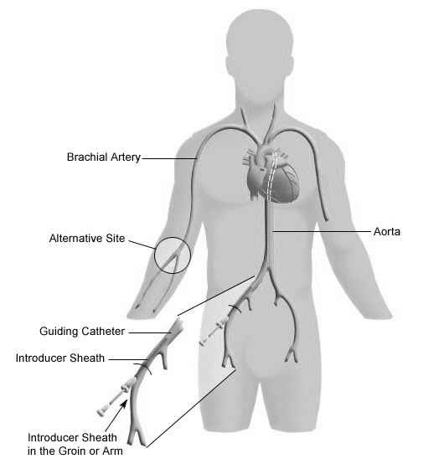

Fig. 15-1. Scheme of cardiac catheterization

Cardiac arrest

- Causes of cardiac arrest include: anoxia, coronary thrombosis, electrolyte disturbances, myocardial depressants (anesthetic agents, antiarrhythmic drugs, or digitalis), conduction disturbances, vagotonic maneuvers.
- Immediate cardiopulmonary resuscitation is critical, as brain injury results after 2-4 minutes of diminished perfusion.
- Treatment should be according to “ABCDE” algorithm.
- Establishing an airway (“A”-step, for airways) and giving ventilatory support (“B”-step, for breath). These are best accomplished by endotracheal intubation and controlled ventilation.
- Cardiac massage (“C”-step, for cardiac). Closed-chest cardiac massage is usually appropriate. In the patient with cardiac tamponade, acute volume loss, an unstable sternum, or an open pericardium, open-chest massage usually is required.
- Drug therapy (“D”-step, for drugs). Commonly used agents include: epinephrine (for its cardiotonic effect), calcium (also for its cardiotonic effect), sodium bicarbonate (to treat associated acidosis), vasopressor agents (to support blood pressure), atropine (to reverse bradycardia). Replacement of blood volume should be performed, if necessary.
- Electrical defibrillation (“E”-step, for electrical), if cardiac arrest is the result of ventricular fibrillation.

Extracorporeal circulation

- The rationale for using extracorporeal circulation is to provide the operating team with a motionless heart and a bloodless field in which to work while simultaneously perfusing the different organ systems with oxygenated blood.
- Blood is drained from the right atrium, passed through an oxygenator and a heat exchanger, and pumped back to the aorta.
- Protection of the myocardium during the ischemia induced by the procedure is accomplished by hypothermia and cardioplegia.
- Pathophysiologic effects of extracorporeal circulation include: widespread total body inflammatory response with initiation of humoral amplification systems (coagulation cascade, fibrinolytic system, complement activation, kallikrein-kinin system); release of vasoactive substances (epinephrine, norepinephrine, histamine, bradykinin); retention of both sodium and free water, causing diffuse edema; trauma to blood elements, resulting in hemolysis of red cells and destruction of platelets; respiratory insufficiency, which is usually self-limited.

Prosthetic valves

- The three general categories are tissue valves, mechanical valves, and human allograft valves (see Fig. 15-3).
- Tissue valves consist primarily of porcine heterografts. These valves usually do not require long-term anticoagulation postoperatively; however, they lack long-term durability, with a 10% - 30% failure rate at 10 years.
- Mechanical valves are durable for long periods of time, but they require permanent anticoagulation therapy.
- Human allograft (cryo-preserved) valves do not require anticoagulation and, at the present time, have demonstrated long-term durability. Wider use of this valve is anticipated, especially in the aortic position.

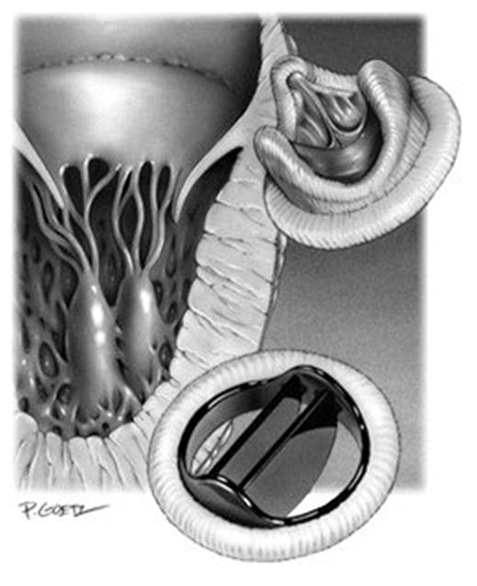
Fig. 15-3. Artificial heart valves

Aortic stenosis

Overview

- Congenital bicuspid aortic valves occur in 1% - 2% of the population. They usually develop calcific changes by the fourth decade and symptoms by the sixth decade.
- Acquired stenosis results from progressive degeneration and calcification of the valve leaflets.
- Patients with a history of rheumatic fever rarely have isolated aortic stenosis but usually have a mixed lesion of stenosis and insufficiency.
- Thickening and calcification of the leaflets result in a decreased cross-sectional area of the valve. Symptoms usually begin when the valve area is less than 1.0 cm² (the normal aortic valve is 2.5 - 3.5 cm²). Critical aortic stenosis imposes a significant pressure load on the left ventricle, which increases left ventricular work, resulting in concentric left ventricular hypertrophy (without associated dilation). Eventually, myocardial decompensation occurs.

Clinical features

- Classic symptoms are angina, syncope, and dyspnea.
- Symptoms usually occur late in the course of the disease and represent myocardial decompensation. Sudden death is a frequent occurrence in untreated patients at this stage.
- Life expectancy averages 4 years after the onset of symptoms.
- The classic systolic crescendo-decrescendo murmur is heard best in the second right intercostal space. Radiation of the murmur to the carotid arteries is common. An associated thrill is often appreciated.
- A narrowed pulse pressure along with pulsus parvus et tardus is frequently found.

Visualization data

- Chest x-ray usually shows a heart of normal size. Calcification of the aortic vail may be seen.
- Electrocardiogram demonstrates left ventricular hypertrophy.
- Echocardiography estimates the degree of stenosis, any associated insufficiency and quality of left ventricular function.
- Cardiac catheterization (see Fig. 15-2) is important to measure the pressure gradient across the aortic valve, to calculate its cross-sectional area, and to identify any associated mitral valve or coronary artery disease, which occurs in 25% of the patients.

Treatment

- Surgical correction is recommended for patients with symptoms of syncope, angina, or dyspnea or with a peak systolic gradient across the aortic valve greater than 50 mmHg or with a valve area less than 0.7 cm².
- Surgery consists of excision of the diseased valve and replacement with one of the prosthetic valves (see Fig. 15-4).

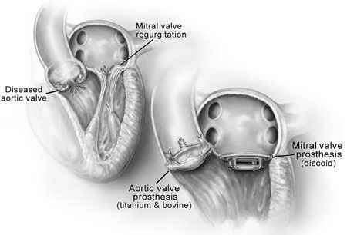

Fig. 15-4. Scheme of replacement of heart valve

Aortic insufficiency

Overview

- Myxomatous degeneration, aortic dissection, Marfan's syndrome, bacterial endocarditis, rheumatic fever, and annuloaortic ectasia are common causes.
- The underlying pathologic process may be a fibrosis and shortening of the valve leaflets (as occurs in rheumatic fever), a dilatation of the aortic annulus (as occurs in Marfan's syndrome), or myxomatous degeneration of the leaflets.
- Aortic insufficiency imposes a significant volume load on the left ventricle in accordance with Starling's law of the heart. This extra load leads to early left ventricular dilatation. If uncorrected, this dilatation may lead to left ventricular failure with pulmonary congestion. Secondary mitral insufficiency may occur at this stage.

Clinical features

- There is a greater variability in time between the onset of aortic insufficiency and the appearance of symptoms than occurs with aortic stenosis.
- Early symptoms include palpitations secondary to ventricular arrhythmias, and dyspnea on exertion.
- Later, severe congestive heart failure is seen. Death results from progressive cardiac failure.
- The characteristic diastolic murmur is heard along the left sternal border. The duration of the murmur during diastole often correlates with the severity of the aortic insufficiency. The murmur radiates to the left axilla.
- The pulse pressure is often widened. Short, intense peripheral pulses ("water-hammer pulses'') are characteristic.

Visualization data

- Chest x-ray shows left ventricular dilatation.
- Echocardiography estimates the degree of insufficiency and quality of left ventricular function.
- Cardiac catheterization with aortography is used to quantitate the degree of aortic insufficiency, estimate the valve cross-sectional area, and determine the presence of associated coronary artery stenosis.

Treatment

- Surgery is recommended whenever ventricular decompensation is demonstrated. Patients at this stage may or may not have significant symptoms.
- Valve replacement with a prosthesis (see Fig. 15-4) is the indicated therapy.

Mitral stenosis

Overview

- Although only 50% of patients report a history of rheumatic fever, this condition is thought to be the cause of mitral stenosis in virtually all cases. Congenital defects causing adult mitral stenosis are very rare.
- The time interval between the episode of rheumatic fever and the manifestation of mitral stenosis averages between 10 and 25 years.
- The underlying pathologic changes are fusion of the commissures and thickening of the leaflets with or without shortening of the chordae tendineae.
- The normal cross-sectional area of the mitral valve is 4-6 cm². In mild mitral stenosis the area is reduced to 2 - 2.5 cm²; in moderate stenosis, to 1.5 - 2 cm²; and in severe stenosis, to 1 - 1.5 cm².
- Pathophysiologic changes induce: increased left atrial pressure, pulmonary hypertension, atrial fibrillation, decreased cardiac output, increased pulmonary vascular resistance.
Clinical features

- Dyspnea is the most significant symptom: it indicates pulmonary congestion secondary to increased left atrial preasure.
- Other manifestations include: paroxysmal nocturnal dyspnea and orthopnea, chronic cough and hemoptysis, pulmonary edema, systemic arterial embolization (see Chapter 16), usually from a left atrial thrombus.
- Long-standing pulmonary hypertension may result in right ventricular failure and secondary tricuspid regurgitation.
- The typical patient is thin and cachectic.
- Auscultation reveals the classic triad of an apical diastolic rumble, opening snap, and loud first heart sound.

Visualization data

- Chest x-ray typically shows a prominent pulmonary vasculature in the upper lung fields. The cardiac silhouette may be normal or may show a double density of the right heart border. A lateral chest x-ray with a barium swallow may detect left atrial enlargement.
- Electrocardiogram may be normal or may show P-wave abnormalities, signs of right ventricular hypertrophy, and right axis deviation.
- Transthoracic and transesophageal echocardiography evaluate valvular and ventricular function.
- Cardiac catheterization is used to calculate the mitral valve cross-sectional area, the mitral valve end-diastole pressure gradient, pulmonary artery pressure, and any associated valvular or coronary artery disease.

Treatment

- Surgery is recommended for all patients with symptomatic mitral stenosis. The choice of operative approach depends on the extent of these changes.
- Closed or open mitral valve commssurotomy (see Fig. 15-5) should be attempted for a patient with simple fusion of the commissures and minimal calcification, although a later prosthetic valve replacement may be necessary.
- Mitral valve replacement (see Fig. 15-4) is required for patients with severe disease of the chordae tendineae and papillary muscles.
- Permanent anticoagulant therapy is especially important for mechanical prosthetic valves in the mitral position because this therapy prevents thromboembolization.

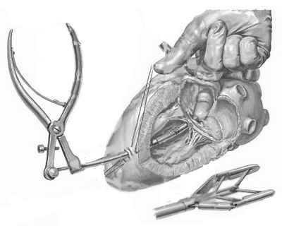

Fig. 15-5. Scheme of closed mitral valve commssurotomy

Mitral insufficiency

Overview

- Mitral insufficiency is usually due to rheumatic fever. Other causes include: myxomatous degeneration, papillary muscle dysfunction or rupture secondary to coronary artery disease, and bacterial endocarditis.
- The pathogenesis in mitral insufficiency secondary to rheumatic fever is similar to that in mitral stenosis. Why insuficiency predominates in some patients and stenosis in others is not understood.
- Pathophysiologic changes include: increased left atrial pressure during systole; late-appearing pulmonary vascilar changes, including increased pulmonary vascular resistance; increased left ventricular stroke volume.

Clinical features

- Many years may elapse between the first evidence of mitral insufficiency and the development of symptoms.
- In general, symptoms occur late in the course of cardiac decompensation, and include dyspnea on exertion, fatigue, and palpitations.
- Physical examination reveals a holosystolic blowing murmur at the apex that radiates to the axilla, accompanied by an accentuated apical impulse. The duration of the murmur in systole correlates with the severity of the disease.
- Atrial fibrillation may be present.

Visualization data

- Chest x-ray demonstrates an enlarged left ventricle and atrium.
- Electrocardiogram shows evidence of left ventricular hypertrophy in 50% of cases.
- Echocardiography estimates the degree of stenosis, any associated insufficiency and quality of left ventricular function.
- Cardiac catheterization is important to determine left ventricular function, the degree of the mitral valve insufficiency, the pulmonary artery pressure, and any associated valvular or coronary artery disease.

Treatment

- Medical treatment with digitalis, diuretics, and vasodilator agents has a significant place in the treatment of stable mitral insufficiency and in preparation for surgery.
- Surgical indications include: progressive congestive heart failure; progressive cardiac enlargement; mitral insufficiency of acute onset, as from ruptured chordae tendineae; disease in more than one valve.
- When possible, mitral valve repair (see Fig. 15-6) and annuloplasty are performed. The valve is replaced if necessary.

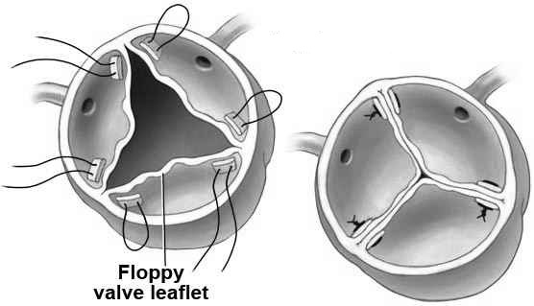

Fig. 15-6. Scheme of valvuloplasty

Tricuspid stenosis and insufficiency

Overview

- Organic tricuspid stenosis is almost always due to rheumatic fever and is most commonly found in association with mitral valve disease. Isolated tricuspid disease is rare.
- Functional tricuspid insufficiency is the result of right ventricular dilatation secondary to pulmonary hypertension and right ventricular failure. Functional insufficiency is more common than organic tricuspid valve disease.
- Tricuspid insufficiency is sometimes seen in the carcinoid syndrome, secondary to blunt trauma or secondary to bacterial endocarditis in drug addicts.
- The pathogenesis in tricuspid stenosis secondary to rheumatic fever is similar to that in mitral valve disease.
- Elevation of right atrial pressure secondary to tricuspid stenosis leads to peripheral edema, jugular venous distention, hepatomegaly, and ascites.

Clinical features

- Moderate isolated tricuspid insufficiency is usually well tolerated.
- When right-sided heart failure occurs, symptoms (edema, hepatomegaly, ascites) develop.
- Tricuspid insufficiency produces a systolic murmur at the lower end of the sternum.
- Tricuspid stenosis produces a diastolic murmur in the same region.
- A prominent jugular venous pulse may be observed.
- The liver may be pulsatile in tricuspid insufficiency.

Visualization data

- Chest x-ray shows enlargement of the right heart, which may also be reflected on the electrocardiogram.
- Echocardiography estimates the amount of tricuspid valve pathology.
- Echocardiography estimates the degree of stenosis or insufficiency and condition of heart chambers.
- Cardiac catheterization is the most accurate guide to diagnosing tricuspid disease. It should include evaluation of any associated aortic or mitral valve lesions.

Treatment

- Isolated tricuspid disease, especially tricuspid insufficiency, may be well tolerated without surgical intervention.
- In mild to moderate tricuspid insufficiency associated with mitral valve disease, opinion varies concerning the need for tricuspid surgery.
- In the case of extensive tricuspid insufficiency associated with mitral valve disease, the consensus is that either tricuspid repair or tricuspid valve replacement is appropriate.
- Tricuspid stenosis, when significant, is remedied by commissurotomy or valve replacement.
- Valve excision alone may be indicated in certain cases of tricuspid insufficiency secondary to endocarditis, especially in intravenous drug abusers.

Pulmonic valve disease

- Acquired lesions of the pulmonic valve are uncommon. The carcinoid syndrome, however, may produce pulmonic stenosis.
- Surgical repair or replacement of the valve is carried out when warranted by the degree of dysfunction.

Multiple valvular disease

- More than one valve may be involved in rheumatic fever, as indicated in the foregoing discussions.
- Abnormal physiologic responses to multivalvular disease may be additive but usually reflect the most severely affected valve.
- Treatment involves repair or replacement of all valves with significant dysfunction.

Table 15-2. Acquired cardiac valvular diseases that cause congestive heart failure: pathophysiologic factors, diagnosis, and treatment

 | Mitral stenosis | Mitral regurgitation | Aortic stenosis | Aortic regurgitation | Tricuspid disease
Cause | Usually rheumatic fever; rarely, congenital factors | Rheumatic fever, myxomatous  degeneration, rupture of chordae tendineae or papillary muscles, myocardiopathy, infective endocarditis | Rheumatic fever, congenital bicuspid valve anomaly, senile degeneration and calcification | Rheumatic fever, infective endocarditis that causes dissecting aneurysm, Marfan's syndrome, annuloaortic ectasia | Usually associated with mitral or aortic disease; exceptions: infective endocarditis, tumor, rheumatic fever in Third World countries, carcinoid syndrome (rare)
History | Congestive heart failure; predominant in women | Thromboemboli, fatigue, congestive  heart failure; patients may be asymptomatic | SOB, DOE, syncope, angina during exertion | Cardiac failure that may occur late, especially if disease develops slowly | Usually minimal, because even complete tricuspid excision is well tolerated
Cardiac examination | Accentuated mitral first sound, loud opening snap, increased P2, low- pitched diastolic murmur with presystolic accentuation; TR in  advanced cases | Left ventricular heave, apical systolic murmur; widely referred  LV enlargement | Diamond-shaped systolic ejection murmur in the right second interspace, radiating to the neck; diminished peripheral pulses, decreased A2 and decreased pulse pressure | Diminished arterial diastolic pressure that increases as disease worsens; blowing systolic murmur at left sternal border | Edema, ascites, elevated venous pressure, peripheral edema, pulsatile liver
ECG | Atrial fibrillation, LAH, RVH | Atrial fibrillation, left atrial  enlargement, LVH | LVH; atrial fibrillation in late stages | LVH | RAH
Chest radiograph | Prominent left atrial appendage and pulmonary artery, calcific deposits on valve, Kerley B lines (lymphatic engorgement in lung periphery)  Increased pulmonary plethora | Prominent left atrium, left ventricular hypertrophy, Kerley B  lines, pulmonary congestion | LVH in long-standing disease, calcified valve on fluoroscopy; - occasional poststenotic dilation | LVH, pulmonary congestion, LV dilation | RAH
Cardiac catheterization | Increased pulmonary artery and wedge pressures, rising with exercise | Increased LAP, high V wave, regurgitation of contrast during  LV angiography | Left ventricular pressure > aortic pressure; increased LVEDP, slow upstroke LV pressure | Increased LVEDP, wedge pressure, regurgitation of contrast on aortography | Increased right atrial pressure with high V wave
From: Basic surgery/ed., H.C. Polk, Jr., et al. – 5th ed.

Scheme 15-1. Algorithm of indications for referral to a cardiosurgeon

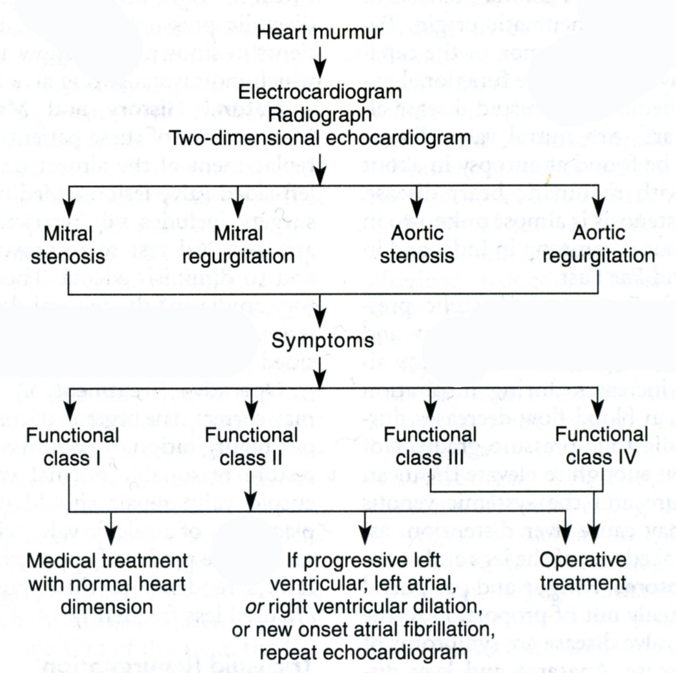

From: Basic surgery/ed., H.C. Polk, Jr., et al. – 5th ed.

Coronary artery disease (ischemic heart disease)

Overview

- Atherosclerosis is the predominant pathogenetic mechanism underlying obstructive disease of the coronary arteries. Uncommon causes of coronary artery disease include vasculitis (occurring with collagen vascular disorders), radiation injury, and trauma.
- Atherosclerotic heart disease represents the most common cause of death in the United States and most other developed nations.
- Coronary artery disease is four times more prevalent in men than in women, although the incidence in women is rapidly increasing.
- Risk factors for coronary artery disease that have been identified by epidemiologiс studies include: hypertension, smoking, hypercholesterolemia, family history of heart disease, diabetes, obesity.
- Pathophysiologic effects of coronary artery disease of the myocardium include: decreased ventricular compliance, decreased cardiac contractility, myocardial necrosis.

Clinical features

- Coronary artery disease may take the form of angina pectoris, myocardial infarction, congestive heart failure, arrhythmias, and sudden death.
- Angina pectoris typically presents as substernal chest pain lasting 5-10 minutes. The pain may be precipitated by emotional stress, exertion, or cold weather, and is relieved by rest and nitrates.
- Angina may be characterized by its patterns of occurrence: stable angina (angina that is unchanged for a prolonged period), unstable angina (angina that shows a recent change from a previously stall pattern, including new-onset angina), angina at rest, variant angina, postinfarction angina, postoperative angina (after coronary artery bypass grafting, CABG).
- The diagnosis of angina pectoris due to coronary artery disease is most often made from the patient's history.

Visualization data

- The electrocardiogram is normal in up to 75% of patients when they are at rest without pain. ST-segment changes and T-wave changes may be seen. Evidence of a previous infarction may be apparent. See also Scheme
- Holter’s monitoring is used to confirm the diagnosis.
- Exercise stress testing also helps to evaluate the induction of angina and associated electrocardiographic changes.
- A radiothallium scan of the heart delineates ischemic and infarcted areas of myocardium.
- Elevation of specific enzymes (creatine phosphokinase, lactate dehydrogenase, troponins, ect.) is susceptive for acute myocardial infarction.
- Cardiac catheterization and coronary angiography provide the most accurate means of determining the extent of coronary artery disease (see Fig. 15-7). Obstruction is considered physiologicaily significant when the diameter of the vessel on angiography is narrowed by 50%. In addition, left ventricular function may be assessed by the ventriculogram and hemodynamic measurements.
- CT angiography is novel non-invasive technique showed the similar diagnostic value (see Fig. 15-8).

Scheme 15-2. Different changes in electrocardiogram: A, normal ECG wave; B, early acute myocardial infarction; C, early acute MI; D, ccute MI; E, primary T-wave inversion, ischemia, or primary muscle disease; F, MI, healed.

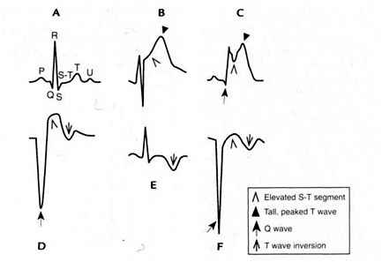

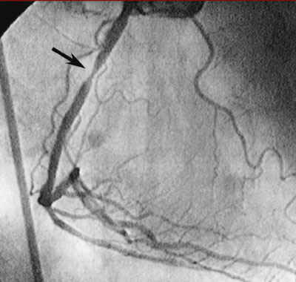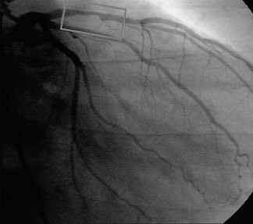

Fig. 15-7. Coronary angiograms

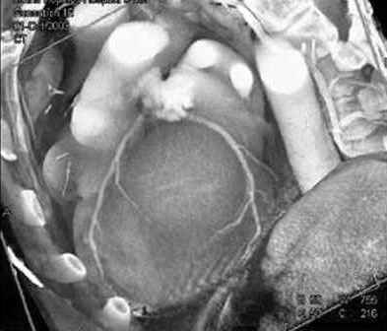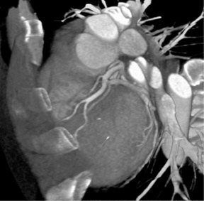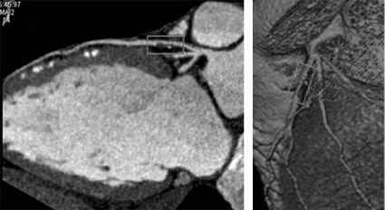

Fig. 15-8. Coronary CT angiograms

Scheme 15-3. Algorithm for the evaluation of new onset chest pain thought to be cardiac in origin without evidence of myocardial infarction
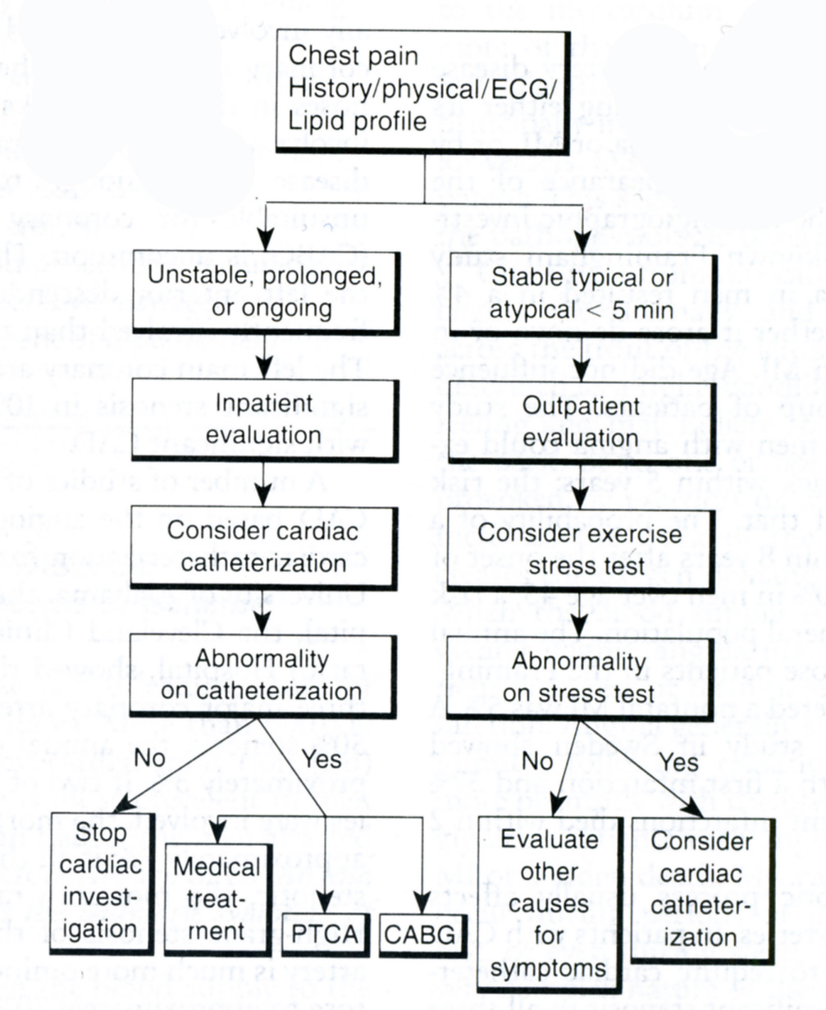
From: Basic surgery/ed., H.C. Polk, Jr., et al. – 5th ed.

Treatment

Table 15-3. Candidate selection guidelines for patients with ischemic heart disease

Medical therapy candidates

Patients with non-disabling angina pectoris who are not felt to be candidates for PTCA or CABG

Percutaneous transluminal coronary angioplasty (PTCA) candidates

Patients with single- or double-vessel disease with limiting angina pectoris with discrete stenosis amenable to PTCA
Significant angina pectoris with lesions amenable to PTCA with a high degree of success
Large areas of myocardium at risk with or without significant symptoms

Coronary artery bypass surgery (CABG) candidates

Patients with disabling angina pectoris despite medical treatment who are not candidates for PTCA
Significant angina pectoris with triple-vessel disease with impaired ventricular function
Significant angina pectoris with large areas of potential myocardial jeopardy
Critical left main coronary artery stenosis (70% cross-sectional area reduction)

From: Basic surgery/ed., H.C. Polk, Jr., et al. – 5th ed.

Medical treatment

- Management of coronary artery disease is initiated with medical therapy in patients with stable angina and with no evidence of congestive heart failure.
- Drugs used include nitrates, β-blockers, digitalis derivatives, and calcium channel blockers.
- In addition, the patient is encouraged to adopt a low-fat diet, stop smoking, and begin a graded exercise program.
- Acute myocardial infarction that presents in less than 6 hours is generally treated with thrombolytic therapy and percutaneous transluminal coronary angioplasty (PTCA).

Surgical treatment

- Coronary artery bypass surgery (CABG). Coronary artery obstructive disease is treated surgically by providing a bypass around physiologically significant lesions, using an internal mammary artery or a reversed autogenous saphenous vein (see Fig. 15-9).
- Percutaneous transluminal coronary angioplasty (PTCA) (see Fig. 15-10, 15-11) is an increasingly more frequent alternative to coronary artery bypass in select "morphologically" favorable lesions.
- Indications for CABG and PTCA are shown in Table 15-3.
- The results of coronary artery revascularization depend on the patient's preoperative left ventricular function. A left ventricular systolic ejection fraction of less than 0.3 constitutes an increased but acceptable operative risk.
- In patients with stable angina, the accepted operative mortality rate is аррroximately 1%. Approximately 85% - 95% of patients are helped significantly, with 85% having complete freedom from angina.
- Surgery increases survival in patients with "left main disease" and triple-vessel disease with depressed ventricular function.
- Ten-year patency rates for internal mammary artery grafts are more than 90%, whereas vein graft patency is only 50% at 10 years.
- The patency of the coronary stents is twofold or threefold lesser than vascular grafts.
- The novel generation of stents impregnated by anticoagulants promise more favorable results but comparative trials are still ongoing.

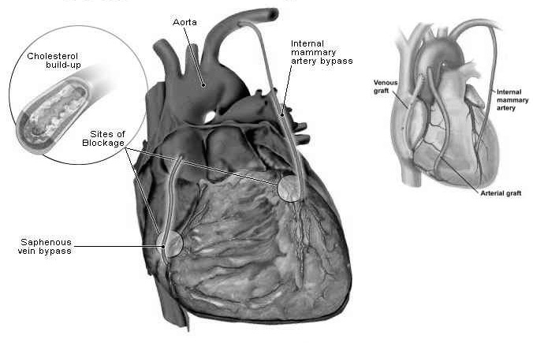

Fig. 15-9. Scheme of CABG

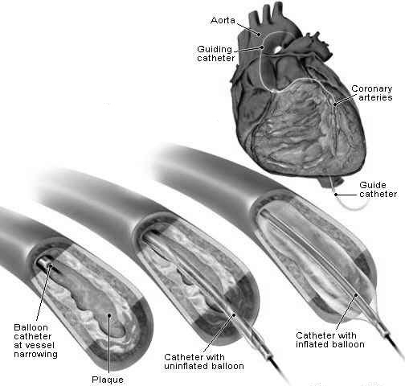

Fig. 15-10. Scheme of PTCA

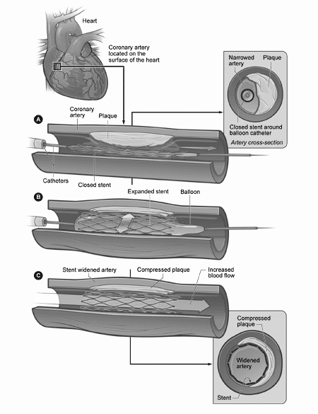
Fig. 15-11. Scheme of PTCA with stenting

Scheme 15-4. Survival after myocardial infarction
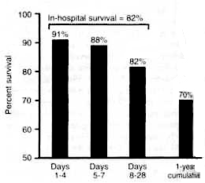
From: Basic surgery/ed., H.C. Polk, Jr., et al. – 5th ed.

Scheme 5-5. Guidelines for treatment of patients who have had uncomplicated myocardial infarction and who are not thought to be candidates for thrombolytic therapy

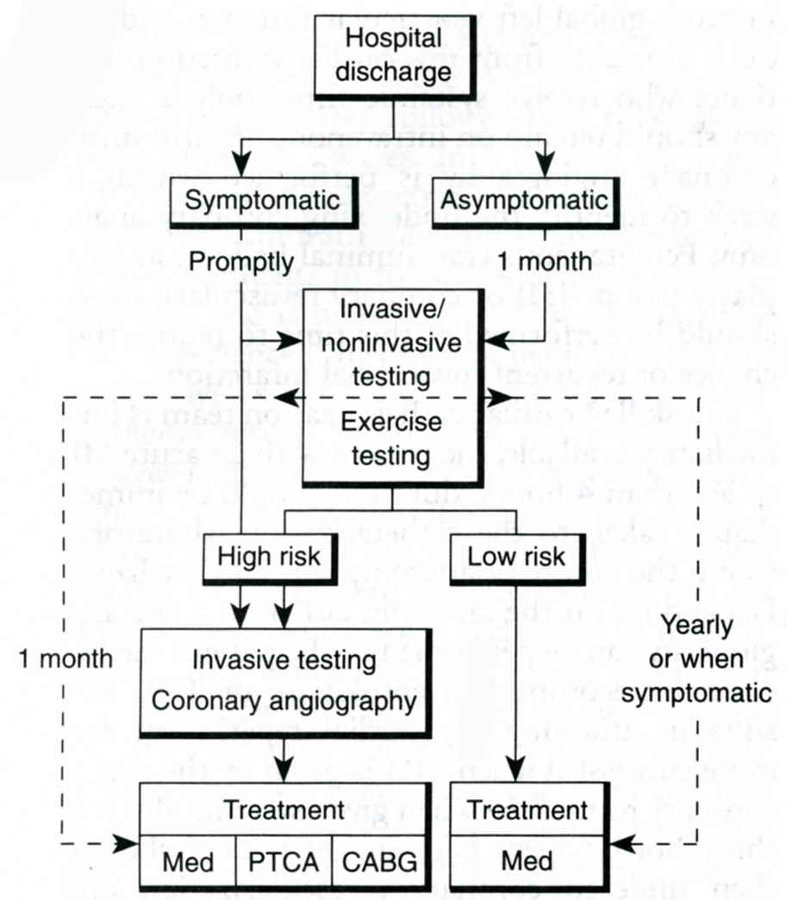

From: Basic surgery/ed., H.C. Polk, Jr., et al. – 5th ed.

Surgical treatment of myocardial infarction complications

- Myocardial infarction and many of its complications are treated medically, but some complications warrant surgery.
- Ventricular aneurysms. The scarred myocardium may produce either akinesia оr dyskinesia of ventricular wall motion, decreasing the ejection fraction. This decrease may result in congestive heart failure, ventricular arrhythmia, rarely, systemic thromboembolization. Surgical correction of the aneurysm is undertaken when these problems occur. Coronary revascularization may also be warranted at the same time.
- Ruptured ventricle is rare, and the mortality rate approaches 100% without surgery.
- Rupture of the interventricular septum carries a high mortality rate. Again, early operative repair is important.
- Mitral valve papillary muscle dysfunction or rupture. Usually the posterior papillary muscle is involved. Treatment is by mitral valve replacement or repair. Long-term survival is dependent on the extent of myocardial damage.

Pericardial disorders

Pericardial effusion

- The pericardium responds to noxious stimuli by an increased production of fluid.
- A pericardial effusion volume as small as 100 ml may produce symptomatic tamponade if the fluid accumulates rapidly, while larger amounts may be tolerated if the fluid accumulates slowly (see Fig. 15-12).
- Pericardial effusion is treated by pericardiocentesis (see Fig. ) or by tube pericardiostomy via a subxiphoid approach.
- Chronic effusions, such as those that occur with malignant involvement of the pericardium, may require pericardiectomy via left thoracotomy or sternotomy, or videothoracoscopically.

A 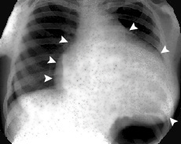 B 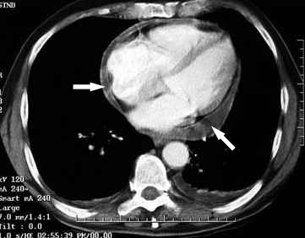

Fig. 15-12. Radiological (A) and CT (B) pictures of pericardial effusion

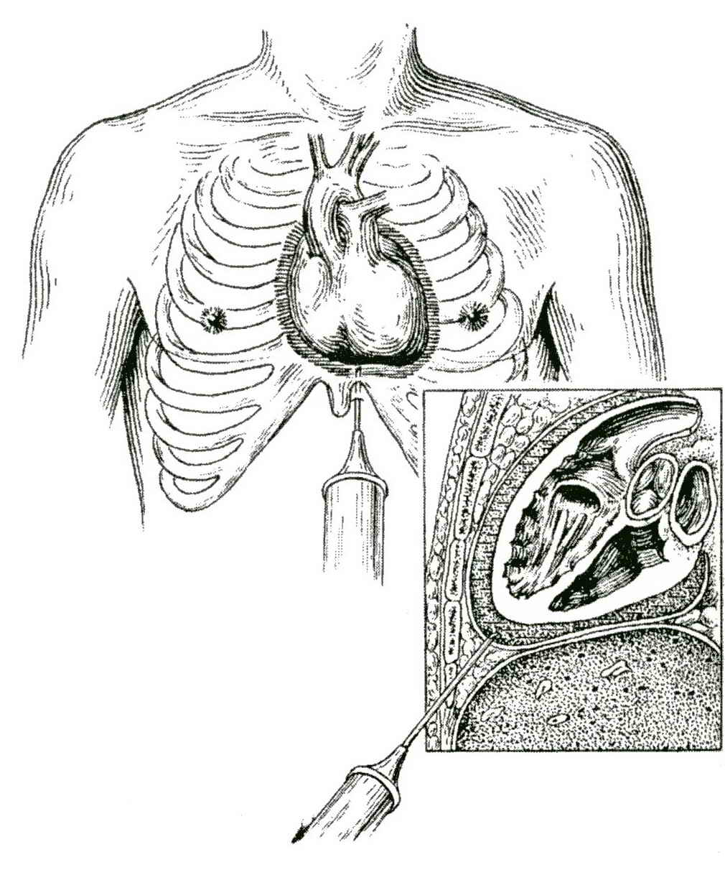

Fig. 15-13. Technique of pericardiocentesis

Pericarditis

Acute pericarditis

- Causes of acute pericarditis include:
- Bacterial infection, as from staphylococci or streptococci (acute pyogenic pericarditis is uncommon and is usually associated with a systemic illness), viral infection, uremia, traumatic hemopericardium, malignant disease, connective tissue disorders.
- Treatment consists of managing the underlying cause. Open or thoracoscopic pericardial drainage may be required.
- Most cases of acute pericarditis resolve without serious sequelae.

Chronic pericarditis

- Chronic pericarditis may represent recurrent episodes of an acute process or undiagnosed long-standing viral pericarditis.
- The etiology is often impossible to establish. It may go unnoticed until it results in the chronic constrictive form, causing chronic tamponade.
- Chronic constrictive pericarditis presents with dyspnea on exertion, easy fatigability, marked jugular venous distention, ascites, hepatomegaly, and peripheral edema.
- The pericardium may become calcified, which is evident on chest x-ray.
- Echocardiography is needed to confirm the diagnosis.
- Once the diagnosis has been established in the symptomatic patient, pericardiectomy should be undertaken with or without the use of cardiopulmonal bypass.

CONGENITAL HEART DISEASE

General considerations

Overview

- The incidence of congenital heart disease is approximately 3/1000 births.
- In most cases the etiology is unknown. Rubella occurring in the first trimester of pregnancy is known to cause congenital heart disease (e.g., patent ductus arteriosus). Down syndrome is associated with endocardial cushion defects.
- The most common forms of congenital heart disease are in decreasing orders: ventricular septal defect, transposition of the great vessels, tetralogy of Fallot, hypoplastic left heart syndrome, atrial septal defect, patent ductus arteriosus, coarctation of aorta, and endocardial cushion defects.

History

- The mother should be questioned about difficulties during the pregnancy, especially in the first trimester.
- The mother often states that the child shows the following symptoms, which indicate pulmonary overcirculation and congestive heart failure: easy fatigability and decreased exercise tolerance, poor feeding habits and poor weight gain, and frequent pulmonary infections.
- A history of cyanosis should be sought, as this indicates a right-to-left shunt.

Physical examination

- Abnormalities in growth and development should be identified.
- Cyanosis and clubbing of the fingers may be noted.
- Examination of the heart should proceed in the same manner as in the adult.
- Systolic murmurs are frequently found in infants and small children and may be of clinical significance.
- A gallop rhythm is of great clinical importance.
- Congestive heart failure in children is frequently manifested by hepatic enlargement.

Visualization data

- Echocardiogram is the mainstay of diagnosis and can define abnormal anatomy and physiology.
- Cardiac catheterization may be required.

Patent ductus arteriosus

Overview

- Hypoxia and prostaglandins E₁ and E₂ act to keep the ductus open in utero.
- In the normal infant born at term, circulation of the blood through the pulmonary vascular bed results in elevated oxygen levels and breakdown of the prostaglandins, which results in closure of the ductus within a few days.
- The natural history of patent ductus arteriosus is variable. A small percentage of patients experience heart failure within the first year of life. Many patients remain asymptomatic and are diagnosed upon routine examination. Some patients eventually develop pulmonary vascular obstructive disease, which can lead to elevated pulmonary vascular resistance.
- Patent ductus arteriosus may be seen in combination with other defects, such as ventricular septal defect and coarctation of aorta.

Clinical features and visualization data

- Common presenting complaints are dyspnea, fatigue, and palpitations, signifying congestive heart failure.
- Diagnosis is based primarily on the physical findings.
- The classic continuous "machinery-like" murmur is usually heard, but it may be absent until age 1 year.
- Other signs include a widened pulse pressure and bounding peripheral pulses.
- Cyanosis may be seen in patent ductus arteriosus that is associated with other anomalies or in right-to-left shunt from pulmonary vascular disease.
- Echocardiography can define a patent ductus arteriosus and other associated anatomic abnormalities.

Treatment

- Surgical management consists of ligation or dissection of the ductus (see Fig. 15-14). This is reserved for: premature infants with severe pulmonary dysfunction, infants who suffer from congestive heart failure within the first year of life, asymptomatic children with a patent ductus that persists until the age of 2 or 3 years.
- Indomethacin, a prostaglandin inhibitor, has been used with some success to close the ductus in premature infants with symptomatic simple patent ductus arteriosus.

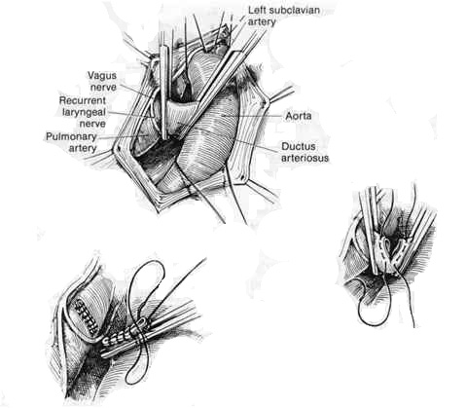

Fig. 15-14. Technique of dissection of patent ductus arteriosus

Coarctation of the aorta

Overview

- Coarctation, a severe narrowing, is found twice as often in male as in female children.
- It is commonly located adjacently to the ductus arteriosus.
- Coarctation may be fatal in the first few months of life if not treated.
- Associated intracardiac defects, present in up to 60% of patients, include patent ductus arteriosus, ventricular septal defect, and bicuspid aortic valve.

Clinical features

- Some children are asymptomatic for varying periods of time.
- In others, symptoms suggesting congestive heart failure are present shortly after birth.
- Headaches, epistaxis, lower extremity weakness, and dizziness may be seen in the child with symptomatic coarctation.
- Physical findings include: upper extremity hypertension, absent or diminished pulses in the lower extremities, and systolic murmur.

Visualization data

- Chest x-ray may reveal "rib-notching" in older children, representing collateral pathways via intercostal arteries.
- Echocardiography suggests the degree of flow limitation and other associated anomalies.
- Cardiac catheterization is usually recommended to define the location of the coarctation and any associated cardiac defects.

Treatment

- Surgical correction of the coarctation is indicated for all patients and may be delayed until age 5 or 6 years in asymptomatic patients.
- Operative procedures include: resection and end-to-end anastomosis, prosthetic patch graft, a subclavian flap procedure (the distal subclavian artery is transected, a proximal-based subclavian artery flap is used to enlarge the aorta at the level of the coarctation) (see Fig. 15-15).
- Any associated defects must also be corrected.
- Postoperative complications are: residual hypertension may be a problem postoperatively, spinal cord injury due to ischemia during surgery rarely occurs, postoperative mesenteric ischemia is seen in a small but significant number of patients and is related to postoperative hypertension.

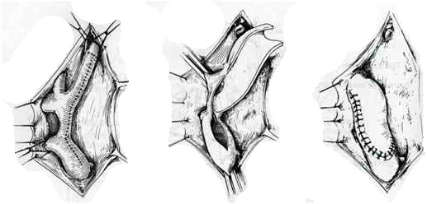

Fig. 15-15. Technique of repair of coarctation using a subclavian flap

Atrial septal defects

Overview

- Atrial septal defects occur twice as frequently in female as in male chidren.
- Three types are commonly seen (see Fig. 15-16): ostium secundum defects, which account for most atrial septal defects, are found the midportion of the atrial septum; sinus venosus defects are located high up on the atrial septum and are often associated with anomalies of pulmonary venous drainage; ostium primum defects are components of atrioventricular septal defects and are located on the atrial side of the mitral and tricuspid valves.
- A patent foramen ovale is not considered an atrial septal defect.
- Atrial pressures are equal on both sides of a large atrial septal defect. Since atrial emptying occurs during ventricular diastole, the direction of shunt at the atrial level is determined by the relative compliances of the right and left ventricles (diastolic phenomena). Since the right ventricle is more compliant than the left, flow is left to right across an atrial septal defect. This results in a modest increase in pulmonary blood flow, which causes mild growth retardation. If uncorrected, pulmonary vascular obstructive disease may develop. This condition results in the right ventricle becoming less compliant than the left, with blood flow shunting right to left across the atrial septal defect.

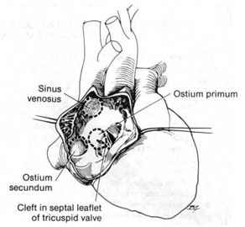

Fig. 15-16. Types of atrial septal defects

Clinical features

- Mild dyspnea and easy fatigability are seen in infancy and early childhood.
- Such symptoms increase in severity with age and may manifest in adults as congestive heart failure, often brought on by the onset of atrial fibrillation.
- Physical examination reveals a systolic murmur in the left second or third intercostal space and a fixed, split, second heart sound.

Visualization data

- Chest x-ray reveals moderate enlargement of the right ventricle and prominencу of the pulmonary vasculature.
- Electrocardiogram reveals right ventricular hypertrophy.
- Echocardiography can define the atrial septal defect and note the direction of shunting.
- Cardiac catheterization can make the diagnosis from the "step-up" in oxygen saturation in the right atrium. The amount of left-to-right shunt may be calculated.

Treatment

- Treatment is based on the size of the left-to-right shunt.
- Some atrial septal defects may close spontaneously.
- Surgical closure of the detect is indicated if the pulmonary blood flow is 1½ to 2 times greater than the systemic blood flow.
- Surgery carries a mortality risk of less than 1%.
- Ideal time for closure is age 4 or 5, prior to beginning school.

Ventricular septal defects

Overview

- Ventricular septal defects are the most common congenital heart defects. Associated anomalies, such as coarctation of aorta, are common.
- They may be classified according to their location in the ventricular septum (see Fig. 15-17): infracristal (membranous, the most common type), supracristal, atrioventricuiar canal type, muscular.
- Ventricular pressures are equal on either side of a large ventricular septal defect. Since ventricular emptying occurs during systole, the direction of the shunt at the ventricular level is determined by the relative resistances of the pulmonary andsystemic circuits (systolic phenomena). Since the pulmonary vascular resistance is much less than the systemic vascular resistance, flow is left to right across a ventricular septal defect. This causes markedly increased pulmonary blood flow, which imposes a volume load on the left ventricle and may lead to early congestive heart failure.
- Other adverse effects of pulmonary overcirculation include: poor feeding, failure to thrive, frequent respiratory tract infections, increased pulmonary vascular resistance, development of irreversible pulmonary vascular obstructive disease.

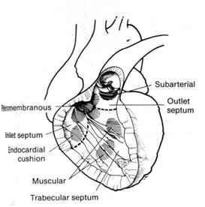

Fig. 15-17. Types of ventricular septal defects

Clinical features

- Small ventricular septal defects rarely cause significant symptoms in infancy or early childhood and may undergo spontaneous closure before they are recognized.
- Symptoms are usually seen with ventricular septal defects, which approach the diameter of the aortic root.
- Children with large defects usually have dyspnea on exertion, easy fatigability, and an increased incidence of pulmonary infections.
- Severe cardiac failure may be seen in infants but is less common in children.
- Physical examination reveals a harsh pansystolic murmur.

Visualization data

- Chest x-ray and electrocardiogram, especially in large ventricular septal defects, show evidence of biventricular hypertrophy.
- Echocardiography can define the ventricular septal defect and note the direction of shunting.
- Cardiac catheterization is essential for delineating the severity of the left-to-right shunt, pulmonary vascular resistance, and the location of the defects.

Treatment

- Surgical closure of the defect should be performed in: infants with significant cardiac failure or increased pulmonary vascular resistance, asymptomatic children with significant shunts who have not had spontaneous closure by age 2, patients with pulmonary blood flow 1½ to 2 times greater than systemic blood flow.
- Operative mortality risk (< 5%) is related to the degree of preoperative pulmonary vascular disease.

Tetralogy of Fallot

Overview

- The tetralogy of Fallot, one of the most common cyanotic congenital heart disorders, consists of: obstruction to right ventricular outflow, a ventricular septal defect, hypertrophy of the right ventricle, and an overriding aorta (see Fig. 15-18).
- The addition of an atrial septal defect (which is of little further physiologic significance turns the condition into the pentalogy of Fallot.
- Since resistance to right ventricular outflow exceeds the systemic vascular resistance the shunt is right to left, resulting in desaturation of the blood and cyanosis.
- Exercise tolerance is limited because of the inability to increase pulmonary blood flow.

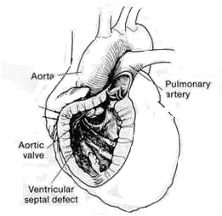

Fig. 15-18. Scheme of tetralogy of Fallot

Clinical features and visualization data

- Cyanosis and dyspnea on exertion are routinely seen in patients with tetralogy of Fallot.
- Children soon learn that by squatting they can temporarily alleviate these symptoms. Squatting increases the systemic vascular resistance, which decreases the magnitude of right-to-left shunt and causes an increase in pulmonary blood flow.
- The cyanosis is seen at birth in 30% of the cases, by the first year in 30%, and later in childhood in the remainder.
- Polycythemia and clubbing accompany the cyanosis.
- Cerebrovascular accidents and brain sepsis constitute the major threats to life, as cardiac failure is rare.
- Physical examination reveals clubbing of the digits and cyanosis. A harsh systolic murmur of pulmonary stenosis is often heard.
- Cardiac catheterization is important for determining the level of pulmonic outflow obstruction and the size of the main and branch pulmonary arteries.

Treatment

- Treatment depends on many variables, including the anatomy of the defect and the age of the child.
- Total correction is undertaken after the age of 2 years.
- Controversy exists over whether the defect should be corrected before this age. Many feel that a palliative systemic-to-pulmonary (Blalock-Taussig) shunt should be done initially, followed by definitive correction at a later date.
- The risk of surgery depends on the age of the patient and the degree of cyanosis.
- After correction, a dramatic improvement is usually seen.

Transposition of the great arteries

Clinical characteristic

- Transposition of the great arteries occurs when the aorta arises from the morphologic right ventricle, and the pulmonary artery arises from the morphologic left ventricle. This results in two independent parallel circuits (see Fig. 15-19).
- Survival depends on a communication between the right and left sides of the heart to allow mixing of oxygenated and unoxygenated blood. This communication usually occurs across an atrial septal defect, although a patent ductus arteriosus or ventriallar septal defect could also be present.
- Diagnosis is based on arterial blood gas, chest x-ray, and echocardiogram.

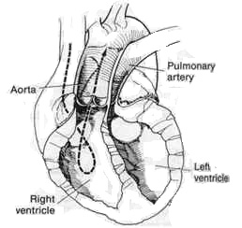

Fig. 15-19. Scheme of for transposition of the great arteries

Treatment

- Initial balloon atrial septostomy is performed to increase the size of the interatrial communication and facilitate mixing of blood.
- Septostomy is followed by definitive surgical correction. Operative procedures include: atrial inversion (Senning or Mustard operation), arterial switch (Jatene operation (see Fig. 15-20)).

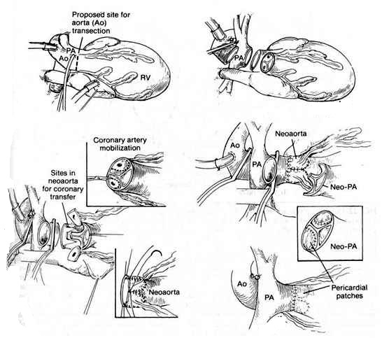

Fig. 15-20. Scheme of Jatene operation for transposition of the great arteries

REVIEW TESTS

1. A 78-years-old previously healthy man is admitted to the ER with complaints of angina, dyspnea, and near syncope. Electrocardiogram is normal, and a loud systolic murmur is heard in the second right intercostal space with radiation to the carotids. What’s the most appropriate tactics of managing the patient?

- Myocardial infarction
- Pericarditis
- Mitral regurgitation
- Aortic stenosis
- Aortic insufficiency

2. A 72-years-old woman was admitted to ER with unstable angina. Cardiac catheterization reveals severe triple vessel coronary artery disease. What’s the most appropriate tactics of managing the patient?

- Coronary artery bypass surgery
- Observation
- Medical management (e.g., nitrates, β-blockers)
- Percutaneous coronary angioplasty
- Administration of tissue plasminogen activator (e.g., streptokinase)

3. Cardiac tamponade is a surgical emergency and should be managed by immediate:

- Surgical exploration
- Pericardiocentesis
- Infusion of fluid
- Injection of NSAIDs

4. A 4-years-old boy is evaluated for a systolic murmur upon auscultation of the chest. Chest radiograph demonstrates cardiomegaly and rib notching. Physical examination reveals diminished femoral pulses. A 40 mm differential exists between upper and lower extremity blood pressures. Give your presumable diagnosis:

- Patent ductus arteriosis
- Coarctation of aorta
- Atrial septal defect
- Bilateral common femoral artery stenosis
- Aortic stenosis

5. An isolated large atrial septal defect results in:

- Right-to-left shunt
- Left-to-right shunt
- No shunt
- Bidirectional shunting

6. All of the following lesions but one have a right-to-left shunt in the presence of normal pulmonary vascular resistance:

- Tetralogy of Fallot
- Ventricular septal defect
- Tricuspid atresia
- Pulmonic stenosis and atrial septal defect
- Complete atrioventricular canal

7. A 1-week-old severely cyanotic infant is most likely to have:

- Aortic stenosis or partial anomalous pulmonary venous drainage with atrial septal defect
- Transposition of the great vessels, tetralogy of Fallot, or truncus arteriosus
- Coronary arteriovenous fistula or pulmonary stenosis

8. Tetralogy of Fallot includes all but one of the following lesions:

- Ventricular septal defect
- Pulmonic stenosis
- Hypoplastic left ventricle
- Overriding aorta
- Right ventricular hypertrophy

9. All of these defects have a left-to-right shunt except:

- Atrial septal defect
- Patent ductus arteriosus
- Tetralogy of Fallot
- Ventricular septal defect

Correct answers: 1 - D, 2 - A, 3 - B, 4 - B, 5 - B, 6 - B, 7 - B, 8 - C, 9 - C.

