CHAPTER 17: SWOLLEN LOWER LIMB

- Edema of lower extremity may appear due to various diseases of its venous and lymphatic system, congestive heart failure, chronic renal failure, hypoproteinemia, and fluid overload (see Table 17-1).

VENOUS DISEASE OF THE LOWER EXTREMITIES

Overview

- Venous disease may be caused by either congenital or acquired disorders.
- Valvular incompetence is the congenital or acquired inability of the valves to prevent reflux and gravitational hypertension of the venous system.
- Venous thrombosis is the formation of thrombi in the venous system. The thrombi usually originate at the calf vein level and progress cephalad. They occur as a result of elements of Virchow's triad: trauma to the vein wall (e.g., caused by surgery or physical injury), decreased velocity of venous blood flow (e.g., due to postoperative immobility or drugs, such as estrogen, which decrease venous tone), and increased coagulability or a change in the cellular components of blood (e.g., due to surgery or polycythemia vera).

Superficial thrombophlebitis

Overview

- Superficial thrombophlebitis is inflammation or thrombosis of the superficial veins.
- A pulmonary embolus rarely is present with superficial thrombophlebitis.

Clinical features

- A tender palpable cord along the course of a superficial vein is present.
- A red, warm, indurated vein is palpable.

Treatment

- Treatment measures for acute thrombophlebitis include the following:
- Bed rest and elevation of the extremity.
- Local application of heat for relief of pain.
- Support hose worn both during the period of inflammation and for prophylaxis.
- Broad-spectrum antibiotics in severe cases.
- Anticoagulants (enoxaparin, fraxiparin, ect.) are used in prophylactic or therapeutic dosages.
- Nonsteroidal anti-inflammatory drugs.

Complications

- Chronic recurrent superficial thrombophlebitis is treated with antibiotics in addition to the treatment described previously because the syndrome often includes a streptococcal lymphangitis. If untreated, lymphangitis results in additional occlusion of the lymphatics, resulting in continued edema, dilatation, and inflammation, creating a vicious circle.
- Suppurative thrombophlebitis usually is associated with intravenous infusions in immunocompromised or burn patients. It is treated by excision of the infected vein.

Varicose veins

Overview

- Varicose veins are dilated networks in the subcutaneous venous system and result from valvular incompetence of the deep, superficial or perforator systems.
- Varicose veins may be primary (a couple of etiological factors were considered, including congenital insufficiency of valves due to defects of connective tissue, and such acquired factors as multiparity, oral contraceptives use, obesity, ect.), and secondary (compression of veins by tumors, enlarged lymph nodes, ect.).
- Deep venous thrombosis is not often a factor in the development of varicose veins.

Clinical features and visualization data

- Signs and symptoms include:
- Local pain and edema.
- Local inflammation.
- Local hemorrhage into the surrounding tissue.
- Dilated superficial veins.
- A positive Trendelenburg test, which is a method of proving incompetent valves by occluding the superficial vein and demonstrating filling from the deep system.
- Duplex ultrasound (see Fig. 19-1) is used to determine the direction of reflux of blood (vertical, due to insufficiency of valves of great saphenous vein; or horizontal, due to insufficiency of perforants, and their position), and to assess the function of deep venous system.

Treatment

- The treatment of primary varicose veins includes a variety of methods directed to vein or its insufficient valves described below, whenever treatment of secondary varicose veins should remove the cause of obstruction.
- Nonoperative management principally involves the use of support hose, which keeps the superficial system collapsed and minimizes the effect of venous hypertension on venous dilatation.
- Medical treatment mainly includes withdrawal of oral contraceptives, and usage of phlebotonics.
- Sclerotherapy (see Fig. 17-1), endovenous laser ablation (see Fig. 17-2), cryotherapy, or heat-mediated obliteration (see Fig. 17-3) is used for small varices.
- Indications for surgery include: recurrent pain over the varicosity or recurrent superficial phlebitis of the varicosity; cosmetic considerations; and previous or impending hemorrhage from an ulcerated varicosity.
- In the case of incompetence of valves of superficial venous system, the high ligation of great saphenous vein (Trendelenburg procedure) and its branches (crossectomy), and phlebectomy (or vein stripping) (Babcock procedure) is indicated (see Fig. 17-4). Preoperative evaluation of the patency of the deep venous system is mandatory because ligation of the saphenous vein in the presence of a thrombosed deep system could result in massive venous obstruction and venous gangrene. Surgical excision of the individual varicosities of the calf through small incisions (the "stab avulsion technique") may be added to the procedure.
- When the valves of perforators are insufficient, ligation of incompetent perforators is indicated. This operation may be performed endoscopically (see Fig. 17-5).

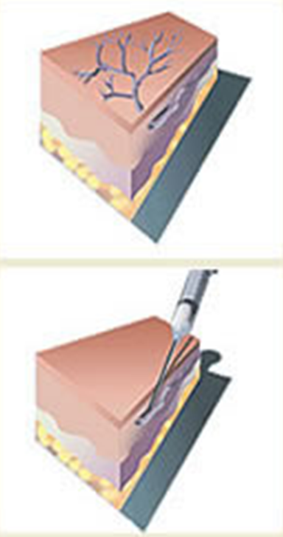

Fig. 17-1. Scheme of sclerotherapy of varicose veins

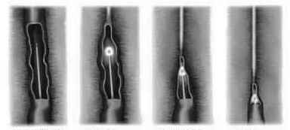

Fig. 17-2. Scheme of endovenous laser ablation of varicose veins

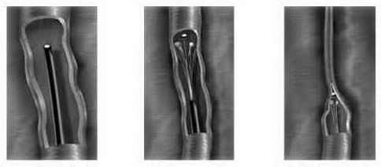

Fig. 17-3. Scheme of heat-mediated obliteration of varicose veins

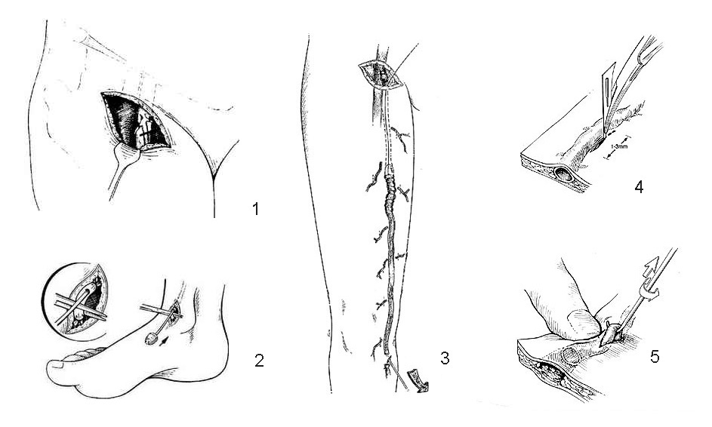

Fig. 17-4. Scheme of crossectomy, great saphenous vein stripping and excision of individual varices

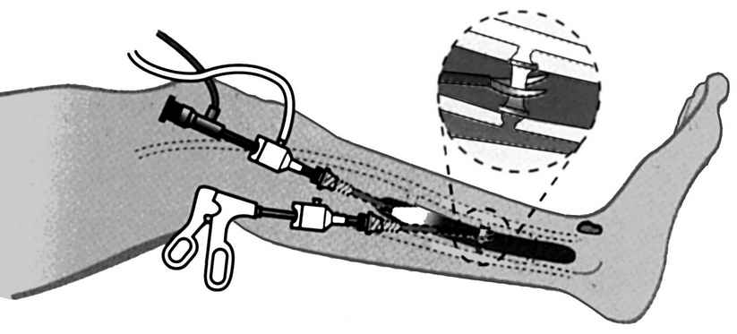

Fig. 17-5. Scheme of endoscopic dissection of perforants

Deep venous thrombosis

Overview

- Deep venous thrombosis is thrombosis of part or all of the deep venous system of an extremity. It occurs in 250,000 individuals a year.
- Deep venous thrombosis usually originates in the lower extremity venous system, starting at the calf vein level (from 80% - 90% of pulmonary emboli originate here) and progressing proximally to involve the popliteal, femoral, iliac system, and, ultimately, inferior vena cava with possible subsequent pulmonary artery embolism.
- Other veins in which thrombi occasionally develop include: pelvic veins, especially during pregnancy, pelvic surgery, and from gynecologic cancer or cancer of prostate; renal veins, especially when intrinsic renal disease is present; and ovarian veins.

Clinical features and visualization data

- The classic clinical syndrome includes calf or thigh pain, edema, tenderness, and a positive Homan's sign (calf pain on dorsal flexion of the foot). In patients with venographically proven deep venous thrombosis: fifty percent have the classic clinical findings, fifty percent have no associated physical findings in the extremities.
- Pulmonary embolism is the presenting symptom in some patients.
- Evaluation must ascertain the presence of arterial vascular insufficiency.
- Duplex ultrasound has become an accurate and commonly performed noninvasive method to diagnose deep venous thrombosis. In experienced hands, it is as accurate as such conventional method as venography.

Treatment

- Anticoagulants (enoxaparin, fraxiparin, ect.) are used in therapeutic dosages.
- Thrombolytic therapy with streptokinase and urokinase may be used in extensive deep venous thrombosis results in impaired perfusion of the extremity.
- Broad-spectrum antibiotics are also used.
- Thrombectomy (see Fig. 16-15) is surgical procedure of choice followed by inferior vena cava filter (see Fig. 17-6) when a pulmonary embolus occurs in spite of adequate anticoagulation therapy (or increased risk of this complication persists, e.g. thrombosis progresses upwards). However, this treatment prevents only pulmonary embolism and does not treat the deep venous thrombosis.

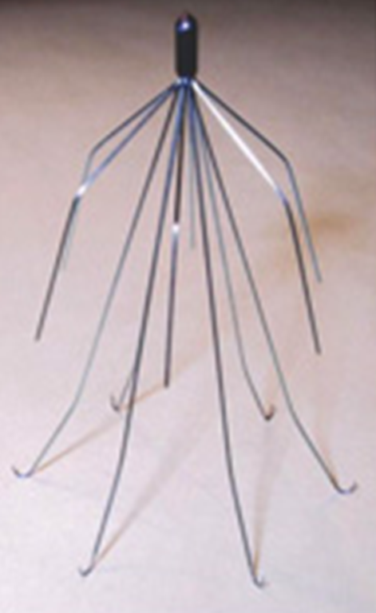

Fig. 17-6. Vena cava filter

Prevention

- Simple preventive measures include leg elevation, early mobilization after surgery, use of support hose (which compresses superficial veins in the legs and increases flow in the deep veins), and the correction of preoperative risk factors, such as hypercoagulation state.
- Pre- and postoperative administration of prophylactic anticoagulants is effective in preventing deep thrombosis. For postoperative phlebitis, there was a 25% incidence in controls versus a 7% incidence in patients treated with anticoagulants. For fatal pulmonary embolism, there was a 7% mortality rate in controls versus a 1% mortality rate in those treated with anticoagulants.

Complications

Postphlebitic syndrome

- Postphlebitic syndrome is a common late complication of deep venous thrombosis, often occurring several years after the acute event.
- Clinical presentation includes swelling and ulceration. Leg edema usually is worse as the day progresses and as the leg is dependent, it usually resolves with elevation and rest. This edema and exudation then lead to brawny induration from hemoglobin metabolism. Tissue necrosis and skin ulceration result from poor oxygen diffusion secondary to pericapillary protein deposition as well white blood cell release of proteolytic enzymes, superoxide radicals, and various cytokines.
- Treatment includes several options. Support hose must be worn continually to prevent superficial venous hypertension and swelling. If swelling can be prevented, most ulcers can be prevented. Reconstructive surgery (see Fig. 17-7) is used in causes of severe or complete occlusion of distinct segment of the vein.

A 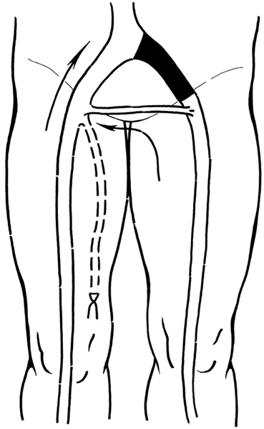 B 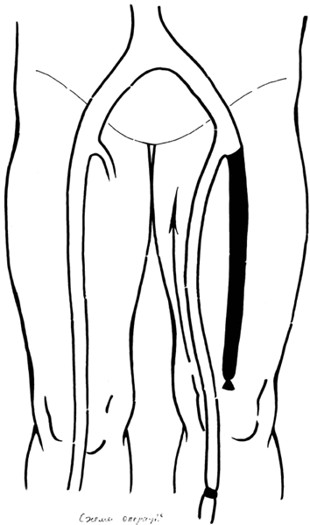 C 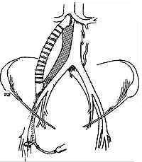

Fig. 17-7. Reconstructive operations for postphlebitic venous occlusion: Palma-D’Esperson procedure (A), Worren-Tair procedure (B), prosthetic graft bypass (C)

Phlegmasia alba dolens

- Phlegmasia alba dolens is caused by acute occlusion of the iliac and femoral veins due to deep venous thrombosis.
- This phlebitis results in a pale cool leg with a diminished arterial pulse due to spasm.
- Treatment is thrombolytic therapy followed by heparin administration to prevent progression to phlegmasia cerulea dolens.

Phlegmasia cerulea dolens

- Phlegmasia cerulea dolens is secondary to acute and nearly total venous occlusion of the extremity outflow, including the iliac and femoral veins. It is more common in the left leg. Association with another disease is common: for example, 30% of cases occur in postoperative and postpartum patients, and pelvic malignancy is not infrequent.
- Physical findings include cyanosis of the extremity with massive edema, severe pain, and absent pulses, followed by venous gangrene. Shock may occur as a result of sequestration of a significant amount of blood in the leg.
- Treatment is thrombolytic therapy followed by anticoagulants administration. Thrombectomy is occasionally used if nonoperative therapy is unsuccessful.

PULMONARY EMBOLISM

Overview

- Pulmonary embolism is a mechanical obstruction of the flow of blood in the pulmonary arterial system due to lodgment of a thromboembolus. The results of lodgment include decreased cardiac output, pulmonary vasospasm, hypertension, impaired blood oxygenation, and bronchospasm.
- Pulmonary embolism is one of the most common causes of sudden death in hospitalized patients.
- Normal individuals can tolerate a 60% - 70% occlusion of the pulmonary vasculature, but patients with preexisting cardiac or pulmonary disease tolerate much smaller occlusions poorly.
- Pulmonary embolism is frequently sudden and seemingly unheralded, although it is often preceded by the development of small and clinically unrecognized emboli. Only 10% of all autopsy-proven cases of pulmonary embolism are diagnosed pre-mortem.
- Ninety percent of deaths occur within 2 hours after the onset of the initial symptoms. Therefore, if the patient lives longer than 2 hours, the chance of survival is very high.
- Pulmonary embolism develops in 10% - 40% of patients with deep venous thrombosis. However, approximately 33% of patients with pulmonary embolism have no antecedent symptoms of deep venous thrombosis.
- Pulmonary embolus formation can be prevented through the early diagnosis and prevention of deep venous thrombosis.
- Risk factors are listed below.
- Pregnant women and women in the postpartum period have an incidence of pulmonary embolism five times greater than the incidence in age-matched controls. Pulmonary embolus formation is a common cause of death after pregnancy.
- Estrogen therapy is associated with an increased risk of pulmonary embolism 4-7 times that of controls.
- Heart disease is associated with a 3-4 times higher risk of pulmonary embolus formation. This risk is directly related to the severity of the heart disease.
- Obesity is associated with a 1½-2 times greater risk of pulmonary embolism.
- Carcinoma is associated with a 2-3 times greater risk of pulmonary embolism.
- Major trauma, especially spinal cord injury and pelvic or femoral shaft fractures, carries an increased risk of pulmonary embolus formation.
- A history of pulmonary embolism increases the risk of later pulmonary embolus formation, especially after surgery.
- Varicose veins are associated with a 2 times greater risk of pulmonary embolism.
- Older age-groups are associated with an increased risk of developing pulmonary emboli.

Clinical features and visualization data

- Symptoms of pulmonary embolism range from none to severe cardiopulmonary dysfunction. In general, the more complicated the symptoms, the more unreliable the clinical diagnosis.
- Classic signs – hemoptysis, pleural friction rub, cardiac gallop, cyanosis, and chest splinting – are present in only 24% of patients.
- Nonspecific findings, including tachycardia (in 60% of patients), tachypnea (in 85% of patients), and dyspnea (in 85% of patients), are common. Bronchospasm and pleuritic chest pain also occur frequently.
- Electrocardiographic changes, including arrhythmias and evidence of right ventricular strain, may appear.
- Chest x-ray may be abnormal or totally normal. Occasionally, a marked diminution of the pulmonary vasculature produces increased radiolucency in the area of the embolus (Westermark's sign). Pleural effusion, which is usually hemorrhagic, or pulmonary infiltration may be present, especially in cases of pulmonary infarction, which occurs in 10% - 25% of cases of pulmonary embolism (see Fig. 17-8).
- Arterial blood gases frequently show hypoxemia with a low carbon dioxide partial pressure associated with hyperventilation.
- Pulmonary arteriogram is the best technique for diagnosing pulmonary embolism. This test is virtually 100% accurate, but it is invasive. The attendant risk of cardiac arrest is small in stable patients, but it can be unacceptably high in hypotensive, unstable patients.
- Pulmonary radioisotope scanning is less invasive than arteriography.

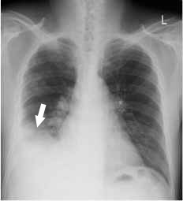

Fig. 17-8. Radiological picture of pulmonary embolism

A 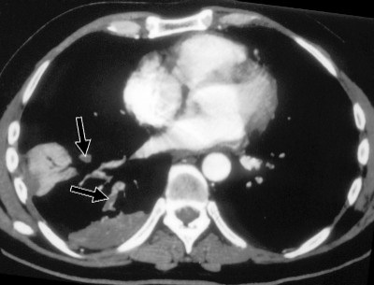 B 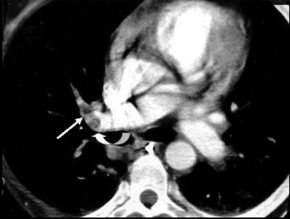

Fig. 17-9. Contrast-enhanced CT scans of pulmonary embolism demonstrating thrombi in pulmonary arteries (A,B), zone of pulmonary infarction and pleural effusion (A)

Treatment

- Treatment of pulmonary embolism includes both supportive measures to maintain circulatory function and administration of thrombolytics and anticoagulants.
- Cardiovascular support is frequently necessary in patients with significant pulmonary embolism and should be instituted immediately. The supportive measures include oxygen administration, assisted ventilation, correction of cardiac arrhythmias, and treatment of shock by means of adequate hydration and vasopressors.
- Anticoagulants are used in high therapeutic dosages (e.g. clexane 40 mg 1-2 times per day) under the accurate guidance of laboratory data.
- Thrombolytic therapy with streptokinase or urokinase may be used in cases of acute life-threatening pulmonary embolism when cardiopulmonary function is severely compromised as evidenced by shock, profound hypoxemia, or elevated pulmonary arterial pressure. Because thrombolytic therapy results in the lysis of preexisting thrombi, this therapy may be dangerous, and it is contraindicated in patients with recent intracranial hemorrhage, recent surgery, or conditions associated with bleeding, such as peptic ulcer disease, large tumors, or urinary tract diseases associated with bleeding.
- Pulmonary embolectomy is reserved for very ill patients. If patients remain significantly unstable despite rapid resuscitation and, in the opinion of the attending physician, are too unstable to endure the several-hour treatment with thrombolytic therapy, embolectomy should be considered. A closed embolectomy using a suction catheter or open embolectomy on cardiopulmonary bypass are the two most acceptable methods.

Complications of anticoagulation therapy and prophylaxis

- Major hemorrhage requiring transfusions occurs in 1% - 2% of patients on anticoagulants; minor bleeding episodes are common in more than 16%; and fatal hemorrhage occurs in 0.1% - 1%. The risk of hemorrhage is greater if anticoagulants are administered intermittently or is given to elderly or severely hypertensive patients.
- Pulmonary embolism recurs despite anticoagulation therapy in 1% - 8% of patients.

DISORDERS OF LYMPHATIC SYSTEM

Lymphedema

Overview

- Lymphedema is a condition characterized by swelling of one or more extremities because of lymphatic insufficiency.
- Lymphedema may be idiopathic (primary lymphedema) or may be caused by acquired insufficiency due to infections, obstructions, or surgical destruction of the lymphatics (secondary lymphedema).
- Three types of primary lymphedema are distinguished by age of onset.
- Congenital lymphedema is present at birth or occurs early in infancy. It accounts for fewer than 10% of primary lymphedema cases. Lymphedema that is both congenital and hereditary is known as Milroy's disease.
- Lymphedema praecox occurs at any time from puberty until the end of the third decade. Most cases of primary lymphedema are of this type. It is three times more common in women than in men.
- Lymphedema tarda occurs after age 30.
- Secondary lymphedema is due to obstruction from a variety of causes, including infection (e.g., erysipelas), parasites (e.g. elephantiasis due to Wuchereria bancrofti), mechanical injury (including surgery, e.g., following lymphadenectomy), postphlebitic syndrome, neoplasms, and lymphatic destruction from therapeutic radiation.

Clinical features

- Diagnosis of lymphedema is usually made clinically.
- The history characteristically includes edema, which begins at the ankle and progresses proximaily. Progression is slow, usually over the course of several months.
- Unlike the edema secondary to venous disease, the swollen extremity in lymphedema has no dark brawny edema or ulceration of the skin.
- The diagnosis can be proven by lymphangiography, but this test is not done routinely because it is difficult and hazardous.

Treatment

- Medical treatment include simple measures as the first line of treatment. Elevation of the affected limb, weight reduction, and salt restriction may be helpful. Compressive stockings may be of benefit if applied properly. It is extremely important to avoid trauma and infection, because either will greatly exacerbate the condition.
- Pulsatile compression devices may help to ''squeeze" the edema from the swollen extremity in severe cases.
- Surgical treatment to palliate uncontrolled lymphedema includes several options.
- The Thompson procedure is based on the assumption that dermal lymphatics may be functional even though the deep lymphatics are incompetent. A dermal flap is buried deep in the swollen extremity to provide competent lymphatics for drainage.
- The omentum, which contains an extensive lymphatic network, can also be transposed from the abdomen to the extremity.
- The most durable operation for chronic lymphedema is a staged resection of subcutaneous tissue and redundant skin, including muscle fascia, which was described originally by Sistruck and refined by Homans. This skin is excised, and the remaining skin is closed over subcutaneous drains. The procedure is done in stages, first on the medial side and then on the outer aspect of the leg. Approximately 80% or patients treated with this operation have a substantial reduction in extremity size.
- Microsurgical anastomoses between a lymphatic and a small vein have been tried. This procedure works well when proximal lymphatics in the groin or pelvis are obstructed.

Lymphatic tumors

- Benign tumors are most commonly cystic hygromas. These are derived from embryonic lymph sacs and are seen during the first year of life. They are most commonly found in the neck but also occur in the groin, axilla, and mediastinum.
- Lymphangiosarcoma is an extremely rare malignant lymphatic tumor, it can occur in any extremity affected by chronic lymphedema, but it is seen most commonly after a mastectomy that is complicated by lymphedema of the arm.
- Lymphatic metastases are seen with many kinds of primary tumors.
Lymphangitis and lymphadenitis

- Inflammation in the lymphatic channels (lymphangitis) and in the lymph nodes (lymphadenitis) is caused by bacterial invasion, usually by β-hemolytic streptococci or by staphylococci.
- Usually, an extremity is affected. Hyperemia occurs around the affected lymphatic, manifested by a red streak, which advances toward the draining lymph nodes.
- Movement of the affected extremity is painful and also propels the bacteria along the lymphatic channel, exacerbating the condition.
- If the process is not arrested by the lymph nodes, septicemia can occur.
- Treatment consists of immobilizing the limb and giving antibiotics. If a source of bacterial seeding is present (e.g., a paronychia), it should be drained. Uncomplicated cases resolve promptly and usually without sequelae.
- Repeated attacks can result in a chronic secondary lymphedema.

Table 17-1. Differential diagnosis of lower extremity swelling

Condition | Findings | Special Tests | Treatment
Cellulitis | Erythema, fever, leukocytosis; tenderness (diffuse) in the involved area | None; occasionally culture of primary focus of inflammation | Bed rest, elevation, heat, antibiotics
Thrombophlebitis | Unilateral (usually); positive Homans' sign; tenderness in the involved vein, calf tenderness | Phlebography, Doppler ultrasonography,  plethysmography | Bed rest, elevation, anticoagulants, thrombectomy if iliac veins are involved, fibrinolytic agents
Lymphangitis | Unilateral red streaking of the skin, an infected focus; no generalized erythema or deep tenderness | None; culture of primary focus of  inflammation | Bed rest, elevation, heat, antibiotics
Superficial varicose veins | Unilateral and bilateral; dilated superficial veins | Brodie-Trendelenburg test, evaluation of deep venous system | Elastic stockings, avoidance of pressure (e.g., crossing the legs), elevation, operation if the condition is severe or disfiguring, injection sclerotherapy
Deep venous  insufficiency | Dilated superficial veins; pigmentation of the lower leg; ulceration | Brodie-Trendelenburg test, Doppler  examination, phlebography | Same as for superficial varicose veins
Lymphatic obstruction  (lymph node blockage) | Unilateral (usually); palpable nodes; diagnosis of carcinoma or lymphoma; no inflammation | Lymphangiography,  biopsies of palpable nodes | Excision or radiation of nodes, elastic compression
Arteriovenous fistulas | Unilateral enlargement of an extremity; bruit; occlusion that produces bradycardia | Arteriography | Excision, angiographic occlusion
Congenital lymphedema  (Milroy’s disease) | Unilateral (usually); the patient is a young adult or an adolescent, a family history of this condition | Lymphangiography is not usually successful (hypoplasia of lymphatics) | Supportive; excisional therapy if the condition is severe
Cardiac decompensation | Bilateral; pitting edema; pulmonary rales; tender liver; edema elsewhere | Central venous pressure (elevation), prolonged circulation time | Cardiac glycosides, diuretics, salt restriction
Hypoproteinemia | Bilateral; generalized anasarca; underlying disease (usually) | Serum albumin level (decreased) | Depends on the underlying disease; protein repletion
Fluid overload | In-hospital complication (usually); chronic renal disease with uremia, exogenous fluid load | Central venous pressure (elevated), careful intake-output record | Fluid restriction
From: Basic surgery/ed., H.C. Polk, Jr., et al. – 5th ed.

REVIEW TEST

1. Varicose veins:

- Should be surgically corrected to avoid embolization
- Usually result in deep thrombophlebitis
- Result from incompetent perforating veins only
- Should be surgically corrected only to treat severe symptoms or for compelling cosmetic reasons
- Should not be removed, because they can be used if the patient undergoes bypass surgery

2. A 67-years-old woman was referred to vascular surgeon because she notices a swollen right leg following a 6-hour plane flight. What’s the most appropriate diagnostic and treatment procedure?

- Compression stockings and leg elevation
- Start 6 months course of anticoagulants
- Case monitoring
- Perform a venous duplex evaluation
- Perform a pelvic CT scan to look for lymphadenopathy

3. If deep venous thrombosis is documented, initial treatment should include which of the following?

- Subcutaneous heparin therapy
- Intravenous heparin therapy
- Thrombolytic therapy (e.g., urokinase)
- Aspirin therapy
- Warfarin treatment

4. After recovery from the acute illness, the 55-years-old patient returns to vascular surgeon in 6 months, complaining of persistent leg swelling. What’s the most appropriate initial tactics of managing the patient?

- Chronic diuretic therapy
- Venous thrombectomy
- Venous bypass using an autologous vein
- Venous bypass using a prosthetic graft
- Support hose

5. Pulmonary embolism can result in:

- Transient dysrhythmias
- Decrease in arterial pO₂
- Hemoptysis
- All of the above
- A and B

6. Lymphangitis is best treated by:

- Administration of antibiotics and immobilization and elevation
- Hot soaks
- Early motion
- Use of occlusive dressings
- Surgical drainage

Correct answers: 1 - D, 2 - D, 3 - B, 4 - E, 5 - D, 6 - A.

