CHAPTER 18: HYPERTENSION

- Tables 18-1, 18-2, and Scheme 18-1 show the list of most common causes of arterial hypertension and clinical work-up for them.
- The most common causes that could be managed surgically are diseases of renal arteries and adrenal glands.

Table 18-1. Causes of combined systolic and diastolic hypertension

Adrenal hyperactivity

Cushing's syndrome
Hyperaldosteronism
Pheochromocytoma

Renal disease

Renal artery stenosis
Fibromuscular hyperplasia
Dissecting aneurysm (involving renal artery)
Chronic pyelonephritis
Glomerulosclerosis

Mechanical

Coarctation of aorta

Other causes

Idiopathic essential hypertension
CNS trauma

From: Basic surgery/ed., H.C. Polk, Jr., et al. – 5th ed. (modified)

Table 18-2. Guide for work-up of a patient with hypertension
From: Basic surgery/ed., H.C. Polk, Jr., et al. – 5th ed.
Diagnosis | Diagnostic Procedure
Diagnosis | Initial | Additional
Chronic renal disease | Urinalysis, BUN or creatinine, sonography | Renin assay, renal biopsy, intravenous pielography
Renovascular disease | Bruit, isotopic renography and plasma renin before and 1 hr after 50 mg captopril | Aortogram, renal vein renins
Coarctation | Blood pressure in legs | Aortogram
Primary aldosteronism | Plasma potassium; plasma renin/ aldosterone ratio | Urinary potassium; plasma aldosterone after saline
Cushing’s syndrome | AM plasma cortisol after 1 mg dexamethasone at bedtime | Urinary cortisol after variable doses of dexamethasone
Pheochromocytoma | Urine test for metanephrine | Urinary VMA and catechols; plasma  catechols, basal, and after 0.3 mg clonidine is administered

Scheme 18-1. Causes of some forms of hypertension
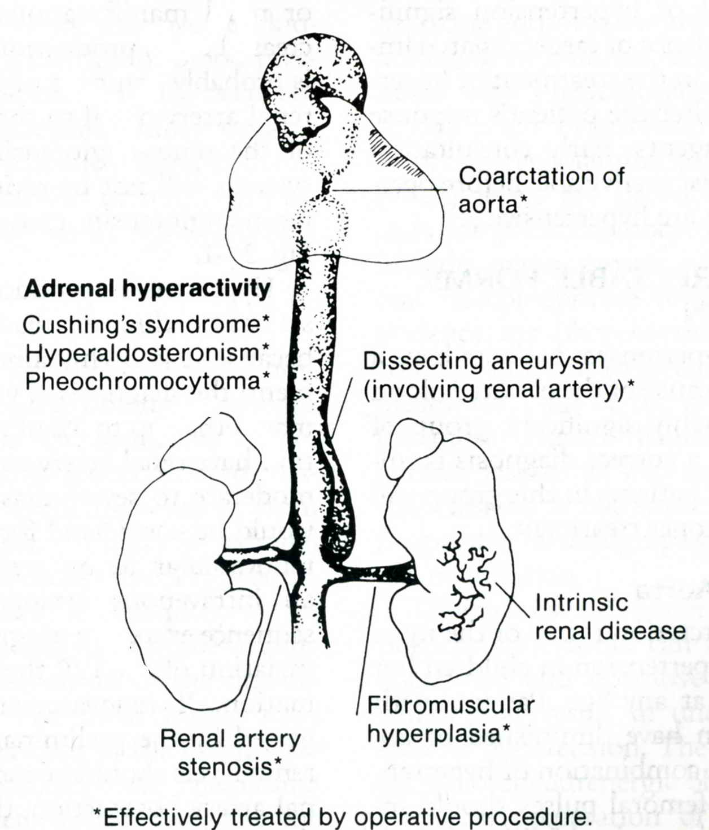

From: Basic surgery/ed., H.C. Polk, Jr., et al. – 5th ed.

Renal artery stenosis

Overview

- Stenosis of the renal artery results in decreased perfusion pressure to the kidney. This reduction stimulates the juxtaglomerular apparatus to release renin, which initiates the formation of angiotensin. This substance is a potential vasoconstrictor and also stimulates the release of aldosterone from the adrenal gland. The end result is systemic hypertension.
- The two most common causes of renal artery stenosis are atherosclerosis and muscular dysplasia (see Scheme 18-1). The latter is a disease that produces single or multiple stenoses of renal arteries, particularly in women. This entity is found in 1% - 5% of hypertensive patients.

Clinical features and visualization data

- The diagnosis should be suspected in patients with the following characteristics: sudden onset of severe hypertension in patients less than 35 or more than 55 years old; sudden worsening of hypertension in a patient who had been well controlled; inability to control blood pressure despite multiple-drug therapy; the presence of flank bruits associated with any of the preceding characteristics.
- Duplex scanning is used to evaluate patients for renal artery stenosis. The technique holds promise as a useful screening test.
- Selective renal arteriography is the definitive examination to demonstrate stenotic lesions of the renal arteries and is essential in planning therapy.
- Laboratory tests (renal vein renin ratio, renal/systemic renin index) may be helpful, although no test is completely reliable.

Treatment

- Medical treatment: antihypertensive drugs can be used to control mild to moderate hypertension from renal artery stenosis (when the diastolic blood pressure is in the 90-100 range). Medical management is a more reasonable approach than surgery in patients with generalized atherosclerosis and less desirable than surgery in children and in patients with fibromuscular dysplasia.
- Percutaneous dilation is a very effective treatment for patients with lesions in the mid-portion of the renal artery (see Fig. 18-1). The lesions frequently occur in this location in patients with fibromuscular dysplasia. Early and late results in well-selected patients are excellent with improvement or cure of hypertension in 90% of patients. The technique is not well suited for atherosclerotic lesions at the origin of the renal artery or for lesions that occur in distal branches of the renal artery.
- Renal artery endarterectomy can be used for unilateral or bilateral localized atherosclerotic osteal lesions of the renal arteries. Nonlocalized lesions in patients with widespread atherosclerosis yield the poorest results.
- Bypass to the renal artery distal to the lesion is the most commonly performed procedure. The saphenous vein in adults and the hypogastric artery in children are the preferred conduits. The aorta above or below the renal artery is usually used as the origin of the graft.
- Stenting procedure may be used in
- A small percentage of patients have multiple lesions, involving both the main artery and the hilar branches. In these patients, the kidney can be removed, cooled and repaired ex vivo. The kidney is then replaced in its anatomic location or transplanted to the pelvis.
- Nephrectomy is an alternative in patients with a unilateral vascular lesion and a normal contralateral kidney. The indication would be refractory hypertension with elevated renin from the involved kidney and suppression of the normal kidney. Nephrectomy is usually chosen for small nonfunctioning kidneys.

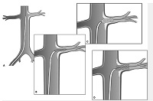

Fig. 18-1. Scheme of percutaneous dilation of renal artery with stent placement

DISORDERS OF ADRENAL GLANDS

- Although not every disorder of adrenal gland leads to hypertension, it’s convenient to include all the disorders into this section.

Diagnostic investigations for pathology of adrenal glands

- CT has been a significant advance in imaging the adrenal glands and in the detection of adrenal masses with an accuracy of 90 per cent (see Fig. 18-2).
- Ultrasonography can detect most adrenal masses larger than 2 cm in diameter, but less accurate.
- A radiograph or CT scan of the pituitary fossa showing its enlargement is suggestive of basophil adenomas of the pituitary gland with excess adrenocorticotrophic hormone (ACTH) pituitary secretion.
- Adrenal gland scintigraphy using NP-59 is of value in addition to CT. In a benign functioning adrenal tumour there is uptake with suppression of the contra lateral gland. By contrast adrenocortical carcinoma does not usually concentrate the isotope and, as a result of contra lateral gland suppression, there is little uptake. Bilateral adrenal hyperplasia produces the opposite result with a prominent bilateral image.
- MRI is of value particularly for small lesions.

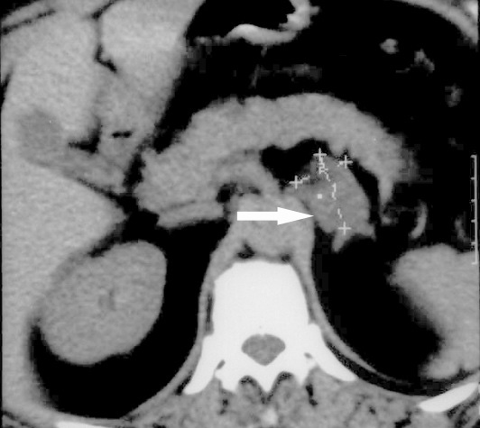

Fig. 18-2. CT picture of tumor of adrenal gland

Hormones of adrenal cortex

- Mineralocorticoids are concerned in the maintenance of water and electrolytic balance. A deficiency of these hormones produces sodium diuresis, potassium retention and dehydration; an excess results in hypertension, edema, cardiac dilatation and hypokalaemia. Aldosterone is the most important of these salt-regulating hormones (see Conn’s syndrome later).
- Glucocorticoids are concerned with the metabolism of proteins and carbohydrates, favouring the formation of the latter from the body’s storehouse of the former (gluconeogenesis). The best known of these are hydrocortisone (also known as cortisol) and cortisone. The therapeutic application of these hormones falls under following headings: adrenocortical insufficiency; treatment of a diversity of diseases, including allergic conditions, granulomatous disorders, blood diseases and the collagenoses; treatment of hypocorticism and shock.
- Sex hormones. Androgenic and estrogenic hormones are produced by the adrenal cortex. Excessive secretion of androgens due to adrenal enzyme deficiencies or tumors causes virilism in females or, rarely, excessive secretion of estrogens brings about effeminacy in males.
- Interhormonic action. The anterior lobe of the pituitary gland secretes ACTH which stimulates the adrenal cortex, whereas the cortisol of the adrenal cortex inhibits the secretion of ACTH. ACTH secretion is also controlled by higher cerebral centers and the hypothalamic corticotrophin-releasing hormone (CRH).

Tests of adrenocortical activity

- Plasma electrolytes. Sodium levels are raised and potassium is low in a hyperfunctioning adrenocortical lesion with the opposite in Addison’s disease (cortical insufficiency), but changes in Addison’s disease may not occur until the patient is approaching crisis.
- Plasma cortisol levels. Diurnal variation with a maximum value at 8.00 am may be lost both in Cushing’s syndrome, where all levels are high, and in insufficiency when levels are low.
- Plasma ACTH levels. Low plasma levels are found with adrenal tumors and high levels with a pituitary lesion or ectopic ACTH production. The ratio of ACTH to related peptides such as beta-lipotrophin may facilitate the distinction between pituitary Cushing’s and ectopic ACTH production.
- Plasma aldosterone levels. The concentration of aldosterone is only one-thousandth that of cortisol, and both dietary sodium and posture may change the value. Plasma renin levels should be measured along with aldosterone to differentiate between primary and secondary hyperaldosteronism.
- There are several following tests for urinary steroid excretion.
- Cortisol secretion rate. The daily output of cortisol is a precise measure of adrenocortical activity, but is routinely performed in only a few centres. The daily output may be determined by the administration of a small amount of radioactive-labelled cortisol, which is metabolised and excreted, and the urinary radioactivity measured. The normal range is 5 - 28 mg per 24 hours, with high levels in Cushing’s syndrome and low levels in adrenal insufficiency.
- Urinary cortisol excretion. The cortisol excretion in a 24-hour urine sample is probably the best screening test for adrenocortical oversecretion.
- 17-Oxosteroids or ketosteroids. These reflect androgen output, and excretion is increased in many women with virilising syndromes.
- Dexamethasone suppression test. Dexamethasone is 25 times more potent than cortisol. Dexamethasone 0.5 mg is administered 6-hourly for 2 days and causes a marked decrease in urinary steroid excretion by inhibiting ACTH production, and thus cortisol, without contributing greatly to the total urinary steroid output. In Cushing’s syndrome, no effect is produced by the dose. Larger doses of up to 2 mg 6-hourly will, over several days, reduce urinary steroid excretion if the overactivity is secondary to bilateral adrenal hyperplasia, but not with an adrenal tumour, which is autonomous. Measurement of the plasma cortisol at 9.00 a.m. after the administration of 2 mg dexamethasone the previous midnight serves as a convenient screening test for Cushing’s syndrome.
- Metyrapone test. This differentiates between excess ACTH production and a lesion in the adrenal cortex causing Cushing’s syndrome. Metyrapone inhibits the biosynthesis of cortisol so plasma levels fall. If the pituitary – adrenal axis is intact, this results in an increase in ACTH production and stimulation of the adrenal cortex. The basal levels of 17-oxosteroids and ketosteroids in the urine are measured for 2 days, 750 mg of metyrapone is given per 4 hours and a 24-hour urine collection completed. A normal response is a two to fourfold increase in the urinary steroids over basal levels. A diminished response in Cushing’s syndrome indicates a primary adrenal lesion.
- Synacthen test. Tetracosactrin (Synacthen) 250 pg is given intramuscularly and blood cortisol measured at 30 and 60 minutes. In normal subjects the basal plasma cortisol should be greater than 60 pg/litre and be at least 70 pg/litre after stimulation. In Addison’s disease the response is impaired.

Disorders of adrenocortical function

Acute hypocorticism (Waterhouse - Friderichsen syndrome)

Overview

- Massive bilateral adrenal cortical haemorrhage occurs in cases of fulminating meningococcal septicaemia and in some cases of streptococcal, staphylococcal or pneumococcal septicaemia.
- Most cases occur in infants and young children, but it can happen in adults with severe haemorrhage or burns.

Clinical features

- The onset is catastrophic, with rigors, hyperpyrexia, cyanosis and vomiting.
- Petechial haemorrhages into the skin which coalesce rapidly into purpuric blotches are a constant feature.
- Profound shock follows, and before long the patient passes into coma. The condition is one of overwhelming sepsis that pursues a galloping course, death occurring in most eases within 48 hours of the onset of symptoms unless correct treatment is given without delay.
- Bilateral tenderness 5 cm below the costal margin, clear urine (oliguria is often present) and an absence of signs in the lungs help to call attention to the adrenal glands.
- It is futile to await the result of a blood culture. In meningoccocal infection the diplococcus may be demonstrated by smears obtained from a punctured petechial spot in the skin.

Treatment

- Antibiotic therapy must be given intensively by the intravenous route.
- Hydrocortisone 100 mg is given intravenously, or intramuscularly if venous access is difficult. Up to 400 mg hydrocortisone may be required in the first 24 hours. Oral medication may be commenced after the first day and then over about 4 days reduced to a maintenance level.
- Oxygen should also be administered.
- Following such treatment, improvement often sets in within 3 hours, and a number of patients has recovered.

Hypocorticism following bilateral adrenalectomy

- If precautions are taken, acute hypocorticism is unusual in the postoperative period.
- Treatment is to give 300 mg hydrocortisone on the first day. Most patients achieve a maintenance dose of 30 mg/day. After about 3 weeks fludrocortisone 0.1 mg may be given.

Postoperative adrenal haemorrhage and infarction

- Adrenal haemorrhage is a rare unexpected cause of deterioration and sudden death in the postoperative period.
- In some cases the left adrenal gland is damaged during radical gastrectomy for carcinoma. In other cases, when adrenal haemorrhage is bilateral, there is no evidence of operative injury, they are usually associated with intra-abdominal sepsis, pneumonia, coagulation defects and cancer.
- Thrombosis of the adrenal veins is the cause of infarction of glands.

Chronic hypocorticism (Addison’s disease)

Overview

- This is due to adrenocortical insufficiency consequent upon progressive destruction with lymphocytic infiltration of the zona reticularis, the zona fasciculata, the zona glomerulosa and the medulla of the adrenal glands, in that order.
- In about 60% of cases the condition is believed to be due to an autoimmune disease, sometimes in association with autoimmune thyroiditis and pernicious anaemia.
- Tuberculosis, metastatic carcinoma and amyloidosis account for the remaining 40 %.

Clinical features

- Addison’s disease usually commences in the third or fourth decade. Sometimes it is the terminal event in cases of adrenogenital hyperplasia.
- The sex distribution is about equal.
- The leading features are muscular weakness and a low blood pressure.
- Irregular dusky pigmentation of the skin, due to deposits of melanin, appears at points of pressure, e.g. garter or belt, and in the flexion creases. Pigmentation of mucous membranes, particularly of the mouth, is often striking.
- When fully established, the course of the disease is punctuated by crises of acute adrenocortical insufficiency (see above).

Treatment

- Treatment is medical. In long-term management, most patients require 20 - 30 mg hydrocortisone in divided doses, with fludrocortisone 0.1 mg daily as mineralocorticoid replacement.
- Signs of overtreatment include hypertension, hypokalaemia and edema; those of under treatment, fatigue and hypotension.
- By the use of replacement corticosteroids, the expectation of life of a patient suffering from Addison’s disease has been extended from up to 3 years to many years.

Prepubertal hypercorticism

- There is never any doubt as to the sex of the infant at birth and during the very early years of life the child is normal. The symptoms commence at about the age of 5 or 6 years.
- In the female. Pubic and axillary hair appear, but there is no gross enlargement of the clitoris. The child is short in stature, the legs being especially stunted, but she looks much older than she is. Puberty is often precocious, menstruation, if it occurs, being scanty. There is a deepening of the voice at this time.
- In the male. The term “infant Hercules” is descriptive. He is extremely short, muscular and hirsute. The genitalia assume adult proportions and spermatozoa are often present in the seminal fluid.
- In both sexes, 17-ketosteroid content of the urine is increased. A very high reading supports the diagnosis of an adrenocortical tumour, which must always be excluded.
- In both males and females, with a later onset or the passage of time, the features of Cushing’s syndrome become superadded.
- Treatment is identical to that of Cushing’s syndrome.

Postpubertal or adult hypercorticism (Cushing’s disease and syndrome)

Overview

- Postpubertal or adult hypercorticism (Cushing’s syndrome) is due to an excessive endogenous production of glucocorticoids, mainly hydrocortisone.
- Pituitary-dependent Cushing’s syndrome (Cushing’s disease) is the commonest form of endogenous hypercorticism accounting for up to two-thirds of all cases. An adrenal adenoma accounts for 20 % and carcinoma (which may be bilateral) for 5 %.
- In the remainder there is no discernible structural alteration in the glands and the condition is due to an ectopic source of an ACTH-like substance being secreted, by either a benign tumour (e.g. bronchial carcinoid) or a malignant tumour of bronchus, mediastinum or pancreas.
- NonACTH-dependent primary adrenocortical hyperplasia is a rare cause of Cushing’s syndrome.
- Alcoholism also must be considered.
- In its most typical form, Cushing’s syndrome is exogenous and is seen in patients treated with large doses of cortisone over long periods for nonendocrine diseases, particularly rheumatoid arthritis, and in patients receiving transplants.
- The female to male ratio is at least 3:1. The great majority of cases (excluding those induced by cortisone therapy) occurs in females between 15 and 30 years of age, in whom it produces highly characteristic features.

Clinical features

- There is a deposition of fat in certain situations. The face becomes rubicund, rounded like a full moon, and the lips are pursed. The abdomen becomes protuberant, the neck thick, the supraclavicular fossae obliterated and a roll of fat appears over the region of the vertebra prominens (buffalo hump). The arms, and especially the legs, are relatively thin, the muscular development is poor, and the patient complains of increasing weakness. The skin becomes of tissue-paper consistency and inelastic.
- Exceedingly characteristic are purple-red striae distentiae, mostly on the abdomen, of a texture that can be likened to an overstretched garter.
- Ecchymoses are frequent and bruising occurs on the slightest trauma.
- Acne is common and there is a low resistance to skin infections.
- Often there is increased growth of lanugo hair, but hirsutism is usually absent.
- Amenorrhoea is usual or, in the male, impotence.
- Owing to a negative calcium balance, the matrix of bone becomes thin and severe osteoporosis results. Pathological fractures, particularly compression fracture of a vertebra, are common, and this is sometimes the first reason for the patient seeking advice.
- Mild glycosuria is often present.
- Hypertension is frequent and eventually congestive heart failure supervenes.
- In about 60 % of cases, various psychoses occur.

Scheme 18-2. Clinical features of Cushing’s disease/syndrome

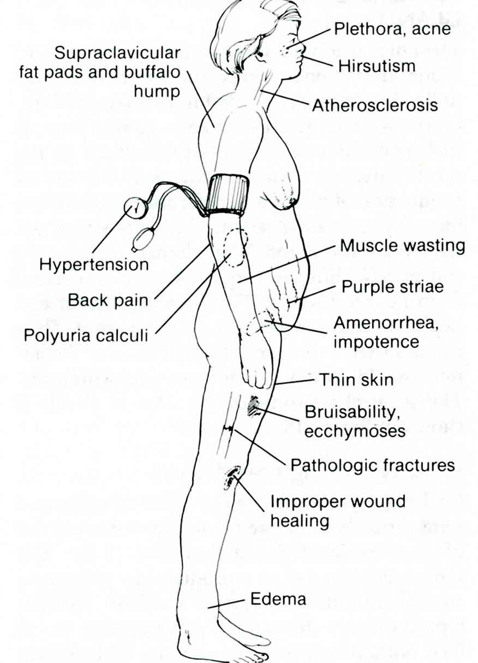

Laboratory data

- There are three simple tests (see above) which may be used to screen patients suspected to have Cushing’s syndrome: plasma cortisol levels and diurnal rhythm; 24-hour urinary free cortisol excretion; overnight dexamethasone suppression test.
- Each of these tests is highly discriminating with false-positive and false-negative results in only about 5 % of cases. However, patients with severe or chronic illness or alcoholism may have elevated midnight plasma cortisol levels and may fail to show overnight suppression after dexamethasone.
- Suspected Cushing’s syndrome may be confirmed by the low-dose dexamethasone suppression test (see above), which is highly reliable.

Differential diagnosis

- After the diagnosis of Cushing’s syndrome has been established, it is necessary to determine the cause of adrenocortical hyperfunction.
- In general, adrenal hyperfunctioning tumors and ectopic ACTH-secreting tumors function autonomously and are unaffected by hormonal manipulation. In contrast, the feedback mechanism in pituitary Cushing’s is functioning although it is abnormal. Thus appropriate investigations (see above) are the high-dose dexamethasone suppression test, measurement of plasma ACTH levels and the metyrapone test, which has largely been replaced by plasma ACTH assay. Nearly all patients with adrenal tumors and with the ectopic ACTH syndrome, in contrast to pituitary Cushing’s, fail to suppress with a high dose of dexamethasone and suppression is indicative of Cushing’s disease.
- In addition, patients with Cushing’s disease or the ectopic ACTH syndrome have detectable or elevated plasma ACTH levels, whereas cortisol-producing adrenal tumors suppress pituitary ACTH secretion and plasma levels are extremely low. A high plasma ACTH level after high-dose dexamethasone indicates autonomous ACTH secretion by a nonpituitary tumor, whereas if the ACTH level is low it indicates the presence of an adrenocortical tumor that has suppressed ACTH secretion by the normal pituitary.

Visualization data

- CT accurately identifies virtually all adrenal tumors in patients with Cushing’s syndrome and has replaced other techniques.
- It is also the most reliable method of detecting nodules in the lungs, mediastinum and pancreas, which are potential sites of ectopic ACTH production.
- Pituitary CT has also replaced other techniques for the detection of pituitary microadenomas in Cushing’s disease, although only 50% of such adenomas are identified.
- Bilateral selective inferior petrosal venous sampling for ACTH levels is a valuable but technically difficult method of confirming and localising pituitary-dependent Cushing’s disease if CT is unhelpful.

Treatment

- Trans-sphenoidal pituitary adenectomy in skilled hands is now the treatment of choice for pituitary lesions. Currently these procedure may be performed cranioscopically in some centers.
- External pituitary irradiation is less reliable in terms of long-term remission but is more successful in children. Yttrium-90 implantation is an alternative form of pituitary irradiation.
- Bilateral total adrenalectomy is a reliable procedure for patients with Cushing’s disease in whom pituitary treatment has failed. The approaches of choice are laparoscopic transabdominal for the right adrenal gland (see Fig. 18-3) and endoscopic retroperitoneal for the left adrenal gland.
- The treatment of an adrenal tumour is surgical resection and resection of benign ectopic ACTH-secreting tumour is curative. Many, however, are malignant and widely disseminated when Cushing’s syndrome becomes clinically apparent.
- Prognosis. Most patients are alive 20 years after successful resection of an adrenal adenoma, but survival beyond 5 years is rare with a carcinoma. Pituitary microadenectomy in expert hands results in cure in about 80 % of patients very rarely, the adrenogenital syndrome appears in youths and men. Owing to excessive production of oestrogenic hormones by the adrenal cortex, gynaecomastia, atrophy of the testicles and psychical signs of effeminacy appear (adrenal feminism).

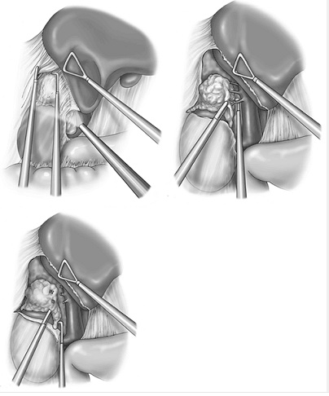

Fig. 18-3. Scheme of laparoscopic right adrenalectomy

Postmenopausal hypercorticism

- Postmenopausal hypercorticism is usually characterised by the growth of a beard and is often accompanied by mental aberration.
- A lesser degree of hirsutism is almost a natural accompaniment of the ageing process, particularly in dark-haired females, and it is difficult to draw the line between the normal and the pathological.
- Thus it is that operative treatment is usually disappointing.

Hyperaldosteronism

Primary aldosteronism (Conn’s syndrome)

- Primary aldosteronism (Conn’s syndrome) is a surgically correctable type of hypertension found in 1 - 2 % of all hypertensive patients.
- The cause is either an aldosteronesecreting adrenal adenoma or bilateral adrenocortical hyperplasia (less common).
- It is characterised by autonomous excessive aldosterone secretion which leads to sodium retention and a fall in serum potassium. The latter causes the typical associated features of the syndrome, namely episodes of muscular weakness associated with polyuria and polydipsia. The plasma sodium is high and the potassium is low. Renin and angiotensin levels are depressed.
- CT and adrenal scanning with radioactive-labelled cholesterol are the appropriate localisation tests to distinguish between them. When these fail, adrenal venous sampling with measurement of aldosterone to cortisol ratios is the next step.
- Unilateral adrenalectomy is the treatment for an aldosterone-producing adenoma and has a high cure rate, whereas surgery has been disappointing in adrenocortical hyperplasia and these patients are generally managed medically.

Secondary aldosteronism

- Secondary aldosteronism is associated with cirrhosis of the liver, and renal artery stenosis with high levels of renin and angiotensin.

The incidental adrenal mass – “incidentaloma”

- CT and MRI have resulted in increasing numbers (up to 1 %) of adrenal tumors being identified in the course of abdominal imaging for the investigation of other conditions.
- The finding may represent an adrenal tumor but more probably a benign lesion.
- Opinion is divided about management but essentially functioning lesions are excised whereas nonfunctioning lesions are managed according to size. Lesions less than 3 cm in size should be followed 3-monthly for a time by CT and excised if they enlarge, whereas those larger than 3 cm should be excised to exclude malignancy.

Adrenal medulla hormones

- The secretion consists of the catecholamines, adrenaline and noradrenaline (80 % of the output is adrenaline and 20 % is noradrenaline). However, in hyperfunctioning medullary tumor (phaeochromocytoma) this ratio is completely reversed.
- Fear, anger, pain and effort give rise to an increased output in response to the stimuli received via the splanchnic nerves.
- Catecholamines exert their effects through specific cell-surface receptors: alpha-receptors and beta-receptors.
- The receptors have quite different pharmacological properties and an organ may have more than one type. The complex actions of catecholamines include altering enzyme activity, metabolic pathways and the permeability of cell membranes to ions.

Tumors of the adrenal medulla

- Tumors of the adrenal medulla are classified as follows: neoplasms of the sympathetic neurons (ganglioneuroma, neuroblastoma); neoplasm of chromaffin cells: phaeochromocytoma.

Ganglioneuroma

- A ganglioneuroma is relatively benign.
- This neoplasm is symptomless, grows to a large size and constitutes one of the varieties of retroperitoneal sarcoma.
- Only 15 % involve the adrenal, the remainder occurring in any position along the sympathetic chain. If removed completely at a comparatively early stage, a cure may be expected.

Neuroblastoma

Overview

- Neuroblastoma is a malignant tumor of neural crest origin arising from sympathetic nervous tissue from the orbit to the pelvis.
- Three-quarters arise in the abdomen and half of these from the adrenal gland.
- It is the most common solid tumor of infancy and childhood, and by far the most common in the newborn.
- The incidence is approximately 1 per 10 000 live births. Ninety per cent of cases of neuroblastoma occur under the age of 8; over half occur in children under 2 years.

Clinical features

- Three-quarters of patients present with an abdominal mass.
- Metastatic spread, via lymphatics and bloodstream, occurs at an early stage, and approximately 70 % of cases have metastases at the time of initial diagnosis.
- Weight loss, failure to thrive, abdominal pain and distension, fever and anaemia may be present. Excessive catecholamine production may cause hypertension, flushing, sweating and general irritability.
- Some of these tumors produce VIP, which results in watery diarrhea and hypokalaemia.
- Acute cerebellar ataxia characterised by opsomyoclonus and chaotic nystagmus or the “dancing eye” syndrome is an unusual manifestation of neuroblastoma of unknown cause.

Visualization data

- Over 80 % of patients excrete catecholamine metabolites in the urine. The most common byproducts assayed in the urine are vanillylmandelic acid (VMA) and homovanillic acid (HVA), and such measurements may be useful in monitoring the course of the disease.
- Plain radiography shows fine, stippled calcification in 50 % of cases.
- Abdominal ultrasound examination shows the anatomical margins and extent of the disease, and is particularly helpful in evaluating the results of treatment.
- CT demonstrates calcium in 80 % of cases and accurately evaluates intraspinal extension as well as hepatic and renal metastatic disease.
- MRI is a promising technique which may supersede CT in many patients. It will also evaluate bone marrow metastases.
- Meta-iodobenzyl-guanidine (MIBG) is metabolised by neuroblastoma cells and may be used for imaging, especially in small residual tumors not evident on other conventional imaging studies.
- Bone-seeking isotope (Tc^{99m}), as well as demonstrating bone involvement, is also concentrated by 60 % of adrenal lesions.

Treatment

- Although surgical excision is the mainstay of cure in localised disease, widespread disease at presentation often makes surgery inappropriate as the primary form of treatment.
- Surgical excision is appropriate in disease confined to one side of the midline, or as a delayed treatment following control by chemotherapy and radiotherapy. However, the cure rare remains low with an overall survival rare of 30 - 35 %.
- Multidrug chemotherapy and radiotherapy are instituted in advanced disease.
- Age has an important favorable influence on prognosis — the younger the patient the better the prognosis, and children in the first year of life have a long-term survival rate of 70 %.

Phaeochromocytoma

Overview

- Phaeochromocytoma has been called the “10 per cent tumor” because approximately 10 % are bilateral, malignant, extra-adrenal, multiple, familial and occur in children.
- Although 90 % of phaeochromocytoma arise in the adrenal medulla, they may be found anywhere along the paraganglionic system. The most common extra-adrenal site is the organ of Zuckerkandl at the aortic bifurcation and less common sites are the urinary bladder, renal hilum, chest and neck.
- Extra-adrenal tumors have a higher incidence of malignancy of 25 - 40 %.
- A phaeochromocytoma is a soft, vascular tumor usually less than 5 cm in diameter but occasionally very much larger.
- This tumor occurs in both sexes, usually during early adult life or middle age. It produces, either intermittently or continuously, an excess of adrenaline, and especially of noradrenaline, causing hypertension which is either paroxysmal or persistent. The latter predominates statistically and probably indicates a late stage of the disease. Consequently all patients under 60 years of age who suffer from sustained arterial hypertension deserve routine tests to confirm or exclude a phaeochromocytoma. Although not more than 0.5 % of cases of hypertension are caused by a phaeochromocyroma.
- Untreated, it progresses to a fatal termination from cardiac dysrhythmia or cerebral haemorrhage.
- The importance of phaeochromocytoma as a component of the multiple endocrine neoplasia syndromes MEN IIa and MEN IIb should be remembered.

Clinical features

- A typical complaint is that of fear – “I thought I was going to die”.
- The most common symptoms, in order of frequency, are: headache (55 %), palpitation, vomiting, swearing, dyspnea, weakness and pallor, i.e. the symptoms of adrenal overdosage.
- The paroxysmal attack may vary from a few minutes to some hours.
- The blood pressure may be very high and hyperglycaemia present.
- The symptoms may be mistaken for hyperthyroidism, hypocalcaemia, an acute anxiety state, paroxysmal atrial tachycardia and carcinoid syndrome.
- The main obstacle to the diagnosis of a phaeochromocytoma is the failure to think of it as a cause of the observed symptoms.

Laboratory data

- The basis of the laboratory diagnosis is measurement of elevated catecholamines and their metabolites in urine and blood.
- Urine studies. Confirmation of the diagnosis is usually readily made by measurement of free catecholamines, VMA and metadrenalines in 24-hour collections of urine. Patients with phaeochrornocytoma usually excrete free catecholamines in excess of 100 pg/24 hours, VMA in excess of 7 mg/24 hours and metadrenalines in excess of 1.3 mg/24 hours.
- Plasma catecholamines. Sensitive assays are now available for plasma catecholamines and patients with phaeochrornocytoma usually have total plasma catecholamines in excess of 1000 pg/ml.

Visualization data

- CT is the method of choice for localisation with an accuracy of 90 - 95 % and has largely replaced more invasive and hazardous techniques such as arteriography and selective venous sampling.
- Because of their size, most adrenal phaeochromocytomas are also visible on ultrasound scanning.
- Radionuclide imaging. The development of a specific radionuclide for catecholamine precursors, iodine-labelled MIBG, has been a significant recent advance in the localisation of adrenal and ectopic phaeochromocytomas. MIBG scanning may be particularly valuable in locating an ectopic phaeochromocytoma when CT shows normal adrenals.

Treatment

- Treatment is surgical excision.

REVIEW TESTS

1. A 76-years-old woman was referred to endocrine surgeon with complaints of refractory hypertension for the last 5 years. Cranial and abdominal CT scans reveal no pathology. Angiography reveals 75 % stenosis of the initial part of left renal artery. Patient has moderate chronic heart failure. What’s the most appropriate tactics of managing the patient?

- Renal artery endarterectomy
- Prolong conservative treatment with antihypertensive drugs
- Percutaneous dilation of stenosis with placement of stent
- Resection of renal part of the aorta with replacement by prosthetic graft

2. A 40-years-old man undergoes an abdominal CT scan for evaluation of blunt abdominal trauma suffered in a motor vehicle accident. Although no traumatic lesions are identified, a 7.0-cm mass of the right adrenal gland is detected. Further workup reveals this mass to be nonfunctional (adrenal hormone levels are normal). What’s the most appropriate tactics of managing the patient?

- Observation and repeat CT scan in 3 months
- Needle biopsy
- Open biopsy
- Right adrenalectomy
- Enucleation of the tumor

Correct answers: 1 - C, 2 - D.

