CHAPTER 19: STROKE (EXTRACRANIAL CEREBROVASCULAR DISEASE)

Overview

- Cerebrovascular accident (stroke) is an injury to the central nervous system resulting in death of brain tissue, it can be a silent event or can result in temporary or permanent loss of function.
- The approximately 600,000 new strokes per year in the United States result in approximately 150,000 deaths (25% mortality).
- Cerebrovascular accidents are the third leading cause of death in the United States.
- Recurrent stroke is the leading cause of death in stroke patients and occurs at the rate of 9% per year.
- Causes include cerebral infarction and hemorrhage. Cerebral infarction (in 85% of cases) is due to embolization (most common), and primary vessel occlusion. Most surgically treatable lesions occur at the carotid bifurcation, and these lesions cause symptoms by producing emboli or by restricting flow to the brain. Hemorrhage (in 15% of cases) is due to intracerebral hemorrhage (most common), subarachnoid hemorrhage (usually due to rupture of an intercranial aneurysm).

Clinical features and visualization data

- Embolization of atherosclerotic debris, fibrin, or platelets from a carotid plaque is the most common cause of ischemic insult to the brain. These emboli can produce a range of symptoms.
- Transient ischemic attacks (TIAs) are episodes of focal neurologic symptoms. The classic TIA syndrome is characterized by abrupt onset; usually the maximal symptoms occur in less than 5 minutes. Rapid resolution occurs usually within 2-15 minutes and always within 24 hours. Neurologic symptoms correspond to a specific hemispheric arterial distribution. No residual neurologic deficits follow resolution. TIAs are frequently associated with a bruit located high in the neck. TIAs are associated with hemispheric neurologic symptoms, including: motor deficit contra lateral to the involved carotid artery; sensory deficit contra lateral to the involved carotid artery; and minor or global aphasia.
- Amaurosis fugax is transient monocular blindness caused by an embolus to a retinal vessel. Examination of the fundus may show a grey fibrin plaque or a bright-yellow (Hollenhorst) cholesterol plaque in a retinal artery.
- Cerebrovascular accident or completed stroke may occur and produce more pronounced clinical presentation.
- A cause-and-effect relationship between the vertebrobasilar vascular system and neurologic symptoms can be very difficult to establish because the symptoms are not as specific. The following symptoms are generally, but not exclusively, related to the posterior circulation of the central nervous system: loss of vision, diplopia; and ataxia or gait disturbance.
- Carotid bruits may be confused with transmitted heart murmurs. Heart murmurs are usually heard bilaterally and in all positions in the neck. Bruits originating in the carotid artery are usually heard high in the neck and may be unilateral. Carotid bruits are not reliable indicators of severe carotid artery disease. Of all patients with hemodynamically significant stenosis, only 50% have bruits. The presence of a carotid bruit is most predictive of a myocardial infarction, not an ipsilateral stroke. Therefore, carotid bruits should alert the examiner to generalized atherosclerotic disease (especially coronary artery disease) not just carotid artery disease.
- A duplex examination of the carotid arteries detects atherosclerotic lesions in the neck and assesses the properties of the blood flow, thus currently is the main diagnostic tool (see Fig. 19-1).
- CT scan should be obtained to look for areas of cerebral infarction or intracranial pathology.
- Arteriography is invasive technique used only preoperatively for determination of distinct location and extent of lesions and in difficult cases of differential diagnosis. CT angiography is very promising noninvasive technique.

A 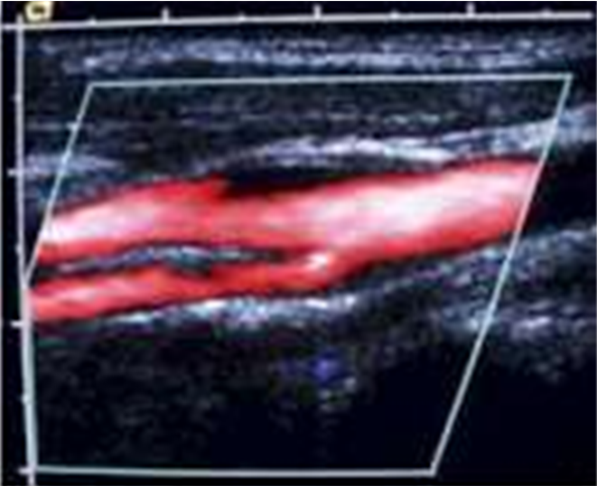 B 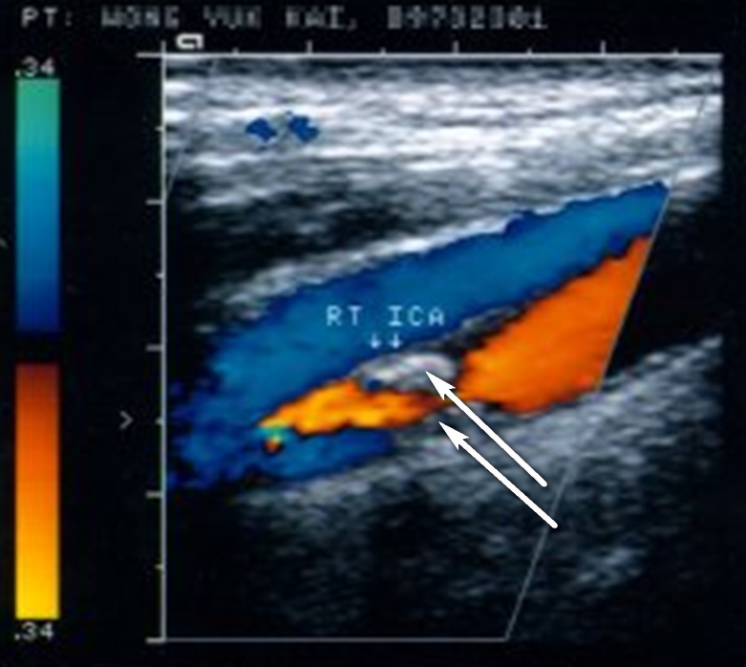

Fig. 19-1. Appearance of duplex ultrasound of carotid artery (A) and ultrasound picture of carotid artery plague (B)

Surgical treatment

- Symptomatic patients with a 70% - 99% carotid artery stenosis in the ipsilateral carotid artery have a highly beneficial effect from carotid endarterectomy (see Fig. 19-2). The 2-year risk of an ipsilateral stroke is 9% in symptomatic patients with a high-grade stenosis treated with surgery and aspirin.
- Asymptomatic carotid stenosis, if it is high-grade (i.e., > 60% diameter reducing) is associated with a stroke rate of approximately 10.6% over 5 years. If the surgery is performed with an operative morbidity and mortality of less than 3%, the 5-year risk of stroke can be reduced to 4.8%.
- Stroke followed by complete or near-complete recovery is an acceptable indication for operation if the patient has an appropriate carotid lesion and is an acceptable candidate for surgery.
- Acute dense neurologic deficit, a totally occluded internal carotid artery, a devastating stroke from which the patient does not recover significant neurologic function, and severe medical illness, which will substantially shorten life expectancy, are indications for surgery.
- Сarotid endarterectomy removes the diseased inner portions of the common, internal, and external carotid arteries. During the operation, the artery is clamped, resulting in decreased blood flow to the brain. Cerebral protection, using a shunt, is used routinely by some surgeons and selectively by others. Complications of the procedure include stroke, transient cerebral ischemia, bleeding, cranial nerve (CN) injury, particularly to CN X and CN XII, and those related to other medical conditions, especially myocardial infarction.
- The alternative technique is PTA with or without placement of stent (see Fig. 19-3). The distinct indications for the procedure have not been established yet, but the method is highly beneficial in terms of minimizing the rate of complications.

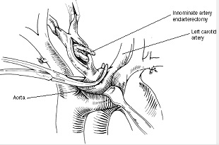

Fig. 19-2. Scheme of carotid endarterectomy

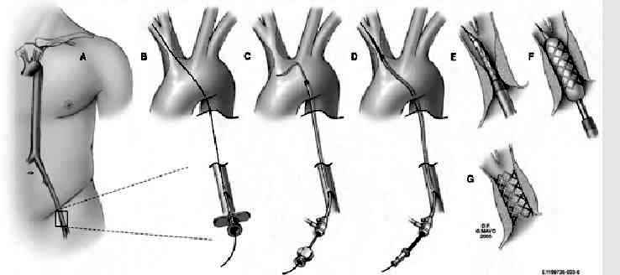

Fig. 19-3. Technique of PTA with placement of stent on carotid artery

REVIEW TESTS

1. A 60-years-old woman was admitted to ER with complaints of weakness in her right arm and leg, and difficulty speaking. This condition resolves after 5 minutes, and she has no residual symptoms. A carotid bruit is not heard, and her electrocardiogram is normal. A carotid duplex ultrasound shows a 75% stenosis of the left carotid artery and an 80% stenosis of the right carotid artery; both are confirmed by a carotid arteriogram. What’s the most appropriate tactics of managing the patient?

- Left carotid endarterectomy
- Right carotid endarterectomy
- Superficial temporal artery to middle cerebral artery bypass
- Percutaneous transluminal angioplasty of the right carotid artery
- Bilateral carotid endarterectomy

2. True or false: Patients with an unstable neurologic condition and a depressed level of consciousness benefit from an urgent carotid artery endarterectomy.

Correct answer: False

3. True or false: A CT scan can reliably diagnose an ischemic cerebral infarction within the first 24 to 48 hours.

Correct answer: False

Correct answers: 1 - A, 2 - False, 3 - False.

