CHAPTER 20: LUMP IN THE BREAST

BENIGN CONDITIONS

- Although fear of breast cancer is what brings most women to the physician, more often than not they have some form of benign breast disease.
- They may present with pain, lumps, or nipple problems.

Infections

Mastitis

- Mastitis (see Fig. 20-1), an infection of the breast, is usually associated with lactation.
- A cracked nipple allows bacteria to enter.
- Treatment is with antibiotics. Mastitis usually requires a minimum course of 10 -14 days.
- An abscess must be surgically drained (see Fig. 20-2).

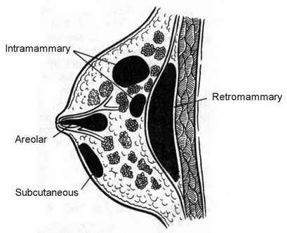
Fig. 20-1. Types of mammary abscesses

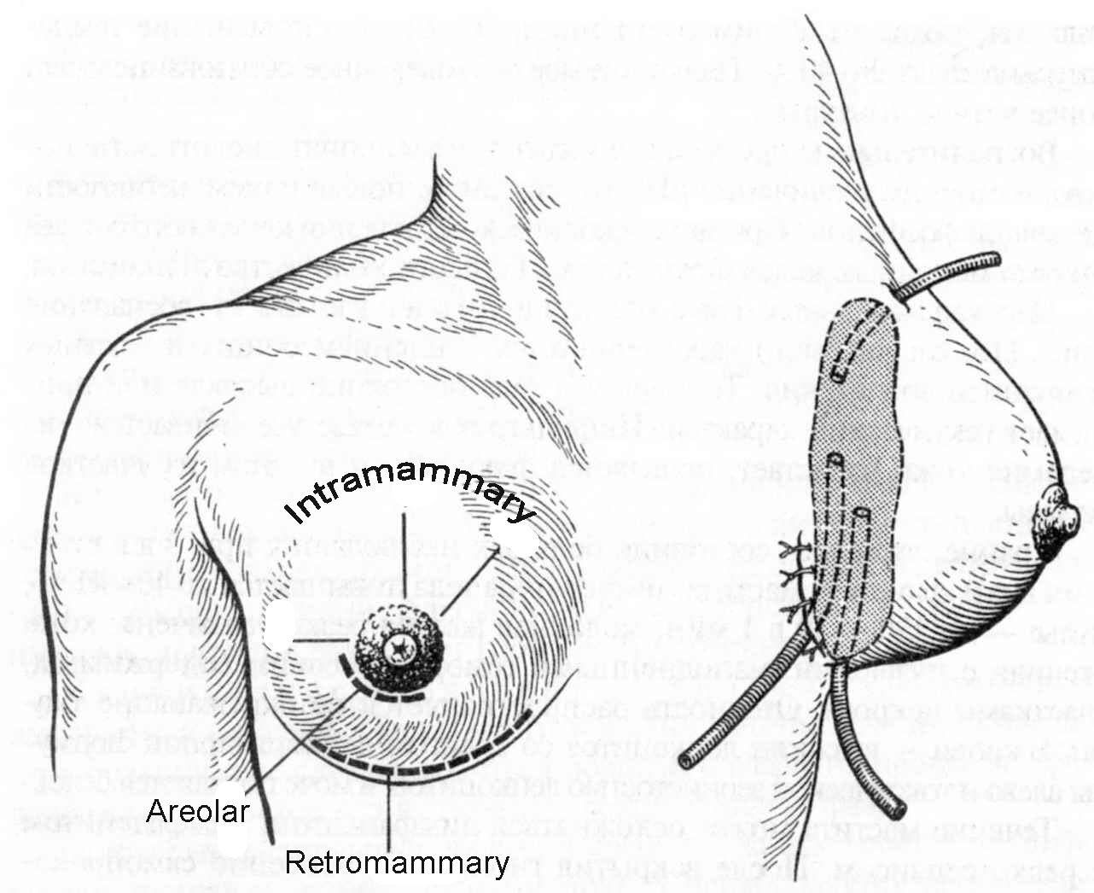

Fig. 20-2. Variants of drainage of mammary abscesses

Chronic subareolar abscess

- Chronic subareolar abscess occurs at the base of the lactiferous duct.
- Squamous metaplasia of the duct may occur and a sinus tract to the areola develops.
- Proper treatment requires complete excision of the sinus tract.
- Recurrences are not uncommon, especially if the entire tract is not excised.

Mondor's disease

- Mondor's disease is phlebitis of the thoracoepigastric vein.
- It is usually self-limited; but if treatment is necessary, anti-inflammatory agents are the choice.

Fibrocystic disorders (chronic cystic mastitis)

Overview

- This term is used for a broad spectrum of benign breast changes. The terminology is inadequate because the correlation between clinical symptoms and histologic changes is poor.
- Sclerosing adenosis is a proliferation of acini in the lobules, which may appear to have invaded the surrounding breast stroma.
- Epithelial hyperplasia can involve ducts or lobules. Moderate ductal hyperplasia is associated with a 1.5 - 3 times higher incidence of breast cancer. Atypical hyperplasia has a 5 times higher risk of breast cancer and may be hard to differentiate from ductal carcinoma in situ.
- Papillomatosis is a proliferation of ductal cells in papillary patterns.
- Stromal fibrosis can obliterate the ducts and lobules in a localized area.
- Galactocele is a milk-filled cyst and is managed like other cysts.

Clinical features and treatment

- Mastalgia occurs in two patterns. Cyclic pain correlates with the menstrual cycle and is usually worst just prior to the menses. Noncyclic pain has no such pattern.
- Nodularity of the breasts may or may not be associated with pain.
- Ultrasound may reveal cysts, single (see Fig. 20-3) or, most commonly, multiple.
- Mammogram should be performed to rule out malignancy (see below).
- Any dominant mass must be biopsied (FNA) to exclude malignancy (see Fig. 20-4).
- Diagnosis of any cysts is by needle aspiration. No further therapy is necessary if the cyst disappears completely after aspiration and the fluid obtained is not bloody (see Scheme 20-1).

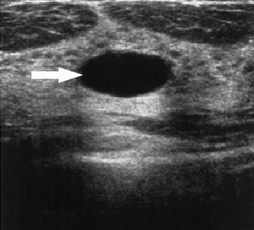

Fig. 20-3. Ultrasound picture of cyst of the breast

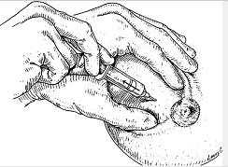

Fig. 20-4. Technique of FNA of lesion of the breast

Mammary duct ectasia

- Mammary duct ectasia, more common in older women, is characterized by dilatation of the subareolar ducts.
- It may be associated with a palpable retroareolar mass, nipple discharge, or retraction.
- Treatment is excision of the area.

Nipple discharge

- Pathologic nipple discharge is persistent, spontaneous, and unassociated with nursing. These discharges require further evaluation.
- Galactorrhea is bilateral, milky nipple discharge. A prolactin level should be obtained; if elevated, a pituitary adenoma should be suspected.
- The most common cause of bloody nipple discharge is an intraductal papilloma, but cancer is present in up to 10% of such cases.
- Cytologic examination can be performed on the discharge.
- A mammogram should be taken to rule out an associated mass.
- The drainage is usually from an isolated nipple duct, which should be excised.

Fibroadenoma

- Fibroadenoma is a benign, well-defined tumor of the breast; its fibrous stromal tissue has an epithelial component.
- These tumors are most common in younger women and, on examination, are distinguished by their mobility.
- Excision (see Fig. 20-8) establishes the diagnosis. The tumors do not need to be removed if the diagnosis is known (e.g., through a fine-needle aspirate).
- Phylloides tumors (previously referred to as cystosarcoma phylloides) are giant
fibroadenomas that rarefy are malignant. They contain more cellular stroma than a fibroadenoma. Malignancy is determined in part by an increased number of mitoses per high-power field in contrast to benign phylloides tumors. Treatment is wide local excision. Inadequate local excision is associated with higher rates of local recurrence. Metastases are rare.

Scheme 20-1. General algorithm of management of lesion of the breast

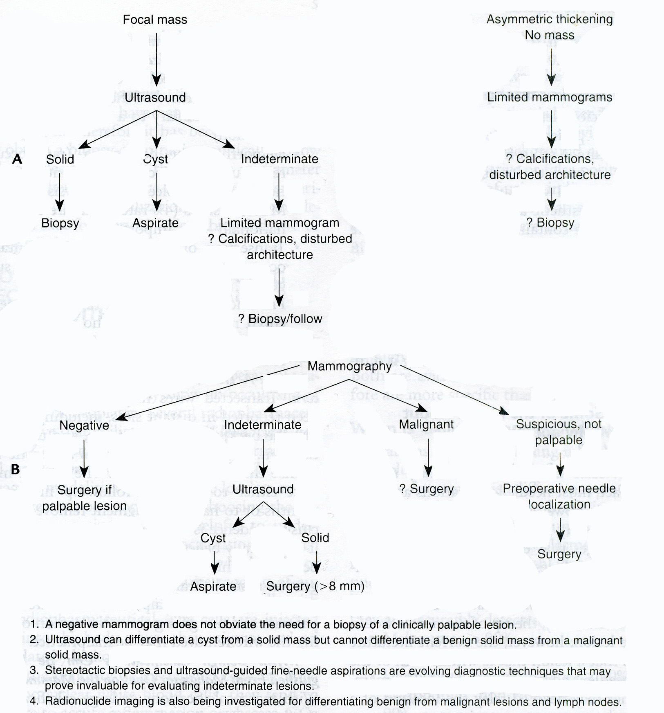
From: Basic surgery/ed., H.C. Polk, Jr., et al. – 5th ed.

CARCINOMA OF THE FEMALE BREAST

Overview

- A woman has a 1 in 8 chance of developing breast cancer at some point in her life.
- The incidence has been increasing over the last several years by approximately 1% each year. This increase is only in part related to early detection.
- Despite advances and improvements in diagnosis and treatment, the mortality rate has not changed significantly in the last several decades.
- Multiple factors listed below increase the risk of developing carcinoma of the breast.
- A family history positive for breast carcinoma produces a 2 to 3 times higher risk. This risk level applies only to first-degree relatives, such as a patient's mother, maternal grandmother, maternal aunts, and sisters. A first-degree relative of a patient with premenopausal breast carcinoma has a 3 times higher risk. A first-degree relative of a patient with bilateral breast carcinoma has a 5 times higher risk. A first-degree relative of a patient with bilateral premenopausal breast carcinoma has an 8 times higher risk.
- A history of chronic cystic mastitis with atypical hyperplasia on histology results in 3 to 6 times higher risk of breast carcinoma.
- A previous incidence of contralateral breast cancer carries a relatively high risk of breast carcinoma occurring in the unaffected breast. A previous adenocarcinoma increases the risk 2 times. For a preceding lobular carcinoma, the likelihood of developing carcinoma in the other breast is 25% - 50%.
- High socioeconomic status carries a high risk of developing breast carcinoma.
- Individuals of western hemisphere extraction have a greater risk of developing breast carcinoma than do those of eastern hemisphere extraction.
- Nulliparous women have a 2 to 3 times higher risk of breast carcinoma than parous women. The risk is lowest in women who become pregnant prior to age 23. Breast feeding may have a small protective effect.
- Women with wet cerumen have a higher risk of breast cancer than women with dry cerumen.
- Estrogen compounds have a variable effect on the development of breast carcinoma in animals. No current evidence has shown that breast cancer in humans is caused by exogenous estrogens.

Clinical features

- Breast lumps are the presenting symptom in 85% - 90% of patients with carcinoma. Approximately 60% of breast masses are discovered by patients on self-examination. Patients may have no symptoms or signs of breast cancer but may be in a high-risk category (i.e., family or personal history of breast cancer) and should be followed closely with mammography and physical examination. They should also be advised to practice breast self-examination. Monthly breast self-examination is recommended, ideally just after the menses.
- Breast pain is rarely a symptom of carcinoma, but this pain should be completely evaluated to eliminate the possibility of malignancy.
- Metastatic disease may also be the initial symptom, either to a distant organ or to the axillary nodes. In 2% of breast cancer cases, patients present with axillary node enlargement but no palpable primary breast tumor.
- Of all patients presenting with isolated axillary enlargement, one third to one half represent occult breast cancer. Hodgkin's disease, lung, ovarian, or pancreatic cancer, and squamous cell carcinoma of the skin must be ruled out. In this situation, a blind mastectomy (i.e., removal of the breast without evidence of malignancy) is indicated.
- Physical examination by a physician is imperative to supplement breast self-examination and radiographic studies because mammograms are negative for 15% of proven breast carcinomas.
- Screening programs, using physical and mammographic examinations of asymptomatic women, have detected many early cancers without axillary node involvement.

Visualization data

- Mammography (using low-dose radiation) reveals breast architecture. Suspicious signs of malignancy are asymmetry, skin thickening, irregular masses (see Fig. 20-5), or architectural distortions. Clustered pleomorphic microcalcifications may also indicate breast cancer. Mammography is useful to follow patients with a previous history of breast cancer, and to screen for subclinical tumors. Despite controversy, most physicians recommend a baseline mammogram by age 35 for asymptomatic women, biannual screening from age 40-50, and yearly mammograms for women over 50.
- Ultrasound is most useful in determining whether a mass (palpable or nonpalpable) is solid or cystic (see Fig. 20-6). Experience with using magnetic resonance imaging to evaluate the breast is also increasing.
- Galactogram should be done to reveal suspected ductal carcinoma (see Fig. 20-7).
- Biopsy of solid breast masses is necessary for diagnosis. Several types of biopsies are available. Any palpable breast mass should be aspirated (see Fig. 20-4). If the lesion is cystic, the mass usually resolves when the fluid is completely aspirated. Recurrence of the mass or bloody fluid in the cyst requires further evaluation. If the lesion is solid, a fine-needle aspirate can be used to extract cells, which can be examined cytologically. The specimen should contain ductal cells to be considered adequate. If the cytology is negative or indeterminate, definitive open biopsy (see Fig. 20-8) may be necessary. Observation is indicated for select young women in whom nodularity or breast lumps appear to be physiologic. These women may be safely watched through one or two menstrual cycles and followed if no change occurs in the physical findings.
- For large, locally advanced lesions, core needle biopsy can be performed in the office.
- For palpable lesions, excisional biopsy (see Fig. 20-8) is most common. This outpatient procedure is often performed under local anesthesia.
- For nonpalpable mammography abnormalities, ultrasound-guided biopsy is performed.
- When preoperative evaluation is complete, the patient with breast cancer should be clinically staged. Criteria for inoperability as defined by Haagensen include: extensive edema of the breast; satellite nodules of carcinoma; inflammatory carcinoma; a parasternal tumor, indicating spread to the internal mammary nodes; supraclavicular metastasis; arm edema; distant metastasis.
- See also Scheme 20-1.

A 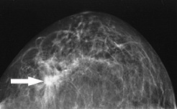 B 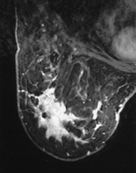

Fig. 20-5. Mammographic pictures of ductal (A) and lobular breast carcinoma

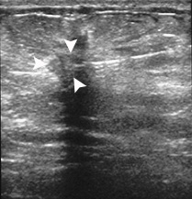

Fig. 20-6. Ultrasound picture of breast carcinoma

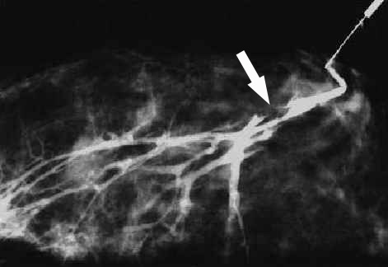

Fig. 20-7. Galactogram demonstrating ductal carcinoma

TNM-classification

Primary tumor (T)

TX Primary tumor cannot be assessed
T0 No evidence of primary tumor
Tis Carcinoma in situ: Intraductal carcinoma, lobular carcinoma in situ, or Paget's disease of the nipple with no demonstrable tumor
T1 Tumor 2 cm or less in greatest dimension
T1a 0.5 cm or less in greatest dimension
T1b >0.5 cm but not >1 cm in greatest dimension
T1c >1 cm but not >2 cm in greatest dimension
T2 Tumor >2 cm but not >5 cm in greatest dimension
T3 Tumor >5 cm in greatest dimension
T4 Tumor of any size with direct extension to chest wall or skin
T4a Extension to chest wall
T4b Edema (including peau d'orange) or ulceration of the skin of the breast or satellite skin nodules confined to the same breast
T4c Both (T4a and T4b)
T4d Inflammatory carcinoma

Regional lymph node involvement (N)

NX Regional lymph nodes cannot be assessed (e.g., previously removed)
N0 No regional lymph node metastasis
N1 Metastasis to movable ipsilateral axillary lymph node(s)
N2 Metastasis to ipsilateral axillary lymph node(s) fixed to one another or to other structures
N3 Metastasis to ipsilateral internal mammary lymph node(s)

Distant metastasis (M)

MX Presence of distant metastasis cannot be assessed
M0 No distant metastasis
M1 Distant metastasis (includes metastasis to ipsilateral supraclavicular lymph nodes)

Stage Grouping

Stage 0 | Tis | N0 | M0
Stage I | T1 | N0 | M0
Stage IIA | T0 | N1 | M0
Stage IIA | T1 | N1 | M0
Stage IIA | T2 | N0 | M0
Stage IIB | T2 | N1 | M0
Stage IIB | T3 | N0 | M0
Stage IIIA | T0 | N2 | M0
Stage IIIA | T1 | N2 | M0
Stage IIIA | T2 | N2 | M0
Stage IIIA | T3 | N1, N2 | M0
Stage IIIB | T4 | N0, N1, N2 | M0
Stage IIIC | Any T | N3 | M0
Stage IV | Any T | Any N | M1

Treatment

- Lumpectomy (partial or segmental mastectomy) (see Fig. 20-8), axillary lymphadenectomy (see Fig. 20-9), and postoperative radiation therapy are combined as the treatment of choice for most stages 0 – II breast cancer. Lumpectomy is defined as removal of the primary lesion, with clear gross margins around the tumor. Axillary lymphadenectomy is defined as removal of level I or II nodes in relation to the axillary vein. Complete axillary dissection is not needed because skip metastases (i.e., involved level III nodes with negative levels I and II nodes) occur in less than 5% of cases. Radiation therapy involves whole breast radiation.
- More radical procedures are performed in such cases: large tumor size compared to small breast size, which compromises the cosmetic results (in general, tumors greater than 5 cm); gross, multifocal disease or diffuse malignant microcalcifications; retroareolar or nipple lesions, unless the nipple-areola complex is removed, which again tends to detract from the cosmetic result.
- Modified radical mastectomy (Patey operation) (see Fig. 20-11) removes the skin, the entire breast, and the axillary contents. The original operation as described also involves removing the pectoralis minor muscle. Breast reconstruction may be performed simultaneously, with either a subpectoral prosthesis or autogenous tissue transfer.
- Radical mastectomy (Halsted procedure) removes the pectoralis major muscle in addition to the muscle that is removed with a modified radical mastectomy. This operation, which is cosmetically deforming, is indicated only when the pectoralis muscle is directly involved.
- Edema of the arm occurs in approximately 10% of women who have had axillary lymphadenectomy and is even higher after mastectomy. This condition may occur acutely or chronically and may be aggravated by radiation therapy to the axilla. Chronic edema can be treated with an elastic sleeve or pneumatic compression device.
- Radiation, along with lumpectomy and axillary dissection, should be the primary approach to patients with stage I and stage II disease. Radiation therapy can be an extremely effective form of palliative therapy in patients with bone or central nervous system metastases – resulting in relief of pain and control of local disease. Radiation therapy can be useful as adjuvant therapy after mastectomy in high-risk patients.
- Chemotherapy or hormone therapy is used in several settings. Adjuvant therapy is designed specifically to eradicate the risk of occult distant disease in stage I and stage II patients. All patients with positive axillary node involvement are felt to be candidates as well as selected high-risk node-negative patients (based on flow cytometry, tumor size, age, and hormone receptor status). The primary application of neoadjuvant therapy is in stage III patients who are otherwise not surgical candidates. The diagnosis is established, several cycles of chemotherapy are given, and it is hoped that bulky local disease is decreased. Future application of neoadjuvant therapy may be in patients with stage I or stage II disease. Chemotherapy and hormone therapy are also used to treat recurrent and metastatic disease.
- Pregnancy at the time of diagnosis of carcinoma of the breast is not a contraindication to mastectomy. Pregnancy is, however, associated with an increased incidence (75%) of positive axillary nodal involvement and, therefore, a worse diagnosis. Chemotherapy presents a danger to the fetus and should be avoided. In selected cases, radiation therapy and breast conservation may be considered. Patients undergoing chemotherapy or radiation therapy may opt to terminate their pregnancies; however, pregnancy termination can usually be avoided.
- See also Scheme 20-2.

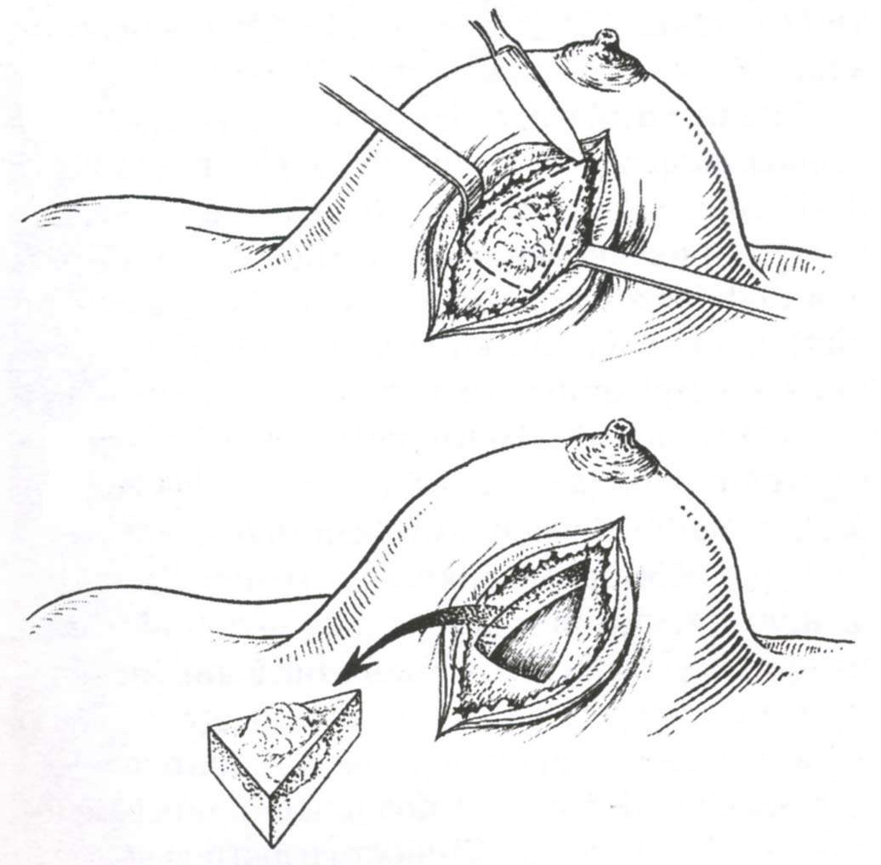

Fig. 20-8. Scheme of lumpectomy (segmental mastectomy)

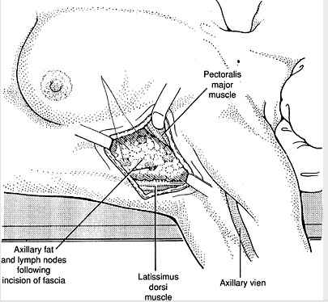

Fig. 20-9. Scheme of axillary lymphadenectomy

A 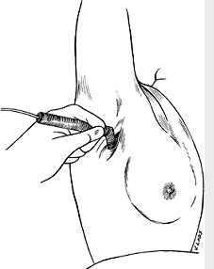 B 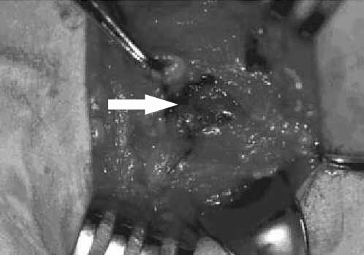

Fig. 20-10. Usage of gamma-probe (A) and blue-stained sentinel lymph nodes (B) for ensuring the adequacy of axillary lymphadenectomy

1 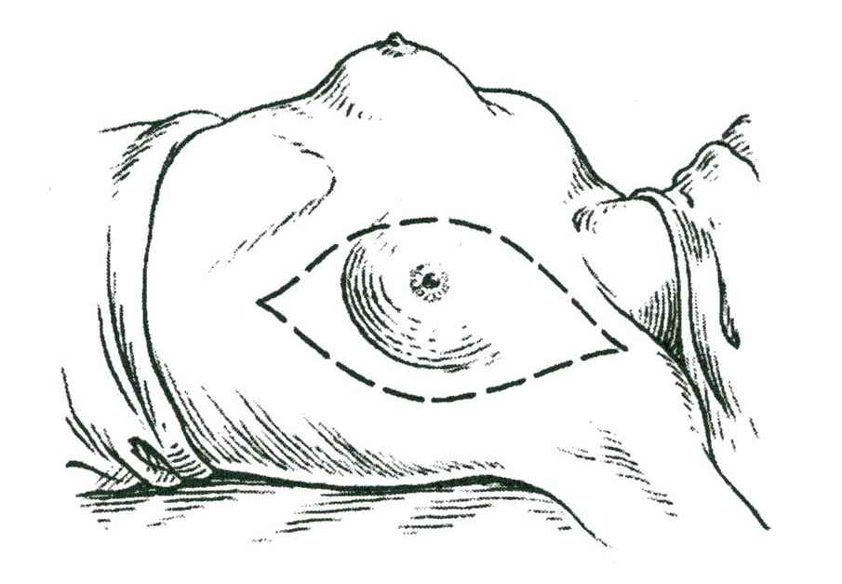 2 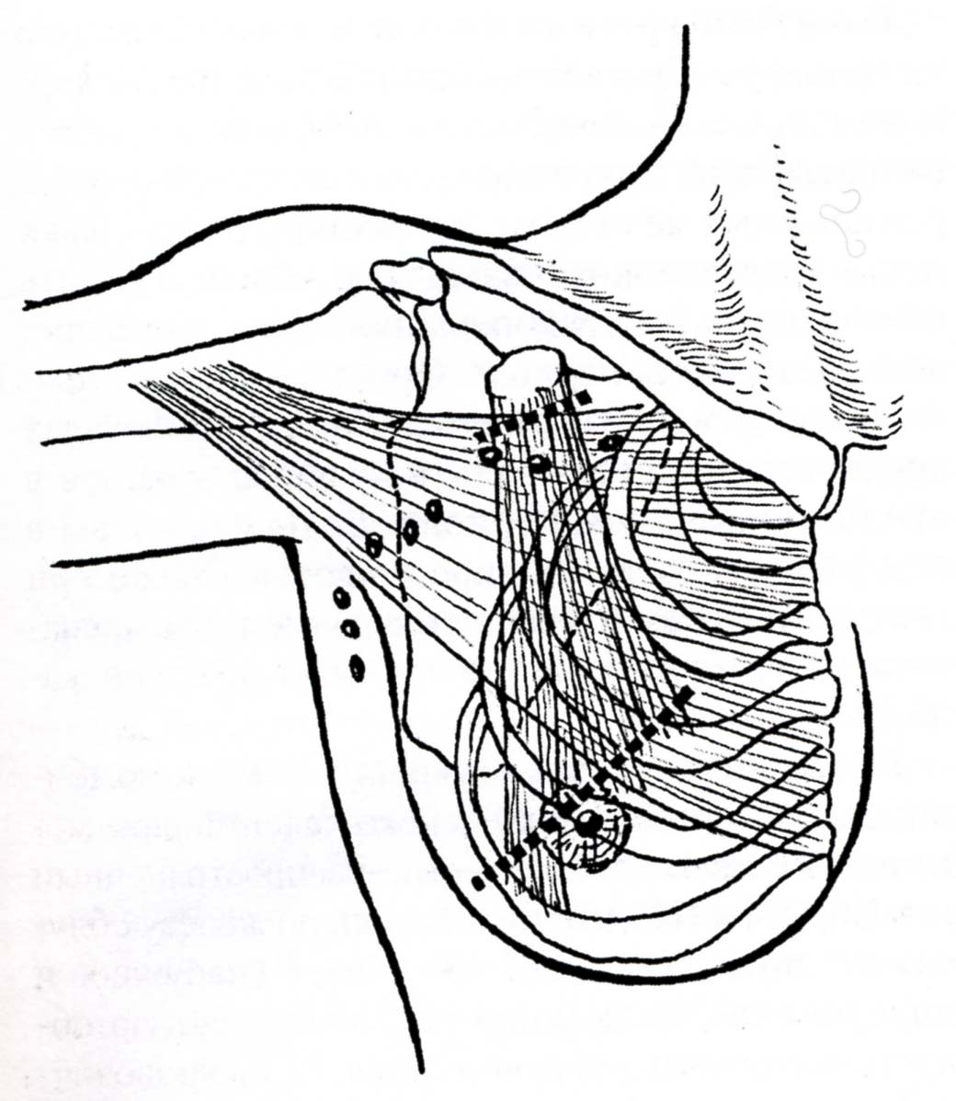

Fig. 20-11. Scheme of Patey operation

Paget's disease

- Paget's disease is an uncommon lesion involving the nipple.
- Histologically vacuolated cells (Paget's cells) are seen in the nipple epidermis and result in an eczematous dermatitis of the nipple.
- This lesion may be associated with an invasive component in the underlying ducts.
- Mammography should be performed to look for a mass.
- Mastectomy is the standard treatment.
- Prognosis is good (80% 10-year survival) if no mass is present and axillary nodes are not involved.

Scheme 20-2. Algorithm of management of breast cancer

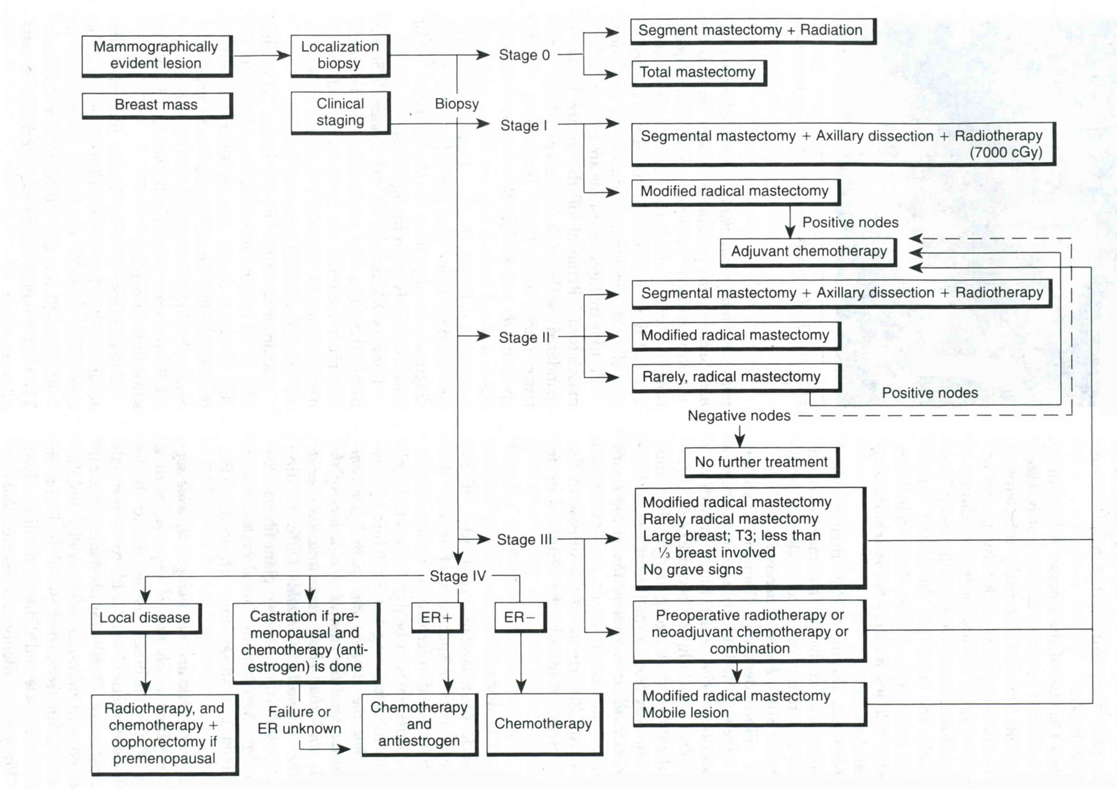
From: Basic surgery/ed., H.C. Polk, Jr., et al. – 5th ed.

Prognosis and follow-up

- Prognosis of patients with carcinoma of the breast strongly depends on a number of clinical and histologic factors at the time of diagnosis.
- Breast cancer prognosis based on stage shows that stage I is characterized by 93% 5-year survival rate, stage II - 72% 5-year survival rate, stage III - 41 % 5-year survival rate, stage IV - 18% 5-year survival rate.
- Follow-up care should continue throughout life to detect local and distant recurrences and new primary tumors in the opposite breast: frequent physical examinations (every 3 months in the first year, every 6 months thereafter); monthly breast self-examination; annual mammography, chest radiograph, and liver function studies.

CARCINOMA OF THE MALE BREAST

Overview

- Cancer of the male breast is uncommon, comprising less than 1 % of all breast cancer.
- Klinefeiter's syndrome has been associated with male breast cancer.
- Many risk factors associated with male breast cancer can be linked to elevated estrogen levels.

Clinical features and visualization data

- Most patients present with a painless unilateral mass.
- Gynecomastia is the primary differential diagnosis.
- Bilaterality favors gynecomastia, as does tenderness.
- A thorough history of drug and hormone use along with alcohol use is necessary.
- Mammography may distinguish between the two.

Treatment

- Treatment is similar to that for carcinoma of the female breast. Radical mastectomy (see above) has been the standard treatment.
- Modified radical mastectomy (see above) may be used if the pectoralis major muscle is not involved.
- Occasionally, a lumpectomy with axillary dissection (see above) and postoperative irradiation can be used if the primary tumor is very small and does not involve the nipple-areola complex.
- Castration is the principal means of endocrine control.
- Survival rates for male breast cancer are probably similar to rates for female breast cancer when compared stage for stage. Male patients tend to present at later stages.

REVIEW TESTS

1. A mammogram reveals a unilateral area of stippled calcification. What’s the most appropriate tactics of managing the patient?

- Repeat mammography in 6 months
- Needle localization biopsy
- Modified radical mastectomy
- Segmental mastectomy and breast irradiation

2. A 65-years-old woman with no other significant past medical history presents with a large mass in the right breast. The mass measures approximately 6 cm in diameter and appears to be fixed to the chest wall. In addition, bulky adenopathy is present in the right axillary region. The patient states that the mass has been enlarging for the last several years. What’s the most appropriate tactics of managing the patient?

- Fine-needle aspiration
- Excisional or core biopsy
- Excisional biopsy
- Modified radical mastectomy
- Radical mastectomy

3. On the basis of core biopsy of breast lesion, the diagnosis for the 65-years-old woman is invasive ductal carcinoma. A mammogram reveals no other lesions in the right breast and no abnormalities in the left breast. A chest radiograph, bone scan, and liver function tests are normal. What’s the most appropriate tactics of managing the patient?

- Neoadjuvant chemotherapy
- Radiation therapy to the breast and axilla
- Radical mastectomy
- Modified radical mastectomy
- Simple mastectomy

4. A 32 -years-old woman who is 33 weeks pregnant was referred to oncologist with a left breast mass measuring 2 cm in diameter. A core biopsy demonstrates an invasive ductal carcinoma of the breast. There are no palpable lymph nodes. Which of the following treatments would NOT be appropriate?

- Modified radical mastectomy and chemotherapy following delivery
- Nuclear isotope guided sentinel node biopsy immediately to assess lymph node status
- Excisional lumpectomy under local anesthetic with delay of further treatment or surgery until after delivery
- Excisional lumpectomy with axillary node excision with radiation therapy and chemotherapy following delivery
- Modified radical mastectomy immediately

5. A 32-years-old woman has bilateral breast masses; both have tested positive for carcinoma. What’s the most appropriate tactics of managing the patient?

- Oophorectomy
- Chemotherapy
- Bilateral definitive operations
- Radiation to both lesions

6. A breast segmental resection reveals a single focus of in situ lobular carcinoma. What’s the most appropriate tactics of managing the patient?

- No further treatment
- Breast irradiation
- Modified radical mastectomy
- Radical mastectomy
- Axillary dissection

7. On breast biopsy, multiple areas of in situ comedo carcinoma are found. What’s the most appropriate tactics of managing the patient?

- Breast irradiation
- Axillary dissection followed by irradiation
- Modified radical mastectomy
- Total mastectomy
- Radical mastectomy

Correct answers: 1 - D, 2 - B, 3 - A, 4 - B, 5 - C, 6 - A, 7 - D.

