CHAPTER 21: NECK MASS

OVERVIEW

- The correct diagnosis of a lump in the neck can often be made with a careful history and examination.
- The clinical signs of size, site, shape, consistency, fixation to skin or deep structures, pulsatility, compressability, transillumination or the presence of a bruit still remain as important as ever.
- The diseases producing mass effect of the neck and their percentage are collected in Schemes 21-1, 21-2, 21-3.

Scheme 21-1. Cause and relative frequency distribution of 100 theoretic cervical masses
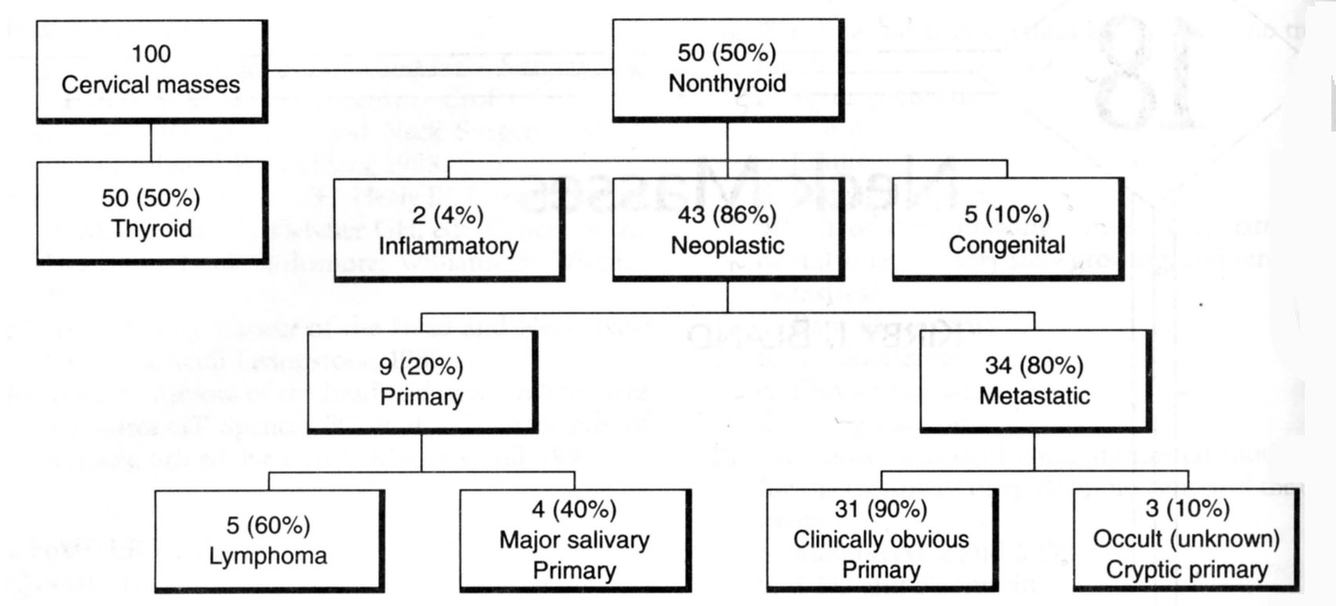
From: Basic surgery/ed., H.C. Polk, Jr., et al. – 5th ed.

Scheme 21-2. Common benign and malignant lesions of the head and neck in adults
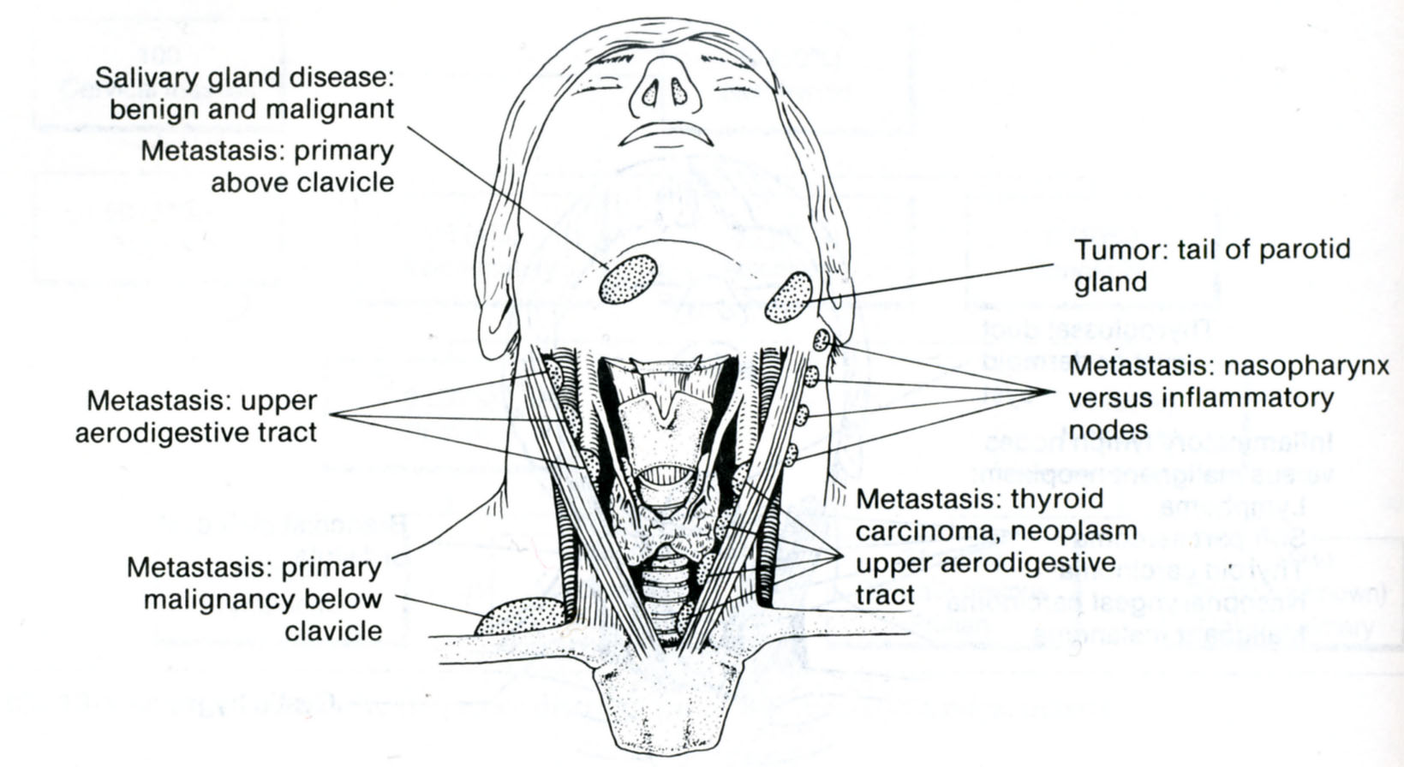
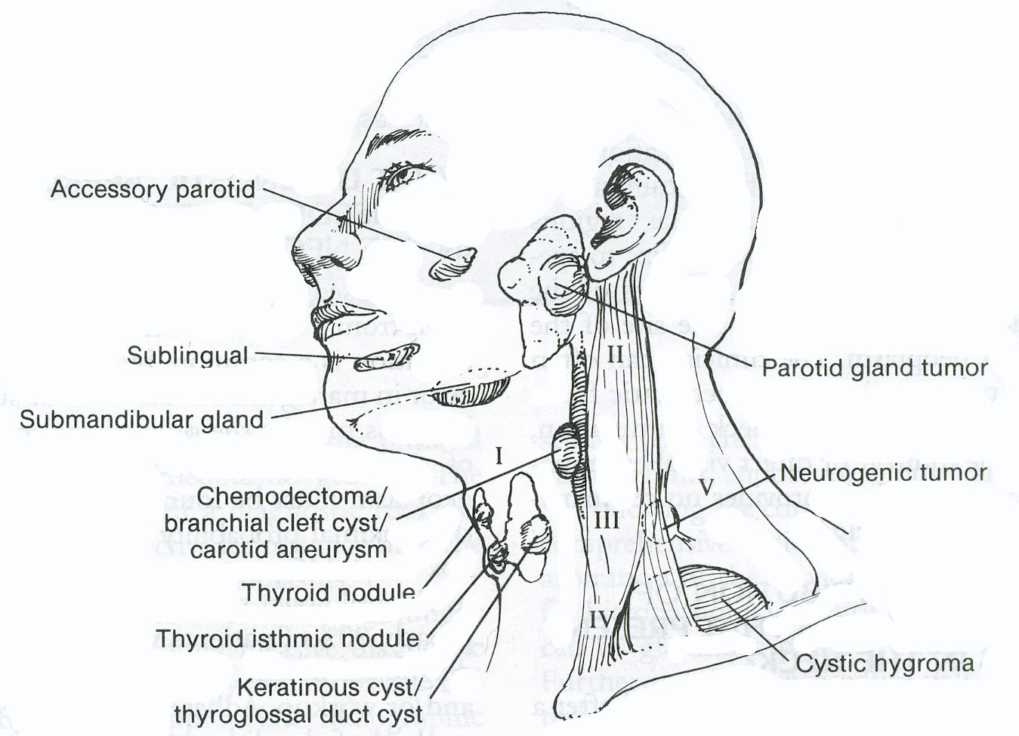

From: Basic surgery/ed., H.C. Polk, Jr., et al. – 5th ed.

Scheme 21-3. Common benign and malignant lesions of the head and neck in children
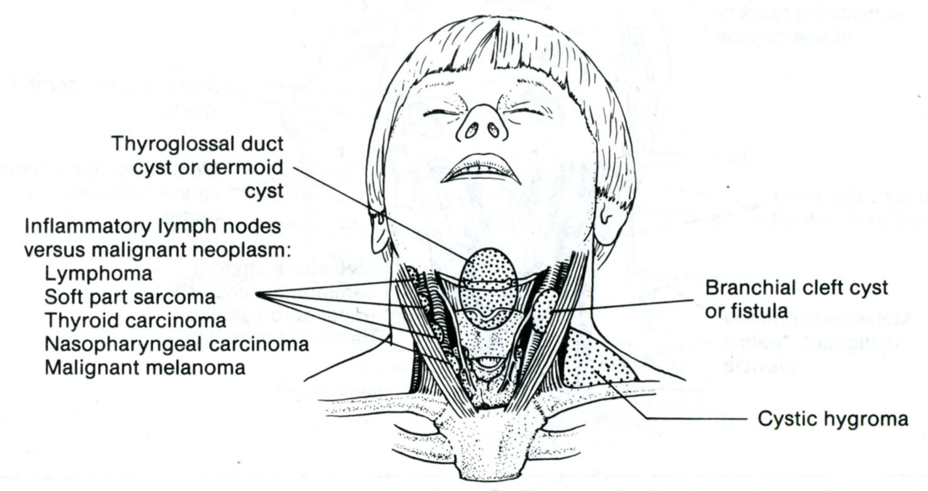
From: Basic surgery/ed., H.C. Polk, Jr., et al. – 5th ed.

CYSTS AND FISTULAS UNRELATED TO THYROID GLAND

Branchial cyst

- A branchial cyst develops from the vestigial remnants of the second branchial cleft, is usually lined by squamous epithelium and contains thick turbid fluid full of cholesterol crystals.
- The branchial cyst usually presents in the upper neck in early or middle adulthood and is found at the junction of the upper third and middle third of the sternomastoid muscle at its anterior border. It is a fluctuant swelling which may transilluminate and is often soft in its early stages so that it may be difficult to palpate.
- If infection occurs it may become markedly erythematous and tender.
- Ultrasound and fine needle aspiration both aid with diagnosis, and treatment is by complete excision. This is best undertaken when the lesion is quiescent as attempted excision of an acutely inflammed cyst may convert it into a branchial sinus which may be more troublesome.
- Although the anterior aspect of the cyst is easy to dissect, it may pass backwards and upwards through the fork of the common carotid artery as far as the pharyngeal constrictors. It passes superficial to the hypoglossal and glossopharyngeal nerves but deep to the posterior belly of the diagastric. The hypoglossal and spinal accessory nerve are encountered in the operative field and must be positively identified to avoid damage.
- Microscopic examination of these cysts commonly shows a layer of lymphoid tissue suggesting that these cysts may arise as a result of branchial epithelium entrapped within a lymph node.

Branchial fistula

- A branchial fistula may be unilateral or bilateral and are thought to represent a persistent second branchial cleft.
- Their external orifice is nearly always situated in the lower third of the neck near the anterior border of the sternocleidomastoid, whilst the internal orifice is located on the anterior aspect of the posterior faucial pillar just behind the tonsil.
- However, the internal aspect of the tract may well end blindly at or close to the lateral pharyngeal wall, constituting a sinus rather than a fistula.
- The tract is lined by ciliated columnar epithelium and as such there may be a small amount of recurrent mucous or mucopurulent discharge on to the neck.
- The tract follows the same path as a branchial cyst and requires complete excision often by more than one transverse incision in the neck.

Branchogenic carcinoma

- It is doubtful whether a primary carcinoma occurs in association with a branchial cyst and it is almost certainly due to cystic degeneration in a lymph node containing a deposit of squamous carcinoma.
- The primary focus giving rise to the squamous carcinoma may not be apparent, but is usually in the nasopharynx, tonsil, tongue base, piriform fossa or supraglottic larynx.
- Full examination, scanning and biopsy of these areas is necessary to exclude the occult primary.

Cystic hygroma (cavernous lymphangioma)

- Sequestration of a portion of the jugular lymph sac from the lymphatic system accounts for the appearance of these swellings.
- Cystic hygroma usually manifests itself in the neonate or in early infancy, and occasionally may be present at birth and be so large as to obstruct labour.
- Swelling usually occurs in the lower third of the neck and as it enlarges it passes upwards towards the ear. Often the posterior triangle of the neck is mainly involved. As a result of the intercommunication of its many compartments, the swelling is soft and partially compressible, it visibly increases in size when the child coughs or cries, but the characteristic that distinguishes it from all other neck swellings is that it is brilliantly translucent.
- The cheek, axilla, groin and mediastinum are other, although less frequent, sites for a cystic hygroma.
- They sometimes expand rapidly and occasionally respiratory difficulty ensues demanding immediate aspiration of much of the cyst’s contents and even, on occasion, a tracheostomy.
- The lesion may become infected when it becomes inflamed and painful.
- Spontaneous regression may occur.
- The cysts are filled with clear lymph and lined by a single layer of epithelium with a mosaic appearance.
- Definitive treatment is excision of all of the cyst at an early stage. This requires a meticulous conservative neck dissection with excision of all lymphatic-bearing tissues whilst preserving the normal neurovascular structures if possible.

Thyroglossal duct cysts

- At the time of its descent the hyoid bone has not been formed and the track of the descent of the thyroid gland is variable passing in front, through or behind the eventual position of the hyoid body. Thyroglossal duct cysts represent a persistence of this track and may therefore be found anywhere in or adjacent to the midline from the tongue base to the thyroid isthmus. Rarely, a thyroglossal cyst may be the only functioning thyroid tissue in the body.
- The cysts almost always arise in the midline but when they are adjacent to the thyroid cartilage they may lie slightly to one side of the midline. Classically, the cyst moves upwards on swallowing and notably with tongue protrusion but this may occur with other midline cysts, such as dermoid cysts, as it merely indicates attachment to the hyoid bone.
- Thyroglossal cysts may become infected and rupture on to the skin of the neck presenting as a discharging sinus. Whilst they often occur in children they may also present in adults even as late as the sixth or seventh decade of life.
- Treatment must include excision of the whole thryoglossal tract which involves removal of the body of the hyoid bone and the suprahyoid tract through the tongue base to the vallecula at the site of the primitive foramen caecum together with a core of tissue on either side. This operation is known as Sistrunk’s operation and prevents recurrence, most notably from small side branches of the thyroglossal tract.

Thyroglossal fistula

- Thyroglossal flstula is never congenital: it follows infection or inadequate removal of a thyroglossal cyst.
- Characteristically the cutaneous opening of such a fistula is drawn upwards on protrusion of the tongue.
- A thyroglossal fistula is lined by columnar epithelium, discharges mucus, and is the seat of recurrent attacks of inflammation.
- Because the thyroglossal tract is so closely related to the body of the hyoid bone, this central part must be excised, together with the cyst or fistula, or recurrence is certain. When the thyroglossal tract can be traced upwards towards the foramen caecum, it must be excised with the central section of the body of the hyoid bone, and a central core of lingual muscle (Sistrunk’s operation).

INFLAMMATORY CONDITIONS OF THE NECK

Cervical lymphadenitis

- There are approximately 800 lymph nodes in the body; no fewer than 300 of them lie in the neck (see Scheme 21-4).
- Inflammation of the lymph nodes of the neck is exceedingly common. Infection occurs from the oral and nasal cavities, the pharynx, larynx, ear, scalp and face. The source of the infection must be sought systematically.

Scheme 21-4. Lymph nodes of the neck

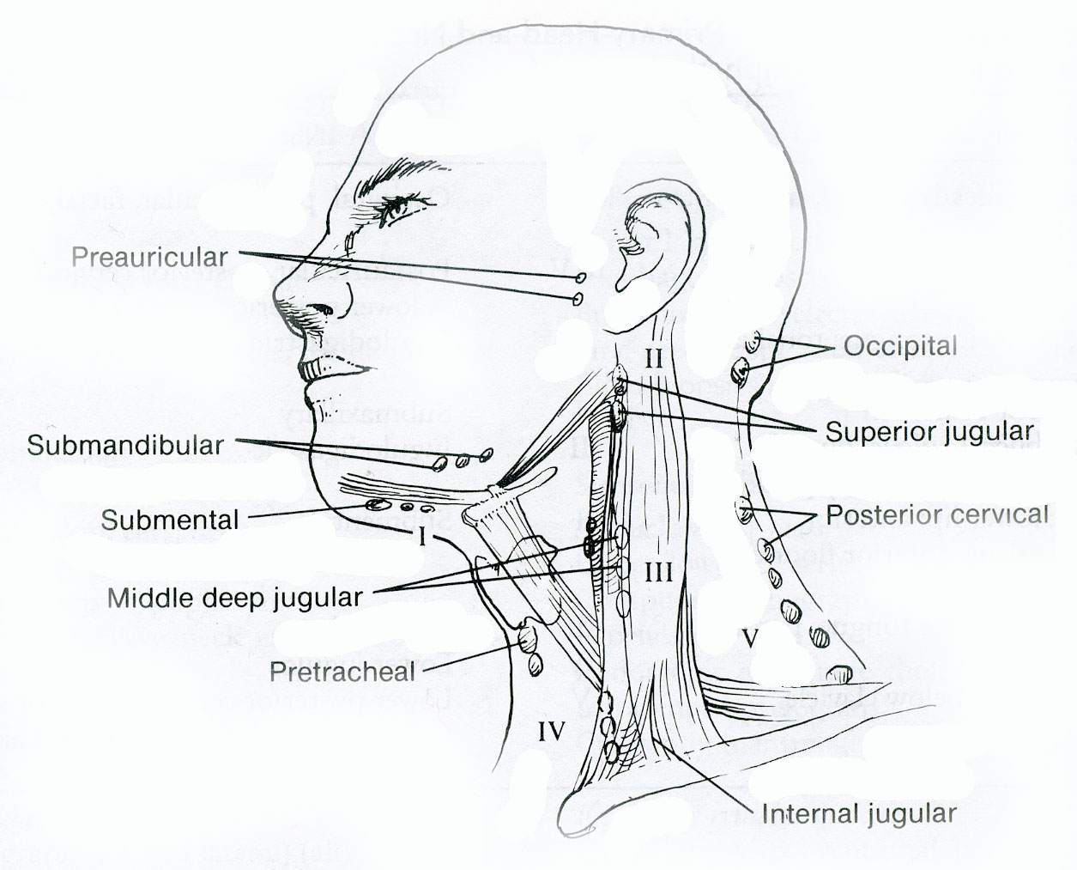

Acute lymphadenitis

- The affected lymph nodes are enlarged and tender, and there may be varying degrees of general constitutional disturbance of the patient with pyrexia, anorexia and general malaise.
- The treatment in the first instance is directed to the primary focus of infection, for example tonsillitis or a dental abscess. If, despite antibiotic therapy, the pain continues or abscess formation occurs in the lymph nodes, parapharyngeal or retropharyngeal space then surgical drainage may be required.

Chronic lymphadenitis

- Chronic painless lymphadenopathy may be either tuberculous, in children or young adults, or due to secondary malignant metastases most commonly from a squamous carcinoma in older people.
- Lymphoma also commonly presents in cervical nodes in young adults. Careful inspection of the upper airways and food passages is essential to exclude primary malignancy of the nasopharynx, tonsil, tongue base, piriform fossa or larynx.
- Fine needle aspiration of enlarged cervical lymph nodes is preferable to any form of open biopsy.

PRIMARY TUMORS OF THE NECK

Neurogenous tumors

Chemodectoma (carotid body tumor)

Overview

- This is a rare tumor but there is a higher incidence in areas where people live at high altitudes, where increased numbers have been reported as a consequence of chronic hypoxia leading to carotid body hyperplasia.
- The tumors most commonly present in the fifth decade and approximately 10 % of patients have a family history.
- There is an association with phaeochromocytoma.
- The tumors arise from the chemoreceptor cells on the medial side of the carotid bulb and at this point the tumor is adherent to the carotid wall. The cells of the chemodectoma are not hormonally active and the tumors are usually benign with only a few proven metastases in a small number of cases.

Clinical features

- The patients often present with a long history of several years of a slowly enlarging painless lump at the carotid bifurcation. About one-third of patients present with a pharyngeal mass pushing the tonsil medially and anteriorly. The mass is firm, rubbery, pulsatile and is mobile from side to side but not up and down, and can sometimes be emptied by firm pressure, after which it will slowly refill in a pulsatile manner.
- A bruit may also be present.
- Swellings in the parapharyngeal space which often displace the tonsil medially should not be biopsied from within the mouth.
- When a chemodectoma is suspected a duplex study and, if indicated, a carotid angiogram should be carried out to demonstrate the carotid bifurcation which is usually splayed and a blush which outlines the normal tumor vessels.
- This tumor must not be biopsied and fine needle aspiration is also contraindicated.

Treatment

- Because these tumors rarely metastasise and their overall rate of growth is slow, the need for surgical removal must be considered carefully as complications of surgery are potentially serious. The operation is best avoided in elderly patients.
- Radiotherapy has no effect.
- In some cases it may be possible to dissect the tumor away from the carotid bifurcation, but at times when the tumor is barge it may not be separable from the vessels and resection will be necessary such that all appropriate facilities should be available to establish a bypass whilst a vein autograft is inserted to restore arterial continuity in the carotid system.

Vagal paragangliomas

- Vagal paragangliomas arise from nests of paraganglionic tissue of the vagus nerve just below the base of the skull near the jugular foramen.
- They also present as slowly growing and painless masses in the anterolateral aspect of the neck, and may also have a long history commonly of 2 – 3 years before diagnosis.
- Diagnosis is confirmed by CT and MRI scanning and additional arteriography if necessary.
- They may spread into the cranial cavity and surgery may be required.

Peripheral nerve tumors

- Schwannomas are solitary and encapsulated tumors attached to or surrounded by a nerve. The vagus nerve is the commonest site for these tumors within the neck. Paralysis of the associated nerve is unusual.

Neurofibromas

- Neurofibromas also arise from the Schwann cell and may be part of von Recklinghausen syndrome of multiple neurofibromatosis.
- Multiple neurofibromatosis is an autosomal dominant hereditary disease and the neurofibromata may be present at birth and often multiple.
- These lesions may occur in the neck and in about 10 % of these tumors malignant change occurs, although they usually enlarge slowly over a period of many years and the painless neck mass is the only sign.
- As with the lesions above, diagnosis requires angiography and scanning to differentiate them from other parapharyngeal tumors, but on occasions the diagnosis must wait until excision.

Secondary carcinoma of the neck

- Secondary carcinomatous infiltration of the cervical lymph nodes is a common occurrence from important primary sites in the head and neck. These are nasopharynx, tonsil, tongue, piriform fossa and supraglottic larynx.
- All of these areas must be carefully assessed to search for the primary growth before considering biopsy or any surgery on the neck. Investigation is further assisted by fine needle aspirate of the neck node.
- The management of the involved cervical lymph nodes depends on the overall treatment regime to be given to the patient.
- If surgery is being used to treat the primary disease and the cervical nodes are palpable, and in excess of 3 cm, they may be excised en bloc with the primary lesion.
- If radiotherapy is used initially, as is always the case in carcinoma of the nasopharynx, then radiotherapy may also be given to the neck nodes whatever their stage.
- In the case of tongue, pharynx or larynx, however, if the node exceeds 3 cm in diameter then surgery may be necessary for the neck nodes even if the primary is treated by radiotherapy.
- If radiotherapy is used initially with resolution of the primary but there is subsequent residual or recurrent nodal disease then this situation will require cervical lymph node dissection. Classical radical neck dissection (Crile) – the classic operation involves resection of the cervical lymphatics, the lymph nodes and those structures closely associated such as the internal jugular vein, the accessory nerve, the submandibular gland and the sternomastoid muscle. Modified radical neck dissection – in selected cases one or more of the three following structures are preserved, the accessory nerve, the sternocleidomastoid muscle or the internal jugular vein, but otherwise all major lymph node groups and lymphatics are excised. Selective neck dissection – in this type of dissection one or more of the major lymph node groups is preserved along with sternomastoid muscle, accessory nerve and internal jugular vein.

Table 21-1. Diagnostic approach to a cervical mass with an unknown primary site

History

Persistent hoarseness, voice change
Dysphasia, pain, sore throat, epistaxis
Prior therapy for skin cancer (e.g., melanoma, epidermoid)

Physical examination

Face and scalp, skin, ears, neck
External auditory canals
Inspect oropharynx, hypopharynx
Perform comprehensive neck examination, indirect laryngoscopy

Radiographic examination (to be completed before biopsies or invasive diagnostic studies are performed)
Chest radiograph (all)
Lateral neck views (if suspicious of thyroid cancer)
Ultrasonography of neck (select cystic vs. solid cervical/thyroid mass)
Facial sinuses/laryngeal tomograms (all)
Computed tomography of head, neck, larynx (select)
Sialogram (select)
Thyroid scan RAI (select)
Esophagogram (select)

Follow-up examination and procedures

Direct laryngoscopy (all)
Esophagogastroscopy (select)
Bronchoscopy (select, with cytology of washings)
Fine-needle aspiration of cervical nodes (select)
Blind biopsies of base of tongue, nasopharynx (select)

Subsequent evaluations

Supraclavicular mass:
Upper/lower GI series
Computed tomography/MRI of chest, abdomen, pelvis
Endoscopic retrograde cholangiopancreatography
Intravenous pyelogram
Cytoscopy, mammography
If primary remains undetected: Open biopsy - conventional neck incision to obtain tissue of cervical mass/nodes for frozen section; delay radical neck dissection if frozen section results are equivocal

From: Basic surgery/ed., H.C. Polk, Jr., et al. – 5th ed.

EVALUATION OF THYROID GLAND

Thyroid gland hormones

- The hormones tri-iodothyronine (T3) and thyroxine (T4) are bound to thyroglobulin within the colloid. Synthesis within the thyroglobulin complex is controlled by several enzymes, in distinct steps: trapping of inorganic iodide from the blood; oxidation of iodide to iodine; binding of iodine with tyrosine to form iodotyrosines; coupling of mono-iodotyrosines and di-iodotyrosines to form T3 and T4; when hormones are required the complex is resorbed into the cell and thyroglobulin broken down.
- T3 and T4 are liberated and enter the blood where they are bound to serum proteins: albumin and thyroxine binding globulin (TBG) and prealbumin (TBPA).
- T3 is quick acting (within a few hours) whereas T4 acts more slowly (4 - 14 days). T3 is the more important physiological hormone and is also produced in the periphery by conversion from T4.
- Synthesis and liberation of thyroid hormones from the thyroid is controlled by thyroid-stimulating hormone (TSH) from the anterior pituitary. Secretion of TSH depends upon the level of circulating thyroid hormones and is modified in a classic negative feedback manner (in hyperthyroidism, where hormone levels in the blood are high, TSH production is suppressed whereas in hypothyroidism it is stimulated). Regulation of TSH secretion also results from the action of thyrotrophin-releasing hormone (TRH) produced in the hypothalamus.
- Thyroid-stimulating antibodies. A family of IgG immunoglobulins binds with TSH receptor sites (TRAbs) and activate TSH receptors on the follicular cell membrane. They have a more protracted action than TSH (16 – 24 hours versus 1.5 – 3 hours) and are responsible for virtually all cases of thyrotoxicosis not due to autonomous toxic nodules. Serum concentrations are very low and not routinely measured.

Tests of thyroid function

Serum thyroid hormones and TSH

- Interpretation of deranged TSH levels however depends on knowledge of the T3 and T4 values.
- In the euthyroid state, T3, T4 and TSH levels will all be within the normal range.
- Florid thyroid failure results in depressed T3 and T4 levels with gross elevation of the TSH.
- Incipient or developing thyroid failure is characterised by low normal values of T3 and T4 and elevation of the TSH.
- In toxic states the TSH level is suppressed and undetectable.

Isotope scanning

- The uptake by the thyroid of a low dose of either radiolabelled iodine (¹²³I) or technetium (^{99m}Tc), will demonstrate the distribution of activity in the whole gland (see Fig. ).
- This test is inappropriate for distinguishing benign from malignant lesions because the majority (80 %) of cold swellings is benign and some (5 %) functioning or warm swellings will be malignant.
- Its principal value is in the toxic patient with a nodule or nodularity of the thyroid.
- Localisation of overactivity in the gland will differentiate between a toxic nodule with suppression of the remainder of the gland and toxic multi-nodular goitre with several areas of increased uptake with important implications for therapy.
- Routine isotope scanning is unnecessary.
- Whole body scanning is used to demonstrate metastases but the patient must have all normally functioning thyroid tissue ablated either by surgery or by ablation with high-dose radioiodine before the scan is performed because thyroid cancer cannot compete with normal thyroid tissue in the uptake of iodine.
- See also Scheme 21-5.

Scheme 21-5. Diagnostic value of ^{99m}Tc scan

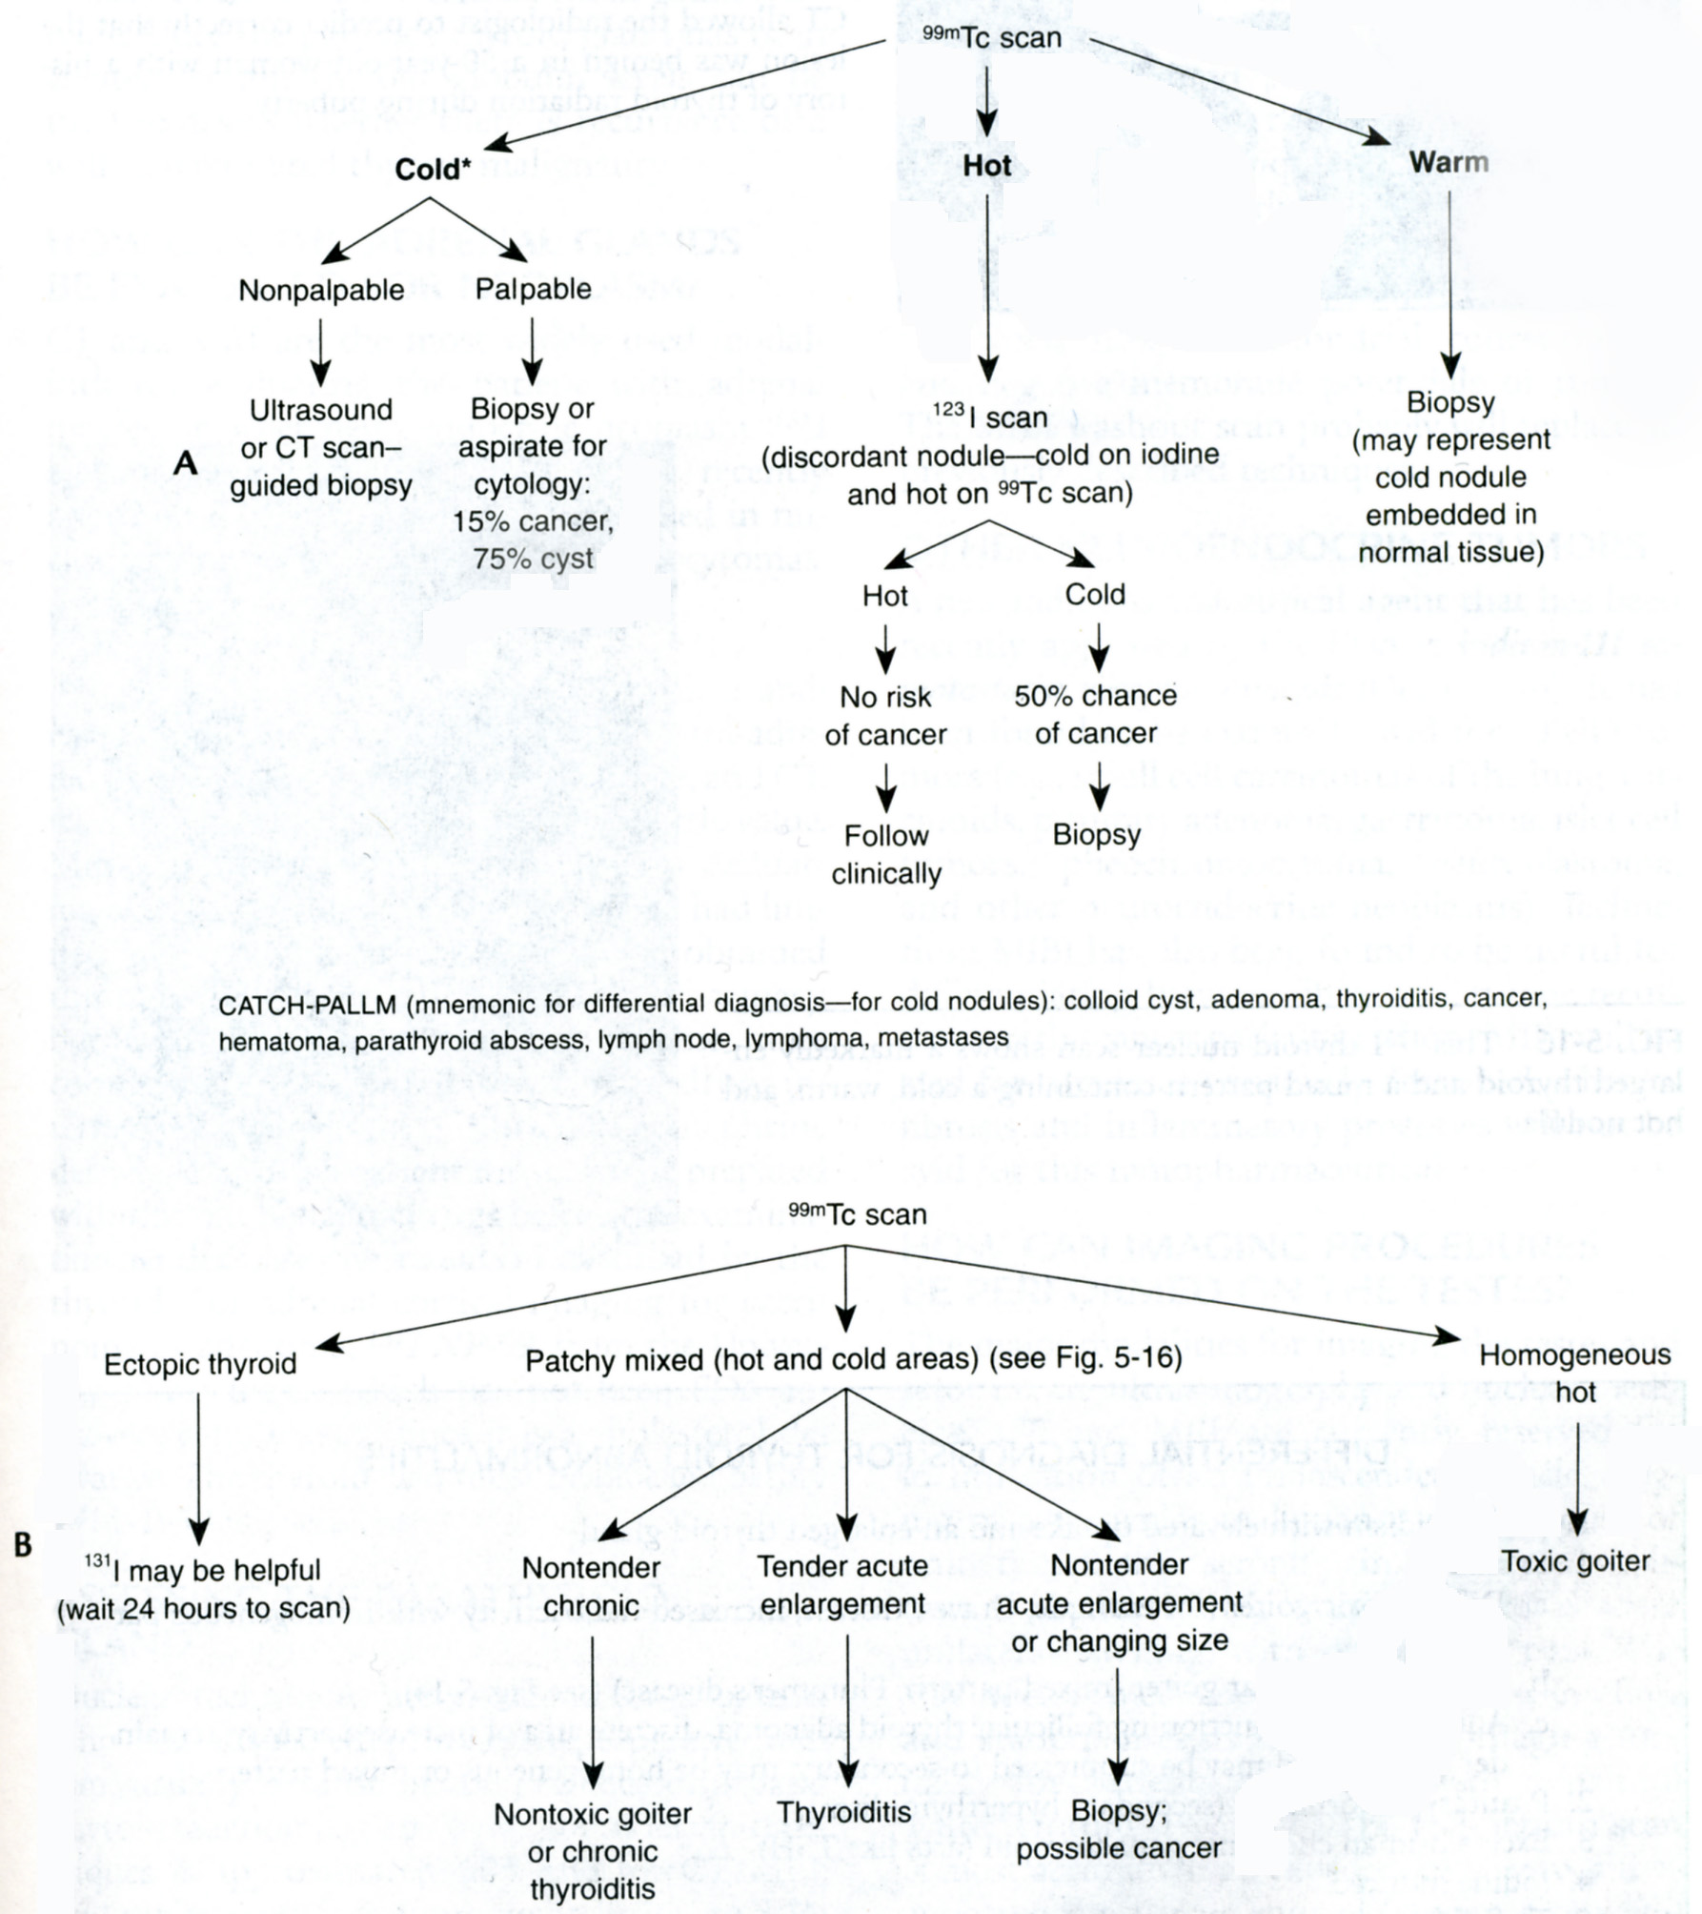
From: Basic surgery/ed., H.C. Polk, Jr., et al. – 5th ed.

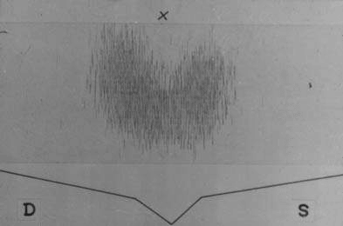

Fig. 21-1. Normal ¹²³I scan

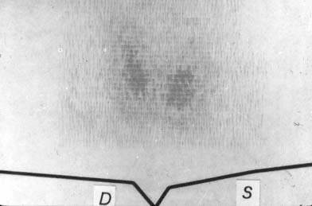

Fig. 21-2. ¹²³I scan demonstrating hypothyreosis
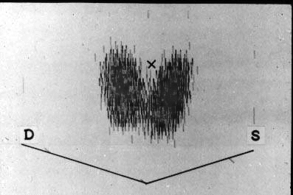

Fig. 21-3. ¹²³I scan demonstrating diffuse toxic goitre

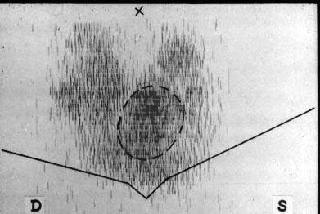

Fig. 21-4. ¹²³I scan demonstrating nodular goitre

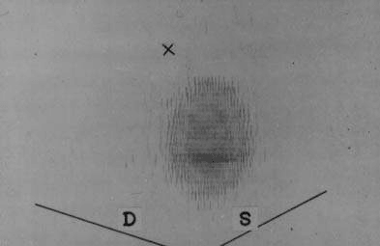

Fig. 21-5. ¹²³I scan demonstrating hot nodule

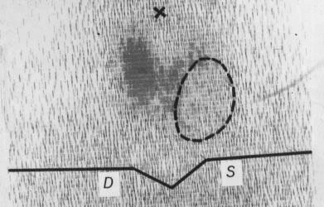

Fig. 21-6. ¹²³I scan demonstrating cold nodule

Thyroid autoantibodies

- Serum titres of antibodies against thyroid peroxidase and thyroglobulin are useful in determining the cause of thyroid dysfunction and swellings.
- Autoimmune thyroiditis may be associated with thyroid toxicity, failure or euthyroid goitre.
- Titres of greater than 1:100 are considered significant but a proportion of patients with histological evidence of lymphocytic (autoimmune) thyroiditis is seronegative.

DISORDERS OF THYROID GLAND

Ectopic thyroid

- Some residual thyroid tissue along the course of the thyroglossal tract is not uncommon, and may be lingual, cervical or intrathoracic.
- Very rarely the whole gland is ectopic.

Lingual thyroid

- This forms a rounded swelling at the back of the tongue at the foramen caecum and it may represent the only thyroid tissue present.
- It may cause dysphagia, impairment of speech, respiratory obstruction or hemorrhage.
- It is best treated by full replacement with thyroxine when it should get smaller, but excision or ablation with radioiodine is sometimes necessary.

Median (thyroglossal) ectopic thyroid

- This forms a swelling in the upper part of the neck and is usually mistaken for a thyroglossal cyst.
- Again, this may be the only normal thyroid tissue present.

Lateral aberrant thyroid

- There is no evidence that aberrant thyroid tissue ever occurs in a lateral position.
- “Normal thyroid tissue” found laterally, separate from the thyroid gland, must be considered and treated as a metastasis in a cervical lymph node from an occult thyroid carcinoma, almost invariably of papillary type.

Hypothyroidism

Adult hypothyroidism

- The term myxoedema should be reserved for severe thyroid failure and not applied to the much commoner mild thyroid deficiency.
- The signs of thyroid deficiency are: bradycardia; cold extremities; dry skin and hair; periorbital puffiness; hoarse voice; bradykinesis – slow movements; delayed relaxation phase of ankle jerks.
- The symptoms are: tiredness; mental lethargy; cold intolerance; weight gain; constipation; menstrual disturbance; carpal tunnel syndrome.
- Comparison of the facial appearance with a previous photograph may be helpful.
- Thyroid function tests show low T4 and T3 levels with a high TSH (except in the rare event of pituitary failure). High serum titres of antithyroid antibodies are characteristic of autoimmune disease.
- Oral thyroxine (0.10 - 0.20 mg) as a single daily dose is curative. Caution is required in the elderly or those with cardiac disease and the replacement dose is then commenced at 0.05 mg daily and cautiously increased. If a rapid response is required, tri-iodothyronine (20 mg three times a day) may be used.
- Myxoedema coma occurs in neglected cases and carries a high mortality; the body temperature is low and the patient must be warmed slowly: 1 g of intravenous hydrocortisone (in divided doses) should be given daily, and intravenous tri-iodothyronine in slowly increasing doses.

Autoimmune thyroiditis

- The so-called primary or atrophic myxoedema is now considered to be an autoimmune disease similar to chronic lymphocytic (Hashimoto’s) thyroiditis (see below) but without goitre formation from TSH stimulation.
- Because of the delay in diagnosis the hypothyroidism is usually much more severe than in goitrous autoimmune thyroiditis.
- Genetically determined deficiencies in the enzymes controlling the synthesis of thyroid hormones, if severe, are responsible for goitre formation with hypothyroidism. If of moderate degree, a simple (euthyroid) goitre results. Similarly goitrogens may produce a goitre with, or without, hypothyroidism.

Thyroid enlargement

- The normal thyroid gland is impalpable.
- The term goitre is used to describe generalised enlargement of the thyroid gland.
- A discrete swelling (nodule) in one lobe with no palpable abnormality elsewhere is termed an isolated (or solitary) swelling. Discrete swellings with evidence of abnormality elsewhere in the gland are termed dominant.

Simple goitre

- Simple goitre may develop as a result of stimulation of the thyroid gland by TSH, either as a result of inappropriate secretion from a microadenoma in the anterior pituitary (which is rare), or in response to a chronically low level of circulating thyroid hormones.
- The most important factor in endemic goitre is dietary deficiency of iodine (see below) but defective hormone synthesis probably accounts for many sporadic goitres (see below). TSH is not the only stimulus to thyroid follicular cell proliferation and other growth factors including immunoglobulins exert an influence.
- The daily requirement of iodine is about 0.1 – 0.15 mg. In nearly all districts where simple goitre is endemic, there is a very low iodide content in the water and food.
- Calcium is also goitrogenic and goitre is common in low-iodine areas on chalk or limestone. Although iodides in food and water may be adequate, failure of intestinal absorption may produce iodine deficiency.
- It is probable that enzyme deficiencies of varying severity are responsible for many sporadic goitres, i.e. in nonendemic areas. There is often a family history suggesting a genetic defect. Environmental factors may compensate in areas of high iodine intake.
- Well-known goitrogens are the vegetables of the brassica family (cabbage, kale and rape) which contain thiocyanate, drugs such as para-aminosalicylic acid (PAS) and, of course, the antithyroid drugs.
- Surprisingly enough, iodides in large quantities are goitrogenic because they inhibit the organic binding of iodine and produce an iodide goitre.

Diffuse hyperplastic goitre

- Diffuse hyperplasia corresponds to the first stages of the natural history.
- The goitre appears in childhood in endemic areas but, in sporadic cases, it usually occurs at puberty when metabolic demands are high – puberty goitre.
- If TSH stimulation ceases, the goitre may regress, but tends to recur later at times of stress such as pregnancy. The goitre is soft, diffuse and may become large enough to cause discomfort.
- A colloid goitre is a late stage of diffuse hyperplasia when TSH stimulation has fallen off and when many follicles are inactive and full of colloid.

Nodular goitre

- Nodules are usually multiple, forming a multinodular goitre. Nodules may be colloid or cellular, and cystic degeneration and haemorrhage are common, as is subsequent calcification.
- Nodules appear early in endemic goitre and later (between 20 and 30 years) in sporadic goitre, although the patient may be unaware of the goitre until the late 40s or 50s.
- Diagnosis is usually straightforward. The patient is euthyroid: the nodules are palpable and often visible; they are smooth, usually firm and not hard, and the goitre is painless and moves freely on swallowing. Hardness and irregularity, due to calcification, may simulate carcinoma.
- A painful nodule, sudden appearance or rapid enlargement of a nodule raises suspicion of carcinoma but is usually due to haemorrhage into a simple nodule. Differential diagnosis from autoimmune thyroiditis may be difficult.
- Tests of thyroid function are necessary to exclude mild hyperthyroidism, and the estimation of titres of thyroid antibodies to differentiate from autoimmune thyroiditis.
- Plain radiographs of the chest and thoracic inlet may show calcification and tracheal deviation or compression.
- Tracheal obstruction is due to gross lateral displacement, or compression in a lateral or anteroposterior plane by retrosternal extension of the goitre.

Secondary thyrotoxicosis

- Many patients with nodular goitres experience transient episodes of mild hyperthyroidism. The incidence is difficult to estimate, but figures as high as 30 % have been suggested.
- Carcinoma, which is usually of follicular pattern. It is uncommon but an increased incidence has been reported from endemic areas.

Treatment

- In endemic areas, e.g. Switzerland, parts of the USA and Argentina, the incidence of goitre has been strikingly reduced by the introduction of iodised salt.
- In the early stages a hyperplastic goitre may regress if thyroxine is given in a dose of 0.15 - 0.2 mg daily for a few months.
- The nodular stage of simple goitre is irreversible. Most patients with multinodular goitre are asymptomatic and do not require operation. Operation may be indicated on cosmetic grounds if the goitre is unsightly.
- Retrosternal extension with actual or incipient tracheal compression is an indication for operation, as is the presence of a dominant area of enlargement which may be neoplastic.
- There is a choice of surgical treatment (see Fig. 21-7): total thyroidectomy with immediate and life-long replacement of thyroxine; or some form of partial resection to conserve sufficient functioning thyroid tissue to subserve normal function whilst eliminating the risk of hypoparathyroidism which accompanies total thyroidectomy. More often, however, the multinodular change is asymmetrically distributed, with one lobe more significantly involved than the other. Under these circumstances total lobectomy on the more affected side is the appropriate management with either subtotal resection or no intervention on the less affected side.
- After subtotal resection it has been customary to give thyroxine to suppress TSH secretion with the aim of preventing recurrence.

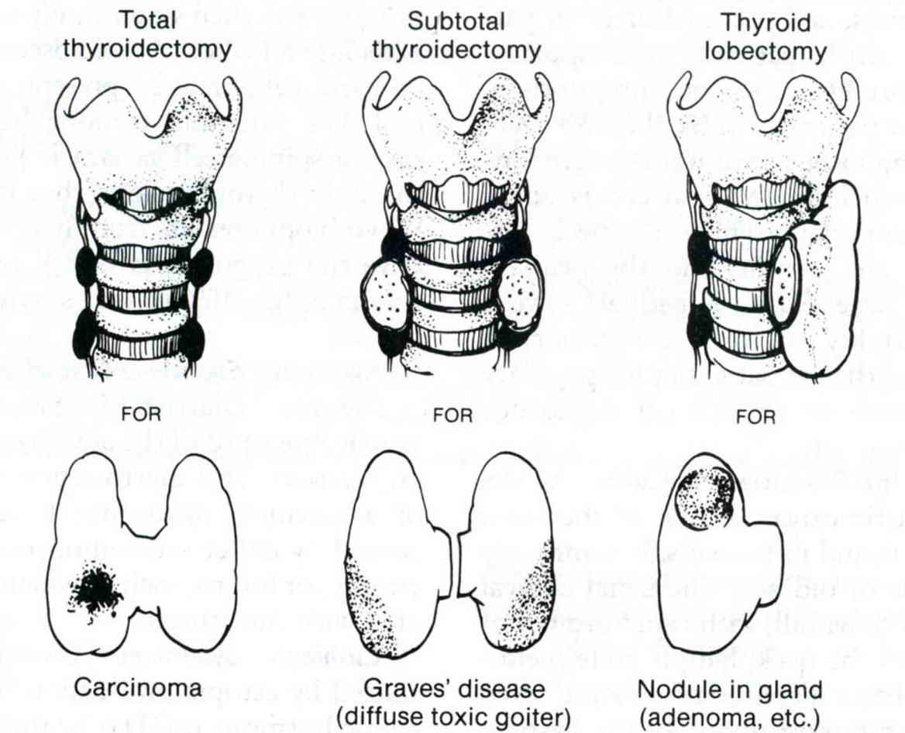

Fig. 21-7. Common operations on thyroid gland

Clinically discrete swellings

Overview

- Discrete thyroid swellings (thyroid nodules) are common and are present in 3 – 4 % of the adult population in the UK and USA. They are three to four times more frequent in women than men.
- About 70 % of discrete thyroid swellings are clinically isolated and about 30 % dominant.
- When such a gland is exposed at operation or examined by ultrasonography, CT or magnetic MRI, clinically impalpable nodules are often detected.
- The true incidence of isolated swellings is somewhat less than the clinical estimate.
- The importance of discrete swellings lies in the risk of neoplasia compared with other thyroid swellings. Some 15 % of isolated swellings prove to be malignant, and an additional 30 - 40 % are follicular adenomas. The remainder are non-neoplastic largely consisting of areas of colloid degeneration, thyroiditis or cysts.

Laboratory and visualization data

- The thyroid functional status should be established by estimation of serum thyroid hormones and TSH. If hyperthyroidism associated with a discrete swelling is confirmed biochemically, it indicates either a “toxic adenoma” or a manifestation of toxic multinodular goitre. The combination of toxicity and nodularity is important and constitutes the only indication for isotope scanning to localise the area(s) of hyperfunction.
- The autoantibody status is important in determining which swellings may be a manifestation of chronic lymphocytic thyroiditis.
- Isotope scanning used to be the mainstay of investigation of discrete thyroid swellings to determine the functional activity relative to the surrounding gland according to isotope uptake. On scanning, swellings are categorised as “hot” (overactive), “warm” (active) or “cold” (underactive). A hot nodule is one that takes up isotope, while the surrounding thyroid tissue does not. A warm nodule takes up isotope and so does normal thyroid tissue about it. A cold nodule takes up no isotope.
- About 80 % of discrete swellings are cold but only 15 % prove to be malignant and the use of this criterion as an indication for operation lacks discrimination. Routine isotope scanning has been abandoned except when toxicity is associated with nodularity.
- Ultrasonography was formerly widely used as a noninvasive supplement to clinical examination in determining the physical characteristics of thyroid swellings (see Fig. 21-8). Although ultrasonography can demonstrate subclinical nodularity and cyst formation, the former is clinically irrelevant and the latter apparent at aspiration, which should be routine in all discrete swellings.
- Fine-needle aspiration cytology (FNAC) (usually, ultrasound-guided) has become established as the investigation of choice in discrete thyroid swellings. Thyroid conditions that may be diagnosed by FNAC include colloid nodules, thyroiditis, papillary carcinoma, medullary carcinoma, anaplastic carcinoma and lymphoma. FNAC cannot distinguish between a benign follicular adenoma and follicular carcinoma as this distinction is dependent not on cytology but on histological criteria, which include capsular and vascular invasion.
- CT and MRI scans give excellent anatomical detail of thyroid swellings but have no role in the first line of investigation. They are occasionally useful in assessing recurrent and retrosternal swellings (see later).

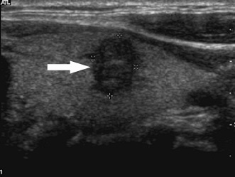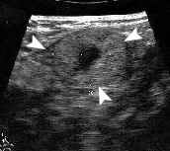

Fig. 21-8. US pictures of thyroid swelling

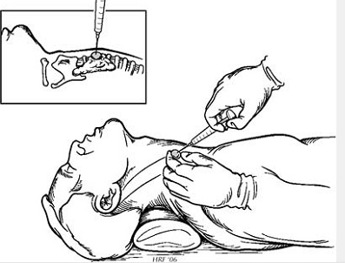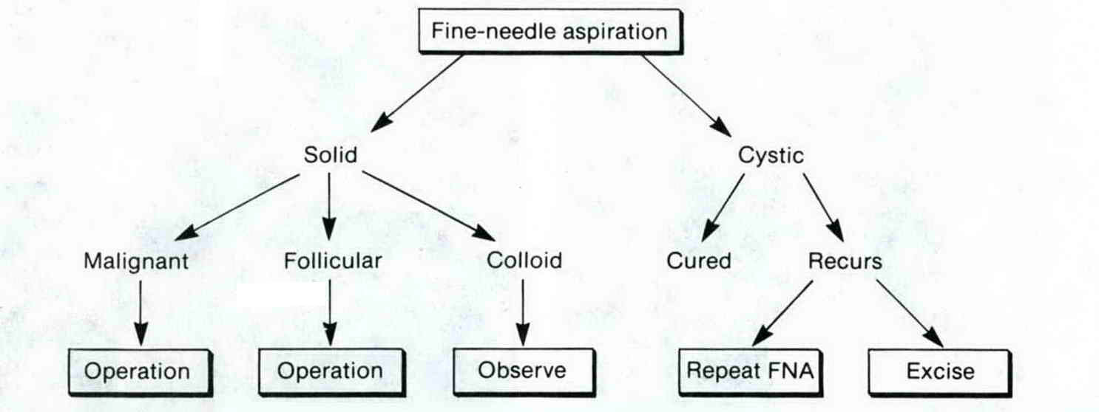

Fig. 21-9. Scheme of FNA of thyroid gland and resultant tactics

Treatment

- The main indication for operation is the risk of neoplasia which includes follicular adenoma as well as malignant swellings. The reason for advocating the removal of all follicular neoplasms is that it is seldom possible to distinguish between a follicular adenoma and carcinoma cytologically.
- There are useful clinical criteria to assist in selection for operation according to the risk of neoplasia and malignancy. Hard texture alone is not reliable since tense cystic swellings may be suspiciously hard but a hard, irregular swelling with any apparent fixity, which is unusual, is highly suspicious. Evidence of recurrent laryngeal nerve paralysis, suggested by hoarseness and a nonocclusive cough, and confirmed by indirect laryngoscopy, is almost pathognomonic. Deep cervical lymphadenopathy along the internal jugular vein in association with a clinically suspicious swelling is almost diagnostic of papillary carcinoma.
- The incidence of thyroid carcinoma in women is about three times that in men, but a discrete swelling in a male is much more likely to be malignant than in a female and it is seldom justifiable to avoid removing such a swelling in a man.

Thyroid cysts

- Routine FNAC (or ultrasonography (see Fig. 21-10)) shows that over 30 % of clinically isolated swellings contain fluid and are cystic or partly cystic. Tense cysts may be hard and mimic carcinoma.
- About 50 % of cystic swellings are the result of colloid degeneration, or of uncertain aetiology. Although most of the remainder are the result of involution in follicular adenomas some 10 - 15 % of cystic follicular swellings are histologically malignant (30 % in males and 10 % in females). Papillary carcinoma is often associated with cyst formation.
- Most patients with discrete swellings, however, are females aged 20 - 40 years in whom the risk of malignancy, although significant, is low and the indications for operation are not clear cut. FNAC is the most appropriate investigation to aid selection.

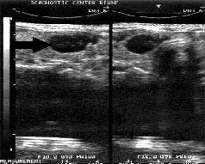

Fig. 21-8. US picture of thyroid cyst

Retrosternal goitre

Overview

- Very few retrosternal goitres arise from ectopic thyroid tissue; most arise from the lower pole of a nodular goitre.
- If the neck is short and the pretracheal muscles are strong, as in men, the negative intrathoracic pressure tends to draw these nodules into the superior mediastinum.

Clinical features and visualization data

- A retrosternal goitre is often symptomless and is discovered on a routine chest radiograph.
- There may, however, be severe symptoms: dyspnea, particularly at night, cough and stridor; dysphagia; engorgement of neck veins and superficial veins on the chest wall; recurrent nerve paralysis.
- The goitre may also be malignant or toxic.
- Radiographs show a soft-tissue shadow in the superior mediastinum – sometimes with calcification – and often causing deviation and compression of the trachea (see Fig. 21-11). Significant tracheal compression and obstruction may be demonstrated objectively by a flow-volume loop pulmonary function test.

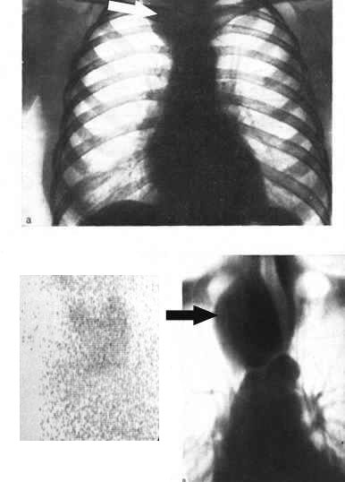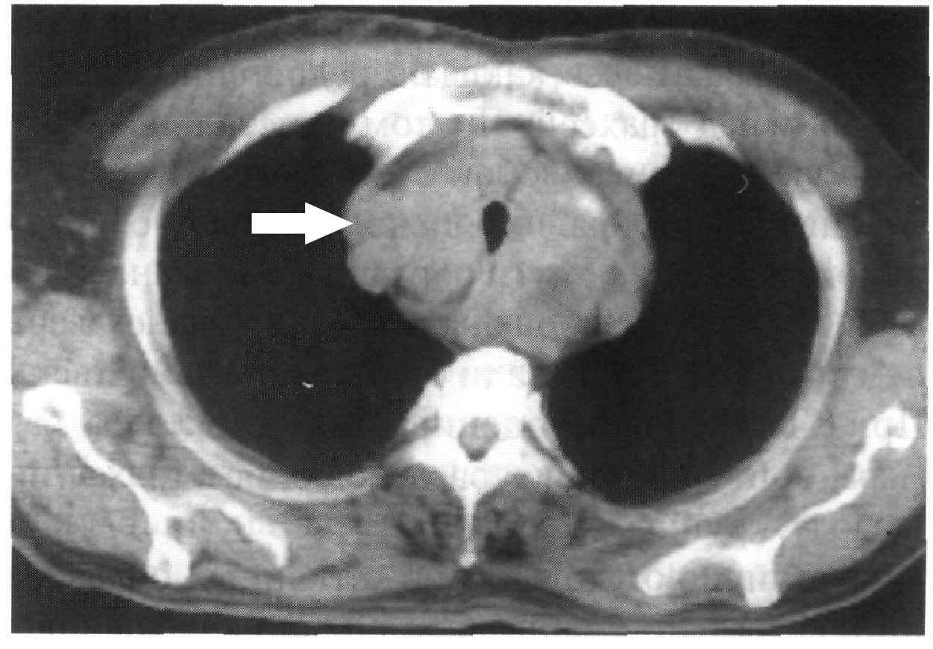

Fig. 21-11. Radiological pictures of thyroid swelling

Treatment

- If obstructive symptoms are present in association with thyrotoxicosis it is unwise to treat a retrosternal goitre with antithyroid drugs or radioiodine as these may enlarge the goitre. Resection can almost always be carried out from the neck and a midline sternotomy is hardly ever necessary.

Hyperthyroidism

Thyrotoxicosis

- The term thyrotoxicosis is retained because hyperthyroidism, i.e. symptoms due to a raised level of circulating thyroid hormones, is not responsible for all manifestations of the disease.
- Clinical types are: diffuse toxic goitre (Graves’ disease); toxic nodular goitre; toxic nodule; hyperthyroidism due to rarer causes.
- Thyrotoxicosis is eight times commoner in females than in males. It may occur at any age.

Diffuse toxic goitre

- Graves’ disease – a diffuse vascular goitre appearing at the same time as the hyperthyroidism, usually in the younger woman and frequently associated with eye signs. The syndrome is that of primary thyrotoxicosis.
- The whole of the functioning thyroid tissue is involved, and the hypertrophy and hyperplasia are due to abnormal thyroid-stimulating antibodies.

Toxic nodular goitre

- A simple nodular goitre is present for a long time before the hyperthyroidism, usually in the middle-aged or elderly and very infrequently associated with eye signs. The syndrome is that of secondary thyrotoxicosis.
- In many cases of toxic nodular goitre, the nodules are inactive, and it is the internodular thyroid tissue that is overactive. However, in some toxic nodular goitres, one or more nodules are overactive and here the hyperthyroidism is due to autonomous thyroid tissue as in a toxic adenoma.

Toxic nodule

- This is a solitary overactive nodule, which may be part of a generalised nodularity or a true toxic adenoma.
- It is autonomous and its hypertrophy and hyperplasia are not due to thyroid-stimulating antibodies. Because TSH secretion is suppressed by the high level of circulating thyroid hormones, the normal thyroid tissue surrounding the nodule is itself suppressed and inactive.

Clinical features

- The symptoms are: tiredness; emotional lability; heat intolerance; weight loss; excessive appetite; palpitations.
- The signs of thyrotoxicosis are: tachycardia; hot, moist palms; exophthalmos; lid lag/retraction; agitation; thyroid goitre and bruit.
- The goitre in primary thyrotoxicosis is diffuse and vascular, it may be large or small, firm or soft, and a thrill and a bruit may be present. The onset is abrupt, but remissions and exacerbations are not infrequent. Hyperthyroidism is usually more severe than in secondary thyrotoxicosis but cardiac failure is rare. Manifestations of thyrotoxicosis not due to hyperthyroidism per se, e.g. orbital proptosis, ophthalmoplegia and pretibial myxoedema, may occur in primary thyrotoxicosis.
- In secondary thyrotoxicosis the goitre is nodular. The onset is insidious and may present with cardiac failure or atrial fibrillation. It is characteristic that the hyperthyroidism is not severe. Eye signs other than lid lag and lid spasm (due to hyperthyroidism) are very rare.
- Stages of development of thyrotoxic arrhythmias are: multiple extrasystoles; paroxysmal atrial tachycardia; paroxysmal atrial fibrillation; persistent atrial fibrillation, not responsive to digoxin.
- Weakness of the proximal limb muscles is commonly found if looked for.
- Some degree of exophthalmos is common. It may be unilateral. Graves’ ophthalmopathy is an autoimmune disease in which there are antibody-mediated effects on the ocular muscles. Exophthalmos tends to improve with time. Sleeping propped up and lateral tarsorrhaphy will help to protect the eye but will not prevent progression.

Laboratory data

- Most cases are readily diagnosed clinically.
- Difficulty is most likely to arise in the differentiation of mild hyperthyroidism from an anxiety state when a goitre is present. In these cases, the thyroid status is determined by the diagnostic tests described earlier. A TRH test is rarely indicated.
- T3 thyrotoxicosis is diagnosed by estimating the free T3. It should be suspected if the clinical picture is suggestive but routine tests of thyroid function are within the normal range.
- A thyroid scan is essential in the diagnosis of an autonomous toxic nodule.

Treatment

- Nonspecific measures are rest and sedation and, in established thyrotoxicosis, should be used only in conjunction with specific measures – the use of antithyroid drugs, surgery and radioiodine.

Antithyroid drugs

- Those in common use are carbimazole and propylthiouracil.
- Beta-adrenergic blockers, such as propranolol, may also be used.
- Antithyroid drugs are used to restore the patient to a euthyroid state and to maintain this for a prolonged period in the hope that a permanent remission will occur. It should be noted that antithyroid drugs cannot cure a toxic nodule.
- Treatment is prolonged and the failure rate after a course of 1.5 - 2 years is at least 50 %. Recently there has been a trend towards the use of shorter courses (6 months) of these drugs.
- It is impossible to predict which patient is likely to go into a remission.
- Some goitres enlarge and become very vascular during treatment - even if thyroxine is given at the same time.

Surgery (see Fig. 21-7)

- In diffuse toxic goitre and toxic nodular goitre with overactive internodular tissue, surgery cures by reducing the mass of overactive tissue. Cure is probable if the thyroid tissue can be reduced below a critical mass.
- In the autonomous toxic nodule, and in toxic nodular goitre with overactive autonomous toxic nodules, surgery cures by removing all of the overactive thyroid tissue: this allows the suppressed normal tissue to function again.
- Recurrence of thyrotoxicosis occurs in approximately 5 % of cases.
- Every operation carries a morbidity but with suitable preparation and an experienced surgeon the mortality is negligible.
- Postoperative thyroid insufficiency occurs in 20 – 45 % of cases.
- Parathyroid insufficiency: this should he permanent in less than 0.5 %.

Radioiodine

- Radioiodine destroys thyroid cells and, as in thyroidectomy, reduces the mass of functioning thyroid tissue to below a critical level.
- There is a high and progressive incidence of thyroid insufficiency which may reach 75 - 80 % after 10 years.
- There is no convincing evidence that radioiodine has been responsible for genetic damage, leukaemia, damage to the foetus if given inadvertently in early pregnancy, or carcinoma in the adult.

Choice of therapeutic agent

- Each case must be considered individually. Below are listed guiding principles on the most satisfactory treatment for a particular toxic goitre at a particular age.
- Diffuse toxic goitre. Over 45: radioiodine. Under 45: surgery for the large goitre, antithyroid drugs for the small goitre.
- Toxic nodular goitre. Surgery. Toxic nodular goitre does not respond as well or as rapidly to radioiodine or antithyroid drugs as does a diffuse toxic goitre.
- Toxic nodule. Surgery or radioiodine. Resection is easy, certain and without morbidity. Radioiodine is a good alternative over the age of 45 because the suppressed thyroid tissue does not take up iodine and there is thus no risk of delayed thyroid insufficiency.
- Recurrent thyrotoxicosis after surgery. In general radioiodine, but antithyroid drugs may be used in young women intending to have children. Further surgery has no place.
- Failure of previous treatment with antithyroid drugs or radioiodine. Surgery or thyroid ablation with ¹²³I.

Neoplasms of the thyroid

Benign tumors

- Follicular adenomas present as clinically solitary nodules and the distinction between a follicular carcinoma and an adenoma can only be made by histological examination: in the adenoma there is no invasion of the capsule or of pericapsular blood vessels.
- Treatment is, therefore, by wide excision – preferably a lobectomy. The remaining thyroid tissue is normal so that prolonged follow up is unnecessary.
- It is doubtful whether there is such an entity as a papillary adenoma and all papillary tumors should be considered as malignant even if encapsulated.

Malignant tumors

Overview

- The vast majority of primary growths is carcinomas. Dunhill classified them histologically as differentiated and undifferentiated: and the differentiated carcinomas are now subdivided into follicular and papillary.
- Secondary growths are rare: blood borne metastases more usually occur from primary carcinomas of breast, colon and kidney and from melanomas.
- Differentiated thyroid carcinoma, particularly papillary, frequently follows accidental irradiation of the thyroid in childhood.
- The incidence of follicular carcinoma is high in endemic goitrous areas, possibly owing to TSH stimulation.
- Malignant lymphomas can present in a patient known to have autoimmune thyroiditis.
- The annual incidence is about 3.7 per 100 000 of the population and the sex ratio is three females to one male.
- The mortality should only be of the order of 2 - 3 %.

Clinical features

- The commonest presenting symptom is a thyroid swelling and a 5-year history is far from uncommon indifferentiated growths.
- Enlarged cervical lymph nodes may be the presentation of papillary carcinoma.
- Recurrent laryngeal nerve paralysis may be a presenting feature of locally advanced disease.
- Anaplastic growths are usually hard, irregular and infiltrating. A differentiated carcinoma may be suspiciously firm and irregular, but is often indistinguishable from a benign swelling.
- Small papillary tumors may be impalpable (occult carcinoma) – even when lymphatic metastases are present (so-called lateral aberrant thyroid).
- Pain, often referred to the ear, is frequent in infiltrating growths.

Visualization data

- Diagnosis is obvious on clinical examination in most cases of anaplastic carcinoma, although Riedel’s thyroiditis (see later) is indistinguishable.
- The localised forms of granulomatous thyroiditis and lymphadenoid goitre may simulate carcinoma.
- It is not always easy to exclude a carcinoma in a multinodular goitre, and solitary nodules, particularly in the young male, are always suspect.
- Failure to take up radioiodine is characteristic of almost all thyroid carcinomas, but occurs also in degenerating nodules and all forms of thyroiditis.
- Thyroid antibody titres are often raised in carcinoma.
- The role of FNAC in preoperative diagnosis has already been discussed. No diagnostic test is absolutely certain, and exploration with excision in the form of lobectomy is essential when in doubt.
- Incisional biopsy may cause seeding of cells and local recurrence, and is most inadvisable in a resectable carcinoma.

Papillary carcinoma

- Most papillary tumors contain a mixture of papillary and colloid-filled follicles, and in some the follicular structure predominates.
- Papillary carcinomas are very seldom encapsulated. Multiple foci may occur in the same lobe as the primary tumor or, less commonly, in both lobes. They may be due to lymphatic spread in the rich intrathyroidal lymph plexus, or to multicentric growth.
- Spread to the lymph nodes is common but blood-borne metastases are unusual unless the tumor is extrathyroidal.
- Occult carcinoma. Papillary carcinoma may present as an enlarged lymph node in the jugular chain with no palpable abnormality of the thyroid. The primary tumor may be no more than a few millimetres in size and is termed occult. Such primary foci of papillary carcinoma may also be discovered in thyroid tissue resected for other reasons, e.g. Graves’ disease. The term occult is now applied to all papillary carcinomas less than 1.5 cm in diameter. These have an excellent prognosis and are regarded as of little clinical significance.

Follicular carcinoma

- These appear to be macroscopically encapsulated but microscopically there is invasion of the capsule and of the vascular spaces in the capsular region.
- Multiple foci are seldom seen and lymph node involvement is much less common than in papillary carcinoma. Blood-borne metastases are almost twice as common and the eventual mortality rate is twice as high.

Treatment

- There is continuing disagreement on the most appropriate operation for differentiated thyroid carcinoma.
- The conservative approach advocates lobectomy with isthmusectomy in most patients with total thyroidectomy reserved for specific indications (those with bilateral disease or judged to be in a high-risk category).
- The more radical approach advocates routine total thyroidectomy (see Fig. 21-7) often as a staged procedure depending on the pathological findings of the initial lobectomy.

Undifferentiated (anaplastic) carcinoma

- This occurs mainly in elderly women and is much less often diagnosed now than in the past when many thyroid lymphomas were mistakenly classified histologically as anaplastic carcinomas.
- Local infiltration is an early feature of these tumors with spread by lymphatics and by the bloodstream.
- They are extremely lethal tumors and survival for more than 1 – 2 years after presentation is most unusual.
- An attempt at curative resection is only justified if there is no infiltration through the thyroid capsule and no evidence of metastases.
- Many of these aggressive lesions present in an advanced stage with tracheal obstruction and require urgent tracheal decompression.
- Radiotherapy should be given in all cases and may provide a worthwhile period of palliation as may combination chemotherapy.

Medullary carcinoma

- These are tumors of the parafollicular C-cells derived from the neural crest and not from the cells of the thyroid follicle as are other primary thyroid carcinomas.
- Diarrhea is a feature in 30% of cases and this may be due to prostaglandins produced by the tumor cells.
- Some tumors are familial and may account for 10 - 20 % of all cases.
- Medullary carcinoma may occur in combination with adrenal phaeochromocytoma and hyperparathyroidism (usually due to hyperplasia) in the syndrome known as multiple endocrine neoplasia type IIa (MEN IIa). The familial form of the disease frequently affects children and young adults whereas the sporadic cases occur at any age with no sex predominance. When the familial form is associated with prominent mucosal neuromas involving the lips, tongue and inner aspect of the eyelids, with occasionally a Marfanoid habitus, the syndrome is referred to as MEN type IIb.
- Involvement of lymph nodes occurs in 50 - 60 % of cases of medullary carcinoma and blood-borne metastases are common.
- As would be expected, tumors are not hormone dependent and do not take up radioactive iodine. Treatment is by total thyroidectomy and resection of involved lymph nodes with either a radical or modified radical neck dissection (see above).
- Phaeochromocytoma must be excluded by measurement of urinary catecholamine levels in all cases before embarking upon thyroid surgery to avoid the potential hazards associated with this condition.

Malignant lymphoma

- In the past, many malignant lymphomas were diagnosed as small round-cell anaplastic carcinomas.
- Response to irradiation is good and radical surgery is unnecessary once the diagnosis is established by biopsy.
- Although the diagnosis may be made or suspected on FNAC, sufficient material is seldom available for immunocytochemical classification, and large-needle (Trucut) or open biopsy is usually necessary.
- In patients with tracheal compression, isthmusectomy is the most appropriate form of biopsy.
- The prognosis is good if there is no involvement of cervical lymph nodes.
- Rarely the tumor is part of widespread malignant lymphoma disease, and the prognosis in these cases is worse.

Thyroiditis

Chronic Iymphocytic (autoimmune) thyroiditis (Hashimoto’s goitre)

Overview

- This common condition is usually associated with raised titres of thyroid antibodies.
- Not infrequently there is a family history of other autoimmune disease.
- It commonly presents as a multinodular goitre with established or subclinical thyroid failure, although it may present as a discrete swelling.
- Features of chronic lymphocytic (focal) thyroiditis are commonly present on histological examination in association with other thyroid disease – notably toxic goitre.
- Primary myxoedema without detectable thyroid enlargement represents the end stage of the pathological process.

Clinical features

- The onset may be insidious and asymptomatic, or so sudden and painful that it resembles the acute form of granulomatous thyroiditis.
- Mild hyperthyroidism may be present initially, but hypothyroidism is inevitable and may develop rapidly or extremely slowly.
- The goitre is usually lobulated, and may be diffuse or localised to one lobe. It may be large or small, and soft, rubbery or firm in consistency.
- The disease is commonest in women at the menopause, but may occur at any age.
- Papillary carcinoma and malignant lymphoma are occasionally associated with autoimmune thyroiditis.

Laboratory and visualization data

- Biochemical tests of thyroid function vary with the thyroid status and are of diagnostic value only if hypothyroidism is present.
- Significantly, raised titres of one or more thyroid antibodies are present in over 85 % of cases. Nevertheless, differential diagnosis from nodular goitre, carcinoma and malignant lymphoma of the thyroid is not always easy. FNAC is the most appropriate investigation although abundant lymphocytes may make the cytological distinction between autoimmune thyroiditis and lymphoma difficult.
- When there is doubt about neoplastic disease, which may coexist with thyroiditis, operation is necessary.

Treatment

- Full replacement dosage of thyroxine should be given for hypothyroidism and if the goitre is large or symptomatic.
- Thyroidectomy may be necessary if the goitre is large and causes discomfort.
- The clinician must, however, be cautious when a lymphocytic goitre increases in size and becomes unresponsive to thyroxine as this may be due to the development of malignant lymphoma.

Granulomatous thyroiditis (subacute thyroiditis —de Quervain’s thyroiditis)

- This is due to a virus infection (an epidemic reported from Israel was due to a mumps virus).
- In a typical subacute presentation there is pain in the neck, fever, malaise and a firm, irregular enlargement of one or both thyroid lobes.
- There is a raised erythrocyte sedimentation rate and absent thyroid antibodies, the serum T4 is high, normal or slightly raised, and the ¹²³I uptake of the gland is low.
- The condition is self-limiting and in a few months the goitre has subsided; subsequent hypothyroidism is rare.
- In 10 % of cases the onset is acute, the goitre very painful and tender, and there may be symptoms of hyperthyroidism.
- Thirty-five per cent of cases are asymptomatic but for the presence of the goitre.
- If diagnosis is in doubt, it may be confirmed by FNAC, radioactive iodine uptake and by a rapid symptomatic response to prednisone.
- The specific treatment for the acute case with severe pain is to give prednisone 10 – 20 mg daily for 7 days and the dose is then gradually reduced over the next month.

Riedel’s thyroiditis

- This is very rare, accounting for 0.5 % of goitres.
- Thyroid tissue is replaced by cellular fibrous tissue which infiltrates through the capsule into adjacent muscles, paratracheal connective tissue and the carotid sheaths.
- It may occur in association with retroperitoneal and mediastinal fibrosis and is most probably a collagen disease.
- The goitre may be unilateral or bilateral and is very hard and fixed.
- The differential diagnosis from anaplastic carcinoma can only be made with certainty by biopsy, when a wedge of the isthmus should also be removed to free the trachea.
- If unilateral, the other lobe is usually involved later and subsequent hypothyroidism is common.

DISORDERS OF PARATHYROID GLANDS

Overview

- The chief cells of the parathyroids produce parathormone. Parathormone stimulates osteoclastic activity, thereby increasing bone resorption by mobilizing calcium and phosphate; increases the reabsorption of calcium by the renal tubules, thus reducing the urinary excretion of calcium; augments the absorption of calcium from the gut; reduces the renal tubular reabsorption of phosphate, thus promoting phosphaturia.
- Calcitonin is secreted by the parafollicular cells of the thyroid (thyrocalcitonin). It lowers the serum calcium and affects calcium storage in bones; quite the opposite action of parathormone.

Hypoparathyroidism

Overview

- Parathyroid tetany, due to hypocalcaemia, is a rare complication of subtotal thyroidectomy (less than 1 %) but a more common complication of total thyroidectomy. It may also occur after surgery to the parathyroids themselves. Symptoms usually appear on the second or third postoperative day, and are temporary. Milder forms of hypoparathyroidism have been described in the follow-up of thyroidectomised patients. Permanent hypoparathyroidism, most commonly encountered following radical thyroidectomy for cancer, requires constant supervision and treatment.
- Spontaneous hypoparathyroidism is an unusual form of autoimmune disease.

Clinical features

- The first symptoms are tingling and numbness in the face, fingers and toes.
- In extreme cases, cramps in the hands and feet are very painful; the extended fingers are flexed at their metacarpophalangeal joints, with the thumb strongly adducted; the toes are plantar-flexed and the ankle joints extended – the so-called carpopedal spasm.
- Spasm of the muscles of respiration results in not only pain and stridor, but also dread of suffocation.
- In infancy, the symptoms of tetany may be mistaken for epilepsy, although there is no loss of consciousness.
- Latent tetany may be demonstrated by the following. Chvostek’s sign: tapping over the branches of the facial nerve at the angle of the jaw will produce twitching at the corner of the mouth, the ala of the nose and the eyelids. Trousseau’s sign: a sphygmomanometer cuff applied to the arm and inflated above the systolic blood pressure for not more than 2 minutes will produce carpal spasm.

Treatment

- In acute cases the symptoms may be relieved speedily by the slow intravenous injection of 10 - 20 ml of a 10 % solution of calcium gluconate. This may be repeated until the patient’s circulating calcium level has been stabilized.
- For longer-term management, the absorption of calcium is enhanced by oral administration of the most active metabolite of vitamin D - 1,25-dihydroxycholecalciferol. Its major action is on the gut, promoting active absorption of calcium and phosphorus, raising calcium levels to normal within a week. Magnesium supplements may occasionally be needed. Serum calcium levels must be estimated daily and the dosage adjusted as appropriate.

Hyperparathyroidism

Overview

- Hyperparathyroidism is a more common condition than had been previously believed.
- The symptomatic presentation may vary but the increased use of auto analysers has resulted in “asymptomatic” hypercalcaemic patients being the largest group.
- A corrected serum calcium concentration above the upper limit of normal and a simultaneous elevation of serum parathyroid hormone level are mandatory for the diagnosis.
- Hyperparathyroidism, rarely found in the first decade of life, is commoner in women than men, and most commonly found between the ages of 20 and 60 years.
- Long-term follow-up is essential as there is a significant increase in risk of death from cardiovascular disease.
- Primary hyperparathyroidism is an unstimulated and inappropriately high parathyroid hormone secretion for the concentration of plasma ionised calcium, and is due to adenoma or hyperplasia, and very rarely carcinoma. A single adenoma is the commonest finding. The whole gland is usually considerably enlarged, darker in colour, firmer and more vascular than normal.
- Carcinoma of the parathyroids is extremely rare, less than 1 %. It tends to invade locally and recur after operation. Blood-borne metastases have been described.
- Secondary hyperparathyroidism is associated with chronic renal failure or malabsorption syndromes. The stimulus for the hyperplasia is chronic hypocalcaemia. All four glands are involved.
- Tertiary hyperparathyroidism is a further stage in the development of reactive hyperplasia where autonomy occurs as the parathyroids no longer respond to physiological stimuli.

Cinical features

- The most common presentation is the detection of unsuspected and asymptomatic hypercalcaemia by routine biochemical screening.
- Specific symtoms (seen in 50 % of patients) include bones, stones, abdominal groans and psychic moans.
- Nonspecific symptoms include muscle weakness, thirst, polyuria, anorexia and weight loss – a challenge to the astute clinician.
- There may be generalised decalcification of the skeleton, as in osteitis fibrosa cystica (von Recklinghausen’s disease), single or multiple cysts, or pseudotumours of any bone. The latter are particularly common in the jaw bones. Early radiological changes first appear in the skull and in the phalanges, with loss of density and subperiosteal erosions. Many patients presenting with vague pains in the bones and joints are mistakenly diagnosed as rheumatic.
- Hyperparathyroidism must be considered in every patient presenting with renal tract stone or nephrocalcinosis, and even in those cases of renal colic where no stone can be demonstrated.
- Patients with nausea, vomiting and anorexia are relatively common. Peptic ulcer and pancreatitis are not infrequently found in association with hyperparathyroidism, but the relationship is not as yet fully understood.
- Psychiatric cases are not uncommon; women, complaining of tiredness, listlessness and with obvious personality changes, are often wrongly labelled “neurotic” or “menopausal”. Patients have been admitted to mental institutions because of irrational behaviour.
- Clinical examination may be unrewarding but the cause of dehydration or confusion may be found in the eyes. Corneal calcification may be detected. It begins on the lateral and medial borders of the limbus (which distinguishes it from arcus senilis) and is best seen through a hand lens by the light of a bright torch reflected off the iris. Less common is band keratopathy in which a transverse band of calcification forms across the front of the cornea, and conjunctival calcification where redness of the eye also occurs.
- Hypertension may be present in up to 50% of cases.
- There may be electrocardiographic changes with a shortened QT interval, primarily by an effect on the length of the S—T segment.
- A parathyroid adenoma is very seldom palpable in the neck.
- Acute hyperparathyroidism. This diagnosis is difficult and only too often made after death. Nausea and abdominal pain is followed by severe vomiting, dehydration, oliguria and finally coma. The serum calcium is very high. Treatment is urgent after rehydration, which is vital. Biphosphonates (disodium etidronate and pamidronate) are specific inhibitors of bone resorption. They are highly effective given parenterally and may also be used in the preoperative, short-term medical management of severe hypercalcaemia in primary hyperparathyroidism.

Laboratory data

- The diagnosis is confirmed with the following biochemical findings.
- Elevation of serum calcium.
- Diminution of serum phosphorus.
- Increased excretion of calcium in the urine.
- Elevation of the serum alkaline phosphatase in cases with bone disease.
- Elevation of serum parathormone concentration.
- The diagnosis of hyperparathyroidism largely depends on confirmed hypercalcaemia, exclusion of other causes of hypercalcaemia (see below) and a raised parathormone level.
- Present day immunoradiometric assays (upper limit of normal varies according to the laboratory) for biologically active intact parathormone are highly reliable and a raised level is even more reliable.
- Detectable levels of parathormone within the normal range, in the presence of hypercalcaemia, are suggestive of the diagnosis.

Visualization data

- The simplest localisation test is an ultrasonic scan but results vary according to the skill and experience of the investigator.
- CT is of most value in localising a lesion in the mediastinum rather than the neck.
- Thallium-technetium isotope subtraction imaging may locate up to 90 % of parathyroid adenomas before surgery. Like ultrasonography, subtraction scintigraphy is more accurate the larger the adenoma, and is inaccurate in parathyroid hyperplasia.
- MRI is improving rapidly with some centres reporting up to 64 % detection prospectively.
- Invasive techniques such as selective angiography and selective venous sampling may be helpful in locating an abnormally situated gland after a failed initial exploration.

Differential diagnosis

- Other causes of hypercalcaemia must be remembered and excluded. They are: secondary cancer in bone (breast, prostate, bronchus, kidney and thyroid); carcinoma with endocrine secretion (bronchus, kidney and ovary); multiple myeloma; vitamin D intoxication; sarcoidosis; thyrotoxicosis; immobilisation; medication: thiazide diuretics, lithium.
- The differential diagnosis presents no problem if the parathormone level is estimated. In none of the above-mentioned conditions will parathormone be detectable in the blood.

Treatment

- The only corrective treatment is surgical removal of the overactive gland or glands.
- In symptomatic patients, the indications for operation are clearcut.
- Many patients, however, in whom hypercalcaemia has been discovered incidentally, are not overtly symptomatic and a decision in favour of operation is more difficult.
- Parathyroid tissue can be successfully autotransplanted into the arm, a useful technique to avoid repeated potentially difficult explorations of the neck. The indications are tertiary hyperparathyroidism in patients undergoing chronic renal dialysis, and recurrent hyperparathyroidism.
- With successful surgery in severe cases, bones will recalcify and pseudotumours resolve. Renal stones will not disappear, but the incidence of recurrence after surgical removal is reduced and deterioration in renal function is prevented. Psychiatric patients show an early and often remarkable recovery. Many patients who are not overtly symptomatic beforehand are aware of an improvement in well-being after correction of hypercalcaemia.
- In a small minority of cases, hyperparathyroidism recurs after several years and may warrant further surgery. In some of these, autotransplantation (above) offers reasonable prospects of control.
- Mild asymptomatic hypercalcaemia is a relative contraindication to further surgery but regular follow-up is mandatory.

Parathyroid carcinoma

- Parathyroid carcinoma is a rare condition to be considered when a high serum calcium is associated with a palpable lump in the neck.
- At operation it has a characteristic grey-white colour and is adherent because of local invasion of adjacent soft tissue.
- The best results are obtained by early recognition, avoiding rupture of the tumor capsule, and aggressive surgical management including ipsilateral thyroid lobectomy.
- Surgical clips should be used to outline the tumor bed for postoperative radiotherapy.

MULTIPLE ENDOCRINE NEOPLASIA SYNDROME

Overview

- Always consider that a patient with hyperparathyroidism may also have multiple endocrine adenomas.
- The cells involved, irrespective of the site, have the common chemical characteristics of amine precursor uptake and decarboxylation and are thus known as APUD cells.
- The disorder is inherited as an autosomal dominant, the manifestations in any one family tend to be similar and all members of the family should be investigated.

Type I

- This most common variant involves the parathyroid glands (90 %), pancreatic islets (80 %), pituitary (65 %), thyroid and adrenal cortex.
- There is hyperplasia of the parathyroid glands and a chromophobe adenoma of the pituitary which may result in increased prolactin production or acromegaly.
- The pancreatic tumor may produce gastrin (the Zollinger-Ellison syndrome) or insulin, glucagon, somatostatin or vasoactive intestinal peptide (VIP) causing watery diarrhea.
- Treatment is surgical excision.

Type IIa

- A genetic abnormality located on chromosome 10 has been identified in MEN type IIa syndrome.
- Fifty per cent have parathyroid hyperplasia.
- The associated lesions may be a medullary carcinoma of thyroid, which produces calcitonin, and a phaeochromocytoma.
- The latter should be excluded or be the first priority for treatment before exploration of the neck.

Type IIb

- This is differentiated from type IIa because of additional neurological abnormalities.
- Mucosal neuromas produce “lumpy and bumpy” lips or eyelids, and there is a characteristic Marfanoid facial appearance.
- Megacolon and ganglioneuromatosis are also found.

REVIEW TESTS

1. Approximately half of palpable neck masses in adults originate where?

- Developmental defects
- Inflammatory lymph nodes
- Thyroid gland
- Major salivary glands
- Metastatic lesions with known primaries

2. Common causes for head and neck masses in children include all of the following except:

- Sarcoma
- Carcinoma
- Developmental lesions
- Inflammatory masses
- Goiter

3. What is the most common malignant neoplasm of the head and neck in children?

- Rhabdomyosarcoma
- Neuroblastoma
- Hodgkin's and non-Hodgkin's lymphoma
- Thyroid carcinoma
- Squamous cell carcinoma

4. A 12-years-old bay presents with a 2-cm soft, palpable, midline infrahyoid mass. Probable cause for this lesion includes which of the following?

- Dermoid cyst
- Cystic hygroma
- Goiter
- Lymphosarcoma
- Thyroid carcinoma

5. What is the cardinal physical finding of thyroid carcinoma in most patients?

- Multicentric nodal metastases
- A palpable solitary nodule
- Diffuse symmetric thyroid enlargement
- Hypothyroidism
- Hyperthyroidism

6. Paralysis of a vocal cord on the ipsilateral side of an occult thyroid mass demonstrable on radioactive iodine uptake scan suggests what?

- Thyroid cyst
- Functional thyroid nodule
- Thyroid malignancy
- Entrapment of the recurrent laryngeal nerve by a remote malignancy
- Thyroidal metastasis

7. What is the most common histopathologic variant of thyroid carcinoma?

- Papillary adenocarcinoma
- Follicular adenocarcinoma
- Medullary adenocarcinoma
- Anaplastic (undifferentiated) adenocarcinoma

8. Invasive papillary-follicular and all medullary thyroid neoplasms are best managed by which therapy?

- Ipsilateral lobectomy and isthmusectomy
- Total or near-total thyroidectomy
- Simple ipsilateral lobectomy
- External beam irradiation
- ¹³¹I radioiodine therapy

9. A 35-years-old woman was referred to oncologist for evaluation of a 3-cm movable nodule of the right lobe of the thyroid gland. In addition to a history and physical examination, which element is essential in the initial workup of this lesion?

- Ultrasonography
- Technetium scan
- Fine-needle aspiration
- Radioactive iodine ¹²³I scan
- Serial observation

10. Cervical exploration is performed to evaluate a thyroid nodule that was read as hypercellular and follicular on the fine-needle aspiration. After exposing the thyroid gland at surgery, what is the diagnostic procedure of choice?

- Incisional biopsy of the nodule
- Excisional biopsy of the nodule
- Thyroid lobectomy
- Near total thyroidectomy
- Total thyroidectomy

11. A 20-years-old woman is referred for evaluation to oncologist because her older sister (40 years of age) has medullary carcinoma of the thyroid gland. Physical examination of the thyroid gland and neck reveals no evidence of thyroid nodules and no palpable adenopathy. An ultrasound of the thyroid reveals a normal gland with no abnormalities. Laboratory evaluation reveals a significantly increased calcitonin level. What’s the most appropriate tactics of managing the patient?

- Serial observation and physical examination
- Random needle biopsy of the thyroid gland
- Subtotal thyroidectomy
- Near total thyroidectomy
- Total thyroidectomy

Correct answers: 1 - C, 2 - B, 3 - C, 4 - A, 5 - B, 6 - C, 7 - A, 8 - B, 9 - C, 10 – C, 11 - E.

