CHAPTER 22: TRAUMA, BURNS, AND SHOCK

Management of trauma victims

Initial assessment

- The initial assessment of the patient's state, performed when the patient arrives in the emergency room, determines the extent of injury and the need for immediate care.
- Obviously inebriated patients often have serious injuries, but the presence of alcohol does not diminish the trauma team's responsibility to diagnose all injuries properly.
- The initial assessment can be performed by an experienced physician within seconds. The following three questions should be answered: is ventilation adequate? is tissue being perfused? is significant neurologic injury present?
- APACHE II ("Acute Physiology and Chronic Health Evaluation II") is a severity of disease classification system, one of several ICU scoring systems. After admission of a patient to an intensive care unit, an integer score from 0 to 71 is computed based on several measurements; higher scores imply a more severe disease and a higher risk of death. The point score is calculated from 12 routine physiological measurements (such as blood pressure, body temperature, heart rate etc.) during the first 24 hours after admission, score according to Glasgow coma scale (see Table 22-1), information about previous health status and some information obtained at admission (such as age). The calculation method is optimized for paper schemas or may be done using available on-line Internet forms. The resulting point score should always be interpreted in relation to the illness of the patient.
- ASA stands for American Society of Anesthesiologists. In 1963 the ASA adopted a five category physical status classification system for assessing a patient before surgery. A sixth category was later added. These are: 1. A normal healthy patient. 2. A patient with mild systemic disease. 3. A patient with severe systemic disease. 4. A patient with severe systemic disease that is a constant threat to life. 5. A moribund patient who is not expected to survive with or without the operation. 6. A declared brain-dead patient whose organs are being removed for donor purposes. If the surgery is an emergency, the physical status score is followed by “E”, for example, “3E”. Although more complex scoring systems like APACHE II exists they are time-consuming to calculate, and do not have the same utility for ease of communication between surgeons, anesthetists, and insurers.

ABCDE mnemonic

- Management of severe trauma should follow the “ABCDE” algorithm: establishing an airway (“A”-step) and giving ventilatory support (“B”-step), circulation and cardiac massage (“C”-step), drug therapy (“D”-step), and electrical detibrillation (“E”-step).

Airway assessment and control (“A” and “B” - steps)

Assessment

- The mouth and upper airway chould be inspected for foreign bodies or other causes of obstruction.
- The patient should be examined for chest wall motion and asymmetry, cyanosis, and evidence of air exchange.
- The chest should be examined for subcutaneous emphysema or fractures and auscultated for breath sounds.

Treatment

- Rapid measures are necessary to correct unsatisfactory ventilation.
- Early intubation is important, since unstable patients quickly become apneic.
- Oxygen is needed for all severely injured patients. Rapid intubation is necessary in the presence of: a decreased level of consciousness; hypotension; major head, face, or neck injury; chest trauma; cyanosis.
- The neck should not be extended during intubation unless it is definitely known that no cervical spine injury exists. When this is not known, either a nasotracheal tube should be used in spontaneously breathing patients, or a tracheostomy or cricothyroidotomy should be performed.
- Ventilation should be performed with either hand-held bag or a volume respirator.
- Adequacy of ventilation should be assessed by auscultation of the chest, followed by arterial blood gas measurement.
- The most common causes of inadequate ventilation are: incorrect placement of the endotracheal tube into either the esophagus or the right main stem bronchus; the presence of a pneumothorax. Thus, assessment of the thorax is important after ventilation begins.

Circulatory support

- Once adequate ventilation has been established, the physician should rapidly proceed to the next critical stage of resuscitation, namely, establishment of tissue perfusion, or circulatory support (“C”-step).

Cardiac resuscitation

- Closed chest cardiac massage should be performed while fluid resuscitation is begun if the patient is asystolic or demonstrates evidence of poor cardiac function.
- Emergency room thoracotomies for open cardiac massage are rarely indicated. Thoracotomies should be performed only by trained personnel. Indications for emergency room thoracotomy are: hypovolemic cardiac arrest despite vigorous blood volume replacement plus closed chest massage and defibrillation; cardiac arrest with penetrating injury to the chest.
- Relative contraindications include: major obvious injuries to the central nervous system; failed external cardiac massage lading more than 10 minutes; major blunt trauma.

Assessment of the circulatory status

- Assessment of the circulatory status in a patient with a beating heart should include
appraisal of several options.
- Character of the pulse: a rapid, faint pulse suggests profound hypovolemia in most cases; a slow, full pulse may be indicative of severe neurologic injury with increasing intracranial pressure or hypercarbia.
- Peripheral perfusion, as indicated by level of consciousness, rate of capillary refilling, and body temperature.
- Blood pressure. The presence of a mild hypotension may be associated with inadequate tissue perfusion.
- Stable vital signs with major injury. The condition of patients with major injury and seemingly stable vital signs is dangerous and deceptive. Previously healthy trauma patients, especially if young, are able to maintain pulse and blood pressure, despite a continuing occult hemorrhage, until vasomotor response fails. When this occurs, the patient "crashes," which is manifested by a rapid loss of blood pressure, vomiting, and unconsciousness. At this point they may not respond to further volume replacement.

Venous access

- Lines should be inserted by a reliable method with which the physician is comfortable.
- Subclavian catheterization should be learned in controlled settings, not on unstable trauma patients.
- Two lines are usually inserted simultaneously.
- Shock patients often require four separate lines for volume replacement to raise the blood pressure above 100 mm Hg in under 10 minutes.
- The first intravenous insertion should include the withdrawal of 20 ml of blood for crossmatching and for laboratory studies, including a toxicology profile.
- Femoral artery punctures should be done early for blood gas analyses.
- All resuscitation lines should be replaced in 12-24 hours. The urgent insertion of these lines leaves sterility in question, and catheter sepsis can become a serious problem after 24 hours.

Blood components transfusion

Available blood products

- Whole blood often is preferred for bleeding patients; however, it is not readily available. Fresh whole blood is nearly impossible to provide to a patient because of the time needed to test for human immunodeficiency virus (HIV) and hepatitis. Stored whole blood is low in platelets and coagulation factors. If the platelets and plasma are not separated out (as in individual blood products, fresh frozen plasma), valuable blood products are wasted.
- Packed red blood cells is the blood component of choice for most red cell transfusions. The blood is centrifuged to separate the red cells from most of the plasma and plasma components. In addition to red cells, platelets and other blood components can be obtained. In addition to being packed, red blood cells can be treated more aggressively for use in individuals that have proven febrile or anaphylactic reactions to the blood components that remain after initial centrifugation (i.e., white blood cells, platelets, cellular debris, plasma proteins). The extra processing decreases red cell life, so the cells must be used shortly after preparation. Some patients have very rare blood types or multiple antibodies that make blood transfusion almost impossible. In these cases, red cells can be stored in a frozen state. These cells can be stored for a long time, but the processing and storage are expensive.
- Autologous blood. Autologous blood is blood donated by a patient before his operation [or obtained intraoperatively (e.g. massive hemoperitoneum after spleen rupture when penetration of hollow organ is excluded)]. Autologous blood is beneficial because of the risk of blood-borne disease in donor blood. It also is an advantage for a patient with a very rare blood type to donate his own blood. A patient can donate several units of blood over a period of several weeks. However, blood becomes outdated after approximately 30 days. If a large amount of blood is needed, it can be frozen.
- Fresh frozen plazma contains large amount of proteins and coagulation factors, thus could be used in management of shock, bleeding, coagulopathy (including second phase of disseminated intravascular coagulation), hypoproteinemia and severe toxic states such as sepsis. Fresh frozen plazma valid within 6 months.
- Cryoprecipitate, also called "cryoprecipitated antihemophilic factor" is a frozen blood product prepared from plasma. Each 15 mL unit typically contains 100 IU of factor VIII, and 250 mg of fibrinogen. It also contains von Willebrand factor, factor XIII. Like fresh frozen plasma, compatibility testing is not indicated, but it is given as ABO compatible. Indications for giving cryoprecipitate include: haemophilia; von Willebrands's disease; hypofibrinogenaemia, as can occur with massive transfusions; bleeding from excessive anticoagulation; disseminated intravascular coagulation.

Indications for blood transfusion

Acute blood loss

- If bleeding accounts for approximately 25% - 30% of the patient's blood volume (i.e., approximately 1500 ml in a 70-kg man), transfusion is required. Crystalloid resuscitation usually is adequate for blood loss that is less than 25% of the patient's blood volume. An acute blood loss of 50% of a patient's total blood volume generally is lethal.
- An effective general guideline for treating a bleeding patient is to initially resuscitate with crystalloid (0.9% normal saline and lactated Ringer's solution are the fluids most commonly used for resuscitation). Two liters are administered very quickly (in no more than 10 minutes). If the patient continues to show signs of hypovolemia following infusion of 2 L of crystalloid, blood transfusion should be initiated. It is important to continue to infuse crystalloid in addition to blood.

Hemodynamically stable anemic patient

- Formerly, blood transfusions were given if a patient's hematocrit dropped below 30%. There was no scientific basis for this guideline.
- Presently, blood transfusions are administered based on the patient's signs and symptoms as well as the patient's oxygen delivery. Generally, blood transfusion is strongly indicated when hemoglobin falls to 50 g/l or below in chronic anemic patient.

Complications

Immediate reactions

- Allergic or febrile reactions. Itching, hives, flushing, fever, bronchospasm, and other symptoms that commonly occur with allergies also occur in allergic reactions to blood transfusions. These reactions are caused by antigens on the red cells, whitecells, or platelets of the transfused blood. These reactions do not occur unless a substantial portion of the unit of blood has been transfused. Generally, it is unnecessary to stop the transfusion unless the reaction does not respond to treatment or if the reaction cannot be identified as an allergic reaction. The treatment for this type of reaction is administration of antihistamines and antipyretics, or prednisolone in severe cases. If necessary, the reaction can be minimized by using washed red blood cells, from which most antigenic components have been removed.
- Agglutination or hemolytic reactions occur very early during the transfusion. Pain occurs in the vein that is receiving the transfusion as well as in the chest, flank, and extremities. Fever, chills, oliguria, hemoglobinuria, and jaundice also occur. An agglutination or hemolytic reaction may be difficult to diagnose during an operation. The reaction may only manifest by diffuse bleeding. Treatment is to stop the transfusion and retype and cross the patient and donor blood. Additional transfusions should not be administered until the cause of the reaction is determined. The main focus of treatment is to maintain intravascular volume to minimize sludging of the aggregates in capillary beds. Treatment is aimed at maintaining a high urine output to minimize cellular debris and hemoglobin from plugging the renal tubules. In addition to intravenous fluids, mannitol is administered to enhance diuresis; bicarbonate is administered to alkalinize the urine to prevent the hemoglobin from crystallizing. This type of reaction is almost always caused by a clerical error, which leads to administration of obviously incompatible blood to the patient. Prevention is by meticulous adherence to identification of the patient and donor blood before initiating the transfusion.

Physiologic reactions

- Hyperkalemia occurs because of leakage of potassium from the red cells due to hypoxia during storage. Cells damaged during storage may lyse when infused and release their intracellular potassium. This condition is primarily a concern if large amounts of blood are going to be transfused in a short period of time.
- Hypocalcemia occurs because of the excess citrate in the unit of blood being transfused. The citrate binds with the calcium in the plasma and effectively removes calcium from the circulation.
- During large transfusions (as a rule, more than 5 units over a period of 4 hours or more), calcium can be rapidly mobilized from the bone to maintain adequate calcium levels. However, some patients may not have sufficient calcium stores in the bone. In hypotensive patients who receive large transfusions, the bone may not be perfused well enough to allow mobilization of calcium. In these cases, calcium levels may decrease enough to impair cardiac function, coagulation, and other calcium-dependent functions. Generally, calcium should be administered at the rate of 1 g of calcium chloride or 4 g of calcium gluconate for every 5 units of blood being administered.
- Hypothermia. Banked blood is stored at approximately 5°C. Transfusion of large amounts of banked blood can lower the patient's body temperature. Hvpothermia causes dysfunction in almost every organ system in the body. In surgical patients, proper functioning of the clotting system and the cardiac system is most important. Hypothermia causes an increase in energy expenditure as the body attempts to rewarm itself. This expenditure can cause an oxygen deficit that leads to acidosis. Warming the blood (including uasage of special blood warmers) is the best prevention of hypothermia.
- Hypervolemia can easily occur from blood transfusion in patients being treated for chronic anemia, because these patients tend to have an increased intravascular volume. If there is accompanying cardiac dysfunction, congestive heart failure may occur. Hypervolemia rarely occurs in acutely bleeding patients being resuscitated by transfusion. Blood accounts for more intravascular volume than an equivalent amount of infused crystalloid. The vascular volume needs to be assessed in patients before transfusion of each unit of blood. The rate of transfusion can be adjusted, and diuresis can be used as indicated.
- Coagulopathy. When massive transfusions are being administered for resuscitation, it is possible to dilute the coagulation factors in the plasma to a level where a coagulopathy occurs. The packed red blood cells that usually are transfused have virtually no coagulationfactors or platelets. When massive transfusions are being administered, fresh frozen plasma and cryoprecipitate may be necessary.

Delayed reactions

- Hemolysis can occur days after a transfusion of apparently compatible blood. It most likely is caused by previously formed antibodies that were not at levels high enough to be detected during crossmatching. There is no means of preventing this type of reaction. Specific treatment is unnecessary unless the hemolysis becomes severe enough to cause symptoms similar to an immediate hemolytic reaction, in which case the treatment is the same as for an immediate reaction.
- Infections. Many diseases can be transmitted through the blood, the most common of which are hepatitis B and C, cytomegalovirus (CMV), and HIV. In addition to the seviral diseases, bacterial and parasitic diseases can be transferred, and bacterial contamination of blood can occur during donation or storage. The rate of disease transmission may be as high as 5% - 7%. The frequency of transmission is decreasing as more effective screening tests are developed; however, this risk can never be entirely eliminated, because some viruses have long incubation periods (e.g., HIV) and may be transmitted before detection. The use of volunteer donor pools and quarantine reassessment offrozen blood products reduce the risk.

Maintenance of circulating blood volume

- Fluid replacement at first is based on judgments made during the initial assessment concerning shock and visible sources of blood loss. Continuing fluid replacement, after an initial 2-3 I of lactated Ringer's solution, is based on the patient's urine output and central venous pressure. Further replacement should be based on continued assessment.
- Monitoring the trends in the patient's urine output provides an important guideline to the accuracy of fluid resuscitation and the changing needs of the patient. Renal perfusion disappears early in shock. A urine output in excess of 30 ml/hr implies adequate perfusion to all vital organs and indicatesn that the patient is not in shock.
- Central venous pressure is usually monitored via a subclavian vein puncture. Central venous pressure reflects the available blood volume, which is not necessarily the same as the absolute amount of circulating blood. An inadequate circulating volume, as implied by diminished central venous pressure, generally indicates inadequate venous return to the heart. If venous return is inadequate, the cardiac chambers cannot distend to their normal filled volumes and cardiac output, therefore, diminishes. The trends in a series of central venous pressure measurements are sometimes more informative than the absolute magnitude on a single reading.
- Fluid challenges can provide valuable guidance in judging the adequacy of volume resuscitation. Examples include the following. Rapid infusion of 200 ml of colloid solution (e.g. albumin, hydroxyethyl starch) in a patient with progressive tachycardia: if the central venous pressure rises beyond normal limits (15 cm H₂O), it signifies overload or failure, pericardial tamponade, or tension pneumothorax; if the central venous pressure falls or remains low, it indicates inadequate volume replacement or continued volume loss. Infusion of 200 ml of colloid solution in a patient with a slowing pulse rate: if the central venous pressure rises, it indicates adequate or improving volume status.

Control of hemorrhage

External bleeding

- Applying direct pressure on bleeding wounds with manually held gauze pads is safe and usually effective.
- Proximal and distal digital compression of bleeding superficial vessels (see Fig. 22-1) may allow visualization of the bleeding point and accurate clamping. Blind clamping is never indicated.
- Pressure dressings may be used to control diffuse bleeding from abrasions and avulsions that involve large areas.
- Temporary packing of missile tracts and stab wounds can slow the blood flow until surgical exposure is obtained.
- The antishock trousers provide increased peripheral resistance without the pharmacologic effects of pressor agents.

A 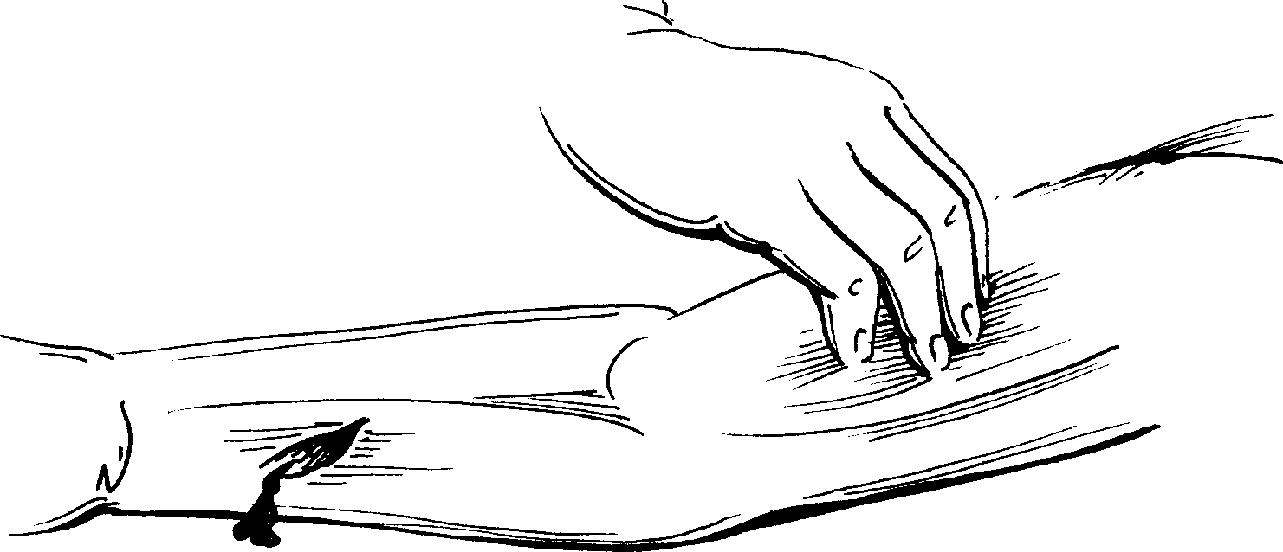 B 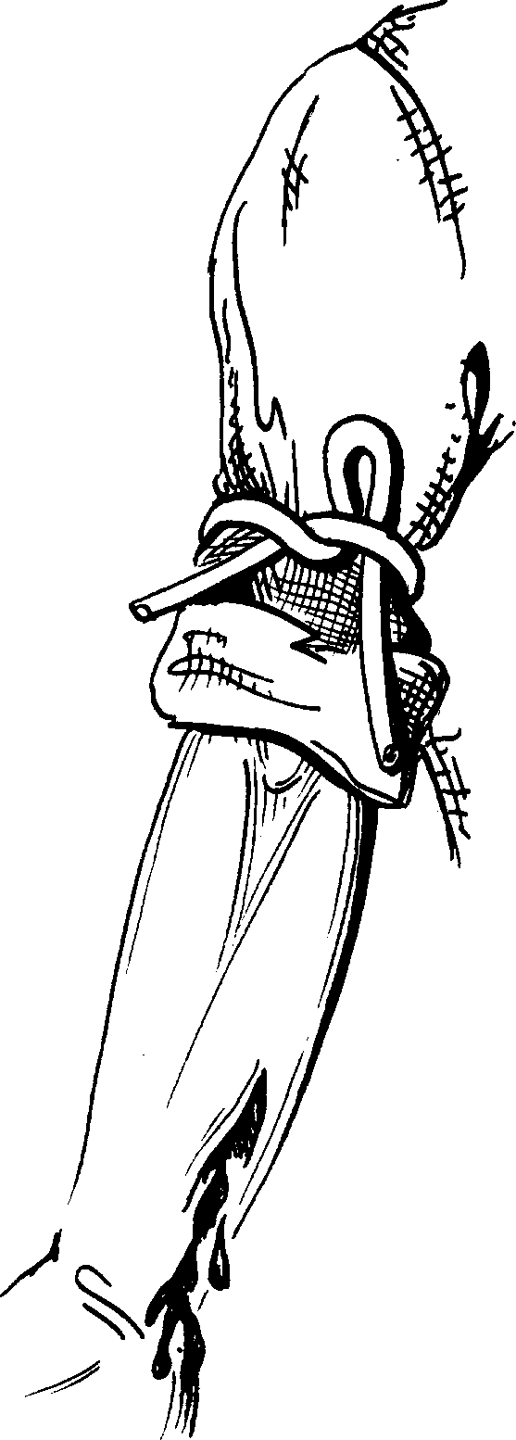 C 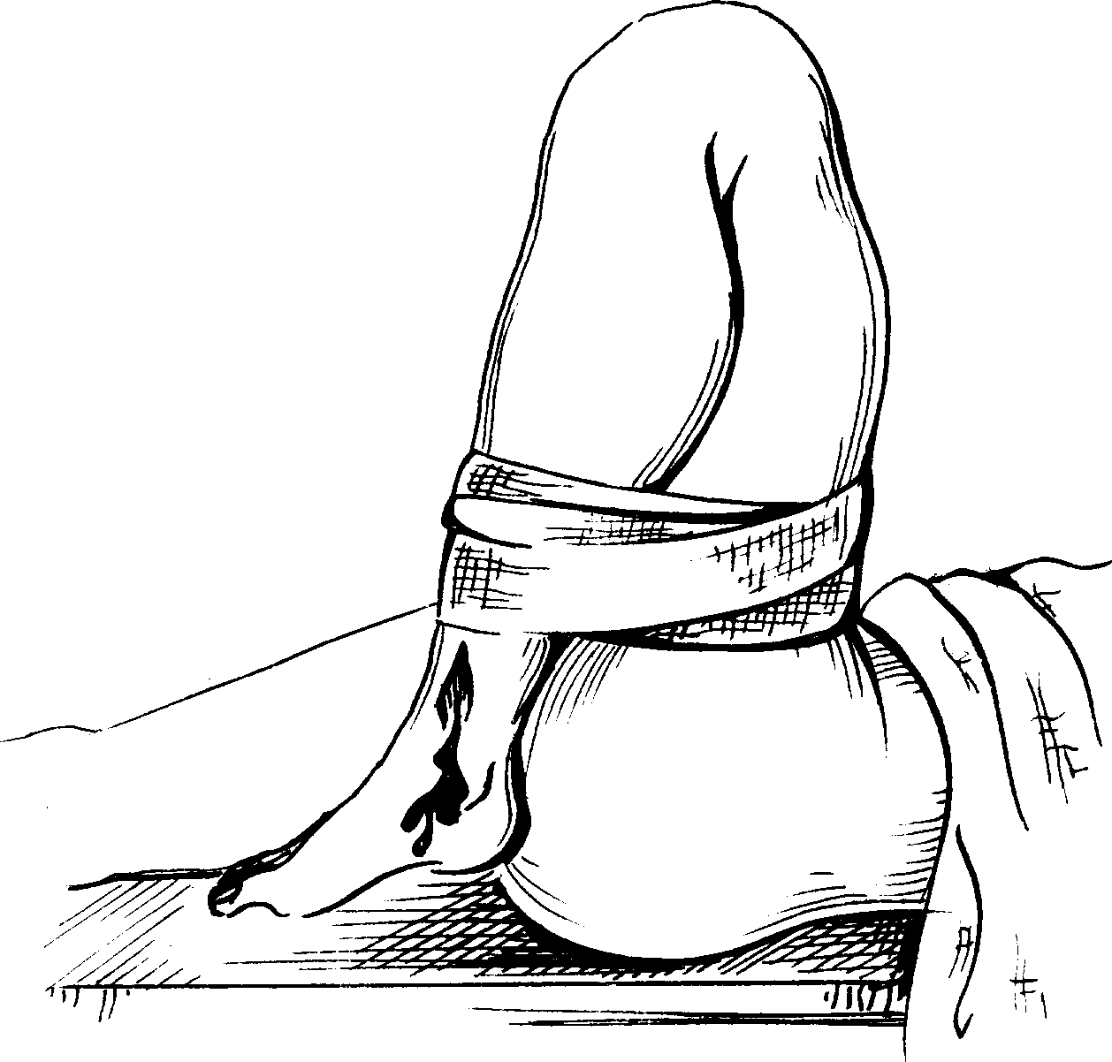

Fig. 22-1. Methods of temporary control of external bleeding

Internal bleeding

- Internal bleeding requires early diagnosis and prompt treatment by appropriate surgical intervention (see below).

Neurologic injury

- After adequate ventilation and tissue perfusion have been restored, immediate attention must be given to the patient's neurologic condition.
- The Glasgow coma scale is used for assessment of severety of СNS trauma (see Table 22-1)

Table 22-1. Glasgow coma scale

1. Eye opening

Spontaneous
To voice
To pain
None

2. Verbal response

Oriented
Confused
Inappropriate words
Incomprehensible sounds
None

3. Motor response

Obeys command
Localized pain
Withdraw (pain)
Flexion (pain)
Extension (pain)
None

Total GCS points (1+2+3)

Head trauma

Assessment

- Loss of consciousness signifies a head injury until such an injury has been ruled out.
- Intracranial trauma cannot be adequately assessed while the patient is in shock.
- If hypotension is present in a patient with a head injury, it is rarely secondary to the head trauma, and the physician must look tor another cause of the hypotension.
- The neurologic evaluation should assess the following factors rapidly: level of consciousness (is the patient alert, lethargic and disoriented, comatose but responsive to pain, or unresponsive?); motor activity and tactile sensation; obvious head trauma (such as a depressed skull fracture, gunshot wound, or leaking cerebrospinal fluid); pupil size and response to light; oculocephalic (”doll's eye”) reflex (since testing involves rotating the patient's head, it should only be done after spinal cord injury has been ruled out).
- Evolving hypertension and bradycardia (Cushing's phenomenon) indicate increasing intracranial pressure and a worsening neurologic problem.

Treatment

- If a neurosurgeon, who is imperative for proper management of patients with head injuries, is not available, then a telephone consultation should be obtained and initial treatment begun, followed by transfer of the patient to a center with a neurosurgeon. Initial management includes the following considerations.
- Sterile saline-soaked gauze should be placed over open injuries.
- Mannitol and other drugs to lower intracranial pressure should be given after consultation with the neurosurgeon.
- Hypotension and hypoventilation seriously injure brain cells. It is, therefore, important to assess adequately fluid requirements and ventilation.
- Overhydration increases intracranial pressure and should be avoided once fluid requirements have been met and the patient is stable.

Spinal cord trauma

Assessment

- Until proven otherwise, the spine should be considered unstable and the cord, therefore, liable to injury in all patients with major blunt trauma.
- The cervical spine should be considered unstable in: every unconscious patient; every patient with face and head contusions; every patient with decreased mentation, which precludes adequate neurologic examination
- Radiographic films showing all seven cervical vertebrae intact should be obtained before allowing the patient's neck to be extended for any reason. At least three views need to be obtained, including cross-table lateral, anterior-posterior, and odontoid views.
- Evidence of injury to the spinal cord should be sought.
- It should be recognized that the cord may not yet be injured although the spine is unstable. A negative neurologic examination does not prove the absence of injury to the cervical spine.
- Appropriate spinal stabilization must be performed until proper studies have been done.
- Findings, such as absence of motor or sensory function below the injury, loss of muscle tone, and loss of anal sphincter tone, should be sought.

Treatment

- The required stabilization and reduction of the injury must be done under the supervision of a neurosurgeon or an orthopedic surgeon experienced in treating these injuries.

Further management

- Once the immediate life-threatening crises have been cared for and the patient is stabilized, other injuries can be assessed.
- Information about events surrounding the injury, allergies of the patient, the patient's medical history, and any medications taken by the patient must be obtained from the patient or others.

Thoracic injuries

General assessment

- Upright chest x-rays (see Fig. 22-2, 22-3, 22-4) should be obtained to: detect fluid collections or a pneumothorax, which may have been missed in the initial assessment; search for the presence of great vessel injury; a tracheal shift; rib fractures; or other injuries.
- Electrocardiogram and central venous pressure should be monitored for clues regarding cardiac contusions or tamponade, such as elevated S-T segments and arising central venous pressure.
- Bronchoscopy to determine if a bronchus is ruptured may be needed urgently if air continues to leak through a chest tube in a patient with a lung that fails to expand with suction.
- Contrast esophagography and great vessel aortography to rule out esophageal perforation or aortic injury may be indicated by penetrating wounds that traverse the mediastinum.
- Angiography may be needed if the following are found on radiograph: lateral deviation of the nasogastric tube in the esophagus; a widened mediastinum (greater than 8 cm); loss of visualization of the aortic knob; hematoma of the left cervical pleura ("pleural cap"); a depressed left main stem bronchus; right lateral deviation of the trachea; forward displacement of the trachea on the lateral chest film; fracture of the first or second rib; massive chest trauma with multiple rib fractures; fracture or dislocation of the thoracic spine; a major deceleration injury.

A 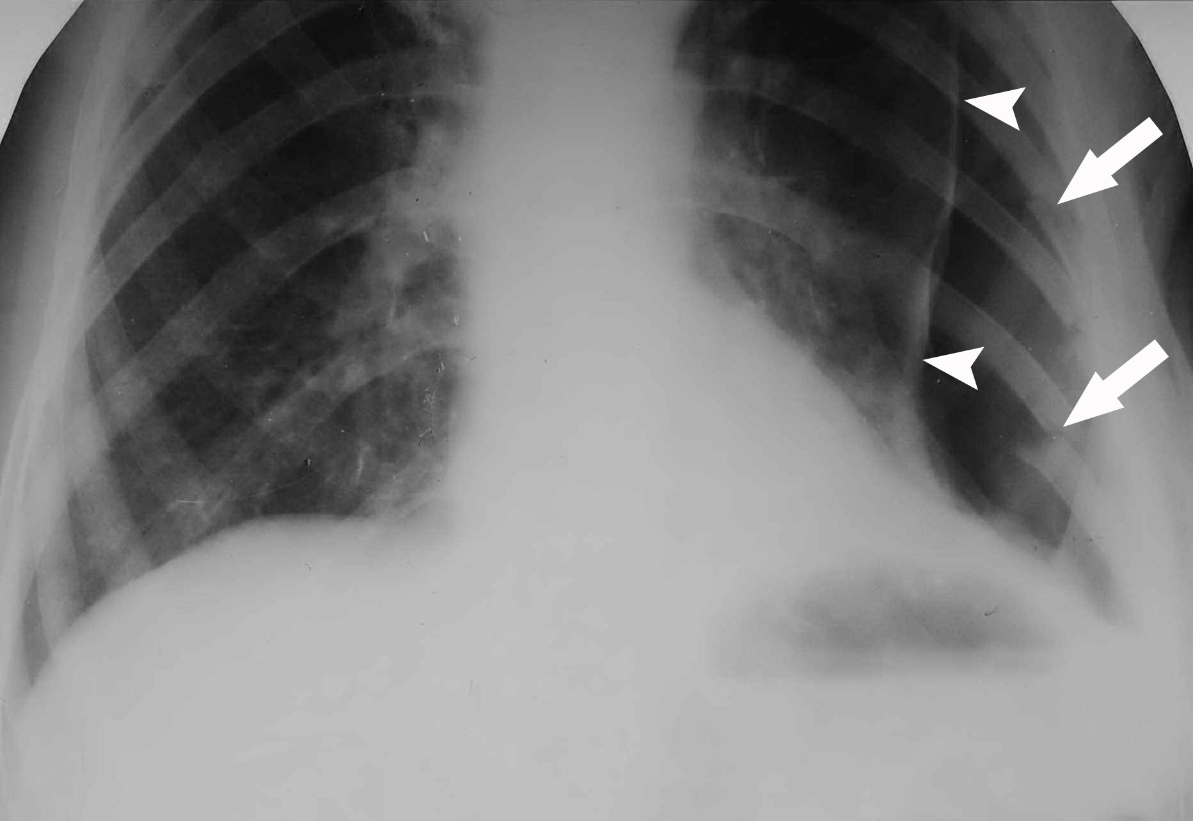 B 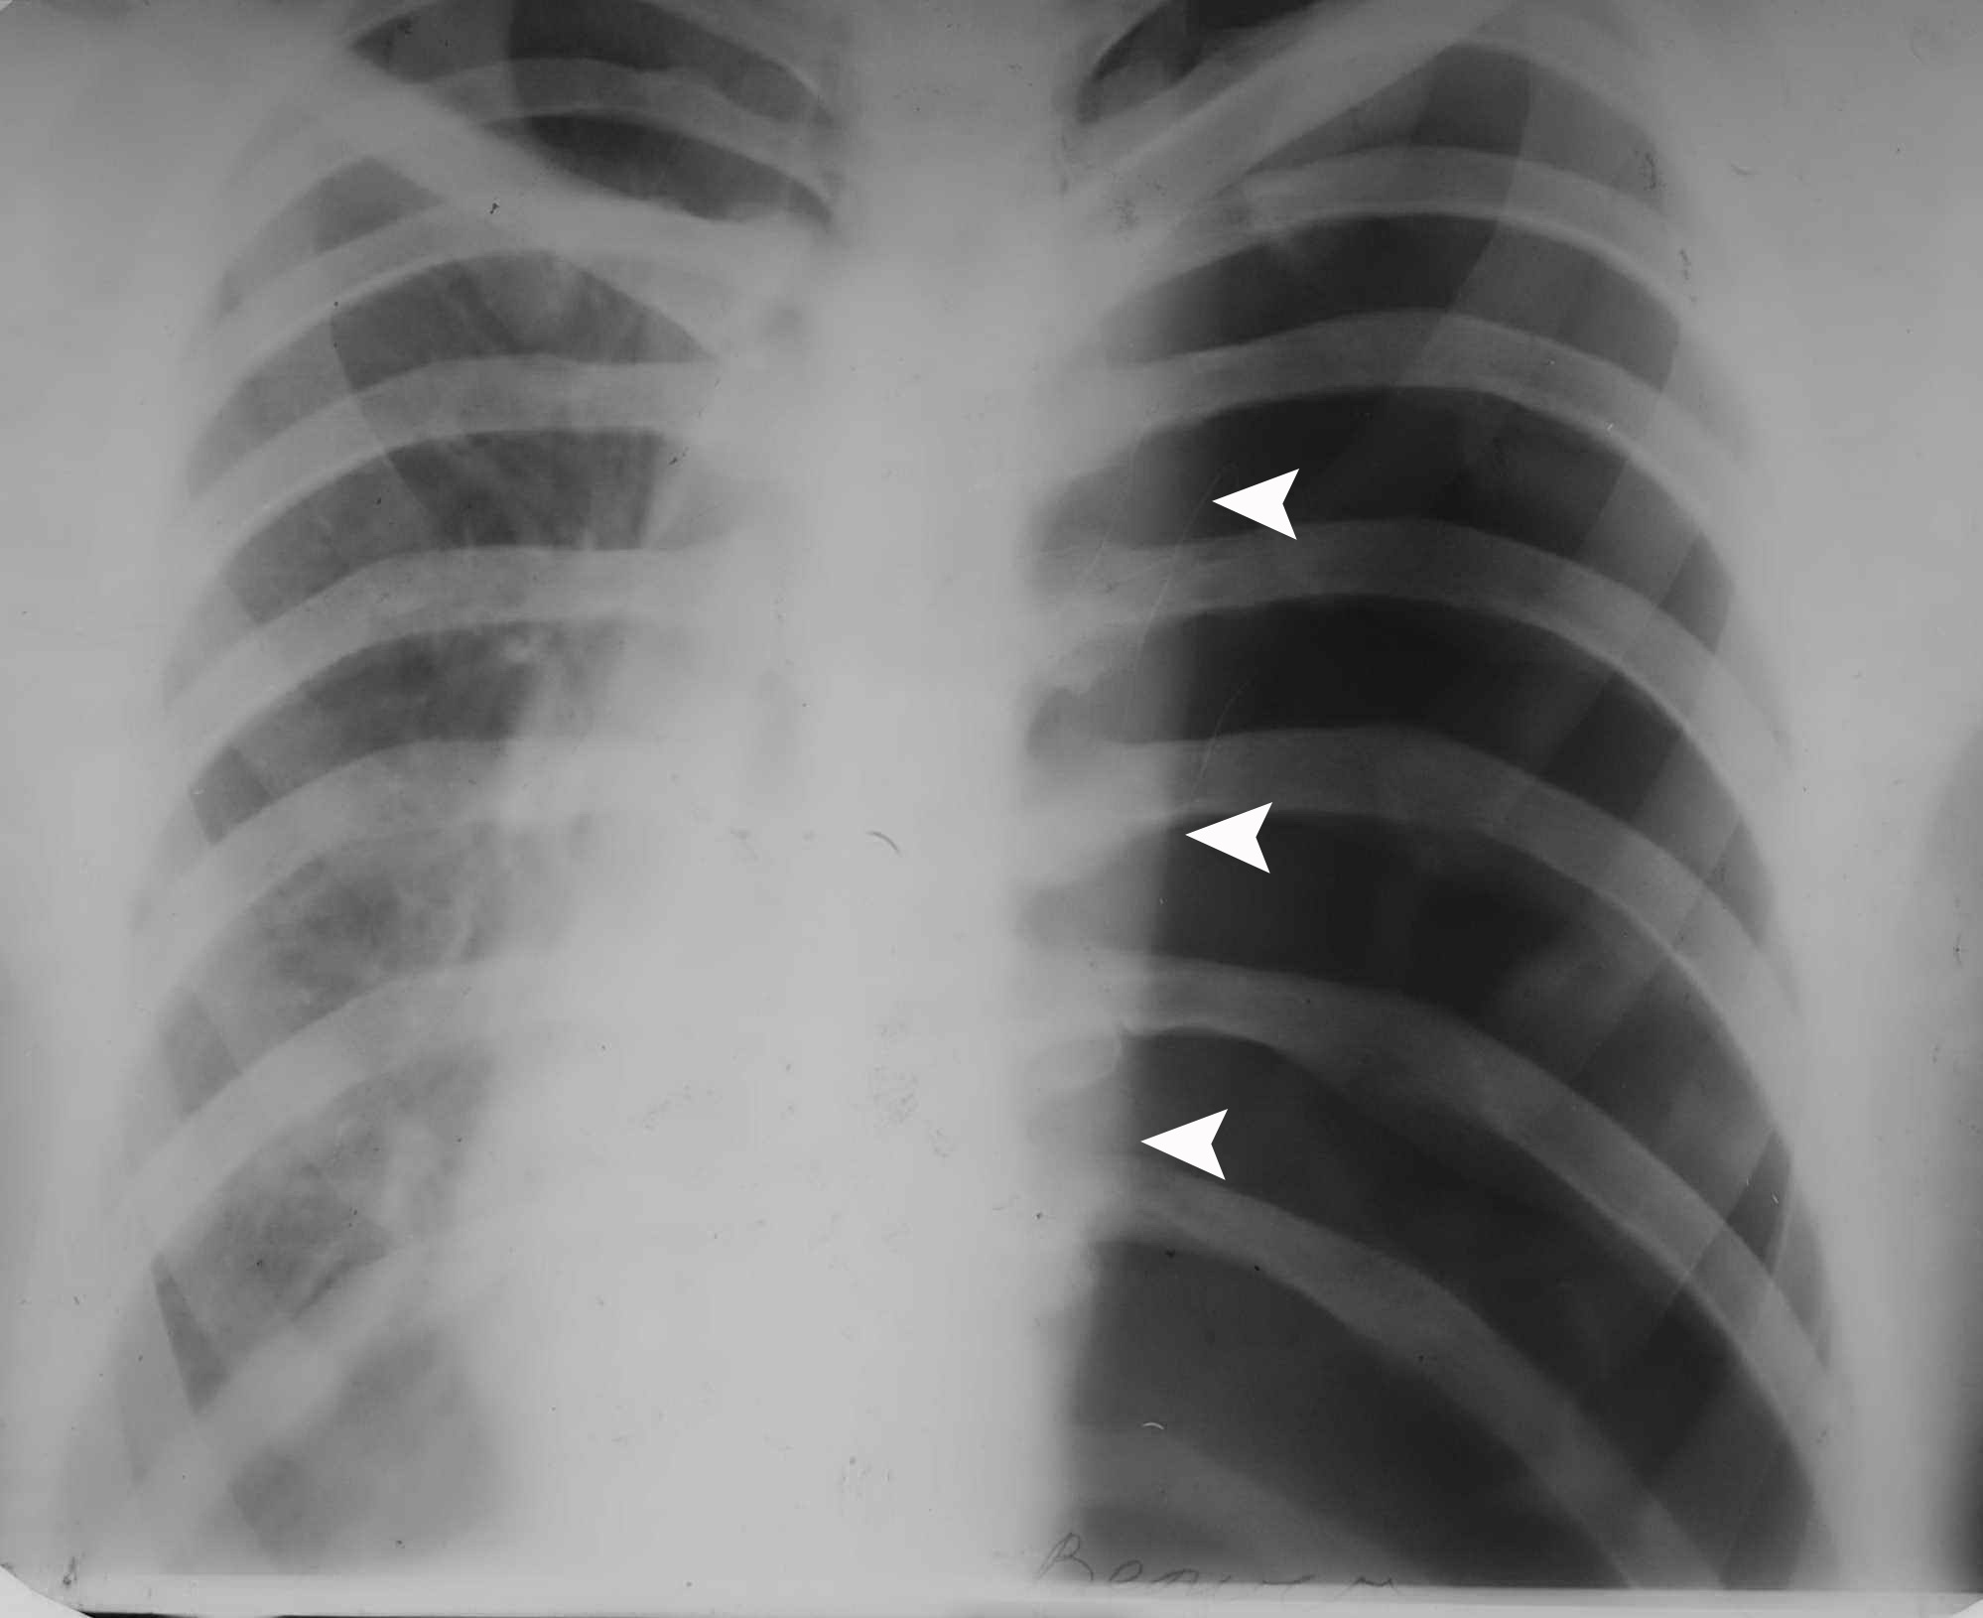

Fig. 22-2. Radiological picture of partial pneumothorax due to fractures of ribs (A) and total pheumothorax (B)

A 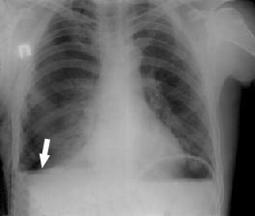 B 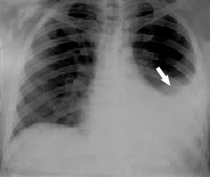

C 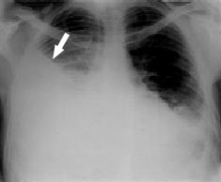 D 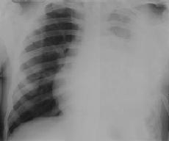

Fig. 22-3. Radiological pictures of small (A), moderatre (B), subtotal (C), and total (D) haemothorax

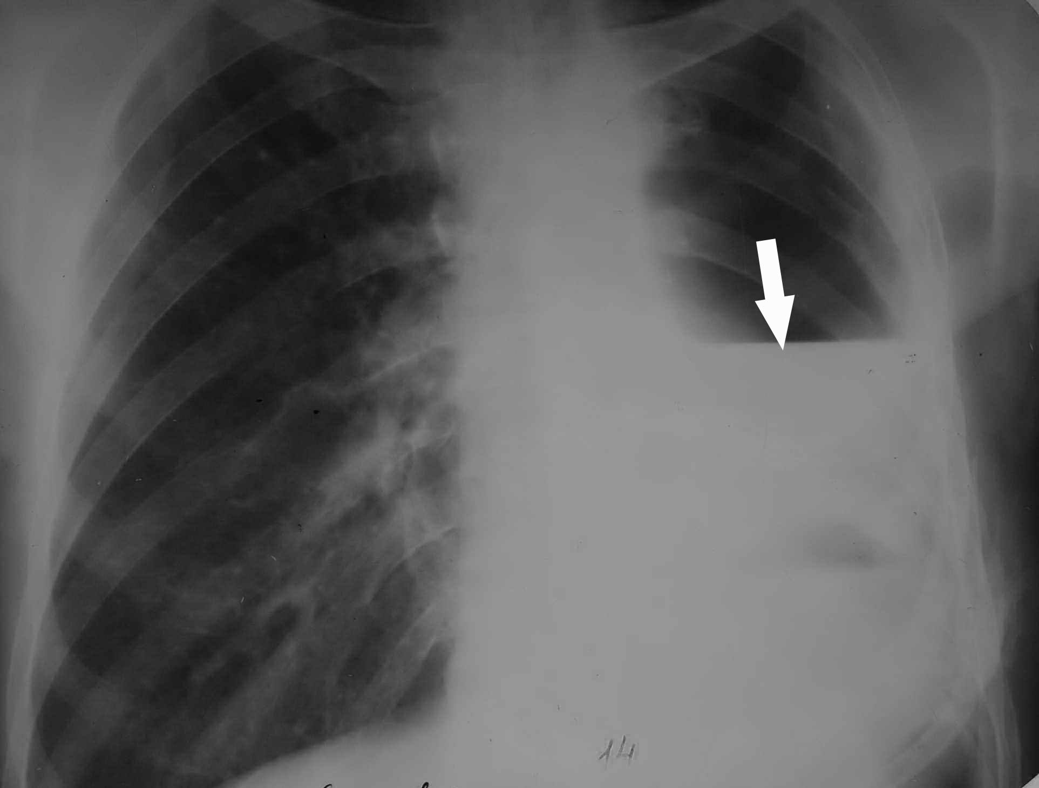

Fig. 22-4. Radiological picture of pheumohaemothorax

Management of specific conditions

- Most thoracic trauma can be managed nonoperatively, using expeditious control of the airway and thoracostomy tube drainage of the pleural space (see Fig. 22-5).
- Less than 25% of chest injuries require surgical intervention.
- Thoracic trauma can be divided into immediately life-threatening injuries and potentially life-threatening injuries.
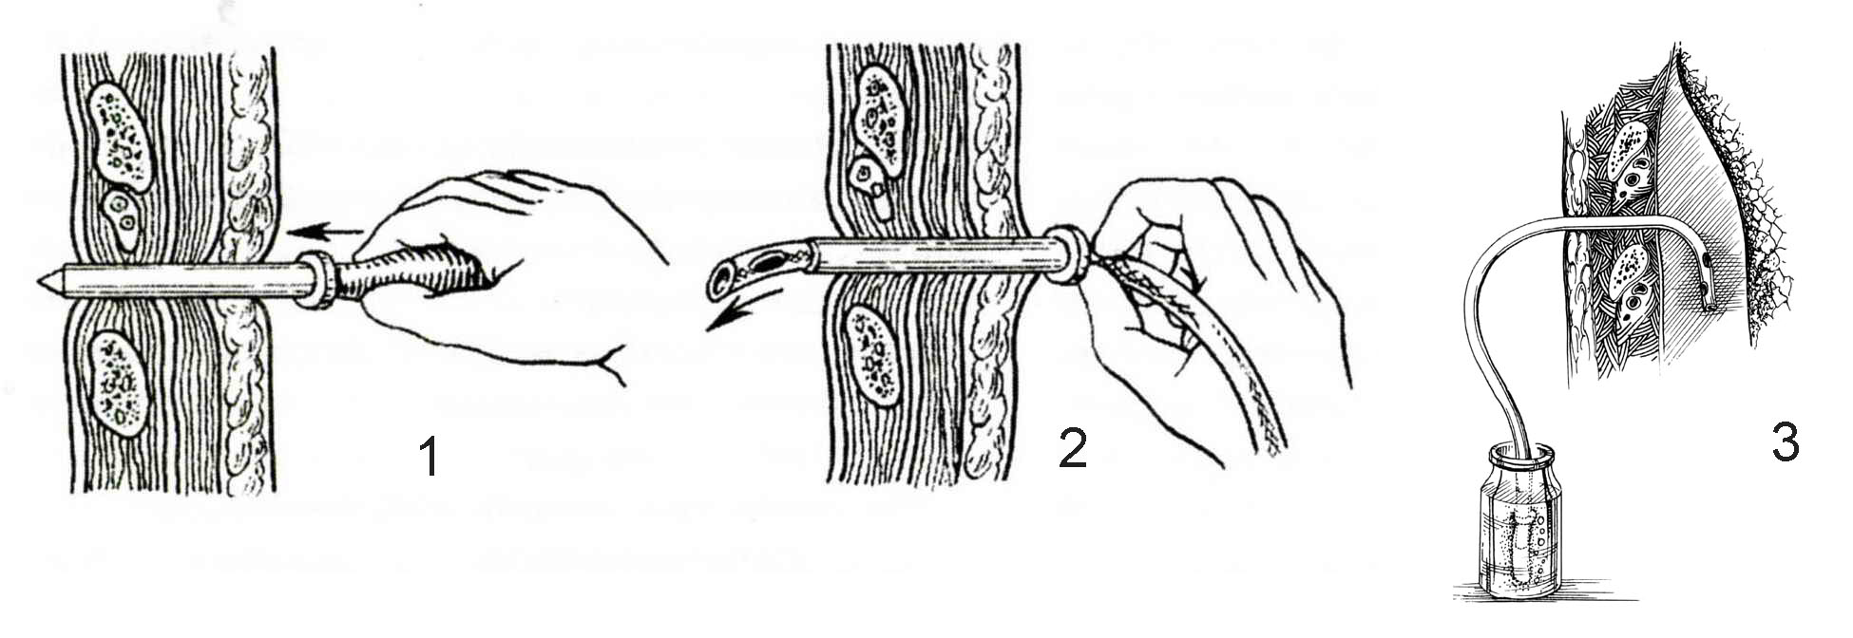
Fig. 22-5. Technique of drainage of pleural space for thoracic trauma

Immediately life-threatening injuries

- Immediately life-threatening injuries are those which can cause death in a matter of minutes and, therefore, must be rapidly identified and treated during the initial evaluation and resuscitation.

Airway obstruction

- Airway obstruction quickly leads to hypoxia, hypercapnia, acidosis, and cardiac arrest.
- The highest priority is rapid evaluation and securing the upper airway by clearing out secretions, blood, or foreign bodies; endotracheal intubation; or cricothyroidotomy.

Tension pneumothorax

- Tension pneumothorax implies that the pleural air collection is under positive pressure significant enough to cause marked mediastinal shift away from the affected side.
- Tension pneumothorax is caused by a check-valve mechanism in which air can escape from the lung into the pleural space but cannot be vented. It is a cause of sudden death.
- The collapsed lung results in chest pain, shortness of breath, and decreased or absent breath sounds on the affected side. Hypotension results from mediastinal shift to the contralateral side, which compresses and distorts the vena cava and obstructs venous return to the heart (see Fig. 22-6).
- The thorax must be decompressed with a needle, which is replaced by an intercostal tube with underwater seal and suction.

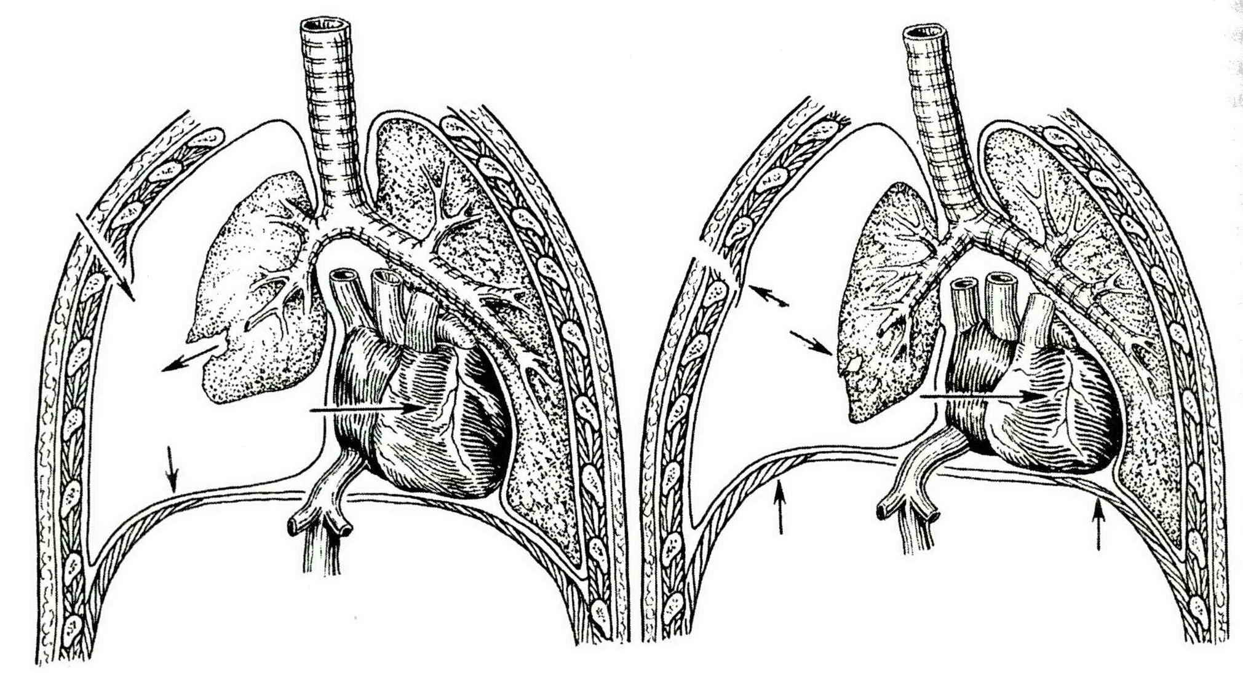

Fig. 22-6. Mechanism of tension pheumothorax

Open pneumothorax

- Open pneumothorax describes an injury in which an open wound in the chest wall has exposed the pleural space to the atmosphere.
- The open wound allows air movement through the defect during spontaneous respiration, causing ineffective alveolar ventilation (see Fig. 22-7).
- Treatment involves covering the wound and inserting a thoracostomy tube (see Fig. 22-8). Later, debridement and closure of the wound may be necessary.

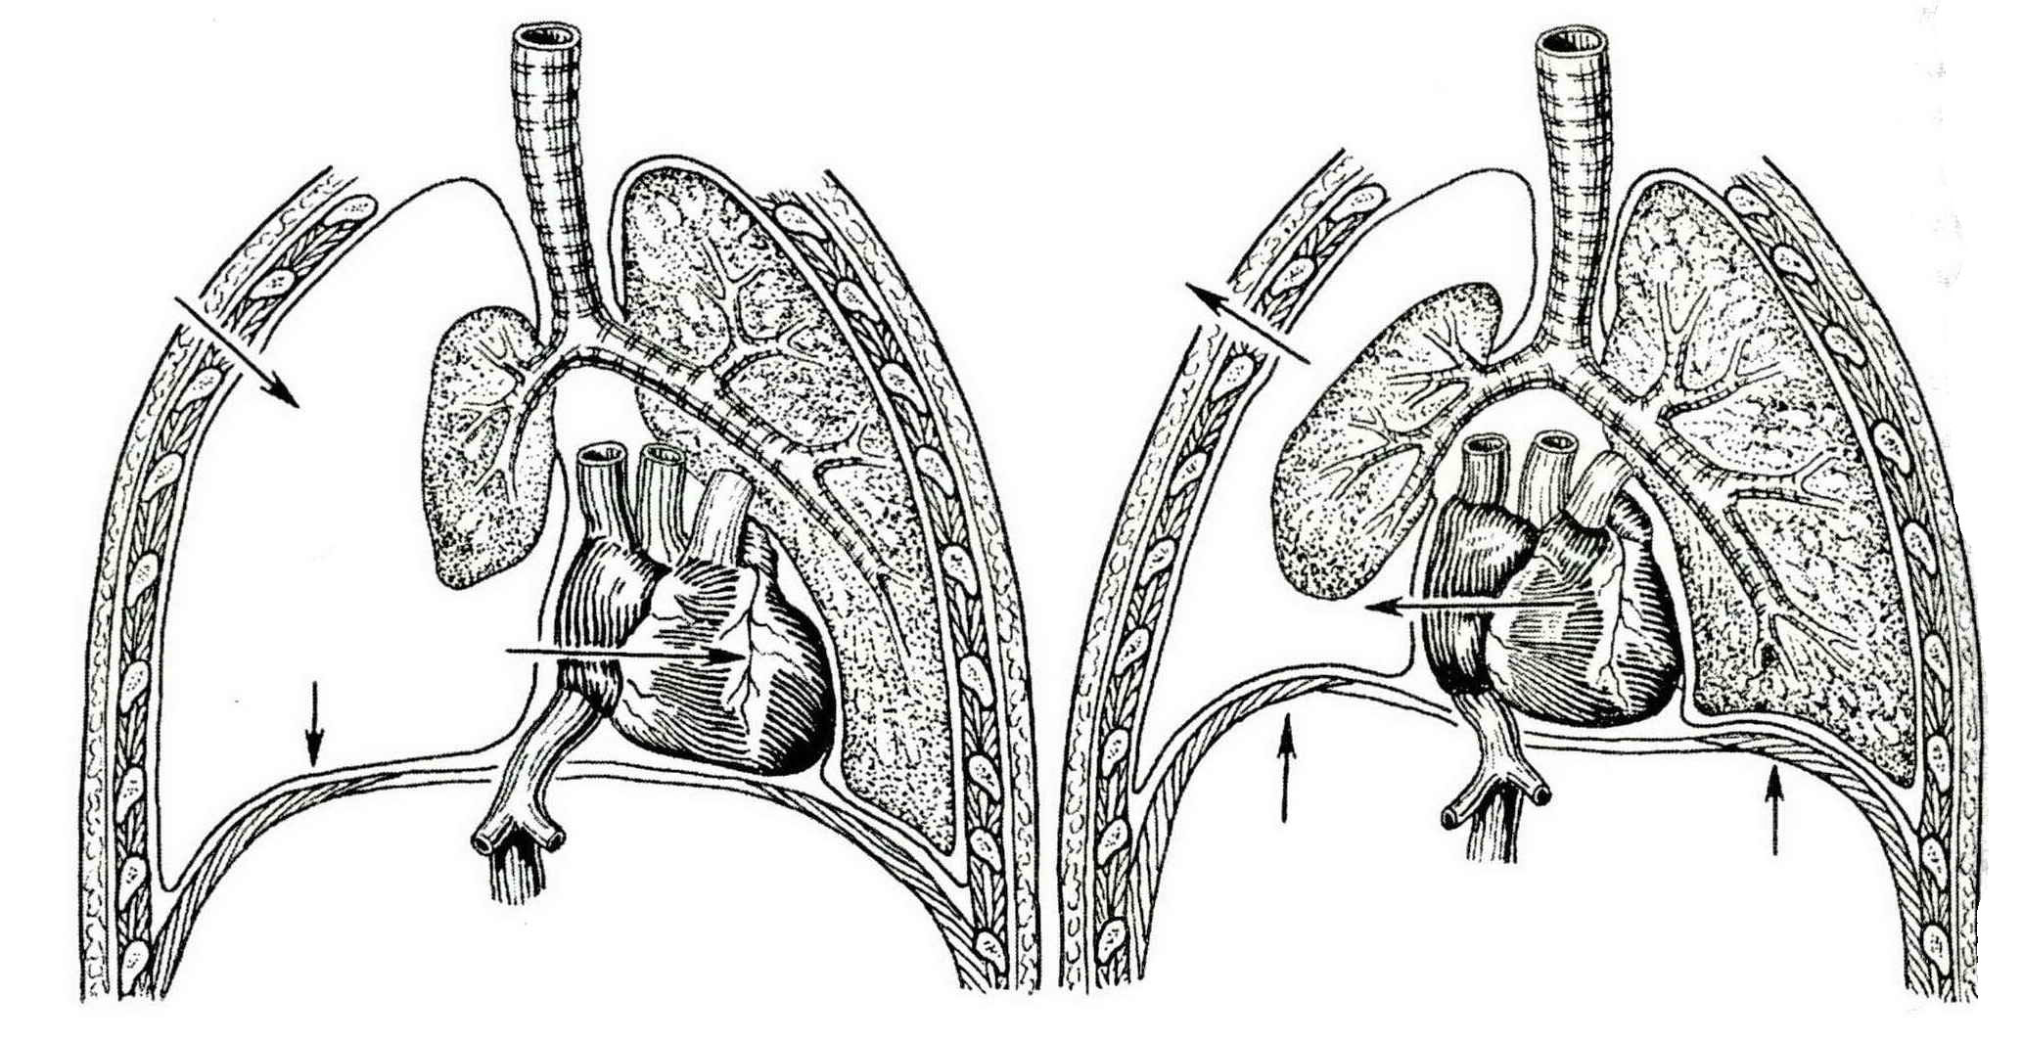

Fig. 22-7. Mechanism of open pheumothorax

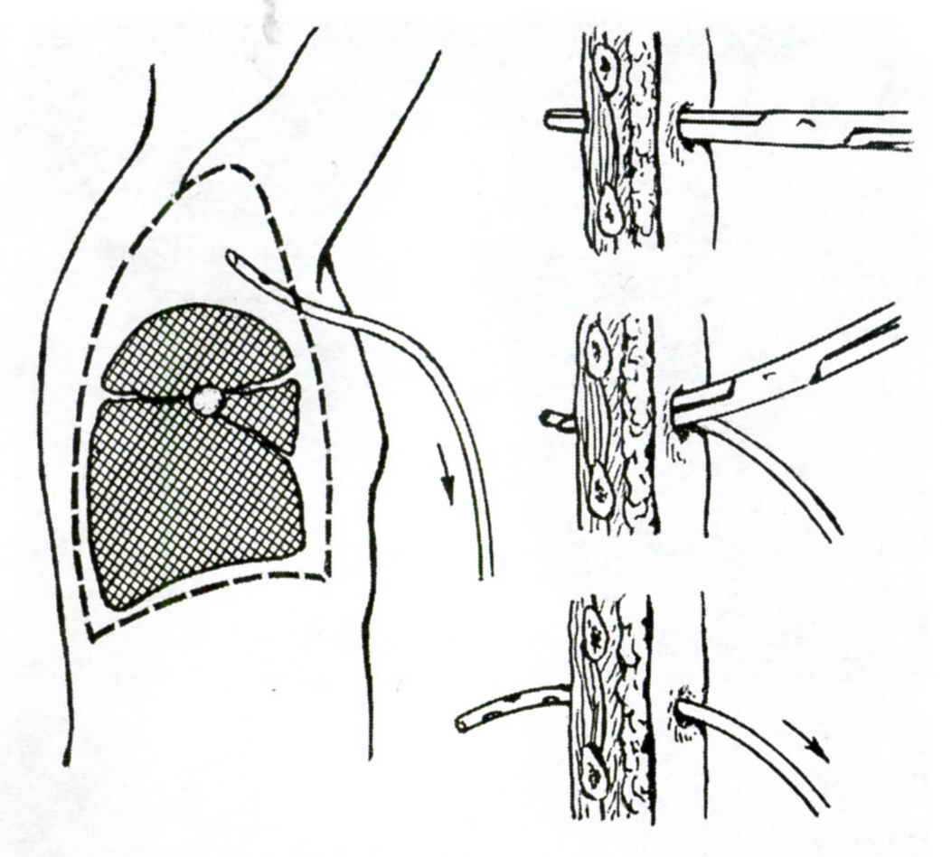

Fig. 22-8. Technique of drainage of pleural space for pneumothorax

Massive hemothorax

- Massive hemothorax occurs with the rapid accumulation of blood in the pleural space which causes both compromised ventilation as well as hypovolemic shock.
- Treatment entails securing intravenous access and beginning volume restoration followed immediately by placement of a thoracostomy tube.
- The patient should undergo urgent thoracotomy in the operating room if more than 1500 ml of blood are found in the chest or if bleeding continues at a rate of 100 ml/hr after the initial hemothorax is evacuated via a chest tube. Ligation of bleeding vessel (usually, intercostal artery) or wedge resection of the part of the lung (see Fig. 22-9) is then performed.
- If the hemothorax is inadequately drained, the patient may develop an empyema or fibrothorax, both of which would require subsequent thoracotomy and decortication.

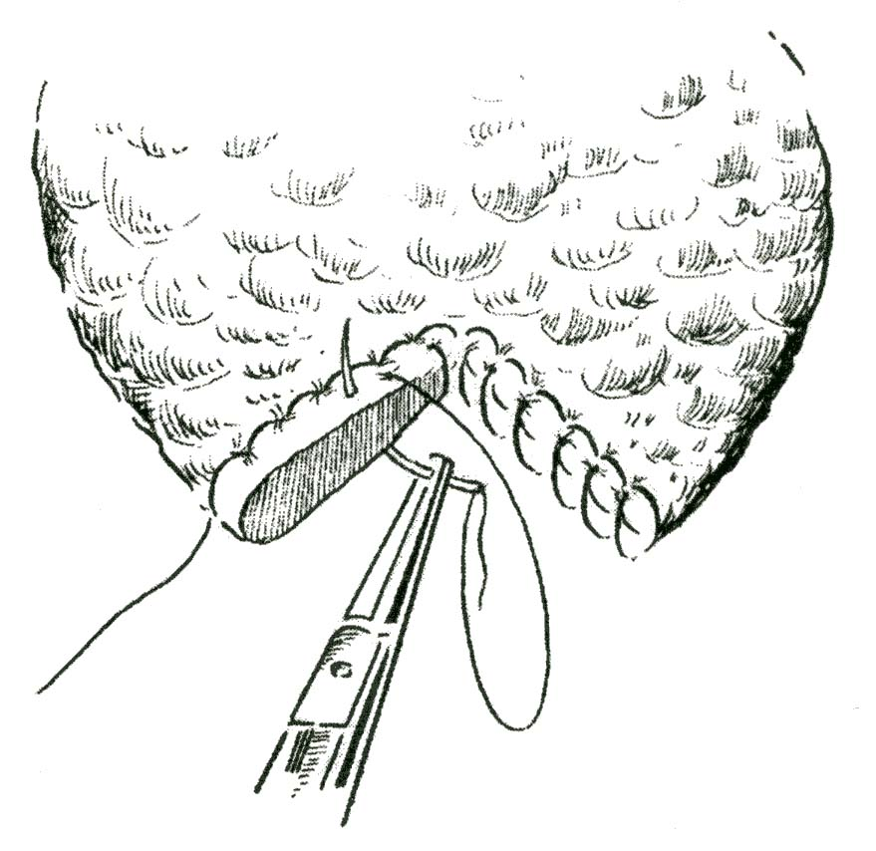

Fig. 22-9. Scheme of wedge resection of the injured lung

Cardiac tamponade

- Cardiac tamponade occurs with the rapid accumulation of blood in the pericardial sac, usually due to penetrating wound of the heart, which causes compression of the cardiac chambers, decreased diastolic filling, and hence, decreased cardiac output.
- Clinical presentation includes hypotension with neck vein distention.
- The principal diagnostic test is a pericardial tap, usually performed by inserting a catheter through the subxiphoid space (pericardiocentesis) (see Fig. 15-3).
- Treatment is prompt pericardial decompression either by pericardiocentesis (if in extremis) or via median sternotomy or left anterior thoracotomy (if more stable).
- In the case of cardiac tamponade, or penetrating chest wound in the area of the heart, emergency thoracotomy and suturing of the heart is inducated (see Fig. 22-10).

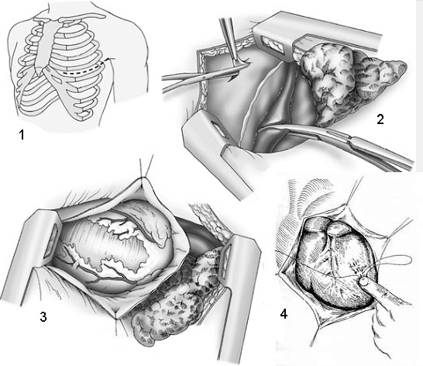

Fig. 22-10. Technique of suturing of the heart wound

Flail chest

- Blunt chest trauma, causing extensive anterior and posterior rib fractures or sternocostal disconnection, results in paradoxical chest wall movement.
- Paradoxical chest wall movement interferes with the mechanics of respiration and if severe, causes acute alveolar hypoventilation. Morbidity is also related to underlying lung injury.
- Treatment includes adequate pain control (intercostal blocks or epidural narcotics) and aggressive pulmonary toilet.
- In the case of multiple rib fractures (as well as in massive sternum fracture), usage of special devices for chest fixation is indicated.
- Mechanical ventilation may be required in severe cases.

Potentially life-threatening injuries

- Potentially life-threatening injuries are those which, left untreated, would likely result in death, but which usually allow several hours to establish a definitive diagnosis and institute appropriate treatment.

Tracheobronchial disruption

- Tracheobronchial disruption usually occurs within 2 cm of carina.
- Diagnosis is made by bronchoscopy and is suspected when a collapsed lung fails to expand, following placement of a thoracostomy tube; massive air leak persists; massive progressive subcutaneous emphysema is present.
- Treatment is by primary repair.

Aortic disruption

- Aortic disruption is the result of a deceleration injury in which the mobile ascending aorta and arch move forward while the descending thoracic aorta remains fixed in position by the mediastinal pleura and intercostal vessels. This movement causes a tear at the aortic isthmus, just distal to the takeoff of the left subclavian artery.
- The aortic injury usually results in fracture of the intima and media with the adventitia remaining mostly intact. However, complete disruption of all layers can occur with the hematoma contained only by the intact mediastinal pleura.
- Chest radiograph findings include: widened mediastinum; indistinct aortic knob; epressed left main stem bronchus; apical cap; deviation of trachea to the right; left pieural effusion.
- Diagnosis is confirmed by aortogram.
- Treatment is repair by interposition graft with or without some means of distal perfusion.

Diaphragmatic disruption

- Diaphragmatic disruption results from blunt trauma to the chest and abdomen, producing a radial tear in the diaphragm, beginning at the esophageal hiatus.
- Diagnosis is by chest radiograph, which shows evidence of the stomach or colon in the chest.
- The immediate placement of a nasogastric tube (if not already in place) will prevent acute gastric dilation, which can produce severe, life-threatening respiratory distress. This is followed by urgent transabdominal repair with simultaneous treatment of any associated intra-abdominal injuries.
- If rupture is not diagnosed until 7-10 days later, transthoracic (or thoraco-abdominal) repair is recommended to free any adhesions to the lung that might exist.

Esophageal disruption

- Esophageal disruption usually results from penetrating rather than blunt trauma.
- It causes rapidly progressive mediastinitis (see Chapter 14).
- Treatment is wide mediastinal drainage and primary closure with tissue reinforcement (pleura, intercostal muscle, or stomach).

Cardiac contusion

- Cardiac contusion results from direct sternal impact. It ranges in severity from subendocardial or subepicardial petechiae to full-thickness injury.
- Complications include: arrhythmias (i.e., premature ventricular contractions, supraventricular tachycardia, and atrial fibrillation); myocardial rupture; ventricular septal rupture; left ventricular failure.
- Diagnosis is made by electrocardiogram, isoenzymes, and echocardiogram.
- Treatment includes cardiac and hemodynamic monitoring, appropriate pharmacologic control of arrhythmias, inotropic support if cardiogenic shock develops.

Pulmonary contusion

- Pulmonary contusion is the most common injury seen in association with thoracic trauma (30%-75% of all patients suffer major chest injury).
- It is caused by blunt trauma, which produces capillary disruption with subsequent intra-alveolar hemorrhage, edema, and small airway obstruction.
- Diagnosis is by chest radiograph, arterial blood gas, and clinical symptoms of respiratory distress.
- Treatment includes fluid restriction, supplemental oxygen, vigorous chest physiotherapy, adequate analgesia (epidural narcotics), and prompt chest tube drainage of any associated pleural space complication.

Abdominal injuries

General assessment

- These injuries may be subtle or overt. Evidence of trauma may be visible on the abdominal wait or pelvis.
- The critical step for the physician is to recognize the presence of an abdominal injury and establish its degree of urgency.
- Early tense abdominal distention usually indicates severe bleeding. An abdomen that progressively becomes scaphoid suggests herniation of the abdominal contents through a traumatic diaphragmatic hernia.
- Knowledge of specific intra-abdominal injuries is not necessary; the presence of bleeding or penetrating perforations of abdominal wall are sufficient indications to operate.
- Diagnostic peritoneal lavage (DPL) should be used when the need for abdominal exploration is not clear. It is also useful when physical assessment is not productive; for example, when the patient is unconscious or neurologically impaired.
- See more in Scheme 22-1.

Scheme 22-1. General algorithm of management of patient with abdominal injury

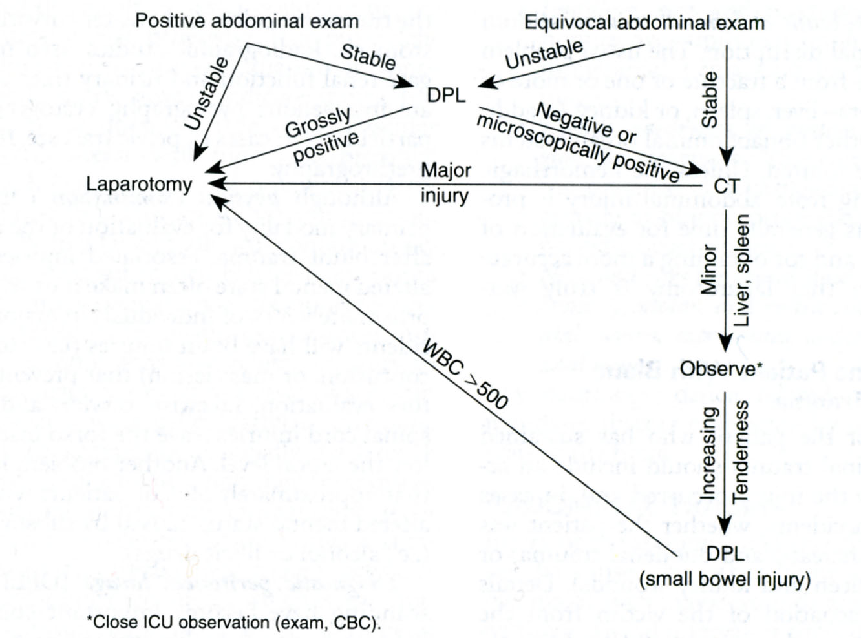
From: Basic surgery/ed., H.C. Polk, Jr., et al. – 5th ed.

Tecnique of peritoneal lavage

- The best technique for peritoneal lavage is the "open" technique.
- The bladder is first emptied with a bladder catheter.
- The nasogastric tube empties the stomach and provides diagnostic information.
- The peritoneal dialysis catheter is inserted through a small incision made in the midline fascia below the umbilicus.
- One liter of crystalloid solution is infused in adults.
- The lavage is positive if gross blood, more than 100,000 red blood cells/ml, vegetable fibers, fecal matter, or bacteria are found.
- It is helpful to leave the dialysis catheter in place after a negative lavage.

Assessment of patients with suspected intraperitoneal bleeding

- The "real world" thought process in assessing multiple trauma patients with hemorrhagic shock: if the blunt trauma patient meets criteria for hypovolemic shock, the evaluator should know that a 30% or more loss of blood volume has to go to one or more of five following places.
- The injury scene: details are available from the history and rescue workers.
- Intrathoracic blood loss: diagnosis is confirmed by chest radiograph and physical examination). Intra-abdominal blood loss (if a rapid answer is needed in an unstable patient, diagnostic peritoneal lavage or ultrasound can be used; if more time is available, especially if the patient has a head injury requiring a CT scan, abdominal CT is accurate and useful.
- Retroperitoneal bleeding: it is almost always associated with pelvic fracture; the initial pelvic radiograph should suggest diagnosis.
- Thighs: bilateral femur fractures cause shock; palpation and radiographs can confirm the diagnosis.
- Summary example: a patient who is in shock, who has no history of external blood loss, who has negative chest and pelvic radiographs, and who does not have femur fractures must have blood loss in the abdomen.

Imaging techniques

- All visualization tools used in acute abdomen (see Chapter 1) and described above may be used in patients with blunt abdominal trauma.
- Laparoscopy may be as accurate diagnostic tool as laparotomy, and may be curative in most cases of moderate abdominal trauma. It also markedly decreases mortality and thus should be used as widely as possible.
- There are some additional urologic imaging techniques that aid in the diagnosis of abdominal injury.
- Intravenous pyelography: a knowledge of bilateral renal function is essential for the surgeon operating on a patient with multiple, massive intra-abdominal injuries.
- Retrograde pyelography provides morphologic evidence of extravasation of urine or disruption of a ureter or collecting system.
- Cystourethrography is indicated in pelvic fractures when urethral bleeding is evident.

A 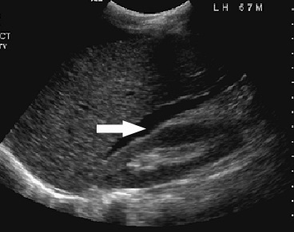 B 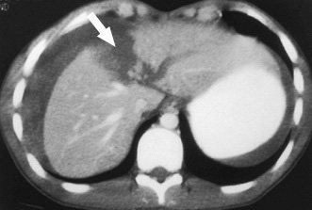

Fig. 22-11. US and CT pictures of hemoperitoneum due to rupture of liver

Inside the abdomen, bleeding control

- A generous midline incision has been found to be the most expeditious.
- If there is no evidence of injury of hollow organ, the blood re-infusion must be done.
- Hemostasis is the major priority in surgery for abdominal trauma. A bleeding aorta can be temporarily clamped for hemostasis while resuscitation is carried out. Rapid methods of temporary hemostasis, such as packing and direct pressure, are applied while fluid resuscitation is carried out. Meticulous exploration and repair should wait until volume replacement is complete and the patient is stable.
- Retroperitoneal hematomas in the pelvis and lower abdominal regions are best not explored unless they are actively expanding or an arterial source has been demonstrated on angiography. Many of these are associated with pelvic fractures and are not controllable by surgical means. However, retroperitoneal hematomas in the upper abdomen, particularly those in proximity to the duodenum, pancreas, and renal pedicles, should be explored.

Management of specific conditions

Trauma of liver

- Due to its large size, the liver is frequently injured by both blunt and penetrating trauma.
- Due to its high blood flow, proximity to the inferior vena cava, nearby vital structures, and propensity to develop infections, the overall mortality of liver trauma remains about 10%-20%.
- Injury to the hepatic veins and retrohepatic inferior vena cava has a mortality of over 50%, regardless of the method used to obtain control of bleeding.
- Diagnosis is usually related to intraperitoneal bleeding. Ongoing bleeding mandates surgery.
- At surgery, initial hemostasis is obtained via packing and the Pringle maneuver (control and compression of the porta hepatis (see Fig. 22-12)). Definitive control of bleeding requires exposure and ligation of individual parenchymal bleeders or resection of damaged liver tissue.
- Less common methods to control bleeding include: resectional debridement, without an anatomic (i.e., segmental or lobar) resection; anatomic resection (mortality is about 50% when done as an emergency); hepatic artery ligation (may control arterial bleeding but is associated with infectious complications in the compromised parenchyma); definitive packing (can be useful when other methods are unavailable or fail).
- Late complications are common.
- Subcapsular and intrahepatic hematomas can be carefully observed, but many ultimately require drainage.
- Perihepatic collections, whether of blood or bile, usually become infected and must be drained.
- Biliary fistulas may track to the skin or into the chest (biliary-pleural, broncho-biliary fistula).
- Hemobilia is due to arteriobiliary fistula formation. Patients present late (more than 1 month after injury) with gastrointestinal bleeding (hematemesis or melena), jaundice, biliary colic, or fever. Diagnosis and treatment are via arteriography and embolization.

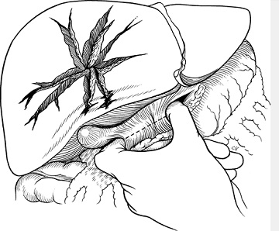

Fig. 22-12. Pringle maneuver

Trauma of gallblader

- Gallbladder injuries are uncommon but are seen after both penetrating and nonpenetrating trauma. Associated visceral injuries are common and most frequently involve the liver.
- Types of injuries to the gallbladder include contusions, avulsion, rupture, and traumatic cholecystitis.
- Right upper quadrant pain, right chest pain, biliary leakage through a penetrating wound, and shock are the most common presenting symptoms.
- Diagnosis is most frequently made at laparotomy/laparoscopy or by peritoneal lavage.
- The treatment is cholecystectomy.

Extrahepatic bile duct injuries

Operative injury

- Most extrahepatic bile duct injuries are iatrogenic, occurring during cholecystectomy.
- Only 15% of intraoperative injuries are diagnosed at the time of surgery, and 85% present days to years later with progressive jaundice, cholangitis, or cirrhosis and its complications.
- Diagnosis is by transhepatic cholangiography or ERCP.
- End-to-end (duct-to-duct) anastomosis may be done at the time of initial injury; otherwise a Roux-en-Y choledochojejunostomy is necessary.
- The mortality rate after repair of a chronic biliary stricture is 8%-10%, and death is usually secondary to liver failure.

Other injuries

- Other extrahepatic bile duct injuries almost always accompany other visceral injuries and result from trauma, such as gunshot wounds. Isolated bile duct injuries are rare.
- Clinical presentation is the same as those in gallbladder injuries.
- The intraperitoneal extravasation of sterile bile results in chemical peritonitis. This may be a mild peritonitis, producing ascites, or a localized collection. Continuous outpouring of sterile bile may produce an extensive chemical peritonitis and shock. Infected intraperitoneal bile induces a fulminant and frequently fatal peritonitis.
- Diagnosis is made at laparotomy/laparoscopy or by peritoneal lavage.
- Treatment involves meticulous exploration of the ducts. Either a primary end-to-end anastomosis, or, more commonly, a Roux-en-Y choledochojejunostomy is appropriate. If the patient is unstable, drainage with a T tube is expedient.

Trauma of pancreas and duodenum

- The pancreas and duodenum should be mobilized and then thoroughly palpated to rule out pancreatic disruption.
- The duodenal disruption can be patched or repaired if the injury is diagnosed early. Delay may cause poor tissue quality that is not safely repaired.
- Pancreatic transections are best treated by distal resection. Most pancreatic injuries can be handled by simple sump drainage if transection or major duct damage has not occurred.

Bowel injuries

- Separated small bowel injuries should be sutured.
- Massive small bowel injuries may require resection with primary anastomosis or (if the latter is not safe) jejunostomy (loop jejunostomy, Maydle jejunostomy).
- Separated colon injuries are sutured with further proximal loop coloctomy or caecostomy.
- Massive large bowel injuries may require resection with colostomy (loop colostomy, proximal end colostomy, caecostomy).

Other injuries

- Ruptures of mesentery without impairment of bowel blood supply requires simple suturing.
- If great mesenteric vessels are injured and the risk of bowel gangrene exists, the bowel resection is necessary.
- Spleen trauma (see Fig. 22-13) is very common in blunt abdominal trauma, especially of left upper quandant and left lower part of chest. As a rule, it requires spleenectomy (see Fig. 22-14).

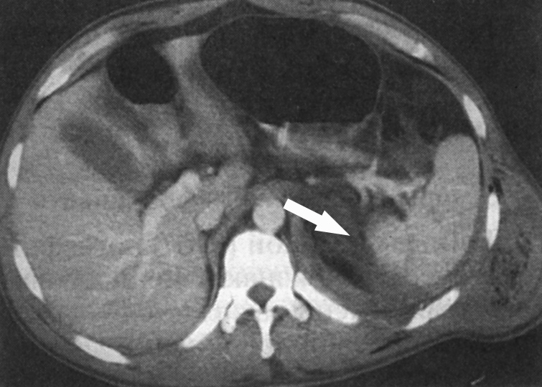

Fig. 22-13. CT picture of haemoperitoneum due to rupture of the spleen

1 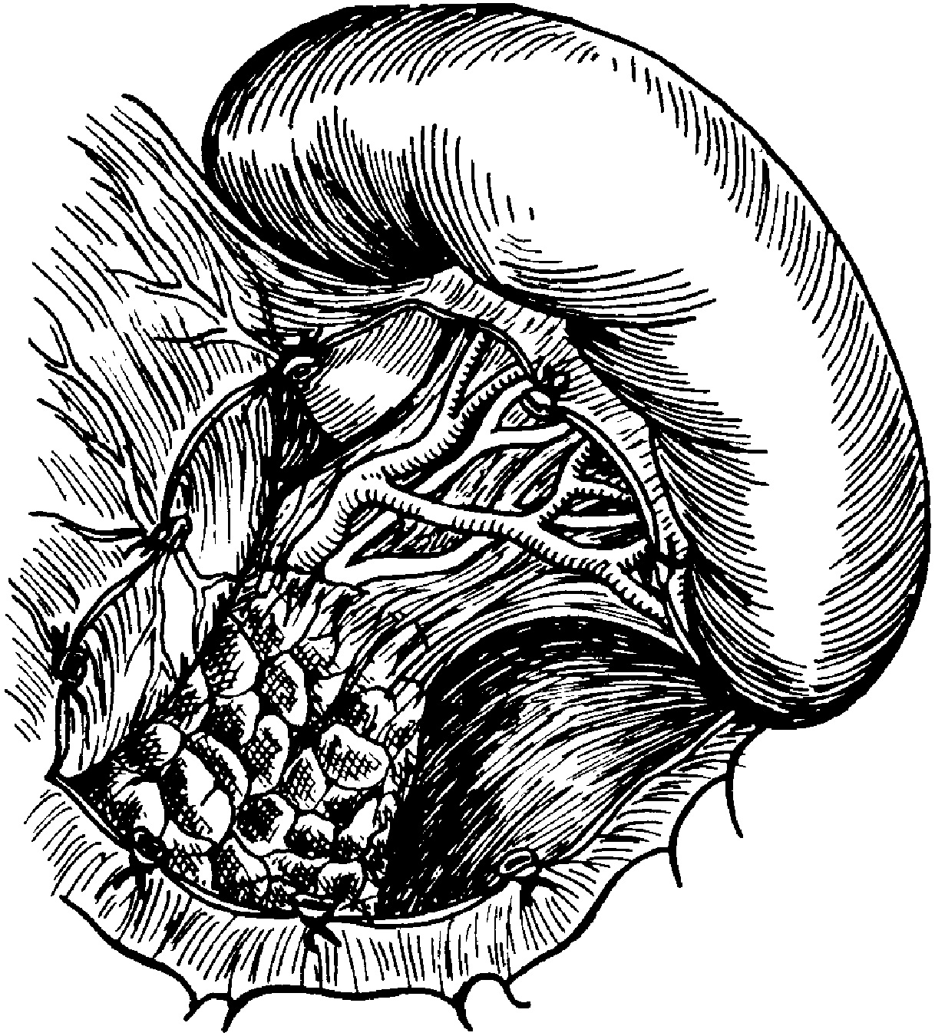 2 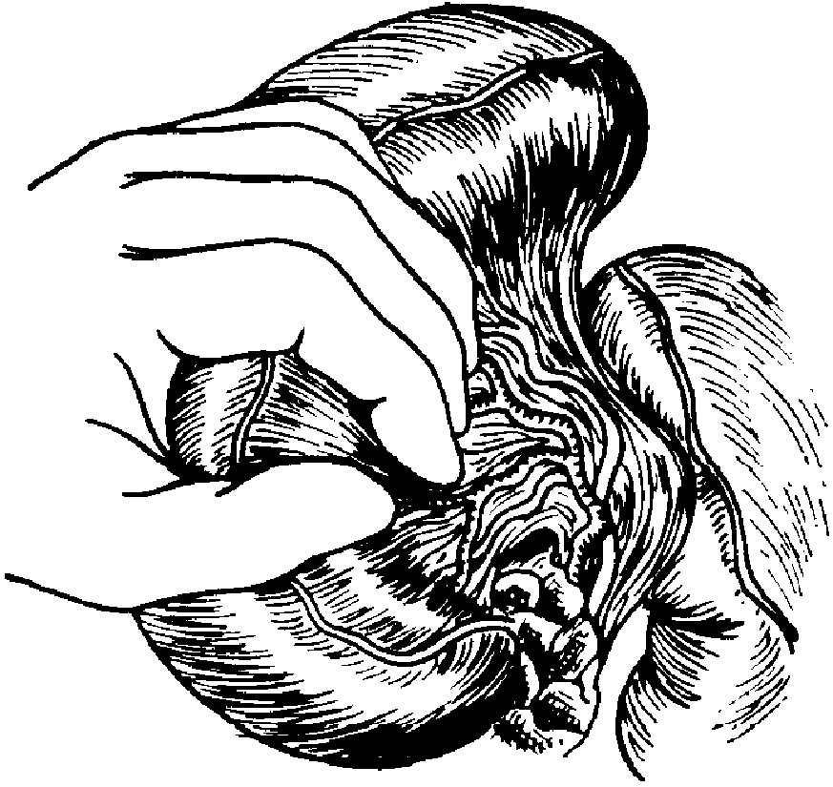 3 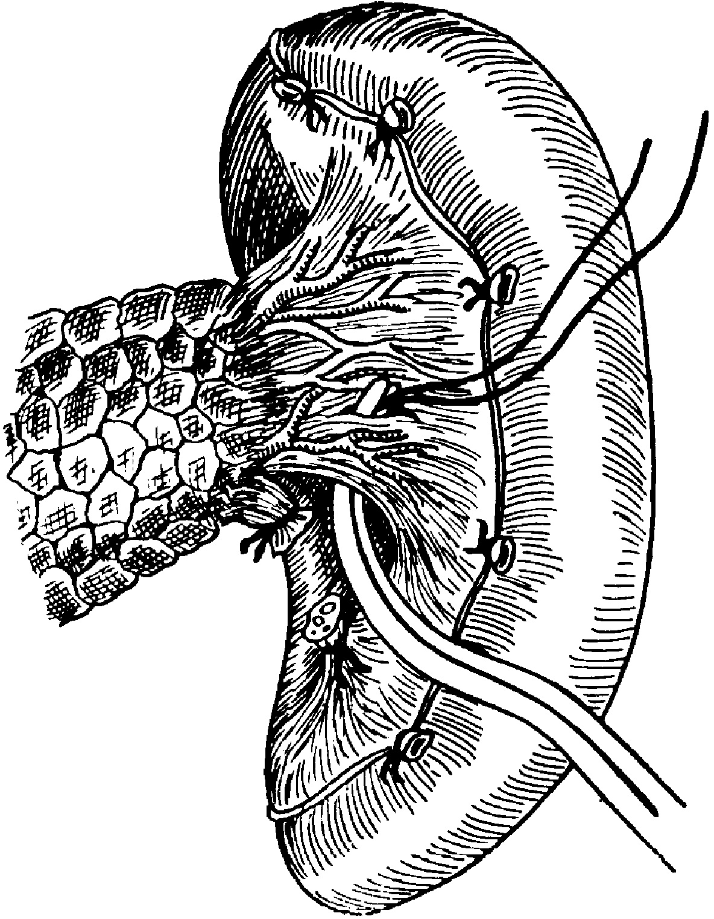

Fig. 22-14. Scheme of spleenectomy

Genitourinary injuries

Urethral injury

- Blood at the meatus is an indication for retrograde urethrography.
- Even gentle insertion of a Foley catheter can disrupt a partially divided urethra.
- Major injuries should be repaired surgically.

Bladder injuries

- Bladder injuries usually heal spontaneously if adequate urinary drainage is established.
- Generally, intraperitoneal bladder ruptures require operative repair.

Trauma of kidneys

- Kidneys are commonly injured organs.
- Most renal injuries can be managed nonoperatively; however, renal pedicle disruption or major parenchymal damage with hemorrhage are the primary indications for surgery.
- Intravenous pyelography provides a good test of renal function, but it is not adequate for determining anatomic continuity of the organ. Extravasated contrast medium is an indication for drainage of the area where the leakage occurred.

Soft tissue injuries

General

- Debridement is the key to avoiding infection and promoting rapid healing.
- All devitalized tissue must be removed during debridement.
- It is helpful to understand how different tissues respond to injury. The degree of injury often depends on the density of the tissue and its water content. The lung, for example, tends to receive relatively minor degrees of damage remote from the missile tract. By contrast, muscle or liver, due to their greater density and water content, develop large temporary cavities and require extensive debridement beyond the apparent missile tract.

Muscle injury

- Wide areas of devitalized tissue occur in high-velocity wounds and require debridement.
- Viable muscle tissue visibly contracts when touched with an electrosurgical instrument set on a low power.
- Muscle that does not react must be removed even though weakness and deformity will result.

Injuries of vessels

- Palpable pulses do not rule out arterial injury.
- Grossly injured vascular areas that exhibit intramural bleeding or disruption require removal. It is not necessary to remove apparently normal areas of arteries.
- Repair (see Fig. 22-15) should be done with autogenous material if at all possible. There is an increased incidence of infection and failure when prosthetic material is used.
- Fasciotomies are almost always required in conjunction with vascular repair. It is far better to do a fasciotomy early in anticipation of swelling and tension in muscle compartments than to wait until tissue loss has occurred.
- Stab wounds and missile tracts in proximity to major vascular structures require either surgical exploration or, at a minimum, emergency arteriography.
- Major veins should be repaired when injured.

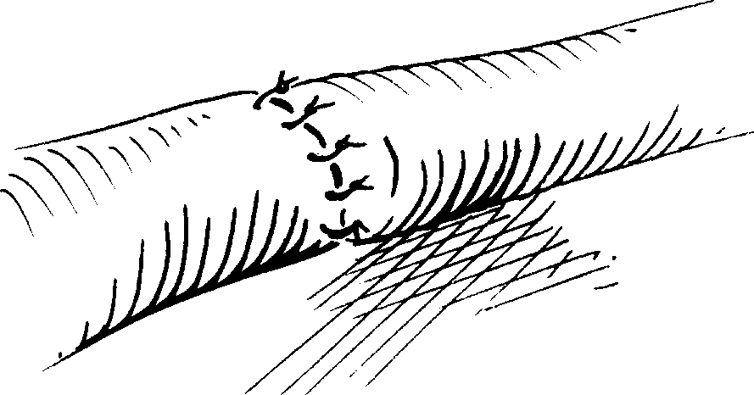

Fig. 22-15. Technique of vascular suture

Injuries of nerves

- It is not necessary to debride nerves that are injured incompletely. Exposed nerves should be covered with normal muscle or fat, leaving definitive repair for a future time.
- In complete or near-complete nerve injury microsurgical repair ia beneficial.

Injuries of bones

- Contaminated small pieces of bone that are not attached to soft tissue may be removed.
- Attached bones should generally be left in situ to speed healing.

Injuries of genitalia

- Very conservative debridement is indicated.
- Exposed testicular tissue should be covered with scrotal skin or reimplanted under attached skin, if possible.

Tendon injuries

- Incomplete tendon injuries require conservative debridement only. They should be covered with normal tissue or they become devitalized and useless.
- Completely cut tendons should be repared.

Neck injuries

- All penetrating neck injuries and all hematomas in the neck should be surgically explored (see Fig. 22-16).
- Arteriography is recommended for penetrating injuries above the angle of the mandible or in the supraclavicular area.
- Bronchoscopy, esophagoscopy, and x-rays can help to rule out tracheal or esophageal injuries.

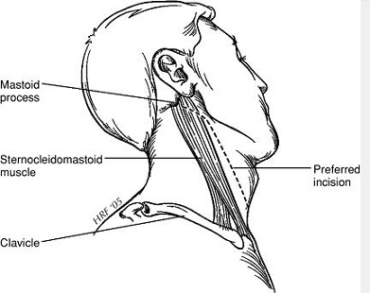

Fig. 22-16. Incision for exploration of the neck for trauma

Fractures

- A fracture is seldom a major priority in the presence of other, life-threatening injuries.
- Hemorrhage or vascular compromise associated with a fracture gives it a higher priority, as does a threat to the viability of an extremity.
- Bleeding associated with a fracture can account for a large portion of a patient's circulating blood volume, and hypovolemic shock (see below) is commonly associated with bilateral femoral fractures. A femur fracture can account for 1 L of blood loss, pelvic fractures can cause blood loss of several liters.
- Early fractures that are open can be treated in accordance with the associated soft tissue injury.
- Debridement, vascular repair, and other soft tissue surgery should be done prior to stabilization of the fracture.
- Adequate splinting and stabilization should be accomplished because it decreases the risk of fat embolism syndrome.
- Internal fixation devices are generally hazardous in the presence of extensive soft tissue injury and should be avoided if possible.
- Fractures that are more than 6-8 hours old should be allowed maximal spontaneous recovery before any attempt is made to stabilize them surgically.

BURNS

Assessment

- The initial treatment of burns is based on the same principles and priorities as for other forms of trauma.
- However, one special priority is to stop any continuing burn injury caused by smoldering clothes or corrosive chemicals, using neutral solutions to flush away all garments from the injured area.
- It is also mandatory to assess any concomitant injuries.
- The management of the burned patient depends on the depth, extent, and location of the burned area.
- Transfer of the burn patient to a burn center or consultation with the center should be considered for all but minimal burn injuries.

Depth of burns

- First-degree burns (involvement of epidermis only). Clinical findings are limited to erythema.
- Second-degree (partial-thickness or intradermal) burns. Clinical findings include vesicles, swelling, and a moist surface. Partial-thickness burns are painful and are hypersensitive to a light touch or even the movement of air. Epithelial remnants (skin appendages) are spared. Second-degree burns are categorized into superficial and deep dermal burns.
- Third-degree (full-thickness, entire depth of dermis) burns. These burns have a charred, waxen, or leathery appearance and may be white-grayish in color. They usually appear dry. Thrombosed vessels may be evident. The burn surface is pain free and is anesthetic to a pinprick or to touch.

Extent of burns

- This is determined by the "rule of nines" (Fig. 22-17).
- Inpatient treatment is required for a patient with either: full-thickness burns extending over 2% or more of the body surface area (BSA); partial-thickness burns extending over 10% or more of the BSA.
- Intravenous fluid resuscitation is required for all partial- or full-thickness burns extending over 20% or more of the BSA.

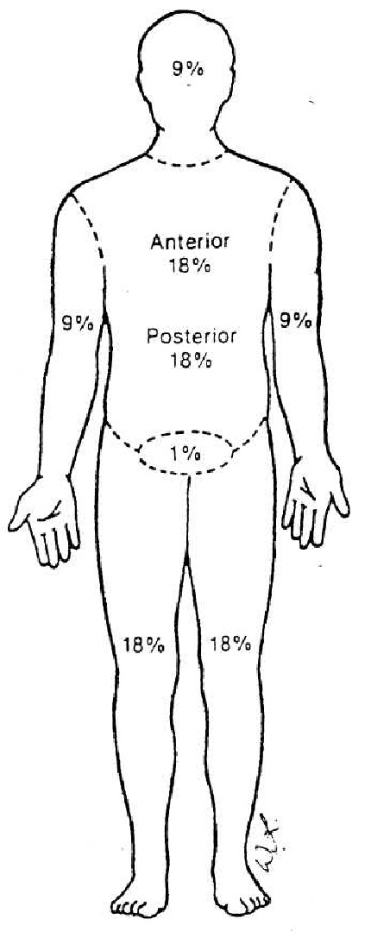
Fig 22-17. "Rule of nines" for determination of the extent of burns

Location of burns

- Inpatient treatment is required for second- or third-degree burns of the face, hands, feet, or genitalia.
- Second- or third-degree burns involving major flexion creases usually require hospital treatment to minimize contractures and other late problems.

Airway control and ventilation

- Airway obstruction may develop rapidly after inhalation injury or may be delayed. Delayed airway obstruction is due to progressive swelling and is apt to develop 24-48 hours after the injury. This possibility should be suspected if any of the following conditions are present: a history of being burned in a confined space; a facial burn or singed facial hair; charring or carbon particles in the oropharynx; carbonaceous sputum; circumferential burns of the trunk, especially those with a thick eschar (which may require emergency excision).
- Measurement of arterial blood gases is indicated as well as measurement of carbon monoxide level (carboxyhemoglobin value over 10% is significant).
- Endotracheal intubation should be done before the patient develops respiratory problems. Intubation is preferable to a tracheostomy in the patient with burns of the face, neck, or respiratory tract, since tracheostomy through a burn carries a high mortality.

Circulatory support and fluid resuscitation

- Major burns – those involving 20% or more of the BSA – call for fluid resuscitation.
- Intravenous fluids should be administered through a 14- or 16-gauge intravenous catheter. The catheter may be placed through the burn wound, if required. Intravenous fluids should not be given via a lower extremity, since the site is prone to sepsis and its increased mortality risk.
- Fluid resuscitation should begin with lactated Ringer's solution.
- The volume to be given is calculated as follows: for adults: % BSA burned x kg of body weight x 2-4 ml of electrolyte solution; for children: % BSA burned x kg of body weight x 3 ml of electrolyte solution. For example, intravenous fluids at a rate to maintain serum sodium concentration at 140 mEq/L is approximately 4-5 L in a 70-kg patient with 50 % burn.
- One-half of the calculated amount of fluid is given in the first 8 hours, and the remaining one-half is distributed over the succeeding 16 hours.
- The volume and rate of fluid administration should be varied, if necessary, depending on the central venous pressure, urine output, and other vital signs. Optimal urine output is 30-50 ml/hr in adults, and 1 ml/kg of body weight/hr in children. To aid urine flow and to allow monitoring of output, an indwelling urethral catheter should be inserted early, even in children.
- Evaporative hypotonic fluid loss is evident after the first 24 hours.

Burn wound care

- Cold compresses may be applied to relieve the pain of partial-thickness burns if the burns cover less than 10% of the BSA. If burns cover a large area, cold compresses or immersion in water will cause an unacceptable lowering of the body temperature with associated problems.
- Maintenance of body temperature is important, especially in children, who have a high evaporative heat loss and may rapidly become hypothermic.
- Shielding the burn from air movement by covering it with a clean, warm linen dressing will help to relieve the pain of partial-thickness burns.
- Topical specific antibacterial burn wound medications should be applied to the burn.
- Debridement and escharectomy are best done in specialized centers; however, escharotomy may be urgently required in circumferential extremity wounds, causing distalcirculatory impairment, and in circumferential trunk or neck wounds, causing respiratory impairment.

Other considerations in the care of burn patients

- Nasogastric intubation is indicated for any patient with nausea or vomiting and for most patients with burns covering 25% or more of the BSA.
- Analgesia should be confined to conservative use of intravenous narcotics in small, frequent doses.
- Systemic antibiotics are usually not indicated. However, in some situations, particularly in the early treatment of patients with partial-thickness burns, prophylaxis against β-hemolytic streptococci is warranted.
- Tetanus toxoid with or without hyperimmune human globulin should be given if the patient's immunization status is not current.

Chemical burns

- Alkali burns are generally deeper and more serious than acid burns.
- All chemical burns should be treated by flushing with neutral solutions.
- Immediate drenching in a shower or with a hose is helpful.
- Burns of the eye require extensive flushing over an 8-hour period.

Electrical burns

- Electrical burns are usually deeper and more severe than indicated by the surface appearance.
- Muscle and soft tissue injury. Electrical energy is converted to heat as it traverses the body along the path of least resistance (i.e., blood vessels and nerves). Thus, muscles closest to bone, which has a high resistance and, therefore, generates the most heat, incur the most damage.
- Muscle involvement may be markedly underestimated by attention to the surface wounds alone (e.g., fluid requirements are about 50% higher than estimated by surface wounds).
- Brawny edema is characteristic.
- Early escharotomy, tasciotomy, and debridement are often necessary, and repeated explorations at 24-48 hours may be needed.
- Serious soft tissue injury results from high-voltage electrical burns (generally considered over 1000 voits); low-voltage electrical burns (household outlets) cause less soft tissue injury but may cause asystole and apnea.
- Surface burns occur at both the entrance and exit points of the current. Unsuspected exit sites, including the scalp, feet, or perineum, should be sought.
- Oliguria is common as is acidosis. Urine output should be maintained at high levels – at least 100 ml/hr in adults. Mannitol administration is usually needed to maintain this level and is mandatory in the presence of myoglobinuria.
- Arterial blood pH should be monitored and maintained with intravenous bicarbonate, given as 50 mEq every half hour until the pH reaches normal levels.
- Myocardial infarction (immediate or delayed) is well-described postinjury, thus making continuous cardiac monitoring essential in all patients with electrical burns.
- Transverse myelitis and cataracts are long-term sequelae.

SHOCK

Overview

- Shock is a clinical condition that occurs as a result of inadequate tissue perfusion.
- Four types are recognized: hypovolemic, septic, cardiogenic, and neurogenic.
- Use of invasive monitoring, including pulmonary arterial pressure monitoring (i.e., Swan-Ganz catheter), helps to distinguish the different types of shock. Some of these measurements include cardiac output, peripheral vascular resistance, and central venous pressure.

Scheme 22-2. General pathogeny of shock

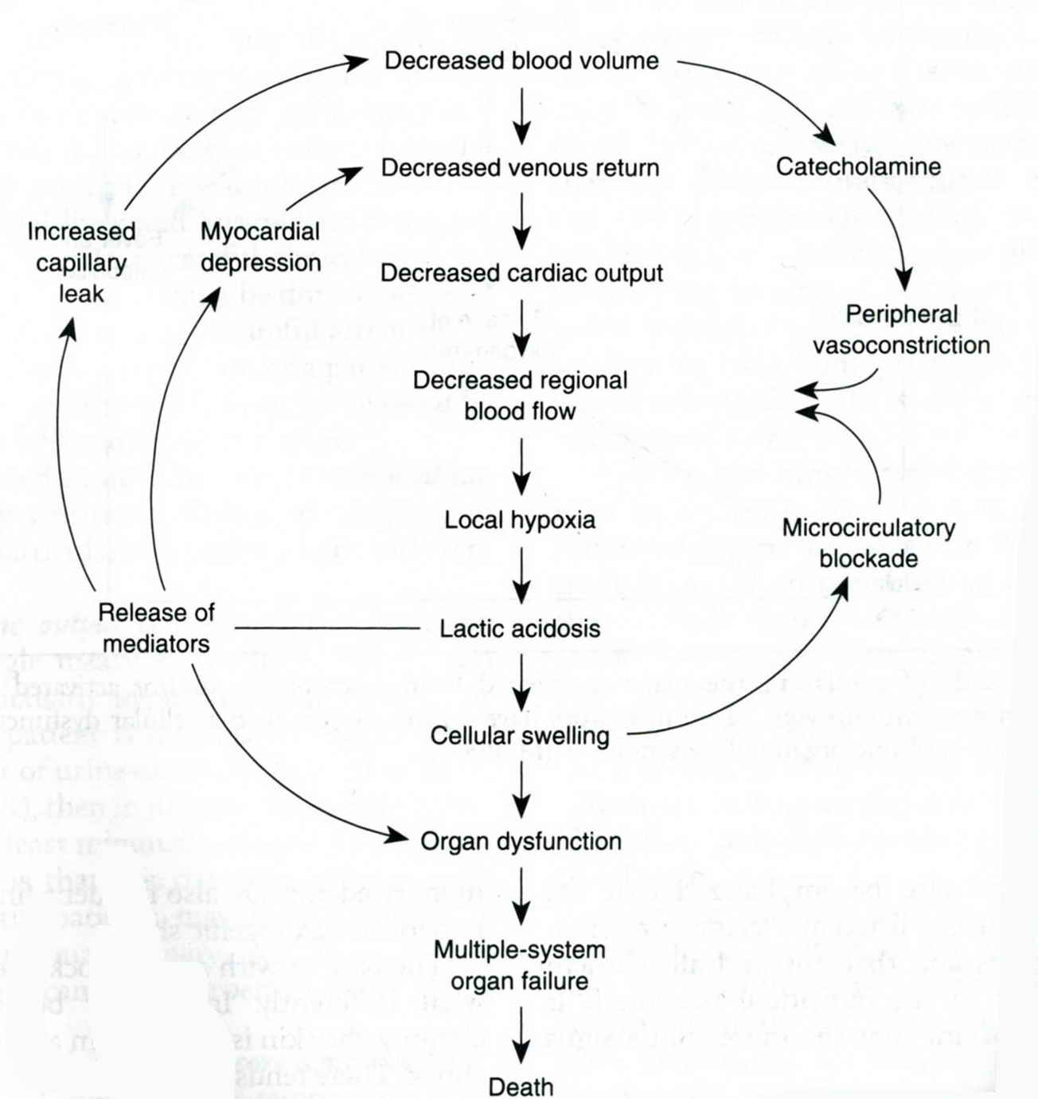
From: Basic surgery/ed., H.C. Polk, Jr., et al. – 5th ed.

Table 22-2. Types of shock in surgical practice

Hypovolemic

Hemorrhage (internal or external)
Crush injury
Burns
Peritonitis

Septic

Gram negative (endotoxin)
Gram positive (toxic shock syndrome)
Fungal

Cardiogenic

Acute myocardial infarction
Following cardiac surgery
Cardiomyopathy

From: Basic surgery/ed., H.C. Polk, Jr., et al. – 5th ed.

Table 22-3. Signs and symptoms of shock

Hypovolemic

Cool, pale skin
Peripheral cyanosis
Tachycardia
Tachypnea
Restlessness

Septic

Warm, dry skin
Tachycardia
Fever
Shaking chill
Mental confusion

Cardiogenic

Gallop rhythm
Pulmonary rales
Distended neck veins
Tachycardia

From: Basic surgery/ed., H.C. Polk, Jr., et al. – 5th ed.

Hypovolemic shock

- Hypovolemic shock is characterized by a loss of circulating volume. The type of fluid lost includes blood, plasma, extracellular, extravascular, or water.
- Common causes include hemorrhage, as in trauma, dehydration, and burns.
- Patients have pale, cool skin and slow capillary refill. They are frequently apprehensive and restless.
- There is low or normal cardiac output, high peripheral vascular resistance, and usually low central venous pressure.
- Treatment is directed at restoring the blood or fluid loss. Regardless of the type of loss, initial treatment involves crystalloid replacement. The source of fluid or blood loss must be identified.

Septic shock

- Septic shock occurs in the setting of invasive infection. Chemical mediators have peripheral vascular effects and probably direct myocardial effects, resulting in decreased systemic vascular resistance, organ dysfunction, and myocardial depression.
- Common causes include genitourinary tract infections, pulmonary infections, wound and soft tissue infections, abscesses, invasive catheters.
- Early (hyperdynamic state), the patient is flushed, warm, and confused. Later, the patient may have a depressed sensorium.
- Early in the course, there is high cardiac output, low peripheral vascular resistance, and usually low central venous pressure.
- Treatment is aimed at controlling the septic focus, including antibiotic therapy. Surgical intervention is often necessary. Additional support includes fluid resuscitation, sometimes vasoactive drugs, and diuretics.

Cardiogenic shock

- Cardiogenic shock is due to an inadequacy of the heart as a pump.
- Common causes may be intrinsic, as in myocardial contusion and infarction, or extrinsic, as in cardiac tamponade and tension pneumothorax.
- Patients have pale, cool skin and slow capillary refill. They may be quiet or apprehensive.
- There is usually low cardiac output, high peripheral vascular resistance, and high central venous pressure in tamponade.
- Treatment consists of ensuring adequate volume while treating the underlying cause (i.e., pericardiocentesis in tamponade).

Neurogenic shock

- Neurogenic shock can occur in severe cerebral, brain stem or spinal cord injury. An interference in the balance of vasodilator and vasoconstrictor influences to vessels results in hypotension. Contrasted to hypovolemic shock where there is volume loss, the patient tends to be in a normovolemic state.
- Common causes include spinal anesthesia, spinal cord injury, anaphylactic shock, and fainting (vasovagal reaction).
- There is little change in skin color and temperature and normal capillary refill. There are varied effects on mental status, which is often normal.
- Cardiac output may be high with low peripheral vascular resistance and low central venous pressure with normal circulating volume.
- Treatment is directed at excluding other causes of shock and giving volume and vasoconstrictor drugs if needed.

Table 22-4. Criteria of adequate perfusion

Normal mental status
Normal pulse rate (no beta-blockade)
Adequate urine output
Warm, pink skin
No core/extremity temperature gradient
Normal systemic vascular resistance
No lactic acidosis
Normal oxygen extraction ratio

From: Basic surgery/ed., H.C. Polk, Jr., et al. – 5th ed.

Table 22-5. Fluid administration for patients in shock

Fluids to replace volume

Crystalloid solutions
Balanced salt solutions (Ringer's lactate)
Normal saline
Hypertonic saline
Colloid solutions
Albumin
Dextran
Hydroxethyl starch

Fluids to replace oxygen-carrying capacity

Whole blood
Fresh
Banked
Component therapy
Packed red cells
Fresh frozen plasma
Platelet concentrates
Type-specific blood

From: Basic surgery/ed., H.C. Polk, Jr., et al. – 5th ed.

Scheme 22-3. Algorithm for using clinical and physiologic parameters to determine how much fluid resuscitation is required for a patient in shock

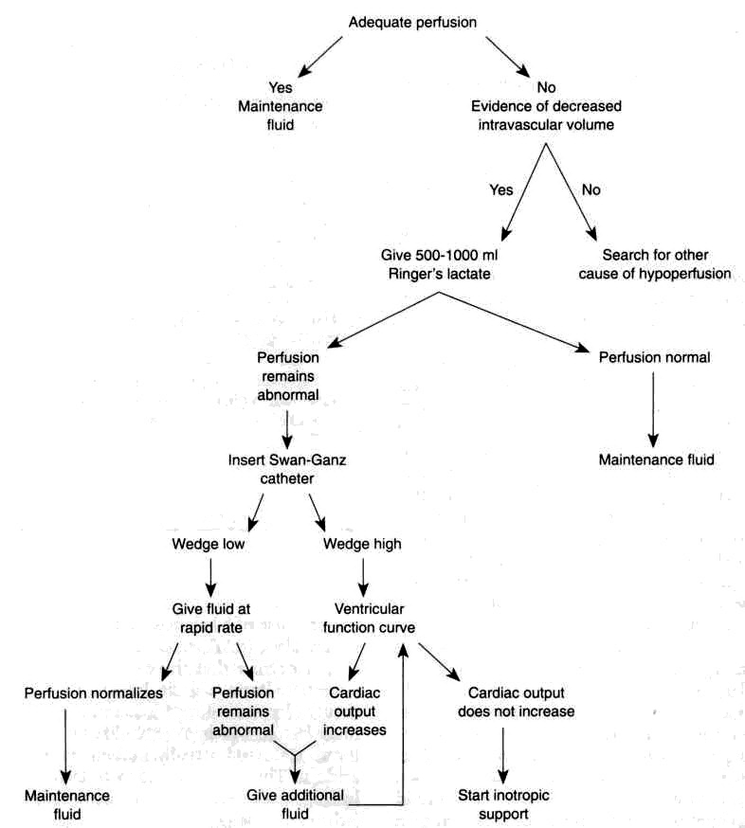
From: Principles of surgery/ed., S.I. Schwartz, et al. – 7th ed.

REVIEW TESTS

1. A 40-years-old man who was an unrestrained passenger in a motor vehicle accident was brought to ER. He was thrown from the car at impact. The patient is unconscious and becomes apneic. Ventilation should be achieved by which of the following?

- Endotracheal intubation
- Nasotracheal intubation
- Face mask
- Cricothyroidotomy
- Tracheostomy

2. Emergency department thoracotomy for cardiac resuscitation would most likely be successful for which of the following?

- Major blunt trauma with cardiac arrest
- Failed closed-chest massage lasting 15 minutes
- Cardiac arrest after a stab wound to the left parasternal area
- Cardiac arrest accompanying a major central nervous system injury
- Hypovolemic cardiac arrest

3. A victim of a motor vehicle accident who was thrown from the vehicle is brought to ER. The patient is unconscious and hypotensive. He has a dilated left pupil, decreased breath sounds over the right chest, a moderately distended abdomen, an unstable pelvis and severe bruises over the thighs. After resuscitation with two liters of crystalloid and two units of type specific packed red blood cells, the patient remains hypotensive with a systolic blood pressure about 80 mmHg. What is the LEAST likely explanation for patient's hypotension?

- Intraperitoneal bleeding
- Bleeding into the chest
- Retroperitoneal bleeding
- Severe closed head injury
- Femoral fractures

4. A 25-years-old, multiple-system-trauma patient has been receiving a blood transfusion for 1 hour, when he develops fever, itching, and difficulty breathing. What type of transfusion reaction is he most likely having?

- Hemolytic
- Delayed
- Physiologic
- Allergic
- Febrile

5. A 50-years-old man was brought to ER with a stab wound to the right chest in the fourth intercostal space in the midaxillary line. The patient is hypotensive, and has absent breath sounds on the right side of the chest. What’s the most appropriate tactics of managing the patient?

- Chest tube insertion
- Chest CT scan
- Local wound exploration
- Pericardiocentesis

6. A 50-years-old man was brought to ER after a head-on automobile accident. He is conscious; he has a significant ecchymosis of the anterior chest. His vital signs are stable. The chest radiograph reveals a widened mediastinum and a small left pleural effusion. What’s the most appropriate tactics of managing the patient?

- Thoracentesis
- Chest CT scan
- Chest MRI
- Aortogram
- Pericardiocentesis

7. An anxious 24-years-old man was brought to ER after a stab wound to the left fourth anterior intercostal space. Blood pressure is 70/30 mmHg, pulse is 150 beats per minute. He has distended neck veins and distant heart sounds. What’s the most appropriate tactics of managing the patient?

- Establish adequate intravenous access
- Ensure patent airway
- Emergent pericardial drainage
- CT scan of the chest
- Administration of intravenous narcotics

8. A 40-years-old man was brought to ER following a motor vehicle accident. The patient has significant facial injuries, is not responsive to voice, and has shallow respirations. A cricothyroidotomy is performed and ventilation is established. The patient is noted to have absent breath sounds in the right hemithorax with good breath sounds on the left side. What’s the most appropriate tactics of further investigation?

- A supine chest radiograph
- An upright chest radiograph
- Insertion of a chest tube
- Assessment of circulatory status
- Assessment for possible neurologic injury

9. The most appropriate care for a patient with a large burn at the scene of injury is:

- Wash with cold water and wrap with cold sterile compresses
- Remove smoldering garments and cover the patient with a clean sheet and blanket
- Start a subclavian intravenous line with Ringer's lactate
- Intubate and transport

10. Shock is best defined as:

- Inadequate blood pressure
- Inadequate tissue perfusion
- Inadequate cardiac output
- Inadequate blood volume
- None of the above

11. Which of the following causes of shock is NOT usually associated with hypovolemia?

- Hemorrhage
- Peritonitis
- Crush injury
- Myocardial infarction
- Burns

12. Which of the following is NOT an early sign of shock?

- Tachycardia
- Peripheral cyanosis
- Hypotension
- Restlessness
- Cool pale skin

Correct answers: 1 - E, 2 - C, 3 - D, 4 - D, 5 - A, 6 - D, 7 - C, 8 - C, 9 - B, 10 - B, 11 - D, 12 - C.

