CHAPTER 22: SURGICAL INFECTIONS AND POSTOPERATIVE
COMPLICATIONS

SURGICAL INFECTIONS

General considerations

- Surgical infections are either infections that require surgical intervention to resolve completely or infections that develop as a complication of surgery. Some are in both categories.
- They usually involve a penetrating injury (e.g., from trauma), a perforating injury (e.g., a perforated ulcer), or an operative site (e.g., the surgical wound).
- Often, multiple organisms are present.
- Treatment requires surgical drainage of the infection and debridement of necrotic or grossly contaminated tissue; antibiotics alone will not resolve the infection.

Surgical wound infections

Overview

- Surgical wound infections form the major type of surgical infections among hospitalized patients.
- The incidence of wound infections is related directly to the nature of the surgical procedure performed.
- The prognosis and tactics of managemanet is based on the classification of wounds by extent of contamination.
- Clean operative sites from elective procedures (e.g., hernia repair) carry a 1% - 2% risk of wound infection. Because the risk is low, the skin edges are closed primarily.
- Clean contaminated operative sites (e.g., from a hysterectomy or cholecystectomy) have an infection rate of 5%-15%, and the skin edges are usually closed.
- Contaminated operative sites (such as a colectomy, a gastrectomy for a bleeding ulcer, or a cholecystectomy in the presence of infected bile), have an infection rate of 10%-20% when the wound is closed; therefore, it may be left open for delayed primary or secondary healing.
- Dirty operative sites occur when an abscess or penetrating trauma has allowed bacteria to contaminate the region prior to surgical intervention. The incidence of wound infection is greater than 50%; therefore, the operative wound is usually left open to heal by second intention.

Clinical features

- Wound infection often presents as a spiking fever at approximately the fifth to eighth postoperative day.
- There may be localized wound tenderness, cellulitis, drainage from the wound, or dehiscence.

Table 23-1. Postoperative wound infections

Onset  (postop days) | Usual pathogen | Wound appearance | Other signs
1-3 | Clostridium perfringens | Brawny, hemorrhagic, cool and related species gaseous crepitation, putrid exudate, intense local pain | High sustained fever (39°-40° С); irrational; leukocytosis 15,000/mm³; jaundice
1-3 | Streptococcus | Erythematous, warm, tender, occasionally hemorrhagic with blebs,  serous exudate | High spiking fever (to 39°-40° С); irrational at times;  leukocytosis > 15,000/mm³; rarely jaundice
3-4 | Staphybcoccus | Erythematous, warm, tender, purulent exudate | High spiking fever (to 38°-39°С); irrational at  times; leukocytosis 12,000-20,000/mm³
>4 | Symbiotic (usually anaerobes plus  gram negative rods) | Erythematous, warm, tender, focal necrosis, putrid exudate | Moderate to high fever (38°-40° С); mentation variable; leukocytosis > 15,000/ mm³;  occasionally jaundice
>6 | Gram negative rod | Erythematous, warm,  tender, purulent exudate | Sustained moderate fever (38°-39° С), rational, leukocytosis 10,000-16,000/mm³
From: Basic surgery/ed., H.C. Polk, Jr., et al. – 5th ed. (modified)

Treatment

- Simple incision and drainage will resolve most postoperative wound infections.
- Deeper wound infections, extensive necrosis, or wound breakdown may require open debridement.

Prosthetic infections

- Prostheses are man-made implantable devices, including vasculargrafts, heart valves, artificial joints, fascial replacements, and metallic bone supports.
- An infected prosthesis usually causes symptoms of either local infection or generalized sepsis. The most common organisms infecting prostheses are staphylococci. These infections are life-threatening.
- Prophylactic antibiotics are always used when implanting a prosthesis; however, most prosthetic infections cannot be sterilized with antibiotics and, therefore, require removal of the prosthesis.

Prophylactic antibiotics

- Prophylactic antibiotics are given shortly before, during, or shortly after surgery (i.e., during the perioperative period) to combat any bacterial contamination of tissues that occurs during the operative procedure.
- A clean procedure would not require prophylactic antibiotics, but the following situations would: colon or rectal surgery (the patient is given oral nonabsorbable antibiotics plus intravenous antibiotics); a procedure (e.g., vascular surgery) in which prosthetic material is to be used; a gynecologic procedure in which the vagina is opened; gross contamination of the operative site.
- The antibiotics used should be effective against the pathogens likely to be present in the operative site.
- The antibiotics must have reached an effective tissue level at the time of the incision. Therefore, they should be given 1-2 hours prior to surgery.
- The antibiotics should be given for only 6-24 hours after surgery. Long-lasting regimens carry a high risk of superinfection and offer no additional protection.
- The benefits of the prophylactic antibiotic should outweigh its potential dangers, such as allergic reactions or the stimulation of bacterial or fungal superinfections from overgrowth of pathogens, such as gram-negative bacteria or Candida.

Tetanus prophylaxis

Active immunization

- Active immunization with tetanus toxoid injections given in the recommended schedule results in a protective titer within 30 days.
- This immunization is usually given in infancy (with the diphtheria-pertussis-tetanus shots) or during military induction.
- A booster dose every 10 years is recommended.

Prophylaxis at the time of injury

- Any person with a penetrating injury must receive tetanus prophylaxis if previous
immunization cannot be documented.
- A previously immunized person should be given a booster dose if none has been given within the past 5 years.
- A patient with a clean injury who has never been immunized may be given the first of three immunizing doses, but it is important that the patient receive the subsequent two doses.
- A patient with a dirty wound who has never been immunized should be given passive immunization with human tetanus immune globulin intramuscularly. The protection period has a half-life of 1 month. The first dose of tetanus toxoid may be given at the same time, but it should be given at a separate intramuscular site.
- Adequate debridement of devitalized tissue and removal of all foreign debris are
also essential.

Abscesses of soft tissues

Overview

- Staphylococcal organisms (S. epidermidis, S. aureus) frequently infect cutaneous lesions (e.g., sebaceous cysts) or intracavitary locations (e.g., the pleural space) to form abscesses. They may also be blood-borne, resulting in multiple abscesses.
- Staphylococci usually produce pus, which must be drained to allow healing.
- Other organisms, including anaerobic and gram-negative organisms, can also cause both cutaneous and deep abscesses. Coliform organisms are often present in inguinal and perineal cutaneous abscesses.

Cutaneous abscesses

Types

Furuncles

- Furuncles (boils) are cutaneous staphylococcal abscesses.
- They are frequently seen with acne and other skin disorders.
- The bacterial colonization begins in hair follicles and can cause both local cellulitis and abscess formation.

Carbuncles

- Carbuncles are cutaneous abscesses that spread through the dermis into the subcutaneous region.
- They may then spread over a large area, often with resultant sepsis.
- They are common in individuals with diabetes.

Hidradenitis suppurativa

- Hidradenitis suppurativa is an infection involving the apocrine sweat glands in the axillary, inguinal, and perineal regions.
- The infection results in chronic abscess formation and scarring, and often requires complete excision of the apocrine gland bearing skin to prevent recurrence.

Felon

- Felon is an infection involving different parts of fingers (see Scheme 23-1).
- The infection has a progressive course a may lead to palmar phlegmon or phlegmone of the forearm.

Scheme 23-1. Types of felons

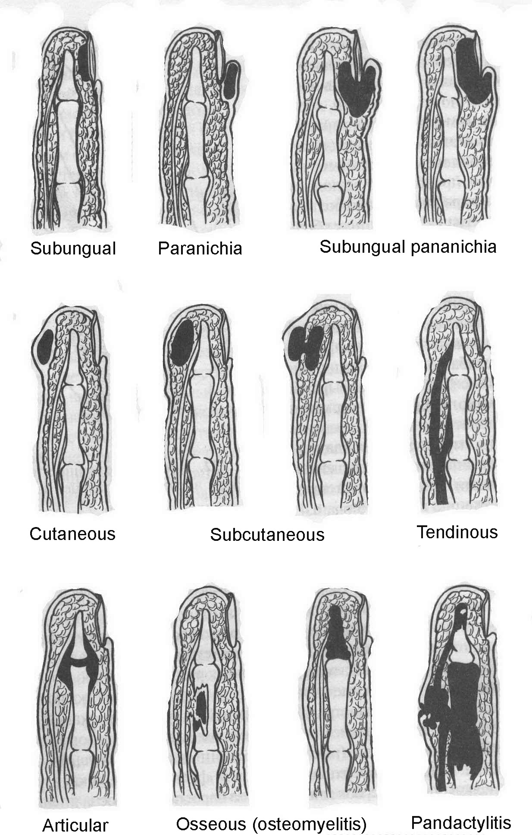

Microbiology

- The microbiologic diagnosis is made by incising the abscess, then culturing and Cram-staining the pus, usually revealing gram-positive cocci.
- Subsequent culture reveals the bacterial type as well as its antibiotic sensitivity.
- Most staphylococcal organisms are resistant to penicillin; therefore, one of the semisynthetic penicillins, or a cephalosporin should be used.

Treatment

- Basic principles of treatment are the following.
- Drainage of pus (see Fig. ).
- Appropriate antibiotic therapy.
- Wound care with irrigation and debridement when necessary.
- Excision of the involved area when it contains multiple small abscesses, sinustracts, or necrotic tissue.

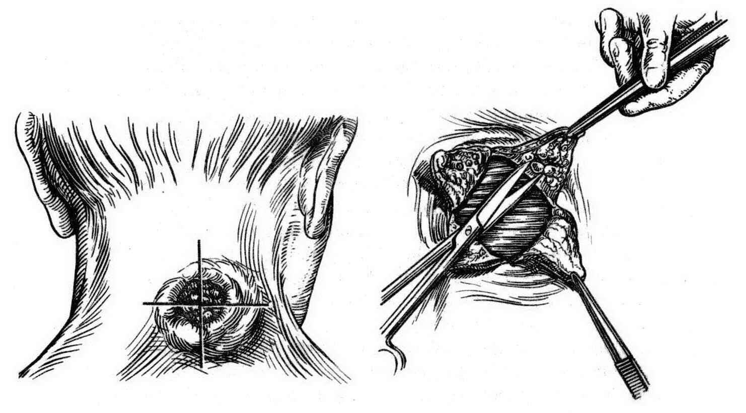

Fig. 23-1. Technique of drainage of carbuncle

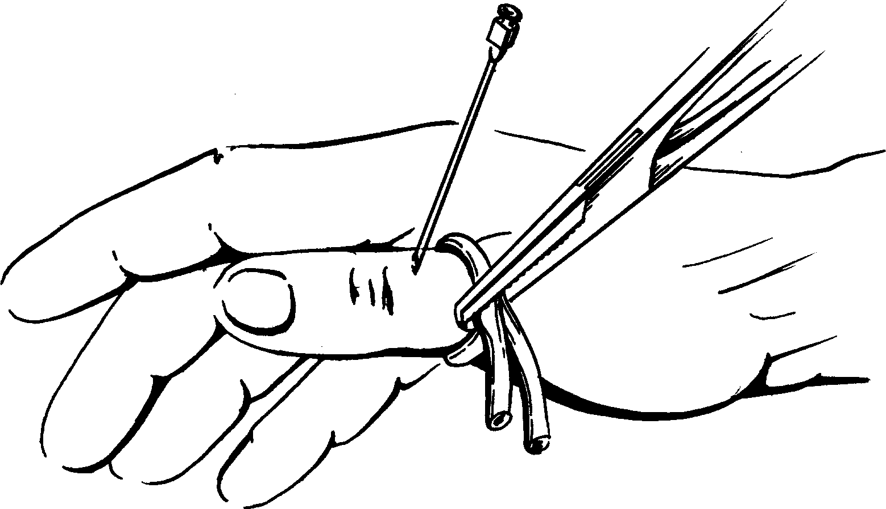

Fig. 23-2. Technique of conduction ahaesthesia for surgery on digits

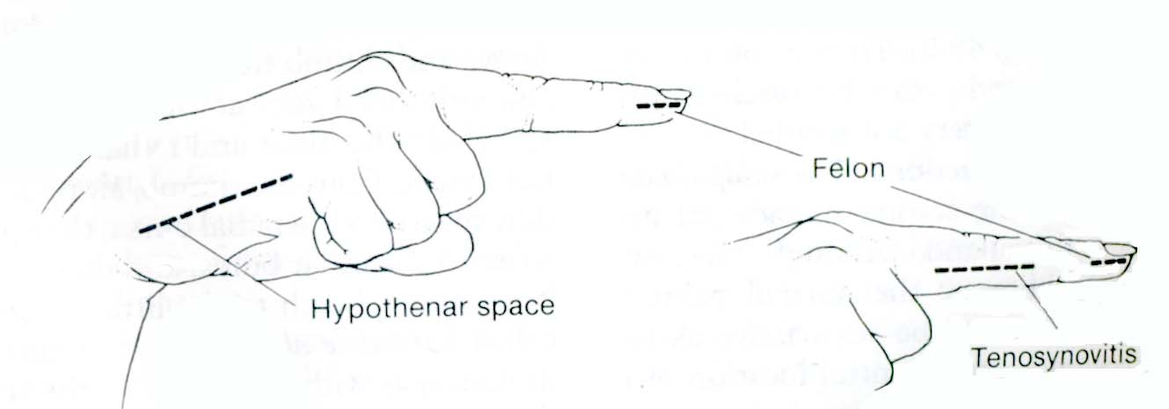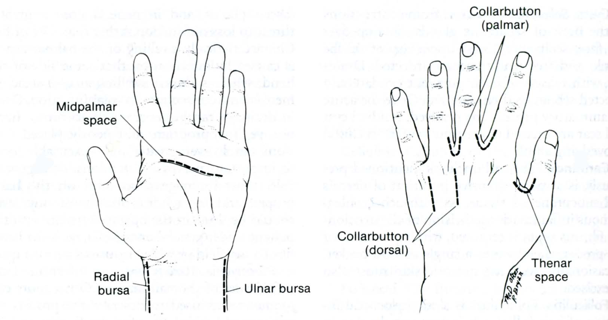

Fig. 23-3. Skin incisions of drainage of felons and phlegmones of hand

Cellulitis

Overview

- Cellulitis is an inflammation of the dermal and subcutaneous tissues secondary to nonsuppurative bacterial invasion.
- It may result from a puncture wound or any other type of skin break.

Clinical features

- Cellulitis produces redness, edema, and localized tenderness. Fever and leukocytosis
are usually present.
- The cellulitis-causing bacteria may also infect the regional lymphatics, resulting in red, tender streaks on an extremity (lymphangitis). Lymphadenitis may also be present.
- A deep abscess can result in an overlying cellulitis and should be suspected when a patient does not rapidly respond to antibiotics.

Treatment

- The usual organism is a Streptococcus, which is almost always sensitive to semisynthetic penicillins or cephalosporins.
- Surgical drainage may be necessary in severe cases.

Necrotizing fasciitis

Overview

- Necrotizing fasciitis is a rapidly progressive bacterial infection in which several different organisms invade the fascial planes.
- The infection travels rapidly along a fascial plane and causes vascular thrombosis as it progresses, resulting in necrosis of the tissue involved.
- The overlying skin may appear normal, leading the clinician to underestimate the severity of the infection.
- Necrotizing fasciitis may result from a small puncture wound, a surgical wound, or any open trauma.

Clinical features

- Hemorrhagic bullae may develop on the skin, accompanied by edema and redness,
and crepitus may be present; however, the skin also may appear normal.
- The patient shows signs of progressive toxicity (fever, tachycardia) and may have localized wound pain.
- The necrotic wound or tissue involved usually has a foul serous discharge.

Microbiology

- Gram stain reveals multiple organisms, which act synergistically, giving the fasciitis its rapidly progressive and destructive character, including: microaerophilic streptococci; staphylococci; Gram-negative aerobes and anaerobes.

Treatment

- Treatment is surgical, and early diagnosis is extremely important.
- It is critical to remove all infected or devitalized tissue at the first debridement because any remaining necrotic tissue will continue the rapidly progressive necrosis.
- The removal of large amounts of skin and surrounding tissue and, occasionally, amputation of an extremity may be required.
- Daily debridement may be needed.
- Broad-spectrum antibiotics in high doses are required.
- This infection is life-threatening, and prompt treatment is essential.

Clostridial myositis and cellulitis (gas gangrene)

Overview

- Gas gangrene is most commonly caused by C. perfringens (C. welchii).
- Characteristics of wounds likely to develop this condition include the following: extensive tissue destruction has occurred; there is marked impairment of the local blood supply, from the injury itself, from complications of the injury (e.g., vascular thrombosis), or from iatrogenic causes (e.g., an overly tight orthopedic device); the wound is grossly contaminated; there has been a delay in treatment (usually more than 6 hours); surgical debridement has been inadequate; the patient has a pre-existing condition that leads to immunologic incompetence, such as corticosteroid drug therapy.

Clinical features

- The onset of symptoms is usually 48 hours after injury but may occur as early as 6 hours after.
- The most common complaint, severe pain at the site of injury, is due to the rapidly infiltrating infection. However, this pain may be missed because the patient is receiving narcotics. Thus, any surgical patient who requires an increase in narcotics should be suspected of having a clostridial infection and should be examined before the narcotics dosage is changed.
- A rapid, weak pulse is usually present; and the patient appears diaphoretic, pale, and weak. There may be mental changes, including delirium or confusion.
- The temperature is often, but not always, elevated.
- The wound is more tender to the touch than is the usual postoperative wound. The skin may appear normal, but the wound usually drains a brownish serous fluid with a foul odor. Crepitus may appear around the wound edges but is often a late sign.

Laboratory and visualization data

- Blood studies often reveal a falling hematocrit and a rising bilirubin due to hemolyIsis.
- The white blood count may be mildly elevated, but this rise is unreliable.
- Gram stain of the wound discharge reveals large gram-positive bacilli. Numerous red blood cells are present but few white cells.
- A plain x-ray of the wound area may reveal air in the soft tissues.

Treatment

- Adequate debridement at the time of initial injury is important for prophylaxis.
- Treatment for established clostridial infection includes extensive debridement within the tissue planes involved and antibiotics, especially penicillin.
- If extensive soft tissue necrosis is present in the extremity, amputation is performed.
- Hyperbaric oxygen therapy is used, but its value is unproven.
- Delay in treatment to consider further diagnostic procedures or to observe the patient's course is usually catastrophic.

Septicemia

Clinical characteristic

- Any invasive bacterial infection may culminate in septicemia.
- When bacteria have invaded the bloodstream, either through infection or by contamination of intravascular monitoring or treatment devices, bacteremia is said to have occurred.
- If this progresses to propagation of bacteria within the bloodstream, actual septicemia has been established and becomes the greatest threat of that originating infection. Prior disease changes in the endothelial lining of cardiovascular structures then provide ideal sites for metastatic infection to complicate the bacteremia.
- Bacteria may also form the nidus of a clot, which can propagate and then embolize to some more distant locus in the vascular system (metastatic abscesses).
- In addition to the septic state caused by the growth of bacteria within the bloodstream, bacterial enzymes and tissue breakdown products (particularly components of erythrocytes and leukocytes), if circulating, exert profound humoral influences on various organ systems.
- Examples are peripheral pooling of blood, heart failure, intravascular coagulopathy, and a multiplicity of other poorly understood phenomena. Characteristic vasomotor responses, resulting in circulatory collapse caused by gram negative bacteremia and septicemia, are referred to as endotoxemia.
- These all effects are called as SIRS (systemic inflammatory response syndrome).

Treatment

- Unless the focus seeding the bloodstream is eradicated, bacteremia will persist and may progress to septicemia. Thus, as soon as is practical, abscesses must be drained, necrotic tissue excised, and responsible venous cannulas eliminated.
- Equally important is the parenteral administration of antibiotics with known activity against the specific pathogens presumed to be present in the blood.
- Blood infections can generally be separated into broad pathogen types by the patient's clinical course, although culture of both the site of origin and the blood itself are required to substantiate an initial clinical assumption. Choice of antibiotic may then need to be altered when more specific information regarding species and antimicrobial sensitivities is available.
- Other treatment measures are directed toward correction of dehydration, electrolyte derangements, acidosis, septic shock if present (see Chapter 22), and any obvious failure in a critical organ system.
- Monoclonal antibody that is specific for endotoxin has shown promise in reducing the likelihood and severity of lethal physiologic derangements in patients with gram negative sepsis.

Table 23-2. Selection of antibiotics for most surgical infections

Aerobic gram positive cocci and bacilli

Penicillin and its analogs
Cephalosporins (first, second and third generations)
Macrolides (Erythromycin, Lincomycin, Clindamycin)
Tetracyclines
Note: Penicillin-resistant Staphybcoccus – Penicillin analogs, second and third generation cephalosporins, Methicillin-resistant Staphybcoccus – Vancomycin, Enterococcus - Penicillin G plus Tobrarnycm or Gentamicin

Aerobic gram negative cocci

Penicillin
Cephalosporins (first and second generation)
Tetracycline
Note: Meningitis – Chloramphenicol

Aerobic gram negative bacilli

Aminoglycosides
Cephalosporins (second and third generation)
Certain penicillin analogs - Ampicillin, Amoxicillin, Carbenicillin, Ticarcillin
Penicillin analogs combined with a beta-lactamase inhibitor (Timentin, Augmentin)
Chloramphenicol
Quinolones (Ciprofloxacin)
Monobactams (Aztreonam)
Note: Pseudomonas and certain resistant gram negative rods - Tobramycin, Gentamicin, Amikacin - or Quinolone or Monobactam
Salmonella - Chloramphenicol and Amptcillm
Shigella - Ampicillin, Tetracyclme, Chloramphenicol

Anaerobes

Metronidazole
Macrolides (Erythromycin, Clindamycin, Lincomycin)
Cephalosporins (selective second and third generation only)
Chloramphenicol
Certain penicillin analogs (Carbenicillin, Ticarcillin)
Tetracycline
Note: Clostridium difficile – Vancomycin, Metronidazole

Fungi

Topical - Nystatin, Chlortrimazole, Amphoteracin В
Parenteral - Amphoteracin B, Fluconazole

Other specific pathogens (not all-inclusive)

Actinomycetes - Penicillin, Erythromycin, Tetracycline
Chancroid - Tetracycline
Mycobacteria tuberculosis and atypical mycobacteria - Isoniazid plus Rifampicin, Streptomycin
Mycoplasma - Macrolides (Erythromycin) and Tetracycline
Rickettsia – Tetracycline, Chloramphenicol
Spirochetes - Penicillin, Tetracyciine, Erythromycin
Vibrio - Tetracycline, Chloramphenicol, Erythromycin

From: Basic surgery/ed., H.C. Polk, Jr., et al. – 5th ed. (modified)

POSTOPERATIVE COMPLICATIONS

Overview

- Postoperative complications can be associated with any operation or can be related to a specific kind of surgery. The latter types are discussed in the relevant chapters, and only the general types of complications are discussed here.
- Thrombophlebitis and pulmonary embolus, which are common postoperative complications, are discussed in Chapter 17. See also Scheme 23-2.
- Most surgical complications develop in relation to some event that occurs in the operating room, emphasizing the fact that prevention is the best form of management.
- Common postoperative problems typically occur on certain postoperative days. Most of these problems produce fever and can be diagnosed by physical examination and simple laboratory tests.

Scheme 23-2. Management of patients with suspected pulmonary embolus

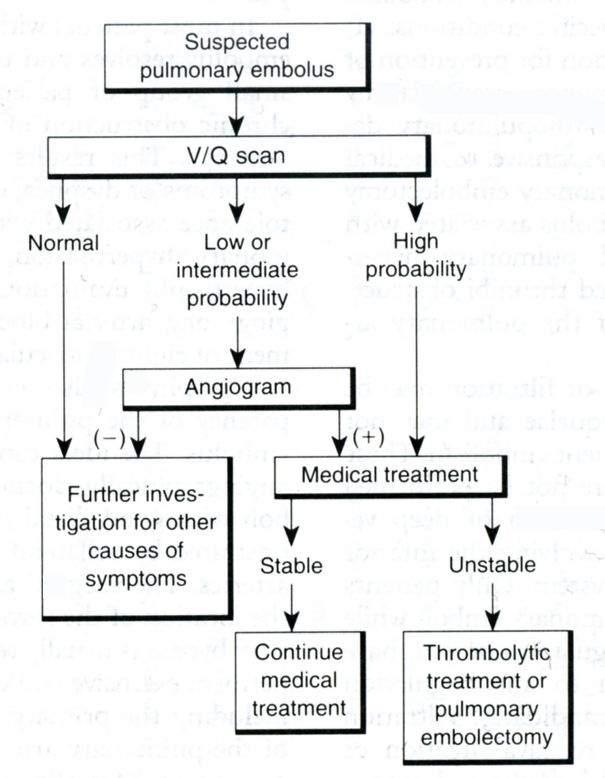
From: Basic surgery/ed., H.C. Polk, Jr., et al. – 5th ed. (modified)

Pulmonary complications

- Pulmonary complications are the most common cause of fever during the first postoperative days. Most pulmonary problems develop because of prolonged mechanical ventilation or because of inadequate ventilation and a poor cough effort. They are made worse by oversedation, pre-existing chronic pulmonary disease, or abdominal distention.
- Atelectasis is the usual problem and is often resolved by coughing, deep breathing, ambulation, and incentive spirometry. For a collapsed lung, nasotracheal suction or bronchoscopy may be needed to remove secretions.
- Pneumonia can supervene if the atelectasis is not quickly treated. Antibiotics should
not be given unless evidence of infection is present.

Urinary tract infection

- Urinary tract infection typically causes the fever that develops on postoperative days 3-6.
- An indwelling catheter or pre-existing bladder outlet obstruction is often the cause.
- Postoperative pain can cause patients to empty the bladder incompletely when voiding; the residual urine predisposes to infection.
- Urinary tract infection is best treated by: using appropriate antibiotics, relieving any obstruction that is present; removing the catheter, if feasible.

Wound infections are discussed above including. Intra-abdominal abscesses are described in Chapter 2.

Gastrointestinal fistulas (see below) may complicate abdominal surgical procedures, particularly surgery performed on bowel.

Dehydration

- Dehydration is common after surgery because of third-space sequestration of fluids in the operative site.
- Dehydration along with electrolyte disturbances may result cardiac function depletion. Leading to hemoconcentration, dehydratation predisposes to deep venous thrombosis and pulmonary embolism.
- Oliguria, tachycardia, and orthostatic hypotension may result.
- Treatment is rehydration.
- On the third or fourth postoperative day, the body begins to mobilize the third-space fluid, which increases the intravascular volume until the fluid is excreted by the kidneys.

Overhydration

- Overhydration may occur in patients with impaired cardiac or renal function.
- Congestive heart failure or pulmonary congestion and impaired oxygenation may result.
- Attending to fluid balance and weighing the patient daily should prevent this problem.
- The intravascular volume increase that results from mobilization of third-space fluid should be anticipated.

General principles of management

- General principles of management during the postoperative period are important both in preventing potential complications and in allowing early detection of problems that do develop.
- These principles include: daily or more frequent examination of the patient, including the surgical wound; removal of all surgical tubes as soon as possible; early ambulation of the patient; close monitoring of fluid balance and electrolyte levels; adequate but not excessive pain medication; good nursing care.
- See also Scheme 23-3.

Scheme 23-3. Management of patients with postoperative fever

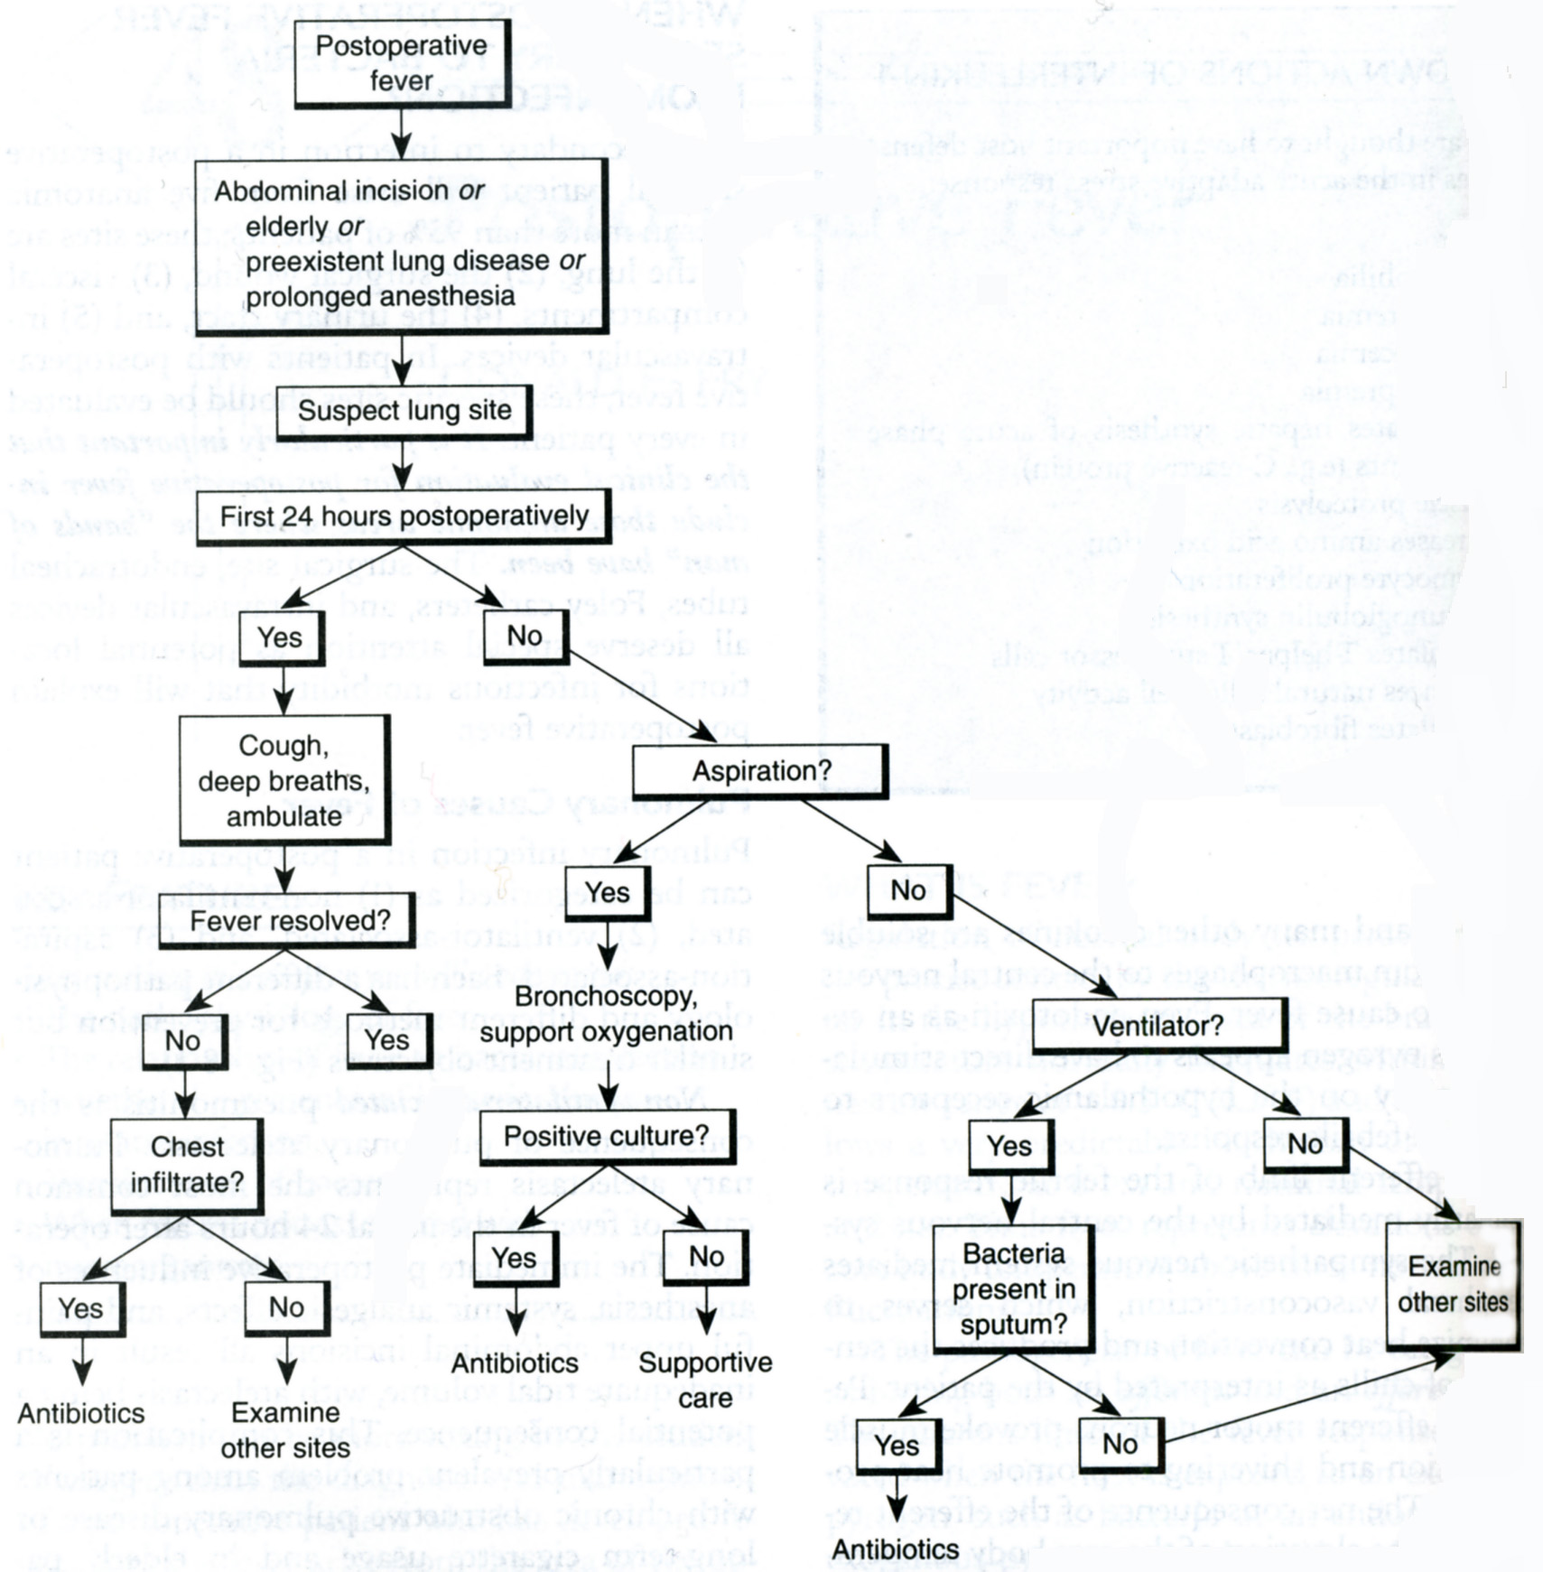

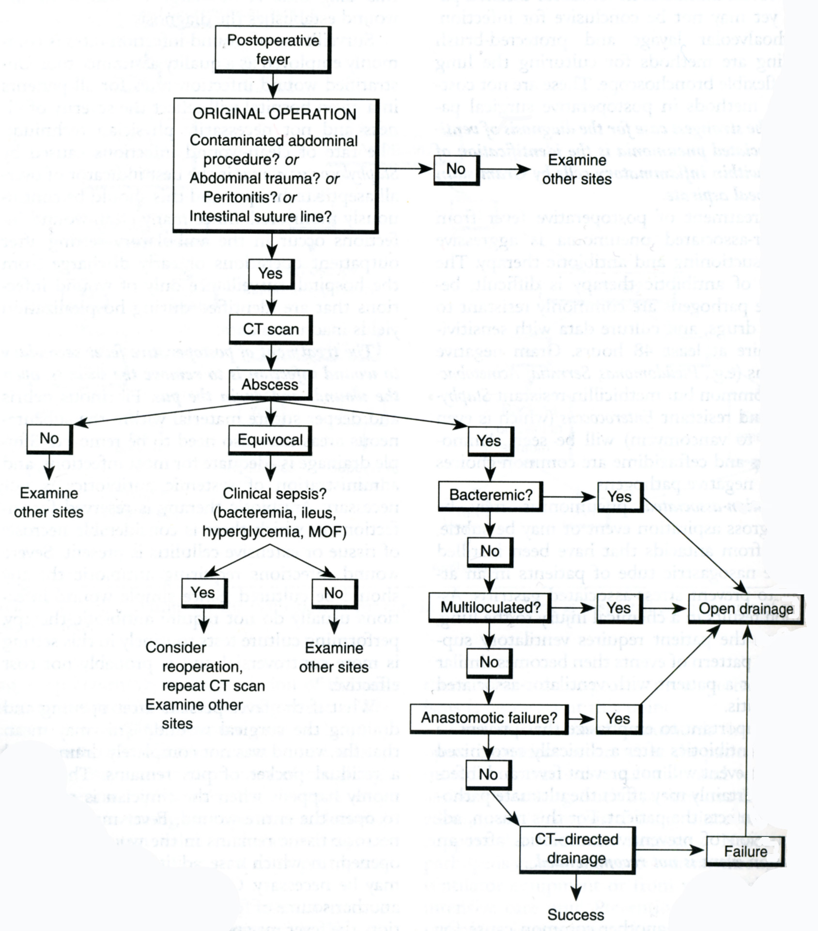
From: Basic surgery/ed., H.C. Polk, Jr., et al. – 5th ed.

GASTROINTESTINAL FISTULAS

Overview

- Fistulas are abnormal communications between two or more hollow organs or between one hollow organ and a body surface. The variety of fistulas is almost limitless, owing to the number of organs and sites that can be involved.
- Fistulas are named according to the sites that they join. Therefore, a bronchobiiiary fistula connects the bronchial tree with the biliary tree; a gastrocutaneous fistula communicates between the stomach and the skin.
- Etiology includes congenital (e.g., distal tracheoesophageal fistula with esophageal atresia) and acquired disorders: trauma or operative injury (traumatic or inadvertent operative injury or anastomotic breakdown can produce fistulization); inflammation (Crohn's disease, for example, can cause many fistulas, including enterovesical and ileosigmoid); malignancy (for example, colovesical fistula might occur in a patient with a large sigmoid colon cancer that erodes into the urinary bladder); radiation damage (enterovaginal fistula can develop after pelvic irradiation for cervical carcinoma); fistulas applied as a part of treatment protocol (e.g., Hartmann procedure).
- Malnutrition can develop because of inadequate absorption of nutrients due to the short-circuiting of part of the bowel or due to external loss of ingested food (e.g., gastrocolic fistula and high-output enterocutaneous fistula, respectively) or because of increased caloric needs due to associated infection or stress.
- Fluid and electrolyte imbalances are frequent complications of fistulas, especially those involving the proximal bowel or pancreas. The electrolyte content of various gastrointestinal secretions is shown in Table 23-3. Electrolyte losses can be directly measured from a sample of the fistula drainage. For example, a pancreatic fistula developing after distal pancreatectomy, which drains 700 ml of bicarbonate-rich fluid a day, can produce dehydration and metabolic acidosis.
- Sepsis, a frequent accompaniment of fistulas, occurs when the contents of an organ
leak and contaminate sterile spaces (e.g., peritoneum and pleura). An abdominal abscess or wound infection can result. Distant infections, such as central venous catheter infections, can develop because of extensive skin contamination or bacteremia.
- Skin excoriation, often severe, can occur when intestinal secretions drain onto abdominal skin. This skin disruption can be painful and can contribute to sepsis.
- Hemorrhage is an infrequent but potentially life-threatening complication of enteric fistulas. It occurs when the inflammation associated with a fistula erodes into a blood vessel, causing severe bleeding.

Table 23-3. Approximate electrolyte content of gastrointestinal secretions

Source | Electrolytes (mEq/L)
Source | Na⁺ | K⁺ | Cl ⁻ | HCO₃⁻
Stomach | 60 | 10 | 50-150 | 0-20
Duodenum | 120 | 5 | 100 | 20
Bile ducts | 145 | 5 | 100 | 40
Pancreas | 140 | 5 | 75 | 100
Ileum | 100 | 5 | 65 | 30
From: Principles of surgery/ed., S.I. Schwartz, et al. – 7th ed.

Evaluation

- The history can provide useful etiologic information.
- Examining the patient provides information about the location of an external fistula and the character of its drainage. The volume of drainage must be determined.
- Dehydration and malnutrition can also be detected.
- Radiographic studies are vital in determining the dimensions of the fistula tract and organ involvement. Contrast material may be administered by mouth, by rectum, or directly into the fistula (fistulogram).
- Ultrasonography, CT scan, and MRI can be useful in locating an undrained collection (e.g., abscess), which may be associated with the fistula.
- Laboratory tests on the drainage are useful for determining the electrolyte content of
the fistula, and bacteriologic cultures should be obtained in patients with suspected
sepsis.

Management

- Hydration and correction of electrolyte disturbances require immediate attention.
- Control of infection also requires immediate attention. Antibiotics and operative
drainage of abscesses may be required before patients improve: a fistula will not heal in
the presence of an undrained collection.
- Control of external drainage helps to minimize further morbidity. Suction catheters, drains, collection bags, or operative diversion may be useful in protecting body surfaces from irritation. Bowel rest, provided by prolonged fasting, often diminishes gastrointestinal fluid losses.
- Therapy to inhibit organ-specific secretions is used when appropriate: for the stomach: proton pump inhibitors, for the pancreas: octreotide or somatulin.
- Correction of malnutrition should begin as soon as the patient is stabilized. Most patienis require parenteral nutrition. Occasionally, tube feedings of a low-residue diet, or even oral feedings, will be possible, especially with distal low-output fistulas.
- “Spontaneous closure” can occur in many patients with conservative therapy to minimize drainage and with appropriate nutrition. Closure with conservative measures may take several weeks to months. However, spontaneous repair is unlikely, and operative repair is required when any of the following is present: distal obstruction beyond the fistula site; pus or foreign body at the fistula site; severe bowel injury, such as radiation damage or extensive inflammatory bowel disease; cancer at the fistula site; epitheiialization of the fistula tract.
- Operative repair should be performed electively in a nonseptic, well-nourished patient.
Operation typically involves: identification of the fistula, resection of the fistula and damaged segments of bowel, anastomosis to restore bowel continuity.

REVIEW TESTS

1. Delayed primary closure would be the most appropriate wound closure technique for which of the following procedures?

A. Removal of perforated appendix
B. Repair of wound dehiscence 1 week after elective left colectomy
C. Emergency drainage of a diverticular abscess with sigmoid resection and end colostomy
D. Vagotomy and pyloroplasty for bleeding duodenal ulcer
E. Repair of an incisional hernia 8 months after an elective left colectomy

2. A 55-years-old woman undergoes laparotomy for small bowel obstruction. During lysis of adhesions, an enterotomy was made in the obstructed, but viable, bowel and a large amount of fecal-looking bowel contents spilled into the abdomen. The incision would now be considered what kind of wound?

A. Clean-contaminated
B. Secondary
C. Infected
D. Contaminated
E. Clean

3. A patient was operated for Crohn’s disease; resection of the distal ileum and caecum was performed. Postoperatively, the patient requires an indwelling bladder catheter for 5 days to treat urinary retention. He does well until the 10th postoperative day, at which point he develops a fever of 38 °C, right lower quadrant pain, and an ileus. The midline wound is not inflamed. Give your presumable diagnosis:

- Blind loop syndrome
- Pyelonephritis
- Recurrent Crohn's disease
- Intra-abdominal abscess
- Pseudomembranous colitis

4. A felon:

- Is a closed-space infection of the pulp space of the fingertip
- Is an infection of a skin appendage
- Involves the flexor tendon of an arm
- Is an infection in the palm of the hand

5. Match the source of postoperative fever with the typical time that it occurs postoperatively.

- Atelectasis
- Deep venous thrombosis
- Wound infection
- Urinary tract infection

- Day 1
- Day 4
- Day 7
- Any time

6. Anaerobic gangrene should be treated primarily by:

- High-pressure oxygen therapy
- Specific antitoxins
- Penicillin group antibiotics
- Radical debridement
- Improvement in arterial flow to the affected area

Correct answers: 1 - A, 2 - D, 3 - D, 4 - A, 5: 1-A, 2-D, 3-C, 4-D; 6 - D.

