ODESA NATIONAL MEDICAL UNIVERSITY

Department of Ophthalmology
The Head of Department M.D., prof. Venger L.V.

CASE REPORT

Patient’s name ___________________________________________

Clinical diagnosis:

OD | OS

Date of examination ______________

Student’s name ___________________________________________
Group __________ course______________ faculty_____________________

Teacher’s name ___________________________________________

Received mark ________________________________

published data of patient
1. Surname, name second name
2. Gender
3. Age
4. Job
5. Address

patient complaints

ANAMNESIS MORBI (A careful history of the patient’s ocular symptoms: duration of eye disease, administered treatment, associated features, previous eye problems, eye surgery)

ANAMNESIS VITAE (Viral hepatitis, tuberculosis, diabetes, hypertension, isease, AIDS, trauma or surgery. Allergic anamnesis.)

DATA OF GENERAL EXAMINATION

1. Nervous system.

2. Respiratory system.
3. Cardiovascular system.
4. Digestive system.
5. Urinary system.

DATA OF external ophtalmologic EXAMINATION

 | OD |  | OS
1. Parts surrounding the orbit
colour of skin
scars
edema
hyperemia
tumors
subcutaneous tissue
mimic muscles
paranasal sinuses
2. Eyelids
colour of skin
scars
edema
hyperemia
tumors
mass of subcutaneous tissue
position of eyelid (entropion, ectropion, ptosis,)
palpebral fissure (shape and size)
eyelid margin
eyelash growth
trichiasis
3. Lacrimal apparatus
lacrimal gland

lacrimal drainage system
4. Conjunctiva
colour
injection (conjunctival, pericorneal, mixed )
conjunctival surface (scars, conjunctival follicles or papillae, chemosis,discharge)
5. Sclera
colour
surface
6. Cornea
transparency
humidity
reflectivity
sensitivity
shape
size (the horizontal and vertical diameter )
opacities (localisation, vascularization, depth)
vessels presence
keratoprecipitates
fluorescein test
7. Limbus
width
vessels presence (pannus)
8. Anterior chamber
contents
depth
hyphaema
hypopyon
9. Iris
colour
iris heterochromia
structure
structural integrity (coloboma, aniridia )
synechia
10. Ciliary body
Painfulness during palpation
11. Pupil
colour
shape
size
pupillary test (direct, indirect, concomitant, on convergence)
12. Lens
presence
transparency
position (normal, subluxation, luxation)
opacities (intensity, localisation,)
13. Vitreous body
transparency
opacities (localisation)
14. Description of the eye fundus
Optic disc
Colour - pink
Margin (clear)
Cup (size and depth; cup/disc ratio — is ratio of diameter of cup to that of optic disc)
Retinal vessels:
- diameter (arteries narrower than veins, ratio approximately 2:3)
- crossing (arteries cross anterior to veins at arteriovenous crossings)
Macular area:
сolour (normally darker than rest of fundus. At centre, normal foveal light reflex, norm)
15. Ultrasonography
A-scan:
axial size
depth of anterior chamber
lens
B-scan:
transparency of vitreous body
retina position
Pathological changes (vitreous body opacities, retina detachment, intraocular tumors)
DATA OF functional ophtalmologic EXAMINATION
 | OD |  | OS
1. Visual acuity for far without correction
2. Visual acuity for far with correction

3. Visual acuity for near without correction
4. Visual acuity for near with correction

5. Refraction

6. Accommodation

7. Intraocular pressure
8. Position of the eye
(orthophoria, exophoria, endophoria)
9. Field of vision
OS |  | OD
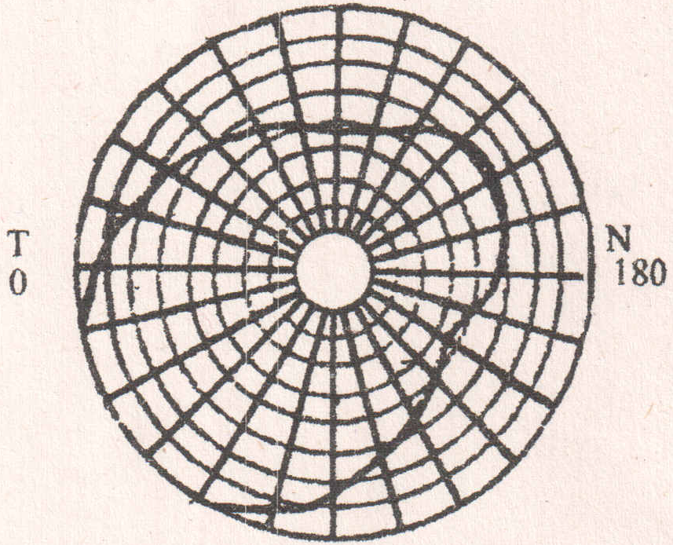 |  | 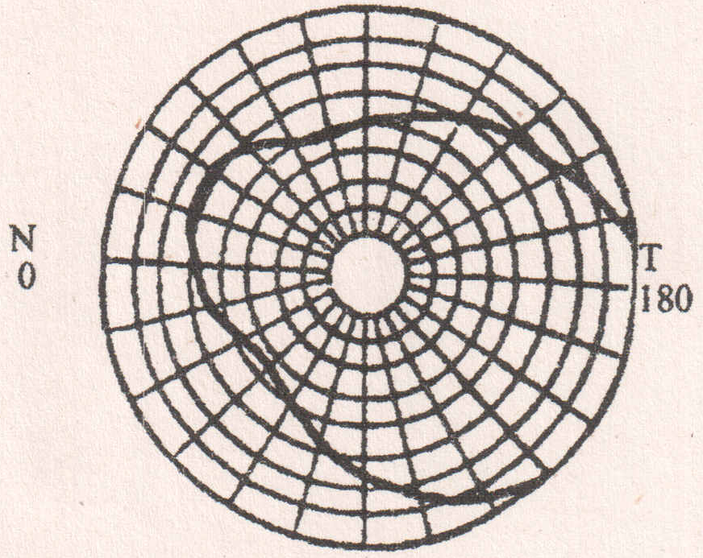

preliminary diagnosis
On the ground of:
patient’s complaints of
Data of external ophthalmologic examination
Data of functional ophthalmologic examination
Is possible to establish the provisional diagnosis:
OD |  | OS

differential diagnosis
Symptoms
final (clinical) diagnosis
OD |  | OS

aetiology and pathogenesis of established nosology
Treatment
I. General principles
II. Treatment of the patient
III. Recommendation and prognosis
doctor’s signature _________________________________

